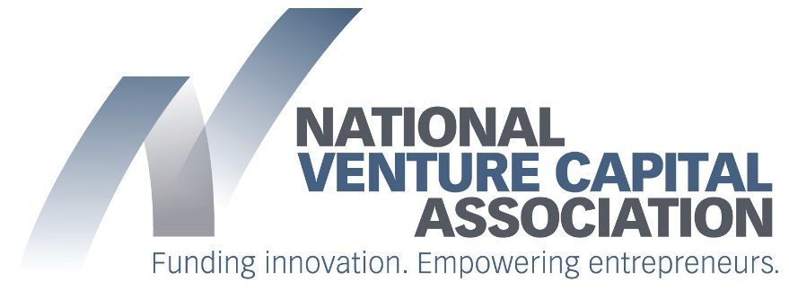
September 29, 2017 | FOR IMMEDIATE RELEASE

Contacts:
Ben Veghte | Melissa Cruz | Stacey Berkowitz
NVCA | American Immigration Council | Mayer Brown
202-864-5923 | 202-507-7518 | 212-506-2636
bveghte@nvca.org | mcruz@immcouncil.org | sberkowitz@mayerbrown.com

Motion for Preliminary Injunction Filed to Compel DHS to Implement International Entrepreneur Rule

WASHINGTON, DC – The National Venture Capital Association (NVCA), entrepreneurs and startup companies today filed a motion for a preliminary injunction in federal court in Washington, D.C. to compel the Department of Homeland Security (DHS) to implement the International Entrepreneur Rule (IER) pending final judgment of the suit brought by NVCA and the other plaintiffs on September 19. Represented by the American Immigration Council and Mayer Brown LLP, NVCA and the other plaintiffs are challenging DHS’s delay in implementing the IER, arguing that because DHS did not solicit advance comment from the public on the delay, it violated clear requirements of the Administrative Procedure Act. Because NVCA and the other plaintiffs are substantially likely to prevail on the merits of the lawsuit, they are seeking the preliminary injunction so that the rule can be implemented immediately and DHS can accept and adjudicate applications from entrepreneurs while the case proceeds.

“Making it easier for talented entrepreneurs to come to the U.S. so that they can grow the next generation of American companies is a no-brainer. By all measures, their contributions would be a net positive for our country and our economy, which is why it’s confusing that the rule was delayed in the first place” said Bobby Franklin, President and CEO of NVCA. “We are already seeing evidence of other countries actively recruiting talented foreign-born entrepreneurs, making it all the more important that we seek this preliminary injunction so that Americans can immediately realize the benefits of new startups in the U.S.”

Finalized by the Obama Administration, the rule would have allowed talented foreign-born entrepreneurs to travel to or stay in the United States to grow their companies for two and a half years with the possible extension of another two and a half years. Less than a week before the IER was to go into effect on July 17, the Department of Homeland Security (DHS) announced that the rule would be delayed and that DHS was “highly likely to rescind the final rule. As a result of the suspension of the IER, foreign entrepreneurs that intended to use the rule, their companies, and would-be and existing investors have been and will be harmed. The U.S. economy will miss out on new businesses and jobs that would have been created but that unfortunately will now be created overseas.

“The government’s unlawful postponement of the International Entrepreneur Rule is depriving foreign entrepreneurs of the only available avenue to grow their businesses in the United States,” said Melissa Crow, Litigation Director at the American Immigration Council. “Today’s filing is intended to jumpstart the implementation process.”
“Immediate implementation of the International Entrepreneur Rule is necessary so that our clients—founders, start-up companies, and their investors—can continue their important work of growing new, innovative business in the United States,” said Paul Hughes, a Partner at Mayer Brown. “These enterprises hire American workers, grow the U.S. economy, and ensure American technological leadership for decades to come.”

Background

The U.S. economy has long thrived on the contributions and innovations of immigrant entrepreneurs. From Google and Intel to Zipcar and Tesla Motors, some of the most iconic American companies that were once venture-backed have at least one immigrant founder. A 2013 NVCA study determined that a full one-third of U.S. venture-backed companies that went public between 2006 and 2012 had at least one immigrant founder. Furthermore, a 2016 study by the National Foundation for American Policy found that immigrants have started more than half (44 of 87) of America’s startup companies valued at $1 billion or more.

Despite their significant contributions to our economy, foreign entrepreneurs often encounter significant barriers to obtaining permission to travel to and work in the U.S. This is not the case in other countries who are adapting their immigration policies to grow their ecosystems. Canada, France, Singapore and the United Kingdom are a few examples of countries that have created dedicated visa programs to attract entrepreneurial job creators. This shift in policy is having a direct impact on venture investment activity globally with the U.S. losing its share of global venture capital investment. Two decades ago, U.S. startups received more than 90 percent of global venture capital investment. That number fell to 81 percent a decade ago and fell further to 54 percent last year.

VIEW THE MOTION FOR A PRELIMINARY INJUNCTION

###

Venture capitalists are committed to funding America’s most innovative entrepreneurs, working closely with them to transform breakthrough ideas into emerging growth companies that drive U.S. job creation and economic growth. As the voice of the U.S. venture capital community, the National Venture Capital Association (NVCA) empowers its members and the entrepreneurs they fund by advocating for policies that encourage innovation and reward long-term investment. As the venture community’s preeminent trade association, the NVCA serves as the definitive resource for venture capital data and unites its member firms through a full range of professional services. For more information about the NVCA, please visit www.nvca.org.

