An Analysis of U.S. Employment Dynamics at Venture-Backed Companies Between 1990 and 2022

Gregory W. Brown, Vedant Mozumdar
University of North Carolina Kenan Institute of Private Enterprise
Shiloh Tillemann-Dick
National Venture Capital Association & Venture Forward

August 2025

In this study, we build upon the existing body of literature focusing on the relationship between young companies and job creation by examining the employment dynamics of over 95,000 U.S. companies that received venture capital (VC) investment between 1970 and 2022. Importantly, we map the location of over 5.3 million employees working at these 95,000-plus companies in 2022. Our efforts are the first attempt (that we are aware of) to analyze the geographic dispersion of employees working for VC-backed companies. We also analyze the employment dynamics of VC-backed companies between 1990 and 2022 (the range of years for which our employment data allows such analysis).
Our analysis uncovers several key findings over the survey period (1990-2022):
- VC-backed employment grew at a significantly faster rate than non-VC-backed employment
  - VC-backed employment outpaced job growth in the overall economy in 47 out of 50 states
  - Employment at VC-backed companies grew at a rate more than four times the pace of employment at non-VC-backed companies.
  - Overall employment at VC-backed companies grew 169% vs. 41% for the overall economy.
- VC-backed jobs are distributed broadly across the entire U.S.
  - VC-backed jobs have been created in all 50 states and all 435 congressional districts.
  - Nearly two-thirds (64.3%) of the jobs created by VC-backed companies are outside the traditional top three VC hubs of California, Massachusetts, and New York.
  - This dispersion of employment contrasts with the concentration in investment, as 64% of VC dollars invested in 2022 went to California, Massachusetts, and New York. This suggests that although investment starts in the traditional hubs, as VC-backed companies grow and achieve a level of scale, they expand across the country, as does their economic and employment impact.
- Employment in the U.S. at VC-backed companies grows much faster than jobs at non-VC-backed companies, consistent with research on employment trends at young, high-growth companies.
  - Employment at VC-backed companies grew 169% between 1990 and 2022. In comparison, total U.S. private sector employment increased by only 41% between 1990 and 2020.
- Employment growth at VC-backed companies is resilient with strong, positive growth rates observed regardless of the stage of the business cycle in the broader U.S. economy.
  - Even amidst several economic contractions (the dot-com bubble, Great Financial Crisis of 2007-2009, COVID, etc.) VC-backed employment continued to increase relative to employment in the overall private sector.
Our findings concerning job growth at VC-backed companies are consistent with previous research that shows that young, high-growth companies are net job creators in the U.S. Importantly, our results indicate that VC investment is a catalyst for job creation in not only a select few metropolitan hubs, but across the entire nation. From a policy perspective, these findings should prompt officials focused on job creation to devise and promote policies that encourage more VC activity in the U.S. and accordingly permit the innovation economy to prosper.

Introduction
The venture capital (VC) industry plays a vital role in the U.S. economy. VC investors make high-risk investments in young, innovative startups. VC investors take these financial risks recognizing many startups will fail, but with the hope that some will yield a robust return on investment, either by being acquired by another company or through listing on a public stock exchange. Many of America’s most iconic companies received VC support early in their development, this includes the six largest public U.S. companies by market capitalization: Apple, Microsoft, Nvidia, Alphabet, Amazon, and Meta. A recent paper by Gornall and Strebulaev (2021) helps emphasize the importance of venture-funded investments. Among Gornall and Strebulaev’s findings are that VC-backed companies constitute 20% of all U.S. public companies, 57% of total market capitalization on U.S. public stock exchanges, produce $2.4 trillion in annual revenue, have annual net income of $257 billion, and employ 5.3 million Americans.
These figures underline the importance of VC-backed companies to the U.S. public equity and labor markets. The relationship between venture capital and labor markets may be of particular interest to empirical researchers who approach the industry with a broader lens than ones solely focused on financial returns and investment, exit, and fundraising activity. This is because a considerable body of literature has found that young companies are essential to net job creation in the United States. In particular, researchers have identified that high-growth young companies disproportionately contribute to job creation in the U.S. Such companies are also referred to as “knowledge-intensive” companies in the literature, and VC-backed startups are the leading edge of that new, knowledge-intensive, high-growth segment.
Data and Methodology
Our research attempts to advance knowledge of the relationship between VC-backed companies and employment dynamics in two primary ways. First, we estimate the geographic distribution of jobs at U.S. companies that have received venture financing. Second, we examine the employment dynamics of jobs at VC-backed companies over time and see if the observed trends are consistent with the literature on job creation at young, high-growth companies. To achieve our goals, we utilize four primary data sources:
- A dataset of 93,422 companies, courtesy of PitchBook, that received VC investment between 2000 and 2020.
- A dataset of 3,340 companies, courtesy of Professor Jay Ritter of the University of Florida, that received venture financing but underwent an IPO. The companies in this dataset date back to approximately 1970.
- Data from the National Establishment Time Series (NETS) database which contains longitudinal administrative data on employment for companies at the establishment level dating back to 1990 and ending in 2022.
- Public company data from standard sources like Compustat and CRSP (accessed through the Wharton Research Data Service) to help identify public companies in the NETS database.
A detailed description of our methodological approach is provided in the appendix to this paper, but we provide an overview here. To the extent possible, we utilized DUNS Numbers (unique 9-digit identification numbers provided by Dun & Bradstreet) to link company records from the PitchBook and University of Florida datasets with same-company records from the NETS database. The PitchBook dataset included 66,625 companies for which we could identify a DUNS number for the corporate headquarters. Of the 3,340 companies in the University of Florida dataset, we acquired DUNS Numbers for an additional 1,378 firms (not including those already in the PitchBook dataset) by matching names and other firm attributes to comparable fields in the NETS database. For all companies with DUNS numbers and available data in the NETS database, we adopted the available longitudinal employment data as the actual annual employment for these companies. For the remaining unmatched 28,759 companies, we imputed employment data for 27,047 based on company age when available (details are provided in the appendix).
Both the PitchBook and NETS datasets include a zip code field associated with each company or establishment in their respective datasets. However, neither dataset includes a similar field for the congressional district in which a company or establishment is located. Allocating a company’s employment at a particular establishment to local congressional districts consequently requires a mapping algorithm to impute geographic dispersion of employment for companies without a DUNS number. We first mapped companies with matching NETS data to congressional districts based on their zip code using the U.S. Department of Housing and Urban Development’s USPS Zip Code Crosswalk File. Using this first set of mapped companies, we subsequently constructed a mapping matrix of employment by company by congressional district and applied the aggregated geographic dispersion to the companies from the PitchBook dataset for which we imputed employment, thus allocating those jobs to the 435 congressional districts with voting members as well as Washington, DC and Puerto Rico. The result is a dataset with employment allocations to congressional districts for over 95,000 companies derived directly from the NETS data and imputed values based on the large sample of firms with NETS data.
Findings
One of the most important findings from our analysis is that on an overall basis, VC employment growth surpassed overall private-sector employment growth in 47 out of 50 states (Table 1). It’s worth noting that states with the highest growth rates, such as Delaware or Montana might be outliers because of their corporate climates or relatively low baselines/anchor investors. Conversely, the three states with below-trend VC-backed employment growth, (Rhode Island, Alaska, and North Dakota) can also be considered anomalies. Rhode Island is notable for its extremely high commuter and part-time populations. Additionally, Alaska and North Dakota both have small labor pools and large energy industries which creates an idiosyncratic environment for entrepreneurship compared to other states.

State | Growth in VC-backed jobs, 1990-2022 | Job Growth State Rank |  | State | Growth in VC-backed jobs, 1990-2022 | Job Growth State Rank
Alaska | 34% | 51 |  | North Carolina | 128% | 32
Alabama | 185% | 15 |  | North Dakota | 25% | 52
Arkansas | 99% | 39 |  | Nebraska | 92% | 43
Arizona | 187% | 12 |  | New Hampshire | 53% | 50
California | 265% | 5 |  | New Jersey | 130% | 31
Colorado | 167% | 20 |  | New Mexico | 127% | 33
Connecticut | 55% | 49 |  | Nevada | 143% | 26
District of Columbia | 152% | 23 |  | New York | 258% | 6
Delaware | 627% | 2 |  | Ohio | 88% | 45
Florida | 199% | 10 |  | Oklahoma | 81% | 46
Georgia | 215% | 7 |  | Oregon | 153% | 22
Hawaii | 105% | 37 |  | Pennsylvania | 134% | 30
Iowa | 174% | 18 |  | Puerto Rico | 121% | 34
Idaho | 139% | 28 |  | Rhode Island | -5% | 53
Illinois | 214% | 9 |  | South Carolina | 104% | 38
Indiana | 186% | 14 |  | South Dakota | 147% | 25
Kansas | 285% | 4 |  | Tennessee | 142% | 27
Kentucky | 109% | 36 |  | Texas | 149% | 24
Louisiana | 92% | 42 |  | Utah | 390% | 3
Massachusetts | 161% | 21 |  | Virginia | 186% | 13
Maryland | 175% | 17 |  | Virgin Islands | 119% | 35
Maine | 73% | 48 |  | Vermont | 180% | 16
Michigan | 98% | 40 |  | Washington | 88% | 44
Minnesota | 139% | 29 |  | Wisconsin | 94% | 41
Missouri | 77% | 47 |  | West Virginia | 173% | 19
Mississippi | 193% | 11 |  | Wyoming | 215% | 8
Montana | 2184% | 1
Source: Author’s Calculations, Federal Reserve of St. Louis, NETS dataset
Table 1

VC-backed jobs are spread broadly across the entire United States. We find that 64.3% of employment at VC-backed companies in 2022 was in states other than California, Massachusetts, or New York. This pattern stands in contrast to the geographic dispersion of VC investment in the U.S. which is concentrated in the traditional hubs of California, Massachusetts, and New York, which received 65% of VC dollars. This geographic concentration of investment has been the norm for decades: since 2004, the annual share of total VC investment attributed to these three states has never fallen below 59%. This also suggests that while investment might be concentrated in a few geographies, the companies receiving investment have impacts well outside their local geographies. As companies scale in traditional hubs they regularly expand outside the borders of their home state with the largest VC-backed companies all having most of their employees based outside their HQ states.

Source: Author’s Calculations; NVCA 2005 & 2024 Yearbooks
Chart 1
Our results also reinforce the findings of prior research: that young, knowledge-intensive companies increase their labor force more rapidly than more traditional employers. Job growth at young, knowledge-intensive companies is important because such businesses are responsible for most aggregate job creation, even as 50% of startups fail within the first five years. Put differently, higher than average job creation at high-growth companies like the ones we examine compensates for the majority of losses associated with an annual startup cohort, so that the cohort retains 80% of its original employment after five years., Our cohort of VC-backed companies demonstrates much faster employment growth compared to total private sector employment during the period between 1990 and 2022. In particular, we find:
- The annualized growth rate of employment at VC-backed companies in our dataset between 1990 and 2022 is 3.14%.
- For total private sector employment (as published by the U.S. Bureau of Labor Statistics), the same rate between 1990 and 2022 is 1.09%.
- Employment at our set of VC-backed companies grew 169% between 1990 and 2022.
- In comparison, total private sector employment increased by 41% between 1990 and 2022.

Chart 2 demonstrates the large gap in employment relative to equivalent initial starting points in employment levels that result from the annualized growth rate we discovered at VC-backed companies (3.1%) versus the growth rate for total private sector employment (1.14%). Beginning with an index value of 100, a growth rate of 3.1% applied for 22 consecutive years (consistent with our period of analysis ranging from 1990 to 2022) grows to 269. By comparison, a growth rate of 1.1% applied to an initial index value for 22 consecutive years grows to only 140. Put another way, if one observed two companies with an equal number of employees —one VC-backed and the other without VC funding—after 22 years, one could expect that employment growth at the VC-backed company would be more than three times the employment growth at the company without VC funding.

Source: Author’s Calculations; US Bureau of Labor Statistics
Chart 2
A third key finding of our analysis is that job creation at VC-backed companies is highly resilient and largely insulated from fluctuations in the business cycle. Chart 3 shows the year-over-year percent change in employment at our cohort of VC-backed companies compared to total private sector employment. Consistent with our earlier findings on annualized growth rates of employment, the average year-over-year percent change for employment at our set of VC-backed companies between 1990 and 2022 was 3.14%. In contrast, the average year-over-year percent change for total private sector employment was only 1.09%.
This should be expected given our earlier results. Of more interest is that job growth at VC-backed companies remained robust and positive almost every year between 1990 and 2022. This means that VC-backed companies increased employment at a fast clip even during the dot-com recession (2001), the Great Recession around the Global Financial Crisis (2007-2009), and the COVID-induced recession (2020). While there was a small dip in VC-backed employment in 1997 it followed a year of exceptional employment growth (16.9% in 1996), likely indicating a reversion to the mean rather than a reduction in long-term health.
Such buoyant performance throughout even the contractionary phases of the boom-bust cycles of the economy stands in contrast to the behavior of total private sector employment. As Chart 3 indicates, U.S. private sector employment shrank during each of the three aforementioned recessions. Perhaps most surprising is that employment growth remained positive at VC-backed companies even during the most extreme period of job losses in U.S. history – specifically in 2020 around the COVID-induced shutdowns.
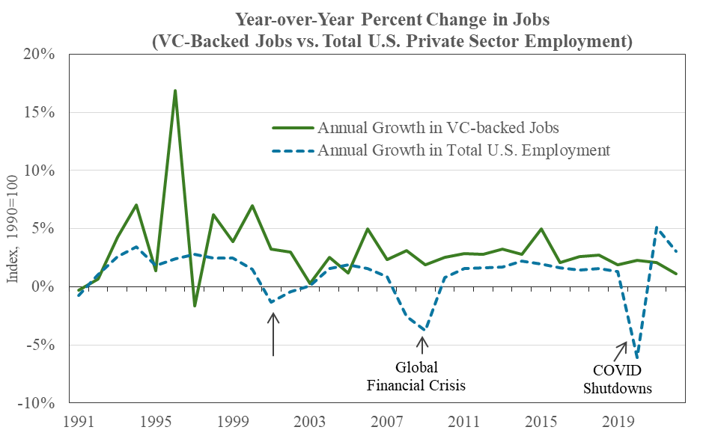
Dotcom Recession
Source: Author’s Calculations; US Bureau of Labor Statistics
Chart 3
VC-backed Employment Dynamics by Geography
Finally, we offer some insights on the geographic dimensions of our analysis of employment dynamics for our set of VC-backed companies. As mentioned previously, VC-backed companies appear to create jobs broadly across the nation despite the concentration of VC investment in California, Massachusetts, and New York. Despite typically receiving less than 30% of total annual VC investment in the U.S., states apart from California, Massachusetts, and New York (so-called “non-hub” states) have accounted for at least 64% of jobs at VC-backed companies every single year dating back to 1990.
A breakdown of each state’s share of total employment in 2022 for our set of VC-backed companies is provided in Table 2 below. We also examine annualized growth rates in VC-backed employment for the last 10-year period. We find that VC-backed jobs are located not only in all 50 states, but also all 435 congressional districts with voting members as well as Washington, DC and Puerto Rico. Excluding California, Massachusetts, and New York, states with noticeable shares of employment (at least 2.0 % of total VC-backed employment in 2022) include Colorado, Florida, Georgia, Illinois, Maryland, North Carolina New Jersey, Ohio, Pennsylvania, Texas, Virginia, and Washington. States exhibiting the most rapid growth rates in VC-backed employment in recent years (at least an annualized growth rate of 3.0% from 2010 to 2022) include California, Delaware, Illinois, Indiana, Montana, New York, and Utah.
Heatmaps of employment at VC-backed companies in our dataset are provided in Figures 1 through 4 below. We map the geographic distribution of employment as well as growth across the U.S. by both congressional district and by state.

Concluding Remarks
Our analysis of over 67,000 U.S. companies that received VC investment, and which employ 5.3 million workers indicates that VC-backed companies create jobs broadly across the entire nation and play a key role in tnet job creation in the U.S. The accelerated growth rates in employment and the resilience of such growth at VC-backed companies suggest that encouraging greater VC investment may be a boon to overall U.S. employment. This should be of interest to policymakers interested not only in creating jobs in general, but in creating durable jobs that can weather the vicissitudes of economic cycles. Our findings suggest that the promotion of policies which encourage more VC activity in the U.S. and permit the innovation economy to prosper will benefit the U.S. labor market and economy.
Table 2: Shares (in 2022) and Annualized Growth Rates of VC-backed Jobs, by State or Region
State/Region | % of VC-backed Jobs in 2022 | # of VC-backed Jobs 2022 | Annualized % Change Between 2012 and 2022
Alaska | 0.1% | 5,717 | 0.8%
Alabama | 0.8% | 40,724 | 1.2%
Arkansas | 0.1% | 7,407 | 2.2%
Arizona | 1.2% | 64,110 | 2.0%
California | 23.0% | 1,221,772 | 4.1%
Colorado | 2.2% | 118,197 | 2.9%
Connecticut | 1.1% | 59,295 | 1.2%
District of Columbia | 0.5% | 24,883 | 2.5%
Delaware | 0.4% | 23,395 | 11.3%
Florida | 3.5% | 187,311 | 2.6%
Georgia | 2.7% | 144,054 | 1.5%
Hawaii | 0.2% | 8,027 | 1.3%
Iowa | 0.3% | 16,122 | 0.9%
Idaho | 0.2% | 9,131 | 2.1%
Illinois | 5.2% | 274,100 | 3.2%
Indiana | 0.9% | 46,337 | 3.0%
Kansas | 0.4% | 22,421 | 2.1%
Kentucky | 0.6% | 31,712 | 1.2%
Louisiana | 0.6% | 29,666 | 0.6%
Massachusetts | 5.2% | 277,799 | 2.8%
Maryland | 2.1% | 109,609 | 0.6%
Maine | 0.2% | 12,035 | 1.6%
Michigan | 1.5% | 82,126 | 1.4%
Minnesota | 1.3% | 68,527 | 2.3%
Missouri | 1.1% | 58,484 | 1.6%
Mississippi | 0.3% | 17,876 | 0.8%
Montana | 0.1% | 5,825 | 5.2%
North Carolina | 2.9% | 153,780 | 1.2%
North Dakota | 0.1% | 6,630 | 1.0%
Nebraska | 0.3% | 13,976 | 1.5%
New Hampshire | 0.5% | 26,274 | 0.6%
New Jersey | 3.2% | 167,564 | 0.8%
New Mexico | 0.3% | 18,225 | 1.1%
Nevada | 0.5% | 26,525 | 1.8%
New York | 7.5% | 396,109 | 5.1%
Ohio | 2.7% | 142,094 | 0.4%
Oklahoma | 0.4% | 20,424 | 0.8%
Oregon | 1.0% | 51,883 | 2.3%
Pennsylvania | 3.5% | 183,241 | 1.8%
Puerto Rico | 0.2% | 12,617 | 0.9%
Rhode Island | 0.3% | 17,560 | 0.4%
South Carolina | 1.0% | 55,392 | 0.7%
South Dakota | 0.0% | 2,384 | 1.2%
Tennessee | 1.6% | 87,066 | 1.8%
Texas | 8.6% | 456,455 | 2.0%
Utah | 1.4% | 74,979 | 3.6%
Virginia | 2.4% | 126,041 | 1.8%
Virgin Islands | 0.0% | 35 | 8.1%
Vermont | 0.1% | 4,903 | 1.1%
Washington | 4.5% | 240,175 | 2.1%
Wisconsin | 0.8% | 44,968 | 0.9%
West Virginia | 0.1% | 7,891 | 1.0%
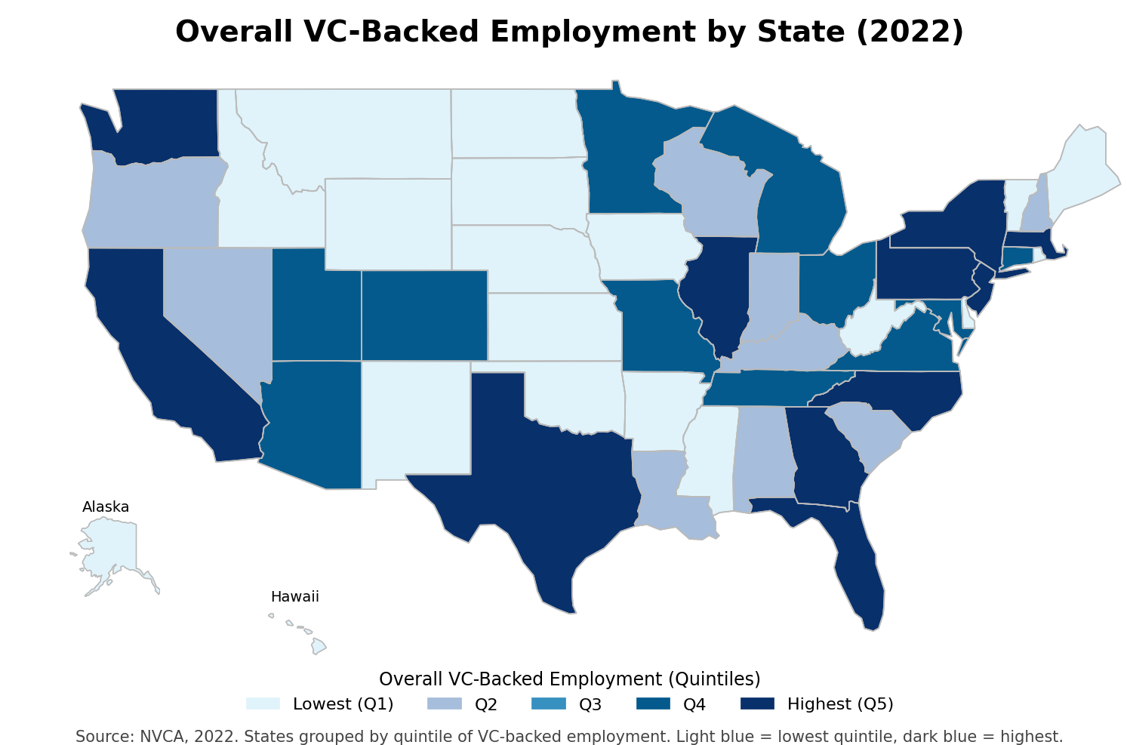
Figure 1
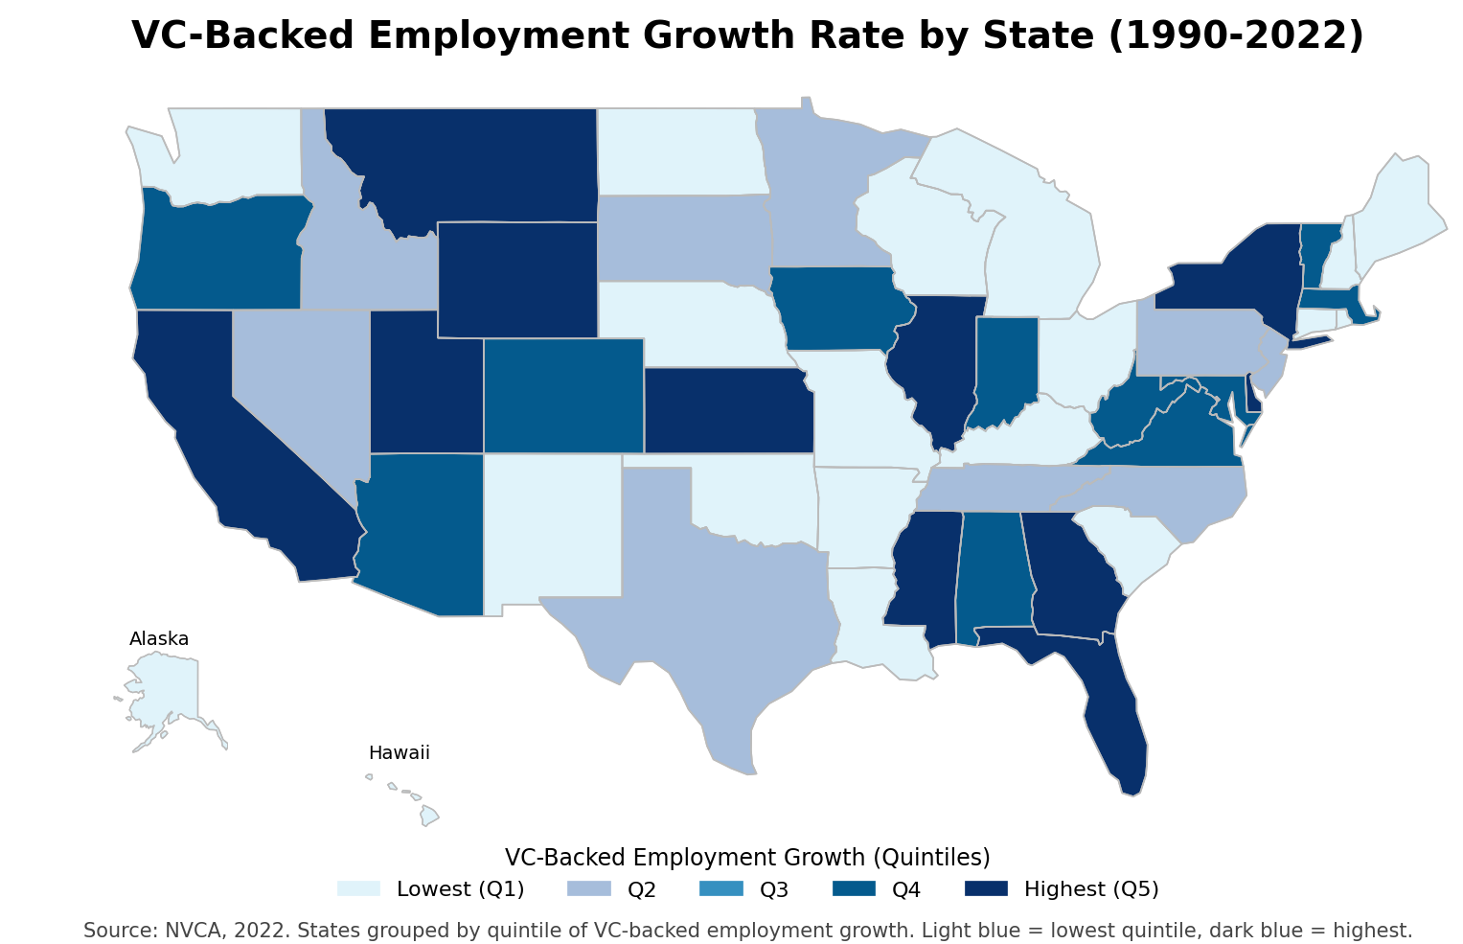
Figure 2
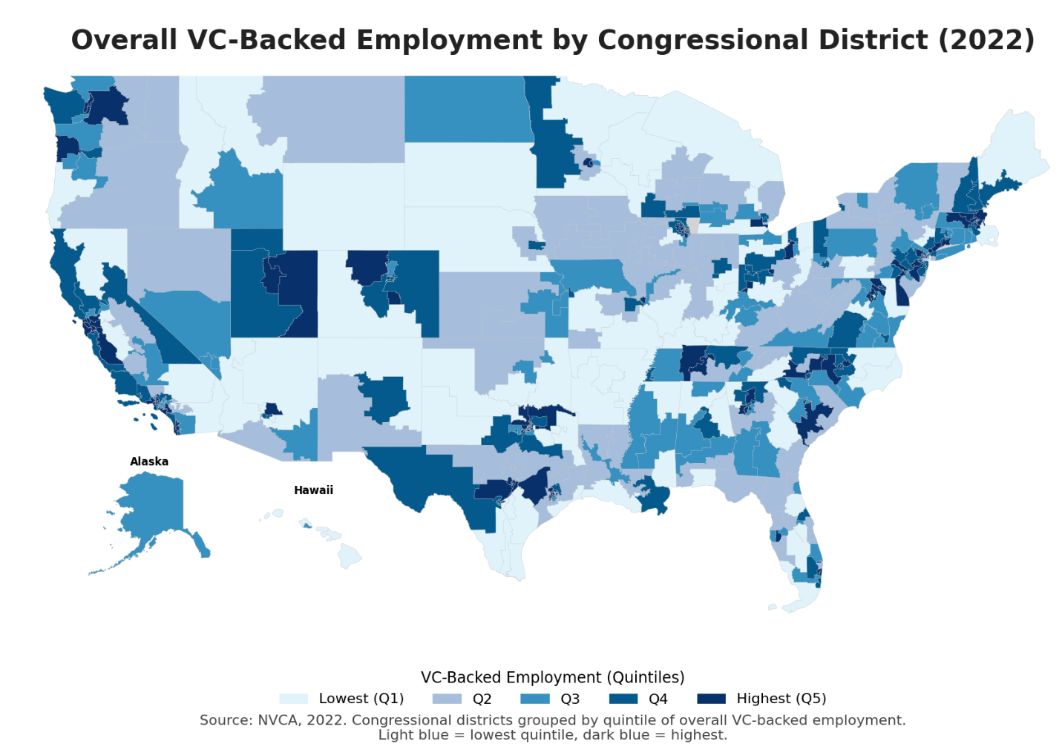
Figure 3

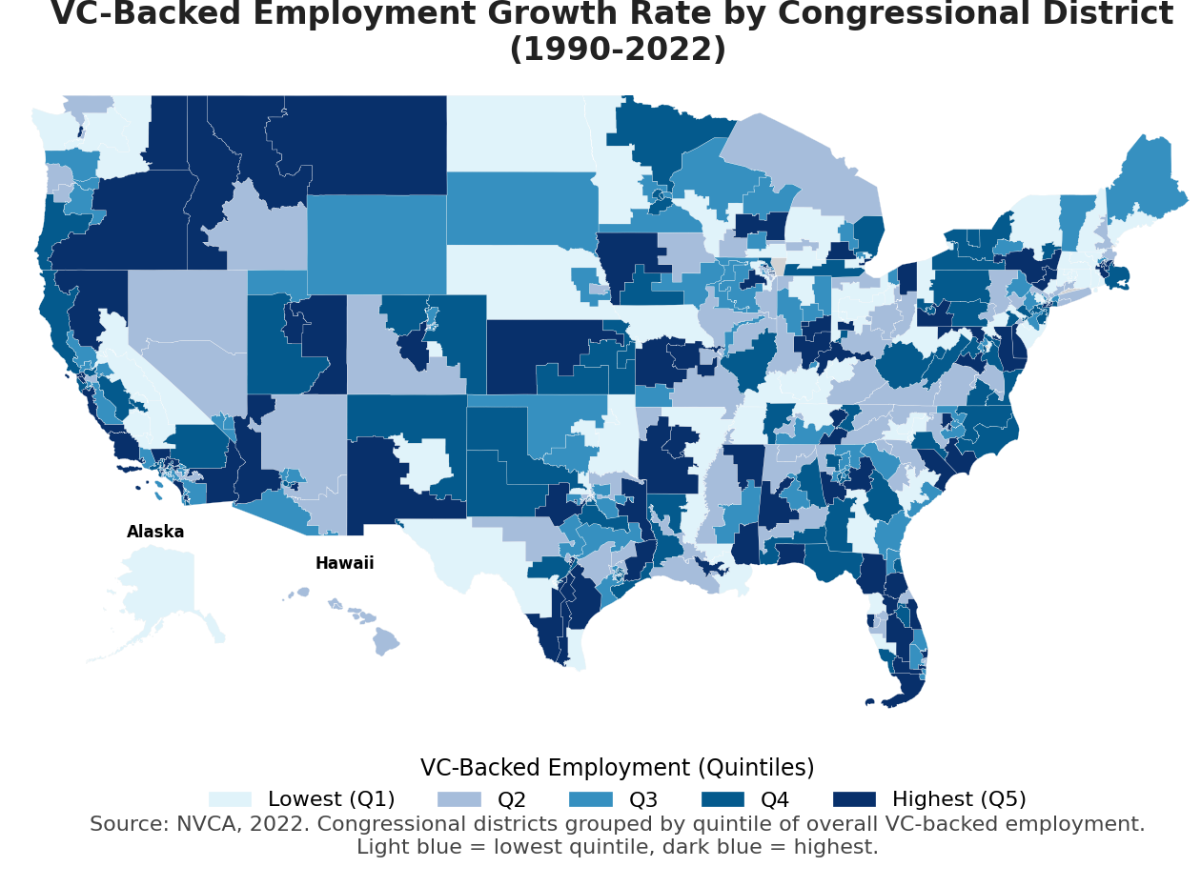
Figure 4
Appendix: Methodology
Overview
The purpose of this project is to estimate employment of VC-backed companies headquartered in the United States at the national, state, and congressional district level. To accomplish this task, we utilized three datasets: (1) a list, courtesy of PitchBook, of 93,422 companies that received venture capital investment from 2000 to the present; (2) a list, courtesy of Professor Jay Ritter at the University of Florida, of 3,697 VC-backed companies that underwent an initial public offering from approximately 1970 onward; and (3) a dataset consisting of a subset of the National Establishment Time Series (NETS) dataset that contains employment time series data dating back to 1990 for establishments linked to the companies contained in the PitchBook or the University of Florida datasets. By matching the companies contained in the PitchBook and the University of Florida datasets with same-company data from the NETS dataset, we are able to link high-quality administrative data on company employment disaggregated at very fine levels of geographic detail.
Matching Company Records Between PitchBook and NETS Datasets
The initial step for generating the dataset required matching company records between the PitchBook, the public companies and NETS datasets. This process involved identifying DUNS Numbers (unique 9-digit identification numbers provided by Dun & Bradstreet and the primary company identifier in the NETS data) for the headquarters of each company. Ideally, we would obtain HQ-DUNS Numbers for all companies in our combined dataset which could then be linked to employment administrative data in the NETS dataset. However, this task poses two significant challenges:
First, the data sources contain no unique common identifiers. For example, company names rarely match exactly and sometimes differed substantially between PitchBook, the public-company data and NETS. In addition, though company names may be similar across datasets, the companies may have had different address information, raising doubts about the match quality. We also find examples in the data where one dataset refers to the original name of a VC-backed startup while another refers to a corporation that acquired and now owns the company. Few records, even those we confirmed as positive matches, matched on every characteristic between the datasets.
The second obstacle is that the NETS dataset is enormous - containing over 70 million corporate entities. The sheer size of the NETS dataset rendered manual hand-matching between the two datasets impractical given long serve times for individual records. It also makes “all versus all” comparisons, or text comparisons between every company name in NETS with every company name in our PitchBook sample, computationally infeasible.
While perfect matches were rare, strong matches between “features” (characteristics of the data such as names, location, phone numbers, etc.) indicate a higher likelihood of a business entity match. While name similarity on its own may not demonstrate an entity match, as additional data characteristics are added to the matching process, our confidence of match, or non-match, will increase.
We use several different data characteristics from the datasets (such as City, Zip Code, Phone Number, Phone Area Code, SICS classification, NAICS classification, and Founding Year) to identify subsets of potential match candidates. We then utilize name similarity to identify matches between companies. We utilize multiple company names when available (common names, trade names, legal names) to improve match quality. In our final sample, we obtained about 68,003 DUNS Numbers for the VC-backed sample. Of these, around 66,625 were provided from the original PitchBook sample, and the remainder were obtained uniquely from the University of Florida sample of VC-backed IPOs (e.g., many companies that had IPOs after 2000 were also present in the PitchBook data).
Despite these efforts, and a substantial growth in the sample size of VC-backed companies since the original 2022 version of this paper, we are certainly missing some VC-backed firms. In particular, the Pitchbook data has few VC-firms prior to 2000, and the University of Florida will only have these older firms if they subsequently had an IPO. In addition, there is no regulatory filing for VC investment and so even the high-quality PitchBook data are likely missing some VC-backed firms founded after 2020. In this sense, our estimates of employment at VC-backed companies almost certainly understate true employment. We hope that our continued efforts on this project will allow for a more complete accounting of employment at VC-backed companies in future updates.
Additional Details on the Matching Process
The NETS dataset contains about 73 million establishments. Our VC-backed company dataset contains a much more modest 95,000 companies, implying approximately 7 trillion possible matches in an “all names versus all names” comparison between the two datasets, more if we consider multiple possible names (trade, common, legal) for each business. To make the matching computationally feasible, we identified common characteristics, such as zip code, that allowed us to get subsets of data that were more likely to contain matches. For instance, when we filter by a single zip code, we may get 20 VC-backed companies and 30,000 NETS entries, requiring many fewer comparisons for that zip code, rather than the trillions from the full datasets. The benefit of these methods is that they allow for a feasible search for firms without known DUNS numbers. The cost of these methods is that we may eliminate the true match from the search set and thus identify an incorrect match or no match.
Cleaning and Matching Features
We conduct a variety of tests to evaluate the accuracy of matches, and we provide an overview of the process here:
- Company Name – Names are our primary matching tool. We start with the most commonly filled-in name fields in each dataset and fill in missing values from other name fields. For instance, if “Company Name” is blank in PitchBook, we fill in the value for this variable using information from the “Common Name” and/or “Official Name” fields. We then remove a limited number of “stop” words (e.g., “corporation”) to improve matching quality. Name fields are then vectorized into 3-letter n-grams for fast string comparison with other names. Finally, strings were compared using a Cosine similarity algorithm.
- State – We standardize to the two-letter abbreviations and perform a simple equality match.
- City – An equality match is performed to determine whether city names are identical.
- Zip – We check if PitchBook and public-company zip codes match either exactly to the same zip code provided in the NETS data or to a neighboring zip code in the NETS data.
- Phone Number & Area Code – Checks on phone numbers and area codes are generally less reliable. This derives from a lack of one-to-one matches between the PitchBook and NETS datasets. When we examine phone numbers by DUNS Number within the NETS database, we find that companies regularly had multiple numbers—sometimes up to 12 numbers for one company in the database. If any of these multiple phone numbers within NETS matched the PitchBook number directly, then we score it as a full phone match.
- NAICS and SIC Classifications – Rather than provide a NAICS or SIC code as the NETS dataset does, PitchBook provides—in levels of increasing detail, respectively—classifications as to a business’s industry through the Industry Sector, Industry Group, and Industry Code variables. The disparate classification systems mean there is no clean crosswalk from either NAICS or SIC to PitchBook industry category. Many NAICS or SIC codes could reasonably be mapped to several different Industry Groups and Industry Sectors. For example, a single NAICS code in the NETS data could match everything from computers to durable goods in the PitchBook dataset. As a workaround, we record every match between Industry Code and NAICS or SIC in our positive match set, creating a type of fuzzy crosswalk. We then employ this crosswalk on proposed matches. This allows us to determine whether the Industry Code/NAICS or Industry Code/SIC combination has been seen before. If the combination has been seen, then we set the corresponding binary variables (NAICS for a NAICS match in the crosswalk, SIC for a SIC match) to true.
- Founding Year – The absolute value of the difference in founding years (NETS versus PitchBook) was used as an input to the matching algorithm.
Acquiring NETS Employment Data
With the combined set of HQ-DUNS Numbers from PitchBook and the University of Florida dataset, we access the related NETS data to obtain employment administrative data. This matching is achieved by utilizing the headquarters, acquiring companies, related establishments, and grabbing all subsidiaries of that new, larger list. This generates a list of around a million establishments, with comprehensive employment information, NAICS/SIC codes, and location information by year for each establishment. With these data, we filter back, dropping any results that were not directly owned or related to originally VC-backed startups. This ensures that we are not counting unrelated employment of non-VC-backed acquiring companies in our totals but instead are only including employment at VC-backed companies. For example, assume our data included a non-VC-backed parent company with several subsidiary businesses that were acquired over time, but which did not begin as VC-backed startups, and that this parent company also acquired one VC-backed startup. We seek to only count the employment associated with the VC-backed startup, which may have multiple establishments across the U.S.
We also make some adjustments and clean the dataset for use in further analysis. Our main adjustment is for currently operating companies not reporting recent employment information. For companies coded by NETS as still in business (i.e., “Out of Business” flag set to false) but missing recent employment information, we backfilled employment for up to three years to increase our estimates’ accuracy. This is consistent with the sometimes-infrequent updating of small companies in the NETS dataset.
In NETS, an establishment is a specific line of business at a specific location (see below), and employment includes all workers at an establishment, potentially including proprietors, independent contractors, and temporary workers supplied by outside organizations. This group of workers constitutes a superset of workers that include employees as traditionally defined and measured in datasets produced by government statistical agencies like the County Business Patterns (CBP) and Quarterly Census of Employment and Wages (QCEW) datasets. However, findings that (a) correlation of NETS employment counts and CBP employment counts across U.S. counties are typically in excess of 0.99, (b) correlations across state-industry-size class cells are above 0.9 on restricted samples, and (c) zip code-level correlations are also remarkably high provide confidence that workers in the NETS data meet the conventional definition of an employee as defined in government datasets. Additionally, while NETS records are annual, information is collected throughout the year, and the timing of measurement for each establishment is not reported in the data. Our estimates of employment should therefore not be thought of as a point estimate of employment at all the VC-backed companies in our dataset on a specific date (in contrast to how some government surveys collect and measure employment data), but rather as more general measures of employment throughout the year. For further details on how employment is defined in NETS, please refer to the NETS documentation and two Federal Reserve research papers available here and here.
Imputing Employment for Companies without DUNS Numbers
Of the over 95,000 VC-backed companies in our combined datasets, we identified 68,003 unique companies in the NETS data that had HQ-DUNS Numbers. 54,314 of these companies have employment data when they appeared as headquarters (HQDUNS) in the NETS data. Among the other 28,759 companies in the PitchBook dataset that either do not have DUNS Numbers or the DUNS Numbers are not in the NETS data, there are 27,047 companies that have information on Founding Year. We imputed the employment of these companies using estimated company age fixed effects estimators obtained through panel regression analysis. This method is equivalent to calculating by-age averages across all companies for which we have NETS data. We then applied these employment statistics to the companies with missing DUNS numbers based on the founding date of the company.
Mapping Employment to Congressional Districts
Both PitchBook and NETS datasets include a zip code field associated with each company or establishment in their respective datasets. However, neither dataset includes a similar field for the congressional district in which a company is located. Allocating a company’s employment at a particular establishment to local congressional districts consequently requires a mapping algorithm. This algorithm was executed in two stages to address the two types of record data we had available: (1) records of employment data with linked zip codes that were pulled directly from the NETS database, and (2) records of imputed employment (imputed because we could not find a proper match within the NETS administrative data) that also had linked zip codes.
To impute how employment for a company headquartered in a certain congressional district may be distributed across multiple congressional districts, we produced an algorithm based on the NETS data that estimates the shares of employment for companies headquartered in each congressional district that may ultimately lie in other congressional districts. Applying this algorithm to non-headquarter locations allowed us to estimate how employment at a branch that is geographically distinct from the company’s headquarters is spread across other congressional districts.
To develop the algorithm, we first assigned companies to congressional districts based on their zip code and state information in the NETS data using the HUD USPS Zip Code Crosswalk File for this mapping. We note that the zip codes do not have a one-to-one relationship with congressional districts, and specifically there are 6,077 zip codes that map to more than one congressional district. For zip codes that span multiple congressional districts, we split employment evenly across all congressional districts. We also removed companies from 8 zip codes that were not in the Crosswalk data. Apart from companies located in these 8 zip codes, we assigned congressional districts to each branch and headquarters for every company for which we had administrative data for employment and associated zip codes and states pulled directly from the NETS data. This assignment addresses the first set of record data mentioned.
This first step provides the ability to address the second set of records consisting of companies with imputed employment and to allocate these companies’ employment to each of 437 congressional districts (we include Washington, DC and Puerto Rico in addition to the 435 congressional districts with voting representatives). In essence, we assumed that the allocation across congressional districts for the companies with DUNS Numbers also applied to companies with imputed data. We limited allocations of branch employment to other districts solely to branches in districts that had at least 1% of employment outside the headquarters district. However, this allocation is quite modest in practice. On average about 98% of employment was found to be in the headquarters district, so the typical imputed company allocates only a small fraction of its employment to just one or two other districts. We augmented the final imputed employment by distributing the total employment to all congressional districts based on the congressional employment matrix.

This analysis represents an update to our original analysis published in 2022. We thank PitchBook and Professor Jay Ritter of the University of Florida for assistance in identifying VC-backed companies. The opinions expressed in this paper are solely those of the authors.
As of August, 2024.
Gornall, Will and Ilya A. Strebulaev, “The Economic Impact of Venture Capital: Evidence from Public Companies” (June 2021). Available at SSRN: https://ssrn.com/abstract=2681841.
Gornall and Strebulaev examine only public companies that previously received venture financing and limit their analysis to a post-ERISA sample of companies that were founded after 1968 and went public after 1978. They exclude analysis of private companies that received venture financing but were never listed on a public exchange.
For example, see: Haltiwanger, John, Ron S. Jarmin, Robert Kulick, and Javier Miranda, “High Growth Young Firms: Contribution to Job, Output, and Productivity Growth,” Measuring Entrepreneurial Businesses: Current Knowledge and Challenges (University of Chicago Press: September 2017). Haltiwanger, John, Ron S. Jarmin, and Javier Miranda, “Who Creates Jobs? Small Versus Large Versus Young,” The Review of Economics and Statistics 95, no. 2 (May 2013): 347-361.
Crews, Jonas, Ross DeVol, Richard Florida, and Dave Shideler, “Young Firms and Regional Economic Growth: Knowledge-Intensive Entrepreneurs Critical,” Heartland Forward, May 2020.
2005 & 2024 NVCA Yearbook.
Crews et al.
Horell, Michael and Robert Litan, “After Inception: How Enduring is Job Creation by Startups?”, Ewing Marion Kauffman Foundation, September 9, 2010.
While our set of VC-backed companies include companies that received venture financing as far back as 1970, our analysis of employment dynamics is limited to the years 1990 to 2020 due to data limitations associated with the NETS dataset (the NETS employment data only date back to 1990).
This resilience is likely the result of a disproportionate number of VC-backed companies operating in the technology and healthcare industries which remained extremely active in 2020.
According to data from the NVCA 2021 Yearbook, startups in California, Massachusetts, and New York have received at least 70% of all VC investment in the U.S. since 2015. Between 2004 and 2014, startups in these three states never received less than 59% of all VC investment in the U.S.
We also include the District of Columbia and Puerto Rico which, per our analysis, are home to a number of VC-backed jobs.

