

NEW FOR 3.0
Enhanced
Model Term Sheet v3.0

In partnership with


What is new in version 3.0?
The Enhanced Model Term Sheet v3.0 includes nine additional deal term insights as well as updated data, comparing calendar year 2021 with aggregate data from the previous five years, 2016-2020. To prepare the data, Aumni’s platform analyzed the executed legal agreements of over 200,000 venture transactions from more than 90,000 investors.
How to use the Enhanced Features in this Model Document
Throughout this document, there will appear blue underlined text, indicating the availability of relevant data or analysis of that specific term. To read this analysis, simply click the link to follow. To return to the original spot in the document, click the “Click to go back” link. The pages containing the data and analysis may be removed for further customization and execution.
Table of Contents
Market Analytics for Deal Term Usage 21
Investors Data 21
Median Fully-Diluted Ownership Percent Purchased by New Money 21
Median Fully-Diluted Ownership Percent Purchased by Lead Investor 21
Median Percentage of Round Purchased by Lead Investor 22
Median Major Investor Threshold $ 22
NEW FOR 3.0
Median Number of Investors (Syndicate) in an Equity Financing 23
Amount Raised Data 23
Median Amount Raised in an Equity Financing in the Round ($M) 23
Median Months in Between Financing 24
NEW FOR 3.0
Median % Change in $ Amount Raised Between Rounds 24
NEW FOR 3.0
Median Convertible Outstanding in the Round (Principal and Interest) 25
Median Valuation Cap in Convertible Security (All Types) 25
Percentage of 20% or Less Convertible Discount 26
NEW FOR 3.0
Pre-Money Valuation Data 27
Median Option Pool Size as a Percentage of Fully-Diluted Post-Money Capitalization 27
Median % Change in Option Pool Shares 27
NEW FOR 3.0
Median Post-Money Valuation ($M) 28
Median % Change in Post-Money Valuation Between Rounds 28
NEW FOR 3.0
Median Common Stock Issued as a Percent of Fully-Diluted Ownership (Includes Option Pool) 29
Dividends Data 30
Percentage of Non-Cumulative Dividends 30
Percentage of 8% or Less Dividend Rate 30
NEW FOR 3.0
Liquidation Preference Data 31
Percentage of 1x Liquidation Preference Multiplier 31
Percentage of Non-Participating Preferred 31
Anti-Dilution Provisions Data 32
Percentage of Broad Based Anti-Dilution 32
Pay-to-play Data 32
Percentage of Pay-to-Play Provision 32
Redemption Rights Data 33
Percentage of Redemption Rights 33
Counsel and Expenses Data 33
Median Lead Investor Counsel Fee Cap 33
Registration Rights Data 34
Percentage of Registration Rights 34
Management and Information Rights Data 35
Median Major Investor Threshold as a Percent of New Money 35
Median Major Investor Threshold as a Percent of Fully-Diluted Ownership 35
Right to Participate Pro-Rata in Future Rounds Data 36
Percentage of Pro-Rata Rights for All Investors in the Round 36
Percentage of Pro Rata Rights for Major Investors 36
NEW FOR 3.0
Employee Stock Options Data 37
Percentage of Employee Vesting 37
NEW FOR 3.0
Right of First Refusal Data 37
Percentage of Right of First Refusal (ROFR) 37
Board of Directors Data 38
Median Number of Board Seats After the Round 38
Drag Along Data 38
Percentage of Drag Along Rights 38

Preliminary Note
This term sheet maps to the NVCA Model Documents, and for convenience the provisions are grouped according to the particular Model Document in which they may be found. Although this term sheet is somewhat longer than a “typical” VC Term Sheet, the aim is to provide a level of detail that makes the term sheet useful as both a road map for the document drafters and as a reference source for the business people to quickly find deal terms without the necessity of having to consult the legal documents (assuming of course there have been no changes to the material deal terms prior to execution of the final documents). For Series B and later transactions, consider substantially shortening to refer to deal terms being “consistent with prior rounds, subject to reasonable review by Lead Investor” (as noted in the prior sentence, deal terms often are negotiated further between term sheet and closing, so relying on a term sheet for one round in a later round may prove inaccurate). ©©
© Aumni 2022. All rights reserved.
TERM SHEET
FOR SERIES A PREFERRED STOCK FINANCING OF
[INSERT COMPANY NAME], INC.
[__________, 20__]

This Term Sheet summarizes the principal terms of the Series A Preferred Stock Financing of [___________], Inc., a [Delaware] corporation (the “Company”). In consideration of the time and expense devoted and to be devoted by the Investors with respect to this investment, the No Shop/Confidentiality provisions of this Term Sheet shall be binding obligations of the Company whether or not the financing is consummated. No other legally binding obligations will be created until definitive agreements are executed and delivered by all parties. This Term Sheet is not a commitment to invest, and is conditioned on the completion of the conditions to closing set forth below. This Term Sheet shall be governed in all respects by the laws of [___________].
Offering Terms
Security: | Series A Preferred Stock (the “Series A Preferred”).
Closing Date: | As soon as practicable following the Company’s acceptance of this Term Sheet and satisfaction of the conditions to closing (the “Closing”). [provide for multiple closings if applicable]
Conditions to Closing: | Standard conditions to Closing, including, among other things, satisfactory completion of financial and legal due diligence, qualification of the shares under applicable Blue Sky laws, the filing of a Certificate of Incorporation establishing the rights and preferences of the Series A Preferred, [obtaining CFIUS clearance and/or a statement from CFIUS that no further review is necessary,] [and an opinion of counsel to the Company].
Investors: | Investor No. 1: [_______] shares ([__]%), $[_________]  Investor No. 2: [_______] shares ([__]%), $[_________]  [as well other investors mutually agreed upon by Investors and the Company]
Amount Raised: | $[________], [including $[________] from the conversion of SAFEs/principal [and interest] on bridge notes].
Pre-Money Valuation: | The price per share of the Series A Preferred (the “Original Purchase Price”) shall be the price determined on the basis of a fully-diluted pre-money valuation of $[_____] (which pre-money valuation shall include an [unallocated and uncommitted] employee option pool representing [__]% of the fully-diluted post-money capitalization) and a fully-diluted post-money valuation of $[______].
CHARTER
Dividends: | [Alternative 1: Dividends will be paid on the Series A Preferred on an as-converted basis when, as, and if paid on the Common Stock.]  [Alternative 2: Non-cumulative dividends will be paid on the Series A Preferred in an amount equal to $[_____] per share of Series A Preferred when and if declared by the Board of Directors.]  [Alternative 3: The Series A Preferred will carry an annual [__]% cumulative dividend [payable upon a liquidation or redemption]. For any other dividends or distributions, participation with Common Stock on an as-converted basis.]
Liquidation Preference: | In the event of any liquidation, dissolution or winding up of the Company, the proceeds shall be paid as follows:  [Alternative 1 (non-participating Preferred Stock): First pay [__ times] the Original Purchase Price [plus [accrued and] declared and unpaid dividends] on each share of Series A Preferred (or, if greater, the amount that the Series A Preferred would receive on an as-converted basis). The balance of any proceeds shall be distributed pro rata to holders of Common Stock.]  [Alternative 2 (full participating Preferred Stock): First pay [___ times] the Original Purchase Price [plus accrued and declared and unpaid dividends] on each share of Series A Preferred. Thereafter, the Series A Preferred participates with the Common Stock pro rata on an as-converted basis.]  [Alternative 3 (cap on Preferred Stock participation rights): First pay [___ times] the Original Purchase Price [plus accrued and declared and unpaid dividends] on each share of Series A Preferred. Thereafter, Series A Preferred participates with Common Stock pro rata on an as-converted basis until the holders of Series A Preferred receive an aggregate of [_____] times the Original Purchase Price (including the amount paid pursuant to the preceding sentence).]  A merger or consolidation (other than one in which stockholders of the Company own a majority by voting power of the outstanding shares of the surviving or acquiring corporation) or a sale, lease, transfer, exclusive license or other disposition of all or substantially all of the assets of the Company will be treated as a liquidation event (a “Deemed Liquidation Event”), thereby triggering payment of the liquidation preferences described above unless the holders of [___]% of the Series A Preferred elect otherwise (the “Requisite Holders”). [The Investors’ entitlement to their liquidation preference shall not be abrogated or diminished in the event part of the consideration is subject to escrow or indemnity holdback in connection with a Deemed Liquidation Event.]
Voting Rights: | The Series A Preferred shall vote together with the Common Stock on an as-converted basis, and not as a separate class, except (i) so long as [insert fixed number or %] of the shares of Series A Preferred issued in the transaction are outstanding, the Series A Preferred as a separate class shall be entitled to elect [_______] [(_)] members of the Board of Directors ([each a] “Preferred Director”), (ii) as required by law, and (iii) as provided in “Protective Provisions” below. The Company’s Charter will provide that the number of authorized shares of Common Stock may be increased or decreased with the approval of a majority of the Preferred and Common Stock, voting together as a single class, and without a separate class vote by the Common Stock.
Protective Provisions: | So long as [insert fixed number or %] shares of Series A Preferred issued in the transaction are outstanding, in addition to any other vote or approval required under the Company’s Charter or Bylaws, the Company will not, without the written consent of the Requisite Holders, either directly or by amendment, merger, consolidation, recapitalization, reclassification, or otherwise:  (i) liquidate, dissolve or wind-up the affairs of the Company or effect any Deemed Liquidation Event; (ii) amend, alter, or repeal any provision of the Charter or Bylaws [in a manner adverse to the Series A Preferred Stock]; (iii) create or authorize the creation of or issue any other security convertible into or exercisable for any equity security unless the same ranks junior to the Series A Preferred with respect to its rights, preferences and privileges, or increase the authorized number of shares of Series A Preferred; (iv) sell, issue, sponsor, create or distribute any digital tokens, cryptocurrency or other blockchain-based assets without approval of the Board of Directors[, including the Investor Directors]; (v) purchase or redeem or pay any dividend on any capital stock prior to the Series A Preferred, other than stock repurchased at cost from former employees and consultants in connection with the cessation of their service, [or as otherwise approved by the Board of Directors[, including the approval of [at least one] Preferred Director]; or (vi) [adopt, amend, terminate or repeal any equity (or equity-linked) compensation plan or amend or waive any of the terms of any option or other grant pursuant to any such plan; (vii)] create or authorize the creation of any debt security[, if the aggregate indebtedness of the Corporation and its subsidiaries for borrowed money following such action would exceed $[____] [other than equipment leases, bank lines of credit or trade payables incurred in the ordinary course] [unless such debt security has received the prior approval of the Board of Directors, including the approval of [at least one] Preferred Director; [or](viii) create or hold capital stock in any subsidiary that is not wholly-owned, or dispose of any subsidiary stock or all or substantially all of any subsidiary assets; [or (ix) increase or decrease the authorized number of directors constituting the Board of Directors or change the number of votes entitled to be cast by any director or directors on any matter].
Optional Conversion: | The Series A Preferred initially converts 1:1 to Common Stock at any time at option of holder, subject to adjustments for stock dividends, splits, combinations and similar events and as described below under “Anti-dilution Provisions.”
Anti-dilution Provisions: | In the event that the Company issues additional securities at a purchase price less than the current Series A Preferred conversion price, such conversion price shall be adjusted in accordance with the following formula:  CP₂ = CP₁ * (A+B) / (A+C)  Where:  CP₂ = Series A Conversion Price in effect immediately after new issue  CP₁ = Series A Conversion Price in effect immediately prior to new issue  A = Number of shares of Common Stock deemed to be outstanding immediately prior to new issue (includes all shares of outstanding common stock, all shares of outstanding preferred stock on an as-converted basis, and all outstanding options on an as-exercised basis; and does not include any convertible securities converting into this round of financing)  B = Aggregate consideration received by the Company with respect to the new issue divided by CP₁  C = Number of shares of stock issued in the subject transaction
The foregoing shall be subject to customary exceptions, including, without limitation, the following:
(i) securities issuable upon conversion of any of the Series A Preferred, or as a dividend or distribution on the Series A Preferred; (ii) securities issued upon the conversion of any debenture, warrant, option, or other convertible security; (iii) Common Stock issuable upon a stock split, stock dividend, or any subdivision of shares of Common Stock; (iv) shares of Common Stock (or options to purchase such shares of Common Stock) issued or issuable to employees or directors of, or consultants to, the Company pursuant to any plan approved by the Company’s Board of Directors [including at least [one] Preferred Director(s)], and other customary exceptions.
Mandatory Conversion: | Each share of Series A Preferred will automatically be converted into Common Stock at the then applicable conversion rate in the event of the closing of a firm commitment underwritten public offering [with a price of [___] times the Original Purchase Price] (subject to adjustments for stock dividends, splits, combinations and similar events) and [gross] proceeds to the Company of not less than $[_______] (a “QPO”), or (ii) upon the written consent of the Requisite Holders.
[Pay-to-Play: | Unless the Requisite Holders elect otherwise, on any subsequent [down] round all holders of Series A Preferred Stock are required to purchase their pro rata share of the securities set aside by the Board of Directors for purchase by such holders. [A proportionate amount/all] of the shares of Series A Preferred of any holder failing to do so will automatically convert to Common Stock and lose corresponding preferred stock rights, such as the right to a Board seat if applicable.
[Redemption Rights: | Unless prohibited by applicable law governing distributions to stockholders, the Series A Preferred shall be redeemable at the option of the Requisite Holders commencing any time after the five (5) year anniversary of the Closing at a price equal to the Original Purchase Price [plus all accrued/declared but unpaid dividends]. Redemption shall occur in three equal annual portions. Upon a redemption request from the holders of the required percentage of the Series A Preferred, all Series A Preferred shares shall be redeemed [(except for any Series A holders who affirmatively opt-out)].
STOCK PURCHASE AGREEMENT
Representations and Warranties: | Standard representations and warranties by the Company customary for its size and industry. [Representations and warranties regarding CFIUS.]
[Regulatory Covenants (CFIUS): | To the extent a CFIUS filing is or may be required: Investors and the Company shall use reasonable best efforts to submit the proposed transaction to the Committee on Foreign Investment in the United States (“CFIUS”) and obtain CFIUS clearance or a statement from CFIUS that no further review is necessary with respect to the parties’ [notice/declaration]].
Counsel and Expenses: | [Company] counsel to draft applicable documents. Company to pay all legal and administrative costs of the financing [at Closing], including (subject to the Closing) reasonable fees (not to exceed $[_____]) and expenses of Investor counsel.
INVESTORS’ RIGHTS AGREEMENT
Registration Rights:
Registrable Securities: | All shares of Common Stock issuable upon conversion of the Series A Preferred and any other Common Stock held by the Investors will be deemed “Registrable Securities.”
Demand Registration: | Upon earliest of (i) [three (3)-five (5)] years after the Closing; or (ii) [six (6)] months following an initial public offering (“IPO”), persons holding [__]% of the Registrable Securities may request [one][two] (consummated) registrations by the Company of their shares. The aggregate offering price for such registration may not be less than $[5-15] million. A registration will count for this purpose only if (i) all Registrable Securities requested to be registered are registered, and (ii) it is closed, or withdrawn at the request of the Investors (other than as a result of a material adverse change to the Company).
Registration on Form S-3: | The holders of [[10-30]% of the] Registrable Securities will have the right to require the Company to register on Form S-3, if available for use by the Company, Registrable Securities for an aggregate offering price of at least $[3-5 million]. There will be no limit on the aggregate number of such Form S-3 registrations, provided that there are no more than [two (2)] per twelve (12) month period.
Piggyback Registration: | The holders of Registrable Securities will be entitled to “piggyback” registration rights on all registration statements of the Company, subject to the right, however, of the Company and its underwriters to reduce the number of shares proposed to be registered to a minimum of [20-30]% on a pro rata basis and to complete reduction on an IPO at the underwriter’s discretion. In all events, the shares to be registered by holders of Registrable Securities will be reduced only after all other stockholders’ shares are reduced.
Expenses: | The registration expenses (exclusive of stock transfer taxes, underwriting discounts and commissions will be borne by the Company. The Company will also pay the reasonable fees and expenses, not to exceed $[______] per registration, of one special counsel to represent all the participating stockholders.
Lock-up: | Investors shall agree in connection with the IPO, if requested by the managing underwriter, not to sell or transfer any shares of Common Stock of the Company held immediately before the effective date of the IPO for a period of up to 180 days following the IPO (provided all directors and officers of the Company [and [1 – 5]% stockholders] agree to the same lock-up). [Such lock-up agreement shall provide that any discretionary waiver or termination of the restrictions of such agreements by the Company or representatives of the underwriters shall apply to Investors, pro rata, based on the number of shares held.]
Termination: | [Upon a Deemed Liquidation Event [in which similar rights are granted or the consideration payable to Investors consists of cash or securities of a class listed on a national exchange]] [and/or after the IPO, when the Investor and its Rule 144 affiliates holds less than 1% of the Company’s stock and all shares of an Investor are eligible to be sold without restriction under Rule 144 and/or] [T][t]he [third-fifth] anniversary of the IPO.  No future registration rights may be granted without consent of the holders of [a majority] of the Registrable Securities unless subordinate to the Investor’s rights.
Management and Information Rights: | A Management Rights letter from the Company, in a form reasonably acceptable to the Investors, will be delivered prior to Closing to each Investor that requires one.  Any [Major] Investor (who is not a competitor) will be granted access to Company facilities and personnel during normal business hours and with reasonable advance notification. The Company will deliver to such [Major] Investor (i) annual, quarterly, [and monthly] financial statements, and other information as determined by the Board of Directors; [and] (ii) thirty days prior to the end of each fiscal year, a comprehensive operating budget forecasting the Company’s revenues, expenses, and cash position on a month-to-month basis for the upcoming fiscal year[; and (iii) promptly following the end of each quarter an up-to-date capitalization table]. [A “Major Investor” means any Investor who purchases at least $[______] of Series A Preferred.]
Right to Participate Pro Rata in Future Rounds: | All [Major] Investors shall have a pro rata right, based on their percentage equity ownership in the Company (assuming the conversion of all outstanding Preferred Stock into Common Stock and the exercise of all options outstanding under the Company’s stock plans), to participate in subsequent issuances of equity securities of the Company (excluding those issuances listed at the end of the “Anti-dilution Provisions” section of this Term Sheet and shares issued in an IPO). In addition, should any [Major] Investor choose not to purchase its full pro rata share, the remaining [Major] Investors shall have the right to purchase the remaining pro rata shares.
[Matters Requiring Preferred Director Approval: | So long as the holders of Series A Preferred are entitled to elect a Director, the Company will not, without Board approval, which approval must include the affirmative vote of [at least one/each of] the then-seated Preferred Directors:  (i) make any loan or advance to, or own any stock or other securities of, any subsidiary or other corporation, partnership, or other entity unless it is wholly owned by the Company; (ii) make any loan or advance to any person, including, any employee or director, except advances and similar expenditures in the ordinary course of business [or under the terms of an employee stock or option plan approved by the Board of Directors]; (iii) guarantee any indebtedness except for trade accounts of the Company or any subsidiary arising in the ordinary course of business; [(iv) make any investment inconsistent with any investment policy approved by the Board of Directors]; (v) incur any aggregate indebtedness in excess of $[_____] that is not already included in a Board-approved budget, other than trade credit incurred in the ordinary course of business; (vi) hire, fire, or change the compensation of the executive officers, including approving any option grants; (vii) change the principal business of the Company, enter new lines of business, or exit the current line of business; (viii) sell, assign, license, pledge or encumber material technology or intellectual property, other than licenses granted in the ordinary course of business; or (ix) enter into any corporate strategic relationship involving the payment contribution or assignment by the Company or to the Company of assets greater than [$________].]
Non-Competition Agreements: | Founders and key employee will enter into a [one] year non-competition agreement in a form reasonably acceptable to the Investors.
Non-Disclosure, Non-Solicitation and Developments Agreement: | Each current, future and former founder, employee and consultant will enter into a non-disclosure, non-solicitation and proprietary rights assignment agreement in a form reasonably acceptable to the Investors.
Board Matters: | [Each Board Committee/the Nominating and Audit Committee shall include at least one Preferred Director.] Company to reimburse [nonemployee] directors for reasonable out-of-pocket expenses incurred in connection with attending Board meeting. The Company will bind D&O insurance with a carrier and in an amount satisfactory to the Board of Directors. Company to enter into Indemnification Agreement with each] Preferred Director with provisions benefitting their affiliated funds in form acceptable to such director. In the event the Company merges with another entity and is not the surviving entity, or transfers all of its assets, proper provisions shall be made so that successors of the Company assume the Company’s obligations with respect to indemnification of Directors.
Employee Stock Options: | All [future] employee options to vest as follows: [25% after one year, with remaining vesting monthly over next 36 months].
[Limitations on Pre-CFIUS-Approval Exercise of Rights: | Notwithstanding anything to the contrary contained in the Transaction Agreements, Investors and the Company agree that as of and following the initial Closing and until the CFIUS clearance is received, Investors shall not obtain (i) “control” (as defined in Section 721 of the Defense Production Act, as amended, including all implementing regulations thereof (the “DPA”)) of the Company, including the power to determine, direct or decide any important matters for the Company; (ii) access to any material nonpublic technical information (as defined in the DPA) in the possession of the Company; (iii) membership or observer rights on the Board of Directors of the Company or the right to nominate an individual to a position on the Board of Directors of the Company; or (iv) any involvement (other than through voting of shares) in substantive decision-making of the Company regarding (x) the use, development, acquisition, or release of any of the Company’s “critical technologies” (as defined in the DPA); (y) the use, development, acquisition, safekeeping, or release of “sensitive personal data” (as defined in the DPA) of U.S. citizens maintained or collected by the Company, or (z) the management, operation, manufacture, or supply of “covered investment critical infrastructure” (as defined in the DPA). To the extent that any term in the Transaction Agreements would grant any of these rights, (i)-(iv) to Investors, that term shall have no effect until such time as the CFIUS clearance is received.]
[Springing CFIUS Covenant: | [In the event that CFIUS requests or requires a filing/in the event of [ ]], Investors and the Company shall use reasonable best efforts to submit the proposed transaction to the Committee on Foreign Investment in the United States (“CFIUS”) and obtain CFIUS clearance or a statement from CFIUS that no further review is necessary with respect to the parties’ [notice/declaration]. Notwithstanding the previous sentence, Investors shall have no obligation to take or accept any action, condition, or restriction as a condition of CFIUS clearance that would have a material adverse impact on the Company or the Investors’ right to exercise control over the Company.]
[Limitations on Information Rights: | Notwithstanding anything to the contrary contained in the Stock Purchase Agreement, the Charter, the Investors’ Rights Agreement, the Right of First Refusal And Co-Sale Agreement, and the Voting Agreement (all of the agreements above together being the “Transaction Agreements”), Investors and the Company agree that as of and following [Closing/the initial Closing], Investors shall not obtain access to any material nonpublic technical information (as defined in Section 721 of the Defense Production Act, as amended, including all implementing regulations thereof (the “DPA”)) in the possession of the Company.]
Other Covenants: | Consult the NVCA Model Investors’ Rights Agreement for a number of other covenants the Investors may seek; Investors should include to the extent they feel any may be controversial if not raised at the Term Sheet stage.
RIGHT OF FIRST REFUSAL/CO-SALE AGREEMENT
Right of First Refusal/  Right of Co-Sale (Take-Me-Along): | Company first and Investors second will have a right of first refusal with respect to any shares of capital stock of the Company proposed to be transferred by current and future employees holding 1% or more of Company Common Stock (assuming conversion of Preferred Stock and whether then held or subject to the exercise of options), with a right of oversubscription for Investors of shares unsubscribed by the other Investors. Before any such person may sell Common Stock, he will give the Investors an opportunity to participate in such sale on a basis proportionate to the amount of securities held by the seller and those held by the participating Investors.
VOTING AGREEMENT
Board of Directors: | At the Closing, the Board of Directors shall consist of [______] members comprised of (i) [name] as [the representative designated by [____], as the lead Investor, (ii) [name] as the representative designated by the remaining Investors, (iii) [name] as the representative designated by the Common Stockholders, (iv) the person then serving as the Chief Executive Officer of the Company, and (v) [___] person(s) who are not employed by the Company and who are mutually acceptable [to the other directors].
[Drag Along: | Holders of Preferred Stock and all current and future holders of greater than [1]% of Common Stock (assuming conversion of Preferred Stock and whether then held or subject to the exercise of options) shall be required to enter into an agreement with the Investors that provides that such stockholders will vote their shares in favor of a Deemed Liquidation Event or transaction in which 50% or more of the voting power of the Company is transferred and which is approved by [the Board of Directors] the Requisite Holders [and holders of a majority of the shares of Common Stock then held by employees of the Company (collectively with the Requisite Holders, the “Electing Holders”), so long as the liability of each stockholder in such transaction is several (and not joint) and does not exceed the stockholder’s pro rata portion of any claim and the consideration to be paid to the stockholders in such transaction will be allocated as if the consideration were the proceeds to be distributed to the Company’s stockholders in a liquidation under the Company’s then-current Charter, subject to customary limitations.]]
OTHER MATTERS
[  Founders’ Stock: | Buyback right/vesting for [__]% for first [12 months] after Closing; thereafter, right lapses in equal [monthly] increments over following [__] months.]
[Existing Preferred Stock: | The terms set forth above for the Series [_] Preferred Stock are subject to a review of the rights, preferences and restrictions for the existing Preferred Stock. Any changes necessary to conform the existing Preferred Stock to this term sheet will be made at the Closing.]
No-Shop/Confidentiality: | The Company and the Investors agree to work in good faith expeditiously towards the Closing. The Company and the founders agree that they will not, for a period of [______] days from the date these terms are accepted, take any action to solicit, initiate, encourage or assist the submission of any proposal, negotiation or offer from any person or entity other than the Investors relating to the sale or issuance, of any of the capital stock of the Company [or the acquisition, sale, lease, license or other disposition of the Company or any material part of the stock or assets of the Company] and shall notify the Investors promptly of any inquiries by any third parties in regards to the foregoing. The Company will not disclose the terms of this Term Sheet to any person other than employees, stockholders, members of the Board of Directors and the Company’s accountants and attorneys and other potential Investors acceptable to [_________], as lead Investor, without the written consent of the Investors (which shall not be unreasonably withheld, conditioned or delayed).
Expiration: | This Term Sheet expires on [_______ __, 20__] if not accepted by the Company by that date.
[Signature Page Follows]

EXECUTED this [__] day of [_________], 20[__].

[Signature Blocks]

Market Analytics for Deal Term Usage
NVCA has partnered with Aumni, an investment analytics company, to provide market insights into deal terms found in this Enhanced Investors’ Rights Agreement. The following section provides anonymized data from more than 200,000 venture transactions, extracted from executed legal agreements in the U.S. This data set represents more than 90,000 unique investors. Each section contains information related to the percentage of use of specific legal and economic terms, segmented by stage where applicable.

Investors Data

Median Fully-Diluted Ownership Percent Purchased by New Money
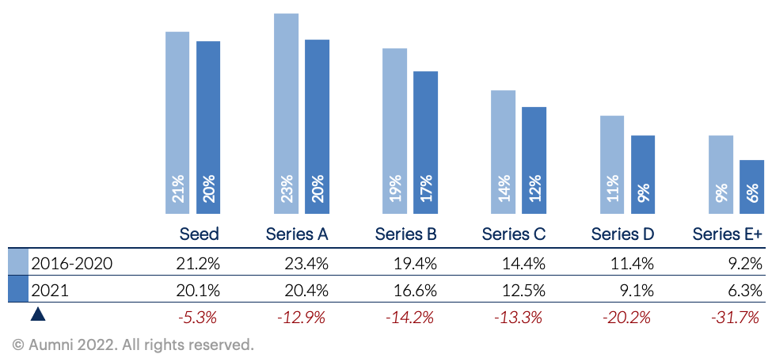

Click to go back

Median Fully-Diluted Ownership Percent Purchased by Lead Investor
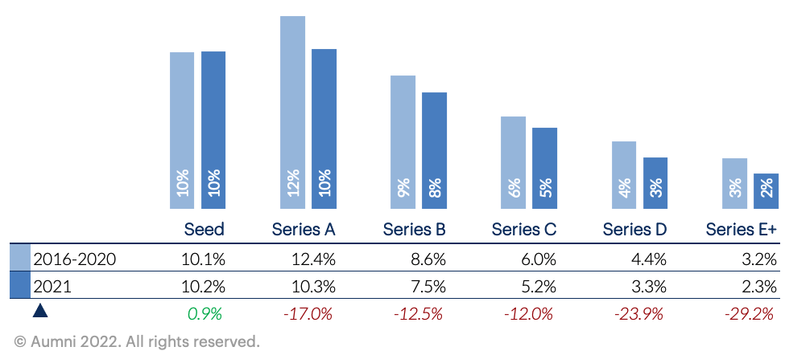

Click to go back

Median Percentage of Round Purchased by Lead Investor
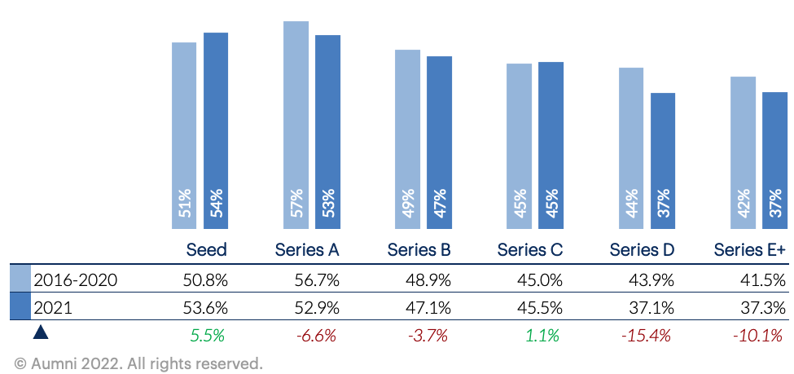
Click to go back

Median Major Investor Threshold $
NEW FOR 3.0
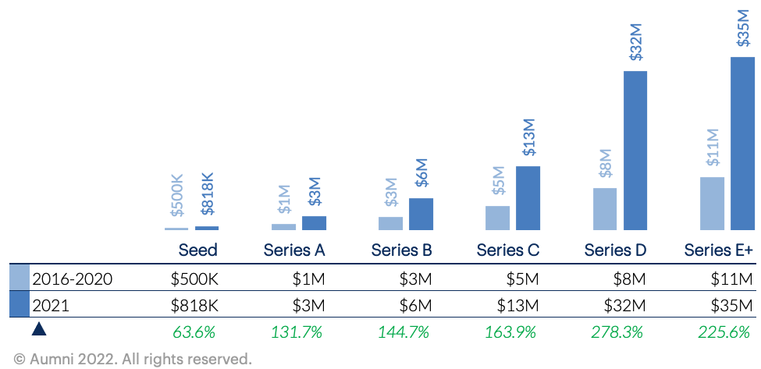
Click to go back

Median Number of Investors (Syndicate) in an Equity Financing
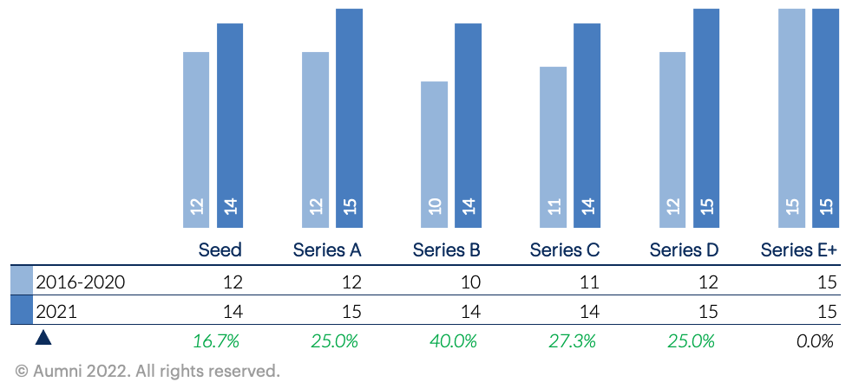
Click to go back

Amount Raised Data

Median Amount Raised in an Equity Financing in the Round ($M)
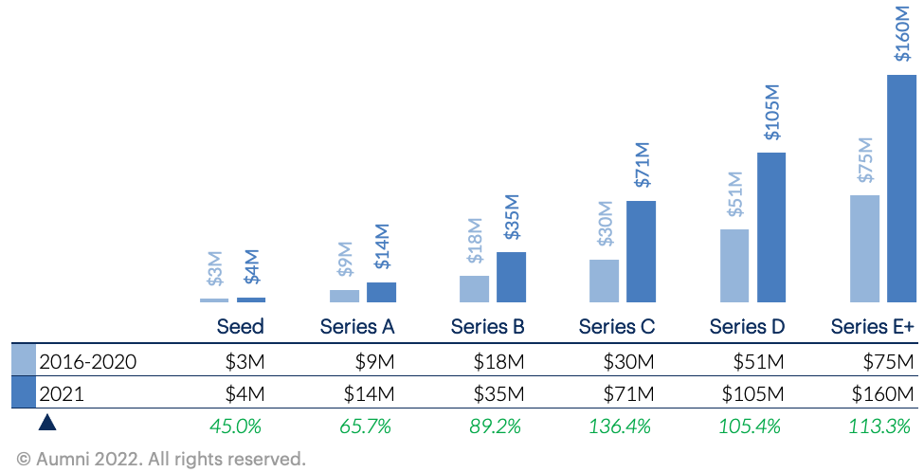
Click to go back

Median Months in Between Financing
NEW FOR 3.0
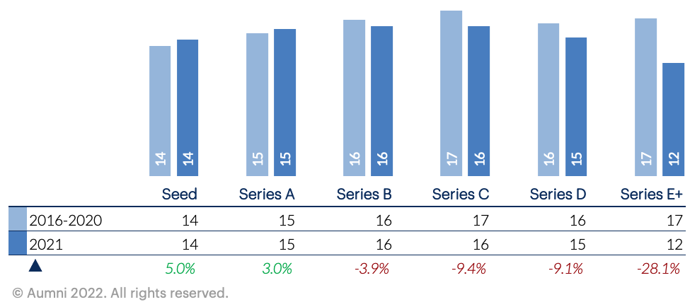
Click to go back

Median % Change in $ Amount Raised Between Rounds
NEW FOR 3.0
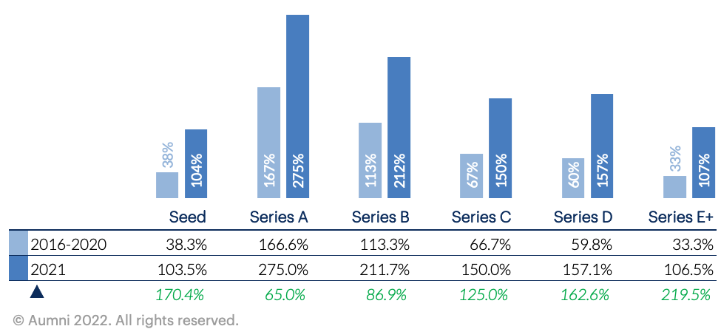
Click to go back

Median Convertible Outstanding in the Round (Principal and Interest)
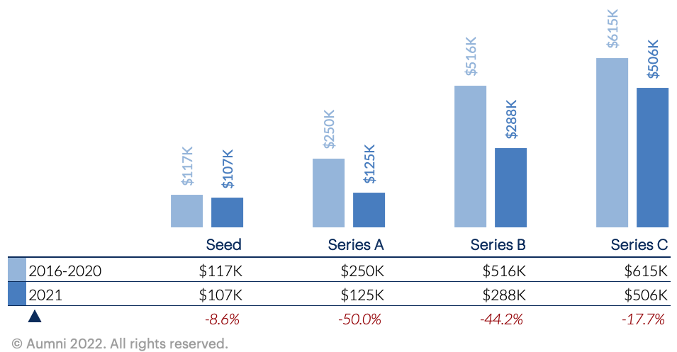
Click to go back

Median Valuation Cap in Convertible Security (All Types)
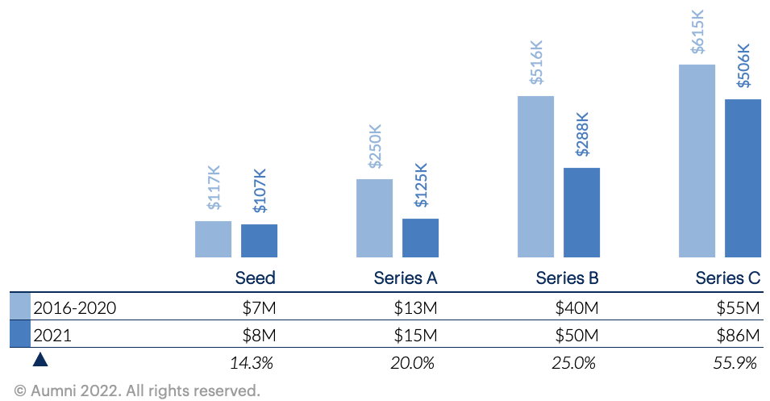
Click to go back

Percentage of 20% or Less Convertible Discount
NEW FOR 3.0
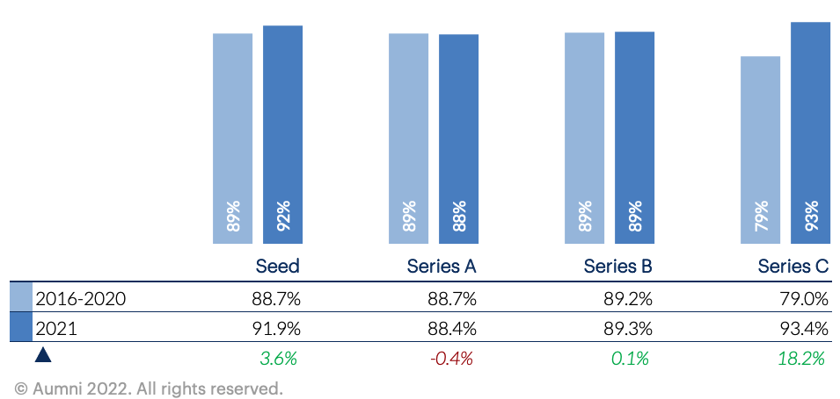
Click to go back

Pre-Money Valuation Data

Median Option Pool Size as a Percentage of Fully-Diluted Post-Money Capitalization
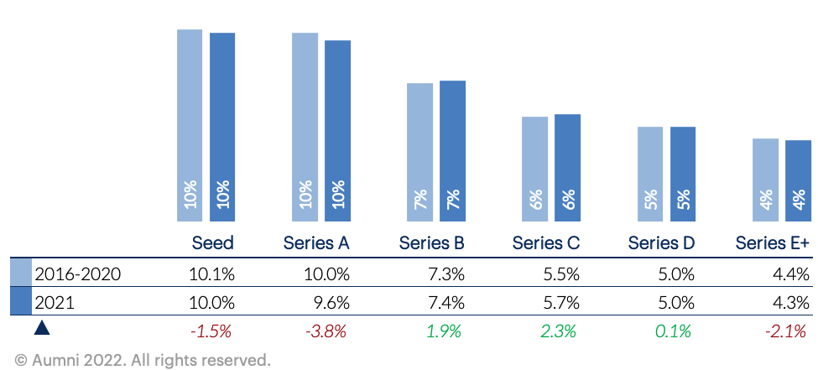
Click to go back

Median % Change in Option Pool Shares
NEW FOR 3.0
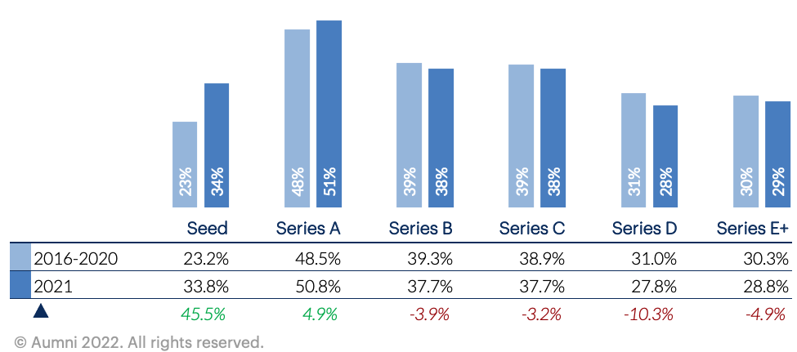
Click to go back

Median Post-Money Valuation ($M)
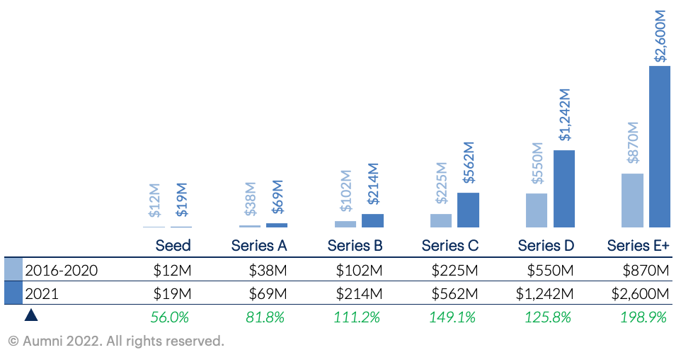

Click to go back

Median % Change in Post-Money Valuation Between Rounds
NEW FOR 3.0
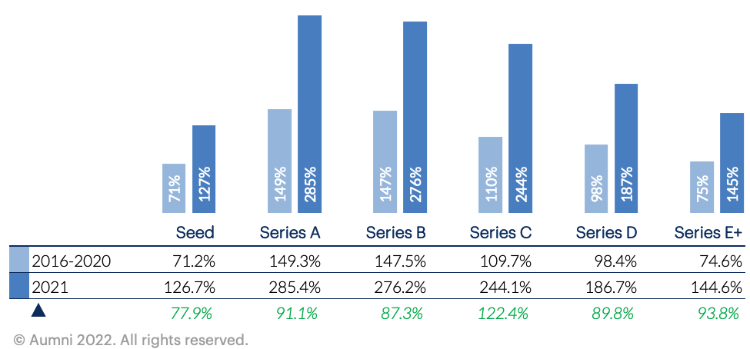

Click to go back

Median Common Stock Issued as a Percent of Fully-Diluted Ownership (Includes Option Pool)
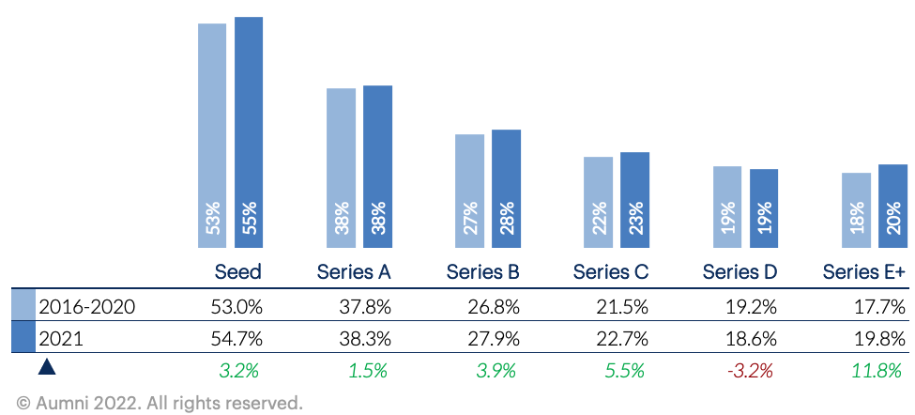

Click to go back

Dividends Data

Percentage of Non-Cumulative Dividends
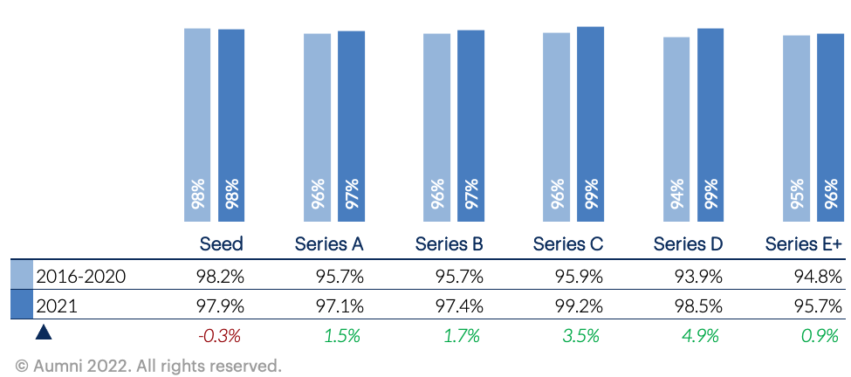
Click to go back

Percentage of 8% or Less Dividend Rate
NEW FOR 3.0
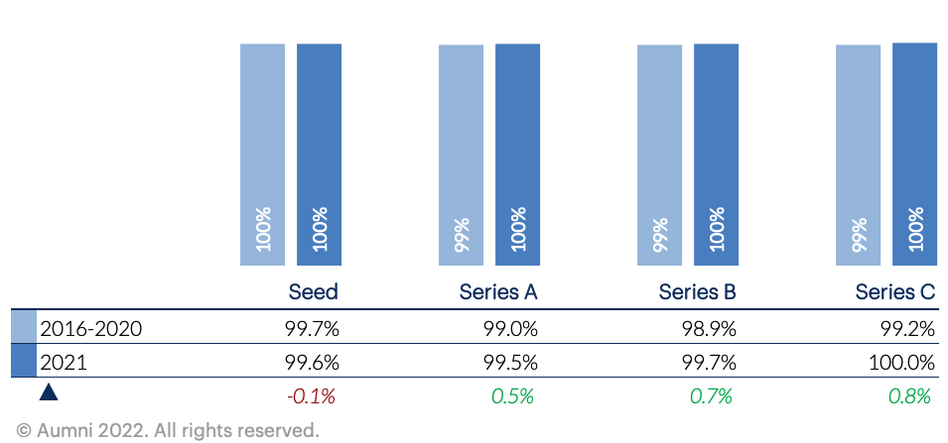
Click to go back

Liquidation Preference Data

Percentage of 1x Liquidation Preference Multiplier
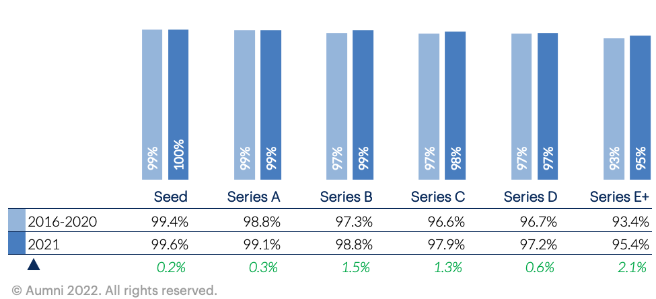

Click to go back

Percentage of Non-Participating Preferred
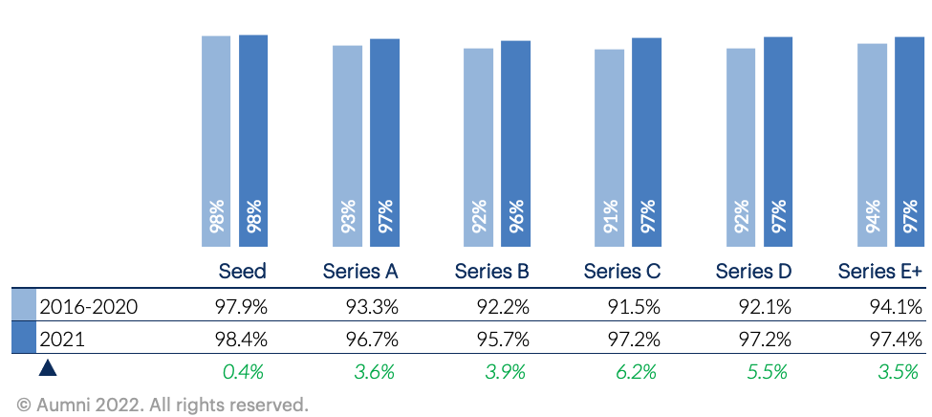

Click to go back

Anti-Dilution Provisions Data

Percentage of Broad Based Anti-Dilution
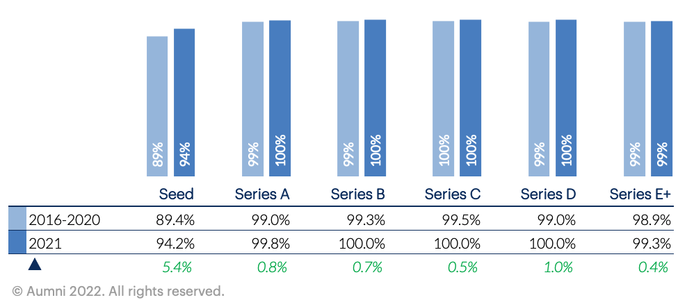

Click to go back

Pay-to-play Data

Percentage of Pay-to-Play Provision
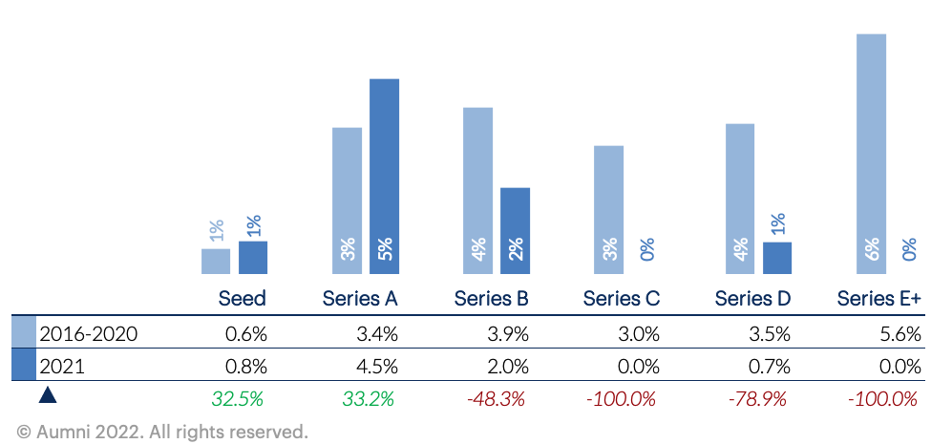

Click to go back

Redemption Rights Data

Percentage of Redemption Rights
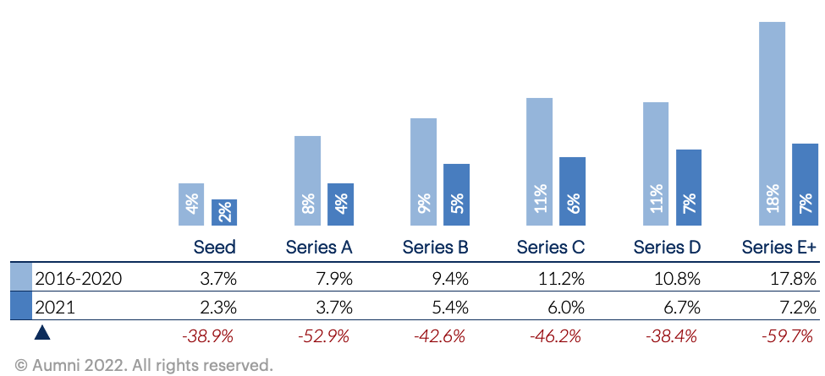

Click to go back

Counsel and Expenses Data

Median Lead Investor Counsel Fee Cap
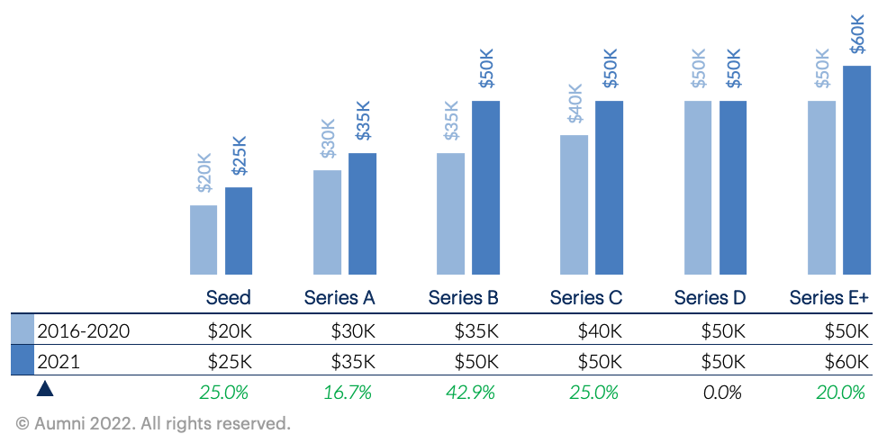

Click to go back

Registration Rights Data

Percentage of Registration Rights
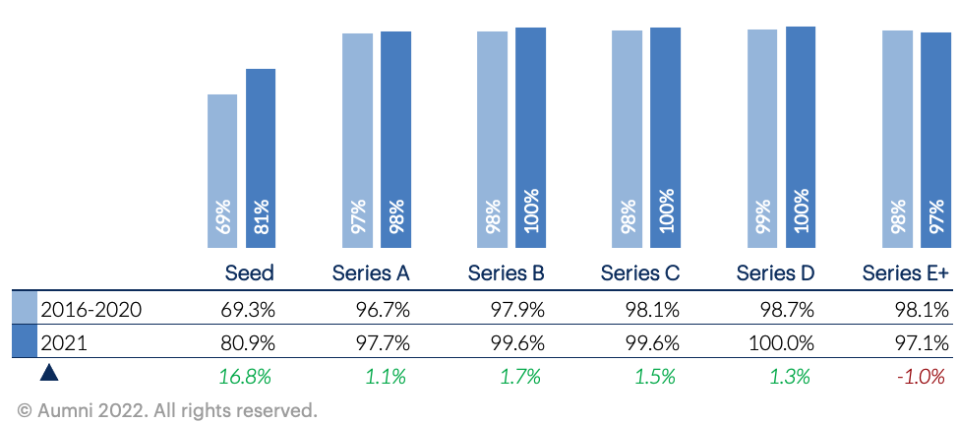

Click to go back

Management and Information Rights Data

Median Major Investor Threshold as a Percent of New Money
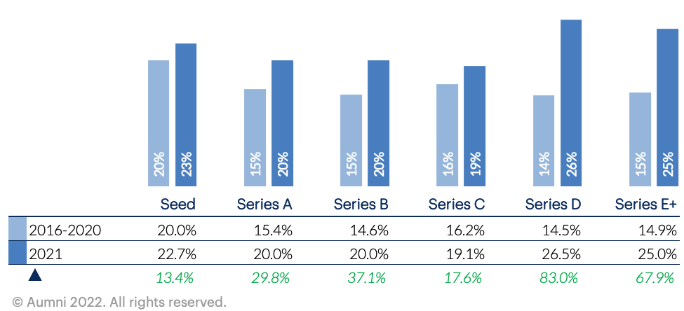
Click to go back

Median Major Investor Threshold as a Percent of Fully-Diluted Ownership
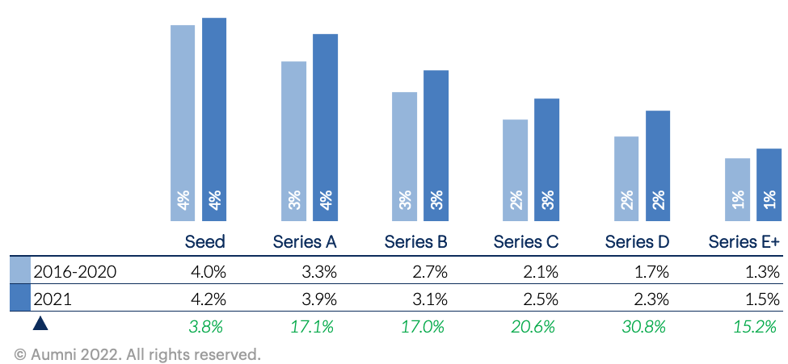
Click to go back

Right to Participate Pro-Rata in Future Rounds Data

Percentage of Pro-Rata Rights for All Investors in the Round
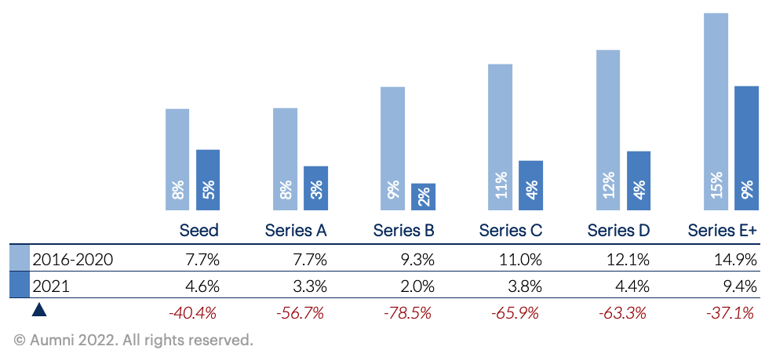

Click to go back

Percentage of Pro Rata Rights for Major Investors
NEW FOR 3.0
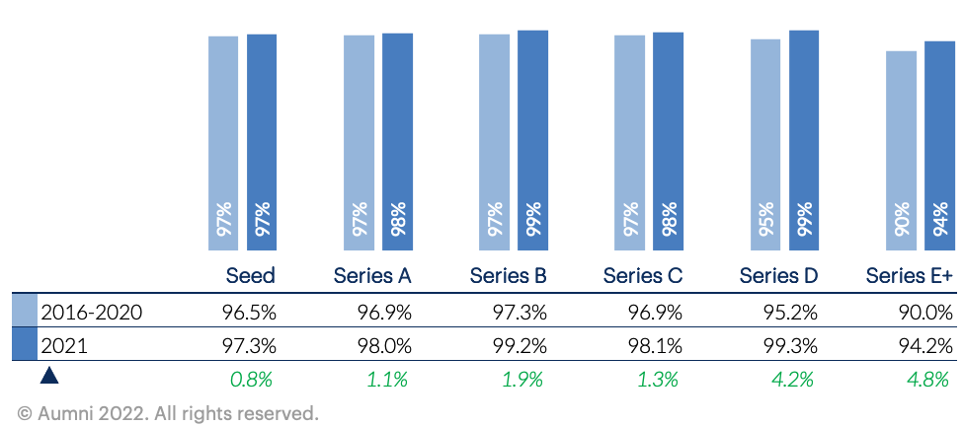

Click to go back

Employee Stock Options Data

Percentage of Employee Vesting
NEW FOR 3.0
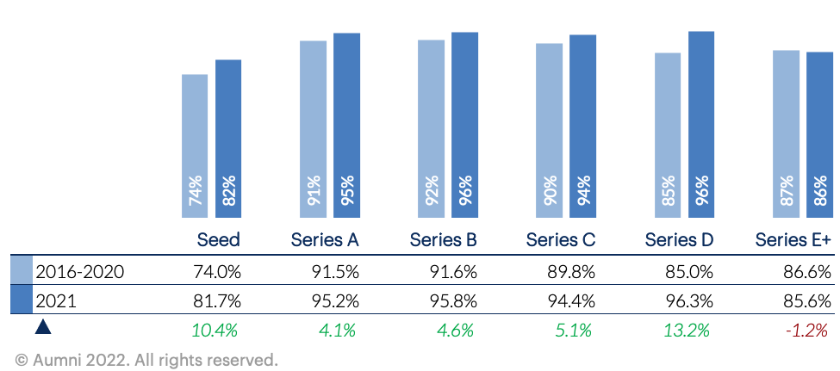
Click to go back

Right of First Refusal Data

Percentage of Right of First Refusal (ROFR)
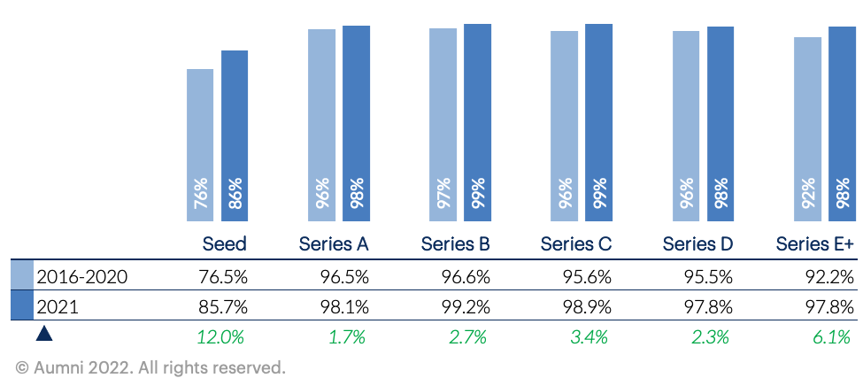

Click to go back

Board of Directors Data

Median Number of Board Seats After the Round
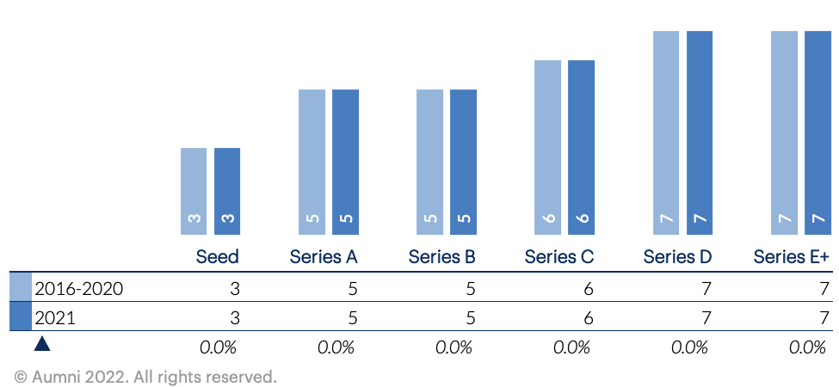

Click to go back

Drag Along Data

Percentage of Drag Along Rights
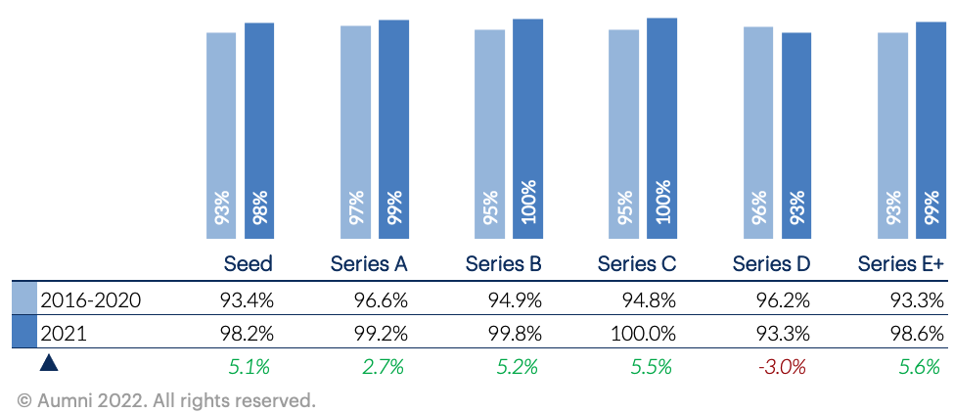

Click to go back

Because a “nonbinding” term sheet governed by the law of a jurisdiction such as Delaware, New York or the District of Columbia may in fact create an enforceable obligation to negotiate in good faith to come to agreement on the terms set forth in the term sheet, parties should give consideration to the choice of law selected to govern the term sheet. Compare SIGA Techs., Inc. v. PharmAthene, Inc., Case No. C.A. 2627 (Del. Supreme Court May 24, 2013) (holding that where parties agreed to negotiate in good faith in accordance with a term sheet, that obligation was enforceable notwithstanding the fact that the term sheet itself was not signed and contained a footer on each page stating “Non Binding Terms”); EQT Infrastructure Ltd. v. Smith, 861 F. Supp. 2d 220 (S.D.N.Y. 2012); Stanford Hotels Corp. v. Potomac Creek Assocs., L.P., 18 A.3d 725 (D.C. App. 2011) with Rosenfield v. United States Trust Co., 5 N.E. 323, 326 (Mass. 1935) (“An agreement to reach an agreement is a contradiction in terms and imposes no obligation on the parties thereto.”); Martin v. Martin, 326 S.W.3d 741 (Tex. App. 2010); Va. Power Energy Mktg. v. EQT Energy, LLC, 2012 WL 2905110 (E.D. Va. July 16, 2012).
To be included if the parties review the facts of the investment and determine that a CFIUS filing is warranted. Where a mandatory filing is necessary, that filing must be submitted 45 days in advance of closing, but obtaining CFIUS clearance in advance of closing is not a requirement of law. However, submitting a CFIUS filing and then closing before the review process is completed creates regulatory risks for all parties that are best avoided if the timing of the investment permits.
See NVCA Model Legal Opinion for detailed commentary on legal opinions.
This provision would have to be modified for staged investments or investments dependent on the achievement of milestones by the Company. See Model Life Sciences Term Sheet for such provisions.
Convertible instruments that convert at a discount may provide for a “shadow” or “subseries” of Preferred that is identical to the new round security except with respect to the amount received on liquidation, so that in a downside exit scenario all investors are at best only getting their money back. Be clear in the term sheet whether the shares issued on conversion are part of the pre-money capitalization or post-money capitalization.
In some cases, accrued and unpaid dividends are payable on conversion as well as upon a liquidation event. Most typically, however, dividends are not paid if the preferred is converted. Another alternative is to give the Company the option to pay accrued and unpaid dividends in cash or in common shares valued at fair market value. The latter are referred to as “PIK” (payment-in-kind) dividends, which are quite rare in this context.
Careful thought should be given to the voting threshold based on the makeup of the round, especially if multiple series/classes are implicated. Also bear in mind that anti-dilution adjustments may result in changes in voting power.
See Section 2.3.4 of the Model Certificate of Incorporation for an explanation of this provision.
For corporations incorporated in California, one cannot “opt out” of the statutory requirement of a separate class vote by Common Stockholders to authorize shares of Common Stock. The purpose of this provision is to “opt out” of DGCL 242(b)(2). If (contrary to the protective provisions in this Term Sheet) the Preferred Stock is not intended to be able to block future financings, include a 242(b)(2) waiver for the Preferred Stock as well.
See footnote in model charter.
The most broad based formula would include shares reserved in the option pool; a narrower base would exclude options or other convertibles. The formula above is the most typical.
See Sections 4.4.1(a)(v)-(viii) of the Model Certificate of Incorporation for additional exclusions; consider building into the term sheet to avoid later “negotiation”.
The per share price floor generally benefits small/minority holders. Consider 1) allowing a non-QPO to become a QPO if an adjustment is made to the Conversion Price for the benefit of the Investor, so that such Investor does not have the power to block an IPO and 2) whether IPO proceeds alone should be sufficient to establish the minimum requirements for an IPO that triggers conversion.
Redemption provisions are rare and even more rarely exercised. If included, note that due to statutory restrictions, the Company may not be legally permitted to redeem in the very circumstances where investors most want it (the so-called “sideways situation”). Accordingly, and particularly in light of the Delaware Chancery Court’s ruling in Thoughtworks (see discussion in Model Certificate of Incorporation), investors may seek enforcement provisions to give their redemption rights more teeth - e.g., the holders of a majority of the Series A Preferred shall be entitled to elect a majority of the Company’s Board of Directors, or shall have consent rights on Company cash expenditures, until such amounts are paid in full. Also, while it is possible that the right to receive dividends on redemption could give rise to a DGCL Section 305 “deemed dividend” problem, many tax practitioners take the view that if the liquidation preference provisions in the Charter are drafted to provide that, on conversion, the holder receives the greater of its liquidation preference or its as-converted amount (as provided in the Model Certificate of Incorporation), then there is no Section 305 issue.
To be considered in order to address issues under the Defense Production Act of 1950 and related regulations (DPA). Relevant representations may include whether or not a company works with “critical technologies” within the meaning of the DPA, whether a company has operations or activities in particular sectors of the U.S. economy or in the U.S. at all, whether a Company stores or maintains certain types of data, whether an Investor is foreign, and whether an Investor has foreign government relationships, among others.
To be included if Investors review the facts of the investment and determine that a CFIUS filing is warranted. When the Investors are foreign persons, a CFIUS filing may be mandatory with respect to certain investments (e.g., some transactions involving “critical technologies”), and voluntary but advisable with respect to others. This covenant may be paired with an explicit reference to the exercise of the redemption right in the Charter in the event of a CFIUS-mandated divestiture of shares. A CFIUS “notice” is a full-form filing that results in a definitive opinion by CFIUS regarding the national security risks associated with the transaction, but may take months to obtain; a CFIUS “declaration” is a short-form filing that may not result in a definitive opinion by CFIUS but is intended to be able to be obtained within 45 days. If a CFIUS filing is warranted, the parties may also elect to negotiate a basic statement laying out the scope of Investors’ obligation to accept CFIUS conditions (e.g., will Investors be obligated to accept conditions or restriction as a condition of CFIUS clearance that would have a material adverse impact on the Investors?). Whether or not a CFIUS filing is made, the parties may wish to consider other risk allocation measures or terms; examples include unilateral or bilateral waivers of responsibility for CFIUS-related costs and penalties, indemnification terms, or other similar language.
Although not typical, founders/management may sometimes be granted limited registration rights.
The Company will want the percentage to be high enough so that a significant portion of the investor base is behind the demand. Companies will typically resist allowing a single investor to cause a registration. Experienced investors will want to ensure that less experienced investors do not have the right to cause a demand registration. In some cases, different series of Preferred Stock may request the right for that series to initiate a certain number of demand registrations. Companies will typically resist this due to the cost and diversion of management resources when multiple constituencies have this right.
A percent threshold may not be necessary in light of the dollar threshold.
See commentary in introduction to Model Managements Rights Letter, explaining statutory basis of such letter.
Non-compete restrictions (other than in connection with the sale of a business) are prohibited in California, and may not be enforceable in other jurisdictions as well. Some states (e.g., MA) require additional consideration in exchange for signing and/or enforcing a non-compete. Consider also whether it should be up to the Board on a case-by-case basis to determine whether any particular key employee is required to sign such an agreement. Non-competes typically have a one year duration, although state law may permit up to two years.
To be included if Investors intend to close the transaction in stages, with at least one stage occurring before CFIUS clearance is obtained. The foreign investor side letter language on point would override any aspect of the other transaction agreements that might, until CFIUS clearance is obtained, grant control of the Company or access to aspects of the Company that might create grounds for CFIUS jurisdiction.
To be included if Investors believe that there is risk that CFIUS may request a filing of the transaction at some future date or that a CFIUS filing may be required in the event of some future occurrence (e.g., when the exit of another investor causes Investor to obtain control over the selection of a Board member). A springing CFIUS covenant provides certainty that all parties will proceed at CFIUS in orderly fashion. The further “notwithstanding” sentence ensures that while parties will cooperate to make the CFIUS filing, Investor will not be obligated to accept CFIUS-required conditions on the deal that might frustrate the purposes of its investment (i.e., the Investor can abandon the proposed investment); more robust mitigation commitment language may be desirable from the perspective of U.S. companies or U.S. investors seeking to limit foreign investors’ ability to abandon the transaction. For more information on the differences between electing to pursue a CFIUS notice vs. a CFIUS declaration and considering a reference to redemption rights, see footnote 16.
To be included if Investors are considered foreign entities under the DPA and intend to make an investment outside the jurisdiction of CFIUS. This assumes that Investors intend not to obtain (i) a Board seat, observer, or nomination right, (ii) more than 10% of the voting rights in the Company, or (iii) control over decision-making at the Company, including with respect to Company technologies, data and infrastructure. If the Stock Purchase Agreements, Charter, and other Transaction Agreements contemplate an investment on those terms, then a disclaimer of information rights with respect to certain technical information should be the last necessary step to remove the transaction from CFIUS jurisdiction. Further markups of the other Transaction Agreements would be necessary to ensure that they are developed consistent with this intention.
Certain exceptions are typically negotiated, e.g., estate planning or de minimis transfers. Investors may also seek ROFR rights with respect to transfers by investors, in order to be able to have some control over the composition of the investor group.
Other formulations might be majority of Common then held by employees and majority of Preferred, for example.
See Section 3.3 of the Model Voting Agreement for a list of additional conditions that might be required in order for the drag-along to be invoked.
Most founders’ shares are already subject to vesting; consider what level of vesting is appropriate and revise to marry up. Investors may also conclude not to change founder vesting.
Necessary only if this is a later round of financing, and not the initial Series A round.

