Context
shape as a character 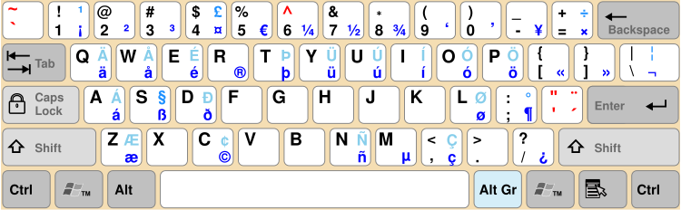 picture as a character

two small shapes anchored to paragraph, red and gold.

Reproduce the bug
sent the two small shapes to the rear : the picture stays behind because it’s like a character, and all shapes are above the characters (normal situation) ; but, when we want to select a small shape by clicking on the part above the picture, it’s impossible, like the shapes are considered as behind (anomaly).

Version: 24.8.2.1 (X86_64) / LibreOffice Community
Build ID: 0f794b6e29741098670a3b95d60478a65d05ef13
CPU threads: 8; OS: Windows 10 X86_64 (10.0 build 19045); UI render: Skia/Raster; VCL: win
Locale: fr-FR (fr_FR); UI: fr-FR
Calc: threaded

