https://bugs.documentfoundation.org/show_bug.cgi?id=163158
Reported: 2024-09-25 19:39 UTC by Piotr Osada

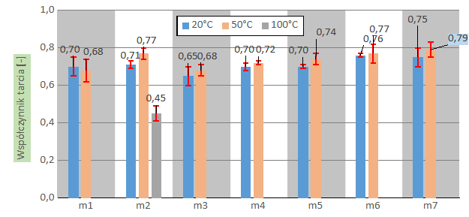

Writer does not support "Chart Wall" background of GDI pasted charts from Calc (background in plot area) when saving as OOXML.

1) In LO Calc open Chart-background-labels.xlsx
2) Copy chart #1
3) In LO Writer press Ctrl+Shift+V → paste as GDI
4) Save As → OOXML
5) Reopen either in Writer or in Word

Result:
Chart background is missing.

Expected result:
The chart background should be preserved.

Version: 24.8.1.2 (X86_64) / LibreOffice Community
Build ID: 87fa9aec1a63e70835390b81c40bb8993f1d4ff6
CPU threads: 8; OS: Windows 11 X86_64 (10.0 build 22631); UI render: Skia/Vulkan; VCL: win
Locale: pl-PL (pl_PL); UI: en-US
Calc: CL threaded

