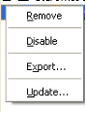
Figure 1.1.1.1: The reduced and reordered context menu of a selected extension.
Update...
Disable
Remove

