Display range selection
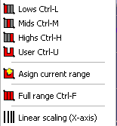
The Range selection is located in the lower menu bar.
Use it to select the visible frequency range for the display.
Beside the three ranges Low, Mid and High you can select a fourth setting, which is called User.
You can change the border of the user setting either (like the borders of the three other settings) at Setup → Post Process or by assigning the currently used borders using the Assign current range option.
The Full range function restores the full frequency range.
If a transfer measurement is performed in the MAT module then this menu contains the Linear Scaling (X-Axis) option, which activates a linear scaling of the frequency axis, opposite to the commonly used logarithmic scaling. The linear scaling might be helpful when you work with the phase trace.
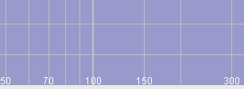 | 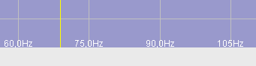
Logarithmic (default) frequency scale | Linear frequency scale

You can also use the right mouse button to select the frequency range you want. Just move the cursor to one end of the desired range, click and hold down the right mouse button. Now you can select the frequency range by moving the mouse to the right or to the left. A dashed rectangle marks the current selection. The display changes to the new values as soon as you release the right mouse button.

