I can not figure out why LibreOffice uses Bulgarian language settings when I edit this file. My locale is en_US.UTF-8 and all Language settings within LO (that I can find) specify English.

This file is mainly in English but also contains some Cyrillic (Bulgarian) text: Лено Ленче
It was originally created using a production build, probably LO 24.2.7.2 and had the same issues. Now I’ve switched to 25.8.x alpha, but the problem persists.

Here is a Field (Date fixed) which I want to display using a normal US-English style, specifically MM/YY/DDDD:
30. April 2025

... but the Language drop-down for the Date field only offers Bulgarian-style options!
When printed, the above Date field appears like this (from screenshot of print-preview):

Using „Edit Fields...“ on the above Date field shows this:
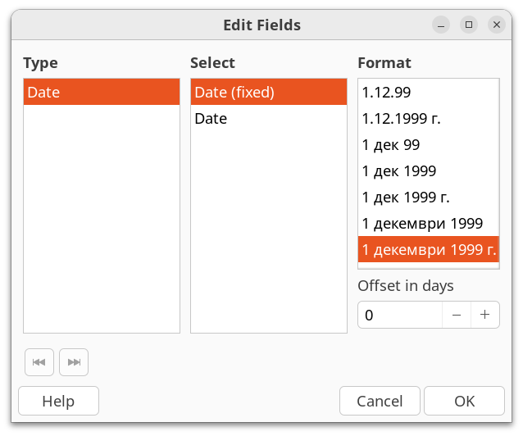

The Paragraph Style of the para containing the Date field has language set to English. Here is a screenshot:
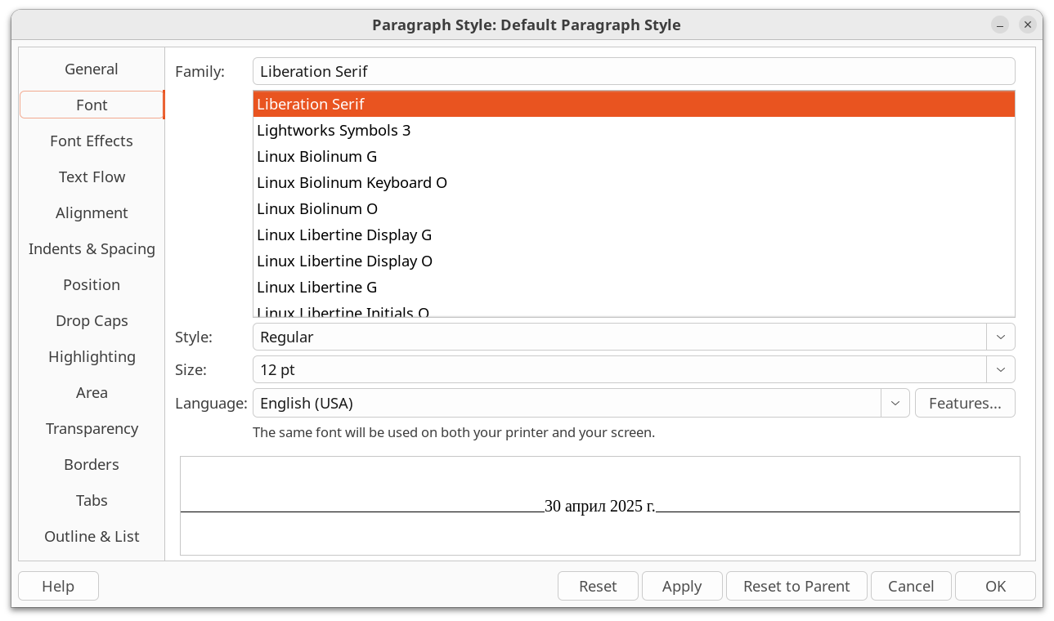
Notice how the text displayed in the Para Style, which comes from the Field, is in Bulgarian not English, even though the „Language“ in the Para Style is English.
Also, my keyboard seems to be stuck in a non-standard layout where the single-quote key inputs a double-angle quote («). This does not occur in other windows, so something is telling LO to do this.
What causes this?

Tools->Options->Languages and Locales->General has *every* option set to „English“. Screenshot here:
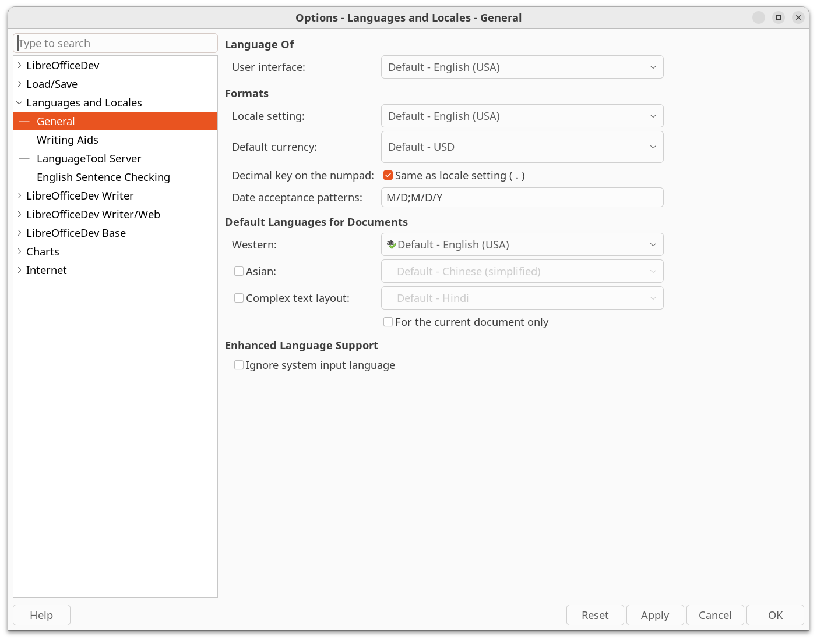
And here is the output from the „locale“ command, run on the terminal where I started soffice:

$ locale
LANG=en_US.UTF-8
LANGUAGE=
LC_CTYPE="en_US.UTF-8"
LC_NUMERIC="en_US.UTF-8"
LC_TIME="en_US.UTF-8"
LC_COLLATE=C
LC_MONETARY="en_US.UTF-8"
LC_MESSAGES="en_US.UTF-8"
LC_PAPER="en_US.UTF-8"
LC_NAME="en_US.UTF-8"
LC_ADDRESS="en_US.UTF-8"
LC_TELEPHONE="en_US.UTF-8"
LC_MEASUREMENT="en_US.UTF-8"
LC_IDENTIFICATION="en_US.UTF-8"
LC_ALL=

Here is the info from Help->About LireOfficeDev ...

Version: 25.8.0.0.alpha0+ (X86_64) / LibreOffice Community
Build ID: 9840136fc91f73b237a81ccbad31721ecba5c689
CPU threads: 12; OS: Linux 6.11; UI render: default; VCL: gtk3
Locale: en-US (en_US.UTF-8); UI: en-US
Calc: threaded

