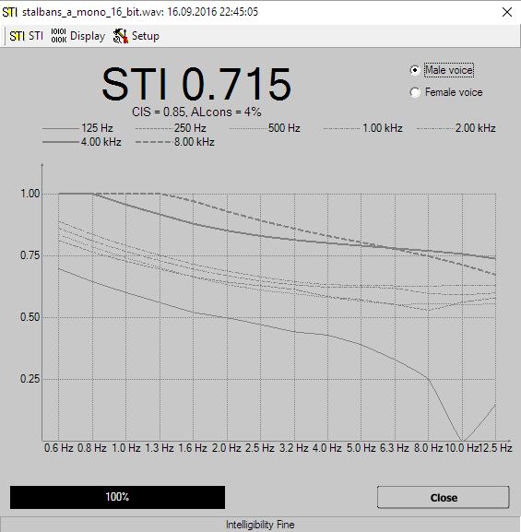
- Show M-Values related to Modulation Frequency draws the values as a function of the different frequencies used for modulation. For each band of the audio signal a single trace is drawn. You can enable the display of individual traces in the option's sub menu.
- Smoothing in the function's sub-menu you can select how much smoothing is applied to the traces.
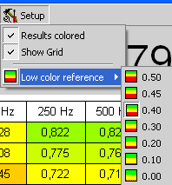
The rightmost entry is the menu Setup.
- Results colored assign a background color to each value according to its value. This setting affects only the Show as Matrix display.
- Show grid shows a grid separating the individual values in the Show as Matrix display.
- Low Color Reference sets the threshold for the red color. Any values below this value is shown in full red in the Show as Matrix display. A value of 1.0 is shown in full green. This setting affects the layout only if the Results colored option is activated.
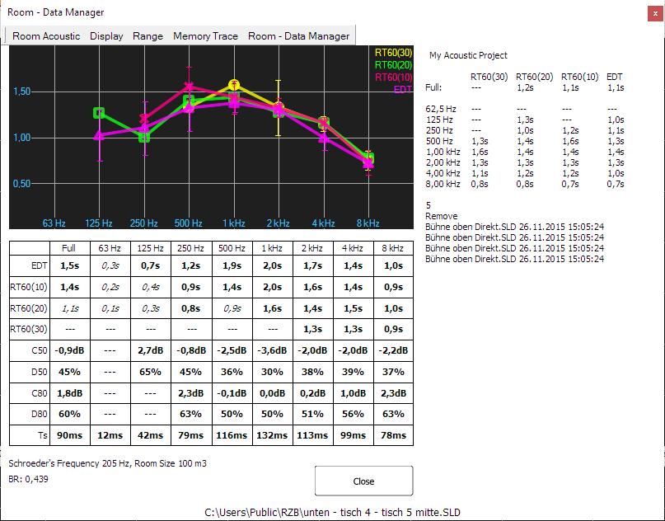
Hint:
- Below the display of the STI value in the top bar you can find two other values used for the judgment of intelligibility. Both are calculated based on the STI value.
  - AL_{cons}, an abbreviation for Articulation Loss of Consonants, a number that aims on the audibility of consonants. This value shows the loss a percentage – value.
  - CIS, which means Common Intelligibility Scale, is a logarithmic conversation of the STI value. It shortens the wide range of ‘good’ STI values to allow a more exact judgment in the critical range of the intelligibility values.

Room Acoustic Calculation
SATlive offers a room acoustic tool to calculate room – acoustic values using an impulse response. The quality of the results relates to the quality of the impulse response used, so you should take care to create a good impulse response (use long impulse responses). The room-acoustic tool is invoked in the menu Tools (see page Error: Reference source not found).
The traces for the reverberation times are shown at the top. Below the graphic there is a

