Trace display modes in the impulse – response module
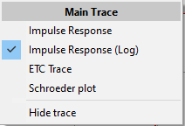
There are different ways to display the impulse – response.
You can select the kind of display you want to use using a selection box located above the trace display window.
The left selection affects the current impulse – response, the right selection the latched (second) impulse – response.
The x – axis shows the time, and the y – axis shows the amplitude value in different ways.

Impulse response
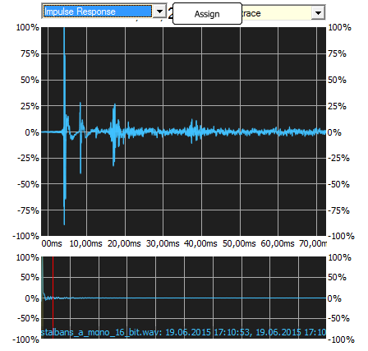
This display shows the impulse – response over time using a linear values and a linear scaling. This is the most basic display.
The lower display always shows the full size of the impulse – response in the linear display mode.
You can use the layout setting (see page Fout: Bron van verwijzing niet gevonden)to change the display of the trace.

Impulse – Response (log)
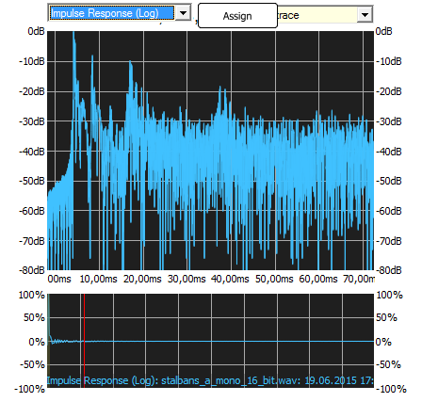
This kind of display shows the amplitude – values on a logarithmic scale. The logarithmic scale, a scaling close to the human reception of levels, makes it easier to detect peaks in the low level part of the impulse – response, which would be nearly invisible on a linear scale. The highest amplitude value is taken as the zero dB reference.
You can vary the display using the Display all data setting (see page Fout: Bron van verwijzing niet gevonden).

