Comment metadata
Comment.

Header
Of course it is a Reply to... but allowing users to delete time of Comment is kinda problematic.
For that they have Security Options.
Solution for that would be read-only header with same color as footer and an extra option in Context menu “Hide All Headers”. Of course not red :)
 | 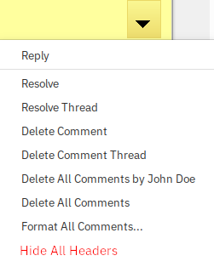

Resolved
Resolved
...could be Resolved by.

Styles
Styles.
Doesn’t copy styles to new document.
It doesn’t even copy basic formatting of all comments which is 10pt, it goes to 12pt and doesn’t get style font too.

