Explained short
This text is below
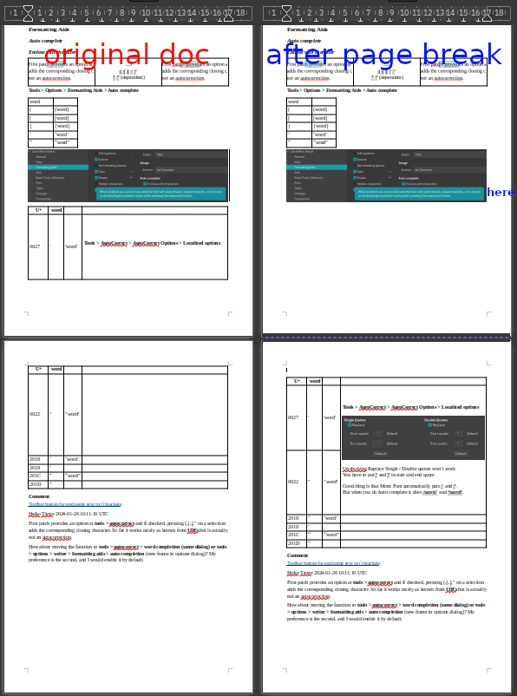

LibreOffice Writer

Formatting Aids

Auto complete

Enclose with character
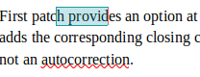 | -->  ( { [ ‘ “  ' " (dependent) | 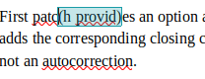
Tools > Options > Formatting Aids > Auto complete
word
( | (word)
[ | [word]
{ | {word}
‘ | ‘word’
“ | “word”
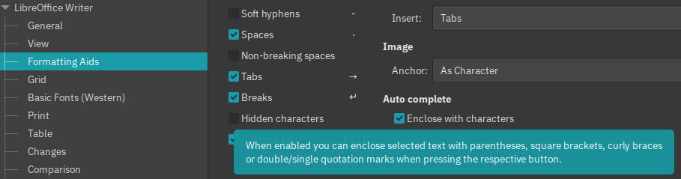
U+ | word
0027 | ' | 'word' | Tools > AutoCorrect > AutoCorrect Options > Localized options  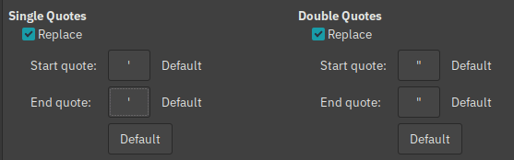  Un-thicking Replace Single / Double quotes won’t work  You have to put ' and " in start and end quote  Good thing is that Mono Font automatically puts ' and ".  But when you do Auto complete it does ‘word’ and “word”.
0022 | " | "word"
2018 | ‘ | ‘word’
2019 | ’
201C | “ | “word”
201D | ”

Comment
Toolbar button for enclosing text in () brackets
Heiko Tietze 2024-01-26 10:11:10 UTC
First patch provides an option at tools > autocorrect and if checked, pressing (,{,[," on a selection adds the corresponding closing character. So far it works nicely as known from IDEs but is actually not an autocorrection.
How about moving the function to tools > autocorrect > word completion (same dialog) or tools > options > writer > formatting aids > auto completion (new frame in options dialog)? My preference is the second, and I would enable it by default.

