Before the commit (Slide 3)

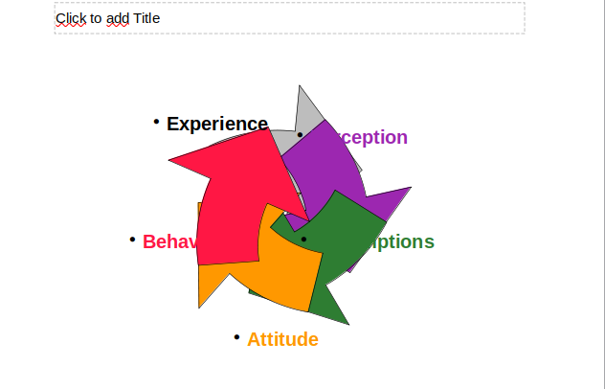
After the commit 132048: tdf#147978 export subpaths individually in custGeom | https://gerrit.libreoffice.org/c/core/+/132048



