https://bugs.documentfoundation.org/show_bug.cgi?id=140135

bibisect/linux-64-6.5

oldest
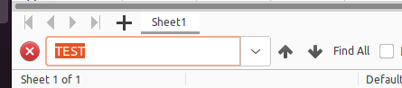

master
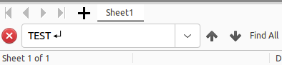

7.4:



