Declaration of authenticity
The research presented in this document presents the findings sourced and referenced through my own references and research, and, these have been documented within the References and bibliography section of this document, which is to be submitted to the University of Malta for academic review.
It is assumed that readers have a knowledge of terminology in computer science and are able to follow logical diagrams and statistical concepts that have been referenced throughout this document.
I would like to thank all the persons who have collaborated with me on this research project leading to the completion of the document and the relevant artifacts that may be complementary to the research.
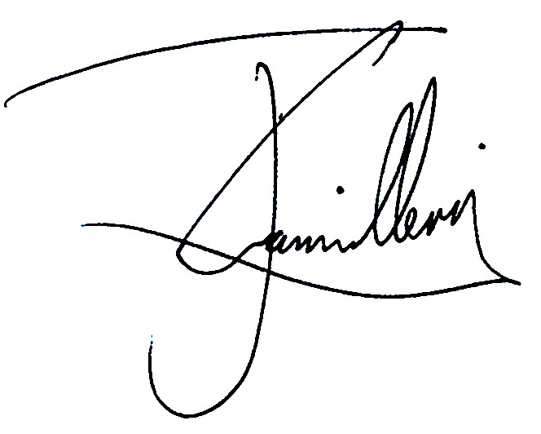

J. Camilleri B.Sc (Hons)
Malta, EU – https://mt.linkedin.com/in/jonathancamilleri.

Document control

Version Date
0.0.1 24th August 2015 Initial template and draft prepared.

