How to search for text without direct formatting
“Use case: from the paragraphs below, retain only underlined or highlighted.
Find and replace finds all underlined or highlighted parts correctly when searching for format “single underline” or highlighted. What you want is find all text without underline or not highlighted and then delete. However, searching for “No underline” (i.e. tab font effects, underlining: without) only finds the none underlined text in the first paragraph after this one. Idem for or “Automatic, Transparent,” (i.e. tab highlighting, None). Behaviour appears less predictable in cells of tables.”
- In the search dialogue box, click the “Format” button while the focus is in the “Find” box.
- Select the desired formatting tab.
- Select the desired non formatting and click OK.

For Font styles it looks like this:
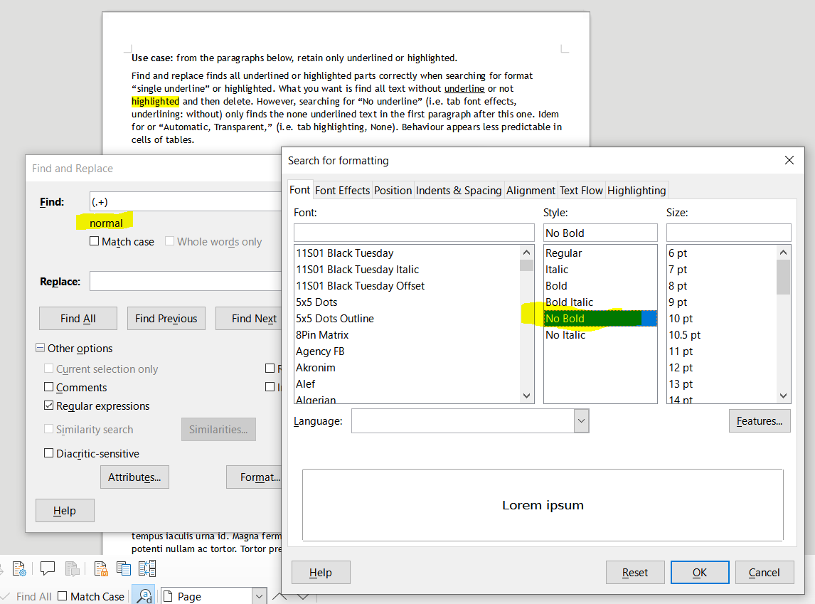

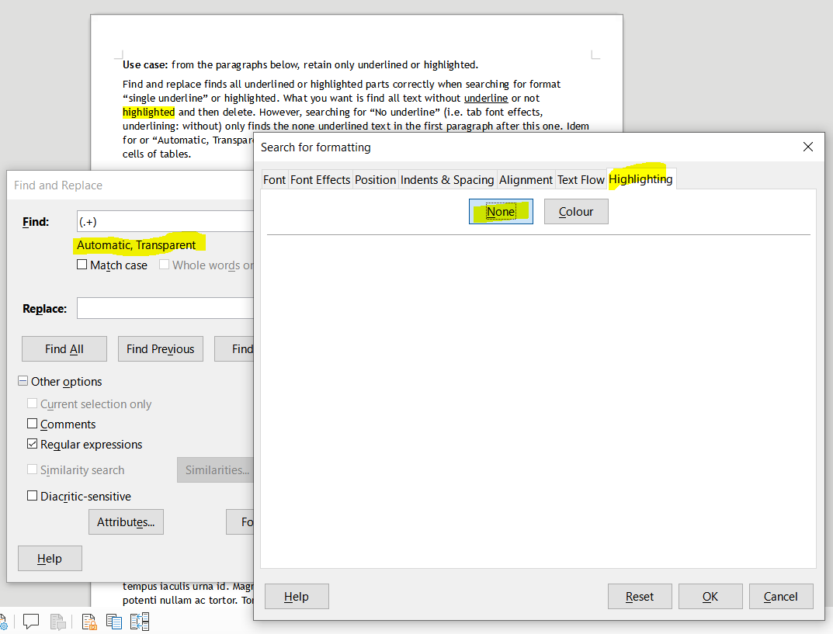
For Highlighting Effects it looks like this:

For Font Effects it looks like this:


