Opening the original document “Test+page+with+picture+export+to+odt.odt” in dark mode and a white page background. You seen the picture is larger than the page with so the picture right border and corners are outside the page visible are (p1)
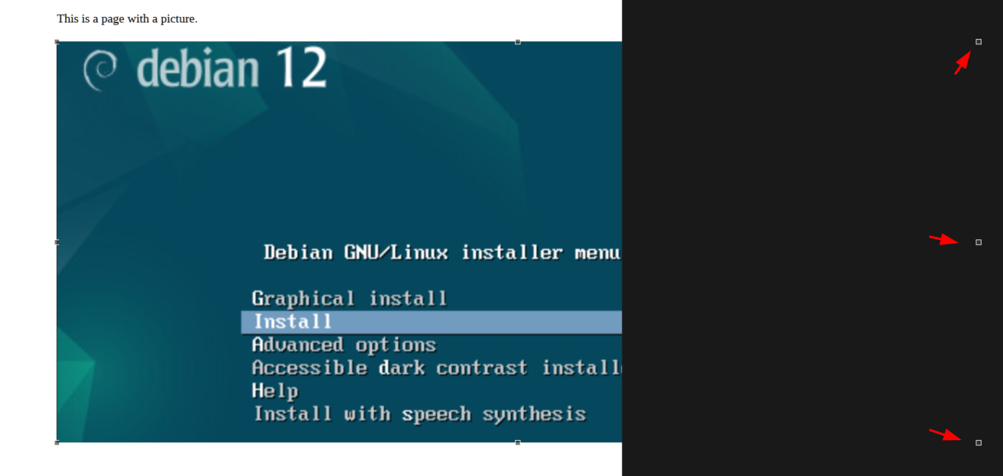
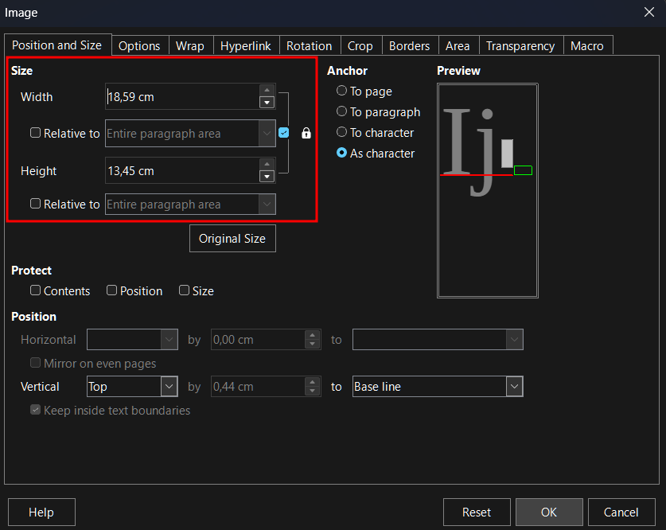
The image properties show the size of the visible area of the picture (p2): 18,59 cm is the visual with of the picture bound by the page style usable page (page size minus left border space minus right border space).

Select Keep Ratio and set Width to 24 cm resizes Height to 10,13 cm which is not in line with the original picture ratio. 14:00 x 10,13 cm ~1.3:1 which turnes the resized result malformed.
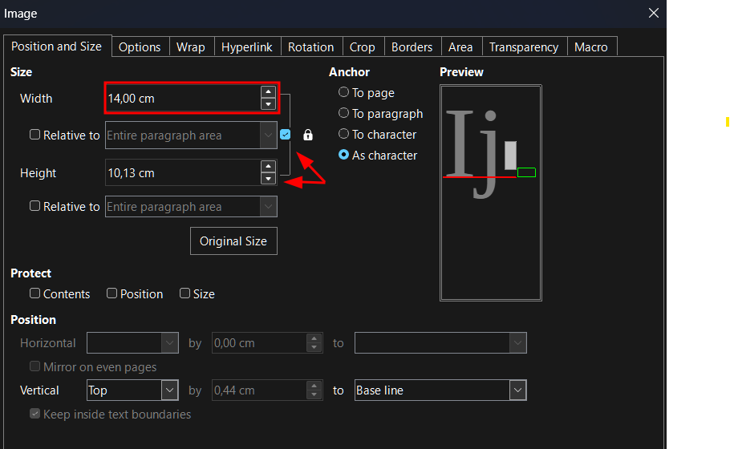
Of one applies the setting the visible area of the picture is resize wrong and looks stretched in height vs the original.
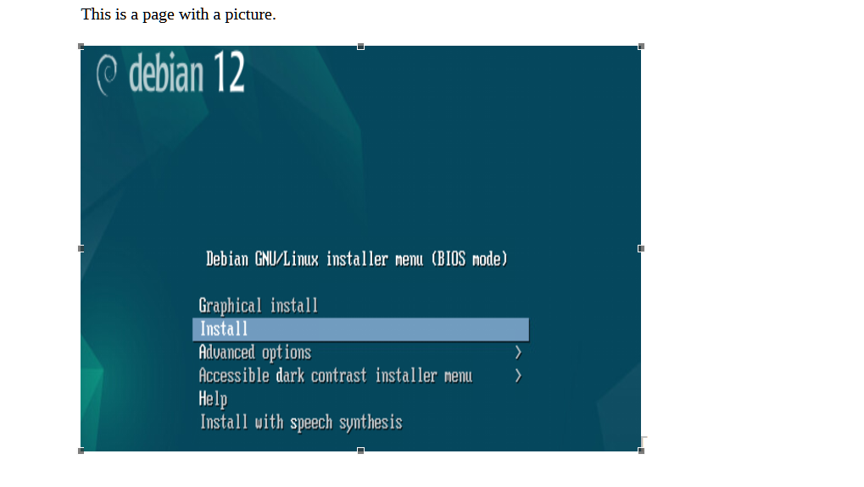
Paste the original picture in the example document too, size is automatically ajusted to the max usable area of the document. See Test+page+with+picture+export+to+odt-MODIFIED-EXAMPLE.odt
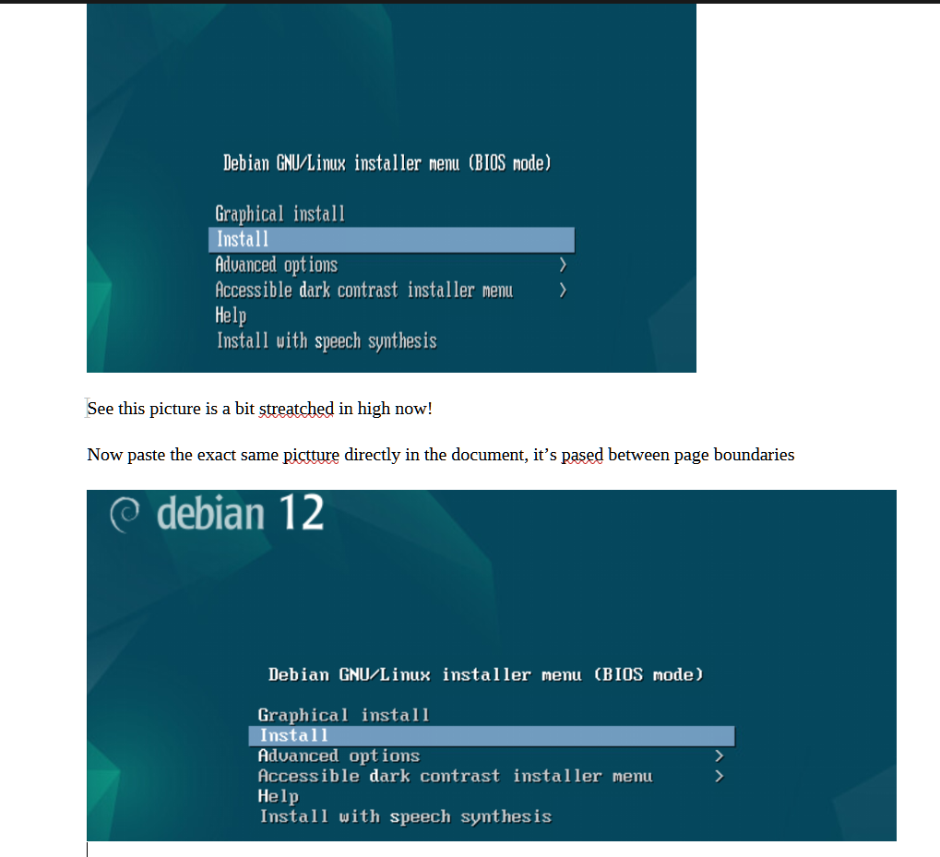

The just imported original picture’s properties reports a max with of 18,59 which is the usable area with.
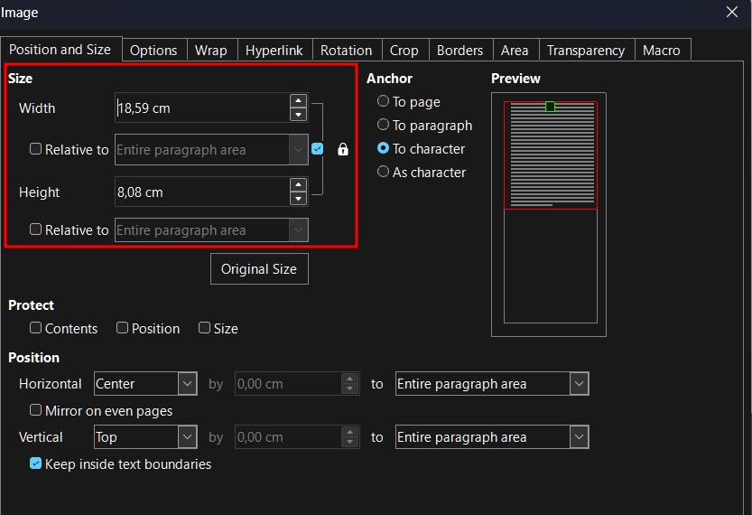
Set the Width to 14 cm with Keep Ratio selected, Heigth is correctly adjusted to 6,08 cm (~2,3:1)
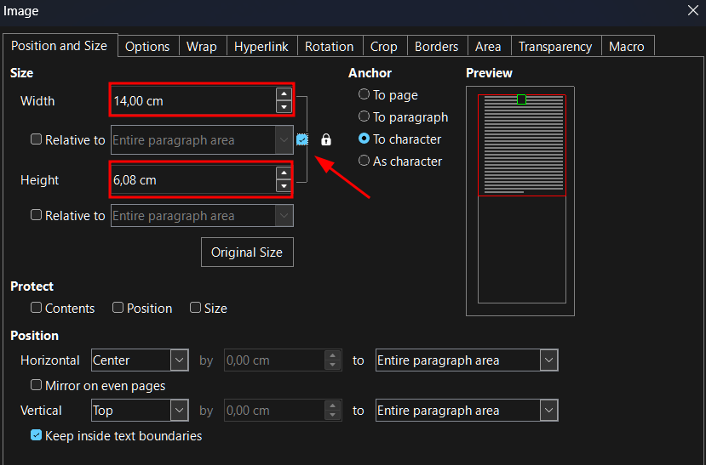
Resizing the pasted image turns into a correctly resized image:


