As the years go by this issue has got worse in a Calc sheet:
- The cell text re-arranges itself
- Selecting a character string to change its colour to red sometimes does not work, or adjacent characters are turned red instead of the selected character string
- Sometimes, instead of using the input line, double clicking the cell enables the text colour to be corrected, but not usually the re-arrangement of text
- Correcting the re-arranged text often makes it worse
- This does not happen with every cell. Date cells seem immune, but character strings often behave this way, but not in every new selected cell. Each row is a new entry
- Deleting the text, waiting for an unspecified time, and typing from scratch can be successful
- Re-arrangements may not be noticed, or occur after or during the save and or close file action
- This is not obviously repeatable. It depends on the day an entry is made or the cell chosen for an entry

Below are screen shots showing time and sequence after several correction attempts were made:

Screenshot 2025-02-17 at 13.37.24:
Screenshot 2025-02-17 at 13.37.54:
Screenshot 2025-02-17 at 13.38.09:
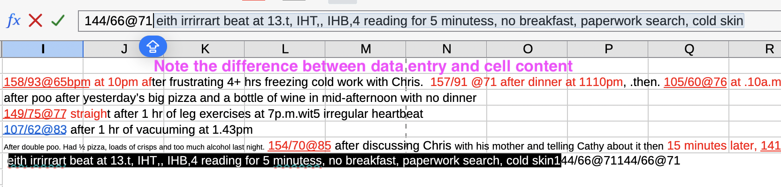
Screenshot 2025-02-17 at 13.38.25:
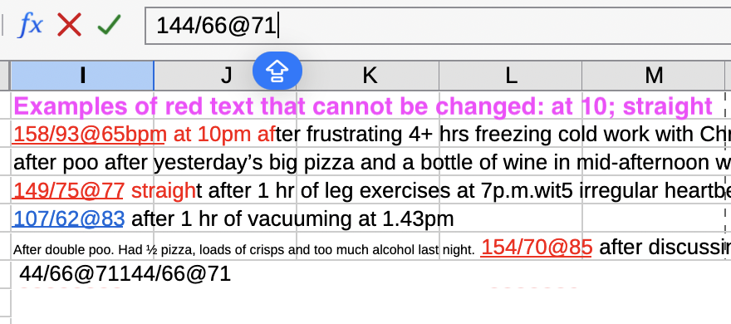

Screenshot 2025-02-17 at 13.42.15:
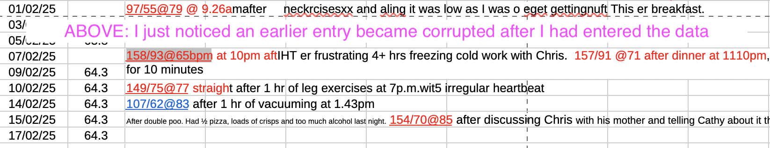
Screenshot 2025-02-17 at 13.45.18:
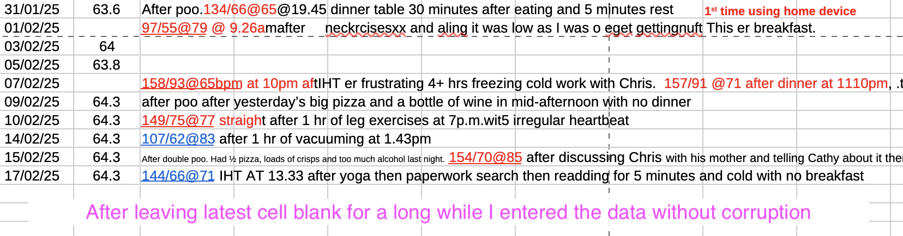
Current LibreOffice version on MacBook Air:
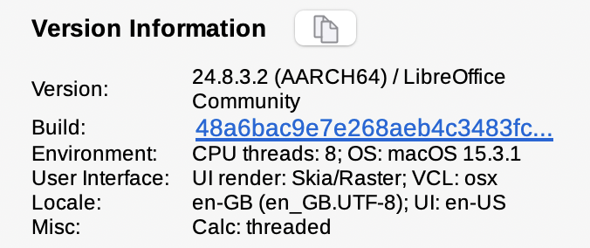

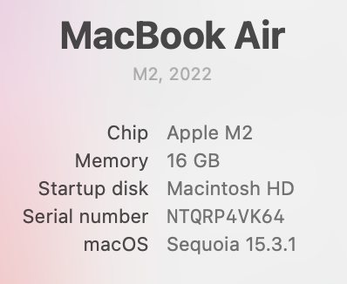

Some actions taken to de-identify me as per instructions in file properties. Content not changed.

