Save As command
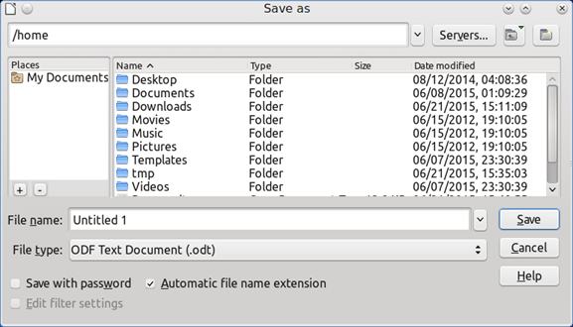
Figure 1: Example of LibreOffice Save As dialog
To save a document if you want to create a new document, or change the filename and/or file

