Our big family

We have met Richard and his wife in Florida February 2020. Gladys is a widow now. I met them 2010 in USA. They visited Norway 1972

You see I have marked Jakob Lien. He was a skipper and I have heard that he was in NY when Dennis was baptised.

My grandfather, Endre Martin Alne, lived in USA several years and found his wife over there. They immigrated back to Norway aprox. 1915. Your great – grand father stayed there. Neither I nor my cousins can remember that we have heard about your family. We did not know you existed. This is unbelievable, but we really lost the contact. Very well that we have established contact again!

This afternoon my cousin Anne Sofie Østhus and her oldest daughter, Ingun Knudsen, visited us at our house in the area of Haugesund. I presented some pictures from your Facebook pages and they look foreword to meet you all.

What o do in Haugesund?

I am planing different alternatives for your stay in Haugesund. You have only few days, so we can’t overcome all of interest. Please send me information about your interests. I suppose there different interests between a baby and your parents! May be we can organize different plans to you.

We are open to try to fix as much as possible.

Some examples:

1) Take a little walk in Haugesund centrum and see the houses where your great – great – grandparents lived.

2) If we drive 1 hour we can see the small farm Alne. May be some of you wold like to see the place?

3) We have old churches from 1200 ad, a reconstructed Viking village and graves from 500 ad, in the near of our house. May be of interest?

4) We have of course supermarkets in Haugesund – not as large as in NY, but more than enough to be poor, or be happy to find something you like.

5) One day trip by car and mountain walk to Preikestolen

6) A little fishing trip on the Førresfjord by our house.

.
.
The most disappointment in our part of Norway is the weather. In worst case you get rain and cold wind from north several days. You need warm jackets protecting both for rain and wind. You need also a good hat to warm your ears. Jogging shoes are better than shoes with high heels in Norway. In August the weather in Norway is never dangerous, but it is easy and annoying to get a cold.

Notice also: The AC in the aeroplane is dangerous – it circulates virus and the cold air give you a cold. Turn it off.

Special notes according to visit Norway.

All electricity systems in Europe are 230 V and most of apparatuses bought in USA can’t be used by us. We have also another electric contact system called schouko.

The digitization is even further in Norway compared to USA. This means we do not use money any more – only cards. Visa and Master Card are the most used, but I think American Card also does the job. Some modern watches and cellphones can fix payment. You need no Norwegian “kroner” . American dollars are not useful because we do not use banknotes. Checks are out of date. Young people in Norway do not know what a check is.

More than 90% of all new cars in Norway are battery electric. Their licence plates starts with an E. There are still many patrol and diesel cars. The most sold cars are Tesla!

The cars have to stop when a pedestrian wants to cross the road, but be careful, observe that the cars have observed you and plan to stop.

You have decided to travel from Bergen – Ullensvang – Haugesund. I have to repeat that this a part of Norway has with narrow roads and millions of sharp swings. But these roads are safe because Norwegian drivers take it normally easy and the speed has to be low.

I have to tell you that it is more comfortable to take a plane from New York directly to Oslo. There is no directly flights from New York to Bergen. Waiting on an airport is never joyful. To stay some days in Oslo is truly of higher interest than Bergen. You can take a plane from Oslo to Haugesund or Stavanger. It’s also possible to drive this (much better) road and get beautiful view along the main road to Stavanger / Haugesund along the cost or over the mountains. Train from Oslo to Stavanger takes 8 hours, is expansive and no good idea. Ullensvang is fine but the fjords near Stavanger / Haugesund are not less dramatic. Example: Lysefjord, Preikestolen and so on.
If you don’t worry about carsick and waiting at airports, booth Bergen and Ullensvang are fine.
Of course you are absolute free to make your personal destinations. My wish is to let you understand the ups and downs of different ideas.

The next pages shows your relatives. You see we are a big “clan”. I hope we can invite them to a big party the 15th or 16th of August. The vacation time is over in Norway at this time so those living far away, get problems to join us.
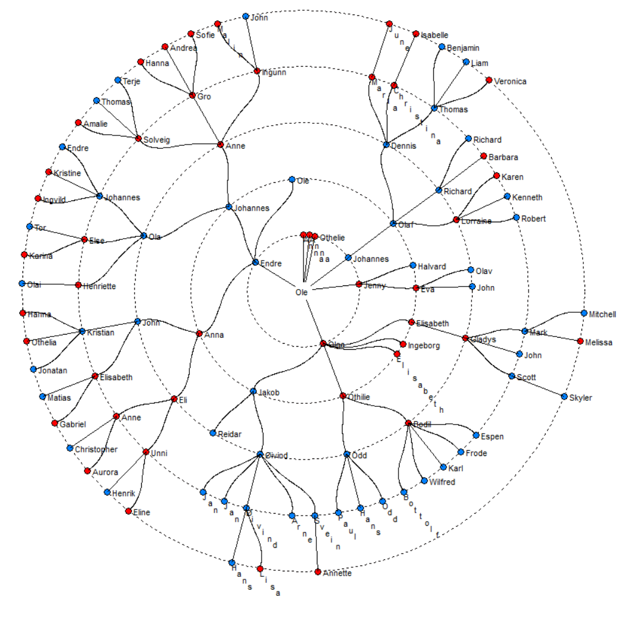
Me
Sponsor baptism, Dennis?
Detroit

Here is much to study!

This is my overview. I know there are several mistakes and not all relatives are listed here. I am working to update as much as possible. May be you observes mistakes? Please send me corrections.

I know many of this relatives but far from all of them.

Notice you have relatives in Detroit. I know Gladys and communicate on Facebook with Scott.
Ole Endresen Alne (1853 – 1906) and Elisabeth Johnsdtr Haukås got thees children:
Anne Bertine, Endre Martin, Olga Elisabeth, Jenny Olsdtr, Othelie og Anna Bertine.


