Along the way
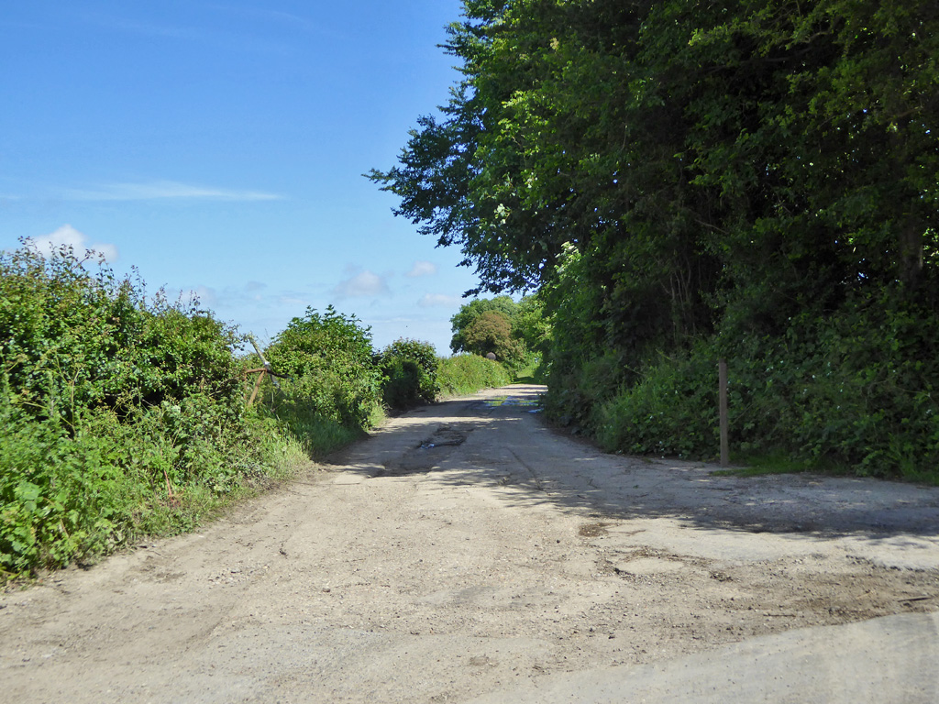Illustration i: at H © Robin Webster
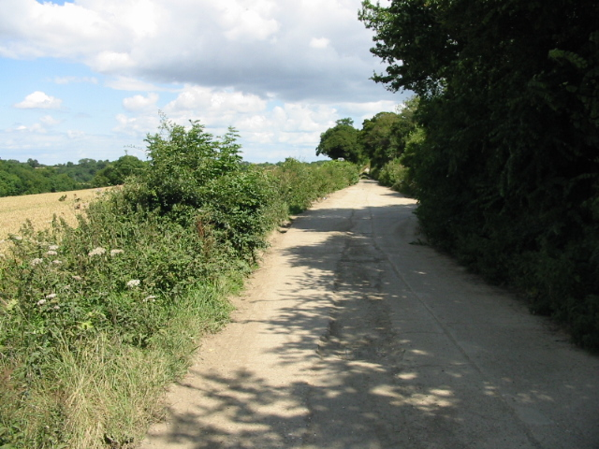Illustration ii: just east of H © Nick Smith
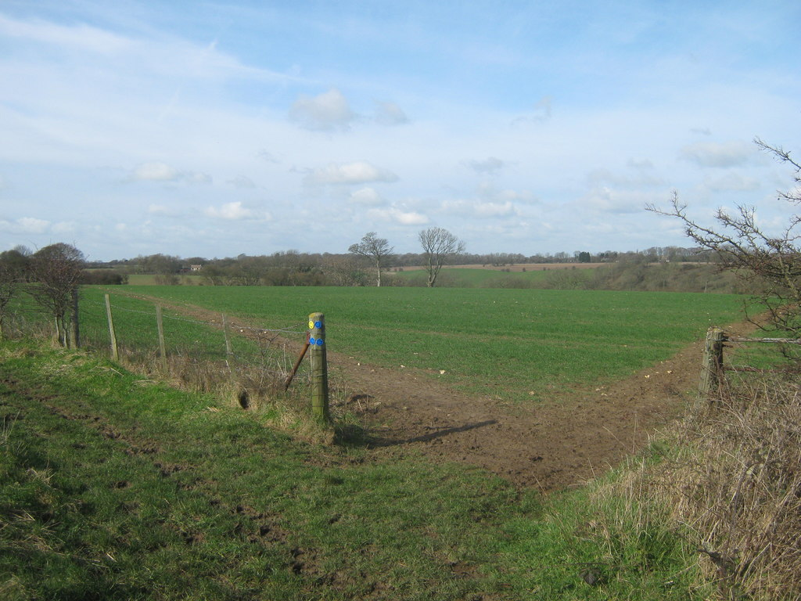Illustration iii: at R © David Anstiss
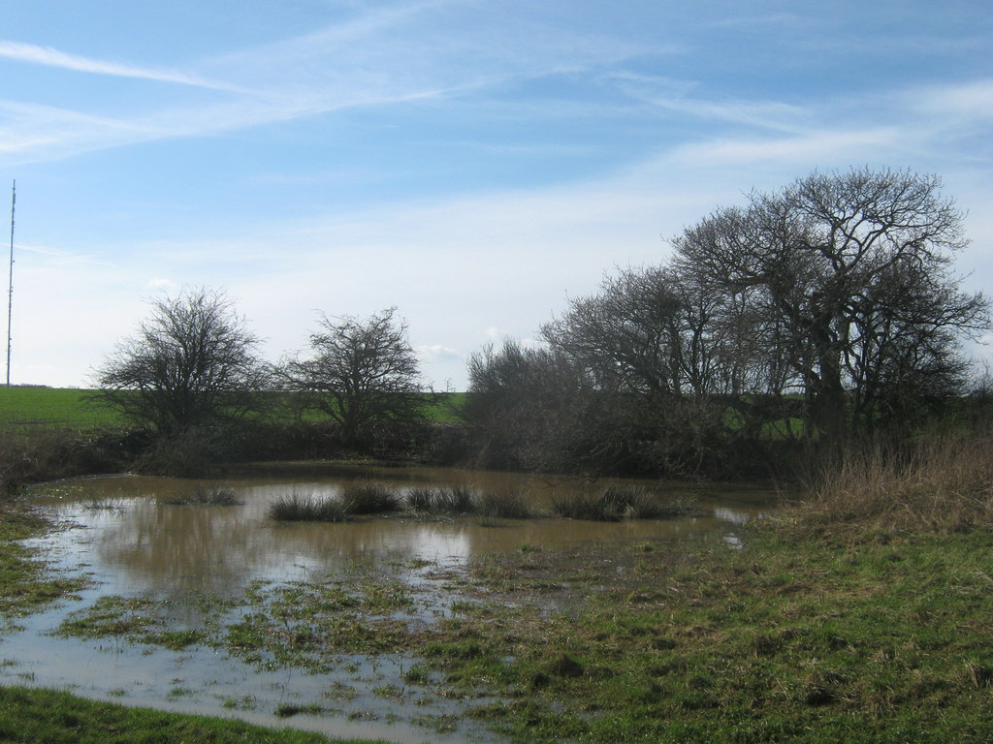Illustration iv: Soval Pond, S © David Anstiss
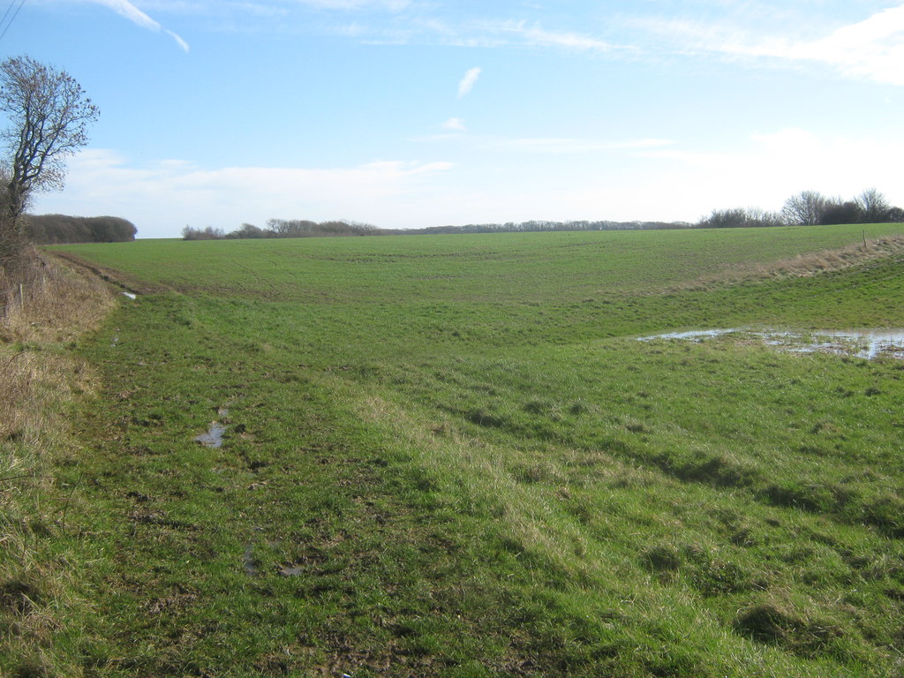Illustration v: East to S © David Anstiss
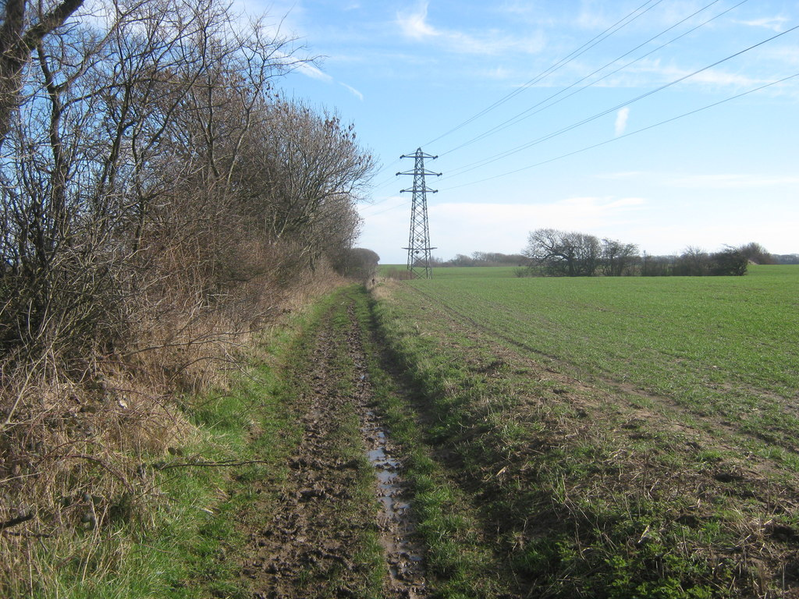Illustration vi: From R to S © David Anstiss
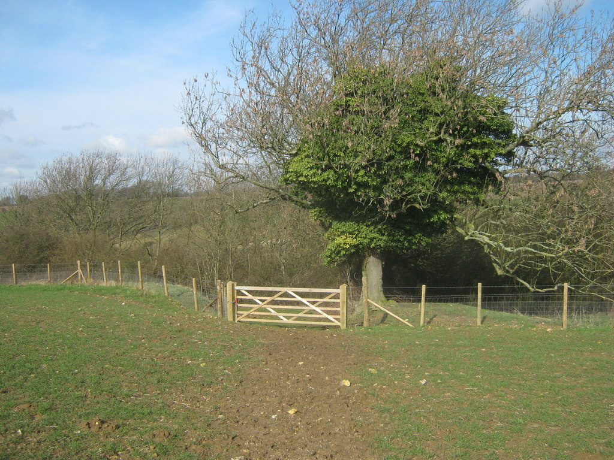Illustration vii: Between R and Q © David Anstiss
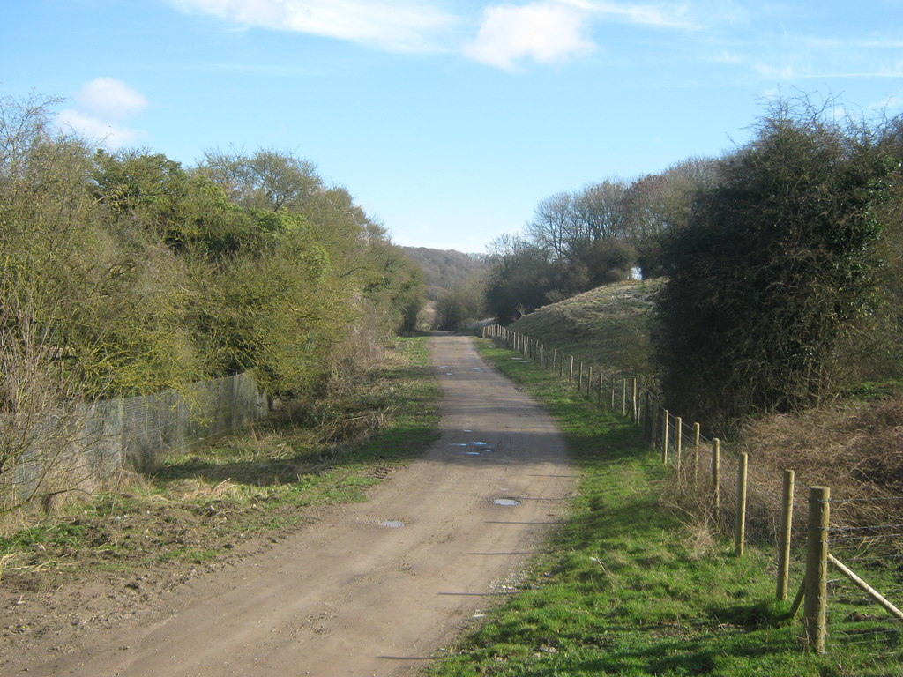Illustration viii: Between R and S © David Anstiss
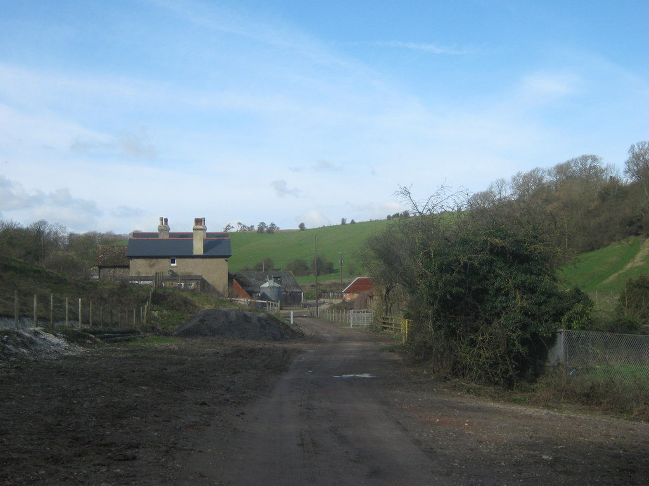Illustration ix: Near P © David Anstiss

Photos are www.geograph.co.uk, licensed for reuse under Creative Commons Licence.

