PMS.SYLQ.CEGID - Y2 Interface

User Guide

Version 1.0.0 – 22/07/2022

Summary
1. Introduction 3
1.1. Architecture description 3
1.2. Y2 driver capabilities 3
2. Installation 4
2.1. Notice 4
2.1.1. Supported systems 4
2.1.2. Supported currencies and countries 4
2.1.3. Supported institutions 4
2.2. Installation overview 4
2.2.1. Prerequisites 4
2.2.1.1. Software 4
2.2.1.2. Hardware 4
2.2.2. Directories 5
2.2.3. Registry 5
2.3. Package description 5
2.4. Installation process 6
2.5. Uninstallation overview 8
2.6. Reinstallation overview 8
3. Setting up the Driver 9
3.1. Prerequisites 9
3.2. Setup procedures 9
3.3. Mandatory settings 9
4. Setup and Modify parameters 10
4.1. Setting up the Y2 system 10
4.1.1. Setup Y2 POS 10
4.1.2. Setup the PMS.SYLQ.CEGID Y2 POS 16
4.2. PMS.SYLQ.CEGID Y2 driver settings 17
4.2.1. Standard settings 17
4.2.1.1. List of transactions 19
4.2.1.1.1. Applying filter 20
4.2.1.2. Transaction details 21
4.2.2. Advanced settings 22
4.2.2.1. Choose device to use for payment 23
5. Making Transactions 25

Introduction
This document describes how to install, configure and use the PMS.SYLQ.CEGID Y2 driver (also called “Driver” inside this document).

Architecture description
The driver provides access to any terminal running the SYLQ application and assigned to the merchant, to perform transactions.

Y2 driver capabilities
The Y2 driver allows making the following transactions or operations:
- Purchase or refund transactions
  - The cashier enters or computes, onto the till, the amount to pay.
  - The cashier initiates the transaction (payment or refund) on the Y2 interface, passing it a command to trigger the operation; the PMS.SYLQ.CEGID Y2 driver than takes over.
  - If a refund is requested and the operation is possible to the cashier, an invite to enter the security code is displayed; only if the security code is successfully entered can the operation carry on.
  - If configured so, the PMS.SYLQ.CEGID Y2 driver asks the cashier on which terminal the transaction is to take place, otherwise the default terminal is used.
  - The PMS.SYLQ.CEGID Y2 driver connects to the terminal and triggers the requested (purchase or refund) operation; a screen is displayed until the operation completes.
  - When the transaction is complete, the result is displayed to the cashier onto the waiting screen.

- Reversal (cancel) transactions
  - The cashier identifies the transaction to reverse and initiates the opération.
  - If the operation is possible to the cashier, an invite to enter the security code is displayed; only if the security code is successfully entered can the operation carry on.
  - The PMS.SYLQ.CEGID Y2 driver determines on which terminal the operation was made and selects this device to perform the operation.
  - The PMS.SYLQ.CEGID Y2 driver connects to the terminal and triggers the reversal operation; a screen is displayed until the operation completes.
  - When the transaction is complete, the result is displayed to the cashier onto the waiting screen.

Installation

Notice

Supported systems
This driver has been tested on:
- CEGID Y2 v22 (valid for any version over v13)
All Y2 versions starting from v12 should normally be supported, subject to a test before.
- Windows 10 and 11 (64 and 32 bits)

Supported currencies and countries
Supported currencies
The PMS.SYLQ.CEGID Y2 driver supports only the EURO currency.
Supported countries
The PMS.SYLQ.CEGID Y2 driver can be used in any country where the acquirer operates.
The only limitation to using the PMS.SYLQ.CEGID Y2 driver is that all messages are only displayed in French or English (depending on the language of the running PC). As long as these languages are accepted by a merchant the PMS.SYLQ.CEGID Y2 driver can be used at any store.

Supported institutions
The PMS.SYLQ.CEGID Y2 driver can operate for any merchant whose operations are conducted using the SYLQ applications.

Installation overview
Installation is made possible using the provided:
InstalPMS.SYLQ.CEGID-vx.x.x.x-vYYYY-MM-DD.exe
file which will:
- Create all directories required to install the Driver.
- Copy files inside the directories.
- Install the required components.
- Provide an uninstall procedure.

Prerequisites

Software
The Driver uses the Microsoft .NET framework version 4.8 and won’t be usable if this framework is not installed on the computer.
If not installed, the Microsoft .NET framework version 4.8 can be downloaded from https://dotnet.microsoft.com/en-us/download/dotnet-framework/thank-you/net48-web-installer.

Hardware
The driver requires the use of an Android terminal supporting the SYLQ application.

Directories
The created (and default) local directories are the following ones:
- C:\Program Files (x86)\PMS.SYLQ.CEGID
This is the main directory inside which are copied the following files:
- PMS.SYLQ.CEGID.dll: the PMS.SYLQ.CEGID Y2 driver itself;
- PMS.SYLQ.dll, PMS.SYLQF.dll, PMS.COMMON.dll and Newtonsoft.Json.dll: support modules required by the CEGID Y2 driver.
- C:\ProgramData\PMS.SYLQ\Settings
This is the default driver’s settings directory. These settings are the ones manipulated while going through the PMS.SYLQ.CEGID Y2 driver settings (§4.2).
Storing the settings in a different directory (on a server for instance) is done by modifying the registry entry .
- C:\ProgramData\PMS.SYLQ\Log
This is the default driver’s log file directory.
Log files are created daily (the date being appended to the end of the file).
Storing the log files in a different directory (on a server for instance) is done by modifying the settings’ file entry as described in chapter Advanced settings (§4.2.2 - Erreur : source de la référence non trouvée).
- C:\ProgramData\PMS.SYLQ\Doc
This directory is where all supporting documents (like this one) are stored.

Registry
When launching the Y2 system, the driver will reach the registry as follows:
- [HKEY_CURRENT_USER\Software\PMS.SYLQ\Parameters]
- "SettingsFilename"=<name of the settings file> (example: "pms.sylq.settings.json")
This file is ALWAYS located inside the “C:\ProgramData\PMS.SYLQ\Settings” folder. The registry entry must therefore only indicate its name.
- "LogFilename"=<name of the log file> (example: "pms.sylq.log")
This file is ALWAYS located inside the “C:\ProgramData\PMS.SYLQ\Log” folder. The registry entry must therefore only indicate its name.
- "SeverityLevel"="TRACE"
The severity level of the trace created by the application: The following levels are available from the least to ythe most verbose: EXCEPT, ERROR, WARNING, TRACE, INFORMATION, DEBUG.
- "LogFilesToKeep"=-1
The number of log files to keep; log files are created daily and older ones are automatically deleted if more than this number of files to keep is reached, thus saving space on the disk; setting this indicator to -1 indicates to never delete any log file.
That entry identifies the path to the driver’s settings file.

Package description
The package is composed of:
- PMS.SYLQ.CEGID.dll
The Y2 driver itself.
- PMS.SYLQ.dll, PMS.SYLQF.dll, PMS.COMMON.dll
Fully equipped interface to the PMS.SYLQ.CEGID server, it requires the Microsoft .NET 4.8 framework to be installed on the target computer.
- Newtonsoft.Json.dll
Utility modules used by PMS.SYLQ.CEGID.dll.
- PMS.SYLQ.CEGID – Y2 Interface – User guide.pdf
Support document.
- SYLQT.exe
A program allowing to test the SYLQ interface outside the Y2.

Installation process
Running InstalPMS.SYLQ.CEGIDYInstallPMS.SYLQ.CEGID-vx.x.x.x-vYYYY-MM-DD.exe will allow to copy all files inside the directories. No directory modification is allowed or even suggested, the user must only agree to install the Driver.
Installation requires to have administrator privileges, to register some components on the computer and finalise procedure.
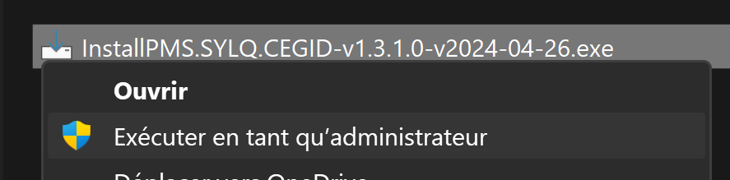
- Click on INSTALL:
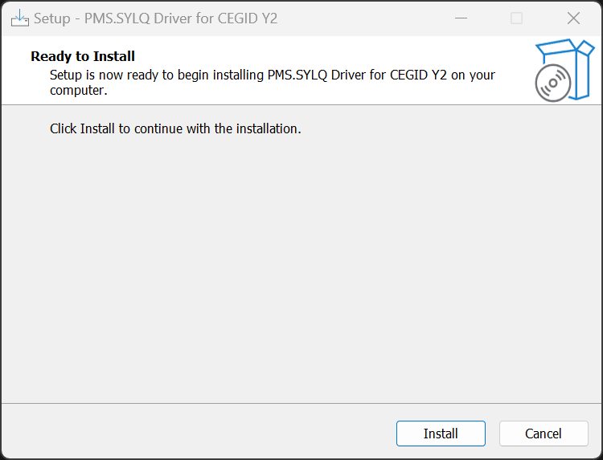
- Installation is in progress:
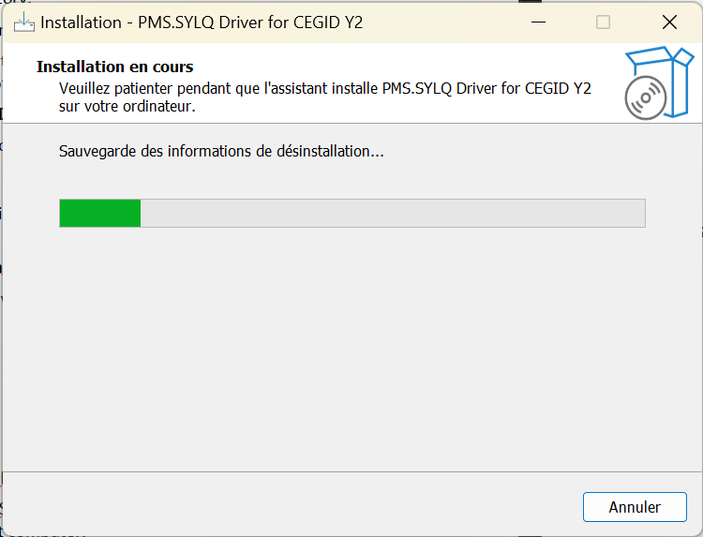

- Click on FINISH:
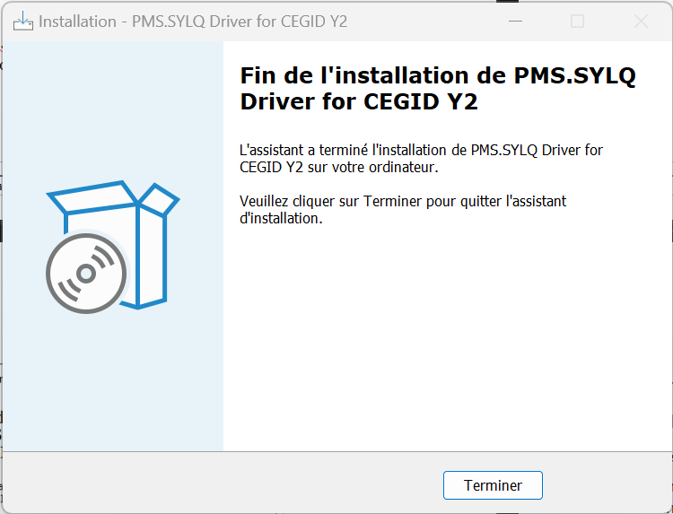

Uninstallation overview
To uninstall the driver it is necessary to go to the system settings using:
Windows Settings-> Applications-> Deinstall application
And choose
PMS.SYLQ Driver for CEGID Y2

Reinstallation overview
When reinstalling the driver (after an update) it is always a good practice to review the Advanced settings (§4.2.2) before proceeding.

Setting up the Driver

Prerequisites
Setting up the driver requires no specific information from the acquirer.
The merchant must however keep in mind the Y2 system communicates with the terminal by TCP/IP and the network must be configure accordingly to allow that communication.

Setup procedures
Setting up the driver is made as follows:
- Display the settings window (§4.2.1).
- Manually enter the Mandatory settings (§3.3).
- Verify the connection to the POS using the self tests provided.

Mandatory settings
To access the PMS.SYLQ.CEGID server and perform transactions, the merchant must at least have the following information at its disposal:
- API Key
This is the security ID provided by SYLQ to access the terminals and be able to perform transactions. That API key will be entered inside the Advanced settings.
All other settings as described below are not mandatory or will find a default value.

Setup and Modify parameters

Setting up the Y2 system
The screens presented in this chapter are all fully native CEGID Y2 screens.

Setup Y2 POS
Create Payment modes
The payment modes must be created inside Y2 before setting the EFT settings. These payment methods will be used to store the payment after the transaction has succeeded (using the mapping table).
The payment codes used hereafter are customer specific but will be used when creating the mapping table.
The first one, here named PPG, can be used to trigger the EFT interface.
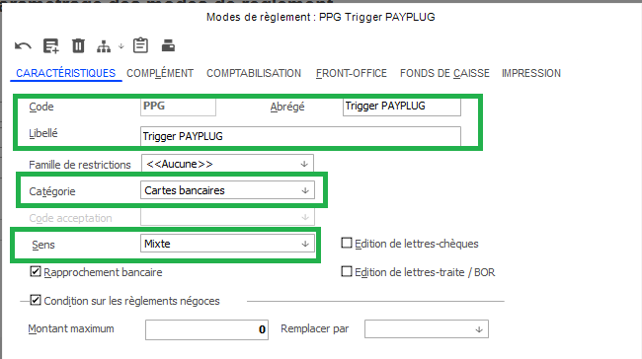
First payment mode creation step
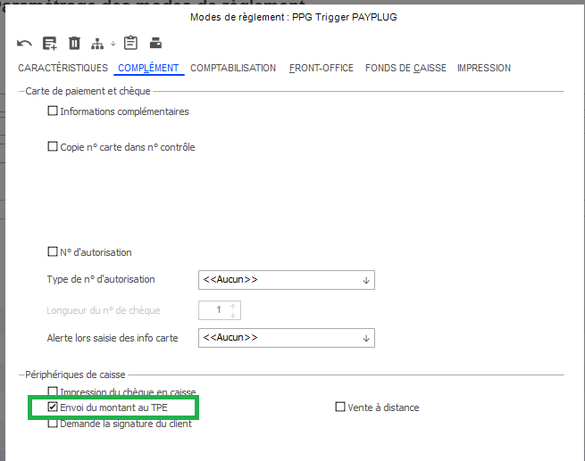
Second payment mode creation step
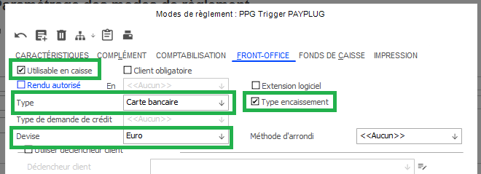
Third payment mode creation step

After having created the first payment method, several other payment methods (with the same settings) will be necessary to correctly manage the payment mapping:
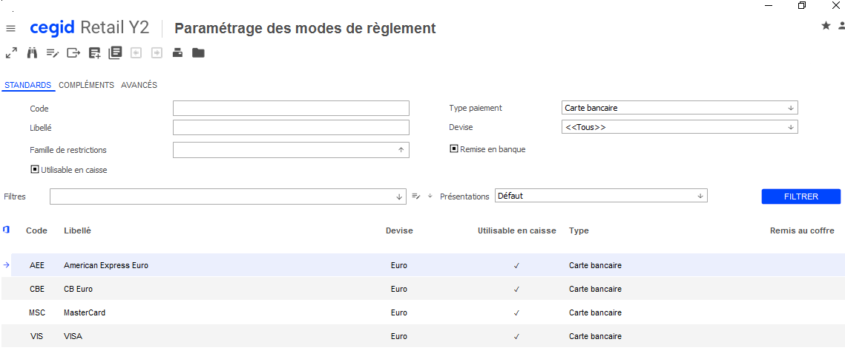
Call EFT settings
- TPE
Call “TPE” (EFT) specific settings.
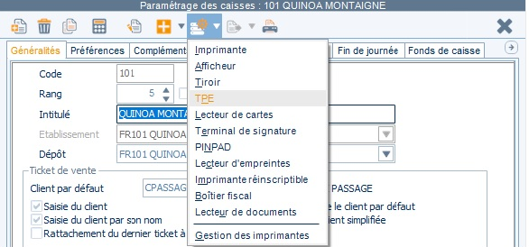
- Set EFT parameters
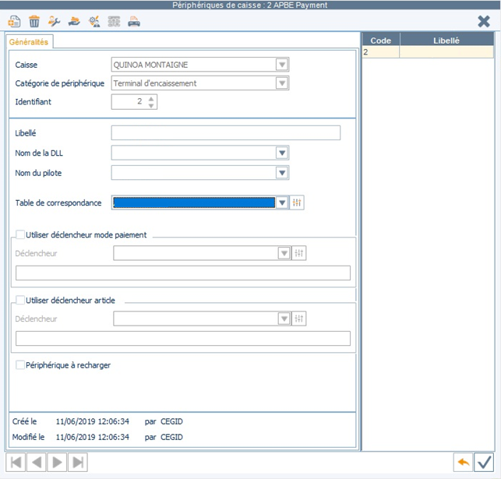
4
1
2
3
- Identifiant
This ID must be equal or greater than 2 (1 being reserved for gift cards).
- Nom de la DLL
Choose PMS.SYLQ.CEGID.
- Nom du pilote
Choose PMS.SYLQ.CEGID Y2 driver.
- Table de correspondance
A mapping table must be created to allow identifying the payment method and print it on receipts.

- Create payment methods mapping table
Please note that in this version the SYLQ application does not provide any way to know which card type was used to perform the transaction. That step must therefore be skipped.
1
2
- At the end of this step, the result is:
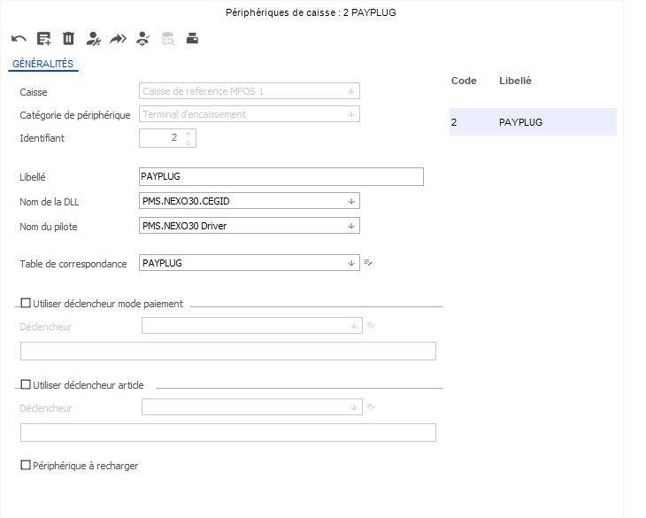
Create till Mapping
Some of the below elements depend on customer functional specifications.
Here, the button will be associated to the trigger payment method.
create the button In the Mapping
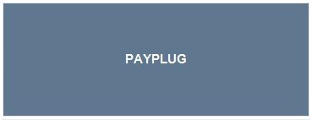

associate the payment mode
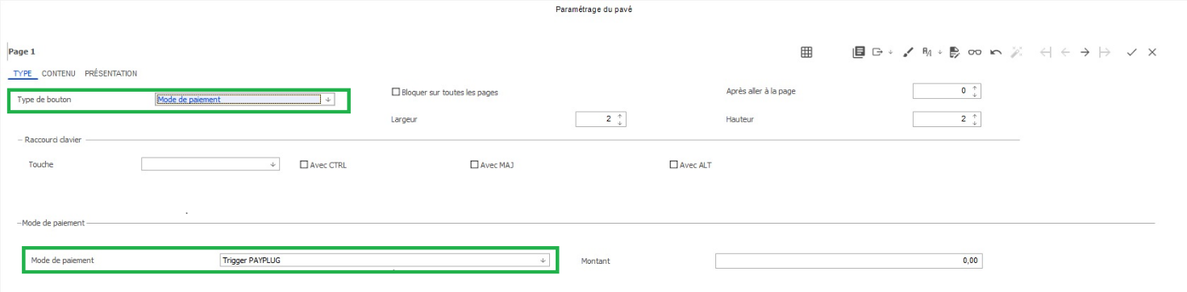
Type of payment must be “Payment mode”.
Payment mode name depends on customer specifications. The chosen payment mode must be an EFT payment trigger.
Choose the name of the button to use
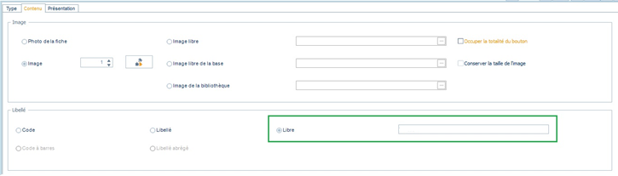

Setup the PMS.SYLQ.CEGID Y2 POS
Call PMS.SYLQ.CEGID Y2 driver settings
- Call the PMS.SYLQ.CEGID Y2 driver settings by clicking onto the dedicated button at the top of the screen. Doing that will bring the merchant to display the screen described in settings (§4.2.1).
Call PMS.SYLQ.CEGID Y2 driver advanced setting
The Y2 system must be put in SAV mode to allow calling Advanced Setting
Putting the Y2 system in SAV mode is done as follows:
- Press ALT+F11, display Y2 settings and call the “Préférences” screen.
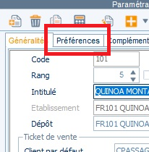
- The “Préférences” screen is displayed.
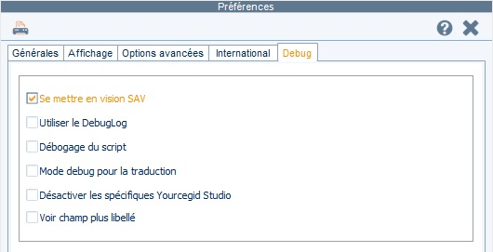
b
a
- Debug
Click on “Debug” tab to access the “SAV” option.
- Se mettre en SAV
Check the option puts the Y2 in SAV mode and allows accessing the Advanced Setting instead of the settings and save.
Beware, once in SAV mode the Y2 system remains in that mode until the SAV mode has been explicitly disabled. To disable the SAV mode do the exact same procedure but uncheck the “Se mettre en SAV” option and save.

PMS.SYLQ.CEGID Y2 driver settings

Standard settings
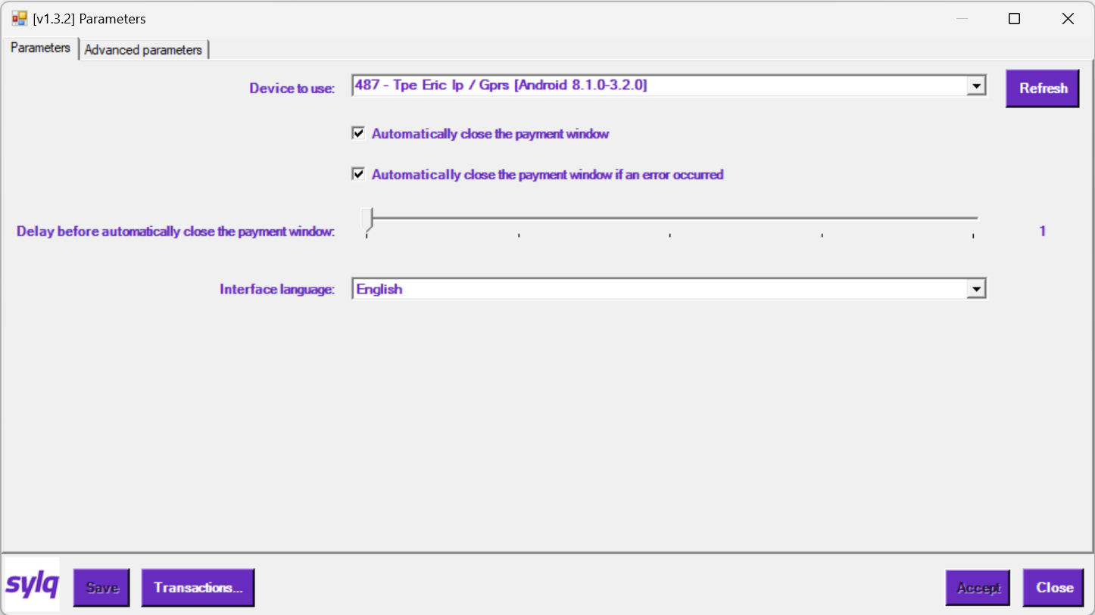
PMS.SYLQ.CEGID Y2 driver Standard settings window
7
4
6
3
5
1
2
- Device to use
Displays all devices the merchant can access. That list is retrieved automatically by the application.
The selected device is the default one that will be used to perform any operation, if not indicated otherwise.
- Refresh
Refreshes the list list of available devices.
- Automatically close the payment window
Indicates whether the payment window must be closed automatically or not once its processing is over.
Not setting that option forces the cashier to manually close the window when it’s finished its processing.
- Automatically close the payment window if an error occurred
Indicates whether the payment window must be closed automatically or not once its processing is over AND if an error occurred. That option is available ONLY if Automatically close the payment window has been checked.
Not setting that option forces the cashier to manually close the window when it’s finished its processing AND an error occurred.
- Delay before automatically close the payment window
Indicates the delay before the payment window is automatically closed once its processing is finished. That option is available ONLY if Automatically close the payment window has been checked.
Delay is between 1 and 5 seconds max and the specified value is show beside the slide bar.
- Interface language
Allows specifying the language the SYLQ windows will be displayed into.
There are 2 supported languages: French and English.
- Transactions
Allows accessing the List of transactions with the SYLQ driver.

List of transactions
That window displays the list of transactions with sorting capabilities.
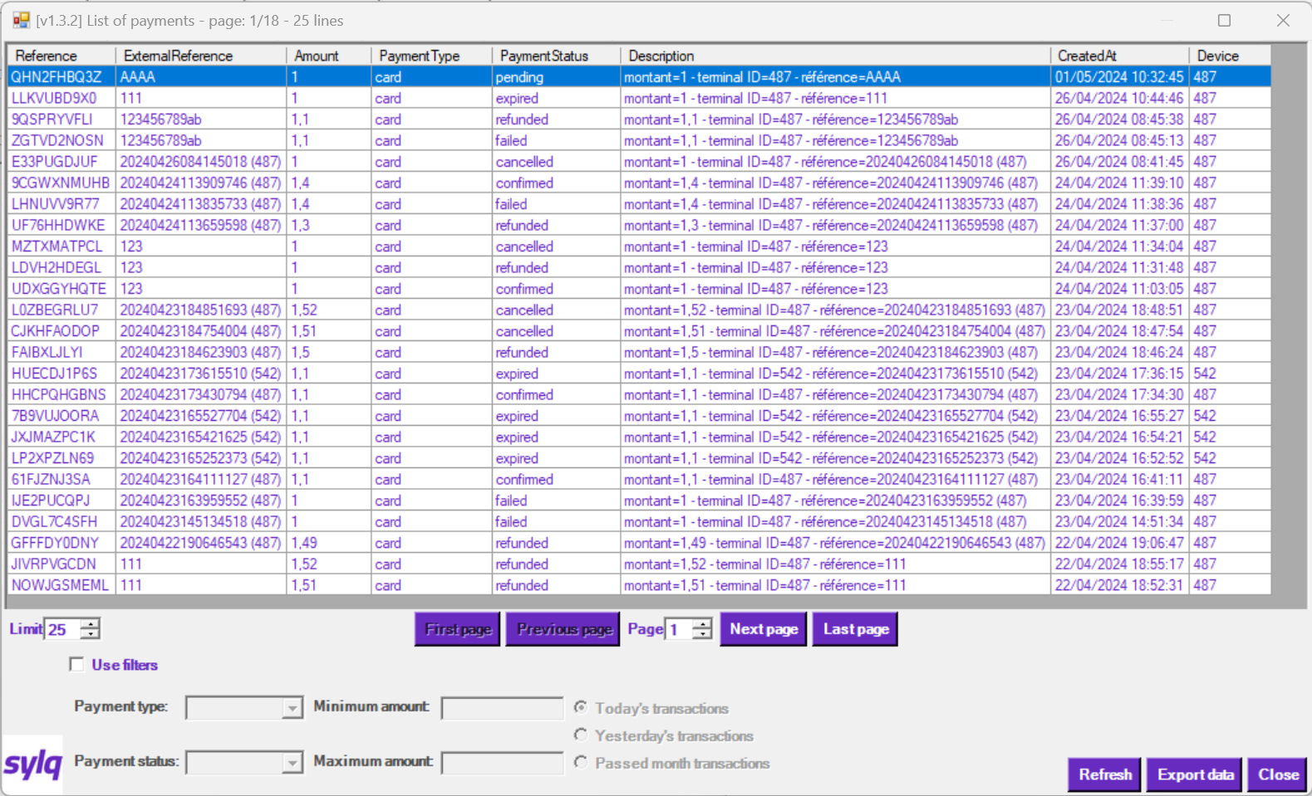
PMS.SYLQ.CEGID Y2 driver List of transactions window
3
1
10
4
2
5
6
8
9
7
- List of transactions
This is the list of transactions found for the current merchant (identified by the API Key).
That list displays all available transactions but can be filtered to narrow the search using the filters described in Applying filter.
Double clicking of an item will display the Transaction details window
- Number of items to display par page
The number of transactions to display. The more items to display the longer it takes to display the transactions. Changing this value has no effect until the Refresh button has been used.
- First page
Move directly to the 1st page of transactions.
- Previous page
Move directly to the previous page of transactions.
- Page number
Move directly to the selected page number.
- Next page
Move directly to the next page of transactions.
Last page
Move directly to the last page of transactions.
- Use filters
If checked gives access to narrow the search of transactions. For a full description refer to Applying filter.
- Refresh
Refresh the List of transactions according to the current search and page settings.
- Export data
Allows exporting the currently displayed List of transactions to the clipboard in JSON format.

Applying filter
To narrow the search of transactions the Use filters option must be checked, allowing to select different search features to display a list of transactions complying with the selected options.
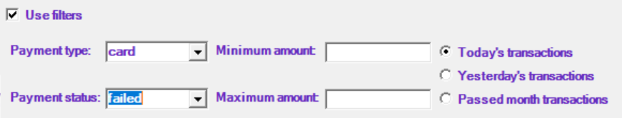
PMS.SYLQ.CEGID Y2 driver filter of transactions window
5
3
1
2
4
- Use filters
If checked gives access to narrow the search of transactions. For a full description refer to Applying filter.
- Payment type
Select the type of payment to display. The available options are:
- empty: all payment types are eligible to the search.
- Other options are: card, bank and crypto describing which payment type is eligible for the search.
For more information about the payment types please refer to SYLQ.
- Payment status
Select the status of the payments to display. The available options are:
- empty: all statuses are eligible to the search.
- Other options are: pending, sent, underpaid, expired, confirmed, failed, pending_cancel, cancelled, refunded, pending_refund, partially_refunded, failed_refund.
For more information about the different statuses please refer to SYLQ.
- Minimum & Maximum amount
Minimum and/or maximum amount of the transaction. Leaving these fields empty makes no limit is applied.
- Today, Yesterday or Passed month transactions
Indicates when the transactions must have been made.

Transaction details
Displays the details of the selected transaction.
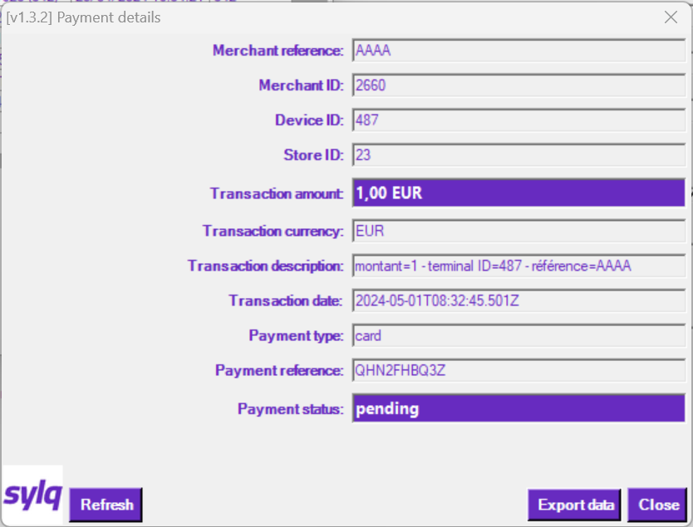
PMS.SYLQ.CEGID Y2 driver Transaction details window
1
2
3
4
- Details of the transaction
Details of the transactions.
- Payment status
The current status of the payment. That status may still not be final and being updatable using the Refresh button, if available.
- Refresh
Allows refreshing the status of the transaction. That button is available only if the status can still be updated asynchronously.
- Export data
Allows exporting the currently displayed Details of the transaction to the clipboard in JSON format.
For more information about the different statuses please refer to SYLQ.

Advanced settings
The advanced settings are only for administration purposes and allow changing internal behaviours of the PMS.SYLQ.CEGID Y2 driver. They can be accessed by calling the PMS.SYLQ.CEGID Y2 driver settings in Y2 “SAV mode” (refer to Se mettre en SAV). It is strongly advised to not provide advanced settings to regular users.
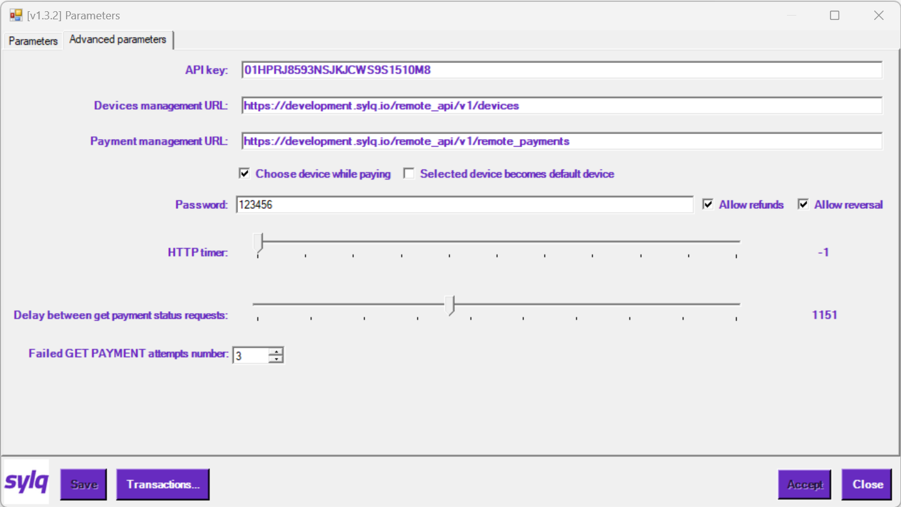
PMS.SYLQ.CEGID Y2 driver Advanced settings window
7
3
2
4
6
8
9
10
5
11
1
- API key
Enter the API Key given my SYLQ.
- Device Management URL
This is the URL the PMS.SYLQ.CEGID Y2 driver will reach whenever device management processes are involved. That URL must be confirmed with SYLQ but is likely to be https://app.sylq.io/remote_api/v1/devices.
- Payment management URL
This is the URL the PMS.SYLQ.CEGID Y2 driver will reach whenever payment management processes are involved (purchase, refund, reversal). That URL must be confirmed with SYLQ but is likely to be https://app.sylq.io/remote_api/v1/remote_payments.
- Choose device while paying
If checked, when performing a payment the cashier will be asked to choose the device to use to perform that payment, allowing to bypass the default Device to use selected in the Standard settings window. In that case the Choose device to use for payment window is displayed to choose the device to use for this transaction.
If not checked the default Device to use selected in the Standard settings window is used to perform the transaction.
- Selected device becomes default device
If checked, the selected device using the Choose device to use for payment window becomes the newly default Device to use. That option can be selected and will be active only if Choose device while paying is checked.
- Password
Password that will have to be entered to perform a refund or reversal (cancel) operation.
The password must have a minimum of 4 characters and a maximum of 15 characters. All displayable characters can be used.
If no password or an invalid password (too short or too long) is defined, the refund and reversal operations can’t be performed.
- Allow refund
If checked refund operations can be performed and will be forbidden otherwise.
- Allow reversal
If checked reversal (cancel) operations can be performed and will be forbidden otherwise.
- HTTP timer
Timer in milliseconds to use between 2 HTTP requests to the SYLQ server while performing a transaction (payment, refund or reversal). Possible values are:
- -1: no timeout, the request never returns if no answer from the server.
- 1 to 5000 milliseconds timer.
The selected value is displayed at the end of the slide bar.
- Delay between get payments status requests
Delay in milliseconds between 2 requests to get the status of a payment (or refund, or reversal) currently being processed. Possible values are between 250 up to 2500 milliseconds.
The selected value is displayed at the end of the slide bar.
- Failed GET PAYMENTS attempts number
Number of consecutive failed GET PAYMENT status requests the driver accepts before raising an error while communicating with SYLQ server. A failed request occurs if the server doesn’t answer in time as indicated in HTTP timer.

Choose device to use for payment
That window is displayed when performing a transaction and the Choose device while paying has been checked.
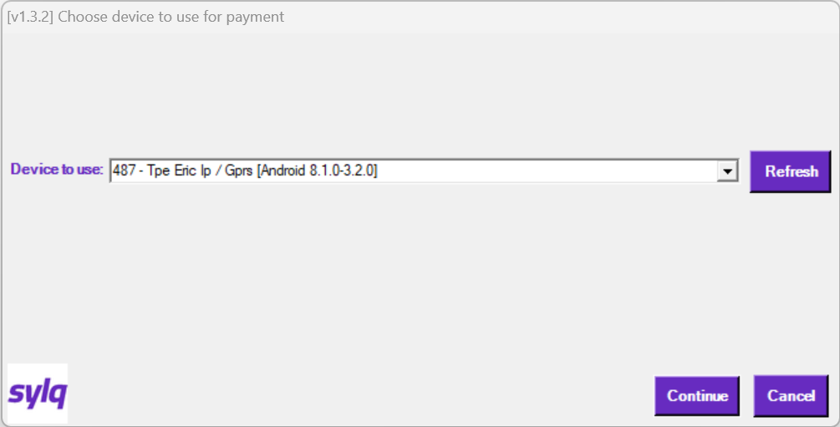
PMS.SYLQ.CEGID Y2 driver Choose device to use for payment window
2
1
- Device to use
Select the device to use to perform the transaction. If the Selected device becomes default device option is checked that device becomes the new default one.
- Refresh
Refresh the list of devices.

Making Transactions
- The merchant enters or compute the amount to pay for and calls the PMS.SYLQ.CEGID Y2 driver payment procedure (the procedure for calling this functionality might vary on cash registers).
- If the transaction is a purchase or a refund and the settings indicate that the merchant must choose the device on which the operation must be performed (refer to Choose device while paying in Advanced settings), the Choose device to use for payment window (§4.2.2.1) is displayed.
If the transaction is a purchase or a refund and the settings do not indicate that the merchant must choose the device on which the operation must be performed, then that step is skipped and the targetted device is the currently selected Device to use (§4.2.1) in Standard settings.
If the transaction is a reversal that step is always skipped, the targetted device to perform the transaction always being the one which made the original transaction and which is automatically selected..
- The procedure carries on by displaying the transaction window.
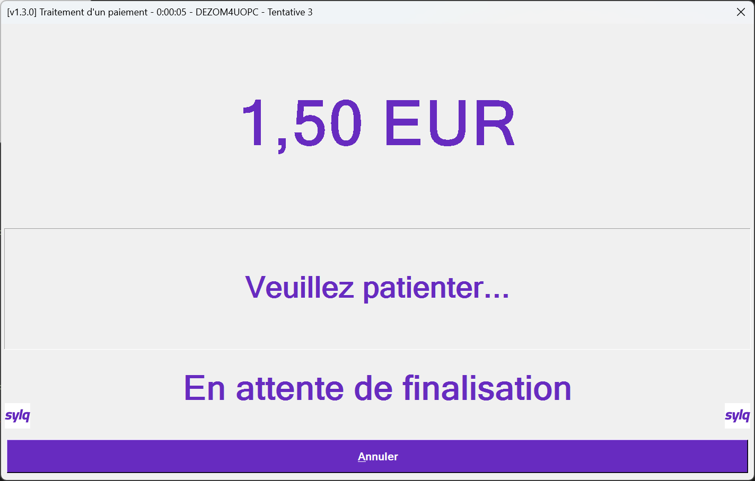
PMS.SYLQ.CEGID Y2 driver Choose device to use for payment window
b
c
a
- AMOUNT
This upper part displays the amount of the transaction along with the transaction currency.
- MESSAGE
The middle part displays information about actions currently taking place.
- STATUS/RESULT
The lowest part displays the current status of the transaction.
Please note that cancelling the transaction using the “Cancel” (“Annuler”) button may leave the transaction is an unknown state, checking status will then have to be done using the Transaction details - §4.2.1.2.
- When the transaction is completed (accepted or not) the STATUS/RESULT part indicates it with a colour code and a message indicating the final result.
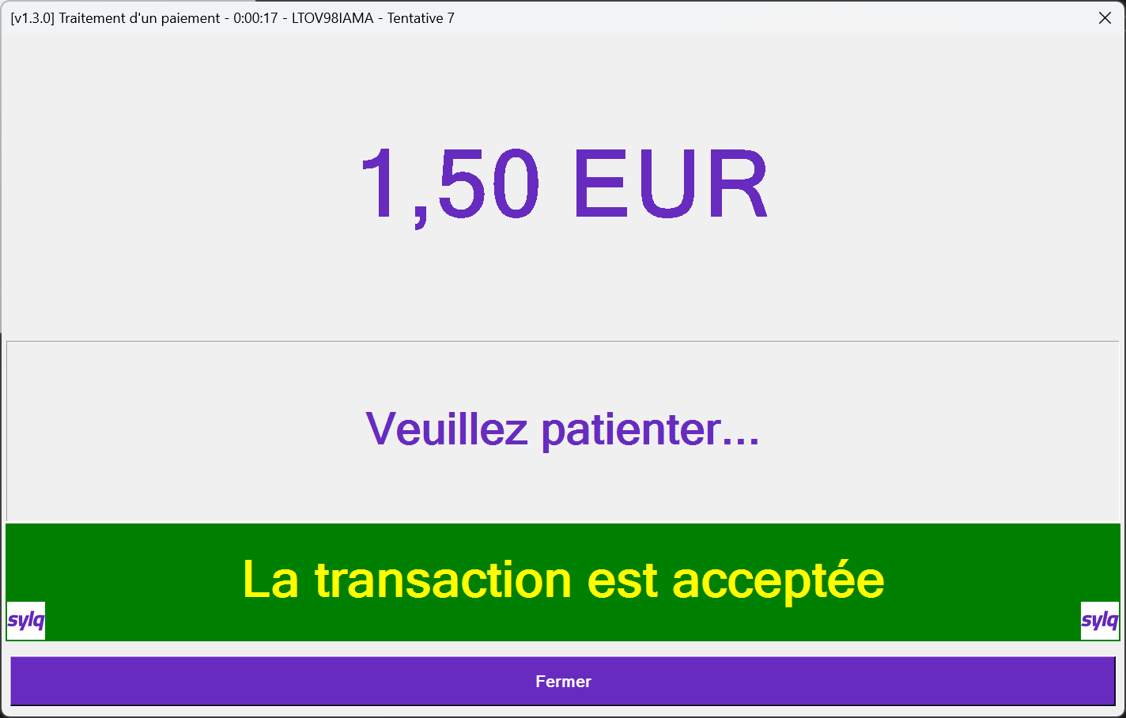
This transaction has been accepted (RESULT is GREEN)

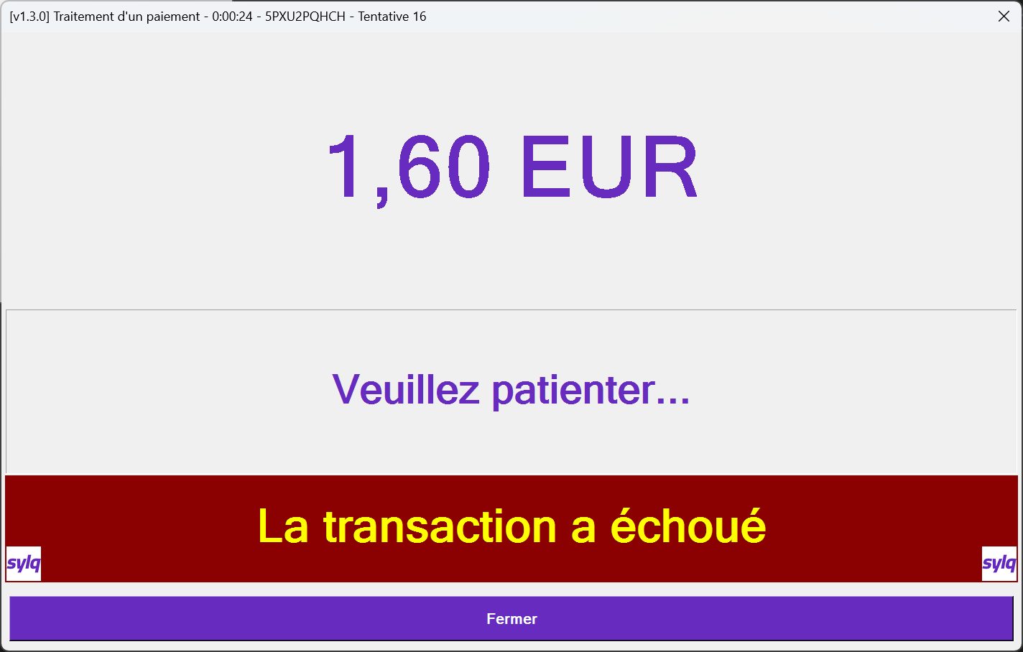
This transaction has been declined (RESULT is RED)
- When the transaction is completed (accepted or not) the STATUS/RESULT part indicates it with a colour code and a message indicating the final result.

