Different behaviour of PDF export

preparing the test case below:
- I set the characters between the brackets to „hidden“
- I selected the text between the brackets and navigated as follows:
- Insert/fields/more fields/set reference and named the text as „originalText“
- then I inserted two references via Insert/fields/more fields/insert reference

error description
- exporting this document via „File/Export/Export as PDF“ works fine
this is the desired behaviour
- exporting this document via „File/Export/Export Directily as PDF“ fails with:
Error: Reference source not found
Please have a look at page 3

error reproduction
try both ways of exporting to PDF

test case

><

here should the referenced text appear: between the brackets is the hidden referenced text

and here too: between the brackets is the hidden referenced text

writer settings:
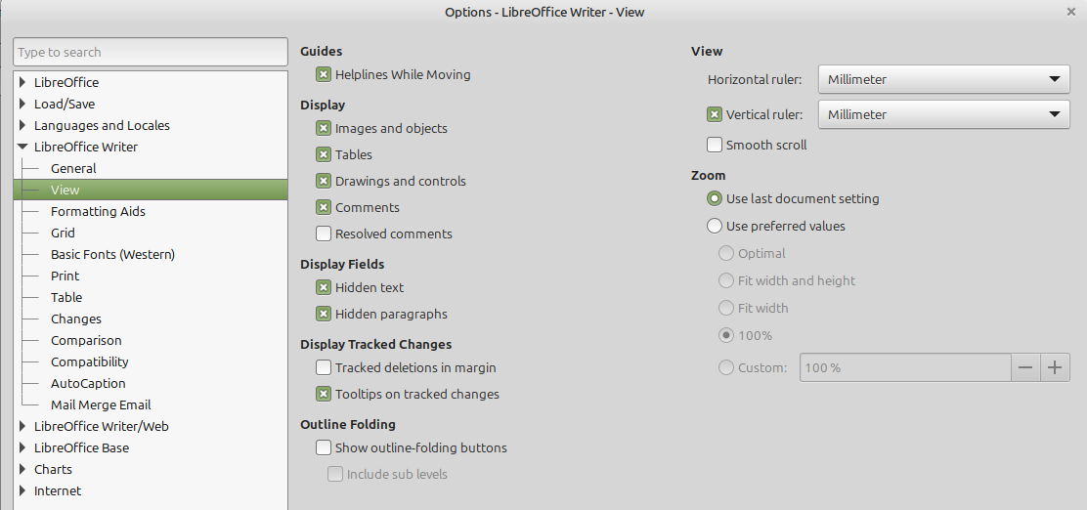
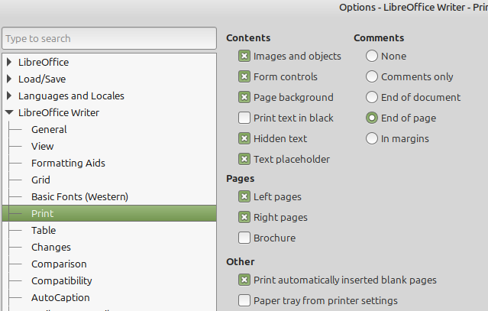

result of „Export Directily as PDF“
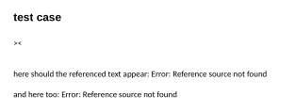

result of „Export as PDF“


