Libre Office Version 24.8.6.2
Pack 1 (X86_64) (6.2 Build 7601)
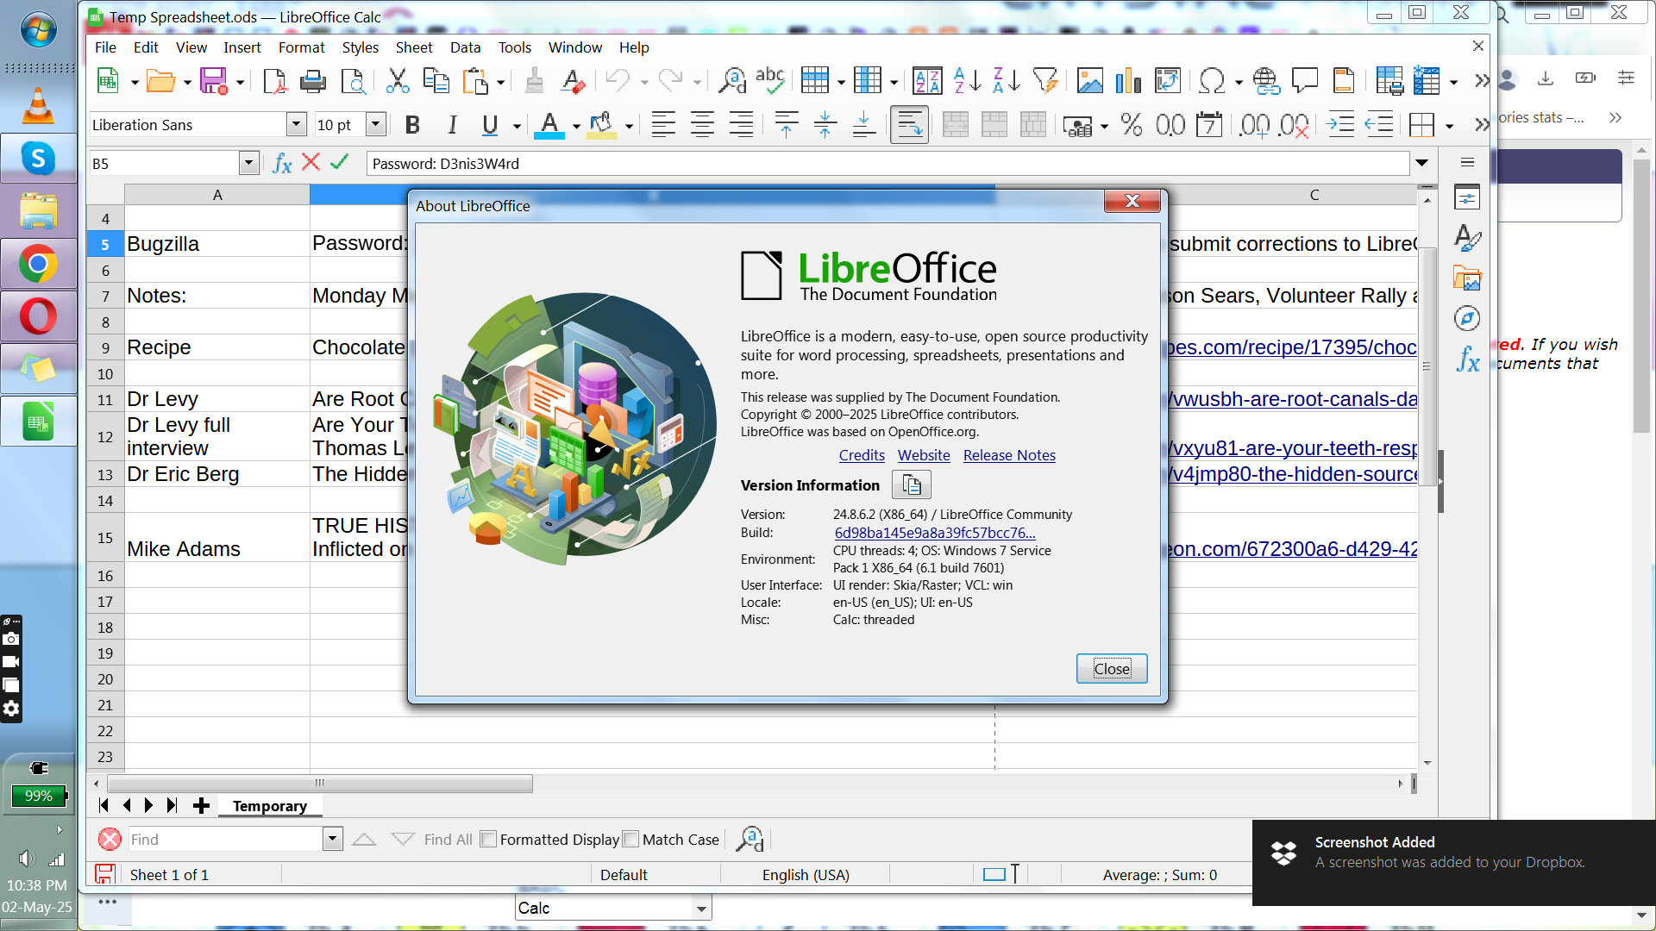
LibreOffice
5.1.25 (Day 28, Tenth Moon, 004)
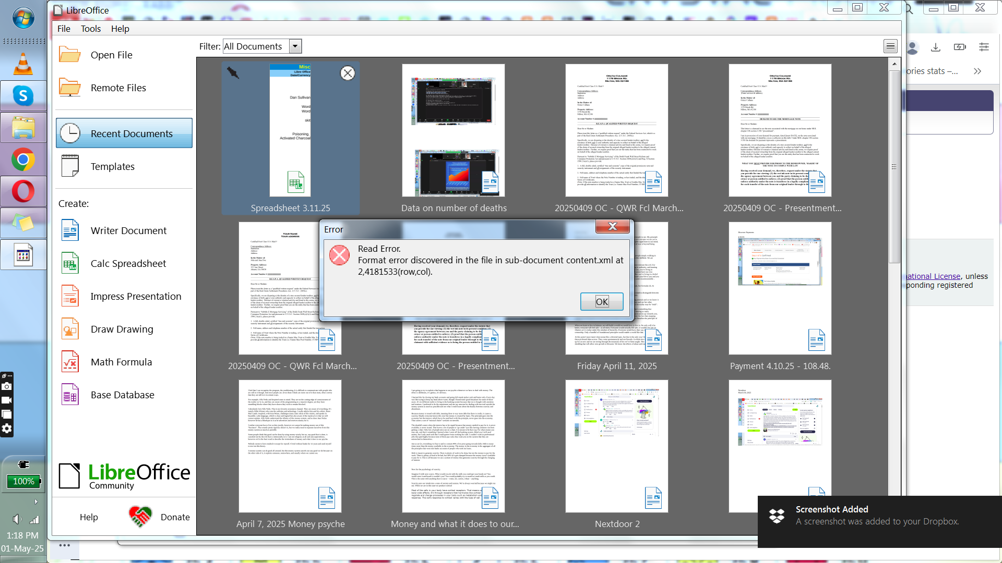

Windows Version 6.1 (Build 7601 Service Pack: 1)



