Bug recreation procedure:
When printing labels, the File > Print dialog does not show the correct paper sizes upon the first print and the Preview is drawn incorrectly.

1) Generate labels as usual
2) File > Print

My default printer is a HP LaserJet 8000. The preview selects HP LaserJet 8000 default paper size, letter and attempts to render the label on that size paper in the drawing.

3) Select the correct printer from the drop down list.
4) The preview will use the printer's default paper size.
5) Even though I click the "Properties" button and select the correct page setup from within the driver, click Apply / OK, LibreOffice doesn't refresh the settings.

6) The preview is still incorrect. If I select from the list of available paper sizes, none of them match my driver's settings.

7) Print using the very first paper size - even though it's wrong.
8) Print once again: File > Print
9) Preview is correct, but paper size is blank.
10) Print - print is correct.

Printer settings:
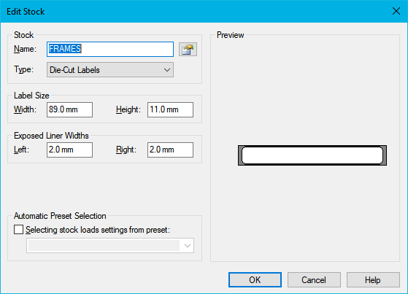
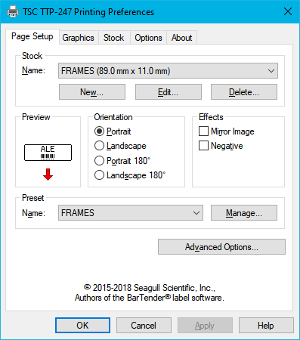

Document looks like:

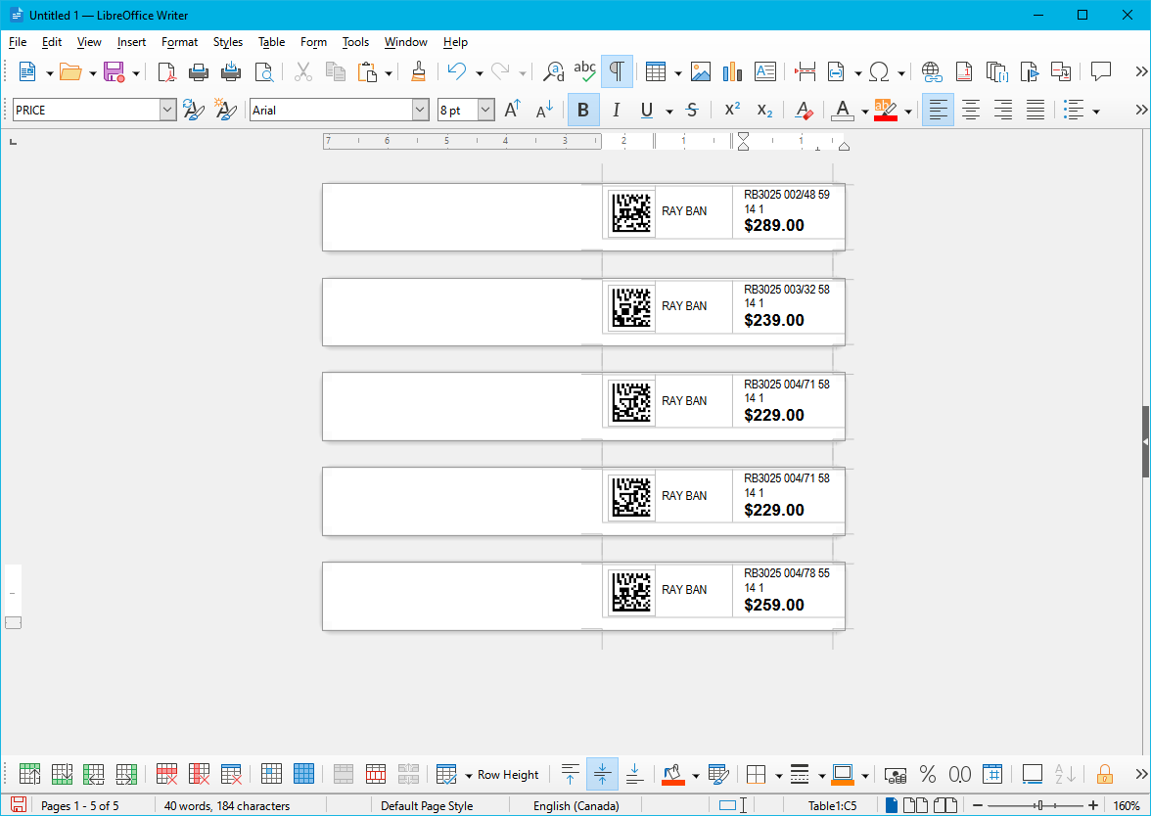
Default printer in my system is HP Laserjet 8000.
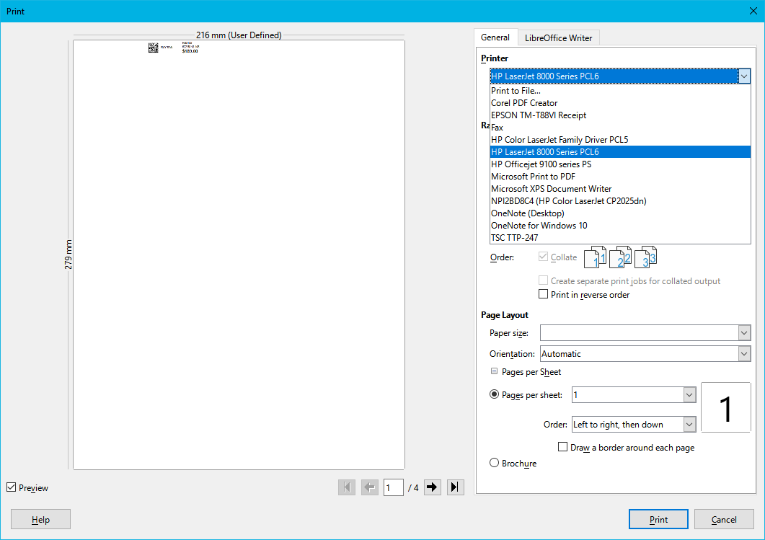

When I change to TSC TTP 247

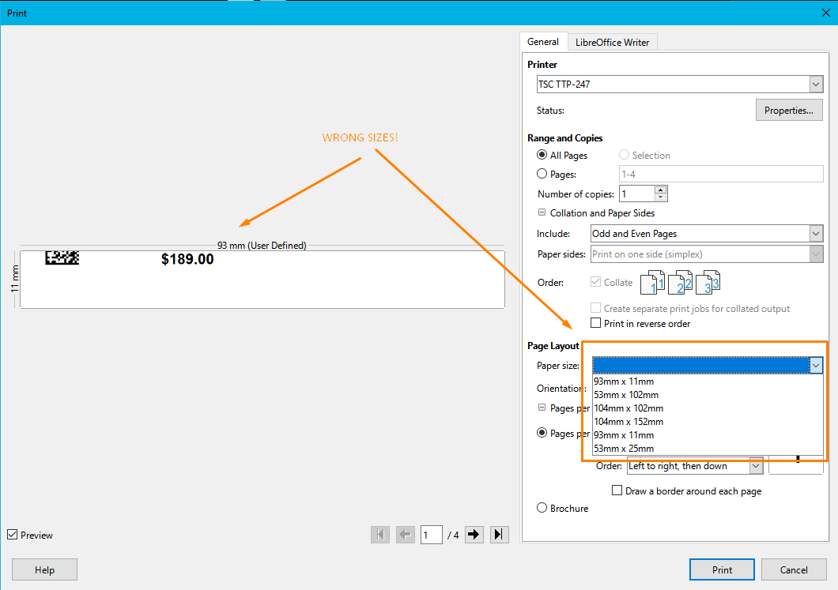
When printing using the incorrect size, at least 1 print and accept whenever I get.

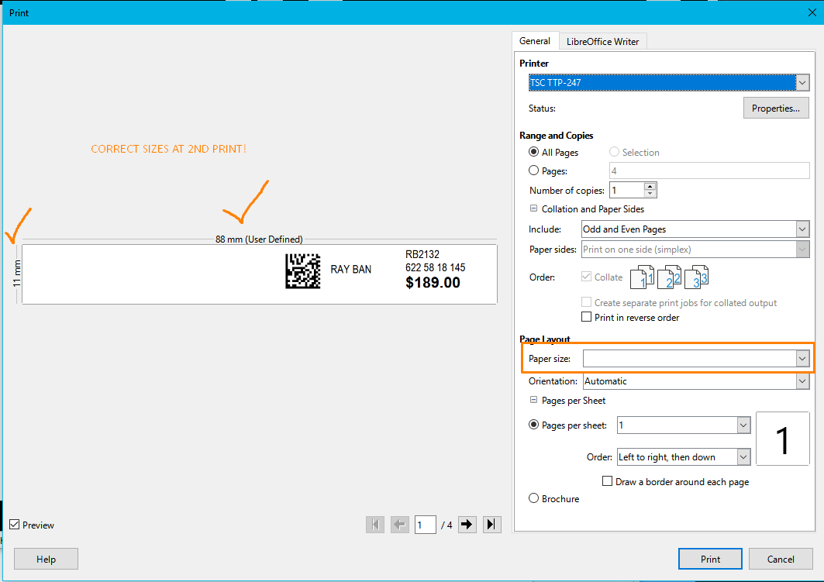
The 2nd time I do a print, I get:

