Reference ok
Cross reference in paragraph to “1 Reference ok”.

Reference error

cross reference error

File → Send → Create HTML Document (.html)
Cross reference in paragraph to “2.1 cross reference error”.
Cross reference in table to | 2.1 cross reference error
Illustration 2.1: a table
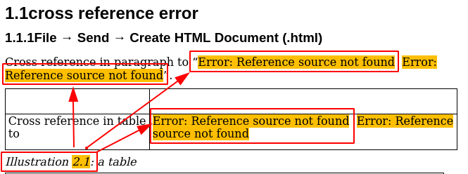
Screenshot of HTML in browser

Bug
All cross references in and before the table are reported as “error”.
This happens only, if the table has a caption, “illustration 2.1:” here.

Fix
???

Nota bene
This bug only occurs for this function but not for “File → Save as…” or and “File → Export”.

