 | Liberation Sans | Liberation Serif | Liberation Mono
Baseline  para valign=1 | Goofy | Goofy | Goofy
Top  para valign=2 | Goofy | Goofy | Goofy
Middle  para valign=3 | Goofy | Goofy | Goofy
Bottom  para valign=4 | Goofy | Goofy | Goofy

Screenshot MS Word for Mac v16.74 (document loaded from odt)
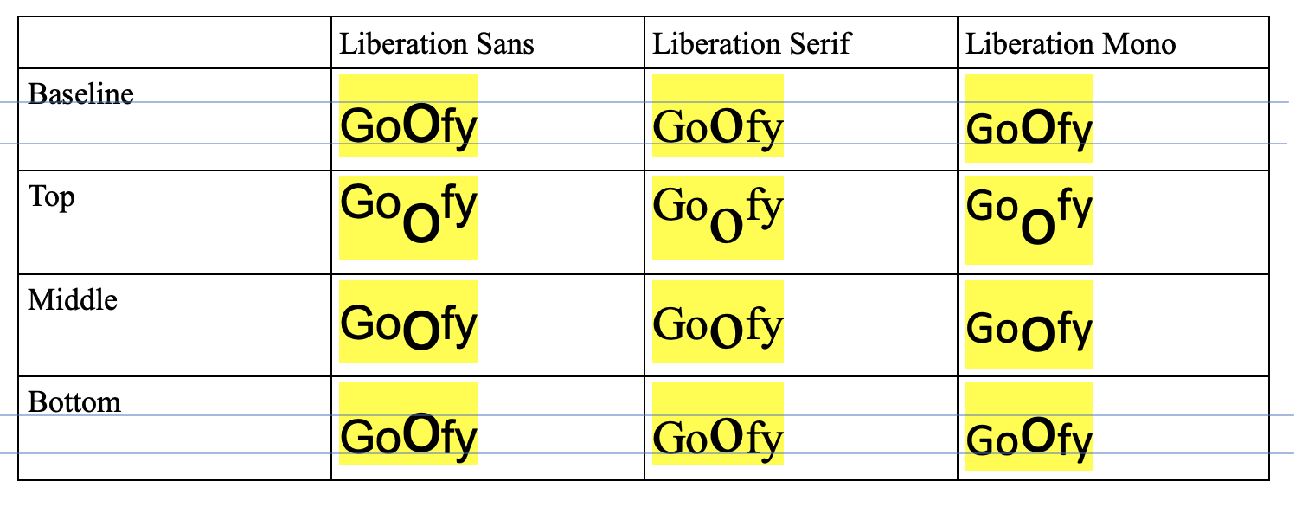

Screenshot Microsoft 365 online (document exported as docx)


