- Increase Paragraph Spacing, Decrease Paragraph Spacing
- Increase Indent, Decrease Indent, Hanging Indent
- Paragraph (to open the Paragraph dialog)
- Set Line Spacing
- Note
Direct formatting (also called manual formatting) overrides styles. This means that when a new style is applied, direct formatting is not removed and still determines the displayed format.

Removing direct formatting
To remove direct formatting, select the text and choose Format > Clear Direct Formatting on the Menu bar, or right-click and choose Clear Direct Formatting in the context menu, or press Ctrl+M on the keyboard, or select the Clear Direct Formatting icon on the Formatting toolbar.
- Note
When clearing direct formatting, the text formatting will return to the applied paragraph and character style and not the default paragraph style or default character style (unless these styles are actually applied to the text).

Formatting characters using styles
To apply a character style, highlight the characters or words and apply the selected character style from the Character Styles tab of the Styles deck on the Sidebar, from the Styles menu on the Menu bar (limited), or from the right-click context menu (limited).

Formatting characters directly
It is recommended that you use styles to format characters as much as possible rather than formatting characters directly, as described in this section.
You can directly apply many formats to characters using the buttons on the Formatting toolbar and by using the Character panel of the Sidebar’s Properties deck. Not all buttons are visible in a standard installation, but you can customize the toolbar to include those you use regularly. These buttons and formats include:
- Font Name, Font Size
- Bold, Italic, Underline, Overline, Double Underline, Strikethrough, Outline
- Superscript, Subscript
- Uppercase, Lowercase
- Increase Font Size, Decrease Font Size
- Font Color (with a palette of colors)
- Background Color (with a palette of colors)
- Highlighting (with a palette of colors)
- Note
Just as direct paragraph formatting overrides the current paragraph style, applying direct character formatting to characters overrides the current character style formatting.

Formatting tables
Tables in a Writer document share the same sets of formatting elements as the spreadsheets in LibreOffice Calc.
To apply table styles, click in the table to be formatted and double-click on a style listed in the Table Styles tab of the Sidebar’s Styles deck. Alternatively, click in the table to be formatted, choose Table > AutoFormat Styles on the Menu bar and select a style from the dialog that opens. For more information, refer to Chapter 13, Tables of Data, in the Writer Guide.

AutoCorrection
You can set Writer to format or correct parts of a document automatically as you type, according to the choices made on the Options tab of the AutoCorrect dialog (Tools > AutoCorrect > AutoCorrect Options).
Some common unwanted or unexpected formatting changes include:
- Horizontal lines. If you type three or more hyphens (---), underscores (___) or equal signs (===) on a line and then press Enter, the paragraph is replaced by a horizontal line as wide as the column in the page. Note that the line is actually the lower border of the preceding paragraph.
- Bulleted and numbered lists. A bulleted list is created when you type a hyphen (-), star (*), or plus sign (+), followed by a space or tab at the beginning of a paragraph. A numbered list is created when you type a number followed by a period (.), followed by a space or tab at the beginning of a paragraph. Automatic numbering is only applied to paragraphs formatted with the Default Style, Text Body, or Text Body Indent paragraph styles.
- Tip
If you notice unexpected formatting changes occurring in your document, this is the first place to look for the cause. In most cases Edit > Undo (Ctrl+Z) fixes the issue.
To turn AutoCorrect on or off, choose Tools > AutoCorrect and select or deselect the items on the list. The Help describes each of these choices.

Creating lists with styles
For more about creating lists using styles, see Chapter 12, Lists: Tips and Tricks, in the Writer Guide.

Creating bulleted and numbered lists
Whenever possible, use paragraph styles for creating bulleted and numbered lists. Writer comes with two sets of paragraph styles for this purpose. However, these styles do not include options for settings such as the type of bullet or position of numbers. Those settings come from list styles, which are a different type of style than paragraph styles. It is recommended to use them together in these ways:
- Use paragraph styles List 1, List 2, List 3, and so on for creating bulleted lists. These styles use Bullet list styles.
- Use paragraph styles Numbering 1, Numbering 2, Numbering 3, etc, for creating numbered lists. These styles use the list styles called Numbering 1, Numbering 2, etc.
To assign a list style to one of these paragraph styles, go to the Styles deck in the Sidebar, right-click on the paragraph style you want to use, then choose Modify. On the Outline & Numbering tab on the Paragraph Style dialog, in the Numbering style drop-down list, choose the appropriate list style (see Figure 1).
Paragraph styles such as List 1 Start and List 1 End enable you to adjust specific properties (such as the space between paragraphs) for items at the beginning or end of the list.
- Note
List styles are not meant to be used on their own. Rather, they are designed to be attached to paragraph styles.
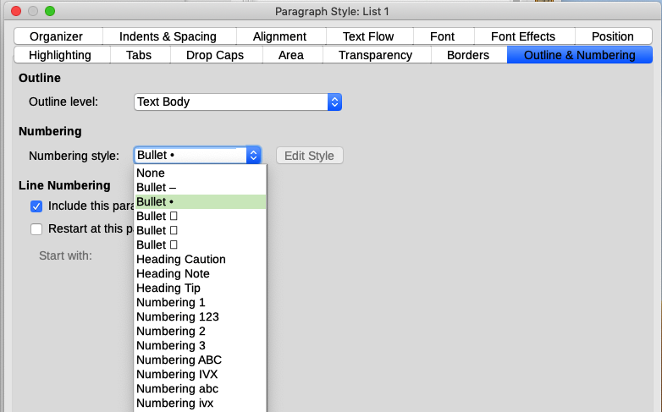Figure 1: Assigning a list style to a paragraph style

Creating nested lists
With paragraph styles, you can easily create nested lists, in which list items have subpoints under them, as in an outline. This requires specifying the settings for the additional levels. To do this, right click on the list style (not the paragraph style), select Modify, and specify how each layer will be labeled, using the Numbering Style tab. Also specify the position and spacing for each level on the Position tab. Refer to the Writer Guide for details.
Once you have set up nested lists, you can readily change the hierarchy of an item. To demote an item one level, position the cursor at the beginning of the line (after the bullet or number) and press the Tab key. To promote an item one level, press Shift+Tab.

Creating lists with direct formatting

Creating bulleted and numbered lists
Bullets and numbers can be manually applied in three basic ways:
- Use AutoCorrect to autoformat text, as described above
- Use the Toggle Bulleted List and Toggle Numbered List buttons on the Formatting toolbar
- Use the Paragraph panel of the Sidebar’s Properties deck
Bullets and numbering can be applied to already selected text or they can be applied as you type.
- Tip
Bullets and numbering applied in these ways cannot be removed with Format > Clear Direct Formatting on the Menu bar, or with the Clear Direct Formatting icon on the Formatting toolbar, or by using Ctrl+M. Rather, they are turned off or removed from selected text by toggling the relevant buttons on the Formatting toolbar, or on the Sidebar’s Properties deck.

Creating nested lists
Use the buttons on the Bullets and Numbering toolbar to move items up or down the list, create sub-points, change the style of bullets, and access the Bullets and Numbering dialog, which contains more detailed controls. Use View > Toolbars > Bullets and Numbering to see the toolbar.
- Note
If numbering or bullets are being applied automatically in a way that you find inappropriate, you can switch them off temporarily by unchecking Tools > AutoCorrect > While Typing.
The Toggle Bulleted List and Toggle Numbered List buttons on the Sidebar’s Properties deck can also be used to create nested lists. Click the down arrow next to the relevant button, then click More Bullets/Numbering to access the Bullets and Numbering dialog. However, the Sidebar does not include tools for promoting and demoting items in the list, as found on the Bullets and Numbering toolbar.

Setting tab stops and indents
The horizontal ruler shows the tab stops. Any tab stops that you have defined will overwrite the default tab stops. Tab settings affect indentation of full paragraphs (using the Increase Indent and Decrease Indent buttons on the Formatting toolbar) as well as indentation of parts of a paragraph (by pressing the Tab key on the keyboard).
Using the default tab spacing can cause formatting problems if you share documents with other people. If you use the default tab spacing and then send the document to someone else who has chosen a different default tab spacing, tabbed material will change to use the other person’s settings. Instead of using the defaults, define your own tab settings, as described in this section.
To define indents and tab settings for one or more selected paragraphs, right-click and choose Paragraph > Paragraph. On the Paragraph dialog, go to the Tabs tab.
A better strategy is to define tabs for the paragraph style. This is done on the Tabs tab of the Paragraph Style dialog.
- Tip
Using tabs to space out material on a page is not recommended. Depending on what you are trying to accomplish, a table or frame might be a better choice.

Changing the default tab stop interval
- Caution
Any changes to the default tab setting will affect the existing default tab stops in any document you open afterward, as well as tab stops you insert after making the change.
To set the spacing of default tab stop intervals, go to Tools > Options > LibreOffice Writer > General.
Figure 2: Selecting a default tab stop interval

Changing measurement units for tab stops and rulers
Change the measurement unit for rulers in the current document by right-clicking on the ruler to open a list of units. Click on one of them to change the ruler to that unit. The selected setting applies only to that ruler.
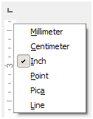Figure 3: Changing the measurement unit for a ruler

Hyphenating words
Hyphenate words at the end of a line in two ways: let Writer do it automatically (using its hyphenation dictionaries), or insert conditional hyphens manually for specific words.

Automatic hyphenation using styles
To turn automatic hyphenation of words on or off:
- On the Styles deck in the Sidebar, go to Paragraph Styles, right-click on Default Style (or another style you want to use) and select Modify.
- On the Paragraph Style dialog (Figure 4), go to the Text Flow tab.
- Under Hyphenation, select or deselect the Automatically option. When automatic hyphenation is on, you can also set the criteria for when it should occur. Click OK to save.
- Note
Turning on hyphenation for the Default Style paragraph style affects all other paragraph styles that are based on Default Style. You can individually change other styles so that hyphenation is not active; for example, you might not want headings to be hyphenated.
Any styles not based on Default Style are not affected. See Chapter 3, Styles and Templates, for more about styles based on styles other than Default Style.
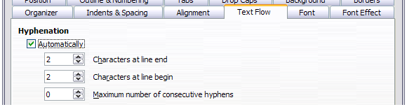Figure 4: Turning on automatic hyphenation in a paragraph style

Setting hyphenation with Writing Aids
You can also set hyphenation options through Tools > Options > Language Settings > Writing Aids. In Options, near the bottom of the dialog, scroll down to find the hyphenation settings.
Figure 5: Setting hyphenation options
To change the minimum number of characters for hyphenation, or the minimum number of characters before or after a line break, select the item, and then click the Edit button in the Options section.
- Note
Hyphenation options set on the Writing Aids dialog are effective only if hyphenation is turned on through paragraph styles.

Manual hyphenation
Manually hyphenate words when you want only a specific word hyphenated at the end of a line. Do not use a normal hyphen, which will remain visible even if the word is no longer at the end of a line (when you add or delete text, or change margins or font size). Instead, use a conditional hyphen, which is visible only when required.
To insert a conditional hyphen inside a word, click where you want the hyphen to appear (when needed) and press Ctrl+hyphen or use Insert > Formatting Mark > Insert soft Hyphen. When the word is at the end of the line it will be hyphenated at this position, even if automatic hyphenation for this paragraph is switched off.

Formatting pages
Every page in Writer is based on a page style. Page styles define basic layout, including page size, margins, headers and footers, borders, backgrounds, and so on. Changes to these settings automatically change the page style. This means that, in contrast to paragraph styles, these settings cannot be used to directly format individual pages.
As with other styles, Writer comes with a number of page styles. You can modify these styles or create new ones. The Default Style page style is used when no other page style has been specified.
In addition to page styles, several features enable you to further control page layouts, including columns, frames, tables, and sections. For more information, see Chapters 5 (Formatting Pages: Basics) and 6 (Formatting Pages: Advanced) in the Writer Guide.
- Tip
Page layout is usually easier if you show text, object, table, and section boundaries in Tools > Options > LibreOffice > Application Colors, and paragraph ends, tabs, breaks, and other items in Tools > Options > LibreOffice Writer > Formatting Aids.

Creating headers and footers
A header is an area that appears at the top of a page above the margin. A footer appears at the bottom of the page below the margin. Information such as a page number is placed in the header or footer of a page style. That information is then displayed on every page with the same page style (unless the page style specifies separate settings for the first page or for left and right pages).

Inserting a header or footer
You can insert a header in several ways. Here is the easiest:
- Click above the top margin (or below the bottom margin) to make the Header or Footer marker appear (Figure 6), and then click on the + sign.
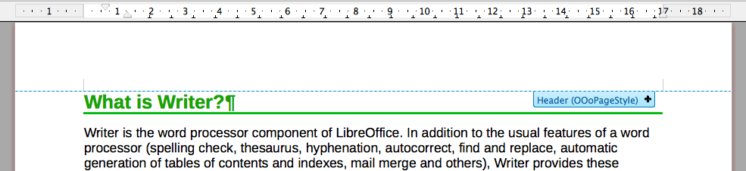Figure 6: Header marker at top of text area
After a header/footer has been created, a down-arrow appears on the marker. Click on this arrow to drop down a menu of choices for working with the header (Figure 7).
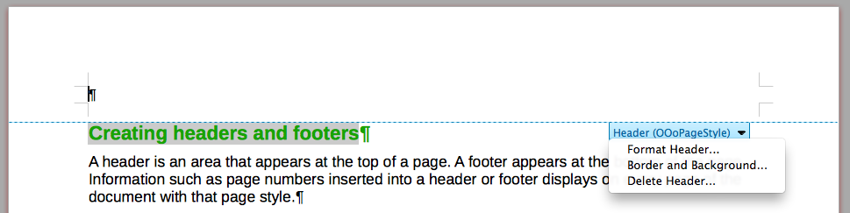Figure 7: Header menu
Alternatively, you can choose Insert > Header and Footer > Header > Default Style (or some other page style, if not Default Style).

Displaying different headers on right and left pages
Page styles can be set up to have the facing left and right pages mirrored or only right (first pages of chapters are often defined to be right-page only) or only left. When you insert a header on a page style set up for mirrored pages or right-and-left pages, you can have the contents of the header be the same on all pages or be different on the right and left pages. For example, you can put the page number on the left-hand edge of the left pages and on the right-hand edge of the right pages, put the document title on the right-hand page only, or make other changes.

Determining header and footer appearance
To format a header (use similar settings for a footer), you can either click on Format Header in the menu shown in Figure 7 or go to Format > Page Style, Header tab. Both methods take you to the same tab on the Page Style dialog.
Here you can specify if headings on the left and right pages should be the same or different. You can also specify whether the first page will have no header or a different header than other pages.
In this dialog, you can also turn the header on or off, set the margins, and set the spacing between the header and document text.
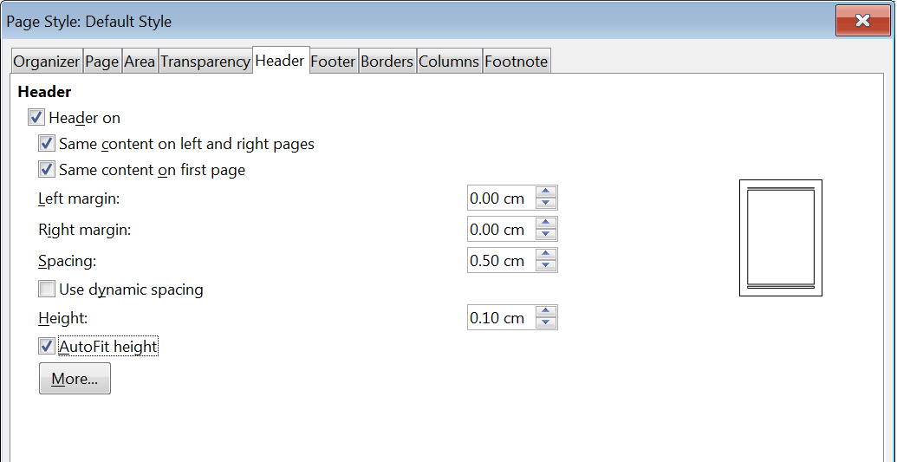Figure 8: Page Style dialog, Header tab

Inserting document title in headers and footers
Information such as a document title is often put into the header or footer. These items are best added as fields. That way, if something (such as the name) changes, the headers and footers are updated automatically. Here is one common way to use fields to insert the document title into the header:
- Choose File > Properties. On the Description tab, type a title for your document, and click the OK button.
- Place the cursor in the header area at the top of the page.
- Choose Insert > Field > Title. The title may appear on a gray background. The background does not show when printed and can be turned off in Tools > Options > LibreOffice > Application Colors.
For more about headers, footers, and fields, see the Writer Guide.

Numbering pages

Displaying the page number
To display page numbers automatically:
- Insert a header or footer as described in Creating headers and footers on page 8.
- Place the cursor in the header or footer where you want the page number to appear and choose Insert > Page Number.
- Change the alignment of the number if you wish (left, right, or center).

Including the total number of pages
To include the total number of pages (as in “page 1 of 12”):
- Type the word “page” and a space, then insert the page number as above.
- Press the space bar once, type the word “of” and a space, then choose Insert > Field > Page Count.
- Note
The Page Count field inserts the total number of pages in the document, as shown on the Statistics tab of the document’s Properties dialog (File > Properties). If you restart page numbering anywhere in the document, then the total page count may not be what you want. See the Writer Guide for more information.

Restarting page numbering
Often you will want to restart the page numbering at 1, for example on the page following a title page or a table of contents. In addition, many documents have the “front matter” (such as the table of contents) numbered with Roman numerals and the main body of the document numbered in Arabic numerals, starting with 1. To restart page numbering:
Place the cursor in the first paragraph of the new page.
- Choose Format > Paragraph.
- On the Text Flow tab of the Paragraph dialog (Figure 4 on page 7), select Insert in the Breaks area, and then select With page style and specify the page style to use.
- Specify the page number to start from, and then click OK.
- Tip
This is also useful for numbering the first page of a document with a page number greater than 1.

Changing page margins
You can change page margins in three ways:
- Using the page rulers, which is quick and easy, but does not allow fine control
- Using the Page Style dialog, which allows to specify margins with precision of up to two decimal places
- Using the Page deck of the Sidebar
- Caution
When you change the margins, the page style is also changed and the changed margins apply to all pages using that style.
To change margins using the rulers:
- The gray sections of the rulers are the margins. Put the mouse cursor over the line between the gray and white sections. The pointer turns into a double-headed arrow and displays the current setting in a tool-tip.
- Hold down the left mouse button and drag the mouse to move the margin.
- Caution
The two small gray triangles on the ruler are used for indenting paragraphs. The double-headed arrows shown in Figure 9 are mouse cursors shown in the correct position for moving the margin markers. Because the triangles and arrows are often in the same place, when changing page margins you need to be careful to move the arrows, not the gray triangles.
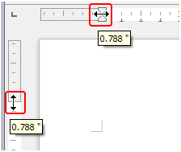Figure 9: Moving the margins
To change margins using the Page Style dialog:
- Right-click anywhere in the text area on the page and select Page Style in the context menu.
- On the Page tab of the dialog, type the required distances in the four boxes in the Margins area.
To change margins using the Page deck of the Sidebar:
- On the Sidebar, open the Page deck.
- On the Format panel, use the Margins drop-down list to select the desired margins. Click the More Options button to open the Page Style dialog where you can enter exact margin distances.

Adding a custom watermark to the page background
To add a watermark to a page background:
- Choose Format > Watermark.
- In the Watermark dialog, type the text and select the font, angle, transparency and color of the watermark. Then click the OK button.
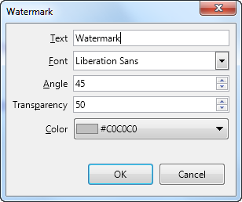Figure 10: The Watermark dialog
- Note
The watermark will automatically become part of the page style where it is inserted and all other pages of the same style will have the watermark. Pages with different or no watermarks need different Page Styles for those pages.

Adding comments to a document
Authors and reviewers often use comments to exchange ideas, ask for suggestions, or mark items needing attention.
You can connect a comment to multiple paragraphs or a single point. To insert a comment, select the text, or place the cursor in the place the comment refers to, and choose Insert > Comment on the menu bar, click the Insert Comment icon on the Standard toolbar, or press Ctrl+Alt+C. The anchor point of the comment is connected by a dotted line to a box on the right-hand side of the page where you can type the text of the comment. A Comments button is also added to the right of the horizontal ruler at the top of the page; you can click this button to toggle the display of the comments.

Formatting comments
At the bottom of the comment, Writer automatically adds the author’s name and a time stamp indicating when the comment was created. If more than one person edits the document, each author is automatically allocated a different background color. Figure 11 shows an example of text with comments from two different authors.
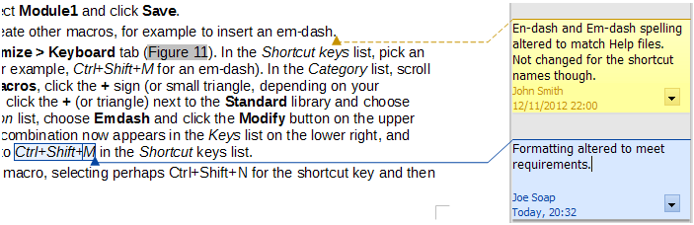Figure 11: Example of comments
Choose Tools > Options > LibreOffice > User Data to provide the name you want to appear in the Author field of comments.
Right-click on a comment to open a context menu where you can delete the current comment, all the comments from the same author, or all the comments in the document. On this menu, you can also reply to a comment, open a dialog to apply some basic formatting to the text, and mark comments as Resolved. These options are also available on a drop-down menu accessed by clicking the down arrow icon at the bottom right of the comment.

Navigating through comments
To navigate from one comment to another, open the sidebar Navigator, expand the Comments section, and click on the comment text to move the cursor to the anchor point of the comment in the document. Click the comment directly to edit it and right-click on the comment to delete it.
You can also navigate through the comments using the keyboard. Use Ctrl+Alt+Page Down to move to the next comment and Ctrl+Alt+Page Up to move to the previous comment.

Printing comments
When a document contains comments, the print dialog has an option for comments to be printed next to the text in the right margin, as they appear on the screen. In that case, the text on each page is scaled down to make space for the comments. The Print dialog also has options for placing comments at the end of the page or at the end of the document, or for printing only the comments.

Using built-in language tools
Writer provides some tools that make work easier if you use more than one language in the same document or if you write documents in various languages. Changing the language for specific text enables you to use the correct dictionaries and rules to check spelling, grammar, and hyphenation. It also applies the localized versions of AutoCorrect replacement options and uses the appropriate thesaurus.

Options for applying languages
- Tip
The language used at the location of the cursor is shown in the Status Bar, next to the page style in use.

Using styles
Languages can be set on the Font tab of the Paragraph Style dialog or the Character Style dialog. See the Writer Guide for information on how to manage the language settings of a style.
- Caution
Be careful when changing a language in character or paragraph styles, as this will change the language for all characters or paragraphs using that style. It may be useful to include the language in the name of the style.
Languages set with direct formatting will override languages set using styles.

Using direct formatting
The language of a whole document can be set by using Tools > Options > Language Settings > Languages. In the Default Languages for Documents section, you can choose the language for all the text that is not explicitly marked as a different language.
Set the language for the whole document, for individual paragraphs, or even for individual words and characters, from Tools > Language on the Menu bar. If the required language is not available in the sub menu, click More. The Tools > Options > Language Settings > Languages menu opens, where you can select the language as described above.
Alternatively, you can set the language for individual paragraphs and characters by selecting text or putting the cursor in a paragraph and changing the language on the Status Bar. There is also an option More, in case the text is not directly available.
- Note
Although these methods are a type of direct formatting, they cannot be cleared by using Format > Clear Direct Formatting on the Menu bar, clicking the Clear Direct Formatting icon on the Formatting toolbar, selecting Clear Direct Formatting from the context menu, or using Ctrl+M.

Preventing text from being checked for spelling
You can set the language for a paragraph or a group of characters as None (Do not check spelling) using any of the methods described above. This option is especially useful for text such as web addresses or programming language snippets that you do not want to check for spelling.

Obtaining resources for additional languages
The spelling checker works only for those languages in the Spelling dialog list that have a dictionary installed. You can install additional dictionaries using Tools > Language > Writing Aids > More Dictionaries Online.

Creating a table of contents
Writer can generate a table of contents from the headings in your document. Before you start, make sure that the headings are styled consistently. For example, you can use the Heading 1 style for chapter titles and the Heading 2 and Heading 3 styles for chapter subheadings. You can also define your own heading styles and set them up in Tools > Chapter Numbering.
Although tables of contents can be customized extensively in Writer, often the default settings are all you need. Creating a quick table of contents is simple:
- When you create your document, use the following paragraph styles for hierarchical heading levels (such as chapter and section headings): Heading 1, Heading 2, Heading 3, and so on. These headings are what will appear in your table of contents.
- Place the cursor where you want the table of contents to appear.
- Choose Insert > Table of Contents and Index > Table of Contents, Index or Bibliography.
- Change nothing in the Table of Contents, Index, or Bibliography dialog (unless you want to change the number of levels shown). Click OK.
If you add or delete text (so that headings move to different pages) or you add, delete, or change headings, you need to update the table of contents. To do this, right-click anywhere within the table of contents and choose Update index in the context menu.
You can customize an existing table of contents at any time. Right-click anywhere in it and choose Edit Index in the context menu. Chapter 15, Tables of Contents, Indexes, Bibliographies, in the Writer Guide describes in detail all the customization options you can choose.

Creating indexes and bibliographies
Indexes and bibliographies work in a similar way to tables of contents. In addition to alphabetical indexes, other types of indexes supplied with Writer include those for illustrations, tables, and objects, and you can even create a user-defined index.
For example, you might want an index containing only the scientific names of species mentioned in the text, and a separate index containing only the common names of species. Before creating some types of indexes, you first need to create index entries in your Writer document. Chapter 15, Tables of Contents, Indexes, Bibliographies, in the Writer Guide describes how to do this.

Using footnotes and endnotes
Footnotes appear at the bottom of the page on which they are referenced. Endnotes are collected at the end of a document.
To work effectively with footnotes and endnotes, you need to:
- Insert footnotes and define their format.
To insert a footnote or an endnote, put the cursor where you want the footnote or endnote marker to appear. Then select Insert > Footnote and Endnote on the Menu bar and choose Footnote or Endnote, or click the Insert Footnote or Insert Endnote button on the Standard toolbar.
A footnote or endnote marker is inserted in the text and, depending on your choice, the cursor is relocated either to the footnote area at the bottom of the page or to the endnote area at the end of the document. Type the footnote or endnote content in this area.
To format the footnotes themselves, click Tools > Footnotes and Endnotes. On the Footnotes/Endnotes Settings dialog, choose settings as required.
See Chapter 3, Working with Text: Advanced, in the Writer Guide for more details.
- Define the location of footnotes on the page, and the color and line styles for separator lines, if the defaults do not meet your needs. These are found on the Footnote tab of the Page Style dialog; see Chapter 5, Formatting Pages: Basics, in the Writer Guide.

Working with images (graphics)
Images in Writer are of these basic types:
- Image files, including photos, drawings, and scanned images
- Diagrams created using LibreOffice’s drawing tools
- Artwork created using clip art or Fontwork
- Charts created using LibreOffice’s Chart facility
See Chapter 11, Images and Graphics, in this book and Chapter 11 in the Writer Guide.

Working with tables of data
Tables are a useful way to organize and present large amounts of information. A well-designed table can often help readers understand better what you are saying. In addition to using tables for text or numbers, you could put other objects, such as pictures, in cells. Writer’s tables can often be used as an alternative to spreadsheets, and they provide limited spreadsheet functions.
To directly insert a table with the default properties, click the Insert Table icon on the Standard toolbar. On the drop-down graphic, choose the size of the table.
To insert a new table using the Insert Table dialog, where you can specify the properties for the table, position the cursor where you want the table to appear, then use any of the following methods to open the dialog:
- Choose Table > Insert Table on the Menu bar.
- Press Ctrl+F12.
- On the Standard toolbar, click the Insert Table icon and select More Options at the bottom of the drop-down graphic.
Writer provides many methods to format tables and the contents of cells. Refer to Chapter 13, Tables of Data, in the Writer Guide.

Printing and exporting to PDF or EPUB
See Chapter 10, Printing, Exporting, E-mailing, and Signing Documents, in this book and Chapter 7 in the Writer Guide for details on previewing pages before printing, selecting print options, printing in black and white on a color printer, printing brochures, and other printing features.
Chapter 10 also covers exporting a Writer document to PDF (Portable Document Format) or EPUB (a popular e-book format).

Using mail merge
Writer provides very useful features to create and print:
- Multiple copies of a document to send to a list of different recipients (form letters)
- Mailing labels
- Envelopes
All these features use data from a Writer table or another registered data source (a spreadsheet or database containing name and address records or other information). Chapter 14 in the Writer Guide describes the merge processes.

Tracking changes to a document
You can use several methods to keep track of changes made to a document.
- Make your changes to a copy of the document (stored in a different folder, or under a different name, or both), then use Writer to combine the two files and show the differences. Choose Edit > Track Changes > Compare Document.
- Save versions that are stored as part of the original file. However, this method can cause problems with documents of non-trivial size or complexity, especially if you save a lot of versions. Avoid this method if you can.
- (Recommended) Use Writer’s change marks (often called “redlines” or “revision marks”) to show where you have added or deleted material, or changed formatting. Choose Edit > Track Changes > Record before starting to edit. Later, you or another person can review and accept or reject each change. Choose Edit > Track Changes > Show. Right-click on an individual change and choose Accept Change or Reject Change in the context menu, or choose Edit > Track Changes > Manage to view the list of changes and accept or reject them. Details are in Chapter 3, Working with Text: Advanced, in the Writer Guide.
- Tip
Not all changes are recorded. For example, changing a tab stop from align left to align right, and changes in formulas (equations) or linked graphics are not recorded. Also, changes of a paragraph’s profile are not recorded.
- Caution
A document with track changes activated but with the changes not shown carries an invisible history of document editing that the current user may not be aware of. Contents deleted or modified can be recovered. While this is a feature, it is also a potential privacy risk.

Using fields
Fields are extremely useful features of Writer. You can use them for data that changes (such as the current date or the total number of pages) and for inserting document properties such as name, author, and date of last update. Fields are the basis of cross-referencing (see below); automatic numbering of figures, tables, headings, and other elements; and a wide range of other functions. See Chapter 17, Fields, in the Writer Guide for more details.

Linking and cross-referencing within a document
If you manually type in cross-references to other parts of a document, those references can easily get out of date if you reorganize the order of topics, add or remove material, or reword a heading. Writer provides two ways to ensure that your references are up to date: hyperlinks and cross-references.
Both methods insert links to other parts of the same document or to an external source, taking you directly to the cross-referenced item. However, they have major differences:
- The text in a hyperlink does not automatically update if you change the text of the linked item (although you can change it manually), but changed text does automatically update in a cross-reference.
- When using a hyperlink, you do not have a choice about the type of content linked to (such as text or page number), but when using a cross-reference, you have several choices, including bookmarks.
- To hyperlink to an object such as a graphic, and have the hyperlink show useful text such as Figure 6, you need to give such an object a useful name (instead of a default name like Graphics6), or use the Hyperlink dialog to modify the visible text. In contrast, cross-references to figures with captions can automatically show useful text, and you have a choice of several variations of the name.
- If you save a Writer document to HTML, hyperlinks remain active but cross-references do not. Both remain active when the document is exported to PDF.

Using hyperlinks
See Chapter 12, Creating HTML Files, for details on creating hyperlinks within a document and to other documents and websites.

Creating and using cross-references
The Cross-references tab of the Fields dialog lists some items, such as headings, bookmarks, figures, tables, or numbered items such as steps in a procedure. You can also create your own reference items; see “Setting References” in Chapter 17, Fields, in the Writer Guide.
To insert a cross-reference:
- In the document, place the cursor where you want the cross-reference to appear.
- If the Fields dialog is not open, click Insert > Cross-reference. On the Cross-references tab (Figure 12), in the Type list, select the type of item to be referenced (for example, Headings or Figure).
- Click on the required item in the Selection list, which shows all the items of the selected type. You can type some characters in the top box under Selection to filter the list in the selection box.
- In the Insert reference to list, select the option needed. The options determine the text inserted for the hyperlink and how it is formatted. The list varies according to the Type chosen. The most commonly used options are Reference (to insert the full text of a heading or caption), Category and Number (to insert a figure number preceded by the word Figure or Table, but without the caption text), Numbering (to insert only the figure or table number, without the word Figure or Table), or Page (to insert the number of the page the referenced text is on). Click Insert.
You can leave this dialog open while you insert many cross-references.
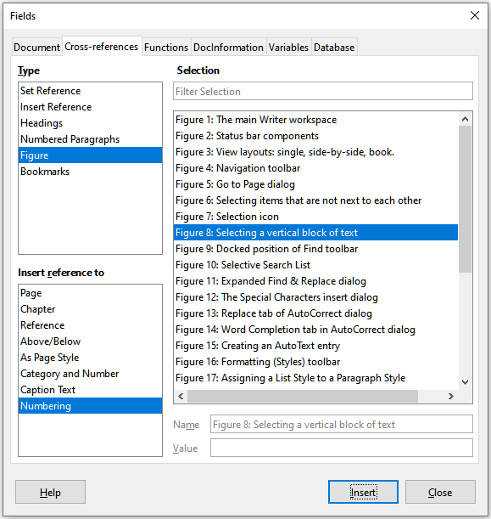Figure 12: The Cross-references tab of the Fields dialog

Using bookmarks
Use bookmarks to rapidly navigate or link to specific locations in a document. They are listed in the Navigator and can be accessed directly from there with a single mouse click. You can cross-reference to bookmarks and create hyperlinks to bookmarks, as described above. To create a bookmark:
- Select the text you want to bookmark. Click Insert > Bookmark.
- On the Insert Bookmark dialog, the larger box lists any previously defined bookmarks. Type a name for this new bookmark in the top box, and then click Insert.

Using master documents
A master document joins separate text documents into one larger document, and unifies the formatting, table of contents, bibliography, index, and other tables or lists. Master documents are typically used for producing long documents such as a book, thesis, or long report. They are especially handy when different people are writing different sections of a document, eliminating the need to continually share the full document. For details on using master documents, see Chapter 16 in the Writer Guide.
You can add master document templates to LibreOffice in the same way as ordinary document templates. Creating a new document based on a master document template creates a master document with the same initial content as the template it is based upon. See Chapter 3, Styles and Templates, for more about creating and using templates.

Classifying document contents
Document classification and security are important for businesses and governments. Where sensitive information is exchanged between users and organizations, the parties agree how such information will be identified and handled. LibreOffice provides standardized means for sensitive information to be identified and protected, using a set of standard fields that can be used to hold sensitive information.
LibreOffice implemented the open standards produced by TSCP (Transglobal Secure Collaboration Participation, Inc.). It contains three BAF (Business Authentication Framework) categories: Intellectual Property, National Security and Export Control. Each category has four BAILS (Business Authorization Identification and Labeling Scheme) levels: Non-Business, General Business, Confidential, and Internal Only.
To enable document classification, open the TSCP bar (View > Toolbars > TSCP Classification). This toolbar contains list boxes to help in selecting the security of the document. LibreOffice then adds custom fields in the document properties (File > Properties, Custom Properties tab) to store the classification policy as document metadata.
To prevent a breach in security policy, contents with a higher classification level cannot be pasted into documents with a lower classification level.

Creating fill-in forms
In a standard text document, such as a report, any text can be edited. By contrast, a form has sections that are not to be edited, and other sections that are designed for the reader to fill in information. For example, a questionnaire has an introduction and questions (which do not change) and spaces for the reader to enter answers.
Forms are used in three ways:
- To create a simple document for the recipient to complete, such as a questionnaire sent out to a group of people who fill it in and return it.
- To enter information directly into a database or data source. Someone taking orders might enter the information for each order into a database using a form.
- To view information held in a database or data source. A librarian might call up information about books.
Writer offers several ways to organize information fields in a form, including check boxes, option buttons, text boxes, pull-down lists, and spinners. Two toolbars are used to create forms: Form Controls and Form Design. See Chapter 18, Forms, in the Writer Guide for more information.

