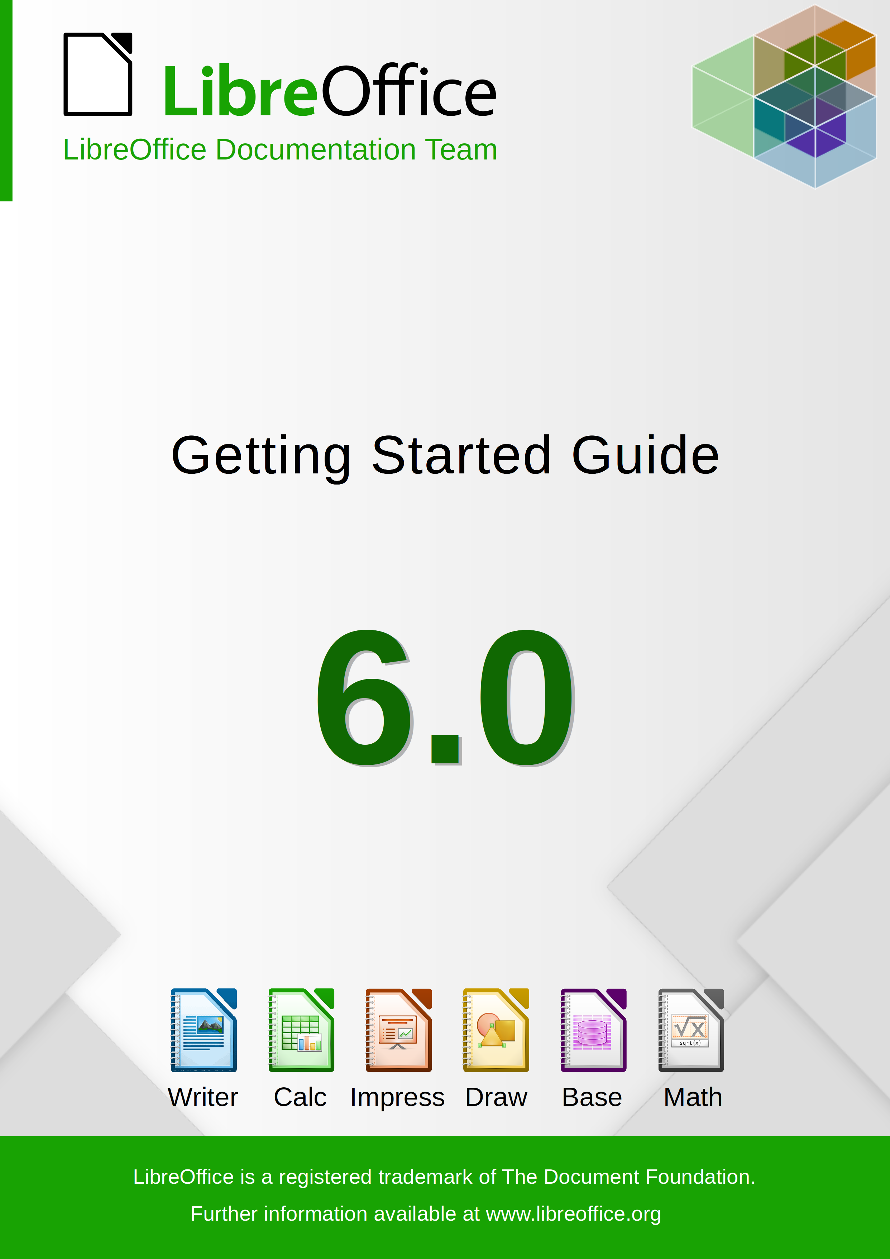

Copyright
This document is Copyright © 2018 by the LibreOffice Documentation Team. Contributors are listed below. You may distribute it and/or modify it under the terms of either the GNU General Public License (http://www.gnu.org/licenses/gpl.html), version 3 or later, or the Creative Commons Attribution License (http://creativecommons.org/licenses/by/4.0/), version 4.0 or later.
All trademarks within this guide belong to their legitimate owners.

Contributors
This book is adapted and updated from Getting Started with OpenOffice.org 3.3.

To this edition
Andrew Jensen | Amanda Labby | Cathy Crumbley
Dan Lewis | Dave Barton | Jean Hollis Weber
Jorge Rodriguez | Olivier Hallot | Paul Figueiredo

To previous editions
Agnes Belzunce | Alan Madden | Alex Thurgood
Alexander Noël Dunne | Andrew Jensen | Andrew Pitonyak
Barbara M. Tobias | Carol Roberts | Chris Bonde
Claire Wood | Dan Lewis | Daniel Carrera
Dave Koelmeyer | David Michel | Gary Schnabl
Hazel Russman | Iain Roberts | Ian Laurenson
Janet M. Swisher | Jean Hollis Weber | Jared Kobos
Jeremy Cartwright | JiHui Choi | Jim Taylor
Joe Sellman | John A Smith | John Kane
Kevin O’Brien | Laurent Duperval | Leo Moons
Linda Worthington | Magnus Adielsson | Martin Fox
Martin Saffron | Michael Kotsarinis | Michel Pinquier
Michele Zarri | Miklos Vajna | Nicole Cairns
Olivier Hallot | Peter Hillier-Brook | Peter Kupfer
Peter Schofield | Rachel Kartch | Regina Henschel
Richard Barnes | Richard Detwiler | Richard Holt
Robert Scott | Ron Faile Jr. | Simon Quigley
Spencer E. Harpe | Stefan A. Keel | Steve Schwettman
Thomas Astleitner | TJ Frazier | Valerii Goncharuk

Feedback
Please direct any comments or suggestions about this document to the Documentation Team’s mailing list: documentation@global.libreoffice.org
- Note
Everything you send to a mailing list, including your email address and any other personal information that is written in the message, is publicly archived and cannot be deleted.

Publication date and software version
Published June 5, 2024. Based on LibreOffice 6.0.


Getting Started Guide

Preface

Who is this book for?
Anyone who wants to get up to speed quickly with LibreOffice will find this Getting Started Guide valuable. You may be new to office software, or you may be familiar with another office suite.

What’s in this book?
This book introduces the main components of LibreOffice:
- Writer (word processing)
- Calc (spreadsheets)
- Impress (presentations)
- Draw (vector graphics)
- Base (database)
- Math (equation editor)
It also covers some of the features common to all components, including setup and customization, styles and templates, macro recording, and printing. For more detail, see the user guides for the individual components.

Where to get more help
This book, the other LibreOffice user guides, the built-in Help system, and user support systems assume that you are familiar with your computer and basic functions such as starting a program, opening and saving files.

Help system
LibreOffice comes with an extensive Help system. This is the first line of support for using LibreOffice. Windows and Linux users can choose to download and install the offline Help for use when not connected to the Internet; the offline Help is installed with the program on macOS.
To display the Help system, press F1 or select LibreOffice Help > LibreOffice Help from the Help menu. If you do not have the offline help installed on your computer and you are connected to the Internet, your default browser will open the online Help pages on the LibreOffice website.
The Help menu includes links to other LibreOffice information and support facilities.
Figure 1: The Help Menu
- Note
The following options shown here prefixed by a ‡ sign are only accessible if your computer is connected to the Internet.
- What's This? For quick tips when a toolbar is visible, place the mouse pointer over any of the icons to see a small box (“tooltip”) with a brief explanation of the icon’s function. For a more detailed explanation, select Help > What's This? and hold the pointer over the icon. In addition, you can choose whether to activate Extended Tips using Tools > Options > LibreOffice > General.
- User Guides ‡ Opens your default browser at the Documentation page of the LibreOffice website https://documentation.libreoffice.org/en/english-documentation/. There you will find copies of User Guides and other useful information.
- Get Help Online ‡ Opens your default browser at the Ask LibreOffice forum of questions and answers from the LibreOffice community https://ask.libreoffice.org/en/questions/.
- Send Feedback ‡ Opens your default browser at the Feedback page of the LibreOffice website https://www.libreoffice.org/get-help/feedback/. From there you can report bugs, suggest new features and communicate with others in the LibreOffice community.
- Restart in Safe Mode Opens a dialog window where you will have the option to restart LibreOffice and reset the software to it's default settings.
- Donate to LibreOffice ‡ Opens your default browser at the Donation page of the LibreOffice website https://donate.libreoffice.org/. There you can choose to make a donation to support LibreOffice.
- License Information outlining the licenses under which LibreOffice is made available.
- Check for Updates ‡ Opens a dialog window and checks the LibreOffice website for updates to your version of the software.
- About LibreOffice Opens a dialog window and displays information about the version of LibreOffice and the operating system you are using. This information will often be requested if you ask the community for help or assistance with the software.

Other free online support
The LibreOffice community not only develops software, but provides free, volunteer-based support. In addition to the Help menu links above, there are other online community support options available, see the table below.
Free LibreOffice support
FAQs | Answers to frequently asked questions  https://wiki.documentfoundation.org/Faq
Mailing lists | Free community support is provided by a network of experienced users  https://www.libreoffice.org/get-help/mailing-lists/
Native language support | The LibreOffice website in various languages  https://www.libreoffice.org/community/nlc/  Mailing lists for native languages  https://wiki.documentfoundation.org/Local_Mailing_Lists  Information about social networking  https://wiki.documentfoundation.org/Website/Web_Sites_services
Accessibility options | Information about available accessibility options https://www.libreoffice.org/get-help/accessibility/
OpenOffice Forum | Another forum that provides support for LibreOffice, among other open source office suites http://forum.openoffice.org/en/forum/

Paid support and training
You can also pay for support through service contracts from a vendor or consulting firm specializing in LibreOffice. For information about certified professional support, see The Document Foundation’s website: https://www.documentfoundation.org/gethelp/support/

What you see may be different

Illustrations
LibreOffice runs on Windows, Linux, and macOS operating systems, each of which has several versions and can be customized by users (fonts, colors, themes, window managers). The illustrations in this guide were taken from a variety of computers and operating systems. Therefore, some illustrations will not look exactly like what you see on your computer display.
Also, some of the dialogs may be different because of the settings selected in LibreOffice. You can either use dialogs from your computer’s operating system or from LibreOffice. The differences affect mainly Open, Save, and Print dialogs. To change which dialogs are used, go to Tools > Options > LibreOffice > General and select or deselect the option Use LibreOffice dialogs.

Icons
The LibreOffice community has created icons for several icon sets: Breeze, Galaxy, High Contrast, Oxygen, Sifr, and Tango. Each user can select a preferred set. The icons in this guide have been taken from a variety of LibreOffice installations that use different sets of icons. The icons for some of the many tools available in LibreOffice may then differ from the ones used in this guide.
To change the icon set used, go to Tools > Options > LibreOffice > View. In the User Interface section, choose from the drop-down lists under Icon size and style.
- Note
Some Linux distributions include LibreOffice as part of the installation and may not include all the icon sets mentioned above. You should be able to download other icon sets from the software repository for your Linux distribution if you wish to use them.

Using LibreOffice on macOS
Some keystrokes and menu items are different on macOS from those used in Windows and Linux. The table below gives some common substitutions for the instructions in this book. For a more detailed list, see the application Help.
Windows or Linux | macOS equivalent | Effect
Tools > Options menu selection | LibreOffice > Preferences | Access setup options
Right-click | Control+click and/or right-click depending on computer setup | Open a context menu
Ctrl (Control) | ⌘ (Command) | Used with other keys
F5 | Shift+⌘+F5 | Open the Navigator
F11 | ⌘+T | Open the sidebar Styles and Formatting deck

What are all these things called?
The terms used in LibreOffice for most parts of the user interface (the parts of the program you see and use, in contrast to the behind-the-scenes code that actually makes it work) are the same as for most other programs.
A dialog is a special type of window. Its purpose is to inform you of something, or request input from you, or both. It provides controls to use to specify how to carry out an action. The technical names for common controls are shown in Figure 2. In most cases the technical terms are not used in this book, but it is useful to know them because the Help and other sources of information often use them.
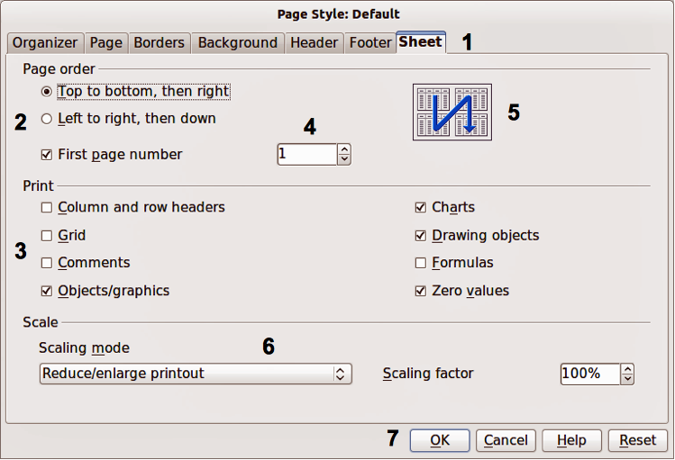Figure 2: Dialog showing common controls
- Tabbed page (not strictly speaking a control).
- Radio buttons (only one can be selected at a time).
- Checkbox (more than one can be selected at a time).
- Spin box (click the up and down arrows to change the number shown in the text box next to it, or type in the text box).
- Thumbnail or preview.
- Drop-down list from which to select an item.
- Push buttons.
In most cases, you can interact only with the dialog (not the document itself) as long as the dialog remains open. When you close the dialog after use (usually, clicking OK or another button saves your changes and closes the dialog), then you can again work with your document.
Some dialogs can be left open as you work, so you can switching back and forth between the dialog and the document. An example of this type is the Find & Replace dialog.

Frequently asked questions
How is LibreOffice licensed?
LibreOffice is distributed under the Open Source Initiative (OSI) approved Mozilla Public License (MPL). See https://www.libreoffice.org/about-us/licenses/
It is based on code from Apache OpenOffice made available under the Apache License 2.0 but also includes software that differs from version to version under a variety of other Open Source licenses. New code is available under LGPL 3.0 and MPL 2.0.
May I distribute LibreOffice to anyone? May I sell it? May I use it in my business?
Yes.
How many computers may I install it on?
As many as you like.
Is LibreOffice available in my language?
LibreOffice has been translated (localized) into over 40 languages, so your language probably is supported. Additionally, there are over 70 spelling, hyphenation, and thesaurus dictionaries available for languages, and dialects that do not have a localized program interface. The dictionaries are available from the LibreOffice website at: www.libreoffice.org.
How can you make it for free?
LibreOffice is developed and maintained by volunteers and has the backing of several organizations.
I am writing a software application. May I use programming code from LibreOffice in my program?
You may, within the parameters set in the MPL and/or LGPL. Read the licenses: http://www.mozilla.org/MPL/2.0/.
Why do I need Java to run LibreOffice? Is it written in Java?
LibreOffice is not written in Java; it is written in the C++ language. Java is one of several languages that can be used to extend the software. The Java JDK/JRE is only required for some features. The most notable one is the HSQLDB relational database engine.
Java is available at no cost. More information and download links to the appropriate edition for your operating system can be found at: https://java.com/en/download/manual.jsp
- Note
If you want to use LibreOffice features that require Java it is important that the correct 32 bit or 64 bit edition matches the installed version of LibreOffice. See the Advanced Options in Chapter 2 of this guide. If you do not want to use Java, you can still use nearly all of the LibreOffice features.
How can I contribute to LibreOffice?
You can help with the development and user support of LibreOffice in many ways, and you do not need to be a programmer. To start, check out this webpage: https://www.libreoffice.org/community/get-involved/
May I distribute the PDF of this book, or print and sell copies?
Yes, as long as you meet the requirements of one of the licenses in the copyright statement at the beginning of this book. You do not have to request special permission. We request that you share with the project some of the profits you make from sales of books, in consideration of all the work we have put into producing them.
Donate to LibreOffice: https://www.libreoffice.org/donate/

What’s new in LibreOffice 6.0?
The LibreOffice 6.0 Release Notes are here: https://wiki.documentfoundation.org/ReleaseNotes/6.0

Getting Started Guide

Chapter 1
Introducing LibreOffice


