Creating a new style from a selection
You can create a new style by copying an existing manual format. This new style applies only to this document; it will not be saved in the template.
- Open the Styles and Formatting window and choose the type of style you want to create.
- In the document, select the item you want to save as a style.
- In the Styles and Formatting window, select on the New Style from Selection icon.
- In the Create Style dialog, type a name for the new style. The list shows the names of existing custom styles of the selected type. Click OK to save the new style.
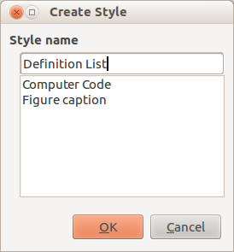
Figure 1: Naming a new style created from a selection

Dragging and dropping to create a style
You can drag and drop a selection into the Styles and Formatting window to create a new style. The element to drag depends upon the LibreOffice application.

