An Enhancement Request

The current problem : Libreoffice Calc Can not merge cells if some cells has been merged

For example, now I have a Calc file it contains some cells (A,B,C):

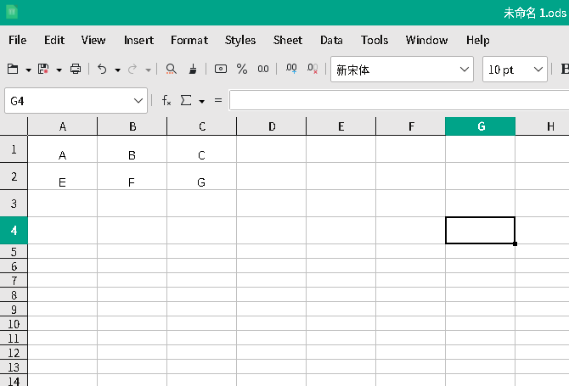

Step 1 :I merge Cell A and Cell B , and them become a new merged cell A .

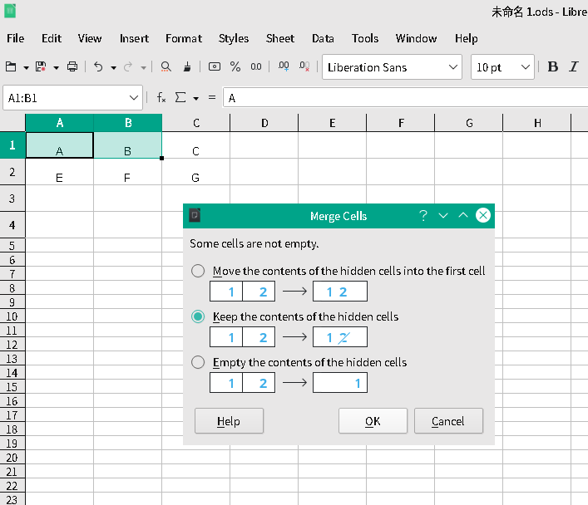

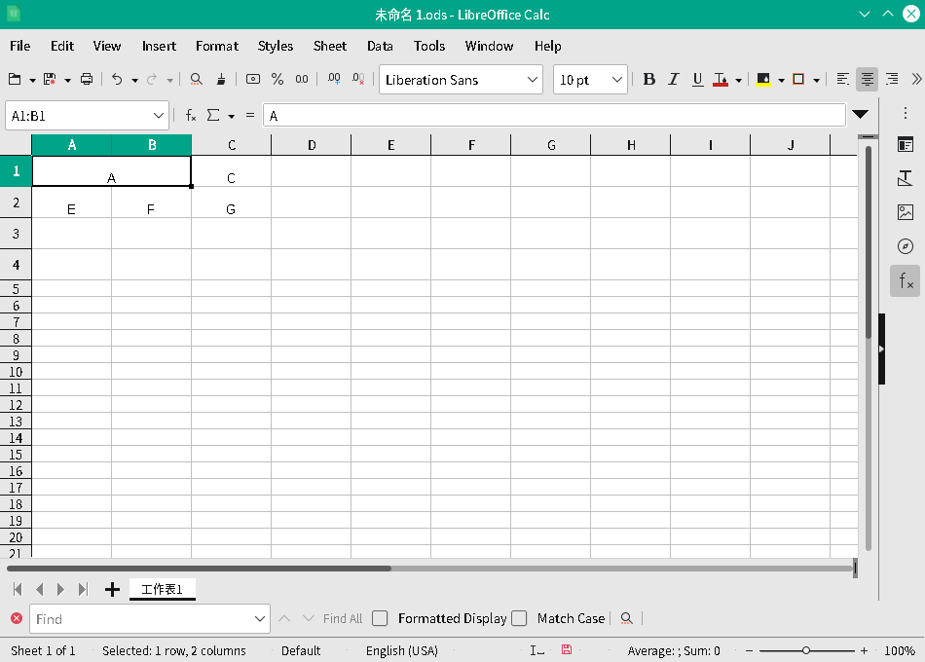

Step 2 :
If I want to merge merged cell A with cell C , it pop up a error dialog box which show the information “ Cell merge not possible if cells already merged ”.

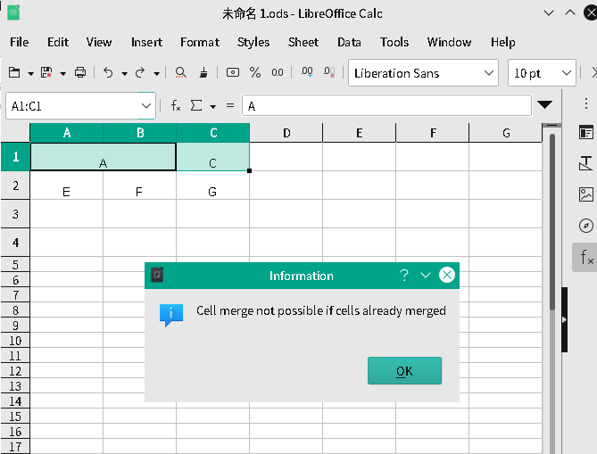

Suggestions for improvement：
I hope Libreoffice Calc can merge cells each oher without limit like as MS Office Excel or WPS , for example :
Cell A merge with B ,then merged Cell A can merge with cell C or other adjacent cell and so on .

