Expected behaviour
I'd like to choose the language "German (Switzerland)" or "Deutsch (Schweiz)".
Actual behaviour
Only "German (Germany)" alone or "Deutsch (Deutschland)" alone is available. Funny thing though, the swiss variant of "Italian" is available.

Lorem test Lorem again test Lorem 3rd time Lorem for Ignore All

What’s going on?
Was ist?

What is in this book?
This book introduces the main components of LibreOffice:
- Writer (word processing)
- Calc (spreadsheets)
- Impress (presentations)
- Draw (vector graphics)
- Base (database)
- Math (equation editor)
It also covers some of the features common to all components, including setup and customization, styles and templates, macro recording, and printing. For more detail, see the user guides for the individual components.
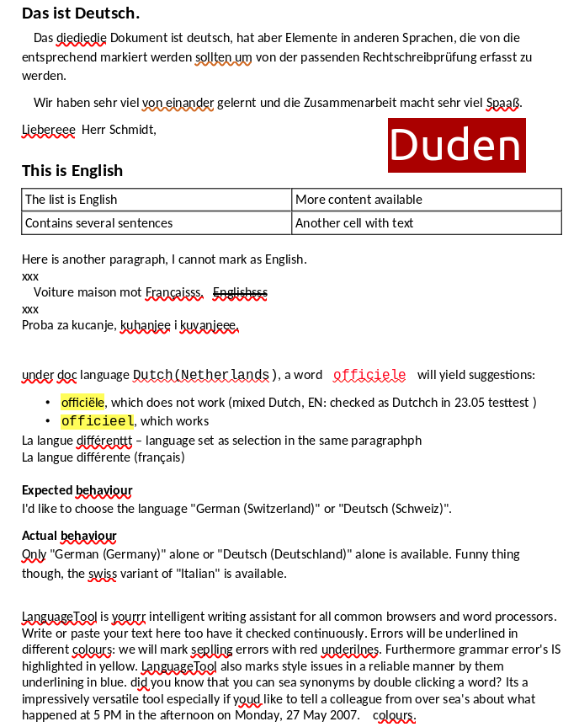

Online LT in 24.2 before port:

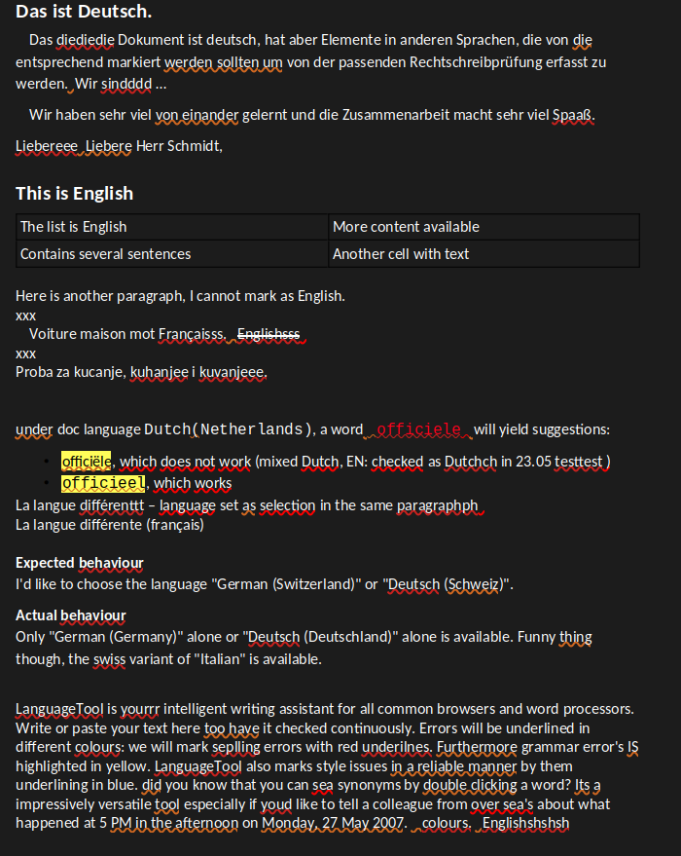

Online LT in 24.2 after LT port:


