Your Book Title
Your Very Long Keyword-rich Subtitle.
Edition: 1.0
Book 1 of Your Series Name
by
Your Author Name

Copyright © Year Your Author Name
All rights reserved. No part of this publication may be reproduced, distributed, or transmitted in any form or by any means, including photocopying, recording, or other electronic or mechanical methods, without the prior written permission of the author/publisher, except in the case of brief quotations embodied in critical reviews and certain other noncommercial uses permitted by copyright law.
See Appendix A: Legal and Credits for contact and other information.
ISBN.

File: DWS-BookTemp.odt
Last Modified: 2020-05-03 08:51 AM by David Snow ― 4316 words 30 pages.

Your Book Description
This is the single most important page of text within your book! Only the cover is a more important page. This page should become the book description at Amazon KDP and other online book distributors. It should be written in third person, so that it appears to have been written by an unbiased expert. Amazon has a 4000 character or about 700-word limit and allow for simple HTML formatting such as bold, italics, h2, etc.
Since only the first few lines are visible online before you have to click Read More make the text really grab the reader’s attention.

Publishing Metadata
- Categories:
- Keywords:
When you publish your book, you can leave this page in or just use the contents for marketing such as KDP’s Author Page

Dedication
To my loving wife and partner who supported me and put up with me while I wrote this book.

Table of Contents
Your Book Description v
Publishing Metadata v
Dedication vii
Table of Contents ix
Introduction xi
Conventions Used in this Book xii
Your First Chapter Title 13
DWS Novel Styles 15
Copying and Pasting 15
DWS More Advanced Styles 17
Microsoft Word Compatibility 17
Block Quotes 17
Direct Formatting is Bad 17
Hyperlinks 18
Scene Break [Use Heading 9] 18
Other Heading Levels [Heading 2] 19
Bullet Lists [Heading 3] 19
Numbered Lists 19
Images 20
Screen Captures 20
Simple Tables 20
Code 20
Typographic characters 22
Accented Characters 23
Fonts 23
Font Character Test 23
Changing Fonts in printed books 24
Footnotes and Endnotes 24
Bookmarks and Cross References 24
Page Styles 24
Keyboard Shortcuts 25
Other Files 25
About The Author 27
Appendix A: Legal and Credits 29
Copyright © Year? Your Author Name 29
Contact Information 29
Credits, Attributions: 29

Introduction
My goals in developing this template were:
- Have a writing environment that my work-in-progress looked professional. That had a reasonable spelling and grammar checker, thesaurus and similar tools built in. I wanted to easily be able to adjust the styles of the few body-text styles so that I could have ragged-right, no hyphenation and slightly increased line spacing during the writing process and quickly adjust them to a more professional look at production.
- I could produce with just a few clicks: a print-ready PDF and an EPUB to be able to frequently check how my work-in-progress would look when complete. I wanted a rather complete sample text that could serve as an example for the more complex items like; images with captions, multilevel lists, bibliography etc. This became my Common Styles chapters in the template.
- Have a check-list of the project setup steps and post-production steps so that I could reproduce this effort for multiple books. I also wanted it to be simple enough that my technology-challenged wife could use it with minimal help.
- I wanted an easy method to create the PDF and JPEG art for covers for both an eBook and a printed paperback version. This would likely become a PSD template, LibreOffice Calc spreadsheet, and a set of instructions.
The result of this effort is.
- A LibreOffice Writer template containing a style sheet and sample content for a book.
- A step-by-step set of instructions for:
  - Setting up the environment on Mac or Windows PC.
  - Starting a book project and producing a PDF file for viewing and printing on US letter (8.5″ x 11″) paper and an EPUB for viewing.
  - Creating both the JPEG cover for an eBook and a PDF file for the front cover, back cover and spine of a paperback book.
  - Final post processing for paperback printing.
  - Producing an EPUB file and MOBI file (Amazon KDP) for viewing and submitting to book distributors.
- Last but not least, an eBook and paperback book made from the above process documenting the process steps above.
Software Used:
- LibreOffice Writer is the word processor that I used to enter and edit the text. It also produced the print-ready PDF file for the paperback book.
- Jutoh is a LibreOffice Writer / MS Word to EPUB/MOBI tool for formatting eBooks.
- Cover Design was done with Affinity Photo but any image editing program that can edit layers in PSD files could work.

Conventions Used in this Book
- Application menu commands are shown like:
File | Templates | Save As Note that if the first part of a command brings up a window that has tabs, I may show the name of the tab in the command.
- Keyboard shortcuts a rarely shown, since they are different on Windows and macOS. When they are shown they are shown like:
Ctrl/Cmd+S for Control+S on Windows and Command+S on macOS.
You can see LibreOffice Writer’s keyboards shortcuts for your operating system via: Tools | Customize… | Keyboard. I have a table of the very few shortcuts that I use in the DWS Common Styles chapter.
- LibreOffice Writer’s style names are shown inside of square brackets like [Normal First Indent]
- Warnings are shown in bold red like: “Warning: Don’t eat Tide bods.”
- Tips are shown in bold blue like: “Tip: Backup your work offsite daily!”

Your First Chapter Title
Add your content here, but do not delete the next chapter (DWS Novel Styles) until you have written and formatted your content using named styles. By leaving that chapter you can set the styles panel to “Applied Styles” and have a much smaller list to view.

DWS Novel Styles
Common Styles [Chapter Subtitle] “optional”
Chapter names are styled as [Heading 1]. [Heading 1] always starts on an odd-numbered, right-hand recto page. The first paragraph after either a [Heading 1] or [Chapter Subtitle] is styled as [Normal] and has no indent.
The next paragraphs are all styled as [Normal First Indent] and have indents on the first line.
[Quote Body] is indented both left and right, smaller type size and italics]
—[Quote Attribution] is right-aligned
Character styles: [Emphasis], [Strong], [Strong Emphasis].
Scene Breaks are styled as [Heading 9], this allows them to appear in the navigator window.

* * *
The small section above show the commonly used styles when writing a novel. The next chapter has additional styles that might be needed for a technical book.

Copying and Pasting
Copy-and-pasting text between two LibreOffice documents created from different style templates can be exciting. It only gets more exciting when the source is Microsoft Word or a web browser. “Copy” is also copying style information as well as the text. You need to think what you really want:
- Do you want to retain the source document’s style and if necessary add a new named style to your destination document.
- Do you want the result styled like the destination document? Same indents, font, type size, etc.
- What do you want to happen to any direct formatting or character styles within the copied text? Footnotes, Comments, Bibliography References, etc. need to be considered.
LibreOffice only gives you a couple of paste options: Paste, Paste Special, and Paste Unformatted Text.
- Just plain Paste will retain the source’s styles including bold and italics.
- Paste Special uses the destination’s named style.
- Paste Unformatted Text will only copy the text in the destination’s style. You may need to manually add any bold italics etc.
The best idea is to guess which paste you want, try it and if necessary undo and try another. For small operations this is easy, but when moving many pages it is difficult to see all potential issues.

DWS More Advanced Styles
Optional Chapter Subtitle
This is the first paragraph of a chapter [Normal. Normally the first paragraph chapter headings and scene breaks aren’t indented. In novels the typical paragraph is indented about .2″ or about three character spaces. In novels there isn’t usually any extra space between the paragraphs. This method of showing the paragraph boundaries was chosen because novels have dialog and many short paragraphs. Extra white space costs money when publishing a printed book. Technical books usually have much longer paragraphs and usually have no indent for the paragraphs but do have extra space (about on blank line) between paragraphs.
This is the second paragraph it is indented. [Normal First Indent].
This Paragraph is styled as [Drop Cap]. Drop Cap paragraphs must be styled manually, can’t begin with a quote symbol, and must be at lease two lines long.
Personally I don’t like drop caps and don’t use them.

Microsoft Word Compatibility
I have included MS Word’s [Normal] paragraph style as well as its [Emphasis], [Strong] and [Strong Emphasis] character styles for compatibility.

Block Quotes
A line of sample text. The quick brown fox jumped over the lazy dogs back.
This is a [Quote Body]. A line of sample text. The quick brown fox jumped over the lazy dogs back. A line of sample text. The quick brown fox jumped over the lazy dogs back. A line of sample text. The quick brown fox jumped over the lazy dogs back.
—This is optional [Quote Attribution].
A line of sample text. The quick brown fox jumped over the lazy dogs back.
Notes:
- Chapter Titles are in the [Heading 1] style.
- In this document style names are enclosed in [Body Test First Indent] brackets.
- LibreOffice Writer Guide 6.0[LOW60] is a great source of information on the word process program. It is available in both PDF and ODT formats.
- Creating Great Ebooks with Jutoh[JutohBook] is very good documentation on Jutoh. It is available in JUTOH, EPUB, MOBI, and PDF formats.

Direct Formatting is Bad
Direct Formatting is when you use the B, I, U, Align Left, Align Center, Align-Right, Justify and other buttons on the toolbar for formatting characters within a paragraph. You are better off using named styles. You should create or adjust named styles to have these attributes if you need them.
Bold, Italic, Bold Italic, Underline, SuperScript¹, SubScript₂, All Caps [TT], Small Caps [Tt], StrikeThru, Centered and selecting a font and type size from the toolbar are direct formatting.
See this YouTube video (tinyurl.com/y9hmxcje) about the issues with direct formatting. In the video MS Word is used, but the issues are the same for any word processor.
I have included three named character styles; Emphasis, Strong and Strong Emphasis. MS Word uses these names. For further compatibility with MS Word I have included a [Normal] style and made it The default for several things.

Hyperlinks
Internet links (hyperlinks) in paperback books and eBooks behave very differently. You can actually click on the link in an eBook and go to the site that the link points to. Paperbacks not so much. When using a common source for both types of books, I recommend handling links the following ways:
- For well-known sites like Google, Amazon, Microsoft it is ok just to use the name with or without the link because the reader should easily be able to find it. But be consistent!
- For less well known sites like LibreOffice (www.libreoffice.org/), I recommend that you show the hyperlink as I have here. Note that I have left off the “http://” since it is redundant. In the paperback the reader can read the link and use it on their browser. In an eBook it is clickable.
- For very long links like those that might list a product on Amazon, I recommend that you first shorten the URL using TinyURL (https://tinyurl.com/).

Scene Break [Use Heading 9]
Novels often have scene breaks. These can be just a blank line, or can be very fancy graphics called a dingus.

* * *
I prefer a simple line with 3 * characters centered. This is easy to see, you can be sure that the eReader font includes the character and you don’t have to mess with the problems that come with JPEG graphics with backgrounds. You can easily adjust the vertical space before and after the paragraph to your taste.
Other scene break ideas are: ~ ~ ~ or § § § or ←+→ or ∞∞∞ or +++ or ⁂ The more exotic the characters that you choose, the less likely that the eReader font will include them.
Characters work better than JPEG images because when the reader chooses sepia or blank background on the eReader the white background of the JPEG images shows up
I have assigned [Heading 9] the characteristics for use as a Scene Break. If you use the Navigator to move around your novel, then these breaks will show up there and you can easily jump to the third scene in chapter 2.

Other Heading Levels [Heading 2]
A line of sample text. The quick brown fox jumped over the lazy dogs back.

Bullet Lists [Heading 3]
LibreOffice likes to force [Normal] style in lists table and other places. I have styled [Normal] to have no first line indent so that it will work in those places. Warning: You should check what style you are using when you exit: lists, tables, quotes, etc. to make sure that you are back to [Normal First Indent].
LibreOffice default list styles use tabs to indent. Tabs don’t work well in eBooks. As a result I have created to new styles that don’t use tabs: [DWS Bullet List] and [DWS Numbered List]. Use these styles to avoid tabs.
A line of sample text. The quick brown fox jumped over the lazy dogs back.
- One [DWS Bullet List]
- Two
  - Two a
    - Two 3rd level
  - Two b
- Three
A line of sample text. The quick brown fox jumped over the lazy dogs back.

[Heading 4]
A line of sample text. The quick brown fox jumped over the lazy dogs back.

Numbered Lists
A line of sample text. The quick brown fox jumped over the lazy dogs back.
- One [DWS Numbered List]
  - One a
    - One roman
      - One ROMAN
- Two
- Three
A line of sample text. The quick brown fox jumped over the lazy dogs back.
Warning: If the list starts with a number other than “1”, select the contents of the list, right-click and select “Bullets and Numbering” then “Restart Numbering.” It seems that the paragraph after a list is [Normal] style. Be sure to check and adjust as required.

Images
Ebooks require images to be in JPEG format. Your should look at any color images and check them out in blank-and-white to see what the will look like in a paperback version or on Amazon’s Paperwhite eReaders. Shades of red and blue can both look the same in black and white. Most screen captures are about 100 dots per inch. Paperback book distributers want at least 300 DPI because 100 DPI can look fuzzy.
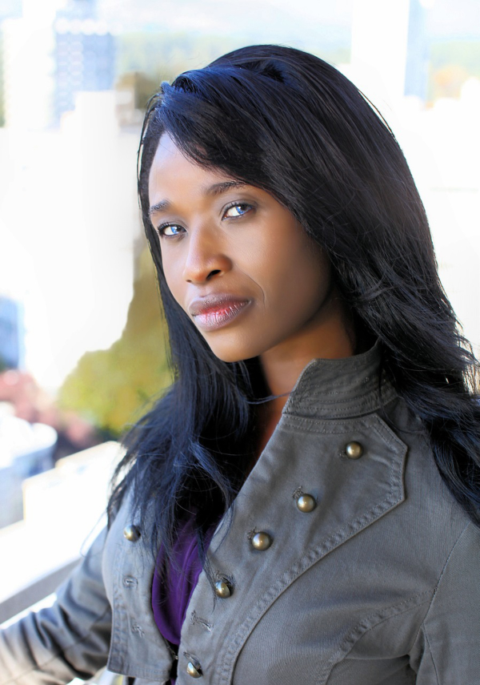
I find that images turn out better if on the image properties I scale them to 85% of the paragraph width.
To wrap text around a narrow photo you have to mess with the image properties and set the wrap to “after”. Since eReaders can be very small, for most images I don’t wrap the text and set the image properties on the “crop” tab to scale the image to 90% of the paragraph width, then “center” the image.

Screen Captures
If your book is going to have any screen captures, you should take them on a system with the highest resolution display possible. My wife’s iMac with a 4K Retina display works much better than my MacBook Pro with only an HD display. This will increase the number of dots per inch.

Simple Tables
A line of sample text. The quick brown fox jumped over the lazy dogs back.
Name | Gender | Age
Dave | Male | 75
Dotti | Female | 73
Table 1: Simple Table with Caption.
A line of sample text. The quick brown fox jumped over the lazy dogs back.
If you need a complex table I suggest that you create it with LibreOffice’s Calc, or Excel and make a JPEG image to insert.

Code
The code below is of [Code] style.
A line of sample text. The quick brown fox jumped over the lazy dogs back.
#include <stdio.h>
// This section is formatted as “Code”
int main() {
// printf() displays the string inside quotation
printf("Hello, World!");
return 0;
}
A line of sample text. The quick brown fox jumped over the lazy dogs back.

Typographic characters
Name |  | Unicode | Use
Non-breaking Space |  | 00A0 | Places where you don’t want to allow a line break.
Figure Dash | ‒ | 2012 | Same width as the numbers. Ages 3‒5
Hyphen | ‐ | 2010 | A hyphen connects two words, or as minus sign.
Non-Breaking Hyphen | - | 2011 | A hyphen where you don’t want to allow hyphenation at the end of line.
En Dash | – | 2013 | Is used in a range. Letters A–F.
Em Dash | — | 2014 | Used where you might use parentheses.
Horizontal Bar | ― | 2015
Ellipses | … | 2026 | Something is left out.
Prime | ʹ | 02B9 | Feet or Minutes symbol. Not curly quote.
Double Prime | ʺ | 02BA | Inches or Seconds. Not curly quote.
Degree | ° | 00B0 | The degree symbol.
Left Double Angle | « | 00AB | Spanish quotes
Right Double Angle | » | 00BB | Spanish quotes
Inverted Question Mark | ¿ | 00BF | Spanish leading question mark
Inverted Explanation Mark | ¡ | 00A1 | Spanish leading explanation mark
Asterism | ⁂ | 2042 | A dingus. Used as scene break.
 |  |  | None of these symbols should have a space either before or after. They would all be bad places to hyphenate a line.
Table 2: Common Typographic Symbols
See Typewolf (tinyurl.com/y9wrs62n) for usage of typographic characters.

Accented Characters
I assume that if you are writing a book that includes lots of words with accents that you know how to type them on your computer. English speakers like myself still need to be able to type some accented characters and the Symbols button on the toolbar is great for occasional use.
My 4ʹ11ʺ fiancée had a tête-à-tête with the naïve maître d'hôtel about 200℃ jalapeños at the €5.00 smörgåsbord. It was déjà vu all over again. ¿Qué pasa?.

Fonts
In a printed book, you can use most of the fonts that came with either your operating system or with LibreOffice without legal issues. In an eBook the font selection is up to the reader not you. It is possible to embed a font but few eReaders actually support this. If you embed a font then you must have a special font license. SIL is an example of a very open and free license that allows you to embed fonts.

Font Character Test
Current Font ― Regular, Bold, Italic, Bold-Italic, X¹, X₂
ABCDEFGHIJKLMNOPQRSTUVWXYZ1234567890$€£¥¢
abcdefghijklmnopqrstuvwxyz1234567890$€£¥¢
‘?’“!”(%)[#]{@}/&,:;_. ′ ″ ` ^ | ⁂ (Common punctuation)
_ - – — … (underscore, hyphen, en dash, em dash & elipses)
Xx®©™ X^~§¶¿x?¡x!«x»‹x› (Xx’s to show heights) • bullet
X<-+÷/×=≈>°∞±≤≥∂∑∏∫√ΜΩ∆ƒß•·X←↑→↓(Math)
ÀÁÂÃÄÅ ÇĆČ Đ ÈÉÊËĒ ÌÍÎÏ Ñ ÒÓÔÕÖØ Š ÙÚÛÜ ÝÞŸ Ž Æ Œ
àáâãäå çćč đ èéêëē ìíîï ñ òóôõöø š ùúûü ýþÿ ž æ œ
First.Last@MyMail.com (Email address test)
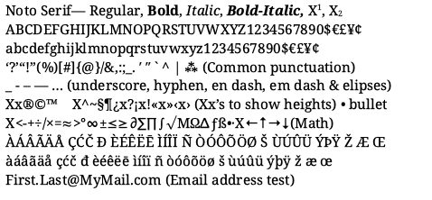Figure 1: Noto Serif Font Image
Compare the common characters above with those in the image. Note: The Noto Serif font has over three thousand glyphs and includes the most of the characters used in the western world. Missing characters are shown as small rectangular boxes. They look like tofu. The “Noto” font name comes from “no tofu.” The Noto fonts are made by Google and have a SIL license. I quick check of the fonts in the Kindle Previewer show that all of these above character are visible. Warning: I have seen some of the more exotic characters missing in EPUB eReaders..

Changing Fonts in printed books
You can change the font for body text by change the [Normal] and [Normal First Indent] font. Most other body-text-like fonts are inherited from them. For [Heading 1 – 10] you must change each one.

Footnotes and Endnotes
LibreOffice Writer allows you to have both footnotes and endnotes. Endnotes are always the very last text in the book. I find this problematic. I’d like to easily place them at a location of my choosing near the end on the book. In printed books footnotes show up at the bottom of the current page. In eBooks where you don’t have physical pages, footnotes sow up at the end of the chapter. My preference is to use footnotes even though they will look different in the two versions of the book.

Bookmarks and Cross References
Bookmarks are hidden names for a location within a book. There are automatically generated bookmarks for chapters, illustrations, tables etc. Cross References are links to bookmarks.

Page Styles
This template uses several styles. All are set to an 8.5″ x 11″ page-size. The margins are set so that the inner margin is .63″ for the spine, the outer margin is set to .75″, the top and bottom are set to .35″.
The margins should work for any page-size as long as the page-count is less that 400 pages. If you want to shift a smaller page-size you should only have to adjust the page-size on those page styles that show up in Applied Styles. Remember that the number of pages effects the width of the spine of a paperback. This means that you must adjust the artwork to match the number of pages in your paperback.

Keyboard Shortcuts

Other Files

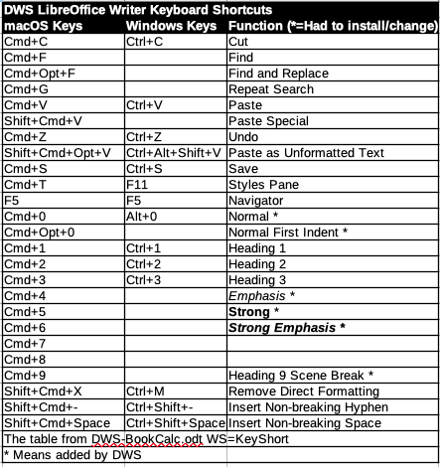Figure 2: My Common Keyboard Shortcuts
Included with this template, are a few Other files.
- DWS-BookTemp.aphoto and DWS-BookTemp.psd These are the artwork for eBook and paperback book covers. The “.aphoto” version is for people using Affinity Photo. The “.psd” version is for people using other image editors.
- TestText.odt—has the first ten chapters of Jane Austin’s Pride and Prejudice. This text is useful when testing page layout and is better than pages of “Lorem Ipsum” text.
- TestFont.odt—is my test of the characters in a font that I care about.
- DWS-Keys-macOS.cfg and DWS-Keys-Windows.cfg—are my LibreOffice Writer keyboard shortcuts for each operating system.
- DWS-BookCals.ods—is a LibreOffice Calc workbook with worksheets that are useful when creating books.
- DWS-Keys-macOS.cfg—is an export of the keyboard shortcuts that I use on macOS.

About The Author
I copy this section from a separate document into each book. It is based on my About The Author page at Amazon and other online book distributors. It should include a little history, and image, a list of other books etc. It is usually written in the third person so it so the reader thinks that someone else wrote it.

Appendix A: Legal and Credits

Copyright © Year? Your Author Name
All rights reserved. No part of this publication may be reproduced, distributed, or transmitted in any form or by any means, including photocopying, recording, or other electronic or mechanical methods, without the prior written permission of the author/publisher, except in the case of brief quotations embodied in critical reviews and certain other noncommercial uses permitted by copyright law.
This is a work of fiction. Names, characters, business, events and incidents are the products of the author’s imagination. Any resemblance to actual persons, living or dead, or actual events is purely coincidental.
Trademarked names appear throughout this book. Rather than use a trademark symbol with every occurrence of a trademarked name, names are used in an editorial fashion, with no intention of infringement of the respective owner’s trademark.
The information in this book is distributed on an “as is” basis, without warranty. Although every precaution has been taken in the preparation of this work, neither the author nor the publisher shall have any liability to any person or entity with respect to any loss or damage caused or alleged to be caused directly or indirectly by the information contained in this book.
Disclosure of Material Connection: Some links/URLs in this document may be “affiliate links.” This means if you follow them and purchase an item, the author may receive an affiliate commission. Regardless, the author only recommends products or services that are personally used and believe will add value to my readers. The author is disclosing this in accordance with the Federal Trade Commission’s 16 CFR, Part 255: “Guides Concerning the Use of Endorsements and Testimonials in Advertising.”

Contact Information
The author may be contacted at YourEmailAddress@gmail.com.

Credits, Attributions:

Appendix B Lists
Most books will not need these tables and should delete them. Other books could have many entries and should make them each no its own page.
Table of Figures
Figure 1: Noto Serif Font Image 23
Figure 2: My Common Keyboard Shortcuts 25

Index of Tables
Table 1: Simple Table with Caption. 20
Table 2: Common Typographic Symbols 22

Bibliography
LOW60: Jean Hollis Weber, LibreOffice Writer Guide 6.0, 2018
JutohBook: Dr. Julian Smart, Creating Great Books with Jutoh, 2011

End Notes

This is a sample footnote. A line of sample text. The quick brown fox jumped over the lazy dogs back. A line of sample text. The quick brown fox jumped over the lazy dogs back.
This is a second footnote. Insert | Footnote and Endnote | Footnote will insert one
This is an End Note

