Bug49328_Form_Subform_Wizard
In the relationships of the database (Tools → Relationships) has been declared a relation betwenn thre tables. The table „Ausleihe“ has two foreign-keys: „Medien_ID“ at the first position in the table“ and „Leser_ID“ at the second position.
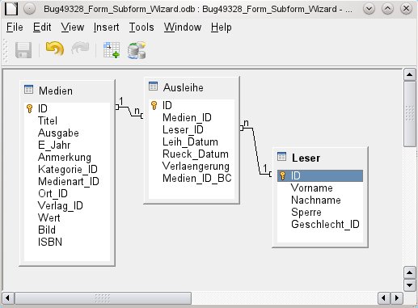Picture 1: Relationship as declared in Tools → Relationship
Start the form-wizard with the table „Leser“.
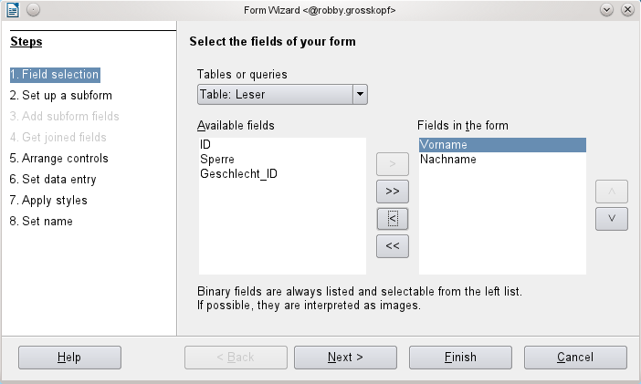
Choose the table „Ausleihe“ as subform. The relation between both tables is choosen automatically.
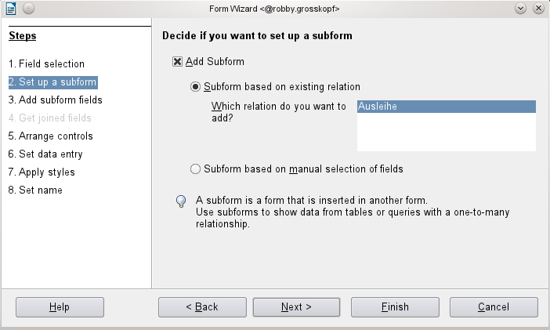
All other steps have nothing to do with the problem. You cold choose "Finish", close the form and reopen it for editing. Have a look at form-properties:
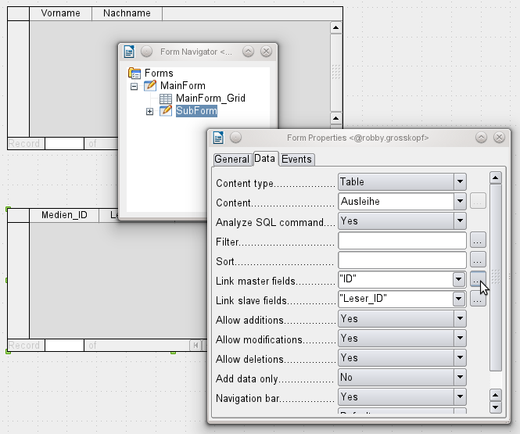Picture 2: You see the mouse-cursor at the dialog "Form Properties". Here you can open the dialog for changing the link between form and subform. There are shown the right linked fields, declared from the form-wizard, which has read it from the relationship.
You see
Link master fields „ID“
Link slave fields „Leser_ID“.
This is the right way. You could choose the „Leser“ and add rows in the „Ausleihe“. „Leser_ID“ is automatically added.
When you haven't used the form-wizard you could chosse the entries for Link fields in a dialog. See the cursor over the three point, which start this dialog.

Picture 3:
This dialog has a button „Suggest“. Press this button. There is suggested „Medien_ID“ from „Ausleihe“ - the wrong value for linking both forms. The table "Medien" doesn't exist in this form.
I tried this also with a copied table of „Ausleihe“ where the field „Medien_ID“ is the last field of the table – it's the same problem.
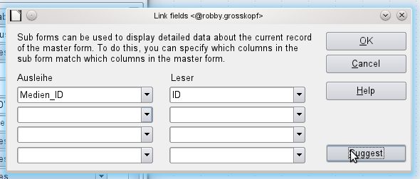Picture 3: Wrong choosen link-fields in the dialog, when pressing the button "Suggest"
I tried it by changing the position in the relationships – same problem.
Then I have deleted the table „Medien“ and the table „Ausleihe“ and created the new. „Medien_ID“ in „Ausleihe“ I positioned at last field. Then it worked.
Wrong suggestion – not declared in relationship. The suggestion seems to be combined by
- time, where the foreign-table („Medien“) has been created
- position of the foreign_key in the table

