First Page of the Source Document:
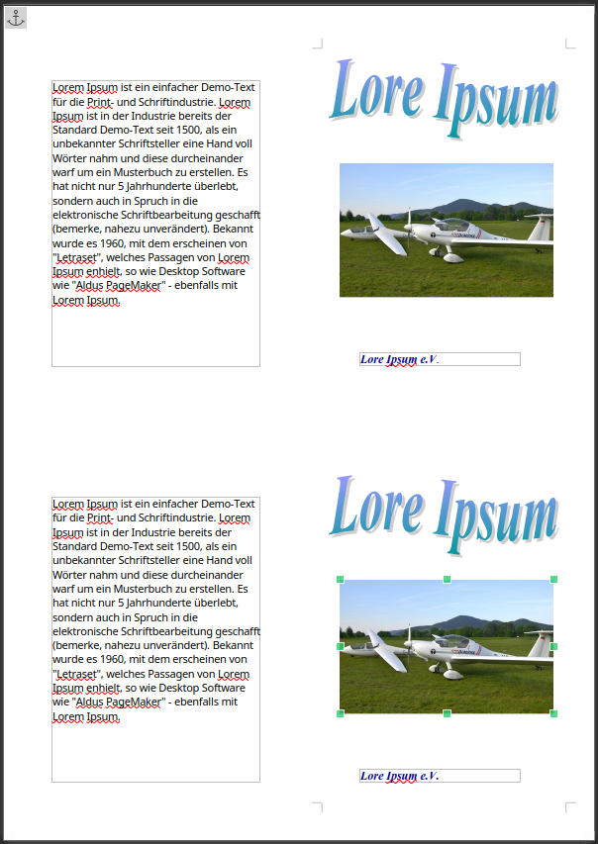

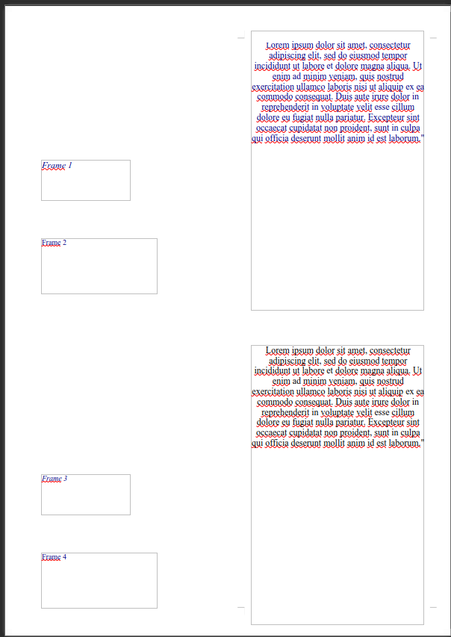
Second Page of the Source Document:

Resultant Page of the „SAVE AS“ .Doc (Word Document)



