Saving document with write-protection
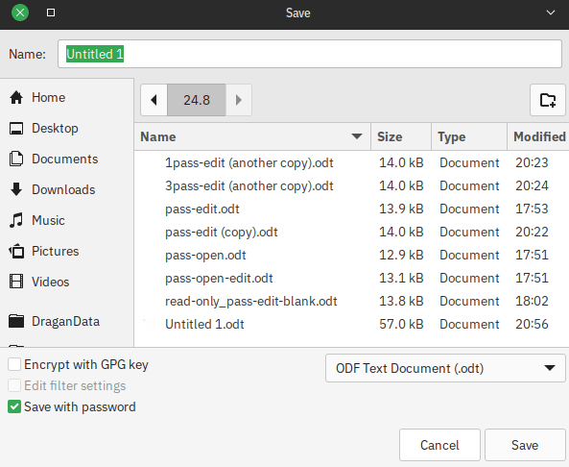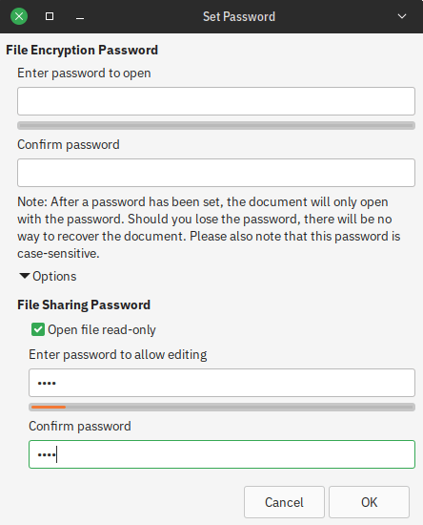
In “File > Properties > Security” it automatically adds: “Open file read-only”.
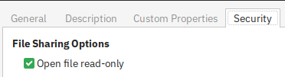

Opening document with write-protection and un-checking “Open file read-only”
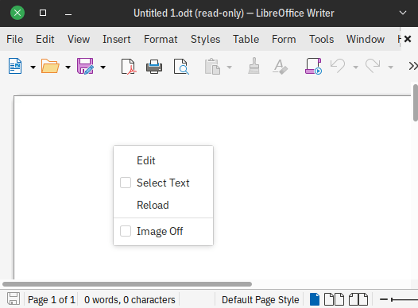 | 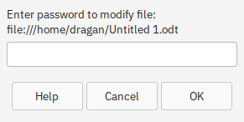  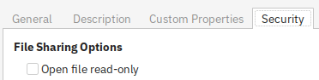

“Open file read-only” Checked vs. Un-checked
 | Checked | Un-checked
Save As... |  | 
Infobar |  | 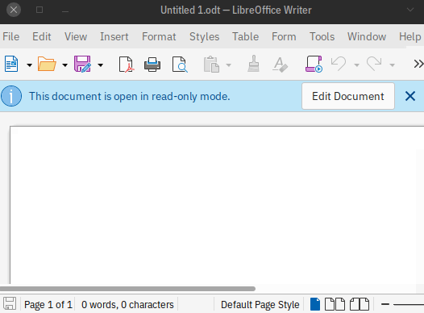
Read-only in window title | Yes | No
In both files we can right-click on page and click Edit.
In “Un-checked” we get Infobar which disappears on right-click > Edit or we can click directly on it.
On file Save As... “Checked” has Save with password by default and “Un-checked” has that unchecked too.
If we save both as new documents without password “Open file read-only” is gone.
Seem to be that both files have the same purpose.
Maybe I’m wrong and don’t get extra things that is for.
If not...

Always Open read only like in MS Word
It gets down to people and working with groups of people.
You can make read-only document and say to everyone that that read-only document is not actually read-only document and it can be overwritten and to be careful and still someone will overwrite it. It has to be read-only “for real”.
You could make:
- 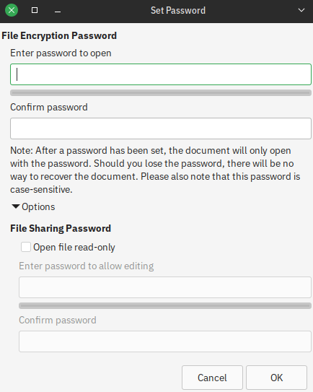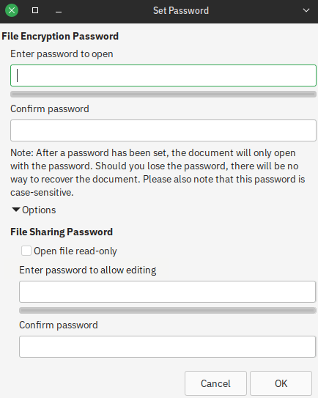
“Enter password to allow editing” input dialog being able to enter password without clicking “Open file read-only” and without faded colors
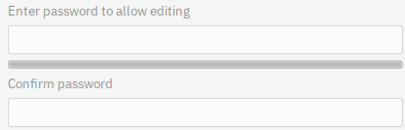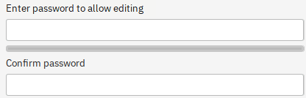
or even better, remove it from “Save with password” dialog and leave it only in “File > Properties > Security” and let it be read-only “for real”
Have new Infobars:
Original Infobar with “Open file read-only” un-checked
Editing with password | Read-only “for real” with read-only in window title
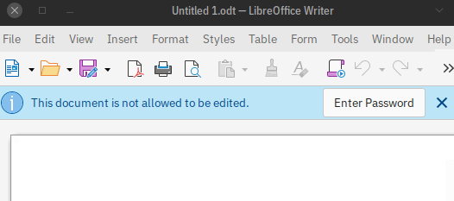 | 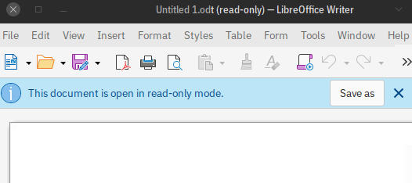

There could be both Edit password and “Open file read-only”. Think you can make something with infobars for that case.
And of course before un-clicking:
when trying to save a document an automatic Save as dialog should appear.

Change Passwords
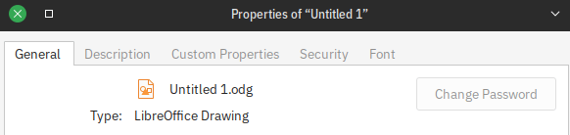
If I only have and password for opening document and try to Change Password:
- entering new password to open changes it
- entering new password to edit doesn’t append password to already changed password

