2026-08-11_LibreOffice from today crashes reproducibly
Table of Contents
Version of the crashing LO Writer and its environment 1
Letting LO Writer report the bug produced meaningless message 1
Is there some relation of the crash to a Table of Content in the document? 2
Are there any LibreOffice crash dump files of today? Yes: 2

Version of the crashing LO Writer and its environment
This bug report is about
Version: 26.2.0.0.alpha0+ (X86_64) / LibreOffice Community
Build ID: 05fb33a4296b48b2910422a2b12228f0a7dfb64a
CPU threads: 8; OS: Linux 6.8; UI render: default; VCL: gtk3
Locale: sv-SE (de_DE.UTF-8); UI: en-US
Calc: threaded
which crashed reproducibly when I worked on it in a big document (more than 1200 pages), the document was equipped with an automatically generated Table of Content.
Most of those crashes happened when I
- saved my document (with Ctrl-S)
- or updated its TOC.

Letting LO Writer report the bug produced meaningless message
When LO Writer crashed, it saved the document and asked whether to report the bug:
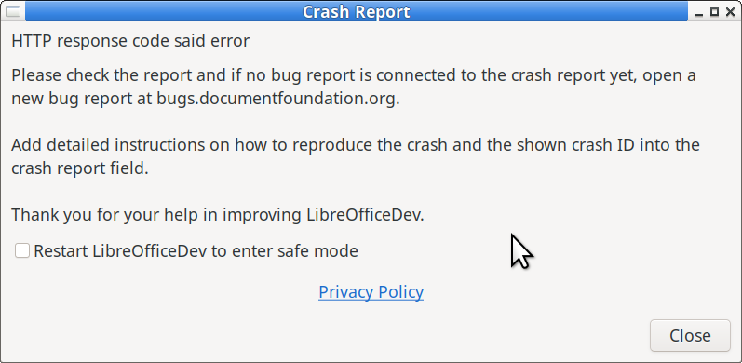
What did the HTTP response code say?
How do I see, whether a bug report is connected to the crash report?
This message is not very helpful. I would expect that some identification, e.g. an bug issue number, were included allowing me to add information how and when the error occurred and how it casn be reproduced.

Is there some relation of the crash to a Table of Content in the document?
It looks that the bug might be triggered by a TOC being present. In addition, the page numbers in the TOC were missing, a @ appeared instead of it:
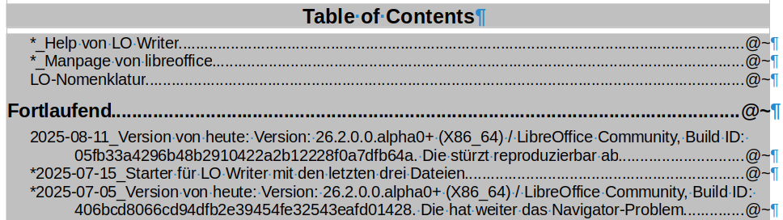
When I tried to update this TOC, LO Writer crashed again.
In order to narrow down the bug, I started this document from new.
I was able to create a TOC for it and no crash happened. But this is a very small document, contrary to my first one with > 1200 paegs.

Are there any LibreOffice crash dump files of today? Yes:
ls -l ~/.config/libreofficedev/4/crash/ | grep 2025-08-11
-rw------- 1 adalbert aoderv 796120 2025-08-11 16:36 0c87d68a-c1b4-4d85-2b4160be-bb998588.dmp
-rw------- 1 adalbert aoderv 772240 2025-08-11 16:46 1dd1b332-0c92-47a9-70df3191-ac2684b1.dmp
-rw------- 1 adalbert aoderv 760048 2025-08-11 16:50 2af25b28-844c-48d5-e6bee6a0-6968bfbb.dmp
-rw------- 1 adalbert aoderv 756648 2025-08-11 16:54 2d63c7f0-dbb6-43bb-3e1d2890-06891152.dmp
-rw------- 1 adalbert aoderv 810656 2025-08-11 16:41 898b0313-5c02-4043-8cc40ab3-8a24c683.dmp
-rw-r----- 1 adalbert aoderv 793 2025-08-11 17:04 dump.ini
The *.dmp files seem to be binary ones. I can open them with ghex, but I can't get anything meaningful out off them. I don't attach them to this bug report because of their >700kB size. Unless told to keep them for reference, I'll delete them tomorrow (and not use this development version any longer but rather update to a newer one in a few days, although it did not crash when writing this document).

