2025-08-14_Tests for bug #167935
m_a_riosv changed bug 167935 saying
"For me, the file does not open a second time. After opening with double-click on the browser and after open the file directly with the application."
Version: 25.2.5.2 (X86_64) / LibreOffice Community
Build ID: 03d19516eb2e1dd5d4ccd751a0d6f35f35e08022
CPU threads: 16; OS: Windows 11 X86_64 (10.0 build 26100); UI render:
Skia/Raster; VCL: win
Locale: es-ES (es_ES); UI: en-US
Calc: CL threaded"
My conclusion: This indicates that the bug might be system dependant and it is not present in Windows 11.
I carried out the following test with
Version: 25.2.2.1 (X86_64) / LibreOffice Community
Build ID: 38d746d66d9b82fa248a2e90142b9dd3ddd1d6cd
CPU threads: 8; OS: Linux 6.8; UI render: default; VCL: gtk3
Locale: de-DE (de_DE.UTF-8); UI: en-US
Calc: threaded
and with
Version: 26.2.0.0.alpha0+ (X86_64) / LibreOffice Community
Build ID: 05fb33a4296b48b2910422a2b12228f0a7dfb64a
CPU threads: 8; OS: Linux 6.8; UI render: default; VCL: gtk3
Locale: sv-SE (de_DE.UTF-8); UI: en-US
Calc: threaded

How I tested it (only under Linux)
- I opened a document by double clicking on a desktop icon pointing to my document (i.e. a link file to the actual document).
- Then I opened the target file again in LO Writer by File>Open.... designating the real location of the file.
- Then I added a single letter at the beginning in one of the two LO Windows without saving the file. Then I checked, if the change appeared in the other window (like it does if a second view is opened with Window>New Window. The change did not appear in the second view, of course.
- For the development version, I further added this test: First save the file without the change via Ctrl-S. No problem with that, which is ok.
Then I tried to save the other file, which was opened second to which I had added a character in step 3 to the LO instance opened as the second one. When I saved this one via Ctrl-S, I got
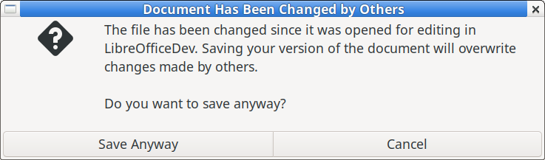

I came across this problem when I was developing a Python script which is called by an icon and which starts LibreOffice with the last n (selectable) last edited files. This script reads the content of LO's elephant memory ~/.config/libreoffice/4/user/registrymodifications.xcu. and it calls LO Writer giving the files to open as command line parameters. I found out that opening via a link file leaves separate entries in this file in the section <item oor:path="/org.openoffice.Office.Histories/Histories/org.openoffice.Office.Histories:HistoryInfo['PickList']/ItemList">. When double clicking on the link, the link file leaves a trace ion the elephant’s memory, in the other case the path to the document itself is recorded.

