2025-07-01_Test cases for Find Find and Replace_2
In https://help.libreoffice.org/latest/en-US/text/swriter/guide/search_regexp.html?DbPAR=WRITER we see this remark:
A search using a regular expression will work only within one paragraph. That is, a \n will match a line break within a paragraph.
Le's see if that is true:
Test case

after two empty paragraphs a paragraph with some text
a line with a forced linebreak at its end
and yet another line below it in the same paragraph

above this one an empty paragraph and another one below it

This is the playground, originally with a copy of the section above.

after two empty paragraphs a paragraph with some text
a line with a forced linebreak at its end
and yet another line below it in the same paragraph

above this one an empty paragraph and another one below it

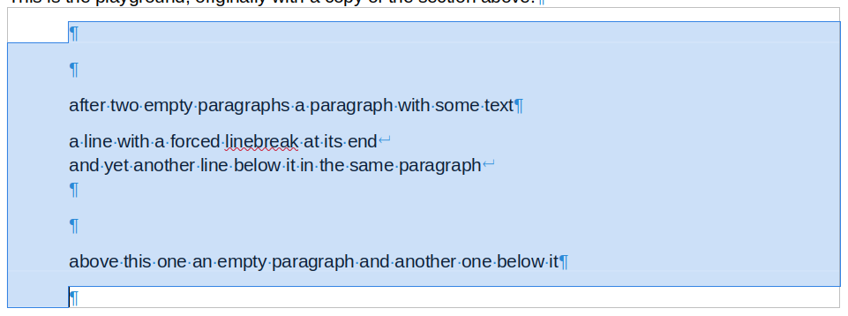
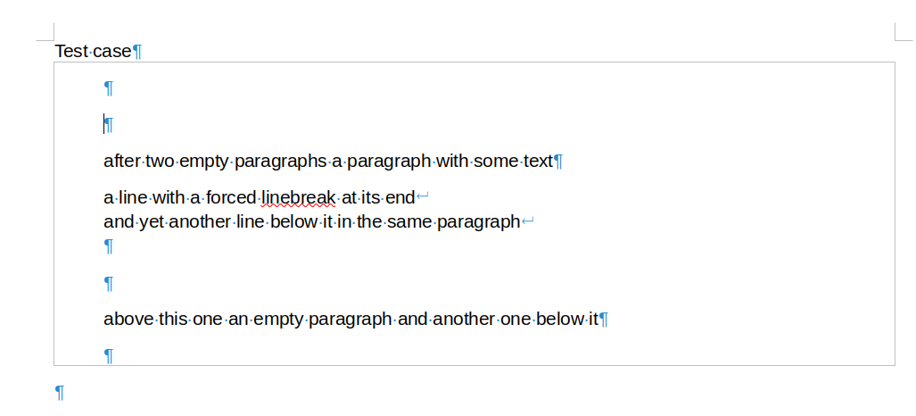
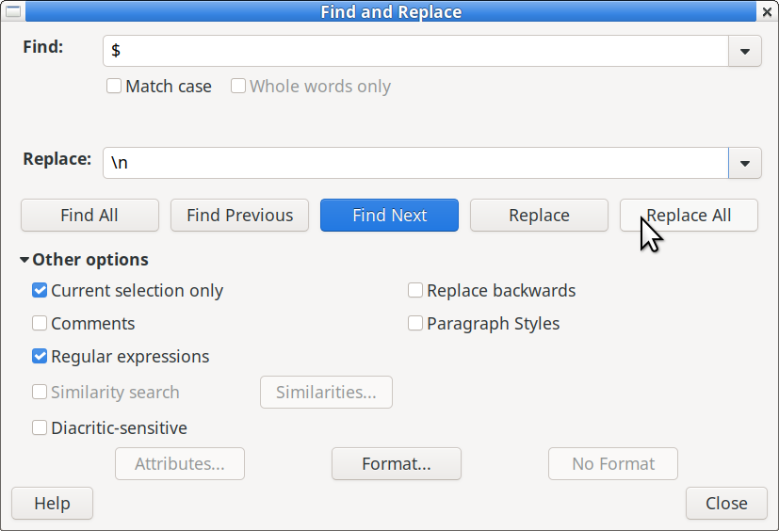
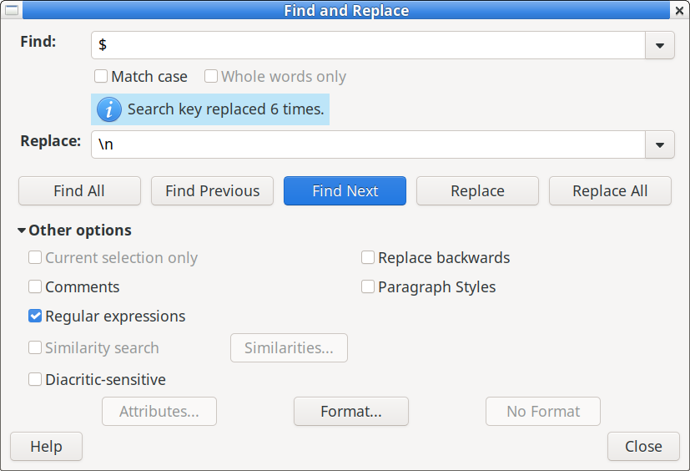
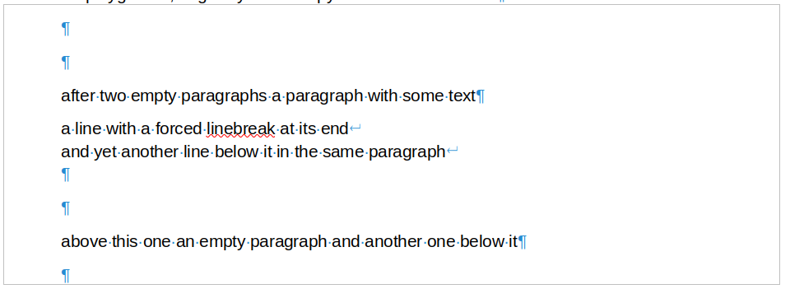
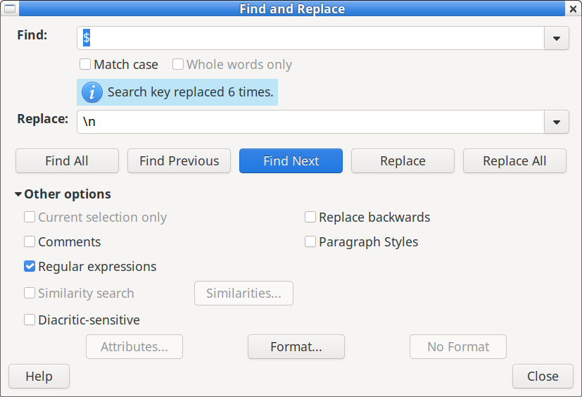
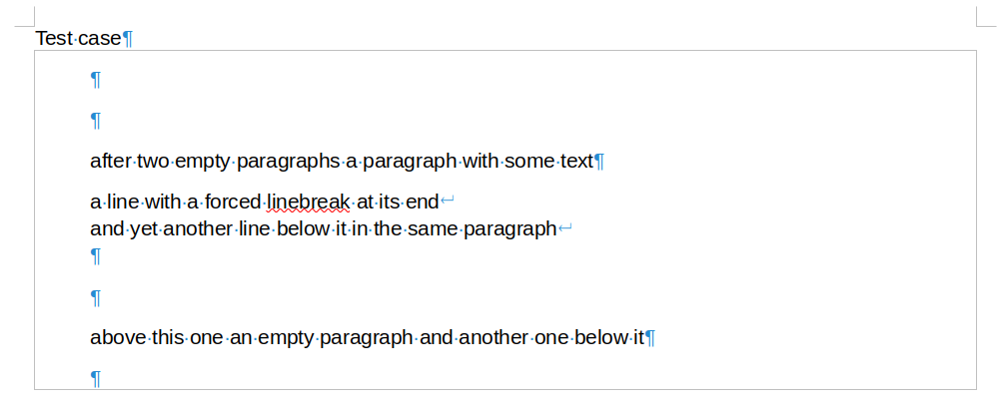
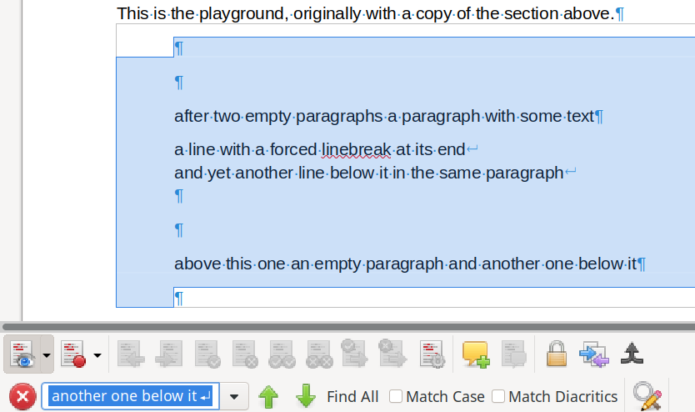
I first mark the whole Section
and then I apply this Find&Replace to it:
After Replace All the dialog shows this:
The outcome of the operation is:
i.e. despite 6 changes being applied, nothing has changed!
Observations:
The Find&Replace operation was done across the whole marked portion, not only on the first paragraph of it, contrary to the documentation at https://help.libreoffice.org/latest/en-US/text/swriter/guide/search_regexp.html?DbPAR=WRITER. So the mentioned remark is not correct.
I don't like it the way it is described. I would prefer if Find and Replace does not stop at the first paragraph mark encountered (in the case it is invoked not for a marked portion). If itr were like this, it would work like with a marked portion spanning a paragraph mark, which makes the function more consistent.
The empty paragraph marks at the beginning were not replaced by a forced linebreak. None of the forced linebreaks was introduced to replace a previous paragraph mark. It looks like in the replace part the only regular expression which is carried out is _dollar sign_N (replace with the N-th catch group of the regex).
I make a similar operation but this time only one copy of my test parcours, i.e. the first section mentioned above:

and this time I apply the same operation to it, but with nothing selected:_paragraph mark_This time again it shows to have made 6 replacements, but nothing has changed:
Side findings:
When I called Find&Replace again, the replacement part of the dialog was preset to empty. I would have expected to have maintained its previous setting.
When I wanted to check if the section after being changed is really unchanged, I marked it all and pressed Ctrl-f. Normally, I would have expected that the whole selection including the paragraph marks in it would go th the find pattern. But alas:
the marked portion goes to the search field with paragraph marks being replaced by forced line feeds. Therefore find backward does not find that the allegedly changed result is the same ans above! If I only mark a portion with text, e.g.:
after two empty paragraphs a paragraph with some text
it goes go to the search field without change after Ctl-f..
My examples should be included in any test parcours for
Find&Replace
The function Ctrl-f, which is Edit>Find.
Can one replace para1_dollar sign_para2_dollar sign_?
This is a test sample for https://bugs.documentfoundation.org/show_bug.cgi?id=38261#c46:
Test case
This first line tests whether a F&R operation stops at the first paragraph mark, i.e. then one at the end of this line.
This second line tests whether one can exchange the dollar sign in the character sequence "para1_dollar sign_para2"
This second line is just the beginning of two empty paragraphs

The first Test is to exchange just the dollar sign in the second line. Of course, the dollar sign has to be escaped in the search pattern in order to mean "literally a dollar sign"!
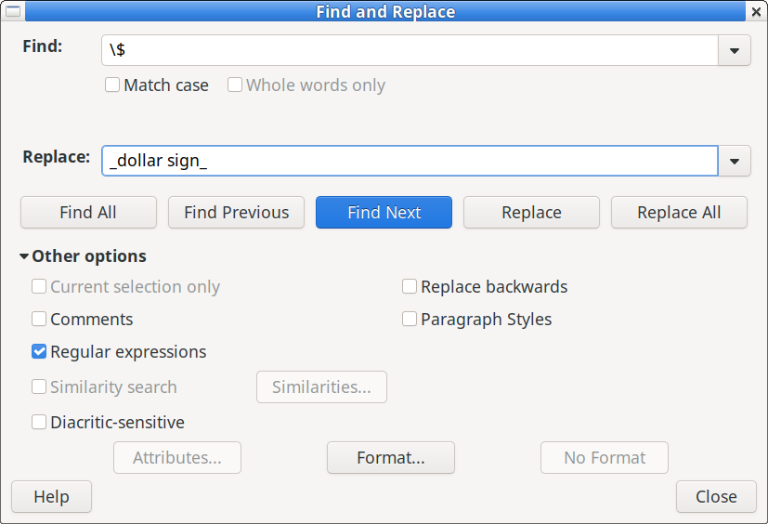
The first find and replace operation will be:

Test playground:
This first line tests whether a F&R operation stops at the first paragraph mark, i.e. then one at the end of this line.
This second line tests whether one can exchange the dollar sign in the character sequence "para1_dollar sign_para2"
This second line is just the beginning of two empty paragraphs

The first Test is to exchange just the dollar sign in the second line. Of course, the dollar sign has to be escaped in the search pattern in order to mean "literally a dollar sign"!
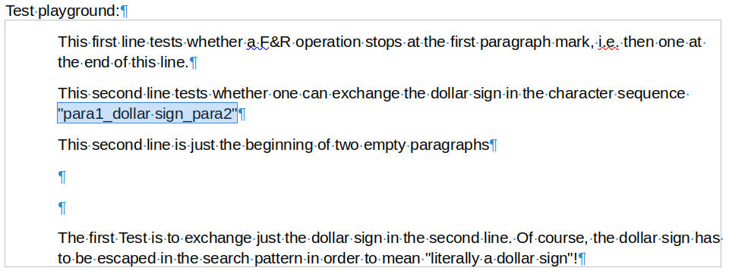
The dialog shows success, look at the highlighted portion:
Of course, there was success: i.e. with the current regex syntax one can search for a dollar sign, one only has to escape it by prepending it with a backslash character.
As the dollar sign (unfortunately instead of \p, which would be the well known PCRE syntax) represents a paragraph mark, it can be replaced with anything except a regular expression, but the placeholder $N for a catch group works as an exemption to the exemption (no example here, but there already was one above):
Second playground
This first line tests whether a F&R operation stops at the first paragraph mark, i.e. then one at the end of this line.
This second line tests whether one can exchange the dollar sign in the character sequence "para1$para2"
This second line is just the beginning of two empty paragraphs

The first Test is to exchange just the dollar sign in the second line. Of course, the dollar sign has to be escaped in the search pattern in order to mean "literally a dollar sign"!
The first find and replace operation will be:
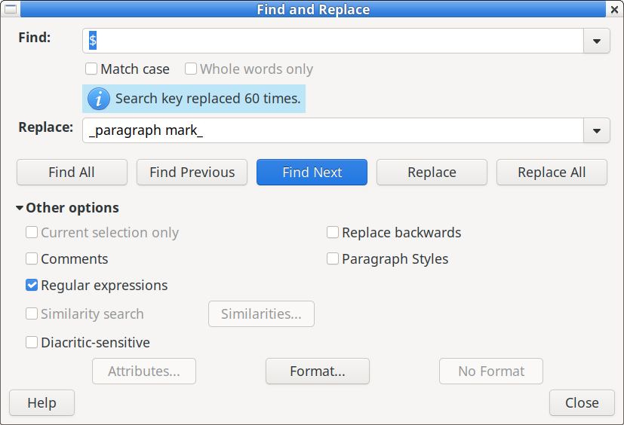
It worked! The result is
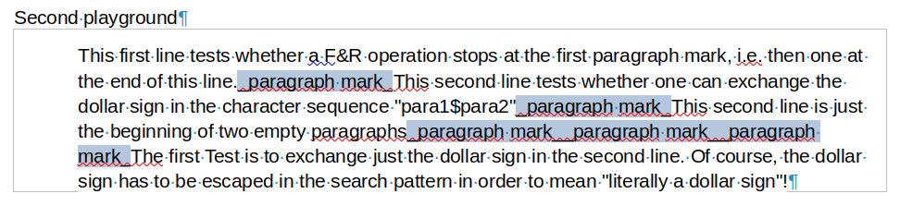
Side finding: Replace all literally replaces all found matches, not just from the current edit point onward! That's not good. The function should be changed and named to Change All Below and it act as such! Unfortunately I have to replace all the other changes inadvertently made in this file by hand again to make it better readable.
Still I think, the paragraph mark should be denoted by \p in regular expressions and they also shall be used when the replace pattern replaces – with the usual exception rule that an escaped special symbol replaces literally.

