2025-07-01_Test cases for Find Find and Replace
In https://help.libreoffice.org/latest/en-US/text/swriter/guide/search_regexp.html?DbPAR=WRITER we see this remark:
A search using a regular expression will work only within one paragraph. That is, a \n will match a line break within a paragraph.
Le's see if that is true:
Test case

after two empty paragraphs a paragraph with some text
a line with a forced linebreak at its end
and yet another line below it in the same paragraph

above this one an empty paragraph and another one below it

This is the playground, originally with a copy of the section above.

after two empty paragraphs a paragraph with some text
a line with a forced linebreak at its end
and yet another line below it in the same paragraph

above this one an empty paragraph and another one below it

I first mark the whole Section
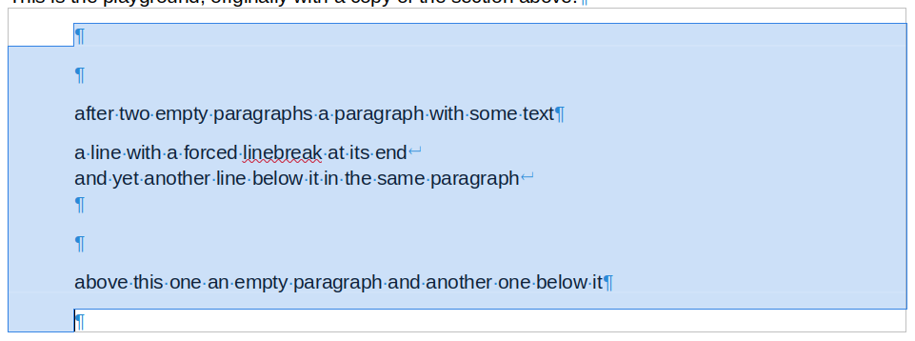
and then I apply this Find&Replace to it:
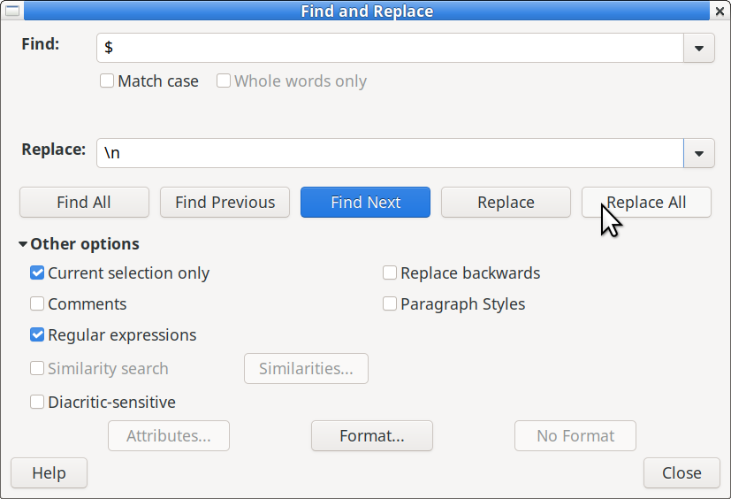
After Replace All the dialog shows this:
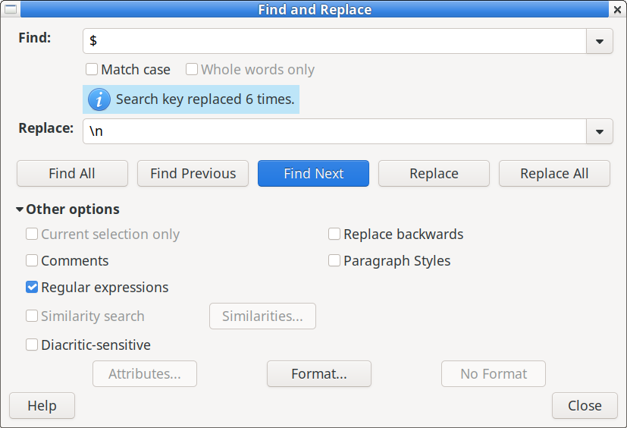
The outcome of the operation is:
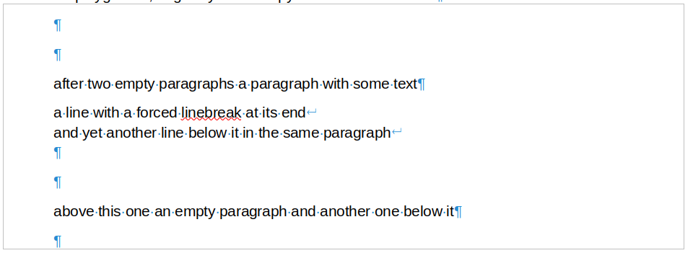
i.e. despite 6 changes being applied, nothing has changed!
Observations:
- The Find&Replace operation was done across the whole marked portion, not only on the first paragraph of it, contrary to the documentation at https://help.libreoffice.org/latest/en-US/text/swriter/guide/search_regexp.html?DbPAR=WRITER. So the mentioned remark is not correct.
I don't like it the way it is described. I would prefer if Find and Replace does not stop at the first paragraph mark encountered (in the case it is invoked not for a marked portion). If itr were like this, it would work like with a marked portion spanning a paragraph mark, which makes the function more consistent.
- The empty paragraph marks at the beginning were not replaced by a forced linebreak. None of the forced linebreaks was introduced to replace a previous paragraph mark. It looks like in the replace part the only regular expression which is carried out is $N (replace with the N-th catch group of the regex).
I make a similar operation but this time only one copy of my test parcours, i.e. the first section mentioned above:
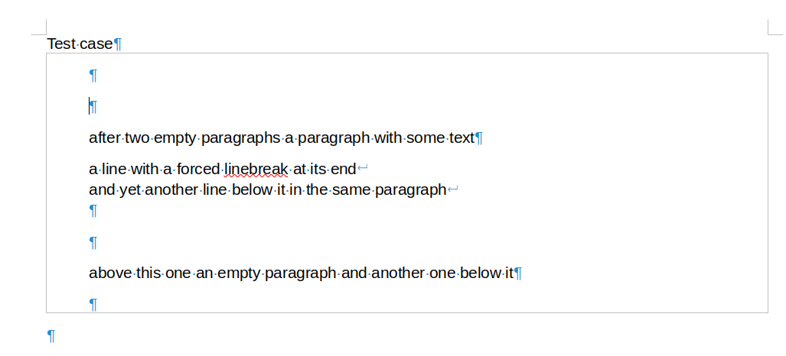
and this time I apply the same operation to it, but with nothing selected:
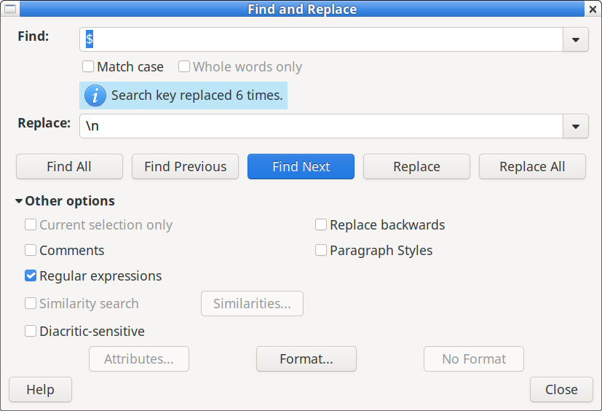
This time again it shows to have made 6 replacements, but nothing has changed:
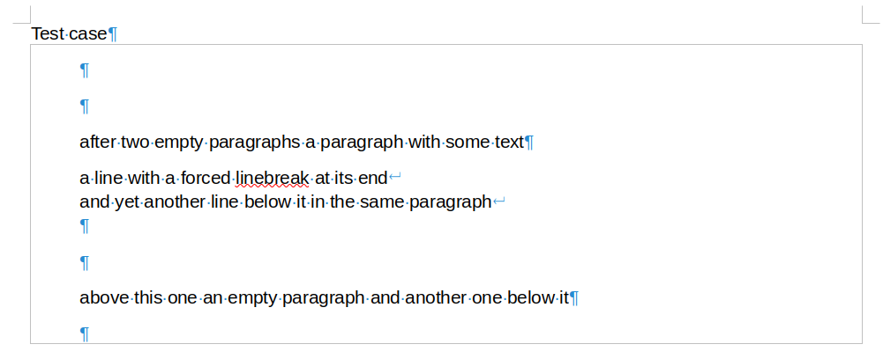
Side findings:
- When I called Find&Replace again, the replacement part of the dialog was preset to empty. I would have expected to have maintained its previous setting.
- When I wanted to check if the section after being changed is really unchanged, I marked it all and pressed Ctrl-f. Normally, I would have expected that the whole selection including the paragraph marks in it would go th the find pattern. But alas:
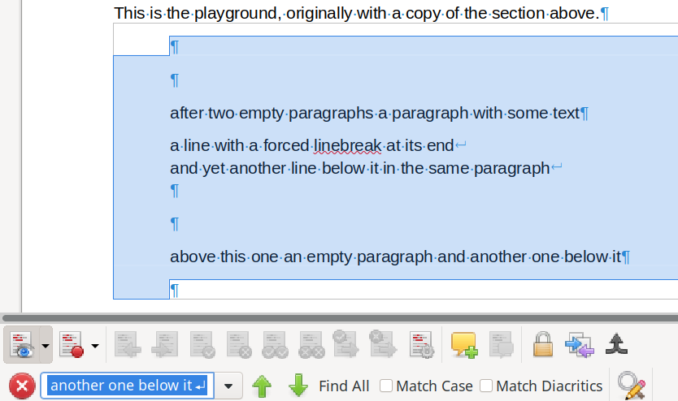
the marked portion goes to the search field with paragraph marks being replaced by forced line feeds. Therefore find backward does not find that the allegedly changed result is the same ans above! If I only mark a portion with text, e.g.:
after two empty paragraphs a paragraph with some text
it goes go to the search field without change after Ctl-f..
My examples should be included in any test parcours for
- Find&Replace
- The function Ctrl-f, which is Edit>Find.

