2024-09-24_Sample for Bug 163122_Selection Problem
This bug report pertains to
Version: 25.2.0.0.alpha0+ (X86_64) / LibreOffice Community
Build ID: f9b5dad09dbdd56ff064096695a946b03e9e2914
CPU threads: 8; OS: Linux 6.8; UI render: default; VCL: gtk3
Locale: de-DE (de_DE.UTF-8); UI: en-US
Calc: threaded
The bug seems to have been introduced recently.
I use something like this to copied output from terminals in my records: They should appear in a monospaced font and become a single paragraph in order to quickly skip over them with Ctl-down arrow while reading. I assign the paragraph style "Preformatted text" to them.
It used to be the case that it didn't matter whether I first replaced the paragraph marks with forced line breaks and then assigned a new paragraph format to the marked text. This is no longer the case: After you have assigned a new format to several paragraphs marked together, nothing is marked any more. There seems to be an "unmark everything" at the end of assigning a paragraph style to some text. It's logically not necessary and it's annoying.
Steps to reproduce:
1. In a LO Writer document, mark some text (it may cross paragraph boundaries).
2. Assign some paragraph prototype to it
3. The previous selection is removed (unexpected), the new paragraph format is assigned to the paragraphs into which the selection extends (expected).
1
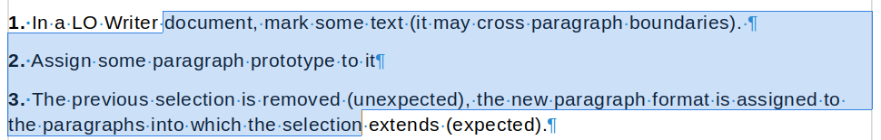
2. Apply "Body Text" to the selection
3. Result of 2.
After doing so, the selection is removed!


