2022-06-01_revisited 2021-01-14_Sample file for Bug 139584
Content
2022-06-01_Bug 139584 revisited 1
Other similar or related bug reports 1
Revisiting my old sample below 1
I want to replace paragraph marks by line breaks 4
Associated flaw in the LO documentation of search pattern $ 6
Side findings 7
Search comes up with what is marked in the search pattern – which is not useful at all 7
Search and Replace forgets the \n in the replacement pattern after it is applied 8
Further proposal: Search and Replace patterns should become storable associating a meaningful name to them 9

2022-06-01_Bug 139584 revisited
2021-12-06 meta Bug report https://bugs.documentfoundation.org/show_bug.cgi?id=146076 has been created and 2022-05-31 it has been updated. among other bugs, it also names #38261 from Timur, dating back to 2011 among related bugs. I don’t know how I am supposed to react on the meta bug report: fill in the Actual Results:/./Expected Results:/./Reproducible: Always/User Profile Reset: No/Additional Info – template?

Other similar or related bug reports
After I had made my suggestion in 139584, 139585, Timur found that he had made a similar suggestion in 2011-06-13: #38261. In the course of that suggestion also came up in 2015-11-09 and a few days after that suggestions to implement Preserve capitalization of AltSearch in replacement: #95708. In the discussion it came up that Preserve capitalization is also already on the buglist at AOO, there #17188 from 2003-07-21. There is also #100672 (2016-06-09...2016-10-12) and #76787 (2014-03-30...2016-10-12), #101517 (2016-08-16...2016-0-12), where it is about being able to enter special characters in the patterns (button "special"). Then there was #119728 (2018-09-06...2018-09-29), where someone wants to search and replace e.g. only italics finds (this can be done in AltSearch). and there was #119924 (2018-09-17...2018-10-02), where someone wants to search and replace formatting characters. He was advised to use AltSearch.

Revisiting my old sample below
I tried this example again using this version
Version: 7.4.0.0.alpha1+ / LibreOffice Community
Build ID: 66d8951df3c11ead0b9415eb292c3ae88689edf1
CPU threads: 4; OS: Linux 5.4; UI render: default; VCL: gtk3
Locale: de-DE (de_DE.UTF-8); UI: en-US
Calc: threaded
I followed exactly my steps below but this time my LibreOffice has an English user interface.
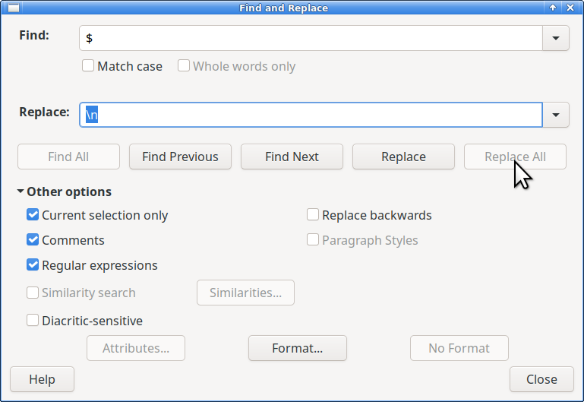
This time Replace All is greyed out! Ok, I take Replace instead:
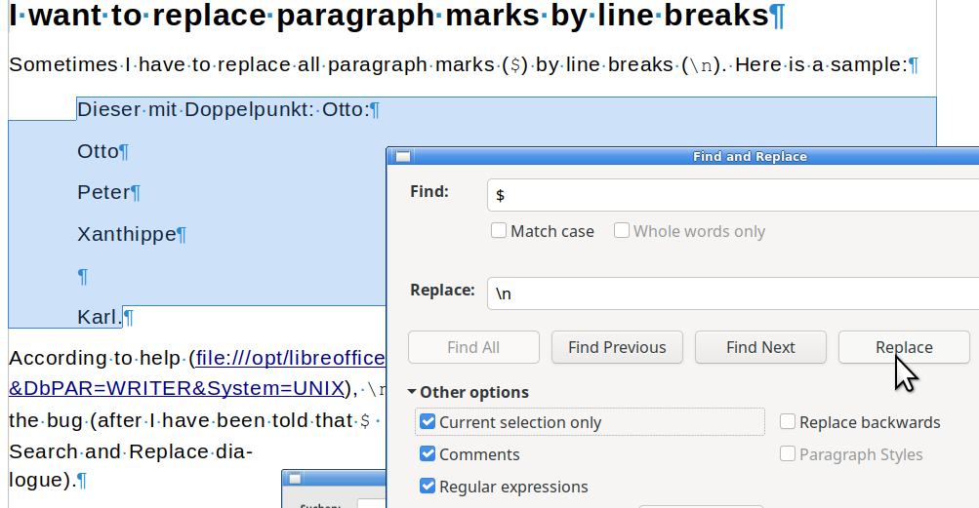
After clicking on Replace, it looks like this:
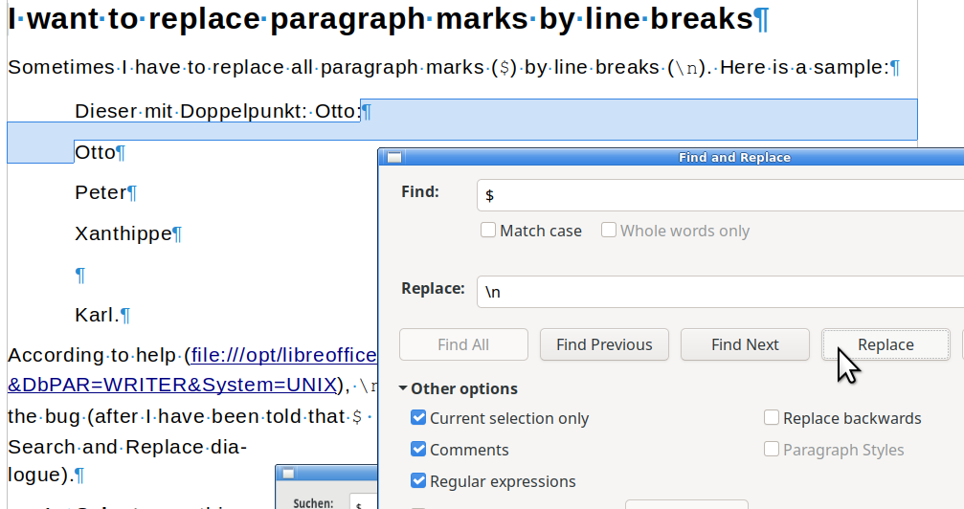
Only the selection has reduced which comes unexpected! I would have expected that the first ¶ after “Otto:” would have been replaced by a forced linefeed (i.e. \n).
Even If I click on Replace again, nothing happens.
So the bug is still present and still can be reproduced.
In my samples below I show that I tried to replace \n (thinking that it does not distinguish between paragraphs and line feeds) by \n. Now the dialog shows:
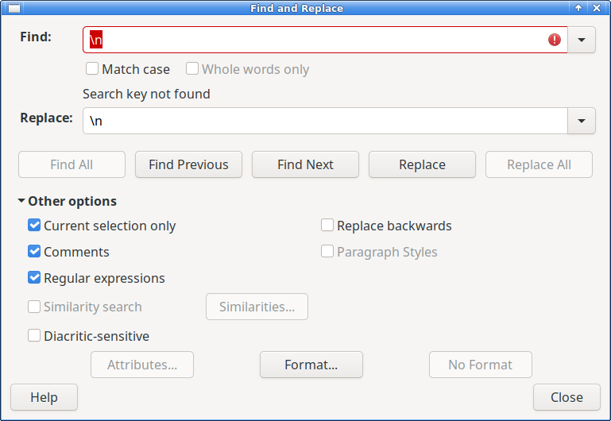
Not being able to replace paragraph marks by forced linefeeds is only one the flaws of Search&Replace in LO Writer. An improved version of it should also incorporate all versions of the extension AltSearch into LO Writer’s own Search&Replace maintaining the capabilities
- to load, store search and replace regular expressions like AltSearch does,
- not only search for sequences of letters or special characters (or what appears on the screen as special character, even if it is something on the implementation level of LO Writer), but also be able to search for
    - formatting properties like paragraph or character styles,
    - formatting properties like boldness, italics, underline, color(ranges), …
What is really useful has been designed carefully in AltSearch – with the exception of the replace part when searching for character styles (you have to search for all occurrences and while this it is found apply the new feature through normal LO dialogs – this could be done by greying out the replace part and replace it by a hint to apply the new feature to all found places as one would do it normally.
What follows is my unaltered old sample, which does not work exactly as it did when I made it. The inability replace paragraphs by linefeeds is still there, as shown above – not to mention the other urgently called for improvements of Search&Replace, beginning at Timur’s post 2011-06-13: #38261. I would not be surprised if somebody digs out even older calls for improvements to Search&Replace!

I want to replace paragraph marks by line breaks
Sometimes I have to replace all paragraph marks ($) by line breaks (\n). Here is a sample:
Dieser mit Doppelpunkt: Otto:
Otto
Peter
Xanthippe

Karl.
According to help (file:///opt/libreoffice6.4/help/de/text/shared/01/02100001.html?&DbPAR=WRITER&System=UNIX), \n designates a (forced) line break. In order to reproduce the bug (after I have been told that $ rather than \p denotes the end of a paragraph in the Search and Replace dialogue).
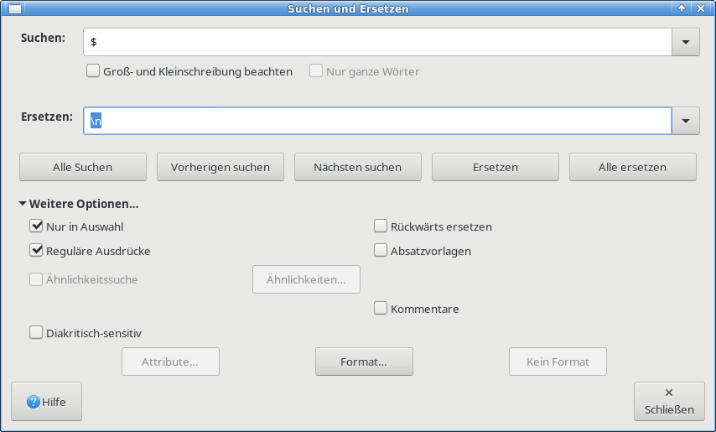
- Select everything between “Dieser mit Doppelpunkt: Otto:” up to and including “Karl.” (the period after Karl shall be included in the selection).
- Involve Search and Replace with search pattern “$” and replace pattern “\n”.
- Apply it to all (Alle ersetzen).
It yields:
Dieser mit Doppelpunkt: Otto:
Otto
Peter
Xanthippe

Karl.
i.e.: no change at all for the selection, but this line below the selection got indented like the line ending with “Karl.”! (I repaired that later in this file).
I would rather have expected this result:
Dieser mit Doppelpunkt: Otto:
Otto
Peter
Xanthippe
Karl.
However I can replace \n by a normal paragraph marker using this substitution:
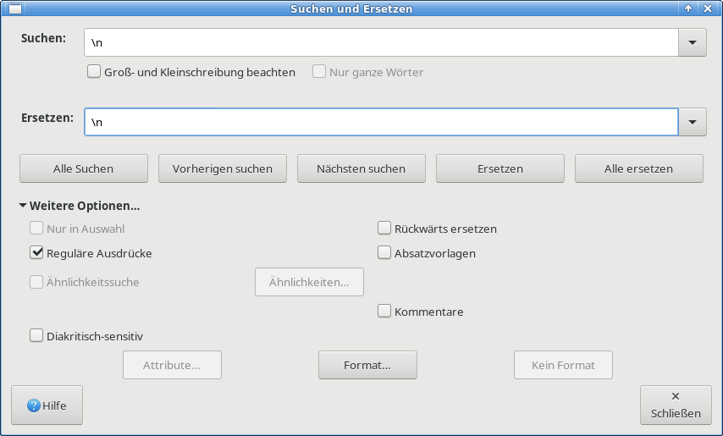
which yields (applied on the sample above):
Dieser mit Doppelpunkt: Otto:
Otto
Peter
Xanthippe

Karl.
Again, the paragraph below the highlighted text (this line) got indented as the paragraph above – which I would not have expected.
Help tells us, that each \n will be replaced by a paragraph mark. So it is a bug by design: \n is a chameleon: in the search pattern it matches a line break or a paragraph mark. In the replace pattern, it denotes a paragraph mark (which otherwise is denoted by $). This of course makes teaching LO Writer more difficult than it would have to be, if \n in search would have the same meaning both in the search pattern and in the replace pattern.
In order to replace paragraphs to line breaks, one has to resort to AltSearch.oxt (which unfortunately is buggy). AltSearch.oxt denotes the paragraph mark by \p, which probably is influenced by ^p denoting a paragraph mark in MS Windows (MS does many things in nonstandard ways. In Word they use ^ as escape character in regular expressions). But \p is not a standard pattern for something like line ends, paragraph ends and the like. However there is a pattern \R in some regex dialects and \R matches any line break, including Unicode line breaks. What makes it special is that \R treats CRLF pairs as indivisible, see http://www.regular-expressions.info/nonprint.html under the heading "Line Breaks".

Associated flaw in the LO documentation of search pattern $
In the German version of it, it says:
...Beispiel: "Peter$" stimmt nur überein, wenn das Wort "Peter" das letzte Wort eines Absatzes ist. Hinweis: Nach "Peter" kann kein Punkt eingefügt werden.

$ allein stimmt mit dem Ende eines Absatzes überein. So ist es möglich, Absatzumbrüche zu suchen und zu ersetzen.
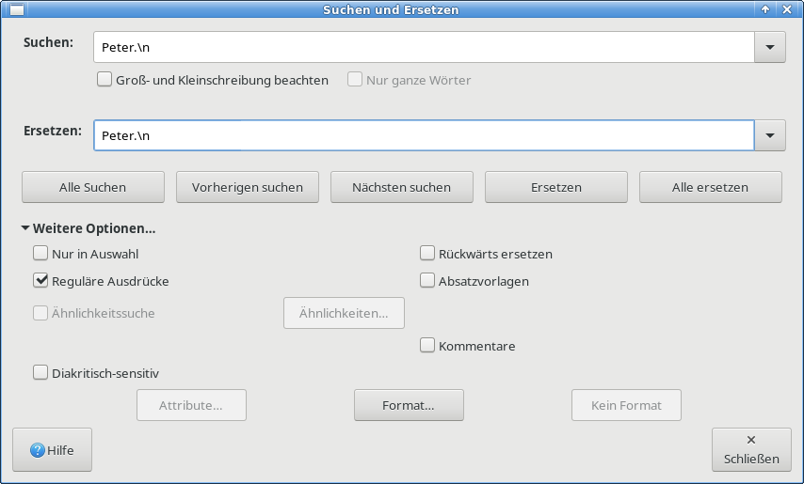
Similar in the English version also, see Comment #1. However, "Peter" can be followed by a period and one can search for “Peter.”: But the period alone in a search pattern denotes any single character except a line break or a paragraph break. In order to escape it, one has to search for “\.”. In order to search for a period immediately before a paragraph mark or a line feed, this would just replace the line break after “Peter.” in this example:
Some names:
Alice is the brother of Peter
who is the son of another Peter.
Carla is the daughter of the second Peter.
So we have two Peters in one lineage.
The result of applying the Search and Replace shown above is (which demonstrates that one can indeed search for “Peter.”:
Some names:
Alice is the brother of Peter
who is the son of another Peter.
Carla is the daughter of the second Peter.
So we have two Peters in one lineage.
Therefore I propose to improve the help. One might drop the whole part about “Peter.”. If we decide to keep it as a period often comes directly before a paragraph mark then instead of
“note "Peter" cannot be followed by a period.”
we should better explain:
“note if it is to search for Peter followed by a period, the period has to be escaped by a backlash, because a period in a regex search pattern matches any single character except a line break or a paragraph break. So in order to search for "Peter." at the end of a line one actually has to search for this pattern: "Peter\.$" ”

Side findings

Search comes up with what is marked in the search pattern – which is not useful at all
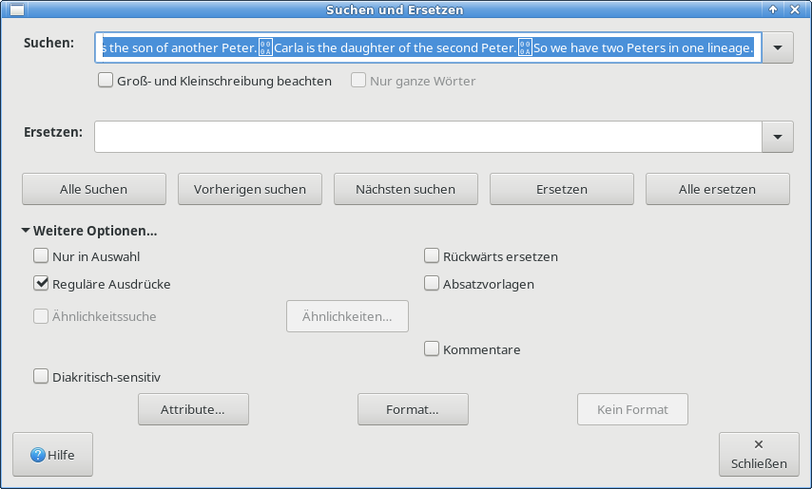
Note the strange appearing special formatting marks in the example.
For search it is indeed useful to have the marked pattern preset (if the search was not restricted to a selection). However for Search and Replace, this is not meaningful. Better keep the previous search pattern in Search and Replace!

Search and Replace forgets the \n in the replacement pattern after it is applied
After applying to the next paragraph (a copy of what I would have expected but did not get in an example above) | 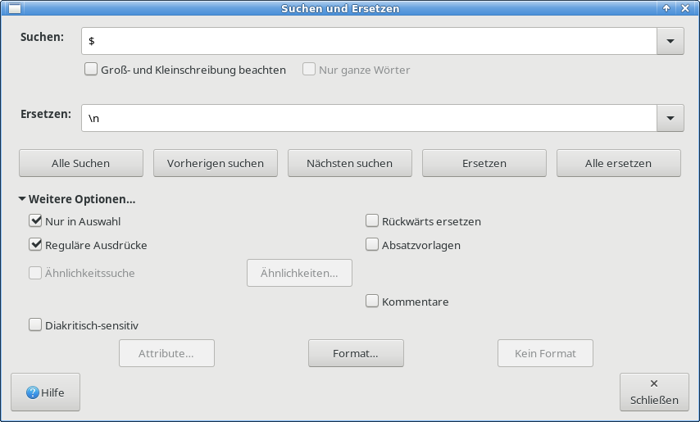

Dieser mit Doppelpunkt: Otto:
Otto
Peter
Xanthippe
Karl.

Search and Replace comes up with this substitution once I call it again:  I would have expected that the replacement string were not wiped, but maintained as it was set by me on the last invocation before! | 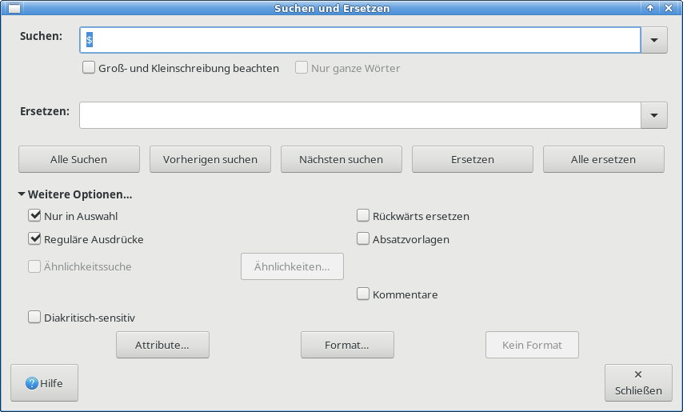

Further proposal: Search and Replace patterns should become storable associating a meaningful name to them
Regexes tend to become not easy to be understood when they to more powerful things (e.g. remove any excess white spaces at the beginning and at the end of each line (\n) or paragraph ($), simultaneously removing empty paragraphs. So one should be able to give names to one's Search and Replace patterns and store them (per user) such that one does not have to enter them again for reuse (with the possibility to make errors in that).
Each entry of such Search and Replace scripts should be the combination of both parts: the search part and the replace part.
When loading a Search and Replace script, of course, the check mark for regex should be enabled automatically.
When involving Search and Replace, both fields should be left unchanged from the last use in the particular LO Writer session, both being empty at the very first use of Search and Replace in a session.

