The last mile of the
protein folding problem
A pilgrim’s staff and skid-proof boots
Elmar Krieger
Cover: YAMI, Yet Another Mascotti, a truly hypothetical protein.

ISBN 90-9018508-9

© 2004-2010 by Elmar Krieger
1st edition 2004, printed by PrintPartners Ipskamp, The Netherlands
2nd edition 2010, with updated references to articles that were not yet published when the 1st edition went to press, printed by Frick Digitaldruck, Germany

No parts of this book may be reproduced, stored in a retrieval system or transmitted in any form without permission of the author. The copyright of the published papers remains with the publishers.
This PhD study was performed at the Center for Molecular and Biomolecular Informatics (CMBI), Radboud University Nijmegen, The Netherlands, from March 2000 until February 2004.
I gratefully acknowledge the collaboration with the Department of Human Genetics, UMC Nijmegen; the Department of Biochemistry, Nijmegen Center for Molecular Life Sciences; the Department of Clinical Genetics, Erasmus MC Rotterdam; the Department of Molecular Cell Biology, VUMC Amsterdam; the Groningen Biomolecular Sciences and Biotechnology Institute; and the Institute of Pharmaceutical Chemistry, University of Graz
The last mile of the
protein folding problem

A pilgrim’s staff and skid-proof boots

een wetenschappelijke proeve op het gebied van bioinformatica

Proefschrift

ter verkrijging van de graad van doctor
aan de Radboud Universiteit Nijmegen,
op gezag van de Rector Magnificus Prof. C.W.P.M. Blom,
volgens besluit van het College van Decanen
in het openbaar te verdedigen op
maandag 27 september 2004,
des namiddags om 1.30 uur precies
door

Elmar Krieger
geboren op 4 juli 1974 te Graz, Oostenrijk

Promotor:

Prof. Dr. Gert Vriend

Manuscript-commissie:

Prof. Dr. Herman J.C. Berendsen (em. RUG)

Prof. Dr. Jaap Heringa (VU)

Prof. Dr. Henk Stunnenberg

Summary
Structural bioinformatics is a research discipline with an ambitious goal: to move experiments from the real world into the computer, ex vivo in silicum, where they should be conducted in a faster and easier way, cost less and require the help of fewer animals. It is needless to say that we are still very far from reaching that goal. The rational design of drugs has not really lived up to the high expectations yet, and none of the major pharmaceutical companies can get away without robotic in vitro screening of real compounds. Why can virtual experiments not catch up with the real ones?
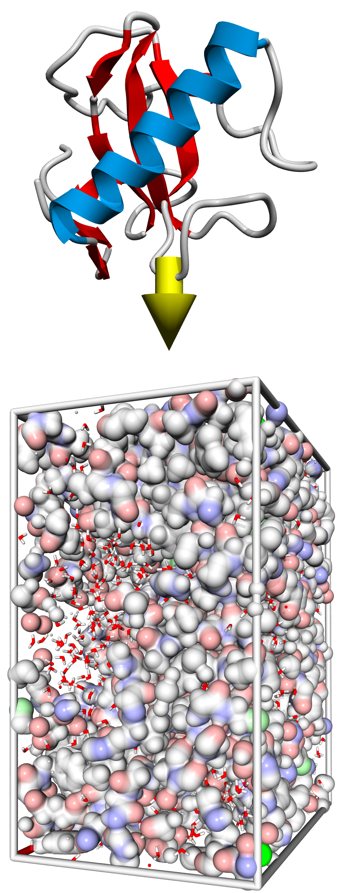
Most applications start with atomic models (e.g. an enzyme with various drug candidates bound in the active site) and end with a simple question: which model is closest to reality? If it was possible to answer this question reliably, one could make random changes to the model and arrive at the correct answer. Today, the common approach is to calculate the model energies and gamble that the one with the lowest energy is also the most realistic model - just like in nature, where the configuration with the lowest energy is the most probable one. At the beginning of this thesis, we concluded that the main reason why this does not work well is the limited accuracy of today’s energy functions. The difference between nature’s real energy function and our partly empirical approximations is just too large. Consequently, the main goal of this thesis is to improve these functions in order to arrive at more accurate predictions. We focus on proteins, since they are the central objects of interest in structural bioinformatics. The straightforward way to test our knowledge is the “protein folding problem” – the prediction of a protein structure from its amino acid sequence. When a prediction is already very close to the real structure (like in homology modeling), the requirements on the energy functions are maximal and it becomes very hard to improve the model. This “last mile of the protein folding problem” must be stridden before we can even hope to win the drug design challenge. Only if we know proteins can we try to understand their interactions.
This thesis is split in four parts: after a general introduction to protein structure prediction¹ in chapter 1, the tools that had to be developed to do the actual research are described in chapter 2. These include YASARA, a molecular-graphics, -modeling and -simulation program², Models@Home, a screensaver that delivers a free super-computer by linking the PCs in a network³, and PDBFinderII⁴, a database to aid protein structure prediction and analysis.
Chapter 3 then introduces a new way of improving protein energy functions and force fields: they are allowed to parameterize themselves while energy-minimizing known protein structures. First this is done in vacuo to obtain the NOVA force field⁵, and then in crystal space with explicit solvent and pH-dependency⁶ to arrive at the YAMBER force fields⁷. All these developments have been integrated with existing tools like the WHAT IF program to turn a protein sequence into a three-dimensional model. This is achieved by ELIZA⁸, an expert system for protein structure prediction that can also incorporate experimental data, e.g. from NMR spectroscopy¹⁰⁻¹².
Chapter 4 finally shows how ELIZA was used in close collaboration with experimental research groups to answer questions of general interest: we investigated mutations in the DJ-1 protein associated with parkinsonism^{13,14}, in gamma actin¹⁵ and myson VIIa¹⁶ causing hearing loss, in fibroblast growth factor 14 leading to cerebellar ataxia¹⁷, and in p63 linked to ADULT syndrome¹⁸. In addition we modeled the interaction of heparin with interleukin-8⁹, the peroxisomal targeting signal receptor Pex5p¹⁹, the gastric H,K-ATPase²⁰ and the HIV-1 receptor on dendritic cells DC-SIGN²¹.

1. Krieger, E., Nabuurs, S. B. & Vriend, G. Homology modeling. Methods Biochem Anal 44, 509-23 (2003).
2. Krieger, E. How to solve the molecular visualization problem. Submitted.
3. Krieger, E. & Vriend, G. Models@Home: distributed computing in bioinformatics using a screensaver based approach. Bioinformatics 18, 315-318 (2002).
4. Krieger, E., Hooft, R. W. W., Nabuurs, S. B. & Vriend, G. PDBFinder2 - a database for protein structure analysis and prediction. Submitted.
5. Krieger, E., Koraimann, G. & Vriend, G. Increasing the precision of comparative models with YASARA NOVA - a self-parameterizing force field. Proteins 47, 393-402 (2002).
6. Krieger, E., Nielsen, J. E., Spronk, C. A. E. M. & Vriend, G. Fast empirical pKa prediction by Ewald summation. J Mol Graph Model 25, 481-486 (2006).
7. Krieger, E., Darden, T., Nabuurs, S. B., Finkelstein, A. & Vriend, G. Making optimal use of empirical energy functions: force field parametrization in crystal space. Proteins 57, 678-683(2004).
8. Krieger, E. et al., Improving physical realism, stereochemistry, and side-chain accuracy in hom. modeling: Four approaches that performed well in CASP8. Proteins 77 Suppl 9, 114-122 (2009).
9. Krieger, E., Geretti, E., Brandner, B., Goger, B., Wells, T. N. & Kungl, A. J. A structural and dynamical model for the interaction of interleukin-8 and glycosaminoglycans: support from iso-thermal fluorescence titrations. Proteins 54, 768-775 (2004).
10. Spronk, C. A. E. M., Nabuurs, S. B., Krieger, E., Vriend, G. & Vuister, G. W. Validation of protein structures derived by NMR-spectroscopy. Prog in NMR Spectroscopy 45,315-337 (2004).
11. Spronk, C. A., Nabuurs, S. B., Bonvin, A. M., Krieger, E., Vuister, G. W. & Vriend, G. The precision of NMR structure ensembles revisited. J Biomol NMR 25, 225-34 (2003).
12. Nabuurs, S. B., Spronk, C. A., Krieger, E., Maassen, H., Vriend, G. & Vuister, G. W. Quantitative evaluation of experimental NMR restraints. J Am Chem Soc 125, 12026-34 (2003).
13. Bonifati, V., Rizzu, P., van Baren, M. J., Schaap, O., Breedveld, G. J., Krieger, E., Dekker, M. C., Squitieri, F., Ibanez, P., Joosse, M., van Dongen, J. W., Vanacore, N., van Swieten, J. C., Brice, A., Meco, G., van Duijn, C. M., Oostra, B. A. & P., H. Mutations in the DJ-1 gene associated with autosomal recessive early-onset parkinsonism. Science 299, 256-259 (2003).
14. Bonifati, V., Rizzu, P., Squitieri, F., Krieger, E., Vanacore, N., van Swieten, J. C., Brice, A., van Duijn, C. M., Oostra, B., Meco, G. & Heutink, P. DJ-1( PARK7), a novel gene for autosomal recessive, early onset parkinsonism. Neurol Sci 24, 159-60 (2003).
15. van Wijk, E., Krieger, E., Kemperman, M. H., de Leenheer, E. M. R., Huygen, P. L. M., Cremer, C. W. R. J., Cremers, F. P. M. & Kremer, H. A mutation in the gamma actin 1 (ACTG1) gene causes autosomal dominant hearing loss. J Med Genet 40, 879-84 (2004).
16. Luijendijk, M. W. J., van Wijk, E., Krieger, E., Bischoff, A. M. L. C., Cremers, C. W. R. J., Cremers, F. P. M., Kremer, H., Pennings, R. J. E., Weekamp, H., Cruysberg, J. R. M., Huygen, P. L. M. & Brunner, H. G. Identification and molecular modeling of a mutation in the motor head domain of myosin VIIA in a family with autosomal dominant hearing impairment (DFNA11). Hum Genet 115, 149-156 (2004).
17. van Swieten, J. C., Brusse, E., de Graaf, B. M., Krieger, E., van de Graaf, R., de Koning, I., Maat-Kievit, A., Leegwater, P., Dooijes, D., Oostra, B. A. & P., H. A mutation in the fibroblast growth factor 14 gene is associated with autosomal dominant cerebellar ataxia. Am J Hum Genet. 72, 191-199 (2003).
18. Duijf, P. H., Vanmolkot, K. R., Propping, P., Friedl, W., Krieger, E., McKeon, F., Dotsch, V., Brunner, H. G. & van Bokhoven, H. Gain-of-function mutation in ADULT syndrome reveals the presence of a second transactivation domain in p63. Hum Mol Genet 11, 799-804 (2002).
19. Boteva, R., Koek, A., Visser, N. V., Visser, A. J., Krieger, E., Zlateva, T., Veenhuis, M. & van der Klei, I. Fluorescence analysis of the Hansenula polymorpha peroxisomal targeting signal-1 receptor, Pex5p. Eur J Biochem 270, 4332-8 (2003).
20. Koenderink, J. B., Swarts, H. G. P., Willems, P. H. G. M., Krieger, E. & De Pont, J. J. H. H. M. A conformational specific interhelical salt bridge is essential for the E2 preference of gastric H,K-ATPase. J Biol Chem 279, 16417-16427 (2004).
21. Geijtenbeek, T. B., van Duijnhoven, G. C., van Vliet, S. J., Krieger, E., Vriend, G., Figdor, C. G. & van Kooyk, Y. Identification of different binding sites in the dendritic cell-specific receptor DC-SIGN for intercellular adh.molecule 3 and HIV-1. J Biol Chem 277, 11314-20 (2002).

Contents
Summary 5
Introduction 13
Introduction to homology modeling 15
Step 1 - Template recognition and initial alignment 18
Step 2 - Alignment correction 20
Step 3 - Backbone generation 22
Step 4 - Loop modeling 23
Step 5 - Side chain modeling 24
Step 6 - Model Optimization 25
Step 7 - Model Validation 27
The Tools 33
How to solve the molecular visualization problem 35
Abstract 35
Introduction 35
Methods 37
Results 37
A new way of drawing molecules 37
YASARA – Yet Another Scientific Artificial Reality Application 38
Models@Home: distributed computing in bioinformatics using a screensaver based approach 41
Abstract 41
Introduction 41
Methods 43
Supervisors 43
Working Clients 43
Server 44
Implementation 45
Discussion 46
Molecular Dynamics Docking 46
Force Field Parameterization 46
Database Maintenance 47
Conclusion 47
PDBFinder II - a database for protein structure analysis and prediction 49
Abstract 49
Introduction 49
Results 50
The PDBFinder II file format 50
Database interfaces 53
The Approach 55
Increasing the accuracy of comparative models with YASARA NOVA - a self-parameterizing force field 57
Abstract 57
Introduction 57
Methods 59
Molecular trees define the chemical environment 59
Building reference trees 60
Bonds 60
Angles 61
Dihedrals 61
Distant Geometry Links 62
Planarity 62
Van der Waals Interactions 62
Electrostatics 63
Optimization and validation sets 64
The practical limit of fold prediction 66
Force field optimization methods 66
Force field evaluation methods 67
Computational requirements 67
Results 67
Force field optimization 67
Force field evaluation 68
Model improvements 69
Force field energy 71
Discussion 72
Fast Empirical pKa Prediction by Ewald Summation 75
Abstract 75
Introduction 75
The goal is pKa prediction in protein crystals 76
Ewald summation captures the periodic environment 77
The pKa can be approximated as a function of electrostatic potential, hydrogen bonds and accessible surface 77
Methods 79
Datasets of experimental pKa values 79
Hydrogen bond counting 79
Calculation of the electrostatic potential 79
Accessibility calculations 80
Results and Discussion 80
Conclusions 82
Making optimal use of empirical energy functions: force field parameterization in crystal space 85
Abstract 85
Introduction 86
Methods 87
Reconstruction of crystallographic unit cells 87
Simulations of crystals and models 88
Results 89
Force field optimization 89
Force field evaluation 91
Refinement of homology models 93
Discussion and Conclusion 94
ELIZA – an expert system for protein structure prediction 99
Abstract 99
The Applications 101
Mutations in the DJ-1 gene associated with autosomal recessive early- onset parkinsonism 103
DJ-1, a novel gene for autosomal recessive, early onset parkinsonism 103

Fluorescence analysis of the Hansenula polymorpha peroxisomal targeting signal-1 receptor, Pex5p 105

A mutation in the fibroblast growth factor 14 gene is associated with autosomal dominant cerebellar ataxia 107

Identification of different binding sites in the dendritic cell-specific receptor DC-SIGN for intercellular adhesion molecule 3 and HIV-1 109

A structural and dynamical model for the interaction of interleukin-8 and glycosaminoglycans: support from isothermal fluorescence titrations 111

Gain-of-function mutation in ADULT syndrome reveals the presence of a second transactivation domain in p63 113

A conformational specific interhelical salt bridge is essential for the E2 preference of gastric H,K-ATPase 115

A mutation in the gamma actin 1 (ACTG1) gene causes autosomal dominant hearing loss 117

Identification and molecular modeling of a mutation in the motor head domain of myosin VIIA in a family with autosomal dominant hearing impairment (DFNA11) 119

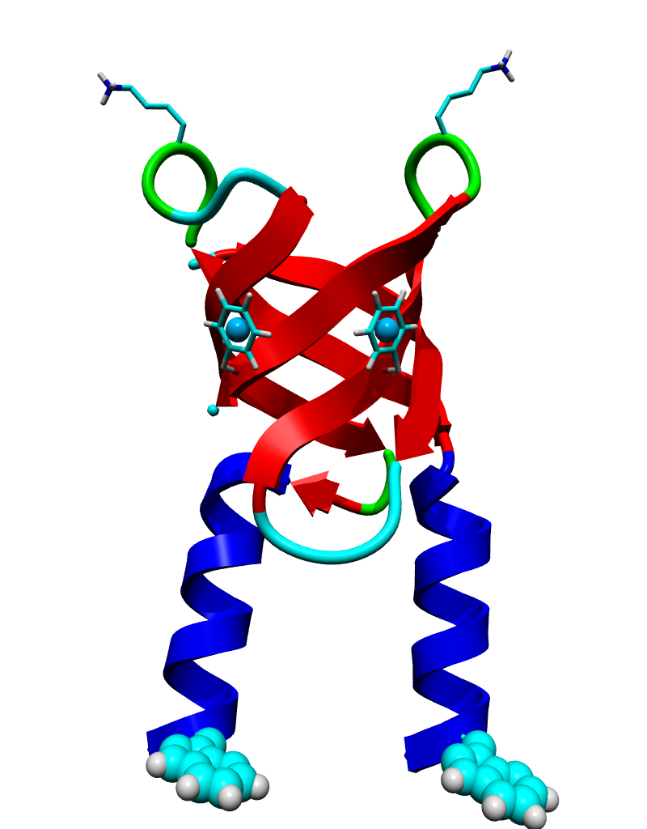

The page on the right shows a schematic representation of proteins that helps us visualize their structure. Proteins are polymers of a few dozen to a few thousand amino acids. There are 20 different types of amino acids, and every protein is defined by its unique sequence of amino acids. Interactions between the individual amino acids give rise to a precisely determined three-dimensional arrangement of the polymer chain – the protein structure. Predicting this structure from the sequence of amino acids is called the “protein folding problem” – the topic of this thesis.

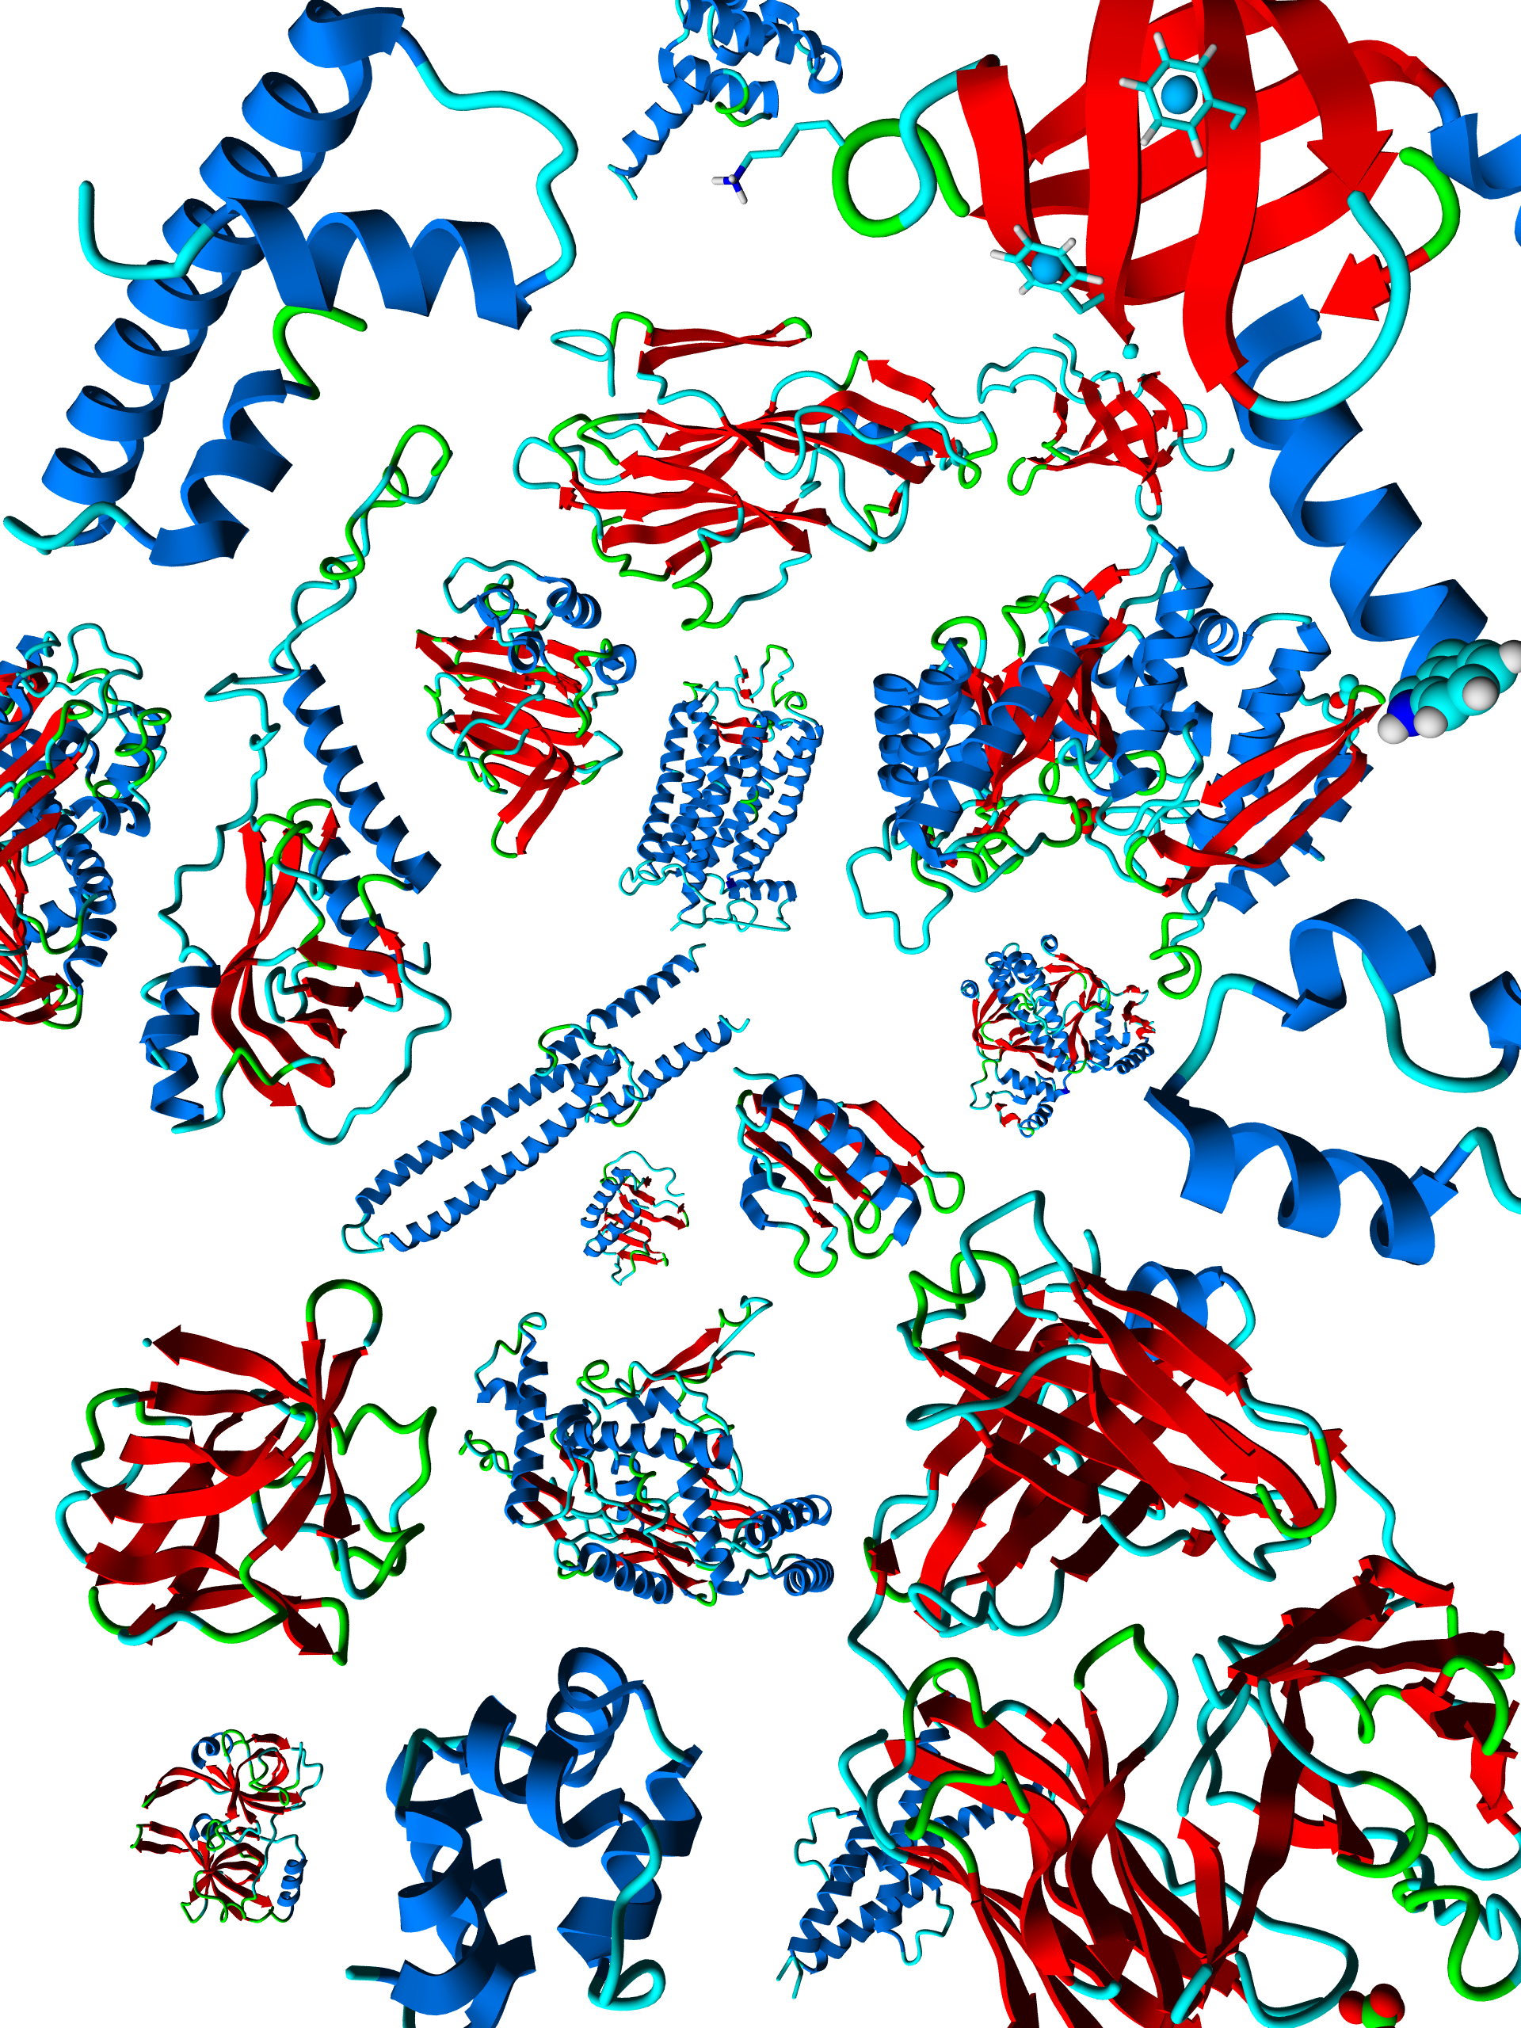
1
Introduction
The ultimate goal of protein modeling is to predict a structure from its sequence with an accuracy that is comparable to the best results achieved experimentally. This would allow to safely use rapidly generated in silico protein models in all the contexts where today only experimental structures provide a solid basis: structure-based drug design, analysis of protein function, interactions, or antigenic behavior, and rational design of proteins with increased stability or novel functions. In addition, protein modeling is the only way to obtain structural information if experimental techniques fail. Many proteins are simply too large for NMR analysis and cannot be crystallized for X-ray diffraction.
Normally time-intensive experiments are required to determine a protein structure. Two main techniques are available: X-ray diffraction on protein crystals, and nuclear magnetic resonance spectroscopy. The first is very accurate, but crystals can be hard to grow and protein structures may differ slightly in the crystal and in the living cell. The second allows to solve structures in their actual environment but yields mainly information about interatomic distances that must be converted to a 3D structure. This “embedding step” does not always work out. Predicting a protein structure is much faster than solving it experimentally, but therefore the accuracy is often also much lower. This chapter describes how structure prediction works.

Introduction to homology modeling
Elmar Krieger, Sander B. Nabuurs and Gert Vriend
Methods of Biochemical Analysis (2003) 44:509-23.

Template sequence B (arabinose binding protein, 300 residues)
Aligned region

|*||* | ||*|*|*| |**|| ||||*|*|||||||** | *|

Target sequence A (150 residues)
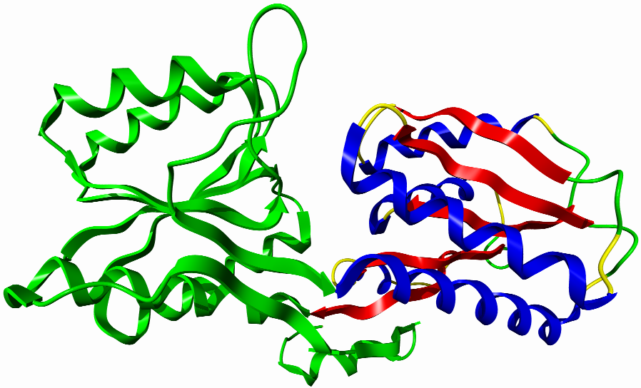Steps 1+2: Template identification
and alignment

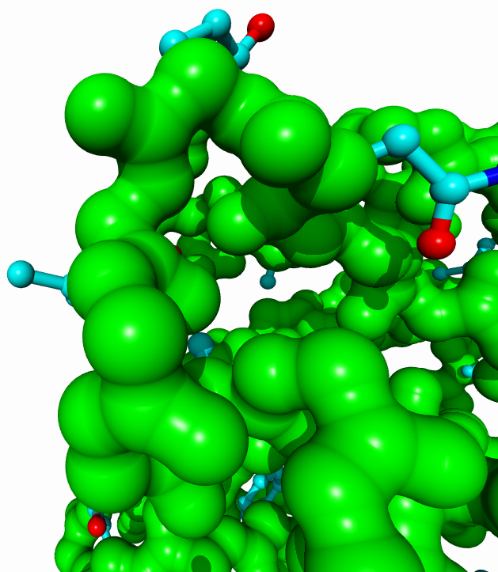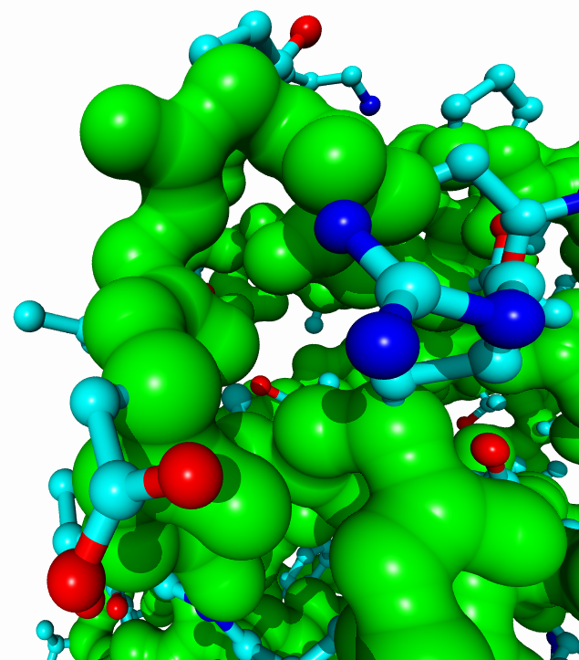

Steps 4+5 - Loop and side chain modeling Step 3 - Backbone generation
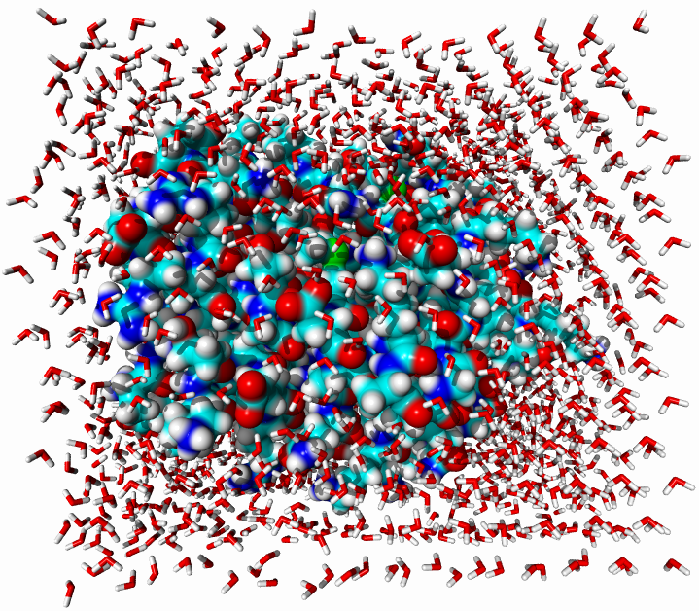

Step 6 - Model optimization
Figure 3: A typical residue exchange or scoring matrix used by alignment algorithms. Because the score for aligning residues A and B is normally the same as for B and A, this matrix is symmetric.
NLKLGFLVKQPEEPWFQTEWKFADKAGKDLGFEVIKIAVPDGEKTLNAIDSLAASGAKGFVICTPDPKLGSAIVAKARGYDMKVIAVDD
GFEVLSIGVPEGDKSLSAVESLPASGAHGYVICTPDPRVASALV
There are two major approaches to 3D structure prediction: one builds proteins from scratch, while the other one tries to modify known structures to arrive at the answer. The second approach, which is the topic of this thesis, is called homology modeling or comparative modeling and is considerably easier. It is based on two major observations:
The structure of a protein is uniquely determined by its amino acid sequence¹. Knowing the sequence should at least in theory suffice to obtain the structure.
During evolution, the structure is more stable and changes much slower than the associated sequence, so that similar sequences adopt practically identical structures, and distantly related sequences still fold into similar structures. This relationship was first identified by Chothia & Lesk² and later quantified by Sander & Schneider³. Thanks to the exponential growth of the Protein Data Bank, Rost could recently derive a more precise limit for this rule, shown in Figure 1⁴. As long as the length of two sequences and the percentage of identical residues fall in the region marked as "safe", the two sequences are practically guaranteed to adopt a similar structure.
Imagine that we want to know the structure of sequence A (150 amino acids long, Figure 2). We compare sequence A to all the sequences of known structures stored in the PDB (using for example BLAST), and luckily find a sequence B (300 amino acids long) containing a region of 150 amino acids that match sequence A with 50% identical residues. As this match ("alignment") clearly falls in the safe zone (Figure 1), we can simply take the known structure of sequence B (the "template"), cut out the fragment corresponding to the aligned region, mutate those amino acids that differ between sequences A and B, and finally arrive at our model for structure A. Structure A is called the "target" and is of course not known at the time of modeling.

Figure 1: The two zones of sequence alignments. Two sequences are practically guaranteed to fold into the same structure if their length and percentage sequence identity fall into the region marked as "safe". An example of two sequences with 150 amino acids, 50% of which are identical, is shown (gray cross).

Imagine that we want to know the structure of sequence A (150 amino acids long, Figure 2). We compare sequence A to all the sequences of known structures stored in the PDB (using for example BLAST), and luckily find a sequence B (300 amino acids long) containing a region of 150 amino acids that match sequence A with 50% identical residues. As this match ("alignment") clearly falls in the safe zone (Figure 1), we can simply take the
V A T T P D K S W L T V
A 0 5 0 0 1 0 0 1 -2 -1 0 0
S -1 1 2 2 0 0 0 5 0 -1 2 -1
T 0 0 5 5 0 0 0 2 -1 0 5 0
P -1 1 0 0 8 0 0 0 -3 -2 0 -1
E -2 1 1 1 1 2 1 1 -2 -2 1 -1
R -1 -1 0 0 0 -2 2 1 0 -1 0 -1
A 0 5 0 0 1 0 0 1 -2 -1 0 0
S -1 1 2 2 0 0 0 5 0 -1 2 -1
W -1 -2 -1 -1 -3 -3 -2 0 6 0 -1 -1
L 2 -1 0 0 -2 -2 -1 -1 0 5 0 2
G -1 0 -1 -1 0 0 0 0 -2 -2 -1 -1
T 0 0 5 5 0 0 0 2 -1 0 5 0
A 0 5 0 0 1 0 0 1 -2 -1 0 0
Figure 4: The alignment matrix for the sequences VATTPDKSWLTV and ASTPERASWLGTA, using the scores from Figure 3. The optimum path corresponding to the alignment on the right side is shown in gray. Residues with similar properties are marked with a star '*'. The dashed line marks an alternative alignment that scores more points but requires to open a second gap.

1 2 3 4 5 6 7 8 9 10 11 12 13
Template PHE ASP ILE CYS ARG LEU PRO GLY SER ALA GLU ALA VAL
Model(bad) 1 PHE ASN VAL CYS ARG ALA PRO --- --- --- GLU ALA ILE
Model(good) 2 PHE ASN VAL CYS ARG --- --- --- ALA PRO GLU ALA ILE
Figure 6. Example of a sequence alignment where a three-residue deletion must be modeled. While the first alignment appears better when considering just the sequences (a matching proline at position 7), a look at the structure of the template leads to a different conclusion (Figure 7).
?
Figure 5: A pathological alignment problem. Sequences A and B are impossible to align, unless one considers a third sequence C from a homologous protein.
Sequence A:
LTLTLTLT
Sequence B:
YAYAYAYAY
LTLTLTLT-
YAYAYAYAY
or
-LTLTLTLT
YAYAYAYAY
Sequence C:
TYTYTYTYT

