Awaken India Movement Vaccine Deaths Weekly Update

Vaccine Deaths in India covered by the Media! File updated till Victim #6174

Date - 22nd November 2021 Covid - 19 Vaccine Deaths in India
SR. NO. | Date | Name of The Newspaper | Relevant Portion of the Article |  | Link
1 | 09.01.2021 | TimesNowNews.com | Bhopal man dies 10 days after participating in Covaxin vaccine trial, MP govt initiates probe into ‘poisoning’ |  | https://www.timesnownews.com/india/article/bhopal-man-dies-10-days-after-being-administered-covaxin-during-vaccination-dry-run-mp-govt-initiates-probe/705056
2 | 18.01.2021 | https://greatgameindia.com/ | Indian Hospital Worker From UP Dies Just 24 Hrs After Receiving COVID-19 Vaccine Covishield |  | https://greatgameindia.com/indian-dies-vaccine-covishield/amp/?__twitter_impression=true
3 | 19.01.2021 | https://www.livemint.com | A health worker in Karnataka dies two days after getting Covid-19 vaccine shot The deceased, 43-year old Nagaraju of Ballari district, was a permanent employee of the state health department.  He was vaccinated on January 16 at around 1 pm and he was normal till this morning, the department said. |  | https://www.livemint.com/news/india/a-health-worker-in-karnataka-dies-two-days-after-getting-covid-19-vaccine-shot-11611015624832.html
4 | 21.01.2021 | https://www.indiatoday.in | Telangana ambulance driver dies hours after getting Covid vaccine, triggers panic |  | https://www.indiatoday.in/coronavirus-outbreak/story/telangana-ambulance-driver-dies-hours-after-getting-covid-vaccine-triggers-panic-1761246-2021-01-21
5 | 22.01.2021 | https://www.indiatoday.in | Gurugram health worker dies 6 days after Covid-19 shot, family seeks ban on vaccine  The family of a health worker who died six days after getting the Covid-19 vaccine is seeking a ban on the vaccine, however, the Gurugram CMO has said that it would be incorrect to connect the death with vaccine until post-mortem report it out. |  | https://www.indiatoday.in/coronavirus-outbreak/vaccine-updates/story/gurugram-health-worker-dies-6-days-after-covid-19-shot-family-seeks-ban-on-vaccine-1761854-2021-01-22
6 | 21.01.2021 | https://www.newindianexpress.com | Shivamogga doctor dies two days after Covid shot |  | https://www.newindianexpress.com/states/karnataka/2021/jan/21/shivamogga-doctor-dies-two-days-after-covid-shot-2252917.html
7 | 22.01.2021 | https://www.indiatoday.in | Rajasthan man dies 5 days after vaccination, panel says kidney issue led to haemorrhage  A panel probing adverse events following the vaccination against Covid-19 has investigated into the death of Suresh Chandra Sharma, who died five days after the vaccination in Rajasthan and concluded that the death was caused by his kidney ailment that led to brain haemorrhage. |  | https://www.indiatoday.in/coronavirus-outbreak/vaccine-updates/story/rajasthan-vaccine-death-panel-blames-kidney-ailment-1761621-2021-01-22
8 | 24.01.2021 | https://www.outlookindia.com | Andhra Pradesh ASHA Worker Dies After Receiving Covid-19 Jab; Unions Protest  ASHA workers staged a demonstration in front of the Government General Hospital in Guntur demanding that a compensation of Rs 50 lakh be paid to the deceased's family. |  | https://www.outlookindia.com/website/story/india-news-andhra-pradesh-asha-worker-dies-after-receiving-covid-jab-unions-protest/371676
9 | 24.01.2021 | https://timesofindia.indiatimes.com | A 45-year-old female healthcare worker in Telangana died on the early hours of Sunday, four-days after undergoing vaccination at Urban Primary Health Centre (UPHC) in New Shayampeta, Warangal Urban.  This is second death of a healthcare worker in Telangana who has received the vaccination. |  | https://timesofindia.indiatimes.com/city/hyderabad/female-health-worker-dies-post-covid-vaccination-in-telangana/articleshow/80434719.cms
10 | 27.01.2021 | https://in.news.yahoo.com | A 27-year-old healthcare worker died in Odisha on Tuesday, three days after taking the COVID-19 vaccine.  He was inoculated on January 23, and died in Veer Surendra Sai Institute of Medical Sciences and Research (VIMSAR) at Burla in Sambalpur district, an official statement said. |  | https://in.news.yahoo.com/odisha-healthcare-worker-dies-taking-184315423.html
11 | 30.01.2021 | https://www.newindianexpress.com | Kerala nurse dies a day after taking Covid vaccine.  Meanwhile, the officials clarified that the exact reason for the cardiac arrest could only be ascertained after getting the postmortem report |  | https://www.newindianexpress.com/states/kerala/2021/jan/30/kerala-nurse-dies-a-day-after-taking-covid-vaccine-2256894.html
12 | 31.01.2021 | https://www.livemint.com | A 55-year-old anganwadi teacher in the Mancherial district of Telangana, who was recently administered a vaccine against the novel coronavirus, died in a state-run healthcare centre. |  | https://www.livemint.com/news/india/telangana-vaccinated-teacher-dies-unrelated-to-covid-jab-say-doctors-11612089908740.html
13 | 01.02.2021 | https://www.indiatoday.in | A 30-year-old sanitation worker died in Gujarat's Vadodara district on Sunday two hours after being administered a coronavirus vaccine. Gujarat: Sanitation worker dies hours after getting Covid vaccine. |  | https://www.indiatoday.in/coronavirus-outbreak/story/gujarat-sanitation-worker-dies-hours-after-getting-covid-vaccine-1764580-2021-02-01
14 | 25.01.2021 | https://www.outlookindia.com | In Umaria township of Uttar Pradesh, a 55-year-old man died hours after being administered the coronavirus vaccine.  Pratap Ram was a Class IV employee of the Child Welfare and Nutrition department. He took the vaccine shot at the Mahila hospital on Thursday morning. By the evening of the same day, he took ill and died even before he could have been taken to the hospital. |  | https://www.outlookindia.com/website/story/india-news-man-dies-in-up-after-receiving-vaccine-shot-cmo-claims-death-due-to-heart-ailment/372583
15 | 02.02.2021 | https://mumbaimirror.indiatimes.com | A 61-year-old radiologist from Ulhasnagar Maharashtra, passed away on Sunday, 11 days after receiving the Covid-19 vaccine. |  | https://mumbaimirror.indiatimes.com/coronavirus/news/ulhasnagar-doctor-dies-11-days-after-receiving-covid-19-vaccine-kin-say-no-link-to-vaccination/articleshow/80641908.cms
16 | 03.02.2021 | https://www.hindustantimes.com | A health worker identified as Mannu Pahan, has died 36 hours after being administered Covid vaccine at Medanta Hospital in Ranchi, Jharkhand. |  | https://www.hindustantimes.com/india-news/jharkhand-health-worker-dies-36-hours-after-vaccination-101612343129545.html
17 | 15.03.2021 | https://hindi.news18.com https://react.etvbharat.com https://www.bhaskar.com | Case of Patepur area: Old man died within 36 hours of getting Kovid-19 vaccine in Patepur |  | https://hindi.news18.com/news/haryana/fatehabad-70-old-man-health-deteriorated-after-giving-corona-vaccine-in-fatehabad-hrrm-3518996.html https://react.etvbharat.com/hindi/haryana/state/fatehabad/man-died-after-corona-vaccination-in-fatehabad/haryana20210315225505714
18 | 21.03.2021 | https://www.livehindustan.com | Bihar: Anganwadi worker Corona suffers despite taking vaccine in Gaya, Patna AIIMS dies |  | https://www.livehindustan.com/bihar/story-anganwadi-worker-affected-from-corona-despite-taking-double-dose-of-vaccine-in-gaya-died-into-patna-aiims-3927384.html
19 | 11.04.2021 | https://www.amarujala.com | Retired SI dies in suspicious circumstances after getting Corona vaccine installed |  | https://www.amarujala.com/delhi/retired-si-dies-under-suspicious-conditions-after-getting-corona-vaccine-ashram-news-noi576455522
20 | 27.03.2021 | https://www.livehindustan.com | Fever after Corona vaccination, death during treatment |  | https://www.livehindustan.com/jharkhand/ranchi/story-fever-after-corona-vaccination-death-during-treatment-3939533.html
21 | 27.03.2021 | https://www.livehindustan.com | Rajasthan: 45 minutes after getting the Corona vaccine, the elderly died, there was no disease |  | https://www.livehindustan.com/rajasthan/story-a-man-dies-after-taking-shot-of-covid19-vaccine-in-rajasthan-sikar-3940336.html
22 | 20.03.2021 | https://www.amarujala.com | The gardener's death of the commissioner's residence, the vaccine was planted a day before |  | https://www.amarujala.com/uttar-pradesh/moradabad/the-gardener-s-death-of-the-commissioner-s-residence-city-news-mbd3835429186
 | 07.02.2021 | https://www.thehindu.com | India: official post vaccination death count as on February 05, 2021 is #22  India has reported 22 deaths so far following vaccination, though ("obviously") none of these are attributable to the vaccine itself!!, the Health Ministry said in a briefing on Friday. |  | https://www.thehindu.com/news/national/coronavirus-22-deaths-following-vaccination-health-ministry/article33762776.ece
 | 17.04.2021 | http://dhunt.in | Vaccine Injury |  | http://dhunt.in/e6o6k?s=a&uu=0x03123bf97938ff9b&ss=pd
23 | 02.02.2021 | https://www.newindianexpress.com | Manoharan from Chinnavanaickenpatti of Vilathikulam in Thoothukudi was employed as a conservancy worker at the Pudhur Village Panchayat.  Following the death of a 40-year-old Manoharan, who was recently administered the vaccine against Covid-19, his family members staged a sit-in protest at the Aruppukottai Government Hospital on Monday, blaming the vaccination for his death. |  | https://www.newindianexpress.com/states/tamil-nadu/2021/feb/02/tamil-naduconservancy-worker-diesdays-after-receiving-covid-19-vaccine-jab-2258209.html
24 | 08.02.2021 | https://timesofindia.indiatimes.com | A senior doctor Dr Kishan Nathani (77), MD (internal medicine), who owns a private hospital in Agra district of Uttar Pradesh died seven days after he was administered the Covid-19 vaccine. |  | https://timesofindia.indiatimes.com/city/agra/agra-doc-77-dies-a-week-after-covid-19-vaccination/articleshow/80738405.cms
25 | 95.02.2021 | https://timesofindia.indiatimes.com | A 33-year-old Accredited Social Health Activist (ASHA) worker from Belagavi, Karnataka state, died on February 3.  She was NOT suffering from any comorbidities including diabetes or hypertension.  This happens to be the third death post vaccination in the state. |  | https://timesofindia.indiatimes.com/city/bengaluru/karnataka-asha-worker-dies-12-days-after-vaccination-in-belagavi/articleshow/80712499.cms?UTM_Source=Google_Newsstand&UTM_Campaign=RSS_Feed&UTM_Medium=Referral
26 | 08.02.2021 | https://www.nationalheraldindia.com | Andhra village volunteer dies after taking COVID-19 vaccine.  Pilla Lalitha, 28, took the vaccine along with eight other volunteers on Sunday. All others suffered headache and fever-like symptoms while Lalitha's condition aggravated, leading to her death.  The Andhra Pradesh government on Wednesday paid ₹ 50 lakh compensation to the kin of village volunteer P Lalitha, who had died of complications after taking a coronavirus vaccine. |  | https://www.nationalheraldindia.com/national/andhra-village-volunteer-dies-after-taking-covid-19-vaccine
27 | 14.02.2021 | https://www.indiatoday.in | India has so far witnessed 27 deaths. Three deaths were reported in the past 24 hours among the people who had taken vaccination in the recent past, the health ministry briefed at a press conference. |  | https://www.indiatoday.in/coronavirus-outbreak/vaccine-updates/story/second-dose-coronavirus-vaccination-27-deaths-health-ministry-1769057-2021-02-14
28 | 16.02.2021 | https://m.timesofindia.com | A 24-year-old medical intern at the All India Institute of Medical Sciences (AIIMS-Rishikesh, Uttarakhand) died on Sunday, 11 days after getting the Covid vaccine. |  | https://m.timesofindia.com/city/dehradun/medical-intern-at-aiims-rishikesh-dies-10-days-after-covid-vaccination/amp_articleshow/80931953.cms
29 | 12.02.2021 | https://www.amarujala.com | Border Security Force (BSF) soilder Manish Chaudhary from Uttar Pradesh's Deoria district, died 5 days after COVID-19 vaccination.  Manish had informed about of his deteriorating health to his family after he was vaccinated on February 5th and there after he died on February 10th. He had also informed his family that his officers are forcing him to do the duty instead of giving him a medical treatment. |  | https://www.amarujala.com/gorakhpur/bsf-jawan-dead-body-reached-home-family-stopped-funeral-in-deoria
30 | 16.02.2021 | https://www.newindianexpress.com | Chhattisgarh cop died on February 15, three days after receiving COVID-19 vaccine.  The 34-year-old Assistant Sub-Inspector, along with nine others, was vaccinated against coronavirus under the frontline worker category at the Police Parade Ground here on February 12. |  | https://www.newindianexpress.com/nation/2021/feb/16/chhattisgarh-cop-dies-three-days-after-receiving-covid-19-vaccine-2264479.html
31 | 17.02.2021 | https://sambadenglish.com | Shakuntala Gochhayat (52), a resident of Kurudulu village in the Angul district of Odisha died while undergoing treatment at a private hospital in Bhubaneswar today morning. She was working as a Class IV contractual employee of the Nalco Hospital.  The woman’s husband, Dandadhara Gochhayat said she fell ill a day after taking the Covid vaccine during a vaccination drive conducted by the Angul District Administration on February 3. |  | https://sambadenglish.com/woman-dies-two-weeks-after-covid-jab-in-odisha/
32 | 18.02.2021 | https://www.timesnownews.com | Ministry of Health and Family Welfare (MoHFW) on Thursday, Feburary 18, said that a total of 32 people have died after being inoculated with Covid-19 vaccine in the country till now. |  | https://www.timesnownews.com/india/article/32-people-died-out-of-9846523-vaccinated-for-covid-19-in-india-till-now-health-ministry/722101
33 | 20.02.2021 | https://www.indiatvnews.com | frontline warrior (56), who was vaccinated on February 10 in Karnataka's Chikaballapura town, died on the way to a hospital here on Friday, February 19, while 2 others, including a woman healthcare worker are in serious condition days after they received the first shot, said the state health bulletin. |  | https://www.indiatvnews.com/news/india/coronavirus-vaccine-jab-sideeffect-frontline-worker-dies-686060
34 | 19.02.2021 | https://indianexpress.com | An Anganwadi worker (48) from Manipur’s Bishnupur district, who reportedly developed side effects after being administered with the Covid-19 vaccine, died on Friday, February 19.  The death came exactly a week after Naorem Sundari (48) received the jab. |  | https://indianexpress.com/article/north-east-india/manipur/manipur-anganwadi-worker-dies-after-taking-covishield-jab-had-recovered-from-asthma-attack-7196158/
35 | 22.02.2021 | https://www.outlookindia.com | Promila Devi, 55, a frontline health worker died due to serious complications she developed after getting vaccinated for Covid-19 at Hamirpur district in Himachal Pradesh. |  | https://www.outlookindia.com/website/story/india-news-anganwadi-worker-dies-after-covid-19-vaccination-govt-orders-probe/374992
36 | 22.02.2021 | https://www.newindianexpress.com | Ranjit Kumar Rout (56) working in Achia Hospital under Puri municipality in Odisha state, had received the first dose of the vaccine on January 16. After being administered the second dose on Saturday at Kamala Devi Matrumangal hospital, he developed chest pain and was rushed by his family to the district headquarters hospital where the doctor declared him brought dead. |  | https://www.newindianexpress.com/states/odisha/2021/feb/22/56-year-old-healthcare-worker-in-odisha-dies-after-receivingsecond-dose-of-covid-19-vaccination-2267187.html
37 | 21.02.2021 | https://www.outlookindia.com | Dipa Goutam (36) an anganwadi worker, who received the jab on February 8 in neighbouring Lakhimpur district, of Assam State died on Saturday February 20, after covid-19 vaccination.  Goutam had fever and started vomiting two-three days after vaccination. |  | https://www.outlookindia.com/newsscroll/no-fresh-covid19-fatality-in-assam-anganwadi-worker-dies-days-after-vaccination/2033933
38 | 23.02.2021 | https://www.india.com | Ramesh Kumar (54), a sanitation worker from New Delhi, received a jab of the Oxford-Serum vaccine Covishield against COVID-19 on February 17, died from health complications.  Ramesh Kumar was rushed to Deep Chand Bandhu Hospital on February 22, Monday morning and died there in the afternoon, his son Dheeraj said. |  | https://www.india.com/news/india/delhi-sanitation-worker-dies-days-after-receiving-covishield-vaccine-4443179/
39 | 11.02.2021 | https://www.newindianexpress.com | Krishnaiah (50), a sanitation worker of Mallamgunta panchayat of Chittoor district, Andhra Pradesh state was administered Covid vaccine around 11 am on Tuesday, February 09.  He died on Wednesday, February 10, a day after being administered Covid-19 vaccine. |  | https://www.newindianexpress.com/states/andhra-pradesh/2021/feb/11/sanitation-worker-dies-a-day-after-vaccination-in-andhra-pradesh-2262434.html
40 | 12.02.2021 | https://indianexpress.com | Nine days after vaccine shot, ASHA worker dies in Haryana State’s Panipat.  Kavita (35) was inoculated at the CHC in Panipat’s Atwala village on February 03. She developed side effects and had fever and died on February 12. |  | https://indianexpress.com/article/india/nine-days-after-vaccine-shot-asha-worker-dies-in-haryanas-panipat-7186230/
41 | 23.02.2021 | https://www.newindianexpress.com | Noorjahan (55) of Malyala village in Nandikotkur mandal, Kurnool district, Andhra Pradesh was an ayah in the local Anganwadi centre.  The death of a 55-year-old Anganwadi worker, who was administered Covid-19 vaccine on February 15, died on Monday, February 22, while undergoing treatment at GGH hospital. |  | https://www.newindianexpress.com/states/andhra-pradesh/2021/feb/23/anganwadiworker-dies-after-covid-jab-inandhra-pradesh-2267641.html
42 | 24.02.2021 | https://www.freepressjournal.in | Rajani Sen, a 60-year-old clerk from Barwani, Madhya Pradesh state, posted at the health department died here on Wednesday, February 24 a day after she received a second shot of corona vaccine. |  | https://www.freepressjournal.in/indore/barwani-60-year-old-clerk-dies-after-second-corona-vaccine-dose-death-creates-panic
43 | 20.02.2021 | https://timesofindia.indiatimes.com | Narayanamma, a 58-year-old anganwadi teacher died on February 20, 15 days after being administered the Covid-19 vaccine, in Ahobilapuram area, Pulivendula town in Andhra Pradesh state. |  | https://timesofindia.indiatimes.com/city/vijayawada/teacher-dies-days-after-vaccination/articleshow/81115450.cms
44 | 28.02.2021 | https://www.newindianexpress.com | Chandrakala (50), an ASHA worker in the government hospital at Kothacheruvu, Anantapur district, Telangana state, who was administered the second dose of Covid-19 vaccine two weeks ago, died of alleged Adverse Events Following Immunisation (AEFI). |  | https://www.newindianexpress.com/states/telangana/2021/feb/28/asha-worker-dies-after-covid-booster-shot-in-telangana-2269964.html
45 | 26.02.2021 | https://www.edexlive.com | 24-year-old dental college student, Mitha Mohan, took the first shot of Covishield vaccine at Government Medical College, Kannur, Kerala state.  The second shot was due in a few days for her, but she developed rashes, allergies and vomiting, following which, on February 24, Mitha succumbed to death. |  | https://www.edexlive.com/news/2021/feb/26/kerala-dental-student-dies-from-covid-after-receiving-vaccine-jab-hospital-denied-proper-treatment-18566.html?fbclid=IwAR12KvV3rdRhgcx5_bFoGIpDYssfV91EdRrrpanBfYxmsv3VHAfjp0di3dM
46 | 02.03.2021 | https://www.newindianexpress.com | Anganwadi worker, Nalluri Sunitha (40), died on Monday, March 01, developed health complications following immunisation against Covid-19. She had taken her first vaccine shot on January 21 at a PHC in Kalikivayi village, Guntur district, Andhra Pradesh state.  Sunitha had no health issues prior to the vaccination. After January 21, she suffered from loose motions and vomiting. A private hospital told that her kidneys were badly damaged. Finally, her husband brought her to SVIMS where she succumbed to death. |  | https://www.newindianexpress.com/states/andhra-pradesh/2021/mar/02/woman-dies-a-monthafter-taking-covid-jab-2270917.html
47 | 03.03.2021 | https://www.hindustantimes.com | Shubhendu Shubham, 23 year old final year MBBS student of Patna’s Nalanda Medical College Hospital (NMCH), who took the first jab of Covaxin, the Covid-19 vaccine around 22 days back, died late on Monday evening at his hometown Begusarai, Bihar State. |  | https://www.hindustantimes.com/india-news/barely-22-days-after-taking-first-jab-of-vaccine-medico-dies-of-covid19-101614707989111.html
48 | 03.03.2021 | https://indianexpress.com | Sukhdev Kirdat (45), a resident of Manorama Nagar, Bhiwandi, Mumbai, Maharashtra, worked as a driver with a private doctor.  Just 15 to 20 minutes after getting the second shot of Covishield Covid-19 vaccine, he fainted in the observation room and died on the spot on March 02, 2021. |  | https://indianexpress.com/article/cities/mumbai/maharashtra-over-33k-get-vaccine-man-dies-after-second-shot-7211725/
49 | 04.03.2021 | https://in.news.yahoo.com | Bahadur Singh Rajput (60), had got his first dose of the anti-Covid vaccination at a government primary health centre, died here on Thursday, March 04, a day after taking his first anti-Covid vaccination shot.  Singh’s family members told police that Singh felt dizziness and collapsed while taking his tea on Thursday, March 04, morning following which they rushed him to the government community health centre at Kaithun town where the doctors declared him “brought dead”.  He was a resident of of Garmodi village in Kota district, Rajasthan state. |  | https://in.news.yahoo.com/man-dies-day-taking-anti-122501280.html
50 | 07.03.2021 | https://www.thesangaiexpress.com | Another Angnwadi worker, Than-sing Hmar from Tui- sholen village, Jiribam district, Manipur state, who had recently received the first shot of the vaccine died on March 06. |  | https://www.thesangaiexpress.com/Encyc/2021/3/8/By-Our-Staff-ReporterIMPHAL-Mar-7-Days-after-an-Aganwadi-worker-died-post-Covid-vaccination-another-Angnwadi-worker-who-had-recently-received-the-first-shot-of-the-vaccine-died-yesterday-Shockin.html
51 | 09.03.2021 | https://timesofindia.indiatimes.com | Mumbai, Maharashtra state:– A 65-year-old Goregaon, resident collapsed within minutes of receiving the first dose of the AstraZeneca's Covishield vaccine at Millat Nursing Home, Jogeshwari, on Monday, March 08 and passed away one-and-half-hours later in ICU. |  | https://timesofindia.indiatimes.com/city/mumbai/mumbai-65-yr-old-goregaon-man-collapses-in-chair-dies-after-vaccine-1st-dose/articleshow/81402017.cms
52 | 10.03.2021 | https://www.newindianexpress.com | Krishna Dutta (64), a businessman and a senior citizen from West Bengal state's Dhupguri area died after being administered the Covishield vaccine, prompting his family members to lodge a police complaint. |  | https://www.newindianexpress.com/nation/2021/mar/10/elderly-man-dies-after-shot-of-covid-vaccine-in-bengal-family-members-lodge-police-complaint-2274492.html
53 | 09.03.2021 | https://www.newindianexpress.com | MUMBAI: A 65-year-old man died some time after he was given the first dose of the COVID-19 vaccine in a private hospital in Andheri in Mumbai on Tuesday, March 09. |  | https://www.newindianexpress.com/cities/mumbai/2021/mar/09/mumbai-senior-citizen-dies-after-covid-19-vaccination-2274412.html
54 | 28.03.2021 | https://www.hindustantimes.com | Mumbai, Maharashtra state:  Ramesh Nangare, Assistant Commissioner of Police (ACP), Sakinaka division, died of cardiac arrest on Thursday, March 11, morning, two days after he took the second dose of Covid-19 vaccine.  Nangare, who was to retire in 2024, was honoured by Governor BS Koshyari and home minister Anil Deshmukh for his outstanding work as a "Covid warrior". |  | https://www.hindustantimes.com/cities/mumbai-news/mumbai-acp-nangare-dharavi-s-covid-hero-dies-of-cardiac-arrest-101615485754878-amp.html
55 | 12.03.2021 | https://indianexpress.com | Mumbai, Maharashtra state:  The 65-year-old woman in Bandra West had received her first dose at Lilavati hospital last week. On March 6, when she did not answer her door bell, a neighbour used a spare key to open the door. She was found lying near her bed and was declared brought dead in the hospital. Officials said the woman, who lived alone, had no comorbidities. |  | https://indianexpress.com/article/cities/mumbai/12-member-panel-to-probe-deaths-of-3-mumbai-residents-after-vaccination/
56 | 12.03.2021 | https://www.indiatoday.in | Parul Dutta (75) from Darjeeling district, West Bengal died after she was inoculated with the Covishield vaccine on March 8. |  | https://www.indiatoday.in/coronavirus-outbreak/story/2-die-after-receiving-covid-19-jabs-in-bengal-probe-launched-1778368-2021-03-12
57 | 14.03.2021 | https://www.newindianexpress.com | Andhra Pradesh State:  Palli Kutumba Rao (65), from Pedavegi mandal, West Godavari district, who took Covid-19 vaccine at the government general hospital in Eluru, 2 days ago, died of health complications following immunisation on Friday, March 12 night. |  | https://www.newindianexpress.com/states/andhra-pradesh/2021/mar/14/elderly-man-dies-2-days-after-vaccination-in-eluru-2276379.html
58 | 14.03.2021 | https://m.timesofindia.com | Karnataka state:  A 71-year-old man who worked as a security guard at a private clinic near Konanakunte suburb of Banglore died on February 28, 18 days after taking the first dose of covid-19 vaccine. |  | https://m.timesofindia.com/city/bengaluru/state-has-seen-five-post-jab-fatalities/amp_articleshow/81490342.cms
59 | 16.03.2021 | https://www.newindianexpress.com | Karnataka state: A 73-year-old woman from Kanakapura, Ramanagara district died within two hours of taking the Covishield vaccine on Tuesday morning, March 16. |  | https://www.newindianexpress.com/states/karnataka/2021/mar/16/karnataka-woman-dies-two-hours-after-taking-covid-jab-sixth-post-vaccine-death-in-state-2277399.html
60 | 17.03.2021 | https://www.dailypioneer.com | Jharkhand state: Bagodar-Saria, Giridih district.  Krishna Kumar Maheshwari (75), father of Deepak Maheshwari, Congress District General Secretary died on Tuesday, March 16, after about 2 hours of taking the corona vaccine. |  | https://www.dailypioneer.com/2021/state-editions/septuagenarian-dies-2--hours-after-corona-vaccine.html
61 | 13.03.2021 | https://www.iraysmedia.in | Tamilnadu: Dr Hariharini 26-year-old Post Graduate Medical student in anaesthesia at the Madurai Medical College, died after developing severe anaphylaxis to Inj. Diclofenac which was given by her husband at home for myalgia and body fever following her COVID19 vaccination. |  | https://www.iraysmedia.in/heartbreaking-incident-in-madurai-happened-today/
62 | 17.03.2021 | https://www.freepressjournal.in | Uttar Pradesh: Mirzapur district  A 38-year-old man, resident of Bahuti village died on Wednesday, March 17, two days after taking Covid 19 vaccination at Community Health Center.  After coming home on March 15, he started vomiting and complained of a severe body ache at night. Local doctors refused to treat the vaccinated patient. When his condition deteriorated further, his wife brought him to the district hospital where he died during treatment. |  | https://www.freepressjournal.in/india/covid-19-in-uttar-pradesh-38-year-old-man-dies-two-days-after-taking-vaccination-jab
63 | 16.03.2021 | NEWSPAPER | 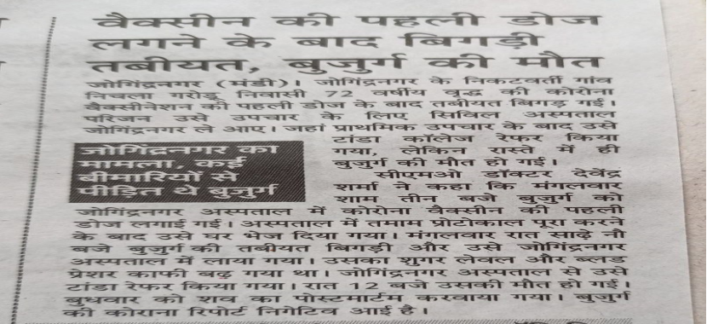  Himachal Pradesh: Mandi district  A 72 year old man from Nichala Garodu village died within 9 hours after he was administered first dose of Covid-19 vaccine.  He was vaccinated on Tuesday March 16 at 3:00 pm and died on the same day at night 12:00 pm. |  | 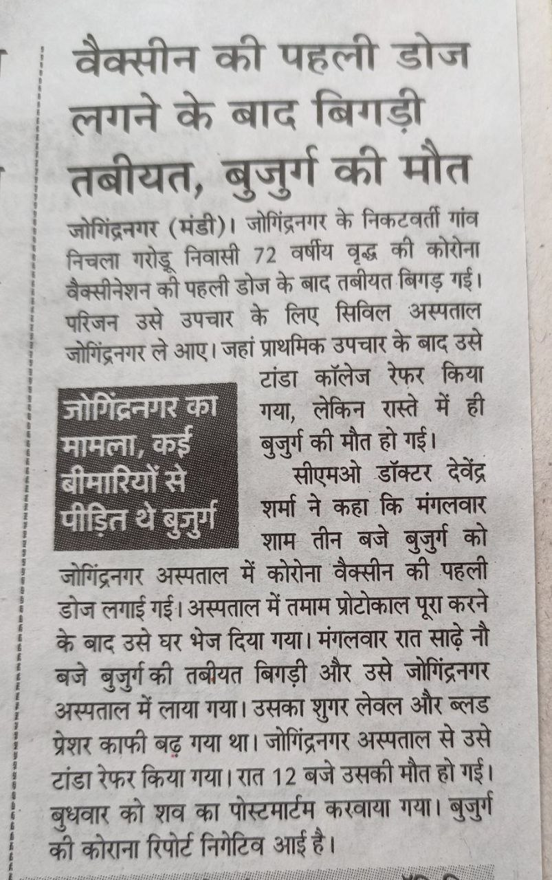
64 | 18.03.2021 | https://timesofindia.indiatimes.com | Jharkhand: Jamtara district  Shivcharan Mandal (72), died on Monday, March 15 night, just 4 hours after getting the first dose of the Covishield vaccine. |  | https://timesofindia.indiatimes.com/city/ranchi/autopsy-report-of-man-who-died-after-vax-awaited/articleshow/81556553.cms
65 | 25.03.2021 | https://www.loktej.com | Surat: Elderly woman dies in 24 hours after taking vaccine, already had sugar-pressure disease |  | https://www.loktej.com/news/surat-elderly-woman-dies-in-24-hours-after-taking-vaccine-already-had-sugar-pressure-disease
66 | 24.03.2021 | https://www.amarujala.com | Elderly person dies of corona after 10 days of getting vaccinated, family members performed the rituals themselves |  | https://www.amarujala.com/haryana/ambala/after-ten-days-of-vaccination-old-man-dead-ambala-news-knl651135111
67 | 22.03.2021 | http://dhunt.in | Was vaccinated 2 days ago, died suddenly |  | http://dhunt.in/dDdex?s=a&uu=0x03123bf97938ff9b&ss=pd
68 | 22.01.2021 | https://www.business-standard.com | Business Standard: Health worker dies days after jab; official says no vaccine link. |  | https://www.business-standard.com/article/current-affairs/health-worker-dies-days-after-jab-official-says-no-vaccine-link-121012201191_1.html
69 | 16.03.2021 | https://www.newindianexpress.com | The New Indian Express: Chhattisgarh cop dies three days after receiving COVID-19 vaccine. |  | https://www.newindianexpress.com/nation/2021/feb/16/chhattisgarh-cop-dies-three-days-after-receiving-covid-19-vaccine-2264479.html
70 | 29.04.2021 | https://economictimes.indiatimes.com/ | World Health Organisation to look into death of Indian doctor after Covishield dose |  | https://economictimes.indiatimes.com/industry/healthcare/biotech/pharmaceuticals/who-to-look-into-death-of-indian-doctor-after-jab/articleshow/82298283.cms
71 | 18.03.2021 | https://web.archive.org/ | As of March 17, 2021,  The National Adverse Events Following Immunisation (NAEFI) committee has recorded 71 deaths post COVID-19 vaccination.  Out of 71 people who have died, 70 had taken the Oxford-AstraZeneca's Covishield vaccine and one had taken Bharat Biotech's Covaxin vaccine. |  | https://web.archive.org/web/20210318200046/https://economictimes.indiatimes.com/industry/healthcare/biotech/healthcare/panel-finds-no-causal-link-yet-between-jabs-and-deaths/articleshow/81560132.cms?from=mdr
72 | 18.03.2021 | https://www.thehindu.com/ | Andhra Pradesh: Visakhapatnam  Chandrakala, a lab technician at the Madhurawada PHC died at the King George Hospital (KGH) here on Thursday, March 18, due to complications after taking her second dose of COVID-19 vaccine |  | https://www.thehindu.com/news/national/andhra-pradesh/lab-technician-dies-several-days-after-second-covid-19-shot/article34102818.ece
73 | 19.03.2021 | https://www.newindianexpress.com/ | Karnataka: Belagavi district  A 69-year-old man, who was a member of Kakati Gram Panchayat died on Tuesday, March 16, just within 9 hours after Covid-19 vaccination, making it the seventh death after vaccination in the stat |  | https://www.newindianexpress.com/states/karnataka/2021/mar/19/nine-hours-after-jab-man-dies-in-belagavi-2278506.html
74 | 19.03.2021 | https://www.newindianexpress.com/ | Chattisgarh: Mahasamund district  Vibhisan Banjare (62), resident of Savitripur died on Friday morning on March 19, after he took the COVID19 vaccine at the local government health and wellness centre on Thursday evening of March 18.  As per his family, Banjare complained of pain in his shoulder where he got the vaccination injection and was also sweating profusely. |  | https://www.newindianexpress.com/nation/2021/mar/19/chhattisgarh-man-dies-after-covid-19-vaccination-probe-begins-2278834.html
75 | 19.03.2021 | https://m.timesofindia.com/ | Haryana state: Panchkula district  The 70-year-old man died immediately after being administered the COVID19 vaccination at a Pinjore hospital on Friday March 19.  Within seconds after vaccination, he collapsed and was rushed to the emergency, where he was declared brought dead. |  | https://m.timesofindia.com/city/chandigarh/chandigarh-70-year-old-dies-after-taking-covid-jab/amp_articleshow/81598035.cms;https://timesofindia.indiatimes.com/city/dehradun/man-52-dies-after-getting-second-dose-of-vaccine-ukhand-reports-99-new-cases/articleshow/81593467.cms
76 | 19.03.2021 | https://timesofindia.indiatimes.com/ | Uttarakhand: Dehradun district  A 52-year-old Doiwala tehsil employee died on Friday, March 19, three days after getting the second dose of Covid vaccine.  The deceased got his second dose of vaccine on March 16 from Doiwala CHC, after that he developed severe chest pain. |  | https://timesofindia.indiatimes.com/city/dehradun/man-52-dies-after-getting-second-dose-of-vaccine-ukhand-reports-99-new-cases/articleshow/81593467.cms
77 | 20.03.2021 | https://m.facebook.com/ | Haryana: Karnal district  61 year old woman from Bijana village died on March 20, three days after being administered COVID19 vaccine on March 17. |  | https://m.facebook.com/KarnalBreakingNews/videos/178303373946705/?sfnsn=wiwspwa
78 | 19.03.2021 | https://timesofindia.indiatimes.com/ | Jharkhand: Simdega district  Jethu Ray Kotwar (60) died after he was administered COVID19 vaccine around 12 pm on Friday March 19 at Hardibera village in Keshalpur panchayat.  He fell ill minutes after taking the vaccine shot. An official at Rims said, “He vomited a few minutes after taking the jab and was shifted to the Simdega district hospital after he fell critically ill. As his condition continued to deteriorate, he was referred to Rims in the evening, but died win transit.” |  | https://timesofindia.indiatimes.com/city/ranchi/elderly-man-walks-10km-to-simdega-vax-centre-dies-hours-after-jab/articleshow/81608793.cms
79 | 20.03.2021 | NEWSPAPER | 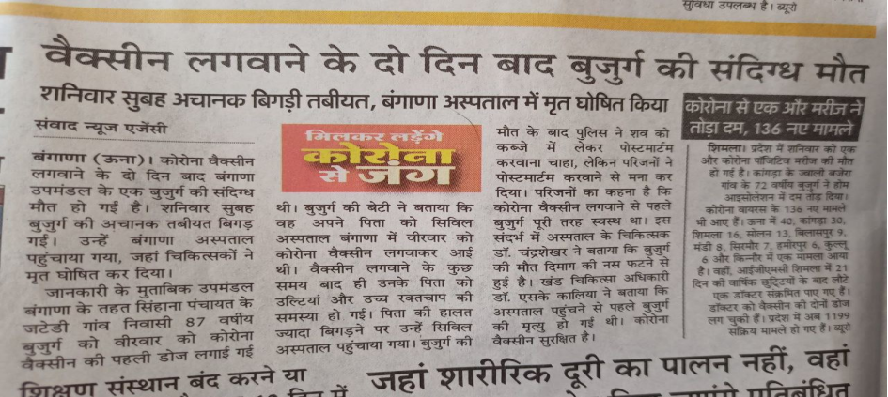  Himachal Pradesh: Una district  A 87 year old man from Jatedi village, Bangana tehsil, died on Saturday March 20, two days after being administered COVID19 vaccine.  According to his family the old man was perfectly fine before vaccination. He started vomiting and suffered from high blood pressure after vaccination and died in local civil hospital on second day due to critical condition. |  | 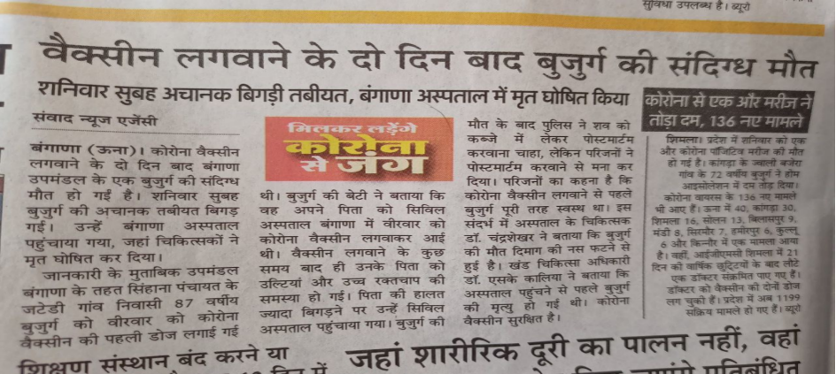
80 | 18.03.2021 | https://www.freepressjournal.in/ | Uttar Pradesh: Kannauj district  Yogesh Kumar Sankhwar, a safai karamchair posted at Bharamal Gram Panchayat, died on Saturday night, March 20, after being administered first dose of COVID19 vaccine on March 18.  The son of the deceased Ajay claimed that his father was avoiding taking vaccination. “He got a call from the department to get vaccination but he avoided taking it. But when the department officials mounted pressure on him, he was left no choice than to take the first dose of the vaccination. His condition worsened after taking the vaccine." |  | https://www.freepressjournal.in/india/uttar-pradesh-second-death-reported-after-taking-covid-19-vaccine
81 | 22.03.2021 | https://timesofindia.indiatimes.com/ | Karnataka state: Chikkaballapura district  68-year-old Venkatalakshmamma from Burudagunte village, Chintamani taluka, died on Sunday March 21, a week after she took the Covid-19 vaccine. She suffered a stroke and brain haemorrhage 24 hours after vaccination and according to Venkatalakshmamma’s son Muniyappa, his mother was doing well before taking the vaccine. “After taking the jab, she developed fever and was unable to speak,” The family’s ordeal continued as many hospitals in Bengaluru denied her admission. She was admitted to a private hospital, but the hospital bill reached ₹32,000 next day.Unable to afford the expense, Muniyappa took his mother back to Chikkaballapura district hospital, where she died around 4pm on Sunday. |  | https://timesofindia.indiatimes.com/city/bengaluru/karnataka-woman-dies-week-after-taking-shot/articleshow/81623910.cms
82 | 22.03.2021 | https://www.tribuneindia.com/ | Haryana: Hisar district  67-year-old Ramphal Sharma reportedly died on March 22, one hour after taking the COVID-19 vaccine in Badala village of Hansi in Hisar district.  Family members says that he died due to side-effects of the vaccination.  The deceased’s cousin Ramesh Pandit and nephew Vikas Sharma said that the vaccination team reached the village on Monday and said that the person who does not get vaccinated, his pension will be discontinued. Because of this threat, Ramphal Sharma got vaccinated, he said. |  | https://www.tribuneindia.com/news/haryana/67-year-old-man-dies-one-hour-after-taking-covid-19-vaccine-in-hisar-228973.
83 | 22.03.2021 | GOOGLE DRIVE LINK | Kedarnath Saroj an elderly man from Kaithola, Pratapgarh died on Monday, March 22, three days after he was administered COVID19 vaccine.  After vaccination he started feeling unwell and his health deteriorated severely on morning of March 22 and he died on the way to Raebareli city hospital. Blood clots were developed on his body due to vaccine. |  | https://drive.google.com/file/d/1TsTg6XiKnIb-T-MtJJM3KZbhl5nm  68zB/view?usp=sharing
84 | 22.03.2021 | NEWSPAPER | Rajasthan: Bundi district  Bhanwarlal Bairwa, 65 year old man from Kala Mal village died on Monday, March 22, just within 3 to 4 hours after being administered COVID19 vaccine. |  | 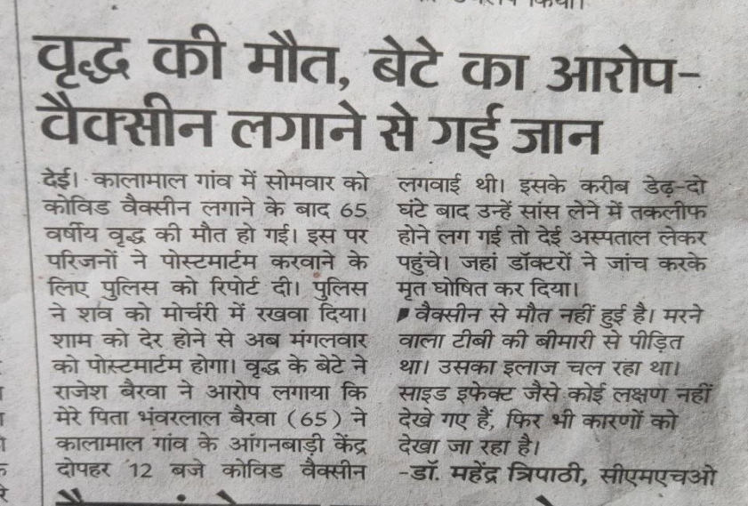  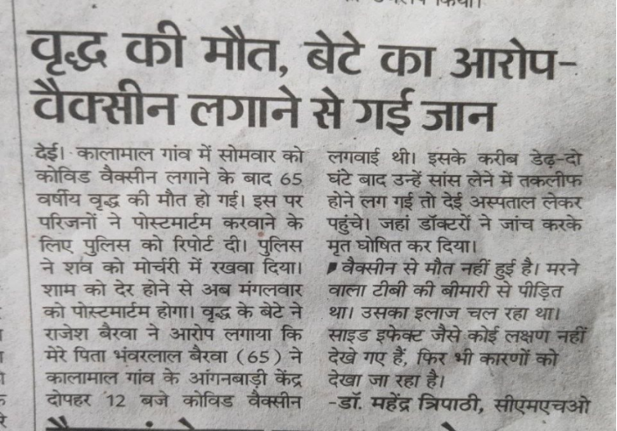
85 | 21.03.2021 | https://www.newindianexpress.com/ | Odisha: Puri district  Ranjit Kumar Rout, A 56-year-old healthcare supervisor working in Achia Hospital under Puri municipality, died after receiving the second dose of Covid-19 vaccination on Sunday, March 21.  After being administered the second dose on Saturday at Kamala Devi Matrumangal hospital, he developed chest pain and was rushed by his family to the district headquarters hospital where the doctor declared him brought dead. |  | https://www.newindianexpress.com/states/odisha/2021/feb/22/56-year-old-healthcare-worker-in-odisha-dies-after-receivingsecond-dose-of-covid-19-vaccine-2267187.html
86 | 27.02.2021 | https://navbharattimes.indiatimes.com/ | 2 detaths of Anganwadi workers in Madhya Pradesh from February month |  | https://navbharattimes.indiatimes.com/state/madhya-pradesh/morena/death-after-corona-vaccine-in-morena-of-mp-44-year-old-woman-dies-after-taking-second-dose-of-vaccine/articleshow/81244333.cms
87 | 27.02.2021 | https://bangaloremirror.indiatimes.com | 23-year-old male from Odisha's Nuapada district died after 1st dose |  | https://bangaloremirror.indiatimes.com/news/india/odisha-man-dies-after-taking-covid-19-vaccine-autopsy-report-awaited/articleshow/80484630.cms
(#88 to #102 missing)
103 | 06.05.2021 | https://www.newindianexpress.com/ | On Tuesday, March 23rd, In written reply to a question in Rajya Sabha, Minister of State for Health, Ashwini Choubey said,  "As on March 16, 2021, a total of 89 deaths of vaccinated persons have been reported. None of the deaths so far have been causally attributed to COVID-19 vaccination as per the current evidence."  ** Death counter has been reset according to Government's AEFI report as on March 16.  There are many unreported deaths happening post vaccination in India,  but Government of India hides AEFI data and don't disclose it regularly. |  | https://www.newindianexpress.com/nation/2021/mar/23/89-deaths-reported-following-covid-vaccination-till-march-16-but-none-attributed-to-vaccine-govern-2280495.html
104 | 07.05.2021 | https://www.telegraphindia.com | Jharkhand: East Singhbhum  Chandredeo Singh, A 71-year-old man died at Tata Main Hospital, Steel city, Jamshedpur on Monday, March 22, two days after taking the first dose of the Covishield vaccine at Seraikela-Kharsawan district on March 20. |  | https://www.telegraphindia.com/jharkhand/71-year-old-dies-two-days-after-vaccination-in-steel-city/cid/1810396
105 | 24.03.2021 | https://ndtv.in/ | Madhya Pradesh: Bhopal  Pushpraj Singh, 42 year old Homeguard Jawan from Bhopal, died on Monday, March 22, after receiving second dose of COVID19 vaccine on March 17.  According to his family, he was admitted at JP hospital on Sunday as his health deteriorated after taking second dose of covid vaccine.  On Monday morning he went missing and hospital informed to his family that the patient has ran away from the hospital without notice. But again 36 hrs later hospital staff reported that he was found dead in hospital ward's bathroom. |  | https://ndtv.in/mp-chhattisgarh-news/mp-hindi-news-home-guard-jawan-goes-missing-from-covid-ward-found-dead-in-toilet-2397799
106 | 24.03.2021 | https://nenow.in/ | Assam state: Jorhat district  Sankar Prasad Khound, a resident of Atila Gaon, has died at the Jorhat Medical College and Hospital (JMCH) on Tuesday, March 23, after being vaccinated on March 13. |  | https://nenow.in/north-east-news/assam/assam-man-who-took-covid-19-vaccine-dies-after-testing-positive-in-jorhat.html
107 | 07.05.2021 | https://www.bhaskar.com/ | Gujarat state: Surat district  Ramilaben Ratilal Ranchor bhai Patel, A 76 year old woman died on Wednesday, March 24, one day after receiving COVID19 vaccine.  Ramilaben resident of Kamrej of Surat city was given COVID19 vaccine on Tuesday 11:51 am. On the next day she complained about breathing congestion and weakness and died on the way to hospital. |  | https://www.bhaskar.com/local/gujarat/news/a-76-year-old-woman-dies-24-hours-after-taking-the-vaccine-128356312.html
108 | 26.03.2021 | https://www.aajtak.in/ | Jharkhand: Khunti district  Lakhmani Devi Munda a 62 year old woman from Jojohatu village died on Thursday March 25 after being vaccinated with COVID19 vaccine on Saturday March 20. She developed fever after being vaccinated and was admitted to RIMS in Ranchi where she died during treatment. |  | https://www.aajtak.in/coronavirus/story/jharkhand-woman-dies-after-the-shot-of-corona-vaccine-claims-family-rims-administration-denies-charges-khunti-1228359-2021-03-26
109 | 24.03.2021 | https://hindi.oneindia.com/ | Jharkhand: Koderma district  89 year old man from Markacho prakhand died within few hours after receiving COVID19 vaccine on Monday March 22 |  | https://hindi.oneindia.com/videos/amphtml/news-c66/kodaramah-vaiksin-lene-ke-bad-bujurg-ki-tabiyat-bigadi-ilaj-ke-dauran-hui-maut-dhnt-1452728.html
110 | 24.03.2021 | https://www.haribhoomi.com/ | Himachal Pradesh: Una district  Mohan Lal Pekha, a Government Revenue dept employee at Rohru, Shimla died at Kala village on Monday March 22, a week after his first dose of COVID19 vaccine. |  | https://www.haribhoomi.com/local/himachal-pradesh/una-coronavirus-fifty-year-old-men-dies-after-getting-corona-vaccine-hindi-news-371385
111 | 22.03.2021 | https://npg.news/ | Chattisgarh: Kanker district  Dhaniram, an old man from Hamatwahi village of Durgkondal died on Saturday March 20, at Pankhajur, within 24 hrs after receiving COVID19 vaccine |  | https://npg.news/breaking-another-death-occurred-shortly-after-applying-corona-vaccine-there-was-also-a-death-yesterday-there-will-be-an-inquiry-into-the-death-by-conducting-a-post-mortem/
112 | 24.03.2021 | https://news4nation.com/ | Bihar state: Vaishali district  An old man, resident of Ghataro Chaturbhuj village in Lalganj died on March 22, ten days after receiving COVID19 vaccine. |  | https://news4nation.com/news/hajipur-news-one-and-a-half-weeks-after-getting-the-corona-vaccine-the-elderly-died-people-were-shocked-the-health-department-made-a-quick-investigation-348130
113 | 26.03.2021 | https://indianexpress.com/ | Jharkhand: Latehar district  Devmani devi, 72 year old woman from Orsa Path village of Mahuadanr, died on Tuesday, March 23 two days after receiving COVID-19 vaccine.  She died at Rajendra Institute of Medical Science (RIMS) Ranchi during treatment in the wee hours on March 23. |  | https://indianexpress.com/article/india/jharkhand-72-year-old-woman-dies-covid-19-vaccine-jab-7245736/
114 | 26.03.2021 | https://www.tv9hindi.com/ | Madhya Pradesh: Ujjain district  Ramarao, a healthcare employee of Maleria department in Ujjain, died on Thursday March 25, two weeks after receiving COVID19 vaccine. |  | https://www.tv9hindi.com/state/madhya-pradesh/coronavirus-latest-news-health-worker-ramarav-dies-of-corona-virus-infection-after-both-doses-of-covid-vaccine-in-ujjain-594697.html
115 | 25.03.2021 | https://www.bhaskar.com/ | Himachal Pradesh: Kullu district  Juhi devi, a 74 year old women, from Shangchan Baradha village in Kullu died hours after receiving COVID19 vaccine on Thursday, March 25. |  | https://www.bhaskar.com/local/himachal/news/kullu-epidemic-woman-died-after-hours-of-corona-vaccine-heart-attack-is-being-told-the-cause-of-death-128360820.html
116 | 27.03.2021 | https://www.patrika.com/ | Rajasthan: Sikar district  Rameshwar lal Saini, 65 year old man from Bagwali dhani Arnia village died just 15 minutes after receiving COVID19 vaccine on Friday March 26.  Furious family members and villagers have surrounded Shrimadhopur police station since last 12 hours, demanding for action against the vaccinator accused. |  | https://www.patrika.com/sikar-news/man-died-after-15-minutes-of-corona-vaccination-6767969/
117 | 27.03.2021 | https://www.tv9hindi.com/ | Bihar state: Vaishali district  Sanjharia Devi, A 70 year old woman from Birma Math village, Belsar died after receiving COVID19 vaccine on Saturday March 27. |  | https://www.tv9hindi.com/state/bihar/70-year-old-woman-dies-after-taking-corona-vaccine-3-people-succumbed-to-virus-infection-in-vaishali-health-officer-reached-in-village-595682.html
118 | 23.03.2021 | https://www.jagran.com/ | Haryana state: Jind district  Hari Shankar, A 56 year old head electrician from Jind, died on Tuesday March 23, just a one day after he received COVID19 vaccine at Kaithal.  His family says Hari Shankar was perfectly fine and had no comorbidities before he took the vaccine and died suddenly a day after. |  | https://www.jagran.com/haryana/panipat-roadways-employee-died-just-one-day-after-taking-first-dose-of-corona-vaccination-in-kaithal-21494438.html
119 | 28.03.2021 | https://www.dailyexcelsior.com/ | Jammu Kashmir: Kupwara district  70 year old Ghulam Mohammad Ganie died within just 2 hours after he was administered COVID-19 vaccine jab in Handwara area of North-Kashmir’s Kupwara district on Saturday, March 27.  A family member said that he had lunch after vaccination and took sheep for grazing. He felt dizziness and went home for having some water but fell unconscious and was taken to hospital where he was declared as brought dead. |  | https://www.dailyexcelsior.com/70-yr-old-man-dies-after-vaccination/
120 | 29.03.2021 | https://www.livehindustan.com/ | Jharkhand: West Singhbhum district  65 year old, Jharkhand Mukti Morcha leader, Gangaram Kohad from Gotamba village of Goilkera prakhand died on Sunday March 28, two days after receiving COVOD-19 vaccine at Kuida panchayat bhavan on Friday, March 26. |  | https://www.livehindustan.com/jharkhand/story-jmm-leader-gangaram-kodah-deteriorates-after-corona-vaccine-dies-three-days-later-3943593.html
121 | 30.03.2021 | https://www.nagpurtoday.in/ | Maharashtra: Nagpur district  Pawar, a 55 year old, MR professional from Nagpur, died on Sunday, March 28, after receiving second dose of Covaxin. He suffered from server fever and cough before he died. |  | https://www.nagpurtoday.in/nagpur-man-dies-of-covid-after-taking-both-doses-of-vaccine/03301046
122 | 30.03.2021 | https://www.amarujala.com/ | Uttar Pradesh: Gautam Buddha Nagar district  Samay Lal Yadav, A 49 year old man from Nithari village, of Birsrakh block, died just within hours after he received COVID-19 vaccine on morning of Tuesday, March 30. |  | https://www.amarujala.com/delhi-ncr/noida/noida-one-man-vaccinated-in-morning-died-in-after-noon-family-create-furor-in-hospital-doctors-say-postmortem-report-will-tell-the-truth
123 | 30.03.2021 | https://www.livehindustan.com/ | Jharkhand: Garhwa district  70 year old woman, Savitri devi, from Gada Khurd village of Kandi prakhand died on Sunday, March 28, a day after receiving the COVID19 vaccine. |  | https://www.livehindustan.com/jharkhand/garhwa/story-elderly-woman-dies-24-hours-after-taking-corona-vaccine-3944652.html
124 | 31.03.2021 | https://news.raftaar.in/ | Assam: Barpeta district  29 year old young man, Deepak Jyoti Talukdar from Bajali Sarupeta village died on 31st March, a day after receiving COVID-19 vaccine.  He was a local school employee and was appointed on election duty, hence he was mandated to take COVID-19 vaccine. |  | https://news.raftaar.in/local-news/assam/a-young-man-dies-after-taking-kovid39s-vaccine
125 | 01.04.2021 | http://mdbharat.com/ | Chhattisgarh: Durg district  54 year old Police ASI, Prakash Das from Durg CSP office died on 1st April during treatment at district hospital, days after receiving second dose of COVID-19 vaccine. |  | http://mdbharat.com/archives/10848
126 | 02.04.2021 | https://www.jagran.com/ | Uttar Pradesh: Agra district  Phul Singh, 62 year old man, resident of Gadhi Ajita village of Khandauli died on Friday, April 02, just 27 hours after being injected with COVID-19 vaccine.  Aggrieved family members and relatives protested at CHC Khandauli & said that the death was caused by vaccine. |  | https://www.jagran.com/uttar-pradesh/agra-city-elderly-death-after-27-hours-of-applying-corona-vaccine-21521941.html
127 | 03.04.2021 | https://www.bhaskar.com/ | Bihar state: Patna district  80 year old Maulana Vali Rehmani from Patna died on Saturday April 03, 15 days after receiving first dose of COVID-19 vaccine at IGIMS in Patna.  He suffered from breathing problems immediately after his first dose of Covid vaccine & was ill from last 15 days before his death at Patna local hospital. |  | https://www.bhaskar.com/local/bihar/news/bihar-news-renowned-religious-leader-of-imarat-e-shariah-patna-syed-wali-rahmani-passed-away-of-corona-128381754.html
128 | 03.04.2021 | https://www.amarujala.com/ | Uttar Pradesh: Aligarh district  55 year old Suresh Kumar, a School Principal from Salpur village of Khair tehsil died on Saturday April 03, one day after receiving COVID-19 vaccine at Jattari village.  Suresh Kumar started to feel severe pain in chest and uneasiness at Friday night after receiving the vaccine on same day, thereafter he was hospitalized at Jevar where he died on Saturday morning. |  | https://www.amarujala.com/uttar-pradesh/aligarh/school-principal-die-after-corona-vaccination-tappal-news-ali260227210
129 | 03.04.2021 | https://www.bhaskar.com/ | Madhya Pradesh: Raisen district  75 year old man, Harnam Singh from Budhapar village of Silwani died on Saturday April 03, 39 hours after receiving COVID-19 vaccine. |  | https://www.bhaskar.com/local/mp/bhopal/raisen/news/death-of-elderly-positive-oxygen-levels-after-39-hours-of-vaccine-128384182.html
130 | 04.04.2021 | https://www.loktej.com/ | Gujarat state: Ahemdabad district  Mansukh Gedia from Thakkar Bappa area of Ahemdabad died on Saturday April 03, within 12 hours after receiving COVID-19 vaccine at Virat Nagar urban health center.  Mansukh's son said that, his father was perfectly fine before vaccination and he had consulted with doctor at vaccination center that he had undergone a bypass surgery 2.5 years ago, but the doctor asked him to go ahead and take the vaccine. Which resulted in death of his father. |  | https://www.loktej.com/news/ahmedabad-man-dies-after-breathing-problem-12-hours-after-taking-vaccine
131 | 04.04.2021 | https://www.naidunia.com/ | Chattisgarh: Raigarh district  75 year old man, Nakul Sidar from Putkapuri village of Pusaur tehsil died on Saturday April 03, three days after receiving COVID-19 vaccine. |  | https://www.naidunia.com/chhattisgarh/raigarh-teka-ka-bad-bigari-bujur-ki-halat-6790206
132 | 01.04.2021 | https://www.tribuneindia.com/ | Punjab: Patiala district  86-year-old, Kuldip Singh, from Patiala city, who received first dose of Covaxin on March 28, died on Thursday, April 1st night.  Kuldip Singh was the father of Dr GB Singh, Director, Punjab Health Department, and the father-son duo had received the vaccine doses at Patiala. |  | https://www.tribuneindia.com/news/patiala/86-yr-old-dies-4-days-after-getting-jabbed-234408
133 | 04.04.2021 | https://www.livehindustan.com/ | Uttar Pradesh: Bijnor district  58-year-old woman, Roshani devi, from Sisauna village, died on evening of Saturday April 03, few hours after receiving the COVID-19 vaccine.  Roshani devi was running as a candidate for district panchayat election, hence she took Covid-19 vaccine shot on afternoon of Sunday & by evening she had blood vomiting, after that she died before her family could take her to hospital. |  | https://www.livehindustan.com/uttar-pradesh/bijnor/story-corona-vaccine-in-the-afternoon-death-in-the-evening-3955514.html
134 | 05.04.2021 | https://www.amarujala.com/ | Uttar Pradesh: Meerut district 60-year-old man, Ompaal Singh, from Paadla village, died on Saturday April 03, two days after receiving COVID-19 vaccine.  Ompaal Singh was vaccinated by Kiratpur heath department team which had arrived in village on April 1st. After vaccination he suffered from server fever which lasted for 3 days before he died on Saturday night. |  | https://www.amarujala.com/uttar-pradesh/bijnor/death-under-suspicious-circumstances-bijnor-news-mrt5331569178
135 | 04.04.2021 | https://timesofindia.indiatimes.com/ | Odisha: Puri district  A 57-year-old man from Puri, died on Sunday, April 04 night, after receiving the first dose of Covishield vaccine in afternoon of the same day.  This is 6th AEFI death in the state, which include two each from Puri and Nabarangpur and one each from Nuapada and Angul districts. |  | https://timesofindia.indiatimes.com/city/bhubaneswar/man-dies-after-vax-in-puri-autopsy-report-awaited/articleshow/81927163.cms
136 | 05.04.2021 | https://www.bhaskar.com/ | Rajasthan: Nagaur district  55-year-old Ramprasad putra Gopiram Meghwal from Baliya village of Didwana tehsil, died on Monday, April 05, just 2 hours after receiving COVID-19 vaccine. |  | https://www.bhaskar.com/local/rajasthan/nagaur/news/death-of-middle-aged-2-hours-after-corona-vaccination-dr-bole-fear-of-heart-attack-report-is-awaited-128389219.html
137 | 06.04.2021 | https://www.patrika.com/ | Uttar Pradesh: Kannauj district  56-year-old, Ravindra Kumar Chauhan who was Assistant Professor at Hiralal inter college, resident of Chhibramau Nagar Parishad, died on Monday, April 05, after receiving COVID-19 vaccine on March 15 |  | https://www.patrika.com/kannauj-news/corona-positive-teacher-death-in-lucknow-6783693/
138 | 06.04.2021 | https://newswing.com/ | Jharkhand: Koderma district  Bhikani devi from Ambadih village of Tetari, Jaynagar Prakhand died on April 06, 24 hours after receiving COVID-19 vaccine |  | https://newswing.com/woman-dies-after-taking-corona-vaccine/244420/
139 | 05.04.2021 | https://www.newindianexpress.com/ | Odisha: Nabarangpur district  40-year-old Kamal Harijan of Chingdabhata village under Hatvarandi in Raigarh block died on Monday April 05 night, just 6 hours after receiving the COVID-19 vaccine. |  | https://www.newindianexpress.com/states/odisha/2021/apr/07/2-deaths-after-jab-in-nabarangpur-probe-underway-2286929.html
140 | 07.04.2021 | https://www.newindianexpress.com/ | Odisha: Nabarangpur district  66 year old Tankadhar Bisoi of Sundhiguda village, Papadahandi tehsil died on Sunday April 04 after receiving COVID-19 vaccine on Saturday April 03 |  | https://www.newindianexpress.com/states/odisha/2021/apr/07/2-deaths-after-jab-in-nabarangpur-probe-underway-2286929.html
141 | 07.04.2021 | https://www.patrika.com/ | Chhattisgarh: Rajnandgaon district  50 year old man from village Bajrangpur Nawagaon died on Tuesday, April 06, 15 days after receiving first dose of Covishield vaccine. |  | https://www.patrika.com/rajnandgaon-news/one-dead-in-rajnandgaon-after-first-dose-of-corona-vaccine-6785164/
142 | 05.04.2021 | https://www.bhaskar.com/ | Bihar state: Muzaffarpur district  52 year old Shivkumar Mehato from village Matlupur of Bandara died on Sunday, April 05, three days after receiving COVID-19 vaccine.  According to Shivkumar's son Pradeep Kumar, his father was in good health before vaccination on April 02, after he suffered from fever, stomach ache and vomitting and died on the way to Patna PMCH. |  | https://www.bhaskar.com/local/bihar/muzaffarpur/news/the-vaccine-was-given-on-2-april-the-doctor-said-no-side-effects-after-4-days-128393619.html
143 | 06.04.2021 | https://timesofindia.indiatimes.com/ | Uttar Pradesh: Bareilly district  A 75 year old man, resident of village Jhaunagla died on Tuesday, April 06, few hours after receiving COVID-19 vaccine.  After taking the vaccine in morning, he fell ill in the afternoon and his condition soon worsened. He was rushed to a Bareilly hospital by his family. He vomited blood in the ambulance and died on the way. |  | https://timesofindia.indiatimes.com/city/agra/elderly-man-dies-hours-after-covid-vaccination-in-bareilly/articleshow/81956760.cms
144 | 21.03.2021 | https://m.livehindustan.com/bihar/ | Bihar state: Gaya district  Vindyavasini devi, an Anganwadi worker, resident of Konch tehsil of Gaya died on Friday March 19, 14 days after receiving second dose of COVID-19 vaccine. |  | https://m.livehindustan.com/bihar/story-anganwadi-worker-affected-from-corona-despite-taking-double-dose-of-vaccine-in-gaya-died-into-patna-aiims-3927384.html
145 | 08.04.2021 | https://www.haryanaekhabar.com/ | Haryana: Rewari district  53 year old farmer from Naichana village of Bawal tehsil died on Tuesday, April 6, 24 hours after receiving COVID-19 vaccine.  The family claim that the death happened due to vaccine as the deceased person was healthy and harvesting crops in the farm before he went for vaccination, after that he started vomitting and died in hospital during treatment. |  | https://www.haryanaekhabar.com/rewari/person-dies-24-hours-after-vaccine-corona-infected-during-postmardem/
146-155 DATA MISSING |  |  |  | According to MoHFW official response, 103 AEFI deaths were recorded after COVID-19 vaccination as on March 18, 2021.  Hence we are resetting our counter to sync with Govt AEFI deaths, adding death reports after March 18. |  |  | 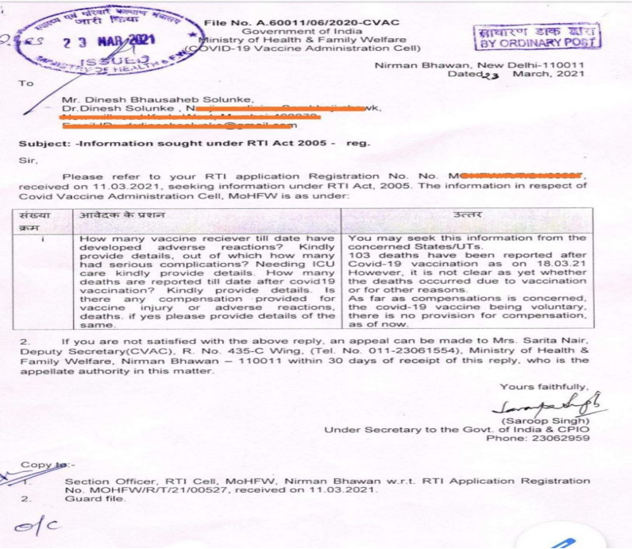
156 | 07.04.2021 | https://www.bhaskar.com/ | Rajasthan: Alwar district  53 year old woman Birma devi resident of Saini area of Shahjahanpur village, Nimrana tehsil died on Wednesday, April 7, just 15 hours after receiving COVID-19 vaccine.  Family of deceased says, Birma devi had no medical history & was perfectly healthy before vaccination. She was working in the farm before she went to vaccination center on Tuesday afternoon and died at 3 am on Wednesday in a local hospital. |  | https://www.bhaskar.com/local/rajasthan/alwar/news/death-of-53-year-old-woman-after-applying-corona-vaccine-in-shahjahanpur-alwar-many-people-got-vaccinated-from-the-same-cell-128396822.html
157 | 09.04.2021 | https://www.amarujala.com/ | Haryana: Faridabad district  63 year old man Krishna Lal, resident of SGM nagar of Faridabad, died on Saturday, April 3, within 24 hours after receiving COVID-19 vaccine.  Son of Krishna Lal, Dheeraj Kumar said his father experienced difficulty in breathing at night after receiving covid vaccine in morning, afterwards he was declared brought dead at local hospital. |  | https://www.amarujala.com/delhi-ncr/faridabad/successfully-sent-vaccination-message-to-dead-person-faridabad-news-noi5759132177
158-205 DATA MISSING
205 | 09.04.2021 | https://www.naidunia.com | A presentation made to the National AEFI (adverse event following immunisation) Committee on March 31st, recorded that there had been 180 deaths till that time and three-fourths (75%) of the deaths happened within three (3) days of the shot.  "Between March 16 and 29 there were 91 deaths", pointed out Siddarth Das, who has been tracking AEFI events reported from across the country.  Earlier in written reply to a question in Rajya Sabha, Minister of State for Health, Ashwini Choubey had reported 89 AEFI deaths through January 16 to March 16.  Note :-  Once again we are compelled to readjust AEFI death count (to #205 as of April 07) due to Government of India's secrecy about AEFI deaths and non disclosure policy. |  | https://www.naidunia.com/madhya-pradesh/sagar-vaccine-se-maut-6797378
206 | 02.04.2021 | https://m.timesofindia.com | Uttar Pradesh: Lucknow district  Former professor from Lucknow University AK Sharma (64) died on Thursday, April 01, due to respiratory failure after receiving COVID-19 vaccine on March 10. |  | https://m.timesofindia.com/city/lucknow/former-lu-prof-who-took-1st-shot-loses-covid-battle/amp_articleshow/81863814.cms
207 | 09.04.2021 | https://m.timesofindia.com | Madhya Pradesh: Sagar district 59 year old man Gulab Gaund, resident of Naiguwa village of Mokla gram Panchayat suffered from intense ferver after receiving COVID-19 vaccine and died on early morning of Friday, April 09, just 15 hours following vaccination. |  | https://www.naidunia.com/madhya-pradesh/sagar-vaccine-se-maut-6797378
208 | 09.04.2021 | https://newswing.com | Jharkhand: Palamu district Professor Kamal Nayan Sharma aged 55, resident of Medininagar, suffered from fever after receiving COVID-19 vaccine and died a week later on Thursday, April 08. |  | https://newswing.com/palamu-professor-who-fell-ill-after-applying-coronas-covishield-vaccine-succumbed-was-vaccinated-on-march-30/245124/
209 | 11.04.2021 | https://telanganatoday.com | Rajasthan: Barmer district Narayanpet: Woman dies after taking vaccine; heart attack, say doctors |  | https://telanganatoday.com/narayanpet-woman-dies-after-taking-vaccine-heart-attack-say-doctors
210 | 10.04.2021 | https://www.aajtak.in | Karnataka: Bangalore Urban district 80 year old man from South Bengaluru , succumbed to death on April 10, after receiving COVID-19 vaccine.  The old man had first dose of vaccine in first week of March, but soon after vaccination he caught fever and paralyzed. He was hospitalized on March 23, where he went in coma and died after 20 days. |  | https://www.aajtak.in/coronavirus/story/coronavirus-vaccine-80-year-old-falls-into-comatose-after-vaccination-dies-1236464-2021-04-10
211 | 08.04.2021 | https://m.facebook.com | Maharashtra: Mumbai City district 61 year old Sunil Mhatre, resident of Dahisar Mumbai died on Wednesday, April 07, within an hour after receiving COVID-19, Covishield vaccine at Nanavati hospital. |  | https://m.facebook.com/story.php?story_fbid=3724809150951626&id=100002677321880
212 | 10.04.2021 | https://newswing.com | Telangana: Narayanpet district 60 year old woman, Balanolla Savaramma, a resident of Kothapalli in Utkoor, who received Covid-19 vaccine on Friday, April 09 morning, died late on the same night.  After vaccination in morning Savaramma developed fever, body pains and chest pain before she breathed her last at around 10.30 pm. |  | https://telanganatoday.com/narayanpet-woman-dies-after-taking-vaccine-heart-attack-say-doctors
213 | 11.04.2021 | https://www.amarujala.com | Delhi: Brijpuri area 60 year old retired police officer, Jagdish Singh , resident of Yamuna Vihar near Brijpuri, who had received Covid-19 vaccine on March 31 died on Friday, April 09.  The deceased suffered from Diarrhea, fever and difficulty in breathing after vaccination for several days and died on the way to hospital on Friday. |  | https://www.amarujala.com/delhi/retired-si-dies-under-suspicious-conditions-after-getting-corona-vaccine-ashram-news-noi576455522
214 | 12.04.2021 | https://newswing.com | Jharkhand: Seraikela Kharsawan district 65 year old retired school teacher, resident of Simla village, died on Friday April 09, just within 8 hours of receiving second dose of COVID-19 vaccine. |  | https://newswing.com/65-year-old-elderly-who-had-taken-two-doses-of-vaccine-died-in-hospital-and-found-positive/245416/
215 | 11.04.2021 | https://m.jagran.com | Jharkhand: Giridih district 40 year old man, Narayan Prasad Verma, resident of Baati village of Jamua, died on Saturday April 10, a week after receiving first dose of COVID-19 vaccine.  Narayan Prasad suffered from fever after vaccination at Surat. While he was on the way to his home, his health deteriorated and he was shifted to Dhandbad hospital where he declared dead on Saturday. |  | https://m.jagran.com/jharkhand/giridih-one-person-from-jamua-died-in-dhanbad-21549718.html
216 | 11.04.2021 | https://www.amarujala.com | Uttar Pradesh: Lalitpur district 52 year old Ayodhya Prasad, State Electricity Board JE at Lalitpur, resident of Bhavanipur in Amethi, died on Sunday April 11, three days after receiving first dose of COVID-19 vaccine. |  | https://www.amarujala.com/uttar-pradesh/jhansi/coronavirus-update-uttar-pradesh-power-transmission-je-dies-after-vaccination-in-lalitpur
217 | 14.04.2021 | https://www.abplive.com | Bihar state: Arwal district Shyam Sundari devi, resident of Wasilpur village in Arwal, died on Monday April 12, four days after receiving COVID-19 vaccine.  Family members said the death was caused by vaccine and put the dead body on Patna–Aurangabad, National Highway 139 & protested furiously jamming the NH for three hours. |  | https://www.abplive.com/states/bihar/woman-dies-after-four-days-of-implanting-corona-vaccine-angry-relatives-created-ruckus-by-placing-bodies-on-nh-ann-1900689
218 | 12.04.2021 | https://navbharattimes | Uttar Pradesh: Agra district 65 year old Rajendra Singh, resident of Tikatpura village, died on late night of Monday April 12, within few hours after receiving COVID-19 vaccine in afternoon of the same day. |  | https://navbharattimes.indiatimes.com/state/uttar-pradesh/agra/person-dies-after-receiving-kovid-19-vaccine-in-agra/articleshow/82035373.cms
219 | 14.04.2021 | https://www.divyahimachal.com | Chattisgarh: Raipur district  Nodal officer of Chhatisgarh COVID-19 control campaign, Dr. Subhash Pandeya died on morning of April 14, after 3 days of hospitalization. He had received both doses of Covid-19 vaccine. |  | https://hindi.news18.com/news/chhattisgarh/raipur-state-nodal-officer-chhattisgarh-covid-control-campaign-dr-subhash-pandey-dies-corona-cgnt-3558068.html
220 | 14.04.2021 | https://www.livehindustan.com | Jharkhand: Garhwa district 60 year old man Mundrika Ram residet of Pipardih panchayat ShriBansidhar prakhand, died on Tuesday, April 13, after receiving COVID-19 vaccine. |  | https://www.livehindustan.com/jharkhand/garhwa/story-mischievous-elements-spread-rumors-of-elderly-death-by-taking-vaccine-officials-worried-3975275.html
221 | 14.04.2021 | https://www.aajtak.in/india | Jharkhand: Ranchi district Former Congress MLA Neil Tirkey resident of Simdega died on Wednesday April 14, after receiving covid-19 vaccine on April 02. He was ill since vaccination & admitted at RIMS hospital. |  | https://www.aajtak.in/india/jharkhand/story/corona-vaccine-ranchi-former-congress-mla-neil-tirki-death-1238682-2021-04-14
222 | 13.04.2021 | https://www.divyahimachal.com | Himachal Pradesh: Mandi district  61 year old man from Bhanvas village of Siraj, died on April 12, nine hours after receiving COVID-19 vaccine. |  | https://www.divyahimachal.com/2021/04/two-died-after-vaccine-in-the-market/amp/
223 | 12.04.2021 | https://www.divyahimachal.com | Himachal Pradesh: Mandi district 60 year old woman from Shodhadhar village of Bung Rail chowk grampanchayat, died on April 13, within 24 hours after receiving COVID-19 vaccine. |  | https://www.divyahimachal.com/2021/04/two-died-after-vaccine-in-the-market/amp/
224 | 14.04.2021 | https://www.livehindustan.com | Uttar Pradesh: Bahraich district A businessman from Rupaidiha village died on Tuesday, April 13, within a week after receiving second dose of COVID-19 vaccine. |  | https://www.livehindustan.com/uttar-pradesh/bahraich/story-potential-prime-candidate-dies-of-corona-3976900.html
225 | 13.04.2021 | http://dhunt.in | Madhya Pradesh: Rewa district 50 year old Hanuman Lal Pandey, resident of Bahera Sumant village of Nai Ghadhi, died on April 13, a day after receiving COVID-19 vaccine. |  | http://dhunt.in/e19Cu?s=a&uu=0x03123bf97938ff9b&ss=pd
226 | 14.04.2021 | http://dhunt.in | Jharkhand: Bokaro district 59 year old woman, Shishubala devi, resident of Balrampur of Jaridih, died on Tuesday April 13, within 6 hours after receiving COVID-19 vaccine. |  | http://dhunt.in/e1A1N?s=a&uu=0x03123bf97938ff9b&ss=pd
227 | 15.04.2021 | https://www.newindianexpress.com | Telangana: Ranga Reddy district Middle aged woman, Rajamoni Mayuri, Sarpanch of Lingamdana village of Keshampet mandal died on Wednesday April 14 night, 2 days after receiving COVID-19 vaccine. Her relatives held a protest on Friday and raised slogans demanding justice. They said that the state government must conduct an investigation into her death and come out with a report. |  | https://www.newindianexpress.com/states/telangana/2021/apr/15/sarpanch-dies-two-days-after-covid-19-vaccination-in-telangana-kin-stage-protest-2290320.html
228 | 12.04.2021 | https://indianexpress.com | Maharashtra: Mumbai city district 54 year old Police Sub-Inspector, Mohan Dagde, posted at the Vakola police station in Santacruz (East), died on April 12 after receiving his first dose of COVID-19 vaccine in February. There's no information if he had his second dose of vaccine.  His family would get a compensation of ₹50 lakh from the state government. Beside this, a sum of ₹10 lakh would also be given from the Mumbai Police welfare fund.  But there's no compensation for commoners if they die due to vaccine injury. |  | https://indianexpress.com/article/cities/mumbai/54-year-old-sub-inspector-dies-of-covid-7270625/
229 | 15.04.2021 | http://dhunt.in | Chattisgarh: Raipur district  Ganeshram Kanvar, Police head constable posted at Khamardih, died on Thursday, April 15, a week after receiving both doses of Covid-19 vaccine. |  | http://dhunt.in/e3kwM?s=a&uu=0x03123bf97938ff9b&ss=pd
230 / 231 | 15.04.2021 | http://dhunt.in | Madhya Pradesh: Satna district Aman Verman & Buti bai Lakhera from same Salayya village of Badera died on Wednesday April 14, within 24 hours of COVID-19 vaccination. |  | http://dhunt.in/e2Oid?s=a&uu=0x03123bf97938ff9b&ss=pd
232 | 16.04.2021 | https://www.amarujala.com | Uttar Pradesh: Gautam Budh Nagar district 44 year old healthworker, Krishna Kumar Chaunkar, resident of Bankapur village, died on Wednesday April 14, days after receiving second dose of COVID-19 vaccine. |  | https://www.amarujala.com/delhi-ncr/noida/health-worker-dies-of-corona-even-after-both-vaccine-doses-in-noida
233 | 16.04.2021 | https://www.facebook.com | Rajasthan: Bhilwara district 53 year old State Government employee Shantilal resident of Bamanwas village, died on Friday, April 16 at Gangapur city civil hospital, a week after receiving COVID-19 vaccine. |  | https://www.facebook.com/gangapurcityportal/videos/819836465292472/
234 | 16.04.2021 | https://bollywoodkeeda.in | Maharashtra: Mumbai city district 67 year old lyricist, Pandit Kiran Mishra, died on afternoon of Friday, April 16 at Andheri East, 15 days after receiving first dose of COVID-19 vaccine. |  | https://bollywoodkeeda.in/2021/04/16/lyricist-pt-kiran-mishra-died-due-to-corona-15-days-before-the-first-dose-of-corona-vaccine-was-applied/
235 | 17.04.2021 | https://m.timesofindia.com | Tamilnadu: Chennai district Tamil actor Vivekh (59) passed away at around 4.35 am on Saturday, April 17 at a private hospital in Chennai. He suffered a massive cardiac arrest on April 16, a day after receiving "Covaxin" COVID-19 vaccine. |  | https://m.timesofindia.com/city/chennai/vivek-tamil-film-actor-dies-in-chennai-hospital/amp_articleshow/82111036.cms
236 | 16.04.2021 | https://www.aajtak.in | Madhya Pradesh: Jabalpur district Mahamandaleshwar Dr Swami Shyam Devacharya of Narsinha Mandir of Jabalpur, died on Friday, April 16, days after receiving second dose of COVID-19 vaccine. |  | https://www.aajtak.in/india/story/mp-jabalpur-priest-of-narsingh-temple-dr-swami-shyam-devacharya-passed-away-went-to-haridwar-kumbh-1240094-2021-04-16
237 | 18.04.2021 | https://www.jagran.com | Uttar Pradesh: Allahabad district Retired Surgeon Dr Jagdish Mishra resident of Mumfordganj locality in Prayagraj, died on Friday, April 16, a week after receiving 2nd dose of COVID-19 vaccine. |  | https://www.jagran.com/uttar-pradesh/allahabad-city-dr-jk-mishra-dies-in-prayagraj-even-after-applying-second-dose-of-covid-vaccine-wife-also-positive-21567900.html
238 | 17.04.2021 | https://www.jagran.com | Bihar state: Siwan district A head clerk in Ziradei zonal office, died on Saturday, April 17, days after receiving COVID-19 vaccine. |  | https://www.jagran.com/bihar/siwan-one-died-by-corona-21567943.html
239 | 17.04.2021 | https://www.naidunia.com | Chhattisgarh: Mahasamund District 56 year old, N.R. Devangan, Asst commissioner of Tribal Welfare Department, at Mahasamund, died on Friday, April 16, a day after receiving COVID-19 vaccine. |  | https://www.naidunia.com/chhattisgarh/mahasmund-two-officers-died-from-corona-in-mahasamund-district-6813337
240 / 241 | 18.04.2021 | https://timesofindia.indiatimes.com | Maharashtra: Thane District Dr. Nagendra Mishra (58) and his son Dr. Suraj Mishra (28), resident of Kalyan city, both died on Friday, April 16, after receiving first dose of COVID-19 vaccine in March month. Father and son, both doctors, die of Covid in Maharashtra; mother serious |  | https://timesofindia.indiatimes.com/city/mumbai/mumbai-father-son-doc-duo-from-kalyan-had-taken-1st-jab/articleshow/82122432.cms https://m.timesofindia.com/city/thane/father-and-son-both-doctors-die-of-covid-in-maharashtra-mother-serious/amp_articleshow/82111403.cms
242 | 18.04.2021 | https://www.jagran.com | Jharkhand: Giridih District 54 year old woman Suma devi resident of Golhayya village of Naudiha, died on Sunday morning, April 18, three days after receiving COVID-19 vaccine. |  | https://www.jagran.com/jharkhand/giridih-woman-dies-three-days-after-taking-the-vaccine-21569934.html
243 | 18.04.2021 | https://www.livehindustan.com | Uttar Pradesh: Kannauj District 55 year old man Shrikrishna resident of Balanpur village of Tirva died on Sunday, April 18, a week after receiving COVID-19 vaccine. |  | https://www.livehindustan.com/uttar-pradesh/kannauj/story-death-of-villager-due-to-high-fever-corona-vaccine-was-introduced-3984581.html
244 | 15.04.2021 | https://hindi.oneindia.com | Bihar: Gopalganj District Urmila devi Mehato, resident of Sonvarsha village of Barauli died on Thursday, April 15, four days after receiving first dose of COVID-19 vaccine. |  | https://hindi.oneindia.com/videos/gopalaganj-korona-tika-lene-ke-char-din-bad-hui-mahila-ki-maut-parijano-me-macha-koharam-dhnt-1494948.html
245 | 14.04.2021 | https://www.facebook.com | Bihar state: Buxar District 60+ year old man Ramashankar Singh resident of Karsar village of Nawanagar tehsil died on Wednesday, April 14, two days after receiving first dose of COVID-19 vaccine. |  | https://www.facebook.com/117141776350918/videos/290392622496788
246 | 18.04.2021 | https://www.newindianexpress.com | Uttar Pradesh: Ballia District 45 year old woman Pushpa resident of Bahadurpur village of Ballia tehsil died on Sunday, April 18, after receiving COVID-19 vaccine. |  | https://www.newindianexpress.com/nation/2021/apr/18/uttar-pradesh-woman-dies-after-taking-covid-vaccine-kin-create-fuss-atballia-government-hospital-2291656.html
247 / 248 / 249 | 18.04.2021 | https://www.newindianexpress.com | Karnataka: Bengaluru Urban District ASI officer from Ashok Nagar aged 50,  Reserve ASI from VIP security division aged 56, and a Head Constable aged 46, from Bengaluru city police department, died on Friday, April 16, days after getting vaccinated against COVID-19. |  | https://www.newindianexpress.com/cities/bengaluru/2021/apr/18/over-100-bengaluru-cops-test-covid-positive-most-vaccinated-2291459.amp
250 | 19.04.2021 | https://himachal.punjabkesari.in | Himachal Pradesh: Kangra District 58 year old man, Hemraj, resident of Rihal pura village of Kangra tehsil died on Sunday, April 18, a day after receiving first dose of COVID-19 vaccine. |  | https://himachal.punjabkesari.in/himachal-pradesh/news/kangra-vaccine-person-death-1369028
251 | 18.04.2021 | http://awazdainik.com | Bihar state: Begusarai District 75 year old retired teacher, Shyam Lal Mandal, resident of Garhara village of Barauni tehsil died on Sunday, April 18, a week after receiving second dose of COVID-19 vaccine. |  | http://awazdainik.com/11127/
252 | 19.04.2021 | Google Drive Link | Chattisgarh: Raipur District Chattisgarh: Raipur District of Guma village of Raipur tehsil died on Monday, April 19, ten days after receiving COVID-19 vaccine. |  | https://drive.google.com/file/d/1f-Z2KsR6ogyFCqYpnlcaHZ8eclZb7HiE/view?usp=sharing
253 | 15.04.2021 | https://www.bhaskar.com | Madhya Pradesh: Sagar District A police head constable Kallu Tiwari, posted at Sanodha village of Sagar tehsil, died on Tuesday morning of April 20, just within 18 hours of receiving second dose of COVID-19 vaccine. |  | https://www.bhaskar.com/local/mp/sagar/news/havildar-dies-of-hurt-attack-during-treatment-in-hospital-deteriorating-after-getting-second-dose-of-corona-vaccine-128431543.html
254 | 20.04.2021 | http://dhunt.in | Chattisgarh: Baster District 72 year old woman, Dayamani, resident of Bhejaripadar village of Tokapal tehsil, died on Tuesday, April 20, within 24 hours of receiving COVID-19 vaccine. |  | http://dhunt.in/eeuAv?s=a&uu=0x03123bf97938ff9b&ss=pd
255 | 10.04.2021 | https://m.jagran.com | Jharkhand: Dhanbad District BJP leader and spokesperson, Ashok Singh Solanki, resident of Dhanbad city, died on Saturday, April 09, 15 days after receiving COVID-19 vaccine. |  | https://m.jagran.com/jharkhand/dhanbad-demise-of-bjp-leader-ashok-singh-solanki-21545697.html
256 | 15.04.2021 | https://www.jagran.com | Uttar Pradesh: Saharanpur District Famous lyricist and poet Rajendra Rajan (65) resident of Saharanpur city, died on Thursday, April 15, days after receiving first dose of COVID-19 vaccine. |  | https://www.jagran.com/uttar-pradesh/meerut-city-famous-lyricist-and-poet-rajendra-rajan-dies-in-saharanpur-mourning-in-the-literary-world-21560556.html
257 | 19.04.2021 | https://m.jagran.com | Uttar Pradesh: Saharanpur District Famous lyricist and poet Rajendra Rajan's wife Vibha Mishra (62) resident of Saharanpur city, died on Monday, April 19, days after receiving first dose of COVID-19 vaccine. She even didn't reach hospital and died on the way. |  | https://m.jagran.com/lite/uttar-pradesh/meerut-city-five-days-after-the-death-of-poet-and-lyricist-rajendra-rajan-his-wife-also-died-from-corona-21573950.html
258 | 06.04.2021 | https://news.raftaar.in | Chattisgarh: Raigarh District 62 year old man Mahummad Fazlul, resident of Kolaibahal village of Raigarh tehsil died on Tuesday, April 06, a week after receiving COVID-19 vaccine. |  | https://news.raftaar.in/raigad-elderly-death-due-to-increased-bp-and-brain-hemorrhage-after-the-introduction-of-corona-vaccine
259 | 07.04.2021 | https://www.livehindustan.com | Uttar Pradesh: Bareilly District 75 year old man Hardayal resident of Zhaungala village of Majhgawan block died on Tuesday, April 06, just within 3 hours of receiving COVID-19 vaccine. |  | https://www.livehindustan.com/uttar-pradesh/bareily/story-sick-elderly-dies-after-being-vaccinated-in-bareilly-3960518.html
260 | 21.04.2021 | https://www.amarujala.com | Delhi: Vinod Nagar 65 year old retired teacher, Surjan Singh Bisht, resident of Vinod nagar, died on Monday, April 19 after receiving first dose of COVID-19 vaccine on March 25. |  | https://www.amarujala.com/delhi-ncr/ghaziabad/ghaziabad-shahibabad-news-gbd2175077127
261 / 262 | 20.04.2021 | https://www.livehindustan.com | Jharkhand: Ranchi District Policeman Santosh Kumar Sav from Ranchi & Shriris Hembram from Devghar died on Tuesday, April 20, days after receiving 2nd dose of COVID-19 vaccine. |  | https://www.livehindustan.com/jharkhand/ranchi/story-policeman-dies-even-after-taking-second-dose-of-vaccine-3988014.html
263 | 19.04.2021 | Google Drive Link | Chattisgarh: Raipur District 58 year old healthy woman, Draupadi Sinha, resident of Charoda village died on Monday, April 19, a week after receiving COVID-19 vaccine. |  | https://drive.google.com/file/d/1cTBsphO3xv1Q0DGuIpjbEhkL42N4iZBT/view?usp=sharing
264 | 17.04.2021 | https://www.esakal.com | Maharashtra: Satara District 60 year old man, Sampat Jadhav, resident of Rethare Budruk village of Karad tehsil died on Friday, April 16, within few hours after receiving COVID-19 vaccine. |  | https://www.esakal.com/satara/one-person-dies-after-receiving-corona-vaccine-at-rethare-satara-news
265 | 21.04.2021 | https://indianexpress.com | Delhi: Outer-North district Police ASI Harish Kumar (38), posted at Samaipur Badli police station, died on Monday, April 19, weeks after receiving first dose of COVID-19 vaccine. |  | https://indianexpress.com/article/cities/delhi/delhi-police-asi-dies-positive-covid-7282659/
266 | 21.04.2021 | https://sambadenglish.com | Odisha: Sundargarh District 53 year old man, Anadi Behera, resident of Bileimunda village in Hemgir tehsil died on Wednesday, April 21, six days after receiving first dose of COVID-19 vaccine. |  | https://sambadenglish.com/odisha-man-dies-six-days-after-receiving-covid-19-vaccine/
267 | 18.04.2021 | https://m.facebook.com | Delhi: capital city Famous playback singer Sonu Nigam's Brother in law, who was about 49 year old, died on Sunday morning of April 18 at Delhi, days after receiving COVID-19 vaccine. |  | https://m.facebook.com/story.php?story_fbid=307089340787366&id=100044589062278
268 | 22.04.2021 | https://www.patrika.com | Rajasthan: Sikar district 25 year old police constable, Banwari Lal Bhinchar, resident of Tarpura village of Sikar tehsil, died on Thursday April 22, days after receiving second dose of COVID-19 vaccine. |  | https://www.patrika.com/sikar-news/25-year-old-constable-dies-of-corona-after-two-doses-of-vaccine-6811547/
269 | 22.04.2021 | https://www.jagran.com | Bihar state: Patna district Manju kumari Dubey, Railway employee at Danapur station, died on Tuesday April 20, four days after receiving first dose of COVID-19 vaccine. |  | https://www.jagran.com/bihar/patna-city-in-rail-mandal-hospital-dead-body-lay-down-21580177.html
270 | 19.04.2021 | https://www.amarujala.com | Uttar Pradesh: Kanpur Nagar district Retired police inspector, Santosh Sachan (65), resident of Naubasta village died on Sunday, April 18, a week after receiving COVID-19 vaccine. |  | https://www.amarujala.com/uttar-pradesh/kanpur/corona-in-kanpur-19-policemen-including-additional-police-commissioner-found-corona-infected
271 | 22.04.2021 | https://www.livehindustan.com | Uttar Pradesh: Kannuj district Retired school head master, Ramsharan Tiwari, resident of Sakrawa village died on Thursday, April 12, days after receiving COVID-19 vaccine. |  | https://www.livehindustan.com/uttar-pradesh/kannauj/story-three-patients-died-again-in-medical-college-3991857.html
272 | 19.04.2021 | https://www.bbc.com | Uttar Pradesh: Allahabad district Dr. Jagdish Kumar Mishra, aged around 80 years, resident of Mumfordganj, Prayagraj, died on Friday, April 16, a week after receiving 2nd dose of COVID-19 vaccine. |  | https://www.bbc.com/hindi/india-56797795
273 | 20.04.2021 | https://www.bhaskar.com | Uttar Pradesh: Jalaun district Lallu Ram Verma (60), a Pradhan candidate in grampanchayat election, resident of Madanpur Pichaura village of Rampura, died on Monday, April 19, two days after receiving first dose of COVID-19 vaccine. |  | https://www.bhaskar.com/local/uttar-pradesh/lucknow/news/uttar-pradesh-coronavirus-updates-cases-lockdown-latest-news-lucknow-kanpur-kanpur-gorakhpur-128429138.html
274 | 23.04.2021 | https://www.livehindustan.com | Jharkhand: Hazaribagh district Ramesh Prasad Mehta (45), an employee at Bokaro CCL, resident of Kuraha village of Ichak tehsil died on Wednesday, April 21, four days after receiving COVID-19 vaccine. |  | https://www.livehindustan.com/jharkhand/hazaribagh/story-bccl-worker-dies-after-applying-vaccine-3992221.html
275 | 24.04.2021 | https://www.divyahimachal.com | Himachal Pradesh: Chamba district 75 year old man resident of Julahkadi village died on Friday, April 23, ten days after receiving first dose of COVID-19 vaccine. |  | https://www.divyahimachal.com/2021/04/%E0%A4%9C%E0%A5%81%E0%A4%B2%E0%A4%BE%E0%A4%B9%E0%A4%95%E0%A4%A1%E0%A4%BC%E0%A5%80-%E0%A4%AE%E0%A5%8B%E0%A4%B9%E0%A4%B2%E0%A5%8D%E0%A4%B2%E0%A5%87-%E0%A4%AE%E0%A5%87%E0%A4%82-%E0%A4%95%E0%A5%8B/
276 | 22.04.2021 | https://www.livehindustan.com | Uttar Pradesh: Gorakhpur district Balaram Tripathi, a Police Inspector from Basantpur police station at Rajghat, Gorakhpur died on Thursday, April 22, days after receiving second dose of COVID-19 vaccine. |  | https://www.livehindustan.com/uttar-pradesh/story-police-sub-inspector-died-due-to-corona-in-gorakhpur-3991394.html
277 | 24.04.2021 | https://english.newstracklive.com | Delhi: capital city. RTE activist, Ambarish Rai (61), resident of Delhi, died on Friday April 23 at Dr BR Ambedkar Hospital in South Delhi, 3 weeks after receiving first dose of COVID-19 vaccine |  | https://english.newstracklive.com/news/rte-activist-ambarish-rai-took-last-breath-sc1-nu321-ta321-1156581-1.html
278 | 23.04.2021 | https://www.jagran.com | Uttar Pradesh: Mainpuri District  54 year old woman, Premlata Pathak, resident of Mainpuri, died on Friday, April 23, 15 days after receiving COVID-19 vaccine. |  | https://www.jagran.com/uttar-pradesh/agra-city-woman-die-after-vaccination-but-could-not-get-treatment-21584374.html
279 | 25.04.2021 | https://www.livehindustan.com | Uttar Pradesh: Budaun District  45 year old man, Pramod Shrivastava, resident of Shahbazpur, died on Saturday, April 24, six days after receiving COVID-19 vaccine. |  | https://www.livehindustan.com/uttar-pradesh/badaun/story-death-of-a-businessman-suffering-from-fever-in-shahbazpur-3995453.html
280 | 23.04.2021 | https://amritvichar.com | Uttar Pradesh: Bareilly District Mithilesh Maheshwari a woman resident of Shanti Vihar colony in Subhash nagar, Bareilly, died on Saturday, April 24, two weeks after receiving first dose of COVID-19 vaccine. |  | https://amritvichar.com/bareilly-woman-dies-of-fever-after-coronas-first-dose/
281 | 25.04.2021 | https://www.firstbihar.com | Bihar state: Patna district  "Chote Lal Mehta" husband of RJD State general secretary Madhu Manjiri, resident of Patna, died on Sunday, April 25, few days after receiving COVID-19 vaccine. |  | https://www.firstbihar.com/news/bihar-me-rjd-ki-mahila-neta-madhu-manjari-ke-pati-chhote-lal-ki-corona-se-maut-266629 https://twitter.com/yuva_rajad/status/1386208163242725379?s=19
282 | 24.04.2021 | https://www.jagran.com | Uttar Pradesh: Mirzapur district  Retired professor, 72 year old man, Krishna Gopal Baranwal, resident of Narghat village, died on Friday, April 23, two weeks after receiving COVID-19 vaccine. |  | https://www.jagran.com/uttar-pradesh/mirzapur-two-including-sp-district-vice-president-died-of-corona-278-infected-21587864.html
283 | 26.04.2021 | https://www.newindianexpress.com | New Delhi: Capital city  Renowned Hindustani classical vocalist Pandit Rajan Mishra (70) died on Sunday April 25 evening, after two cardiac arrests. He had received first dose of COVID-19 vaccine 15 days back. |  | https://www.newindianexpress.com/nation/2021/apr/26/vocalist-rajan-mishra-dies-of-covid-at-delhi-hospital-efforts-to-secure-ventilator-failed-2294773.amp
284 | 26.04.2021 | https://m.facebook.com | Chhattisgarh: Raipur district  63 years old woman, Rampyari Sahu, resident of a village in Raipur district, died on Monday, April 19, a few days after taking COVID-19 vaccine. |  | https://m.facebook.com/watch/?v=4003977559682435
285 | 26.04.2021 | https://www.amarujala.com | Uttar Pradesh: Aligarh district  Professor Rajkumar Singh Hindoliya, resident of Swarna Jayanti Nagar, Aligarh, died on Sunday, April 25, a week after receiving first dose of COVID-19 vaccine. |  | https://www.amarujala.com/uttar-pradesh/aligarh/teacher-s-died-from-corona-city-office-news-ali261880297
286 | 26.04.2021 | https://hindi.news18.com | Haryana: Charkhi Dadri district  An elderly woman from village Kadama of Charki Dadri died on Saturday, April 24, days after receiving COVID-19 vaccine. |  | https://hindi.news18.com/news/haryana/charkhi-dadri-two-women-died-of-corona-virus-in-charkhi-dadri-hrrm-3569615.html
287 | 25.04.2021 | https://newswing.com | Jharkhand: Koderma district  A 54 year old woman, teacher and resident of Jaynagar block, died on Sunday, April 25, within hours after receiving first dose of COVID-19 vaccine. |  | https://newswing.com/koderma-200-infected-on-sunday-seven-killed-one-woman-dead-after-taking-vaccine/249179/
288 | 25.04.2021 | https://www.amarujala.com | Uttar Pradesh: Hardoi district  60 year old man named Munshi, resident of Utara village, died on Saturday, April 25, five days after receiving COVID-19 vaccine. |  | https://www.amarujala.com/uttar-pradesh/hardoi/hardoi-hardoi-news-hardoi-news-knp6253564145
289 | 26.04.2021 | https://www.amarujala.com | Punjab/Haryana: Chandigarh City  Home guard Balvinder Singh, posted at Bapudham chowki in Chandigarh died on Friday, April 23, two weeks after receiving first dose of COVID-19 vaccine. He suffered from high grade fever since the day he received COVID-19 vaccine shot. |  | https://www.amarujala.com/chandigarh/home-guard-posted-at-bapudham-outpost-died-of-corona-in-pgi-chandigarh-news-pkl411504867
290 | 26.04.2021 | https://m.timesofindia.com | Andhra Pradesh: East Godavari district  Singampalli Raju (40), a sanitation worker at Kakinada Municipal Corporation died on Sunday, April 25, a week after receiving COVID-19 vaccine. |  | https://m.timesofindia.com/city/visakhapatnam/family-blames-vax-for-sanitation-staffers-death/amp_articleshow/82246382.cms
291 | 26.04.2021 | https://www.livehindustan.com | Uttar Pradesh: Bareilly district  60 year old woman, Pushpa devi, resident of Sithara village of Nawab ganj tehsil, died on Monday, April 26, four days after receiving second dose of COVID-19 vaccine. |  | https://www.livehindustan.com/uttar-pradesh/bareily/story-returning-old-woman-from-hospital-due-to-lack-of-oxygen-death-3998267.html
292 | 27.04.2021 | https://www.thequint.com | Haryana: Gurugram district  S.P. Dutt, a former Air India official and father to journalists Bahar and Barkha Dutt died on Tuesday, April 27 at Gurugram hospital, due to COVID, weeks after receiving first dose of COVID-19 vaccine. |  | https://www.thequint.com/coronavirus/journalists-barkha-and-bahar-dutts-father-sp-dutt-loses-battle-to-covid-19 https://twitter.com/bahardutt/status/1385189581897670660?s=19
293 | 07.05.2021 | http://www.mithlahindinews.com | Bihar state: Nawada District  54 year old Pramod Kumar Singh from Special Auxiliary Police (SAP), resident of Baijla village of Rohtas district, died at Sirdala PHC on Tuesday, April 27, just within 1 hour after receiving second dose of COVID-19 vaccine. |  | http://www.mithlahindinews.com/2021/04/blog-post_874.html?m=1
294 | 27.04.2021 | https://www.amarujala.com | Uttar Pradesh: Hathras District  A school teacher resident of Aligarh road, died on Tuesday, April 27, within two weeks after receiving COVID-19 vaccine. |  | https://www.amarujala.com/uttar-pradesh/hathras/hathras-fever-death-after-coming-due-to-corona-vaccine-hathras-news-ali262013395
295 | 27.04.2021 | https://www.newindianexpress.com | Kerala: Wayanad district  24 year old woman Aswathi Unnikrishnan, a lab technician at Public Health lab, Sulthan Bathery, resident of Valathoor village, Vellore District (TN), died on Monday, April 26, a week after receiving second dose of COVID-19 vaccine. |  | https://www.newindianexpress.com/states/kerala/2021/apr/27/health-worker-dies-of-covidin-wayanad-2295247.amp
296 | 23.04.2021 | https://www.freepressjournal.in | Maharashtra: Mumbai urban district  76 year old man, Rajendra Prasad Singh, resident of Chembur suburb, died on Saturday, April 24 at BKC vaccination center, within minutes after receiving second dose of COVID-19 vaccine. |  | https://www.freepressjournal.in/mumbai/mumbai-76-year-old-man-dies-minutes-after-taking-second-covid-19-vaccine-jab
297 to 313 | 29.04.2021 | https://www.thehindu.com | Delhi state  As many as 17 Delhi police personnel, who had received the first vaccine shot, succumbed to COVID-19 during the second wave, till Wednesday, April 28, said a senior police officer. |  | https://www.thehindu.com/news/cities/Delhi/17-delhi-policemen-succumb-to-virus-despite-one-dose-of-vaccine/article34434652.ece
314 | 29.04.2021 | https://www.amarujala.com | Uttar Pradesh: Bijnor district 33 year old woman, resident of Salem Sarai village of Dhampur, died on Wednesday, April 28, days after receiving COVID-19 vaccine. |  | https://www.amarujala.com/uttar-pradesh/bijnor/five-died-of-corona-in-the-district-six-died-of-fever-dhampur-news-mrt5363896148
315 | 26.04.2021 | https://www.jagran.com | Uttar Pradesh: Jaunpur district  47 year old man, Rajbahadur Yadav, a teacher and resident of Dehari village of Kerakat tehsil died on Sunday, April 25, within 24 hours after receiving COVID-19 vaccine. |  | https://www.jagran.com/uttar-pradesh/jaunpur-corona-finished-three-teachers-first-21592975.html
316 | 21.04.2021 | https://www.jagran.com | Jharkhand: Hazaribagh district  An elderly man from Jinga village of Daru tehsil, died on Monday, April 19, three days after receiving first dose of COVID-19 vaccine. |  | https://www.jagran.com/jharkhand/hazaribagh-hbz-news-21579421.html
317 | 24.04.2021 | https://www.jagran.com | Bihar: Siwan district 38 year old woman, Manisha Prasad, Block Development Officer (BDO) at Siwan town, died on Saturday, April 24, three weeks after receiving first dose of COVID-19 vaccine. |  | https://www.jagran.com/bihar/siwan-sorrow-and-condolence-on-the-death-of-bdo-21588234.html
318 | 01.05.2021 | https://www.bhaskar.com | Madhya Pradesh: Gwalior district  Middle aged man, Harvir Singh, a police constable at Bijauli police station of Behat circle, died on Friday morning of April 30, three weeks after receiving first dose of COVID-19 vaccine. |  | https://www.bhaskar.com/local/mp/gwalior/news/infected-himself-while-saving-people-struggled-with-death-for-15-days-and-lost-life-could-not-take-second-dose-of-vaccine-128455081.html
319 | 21.04.2021 | https://www.bhaskar.com | Bihar state: Patna district  Dr. Shatrughna Ram (72), resident of Rajendra Nagar Patna, died on Thursday, April 29, around 2 weeks after receiving second dose of COVID-19 vaccine. |  | https://www.bhaskar.com/local/bihar/news/shatrughan-ram-the-famous-doctor-who-started-total-replacement-and-hip-replacement-in-bihar-is-no-more-128455178.html
320 | 29.04.2021 | https://newbuzzindia.com | Madhya Pradesh: Bhopal district  80 year old man, from Govind garden of Govindpura of Bhopal, died on Wednesday, April 28, three days after receiving first dose of COVID-19 vaccine. |  | https://newbuzzindia.com/madhya-pradesh/bhopal-3-days-after-getting-corona-vaccine-80-year-old-man-dies-body-lifter-too/39381/
321 | 23.04.2021 | https://m.facebook.com | Chattisgarh: Durg district  Gopal Prasad Baghel, resident of Nardha village of Dhamdha tehsil, died on April 23, a week after receiving COVID-19 vaccine. |  | https://m.facebook.com/story.php?story_fbid=4016844611729063&id=100002106927719
322 to 323 | 24.04.2021 | https://www.bhaskar.com | Chattisgarh: Janjgir–Champa district  Chetan Prasad Tiwari resident of village Balauda died on April 22, eleven days after receiving COVID-19 vaccine. Nurse Draupadi Tiwari (61) resident of Dewraha Pisaud, died on April 28, two weeks after receiving COVID-19 vaccine |  | https://www.bhaskar.com/local/chhattisgarh/news/coronavirus-vaccine-side-effects-chhattisgarh-farmer-death-of-covid-19-after-vaccination-in-janjgir-128455351.html
324 | 30.04.2021 | https://www.jagran.com | Uttar Pradesh: Sant Kabir Nagar district  Jitendra Kumar Chaudhary, pharmacist at Saunghat drug warehouse, resident of Sant Kabir Nagar, died on Friday, April 30, approximately a month after receiving his second dose of COVID-19 vaccine. |  | https://www.jagran.com/uttar-pradesh/basti-pharmacist-posted-in-drug-ware-house-dies-of-corona-21605783.html
325 | 30.04.2021 | https://www.amarujala.com | Uttarakhand: Garhwal district  70 year old man, Rajesh Singh Rawat resident of Zhangarbau village of Pauri tehsil, died on Friday, April 30, at Pabau CHC due to heart attack. He had received his first dose of COVID-19 vaccine a weeks before. |  | https://www.amarujala.com/uttarakhand/pauri/elderly-died-in-hospital-due-to-covid-vaccine-pauri-news-drn3777377162
326 | 01.05.2021 | https://m.facebook.com | Chhattisgarh: Durg district A woman P. Gunwanti, resident of Kumhari town died around third week of April, few days after getting COVID-19 vaccine. |  | https://m.facebook.com/story.php?story_fbid=4019769024769955&id=100002106927719
327 | 23.04.2021 | https://m.facebook.com | Chhattisgarh: Raipur district  An elderly woman, Bahrain Sahu, resident of Guma village died around second week of April, few days after receiving COVID-19 vaccine. |  | https://m.facebook.com/story.php?story_fbid=4016844611729063&id=100002106927719
328 | 19.04.2021 | google Drive Link | Chhattisgarh: Raipur district  An elderly woman, Ishwari Sahu, resident of Guma village died in first fortnight of April, few days after receiving COVID-19 vaccine. |  | https://drive.google.com/file/d/1oU51FN-wyblZaVy5KGDOBBTk12XZ7IQT/view?usp=sharing
329 | 01.05.2021 | https://m.facebook.com | Odisha: Khordha district  Senior journalist, Debendra Samantaray, resident of Bhuvaneshwar, died on May 01, one month after receiving COVID-19 vaccine. |  | https://m.facebook.com/story.php?story_fbid=10157731401166510&id=528461509
330 | 01.05.2021 | https://www.amarujala.com | Himachal Pradesh: Una district  45 year old woman from Raipur Maidan town, died on Friday, April 30, two weeks after receiving COVID-19 vaccine. |  | https://www.amarujala.com/himachal-pradesh/una/four-killed-by-corona-in-una-district-101-infected-una-news-sml369099986
331 TO 360 | 30.04.2021 | https://www.newindianexpress.com | Madhya Pradesh: BHOPAL: Of the 44 Madhya Pradesh police personnel who lost their lives to COVID-19 this year, 42 died in April alone. The month has seen a dramatic rise in the number of COVID cases in the state. About 30 of the 42 who died this month had received at least one dose of COVID-19 vaccine. |  | https://www.newindianexpress.com/nation/2021/apr/30/madhya-pradesh-loses-42-cops-to-covid-19in-april-2021-2296662.html
361 | 02.05.2021 | https://www.jagran.com | Uttar Pradesh: Kasganj district BJP district head of Kasganj, Purendra Singh Solanki resident of Pathan chowk, died on Saturday, May 01, three weeks after receiving COVID-19 vaccine. |  | https://www.jagran.com/uttar-pradesh/kasganj-corona-21608344.html
362 | 02.05.2021 | https://m.facebook.com | Chhattisgarh: Durg district Elderly man Kanhaya Lal Sahu, resident of Pahanda village of Patan tehsil, died in third week of April, few days after receiving COVID-19 vaccine. |  | https://m.facebook.com/story.php?story_fbid=4023013781112146&id=100002106927719
363 | 02.05.2021 | https://www.bhaskar.com | Chhattisgarh: Kanker district  Middle aged woman, Ruposhi Tarafdar, resident of Yogendra Nagar village of Pakhanjore tehsil, died on Sunday, May 02, two weeks after receiving COVID-19 vaccine. |  | https://www.bhaskar.com/local/chhattisgarh/news/coronavirus-vaccine-side-effects-chhattisgarh-woman-dies-at-hospital-gate-in-kanker-not-admitted-due-to-corona-symptoms-128459987.html
364 | 02.05.2021 | https://m.himachal.punjabkesari.in | Himachal Pradesh: Hamirpur district  62 year old woman, resident of Jahu village of Bhoranj tehsil, died on Saturday, May 01, four days after receiving second dose of COVID-19 vaccine. |  | https://m.himachal.punjabkesari.in/himachal-pradesh/news/62-year-old-woman-dies-of-corona-1376957
365 TO 433 | 02.05.2021 | https://timesofindia.indiatimes.com | Himachal Pradesh: Shimla  NHM mission director Dr. Nipun Jindal said, of the 362 deaths which occurred in the state from April 14 to April 30, 67 were of those who received the first dose of Covid vaccine and two deaths of those who had got the second dose. |  | https://timesofindia.indiatimes.com/city/shimla/of-362-who-died-of-covid-in-hp-between-april-14-30-2-had-been-vaccinated-twice/articleshow/82348350.cms
434 | 30.04.2021 | https://www.newindianexpress.com/ | Kerala : Kozhikode district  A young woman from Kozhikode died in last week of April, one month after receiving second dose of COVID-19 vaccine.  This article is more of a propaganda than sharing the actual news; Name of the victim, age, her town, date of demise everything is missing. |  | https://www.newindianexpress.com/states/kerala/2021/apr/30/false-sense-of-covidvaccine-protectionsecrecy-cost-malabar-womans-life-2296617.html
435 | 30.04.2021 | https://www.amarujala.com | Uttar Pradesh: Badaun district  Elderly man Bhojraj, former pradhan of village Daharpur of Dataganj tehsil, died on Thursday, April 29, within a week after receiving COVID-19 vaccine. |  | https://www.amarujala.com/uttar-pradesh/budaun/sdm-death-due-to-corona-badaun-news-bly4453339189
436 | 15.04.2021 | https://www.tribuneindia.com | Punjab : Ludhiana district  57 years old man, Jagdish Prasad, a resident of Shimlapuri area in Ludhiana, died on Wednesday, April 14, four days after receiving COVID-19 vaccine. |  | https://www.tribuneindia.com/news/ludhiana/man-dies-4-days-after-getting-jab-239793
437 | 03.05.2021 | https://react.etvbharat.com | Delhi : West urban district Satpal Kharwal (51), BJP Councilor from Vishnu Garden of west delhi, died on Monday, May 03, three weeks after receiving second does of COVID-19 vaccine. |  | https://react.etvbharat.com/hindi/delhi/state/west-delhi/bjp-councelor-satpal-kharwal-died-due-to-corona/dl20210503232101458
438 | 04.05.2021 | https://twitter.com | Maharashtra : Mumbai urban district  66 year old Father of Vinaya Deshpande, a Bureau chief at CNN IBN 18 news channel, resident of Mumbai city died on Tuesday, May 04, a month after receiving first dose of COVID-19 vaccine. |  | https://twitter.com/vinivdvc/status/1389585166813650945?s=19
439 - 441 | 01.05.2021 | https://twitter.com | Delhi: Capital city  3 senior citizens & family members of Tina Gurnaney resident of New Delhi died in last 10 days of April 2021, after receiving first dose of COVID-19 vaccine. |  | https://twitter.com/TinaGurnaney/status/1388406417971765249?s=19
442 | 27.04.2021 | https://twitter.com | Uttar Pradesh: Ghaziabad district  Sandeep Kumar Gupta, resident of Ghaziabad city, died at Santosh hospital Ghaziabad, in last week of April 2021, days after receiving second dose of COVID-19 vaccine. |  | https://twitter.com/1975deepakgupta/status/1387022151983661063?s=19
443 | 03.05.2021 | https://twitter.com | Haryana: Gurugram district  Retired Dr. Suman Lal Shrivastava from Gurugram, died on Monday, May 03, a week after receiving second dose of COVID-19 vaccine. |  | https://twitter.com/Ms_Aflatoon/status/1389273315487846408?s=19
444 - 445 | 23.04.2021 | https://twitter.com | Madhya Pradesh: Indore district  Dr. Deepak Singh from MGM medical college Indore and Yogendra Shrivastava, a MPEB lineman of Khajrana zone died in second week of April 2021, two weeks after receiving second dose of COVID-19 vaccine. |  | https://twitter.com/anandrai177/status/1385621384999489538?s=19
446 | 05.05.2021 | https://www.aajtak.in | Uttar Pradesh: Gonda district  Dr. A.P. Mishra, Chief Medical Superintendent (CMS) of Gonda district government hospital, died on Wednesday, May 05 at Lucknow PGI hospital, days after receiving COVID-19 vaccine. |  | https://www.aajtak.in/india/uttar-pradesh/story/up-gonda-district-women-hospital-cms-doctor-ap-mishra-corona-died-1249698-2021-05-05
447 TO 450 | 23.04.2021 | https://twitter.com | Madhya Pradesh: Indore district  Four residents of Indore city,  1. Anil Jain - Shrinagar colony  2. Anil Gelda - Vandana Nagar  3. R.K. Jain - Juna Pitha  4. Pravin Jain - Bada Bazaar Devas  died in first three weeks of April 2021, 15 days after receiving second dose of COVID-19 vaccine. |  | https://twitter.com/anandrai177/status/1385624988628049920?s=19
451 TO 452 | 06.05.2021 | https://indianexpress.com | Uttar Pradesh: Etah district  Rahul Kumar (45), Additional Superintendent of Police (ASP) died on Wednesday, May 05, a month after receiving second dose of COVID-19 vaccine.  A police inspector from the same department also died in April 2021, after receiving second dose of COVID-19 vaccine. |  | https://indianexpress.com/article/cities/lucknow/etah-sp-dies-got-second-vaccine-dose-a-month-ago-7303687/
453 TO 480 | 06.05.2021 | https://www.heraldgoa.in | Goa: Panjim  From April 23, Directorate of Health Services (DHS) began to add to their daily COVID mortality bulletins, information that contained details whether the deceased had taken a vaccine dose or not.  From April 23 onwards, barring two days, the mortality bulletins have reported 28 deaths of people who had taken the vaccine doses. |  | https://www.heraldgoa.in/Goa/28-of-those-who-died-had-received-the-vaccine/174549
481 | 09.04.2021 | https://odishabytes.com | Odisha: Balangir district  A 57 year old man from Titlagarh town, died on Thursday, April 8, a month after receiving second dose of Covishield COVID-19 vaccine. |  | https://odishabytes.com/odisha-man-dies-after-2nd-covid-19-vaccine-dose/
482 | 05.05.2021 | https://m.livehindustan.com | Uttar Pradesh: Agra district  Prof. Dr. Harish Sharma from Agra college, died on Wednesday, May 05, days after receiving COVID-19 vaccine at camp organised by the college. |  | https://m.livehindustan.com/uttar-pradesh/agra/story-agra-college-teacher-dies-from-corona-4014304.amp.html
483 | 27.04.2021 | https://www.barakbulletin.com | Assam: Cachar district  Biswajit Paul, 65 year old social worker, from Kalain Bazar area, died on Tuesday, April 27, 17 days after receiving first dose of Covishield COVID-19 vaccine. |  | https://www.barakbulletin.com/en_US/17-days-after-taking-the-first-dose-of-vaccine-kalain-man-dies-with-covid-at-smch/
484 - 609 | 05.05.2021 | https://twitter.com https://indianexpress.com | Journalist Runjhun Sharma from CNN news 18 reports that IMA (Indian Medical Association) has confirmed 126 deaths of doctors in second COVID, and almost all were vaccinated. Though 126 no of deaths is obvious underreporting. Also IMA do not disclose detailed data of deaths of healthcare workers, instead they use the death figures (864) to seek donations from common people. Whereas it's duty of Government and IMA to provide compensation to families of the deceased.  The Indian Express had also reported total deaths of 747 doctors until April 17, 2021 on behalf of IMA. |  | https://twitter.com/Runjhunsharmas/status/1389918106609274882?s=19  https://twitter.com/Runjhunsharmas/status/1389947413985599489?s=19 https://indianexpress.com/article/cities/pune/747-doctors-died-of-covid-19-in-india-ima-7277087/
610 | 05.05.2021 | https://twitter.com | Uttar Pradesh: Ghaziabad district Vinod Mehra (46), resident of Brij Vihar of Ghaziabad city, died due to Cardiac arrest after blood clotting, on Thursday, April 29, 14 days after receiving Covishield COVID-19 vaccine. |  | https://twitter.com/MehraDileep/status/1389930594746859523?s=19  https://twitter.com/MehraDileep/status/1389982611175477252?s=19
611 | 28.04.2021 | https://www.aajtak.in/ | Rajasthan: Dhaulpur district 55 year old woman, Nathho Ramsingh Kushwaha, resident of Akpura village of Basedi tehsil, died on Wednesday April 28, 10 days after receiving COVID-19 vaccine. |  | https://www.aajtak.in/trending/photo/woman-vaccine-death-hospital-gate-covid-test-dholpur-tsts-1246253-2021-04-28
612 - 613 | 05.05.2021 | https://twitter.com/ | New Delhi Jaikishan Garg died due to COVID in third week of April, 1.5 months after receiving Covaxin COVID-19 vaccine., Account manager Vijay (45) died on Sunday May 02, two weeks after receiving COVID-19 vaccine. |  | https://twitter.com/dkgdelhi/status/1389800291579547652?s=19  https://twitter.com/dkgdelhi/status/1389708439450841089?s=19
614 | 06.05.2021 | https://m.facebook.com/ | Chattisgarh: Durg district  Basant Kumar Sahu from Pahanda village of Patan tehsil, died in last week of April, days after receiving COVID-19 vaccine. |  | https://m.facebook.com/story.php?story_fbid=4034041066676084&id=100002106927719
615 | 07.05.2021 | http://www.krushival.in/ | Maharashtra: Raigad district  Dr. Nitin Chavan, medical officer of Sub divisional district hospital in Karjat, died due to COVID on Thursday April 8, 1.5 months after received his COVID-19 vaccine |  | http://www.krushival.in/raigad/other/-doctor-cheated-even-after-taking-the-vaccine
616-617 | 06.05.2021 | https://twitter.com/ | New Delhi  Dr. Rajan & Commandant B. K. Jha of Border Security Force (BSF) died due to COVID after receiving second dose of COVID-19 vaccine. |  | https://twitter.com/sood_2/status/1390174475316908035?s=19
618 | 05.05.2021 | https://twitter.com/;https://m.nari.punjabkesari.in/ | Madhya Pradesh: Satna district  Uncle of Reenu Yadav (news anchor at News18 India) at Satna, died on Wednesday, May 05, a day after receiving COVID-19 vaccine. |  | https://twitter.com/Reenu_yadav28/status/1390281227786100739?s=19;https://m.nari.punjabkesari.in/nari/news/dr-rajendra-kapila-81-dies-of-covid19-1378391
618 (2) | 05.05.2021 | https://m.nari.punjabkesari.in | Uttar Pradesh: Ghaziabad district  Dr. Rajendra Kapila (81), world renowned infectious disease expert & The Rutgers University professor, died at Ghaziabad on Wednesday April 28, a month after receiving second dose of Pfizer vaccine in US before coming to India. |  | https://m.nari.punjabkesari.in/nari/news/dr-rajendra-kapila-81-dies-of-covid19-1378391
619 | 07.05.2021 | https://www.jagran.com/ | Uttar Pradesh: Muzaffarnagar district  Dental Surgeon Dr. Sanjay from district civil hospital Muzaffarnagar, died in first week of May month, days after receiving second dose of COVID-19 vaccine. |  | https://www.jagran.com/uttar-pradesh/muzaffarnagar-the-armor-of-both-vaccines-did-not-work-21621723.html
620 | 07.05.2021 | http://dhunt.in/ | Himachal Pradesh: Chamba district  60 year old woman from Chamba, died on Thursday, May 06, four days after receiving second dose of COVID-19 vaccine. |  | http://dhunt.in/f3dCU?s=a&uu=0x03123bf97938ff9b&ss=wsp
621-660 | 06.05.2021 | https://www.amarujala.com/ | Uttar Pradesh: Lucknow  DGP, Hitesh Chandra Avasthi, told news media, that 48 number of police personnel in U.P. state have died in second wave of COVID until Thursday, May 06. Majority of deceased were vaccinated with either one or two dose of COVID-19 vaccine and few were unvaccinated. |  | https://www.amarujala.com/lucknow/more-than-four-thousand-policemen-infected-in-the-second-wave-of-corona-48-killed
661 | 18.03.2021 | GOOGLE DRIVE LINK | Delhi : Capital city 62 year old woman, Nirmala Devi, resident of Tri Nagar of Delhi, died on Thursday, March 18, within 9 hours after receiving COVID-19 vaccine. |  | https://drive.google.com/file/d/1-tPV45X06CobKG7IEB3SDyOpphZdqw_G/view?usp=sharing
662 TO 764 | 05.05.2021 | https://sandesh.com | Gujarat: Ahmedabad city  Published in newspaper Sandesh dated May 05, 2021  As many as 100 patients have so far died in Ahmedabad's Civil Hospital alone after taking the first or second dose of the anti-corona vaccine, top official sources said.  In the last one week, 2 doctors from Surat and 1 from Ahmedabad, a total of 3 doctors who had taken two doses of the vaccine, died of corona a month or two after receiving the vaccine, said former president of Gujarat branch of Indian Medical Association, Chandresh Zardosh has stated. - https://sandesh.com/100-patients-died-of-covid-in-civil-after-the-first-second-dose-of-corona-vaccine/ |  | 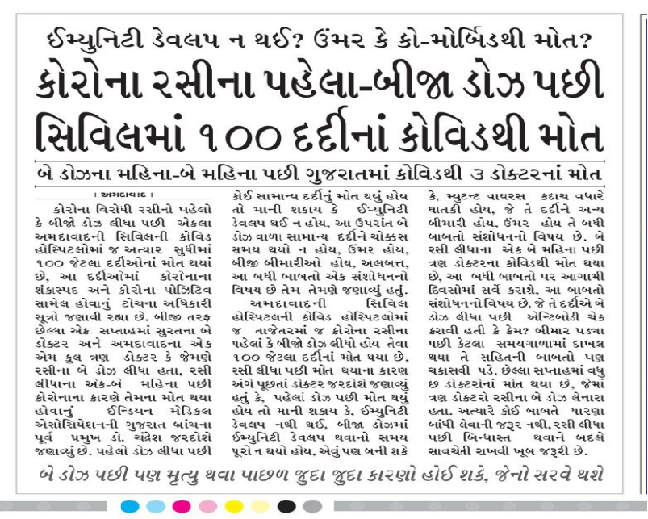  https://sandesh.com/100-patients-died-of-covid-in-civil-after-the-first-second-dose-of-corona-vaccine/
765 | 14.04.2021 | https://m.jagran.com | Uttar Pradesh: Maharajganj district  Deputy Agriculture Director, Vinod Kumar, from Maharajganj, died on Tuesday, April 13, three weeks after receiving first dose of COVID-19 vaccine. |  | https://m.jagran.com/uttar-pradesh/maharajganj-deputy-agricultural-director-dies-from-corona-87-positive-21556589.html
766 | 08.05.2021 | https://twitter.com | Assam: Kamrup district  Eldest uncle (67) of Abhishek Dey, died in Guwahati, on Friday, May 07, a week after receiving first dose of COVID-19 vaccine. |  | https://twitter.com/abhishekdey04/status/1390898175381172226?s=19
767 To 787 | 06.05.2021 To 08.05.2021 | https://m.facebook.com | GOA state : Panjim  Directorate of Health Services (DHS) daily COVID-19 mortality bulletins  08/05/2021 — 7 deaths of vaccinated persons out of 55  07/05/2021 — 8 deaths of vaccinated persons out of 56  06/05/2021 — 6 deaths of vaccinated persons out of 58 |  | https://m.facebook.com/story.php?story_fbid=1084062455448579&id=184103952111105  https://m.facebook.com/story.php?story_fbid=1083492578838900&id=184103952111105  https://m.facebook.com/story.php?story_fbid=1082815708906587&id=184103952111105
788 | 09/05.2021 | https://indianexpress.com | Delhi: Capital city  58 year old Surgeon, Dr. Anil Kumar Rawat, died on Saturday, May 08 morning at Delhi's Saroj Hospital after contracting COVID symptoms 2 weeks before. He had received second dose of Covishield vaccine in first week of March.  He told his colleague before his demise:  “I will come out of this. I have been vaccinated, I will come out.” |  | https://indianexpress.com/article/cities/delhi/delhi-surgeon-who-got-second-covid-vaccine-in-march-dies-of-virus-7307387/lite/
789 | 05.05.2021 | https://twitter.com | Odisha: Khordha district  Retired Chief Engineer of Odisha Govt & father of Rakesh Nayak, resident of Bhubaneswar, died on Wednesday, May 05, days after receiving second dose of Covaxin COVID-19 vaccine. |  | https://twitter.com/OdiSriUS/status/1389949906975084550?s=19  https://twitter.com/OdiSriUS/status/1391081430332190720?s=19  https://twitter.com/OdiSriUS/status/1389883829465272321?s=19
790 | 09.05.2021 | https://indianexpress.com | Maharashtra: Mumbai urban district  48 year old Head Constable, Sandeep Tawade, of Mumbai Police, died on Saturday May 08, a month after receiving second dose of COVID-19 vaccine.  Out of total 432 deaths in Maharashtra Police, 10 nos of cops have died in last week alone, But only few of them get reported in mainstream media due secrecy followed by the govt agencies & corporate owned media to avoid scrutiny on vaccination side effects. |  | https://indianexpress.com/article/cities/mumbai/mumbai-cop-fully-vaccinated-dies-of-covid-7307537/
791 To 796 | 09.05.2021 | https://www.dailyexcelsior.com | Jammu & Kashmir: Jammu region  Among 42 casualties in the Jammu region's 9 districts on May 08,  6 victims had taken first dose of COVID-19 vaccine. |  | https://www.dailyexcelsior.com/spl-secy-ex-ministers-brother-17-yr-old-girl-3rd-member-of-a-family-among-42-more-die-in-jammu/
797 | 07.05.2021 | https://m.facebook.com | Kerala: Thiruvananthapuram district  Molly Ammumma (64), grandmother of Malayalam actress Ahaana Krishna, died on Friday May 07, days after receiving second dose of COVID-19 vaccine.  Ahaana says in her Facebook post,  "She was 64 and vaccinated - both the doses. As per what I had commonly heard .. I was under the assumption that if you have taken both doses of the vaccine , even if you get Covid .. it’d go off mild. Nope , I was wrong. You could be double vaccinated , still you’re not safe." |  | https://m.facebook.com/story.php?story_fbid=317179746442018&id=100044499846945
798 | 07.05.2021 | https://twitter.com | Maharashtra: Mumbai urban district  Uncle of Pratik Khona, from Mumbai city, died on Tuesday, April 13, 25 days after receiving first dose of COVID-19 vaccine. |  | https://twitter.com/khona_pratik/status/1390722004953665538?s=19
799 | 06.05.2021 | https://www.thehindu.com | Tamilnadu: Madurai district  48 year old Head Constable A. Paramasamy, attached to Madurai City Traffic Police, died at Tirumangalam on Wednesday, May 05, after receiving first dose of COVID-19 vaccine in last week of April. |  | https://www.thehindu.com/news/cities/Madurai/head-constable-dies-more-precautions-at-police-stations/article34499674.ece
800 To 804 | 06.05.2021 | https://www.dailyexcelsior.com | Jammu & Kashmir: Jammu region  May 06: Among 34 COVID fatalities, Maximum 21 deaths were reported in Jammu district, 3 each Rajouri and Kathua, 2 each Samba, Poonch and Udhampur and 1 in Kishtwar.  Out of which 5 fresh COVID victims had already taken first dose of COVID-19 vaccine. |  | https://www.dailyexcelsior.com/rohingya-girl-doc-15-women-including-one-from-haryana-among-34-die-in-jammu/
805 To 815 | 09.05.2021 | https://m.jagran.com | Uttar Pradesh: Etah district  According to Karan Vashneya of Berni village, Jalesar tehsil, 11 people have died of COVID in last 18 days in Berni and adjacent villages.  All of the deceased were given first dose of COVID-19 vaccine during the vaccination drive which happened between April 10 to April 14.  Names of the deceased:  From Village Berni (8):  Ram Khiladi, Sunahari Lal, Ved Ram Singh, Raj Singh, Sunahari devi, Kamala devi, Janaki devi, Sarnaam  From Village Sahagarhi (1):  Surajmukhi  From Village Ramraipur (2):  Rajani Sisodia, Kishor Ujwal Kumar |  | https://m.jagran.com/uttar-pradesh/etah-ten-deaths-due-to-corona-in-18-days-in-berani-panchayat-21627700.html
816 & 817 | 08.05.2021 | https://twitter.com | Delhi: Capital City  Jasmine's uncle, residents of Delhi,  Harvinder Singh Kohli (61) died on Sunday, April 18 &  Gurvinder Singh Kohli (70) died on Friday, April 23  weeks after receiving first dose of COVID-19 vaccine.  Information of deceased was later shared by Jasmine in a private message on Twitter. |  | https://twitter.com/urban_lens/status/1391093144473636865?s=19
818 | 07.05.2021 | https://twitter.com | Tamilnadu: Chennai district  D. Muthukrisnan's wife's uncle who was a Doctor, died on Thursday, May 06, days after receiving second dose of Covishield COVID-19 vaccine. |  | https://twitter.com/dmuthuk/status/1390714695779119104?s=19
819 | 08.05.2021 | https://twitter.com | New Delhi  Aunt of Shamit Manchanda, died in first week of May month, days after receiving second shot of Covishield COVID-19 vaccine. |  | https://twitter.com/shamit/status/1391094585590304769?s=19  https://twitter.com/shamit/status/1391104002159349763?s=19
820 | 24.04.2021 | https://twitter.com | Maharashtra: Mumbai urban district  Father-in-law of Mukesh Sahani, died in third week of April, three days after receiving COVID-19 vaccine. |  | https://twitter.com/imukeshsahani/status/1385161877513138176?s=19  https://twitter.com/imukeshsahani/status/1385831971687858179?s=19
821 | 06.05.2021 | https://m.facebook.com | Madhya Pradesh: Gwalior district  Mohan Agarwal died on Thursday, May 06, 10 days after receiving COVID-19 vaccine. |  | https://m.facebook.com/story.php?story_fbid=5505953179478392&id=100001912932438 https://m.facebook.com/story.php?story_fbid=5505953179478392&id=100001912932438
822 | 10.05.2021 | https://www.livehindustan.com | Bihar: Bhagalpur district  A healthcare worker from Sanhoula PHC, who was resident of Mahiyama village, died on Monday, May 10, days after receiving second dose of COVID-19 vaccine. |  | https://www.livehindustan.com/bihar/bhagalpur/story-death-of-corona-infected-health-worker-taking-both-doses-of-vaccine-4022391.html
823 | 10.05.2021 | http://www.dainiksaveratimes.com | Punjab: Ludhiana district  Gyan Singh Doraha, resident of Mahapur village of Khanna tehsil died on Sunday, May 09, a week after receiving COVID-19 vaccine. Unfortunately when his elder brother Didar Singh (64) heard news of his brother's demise he also died of heart attack out of emotional shock. |  | http://www.dainiksaveratimes.com/News.php?Story=Younger-Brother-Died-Of-Corona-1620623820
824 & 825 | 10.05.2021 | https://himachal.punjabkesari.in | Himachal Pradesh: Chamba district54 year old woman from Udaipur village of Chamba tehsil &58 year old woman from Sutki village of Bhattiyat tehsil  Both died on Sunday night of, May 09 at Chamba Covid Hospital, days after receiving first dose of COVID-19 vaccine. |  | https://himachal.punjabkesari.in/himachal-pradesh/news/three-women-died-within-24-hours-from-corona-in-chamba-1381634
826 & 827 | 11.05.2021 | https://timesofindia.indiatimes.com | Gujarat: Ahmedabad district  Rashmikant Raval (73) and his wife Sushila Raval (72) died at Ahmadabad on April 23 & April 24 respectively due to COVID, after receiving first dose of COVID-19 vaccine on April 3 & April 4 respectively. |  | https://timesofindia.indiatimes.com/city/surat/nri-couple-who-came-for-family-time-die-of-covid/articleshow/82533204.cms
828 To 927 | 10.05.2021 | https://www.businesstoday.in  https://www.newindianexpress.com | "A total of 271 personnel of the seven forces of CRPF, BSF, CISF, ITBP, SSB, NSG and NDRF have succumbed to the pandemic so far."  "Officials said the vaccination drive is all these forces is nearing 100 per cent as their personnel were included among frontline workers and administered the COVID-19 vaccine doses first."  *There were 128 covid deaths among paramilitary forces until September 2020 in the first wave. And considering the increased mortality in the second wave after vaccination drive started, we can safely estimate at least 100 deaths out of 271 have occurred after 16th January 2021. |  | https://www.businesstoday.in/current/economy-politics/covid-19-virus-claims-lives-of-108-cprf-jawans-highest-among-central-forces/story/438734.html  https://www.newindianexpress.com/nation/2020/sep/27/over-36000-covid-19-cases-128-deaths-in-central-police-forces-data-2202564.html
928 | 10.05.2021 | https://twitter.com  https://m.facebook.com | Uttar Pradesh: Agra district  Dr. Shiv Prakash Bhardwaj (41), pulmonologist at Agra city, died on Monday, May 10, due to severe COVID, weeks after receiving his second dose of COVID-19 vaccine. |  | https://twitter.com/DrSatyaSaraswat/status/1391818460590592000?s=19  https://m.facebook.com/story.php?story_fbid=3878222228913377&id=100001769141301
929 | 10.05.2021 | https://twitter.com | Haryana: Gurugram district  Mrs. Rama Katoch (63), wife of Major General Dhruv C. Katoch, died on Monday, May 10th, weeks after receiving second dose of COVID-19 vaccine.  Former BJP national general secretary Ram Madhav tweeted about this news & then deleted his original tweet after receiving backlash from the pro vaccine lobby. Now he has posted a new tweet, omitting the vaccine mention. |  | https://twitter.com/madhukishwar/status/1391710841678925826?s=19  https://twitter.com/MrIndianAtheist/status/1391718347192999936?s=19  https://twitter.com/rammadhav_rss/status/1391715195957891078?s=19
930 to 940 | 10.05.2021 | https://www.bhaskar.com | Rajasthan: Jaipur district  11 frontline workers (all aged 35 yr to 44 yr) including 3 Police cops have died in last 24 days. All of them had received Second dose of COVID-19 vaccine. |  | https://www.bhaskar.com/local/rajasthan/jaipur/news/samplers-report-not-received-from-pune-lab-even-in-4-months-which-strain-is-responsible-for-major-infections-and-deaths-128479145.html
941 | 05.05.2021 | https://www.patrika.com | Chhattisgarh: Bilaspur district  59 year old Retired Bank officer, resident of Harsh Kingdom, Chantideeh locality of Bilaspur town, died in first week of May, two days after receiving COVID-19 vaccine. |  | https://www.patrika.com/bilaspur-news/woman-spend-two-days-with-husband-dead-body-6831575/
942 | 13.04.2021 | https://twitter.com | Uttarakhand: Dehradun district  Mr. S. C. Thapa, resident of Dehradun, died on Tuesday April 13, three weeks after receiving first dose of COVID-19 vaccine. |  | https://twitter.com/abundantAK/status/1392152113405251589?s=19
943 | 10.05.2021 | https://twitter.com | Delhi: Capital city  Dr. Shekhar Agarwal (68), an Ortho Surgeon & executive director at Sant Parmanand Hospital from Delhi, died on Monday, May 10, with covid, days after receiving second dose of COVID-19 vaccine. |  | https://twitter.com/prasanto/status/1391808092426293248?s=19
944 | 11.05.2021 | https://twitter.com | Delhi: Capital city  Dr. Wahal (60), senior doctor of Anesthesia department at Hindu Rao Hospital, Delhi, died on Tuesday May 11, due to COVID, days after receiving first dose of Covaxin COVID-19 vaccine. |  | https://twitter.com/hemantrajora_/status/1392149679748435970?s=19
945 | 09.05.2021 | https://twitter.com | Karnataka: Kolar district  Uncle (50+) of Dr. VSB from KGF town, died on Saturday, May 8, due to cardiac arrest, within 12 hours of receiving first dose of Covishield COVID-19 vaccine. |  | https://twitter.com/doctor_vsb/status/1391298174074060803?s=19
946 | 10.05.2021 | https://twitter.com | Bihar state  A 70 year old woman from Bihar state, relative of Abhishek Aman, died on Sunday, May 09 due to blood clotting, a week after receiving second dose of Covishield COVID-19 vaccine. |  | https://twitter.com/abhishekamanjnu/status/1391664714191577095?s=19
947 | 26.4.2021 | https://twitter.com | Uttar Pradesh: Mathura district  Mother of Atebal Kant Singh, resident of Mathura, died on Monday, April 26, weeks after receiving first dose of Covishield COVID-19 vaccine. |  | https://twitter.com/yaduvanshikris/status/1391618047840907265?s=19
948 | 24.04.2021 | https://www.newindianexpress.com | Odisha: Jagatsinghpur district  A 53 year old man from Dantuala village of Naugaon Tehsil died on Saturday, April 24, a month after receiving first dose of COVID-19 vaccine. |  | https://www.newindianexpress.com/states/odisha/2021/apr/25/two-succumb-to-covid-in-odishas-jagatsinghpur-2294583.html
949 | 11.05.2021 | https://www.jagran.com | Jharkhand: Dhanbad district  Mahesh Paswan (58), from Kujama village of Jharia tehsil died on Monday, May 10 due to COVID, ten days after receiving COVID-19 vaccine. |  | https://www.jagran.com/jharkhand/dhanbad-shadow-mourning-in-the-township-due-to-death-of-brother-and-sister-on-the-same-day-in-jharia-21634828.html
950 | 10.05.2021 | https://www.jagran.coml | Bihar: Madhubani district  Rajeshwar Mehato (50) from Betauna village of Jainagar tehsil died on Sunday May 09 due to covid, two weeks after receiving COVID-19 vaccine. |  | https://www.jagran.com/bihar/madhubani-news-21632778.html
951 | 10.05.2021 | https://twitter.com | Uttar Pradesh: Prayagraj district  Shiv Prakash Dwivedi (57), Regional Additional Secretary of UP state education board, died on Monday, May 10, at Prayagraj due to covid complications and cardiac arrest, a month after receiving first dose of COVID-19 vaccine. |  | https://twitter.com/pranshudwivedi/status/1392230841808351237?s=19  https://twitter.com/pranshudwivedi/status/1392267222723092480?s=19
952 | 11.05.2021 | https://twitter.com | Delhi: Capital city  76 year old Father of Sumit Arora, resident of Delhi, died on Monday, May 10, due to covid complications, 3 weeks after receiving second dose of Covaxin COVID-19 vaccine. |  | https://twitter.com/SumitAr20359444/status/1392151784353714183?s=19
953 | 12.05.2021 | https://twitter.com | Karnataka: Koppal district  Dr. Chintamani Joshi (40) resident of Kuknoor, died on Wednesday, May 12, due to cardiac arrest, days after receiving second dose of COVID-19 vaccine. |  | https://twitter.com/shri_v/status/1392391720319344640?s=19  https://twitter.com/shri_v/status/1392461382746984453?s=19  https://twitter.com/shri_v/status/1392430744325087240?s=19
954 | 12.05.2021 | https://twitter.com | Odisha: Khordha district  According to Dr. Pratik Sahoo from Bhubaneswar, one of the three, 60+ year old patient have died due to covid in second week of May month, 15-20 days after receiving second dose of Covaxin COVID-19 vaccine. |  | https://twitter.com/Dr_PratikSahoo/status/1392484440417341449?s=19
955 | 12.05.2021 | https://twitter.com | Punjab: Ludhiana district  An elderly woman from Ludhiana, relative of Sandip Sabharwal, died on Wednesday, May 12, two weeks after receiving Second dose of COVID-19 vaccine. |  | https://twitter.com/sandipsabharwal/status/1392503949945569282?s=19
956 | 12.05.2021 | https://www.jagran.com | Madhya Pradesh: Gwalior district  Rajkumar Shukla, Head constable at Kampoo Police Station of Gwalior city, died on Wednesday, May 12, due to covid complications, 1.5 months after receiving second dose of COVID-19 vaccine. |  | https://www.jagran.com/news/national-even-after-both-doses-of-corona-vaccine-head-constable-police-dies-of-corona-in-gwalior-21638610.html
957 | 12.05.2021 | https://www.amarujala.com | Himachal Pradesh: Hamirpur district  68 year old man Kishor Chand, resident of Kathulag village of Makker panchayat, died on Wednesday, May 12, weeks after receiving second dose of COVID-19 vaccine. |  | https://www.amarujala.com/himachal-pradesh/hamirpur-hp/elderly-person-dies-of-corona-even-after-two-doses-of-vaccine-hamirpur-hp-news-sml370081499
958 | 12.05.2021 | https://twitter.com | North India  Father of Kalpana Sharma, died on Thursday, April 29, due to covid pneumonitis and cardiac arrest, days after receiving second dose of COVID-19 vaccine. |  | https://twitter.com/kalpanasharma78/status/1392446080684466176?s=19
959 | 10.05.2021 | https://twitter.com | Delhi: Capital city  Uncle of AbhiNdy, died on Sunday, May 09 due to severe covid, three weeks after receiving second dose of Covishield COVID-19 vaccine. |  | https://twitter.com/AbhiNdy/status/1391777803574595590?s=19
960 | 13.05.2021 | https://twitter.com | Haryana: Panchkula district  Shri Y. N. Chugh (75+), resident of Panchkula died on Sunday, May 09 due to cardiac arrest, just within 20 minutes after receiving second dose of Covishield COVID-19 vaccine. |  | https://twitter.com/rauneet1/status/1392712881368539142?s=19
961 & 962 | 12.05.2021 | https://indianexpress.com | Delhi–NCR : Ghaziabad  Dr. Vivek Arora (53), an anaesthetist, died on Wednesday May 12, due to pneumothorax, three week after receiving second dose of COVID-19 vaccine.  Dr. Anubha Garg (41), a gynaecologist, also died on Wednesday, May 12, due to covid, days after receiving second dose of COVID-19 vaccine.  Report of other two doctors who died are already documented.  Dr. Shekhar Agarawal (#943) &  Dr. Anil Wahal (#944) |  | https://indianexpress.com/article/cities/delhi/delhi-ncr-loses-four-prominent-doctors-to-covid-this-week-7312689/
963 | 13.05.2021 | https://www.newindianexpress.com | Tamilnadu: Chennai District  A woman doctor from New Century Hospital in Ambattur, died on Wednesday, May 12, due to covid complications, a month after receiving second dose of COVID-19 vaccine. |  | https://www.newindianexpress.com/states/tamil-nadu/2021/may/13/one-more-doctor-succumbs-to-covid-battle-as-tnregisters-30k-fresh-cases-2301881.html
964 & 965 | 10.05.2021 | https://www.bhaskar.com | Bihar : Araria district  Ramvilas Chaudhary (62) & Kumhiya devi (71) from Araria Nagar Parisad ward #7 have died on Sunday May 09, One week & 2 days respectively after receiving second dose of COVID-19 vaccine. |  | https://www.bhaskar.com/local/bihar/bhagalpur/araria/news/bihar-news-two-person-died-in-last-24-hours-in-araria-who-got-both-dose-of-corona-vaccination-128479821.html
966 | 14.05.2021 | https://indianexpress.com | Delhi : Capital city  Renowned gynaecologist Dr S K Bhandari (86), died on Thursday, May 13, due to heart failure at Sir Ganga Ram Hospital (SGRH). weeks after receiving second dose of COVID-19 vaccine. |  | https://indianexpress.com/article/cities/delhi/renowned-gynaecologist-dr-s-k-bhandari-who-delivered-rahul-and-priyanka-gandhi-dies-of-covid-19-7314206/
967 | 13.05.2021 | https://sanmarg.in | West Bengal: Howrah district  Sujit Hajra (58), resident of Kadamtala of Howrah city, died on on Monday May 10 due to Covid pneumonia, two week after receiving second dose of Covishield COVID-19 vaccine.  According to Howrah health department, many people are getting infected with Covid-19 after their vaccination. |  | https://sanmarg.in/state/bengal-news-hindi/corona-dies-person-dies-after-taking-covishield-vaccine/
968 | 01.05.2021 | https://m.timesofindia.com | Uttar Pradesh: Lucknow district  Dr Rishi Kumar Saxena, Orthopedic Surgeon and former Chief Medical Superintendent (CMS) of Balrampur Hospital, Lucknow succumbed to Covid on Friday, April 30, weeks after receiving second dose of Covid-19 vaccine.  In Last 2 week of April, other 5 doctors from Lucknow city had also succumbed to Covid-19. Most probably they all were vaccinated as frontline workers, but there's no confirmation. Dr KD Verma, endocrinologist,  Dr Raj Mehrotra pathologist  Dr Anil Chandra, dean of KGMU's dental dept  Dr Zubair Ali, resident doctor at KGMU  Dr Fazal Karim, cardiologist at Era's Lucknow Medical College, |  | https://m.timesofindia.com/city/lucknow/balrampur-hosps-ex-cms-loses-fight/articleshow/82335513.cms
969 | 03.05.2021 | https://twitter.com | Maharashtra: Pune district  Aunt (60+) of Nikhil Inamdar, resident of Pune city, died on Monday May 03, due to covid complications, days after receiving second dose of COVID-19 vaccine. |  | https://twitter.com/Nik_Inamdar/status/1389193755962396678?s=19
970 | 03.05.2021 | https://twitter.com | Uttar Pradesh: Ghaziabad district  Jyoti N. Sethi (61), resident of Nehru Nagar, Ghaziabad, died on Monday May 03, a month after receiving first dose of Covishield COVID-19 vaccine. |  | https://twitter.com/DrohShankar/status/1393188621650259973?s=19
971 | 14.05.2021 | https://www.prabhatkhabar.com | Karnataka: Dakshina Kannada district  Mangalore city Police Commissioner Shashi Kumar has confirmed that a Police Constable have died on Friday May 14 due to multiple organ failure, weeks after receiving second dose of COVID-19 vaccine. |  | https://www.prabhatkhabar.com/national/a-police-constable-died-due-to-multi-organ-failure-in-karnataka-he-had-taken-both-doses-of-vaccine-rjh
972 | 11.05.2021 | https://twitter.com | Uttar Pradesh: Lucknow district  Dr. Ram Narayan (67), resident of Lucknow, died on Sunday April 25, three weeks after receiving second dose of Covaxin COVID-19 vaccine. |  | https://twitter.com/N_Shivangi_/status/1391990074191990784?s=19
973 & 974 | 14.05.2021 | https://news.abplive.com | Tamilnadu: Chennai district  Assistant Commissioner of Police, Easwaran (52) from Pallavaram and, Special Sub Inspector, Ravi (57) from Valsaravakkam police station, died on May 6 & May 12 respectively, days after receiving second dose of COVID-19 vaccine. Now including these 2 cases, the death toll in Chennai Police has rose to 12. |  | https://news.abplive.com/news/two-cops-in-chennai-succumb-to-covid-after-taking-two-doses-of-vaccine-1458327
975 To 978 | 15.05.2021 | https://www.thehindu.com | Delhi state  On Wednesday, May 12, The officer of Delhi Police confirmed that, four (4 no.) policemen have succumbed to COVID-19 even after taking both the doses of the COVID-19 vaccine over a month ago. |  | https://www.thehindu.com/news/cities/Delhi/100-officers-getting-infected-with-virus-every-24-hours/article34561593.ece
979 | 13.05.2021 | https://indianexpress.com  https://www.pratidintime.com | Assam : Kamrup district  Renowned Assamese author and journalist Homen Borgohain (88) died of a cardiac arrest on Wednesday, May 12, morning in Guwahati, days after receiving second dose of COVID-19 vaccine. |  | https://indianexpress.com/article/north-east-india/assam/renowned-assamese-author-and-journalist-homen-borgohain-passes-away-at-88-7312429/  https://www.pratidintime.com/eminent-litterateur-homen-borgohain-tests-covid-19-ve/
980 | 11.05.2021 | Newspaper | Telangana: Medak district  35 year old RMP doctor, from Siddipet, who was practicing at Kucharam village, died due to covid complications on Tuesday, May 11, three weeks after receiving COVID-19 vaccine. |  | 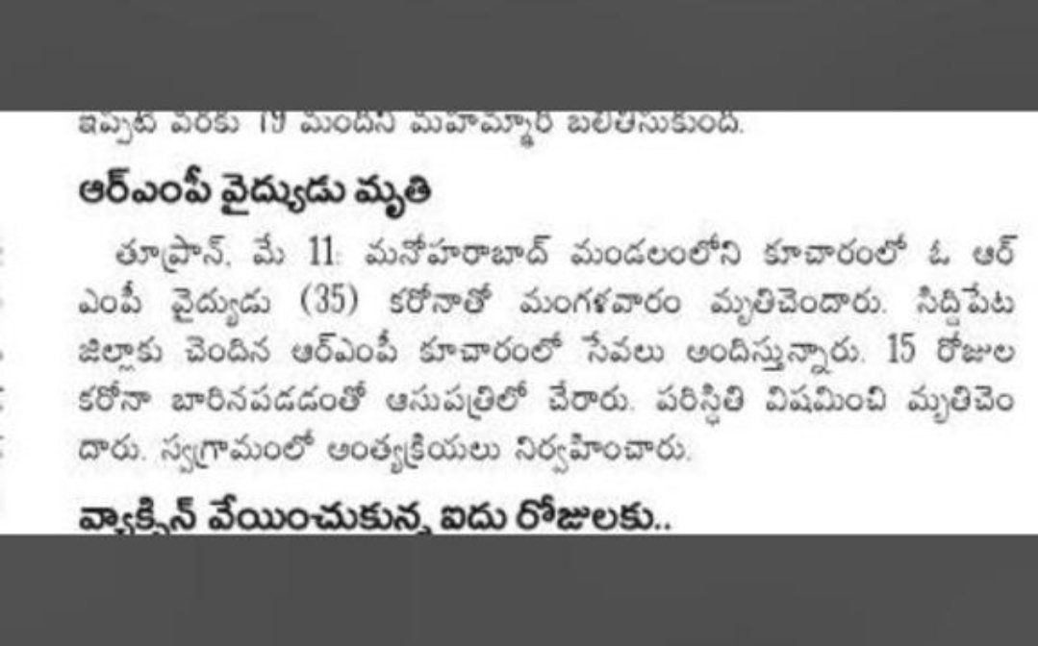
981 | 30.04.2021 | https://twitter.com | Delhi state  55 year old Father of Aditya Gupta, who was a Fighter Pilot in India Air Force & resident of Ansari Nagar, New Delhi, died on Friday April 30, due to covid complications, days after receiving second dose of COVID-19 vaccine.  Aditya Gupta himself is a MBBS resident doctor at AIIMS, New Delhi. But he couldn't save his father. |  | https://twitter.com/Adityaiims/status/1388552381848186884?s=19  https://twitter.com/Adityaiims/status/1393301839659950081?s=19
982 | 1505.2021 | https://m.jagran.com | Jharkhand: Palamau district  60 year old man Rajendra Ram, resident of Rajhara village died due to covid on Sunday May 09, three weeks after receiving COVID-19 vaccine. |  | https://m.jagran.com/jharkhand/palamu-palamau-news-21646411.html
983 | 15.05.2021 | https://indianexpress.com  https://twitter.com | New Delhi  Sunil Jain (58), Managing Editor of The Financial Express, died on Saturday, May15 at AIIMS, due to covid complications & cardiac arrest, 1.5 months after receiving first dose of Covaxin COVID-19 vaccine. |  | https://indianexpress.com/article/india/financial-express-managing-editor-sunil-jain-passes-away-7316637/  https://twitter.com/thesuniljain/status/1377524924332396544?s=19
984 | 15.05.2021 | https://twitter.com | Chandigarh Capital Region  75 year old maternal uncle (mama ji) of Saksham Saigal from Chandigarh, died due to major cardiac arrest on Saturday May 15, 18 days after receiving first dose of Covishield COCID-19 vaccine. |  | https://twitter.com/saigalsaksham/status/1393302091574104064?s=19
985 | 13.03.2021 | Google Drive Link | Maharashtra: Amravati district  Trimbakrao Hirudkar (72), a healthy old man from Amravati died on March 13 due to sudden vomitting and breathing issue, within 12 hours of receiving first dose of COVID-19 vaccine. |  | https://drive.google.com/file/d/1RZ1tGDjJJiH61n84kjDu0frXQgifu1Wc/view?usp=sharing
986 | 07.03.2021 | Google Drive Link | Maharashtra: Akola district  Ramdas Sonalekar (72), a healthy old man from Akola died on Sunday March 07 with sudden vertigo and giddiness in early morning, within 15 hours of receiving first dose of COVID-19 vaccine. |  | https://drive.google.com/file/d/12-jMm9HgUlebEYko8SwzmzpKLMFV84q9/view?usp=sharing
987 | 13.05.2021 | https://twitter.com | Telangana: Mahabubnagar district  Sam Aldrin Talluri (50+), resident of Mahabubnagar, died on Thursday May 13, within 2 days after receiving second dose of Covishield COVID-19 vaccine. |  | https://twitter.com/SamArunKumar9/status/1393317935607816200?s=19  https://twitter.com/SamArunKumar9/status/1393932507754635265?s=19
988 & 989 | 27.04.2021 | https://news4nation.com | Bihar: Patna district  2 persons from Aunta village of Mokama tehsil who were from the same family, died on Saturday, April 24 due to cough and severe fever, within a week after receiving COVID-19 vaccine.  Although all 11 who died in similar condition according to villagers, but the news article hasn't resported about their vaccination status. |  | https://news4nation.com/news/bihar-news-11-people-died-in-5-days-in-a-village-stir-in-the-whole-area-villagers-are-appealing-for-help-824184
990 To 993 | 16.05.2021 | https://www.bhaskar.com | Madhya Pradesh: Indore & Sagar district  Father of Sarpanch Sushil Patidar of Badkuwa village of Mhow Tehsil, died on Wednesday May 05, due to Covid pneumonia, days after receiving first dose of COVID-19 vaccine.  Similarly 3 women died in Chirari village of Rehli Tehsil, Sagar district due to fever after receiving COVID-19 vaccine. |  | https://www.bhaskar.com/national/news/coronavirus-vaccine-fever-fear-madhya-pradesh-news-ground-report-from-indore-sagar-villages-128496577.html
994 & 995 | 16.05.2021 | https://twitter.com | Maharashtra: Aurangabad district  Grandmother & Grandfather of Nikhilesh Kodgaonkar died in 2nd week of May, due to Covid complications, 4 weeks after taking the dose of Covishield COVID-19 vaccine. |  | https://twitter.com/Nithileshkodga1/status/1393942530052419586?s=19
996 | 05.05.2021 | https://twitter.com | Karnataka: Bengaluru urban district  Alan Rasquinha (61) a healthy old man, resident of Bengaluru city, died on Wednesday, May 05, nine days after receiving Covaxin COVID-19 vaccine. |  | https://twitter.com/Richardisawake/status/1392122965521694728?s=19  http://www.fkcaglobal.com/alan-rasquinha-61-bangalore/
997 | 16.05.2021 | https://m.facebook.com | Tamilnadu: Chennai district  Pushpraj Vachali, a HR professional, resident of Chennai, died on Sunday, May 16, due to covid pneumonia, days after receiving second dose of COVID-19 vaccine. |  | https://m.facebook.com/story.php?story_fbid=10219239532440748&id=1282061451  https://www.insightlcs.com/expert_details.php?cid=23
998 To 1053 | 17.05.2021 | https://www.greaterkashmir.com | Jammu and Kashmir  National Health Mission (NHM) J&K has released the fatality data from J&K. As per the figures, 806 people have lost life between 15 April and 12 May in the UT – 311 in Kashmir and 495 in Jammu division.  Death has also taken place in people who were partly vaccinated, that is, had received only one dose of the vaccine out of the required two. However, they constitute a much lesser proportion – 7 percent of the total deaths (56 people). |  | https://www.greaterkashmir.com/news/front-page-2/covid-mortality-analysis-none-among-fully-vaccinated-died-in-jk-government/
1054 & 1055 | 12.05.2021 | https://www.washingtonpost.com | New Delhi  Malay Kumar Chatterjee (82) & his wife Indira Chatterjee (72), died on April 18 & April 27 resp, due to Covid complications, 3 weeks and 4 weeks resp, since after receiving their first dose of Covishield COVID-19 vaccine. |  | https://twitter.com/washingtonpost/status/1392936686271700992?s=19  https://www.washingtonpost.com/world/interactive/2021/india-covid-family/?itid=hp-top-table-main-0430b
1056 | 09.04.2021 | Telegram Channel | Gujarat: Surat district  Bhavana ben Kotecha (63), resident of Surat city, died on Friday, April 09 due to Covid complications, two weeks after receiving first dose of COVID-19 vaccine. |  | https://t.me/kapilbajaj/603 https://drive.google.com/file/d/1b7eo0S76KWr0O_-TJ1h8C93wDt5Vtb1s/view?usp=sharing
1057 | 10.05.2021 | https://twitter.com | New Delhi  Dushyant Kumar (32+), from Delhi, died on Monday, May 10 due to cardiac arrest, only a day after receiving first dose of Covishield COVID-19 vaccine. |  | https://twitter.com/rajsambhusingh/status/1392805679509901317?s=19  https://twitter.com/rajsambhusingh/status/1392823740476444672?s=19
1058 | 15.05.2021 | https://twitter.com | Karnataka: Bengaluru urban district  An elderly woman Meena Gopal, resident of Jaynagar Bengaluru, died on Friday May 14, due to blood clotting on legs, followed by a cardiac arrest, 3 weeks after receiving second dose of Covishield COVID-19 vaccine. |  | https://twitter.com/peelicaavi/status/1393628740077309952?s=19
1059 | 10.05.2021 | https://www.freepressjournal.in | Maharashtra: Mumbai urban district  Police Constable Shivaji Desai (46) from Special Branch of the Mumbai Police, resident of Chiku Wadi in Borivali, died on Monday, May 10, due to Covid complications, 3 weeks after receiving his first shot of COVID-19 vaccine. |  | https://www.freepressjournal.in/mumbai/mumbai-two-more-city-cops-succumb-to-covid-toll-climbs-to-115
1060 | 17.05.2021 | https://twitter.com | New Delhi  "Padma Shri" awardee Dr. K K Aggarwal (63), died on night of Monday, May 17, due to COVID complications, 2 months 26 days after receiving his second dose of Covishield Covid-19 vaccine.  Irony is that he died due to the same vaccine that he was advocating and recommending to others from last few months.  This is a big blow on the face of pro vaccine medical community and government. |  | https://twitter.com/DrKKAggarwal/status/1394389544917639168?s=19  https://twitter.com/DrKKAggarwal/status/1387331650699153410?s=19  https://youtu.be/uNqOsmzHfSs
1061 | 16.04.2021 | https://twitter.com | Chhattisgarh: Raigarh District  Shri. Narinder Pal Singh Bagga (70), resident of Sarangarh, Chhattisgarh, died on Saturday, April 17 due to cardiac arrest, just a day after receiving second dose of Covishield COVID-19 vaccine. |  | https://twitter.com/amrit_sbagga/status/1394366863866437633?s=19  https://twitter.com/amrit_sbagga/status/1394507793550376965?s=19
1062 | 01.05.2021 | https://twitter.com | West Bengal: Kolkata district  Dr. Gouri Shankar Bhatta, from Kolkata city, died on Saturday, May 01, due to COVID complications, weeks after receiving second dose of Covishield COVID-19 vaccine. |  | https://twitter.com/VatsalChirimar/status/1394378478724685835?s=19
1063 | 15.05.2021 | https://twitter.com | Karnataka: Bengaluru urban district  Mother (65) of Dipanjan Das from Bengaluru died on Saturday, May 15, due to cardiac arrest, just 3 days after receiving second dose of Covishield vaccine. |  | https://twitter.com/dipandas82/status/1394358520733044737?s=19
1064 | 18.05.2021 | https://amritvichar.com | Uttar Pradesh: Muzaffarnagar district  Father of Gyanendra Yadav, resident of Rajpur Kala, Jansath tehsil died on Tuesday, April 27 due to covid symptoms, 2 weeks after receiving COVID-19 vaccine.  Article also mentions that, the vaccination camp was arranged in Rajpur Kala village on April 13, and Since then between April 14 to May 15, total 25 people have died due to "mysterious fever". |  | https://amritvichar.com/mysterious-fever-in-rajpur-kla-25-deaths-in-30-days/
1065 & 1066 | 16.05.2021 | https://www.livehindustan.com | Uttar Pradesh: Prayagraj district  Babulal Yadav & Ramjan from Bibipur village of Pratappur, have died due to covid symptoms during last one month, after receiving COVID-19 vaccine. |  | https://www.livehindustan.com/uttar-pradesh/gangapar/story-nine-deaths-shook-the-people-of-bibipur-4034736.amp.html
1067 | 18.05.2021 | https://twitter.com | Gujarat: Ahmedabad district  Mother of Amit Dave from Ahmedabad, died recently due to cardiac arrest, 15 days after receiving second dose of Covishield COVID-19 vaccine. |  | https://twitter.com/amitmdave/status/1394591811809669120?s=19
1068 | 18.05.2021 | https://www.bhaskar.com | Madhya Pradesh: Gwalior district  Dr. Apeksha Bhale (55), from Jayarogya Hospital of Gwalior, died on Tuesday, May 18, due to Covid, 2.5 months after receiving first dose of COVID-19 vaccine. She was sick since her first dose hence didn't took her second vaccine dose. |  | https://www.bhaskar.com/local/mp/gwalior/news/to-save-people-forgot-to-get-themselves-vaccinated-two-doctors-died-due-to-kovid-128502851.html
1069 | 17.05.2021 | https://twitter.com | New Delhi  Senior Advocate Rajiv Bansal (55+), of Delhi Development Authority (DDA), died on Monday, May 17, due to Covid complications, weeks after receiving first dose of COVID-19 vaccine. |  | https://twitter.com/prasanto/status/1394256304240168960?s=19  https://twitter.com/prasanto/status/1394256987815235587?s=19
1070 | 15.05.2021 | https://twitter.com | Telengana: Hyderabad district  Elderly uncle of BV Venkateshwaran, resident of Hyderabad, died recently due to COVID complications, days after receiving second dose of Covishield COVID-19 vaccine. |  | https://twitter.com/bvenkateshwaran/status/1393394469114843137?s=19
1071 | 13.05.2021 | https://rozanapehredar.in | Punjab: Ludhiana district  A young school teacher named Shikha from Blossoms Convent School at Jargaon town in Ludhiana, died on Thursday May 13, the same day she received first dose of COVID-19 vaccine at her school vaccination camp. |  | https://rozanapehredar.in/epaper/m/53435/60a07f5348446  https://m.jagran.com/punjab/ludhiana-corona-vaccination-camp-in-bllossom-convent-school-jagraon-21643586.html
1072 | 18.05.2021 | https://twitter.com | Tamilnadu: Chennai district  Mohammad Fyassuddin Dulvi (53), died on Tuesday May 18 at Vijaya hospital of Chennai, due to Covid pneumonia followed by a cardiac arrest, 3 weeks after receiving second dose of Covishield COVID-19 vaccine. |  | 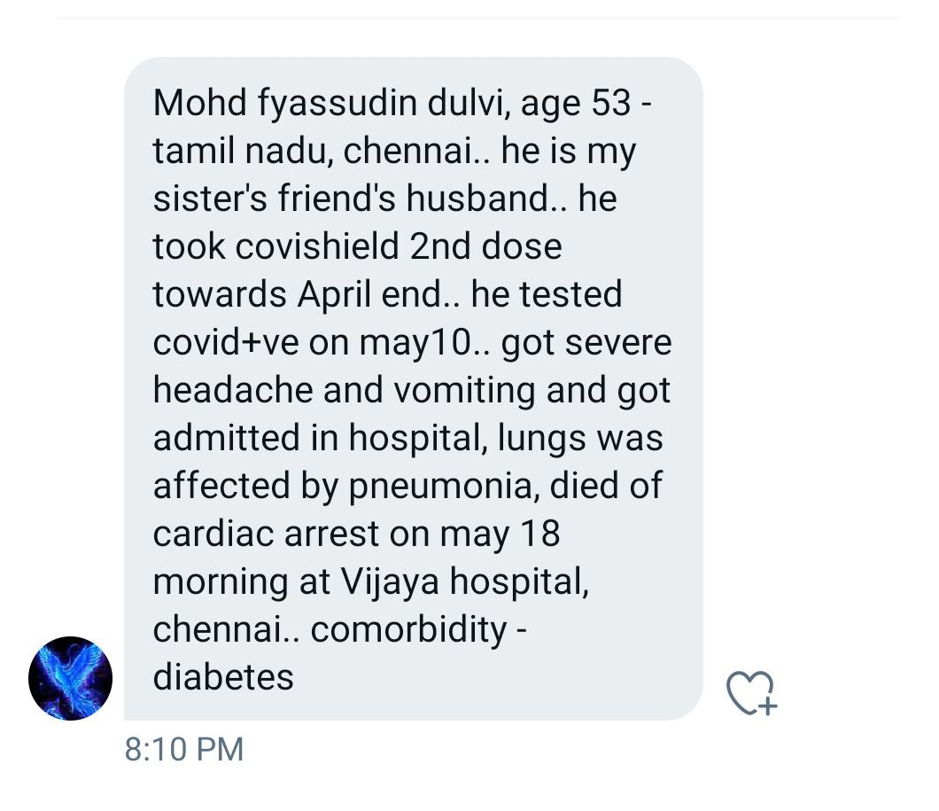
1073 | 19.05.2021 | https://www.tribuneindia.com | Punjab: Patiala district  Dr. Rajan Singh (37), senior resident doctor at Government's Rajindra Hospital, Patiala, died on Tuesday, May 18, due to Covid complications, weeks after receiving COVID-19 vaccine.  Surprisingly, Medical Superintendent of Rajindra Hospital didn't know exact vaccination status of his employee doctor even after his death. |  | https://www.tribuneindia.com/news/punjab/after-a-20-day-battle-doctor-posted-at-covid-isolation-wing-of-patialas-rajindra-hospital-succumbs-to-virus-254673
1074 | 19.05.2021 | https://bengali.abplive.com | West Bengal: Bankura district  Dr. Ashok Kumar Chattopadhyay (60), Bankura branch secretary of Indian Medical Association (IMA), died on Wednesday, May 19, due to Covid, weeks after receiving second dose of COVID-19 vaccine. |  | https://bengali.abplive.com/videos/district/covid-updates-doctor-died-in-covid-19-after-two-vaccine-doses-in-west-bengal-815259
1075 & 1076 & 1077 | 01.05.2021 | https://www.thetimesofbengal.com | West Bengal: Kolkata, Hooghly, Howrah district  3 doctors who died due to Covid, had taken both doses of Covishield vaccine.  Dr Anup Mukharjee (55), Store in-charge of Joka ESI, died on Tuesday, April 20  Dr Prasanta Mukherjee (84), a Gynecologist from Howrah, died on Monday April 26  Dr Partha Pratim Laha (47) a Gynecologist from Hooghly's Serampore, died on Tuesday, April 27 |  | https://www.thetimesofbengal.com/2021/05/01/two-more-prominent-doctors-of-the-state-died-in-corona-how-to-fill-the-gap/
1078 | 19.05.2021 | https://www.bhaskar.com | Rajasthan: Jodhpur district  A young woman Bhanwari, from Shekhasar village of Phalodi Tehsil died recently in Bikampur few days after receiving COVID-19 vaccine. |  | https://www.bhaskar.com/local/rajasthan/jodhpur/news/after-the-vaccination-of-the-daughter-of-the-village-mait-the-villagers-did-not-get-the-illusion-128507719.html
1079 | 18.05.2021 | https://www.patrika.com | Madhya Pradesh: Chhattarpur district  Ranjodi Ahirwar (55), a healthy healthcare worker from Matguwan village hospital in Chhattarpur tehsil, died on Monday, May 17 due to Covid, 2.5 months after receiving his second dose of COVID-19 vaccine. |  | https://www.patrika.com/chhatarpur-news/healthy-worker-dies-of-corona-even-after-taking-both-doses-6851724/
1080 | 20.05.2021 | https://www.amarujala.com | Himachal Pradesh: Una district  A retired Railway employee (68), from Muchhali panchayat of Bangana tehsil, died on Thursday, May 20 due to Covid, days after receiving second dose of COVID-19 vaccine. |  | https://www.amarujala.com/shimla/corona-update-himachal-two-covid-positive-pregnant-women-died-one-person-dead-after-taking-both-doses-of-vaccine
1081 | 20.05.2021 | https://www.aajtak.in | Uttar Pradesh: Sultanpur district  Dr. Mahendra jeet Sharma, an ENT specialist, resident of Sultanpur, died on Friday May 14 due to Covid pneumonia, a month after receiving second dose of Covishield COVID-19 vaccine. |  | https://www.aajtak.in/trending/photo/doctor-covid-death-despite-vaccinated-sultanpur-tsts-1258247-2021-05-20
1082 | 20.05.2021 | http://theprint.in | New Delhi  Deepak Gaur (48), JNU professor & molecular biologist, died on Thursday, May 20, due to COVID complications.  Prof. Pawan Dhar, Dean, SBT said, he had received his 1st dose of COVID-19 vaccine but was not sure whether he had also taken the 2nd dose. |  | http://theprint.in/health/jnu-professor-molecular-biologist-deepak-gaur-dies-of-covid/662201/
1083 | 21.05.2021 | https://www.divyahimachal.com | Himachal Pradesh: Solan district  An accountant of a private contractor from Kasauli, died on Thursday, May 20, due to sudden deterioration in health after receiving first dose of COVID-19 vaccine. |  | https://www.divyahimachal.com/2021/05/death-due-to-deteriorating-health-after-taking-dose-of-vaccine-in-kasauli-turns-out-to-be-positive/
1084 | 14.05.2021 | https://twitter.com | Tamilnadu: Chennai district  Father-in-law of Ajay Maddali, died recently due to cardiac arrest, 14 days after he received COVID-19 vaccine. |  | https://twitter.com/AjayMaddali/status/1394634937450385409?s=19
1085 | 16.05.2021 | https://twitter.com | New Delhi  Elder uncle of Sumit Saurabh, died recently due to Covid, weeks after receiving his first dose of COVID-19 vaccine. |  | https://twitter.com/sumitsaurabh/status/1393881727282475016?s=19
1086 To 1228 | 19.05.2021 | https://www.ibtimes.co.in | IBTimes India reporter, Ashish Shukla reports,  "As the second wave of COVID-19 wreaks havoc in India, at least 269 doctors have died as per the Indian Medical Association (IMA). According to IMA President J A Jayalal, the majority of these doctors have received at least one dosage of the vaccination."  Earlier on May 05, CNN News18, had confirmed 126 deaths of doctors who were vaccinated. Now according to the latest report of IBTimes, 143 recent deaths of vaccinated doctors have occured, totalling it to 269 nos. |  | https://www.ibtimes.co.in/covid-second-wave-killing-doctors-despite-getting-jab-raises-concerns-india-details-836495
1229 | 22.05.2021 | https://in.style.yahoo.com | Maharashtra: Nagpur district  Music composer Vijay Patil (79), also known as Raam Laxman, passed away at Nagpur on Saturday, May 22 due to a cardiac arrest, few days after receiving his second dose of COVID-19 vaccine. |  | https://in.style.yahoo.com/veteran-music-composer-raam-laxman-064125427.html
1230 | 21.05.2021 | https://www.livehindustan.com | Jharkhand: West Singhbhum district  80 years old Ladura Laguri from Popkoda village in Goilkera tehsil, died on Friday May 21, days after receiving COVID-19 vaccine. |  | https://www.livehindustan.com/jharkhand/story-villagers-attacked-on-anm-who-went-in-village-for-vaccination-sabotage-in-jamshedpur-4048059.html
1231 | 20.05.2021 | https://www.livehindustan.com | Uttar Pradesh: Bareilly district  78 year old father of a commodity & cement trader from Bareilly died on Thursday, May 20, days after receiving second dose of COVID-19 vaccine. |  | https://www.livehindustan.com/uttar-pradesh/bareily/story-trader-39-s-father-dies-of-kovid-4046369.html
1232 | 22.05.2021 | https://indianexpress.com | Madhya Pradesh: Bhopal district  Veteran journalist Rajkumar Keswani (72), died on Friday May 21 at Bhopal's Bansal hospital, due to lung related infection.  According to Raunak Keswani, his father had contracted the virus after getting his first dose of COVID-19 vaccine. |  | https://indianexpress.com/article/cities/bhopal/journalist-who-sounded-bhopal-gas-tragedy-warning-dies-of-post-covid-complications-7325083/
1233 | 22.05.2021 | https://twitter.com | Gujarat: Ahemdabad district  Aliasgar B's colleague's father who was on election duty contracted COVID and died recently, a month after receiving second dose of Covaxin COVID-19 vaccine. |  | https://twitter.com/AliBharmalCe/status/1395994768186822657?s=19  https://twitter.com/AliBharmalCe/status/1396002208093638657?s=19
1234 | 22.05.2021 | https://twitter.com | Punjab: Ludhiana district  One of the patient of Dr. Yadvinder Singh recently died of Covid pneumonia, 30 days after receiving first dose of Covaxin COVID-19 vaccine. |  | https://twitter.com/DrYSinghSaini1/status/1396000703257079810?s=19
1235 & 1236 | 21.05.2021 | https://twitter.com  https://indianexpress.com | Punjab: Ludhiana district  Dr. G. P. Mangla (65) & his wife Dr. Indu Bala (60+) from Ludhiana died on May 20 & May 17 respectively due to COVID, weeks after receiving second dose of Covishield COVID-19 vaccine. |  | https://twitter.com/amar_sidhu2017/status/1395790915382480901?s=19  https://twitter.com/amar_sidhu2017/status/1396104879890866182?s=19  https://indianexpress.com/article/cities/chandigarh/icu-beds-money-couldnt-save-parents-7323938/
1237 | 22.05.2021 | https://newswing.com | Jharkhand: Godda district  A 70 year old man Chedi Thakur, from Dhankudia panchayat of Meherma Tehsil died on Friday, May 21, just 3.5 hours after receiving second dose of COVID-19 vaccine. |  | https://newswing.com/one-died-after-getting-corona-vaccine-doctor-said-not-vaccine-died-of-heart-attack/257201/
1238 To 1362 | 22.05.2021 | https://www.newsbytesapp.com | On May 19, IMA had reported deaths of 269 doctors, and now on May 22 they report 420 doctors who have died during the second wave of COVID. i.e.151 new deaths.  According the May 18th report from Union Health Ministry, 66% of healthworkers in the country are fully vaccinated.  And the majority of the doctors who died during the second wave due to COVID have received at least one dosage of the vaccination, says, IMA President J.A. Jayalal. |  | https://www.newsbytesapp.com/news/india/420-doctors-died-in-second-coronavirus-wave-ima/story
1363 | 10.05.2021 | https://twitter.com | Maharashtra: Mumbai urban district  Dr. Ajay Jain, died on Monday May 10, due to Covid, 7 weeks after he received second dose of Covaxin COVID-19 vaccine. |  | https://twitter.com/SunilGu98978766/status/1393230503260475393?s=19
1364 | 22.05.2021 | https://twitter.com | Uttarakhand: Dehradun district  Mr. Chopra (65+), resident of Deharadun died on Friday May 21, due to Covid, weeks after receiving first dose of COVID-19 vaccine. |  | https://twitter.com/JoChopra/status/1395974729928888321?s=19  https://twitter.com/JoChopra/status/1396304398356078597?s=19
1365 | 19.05.2021 | https://www.facebook.com | Maharashtra: Mumbai urban district  Shivani Bodkhe (30), died on Wednesday, May 19, due to Cerebral venous sinus thrombosis (CVST), two weeks after receiving her first dose of COVID-19 vaccine. |  | 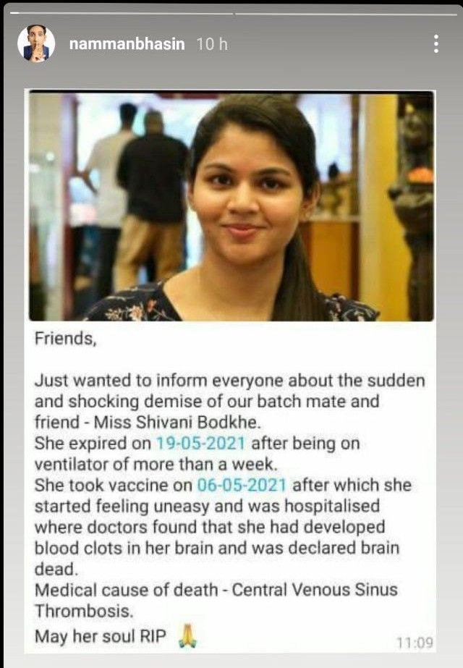
1366 | 16.05.2021 | https://twitter.com | Arunachal Pradesh: Tawang district  A 51 year old woman from Tawang district died on Saturday May 15, after receiving first dose of COVID-19 vaccine. |  | https://twitter.com/arunachaltimes_/status/1393940690237673473?s=19
1367 | 17.05.2021 | https://twitter.com | Mother of Tripti, died recently, due to server Covid, two months after receiving first dose of Covaxin COVID-19 vaccine. Her mother caught covid 12 days after vaccination. |  | https://twitter.com/Tripti26624667/status/1394491112748843008?s=19
1368 | 15.05.2021 | https://twitter.com | Mother of Karthik (NRI), died recently in India due to Covid, weeks after receiving a dose of COVID-19 vaccine. His mother caught covid a week after vaccination. |  | https://twitter.com/kart1811/status/1393311124045672449?s=19
1369 | 19.05.2021 | https://twitter.com | New Delhi  Elder brother of Gurmeet Saharan, died in 3rd week of May, due to Covid pneumonia, a month after receiving his second dose of Covaxin COVID-19 vaccine. |  | https://twitter.com/saharangumeet/status/1395301343682699264?s=19  https://twitter.com/saharangumeet/status/1395302322410979328?s=19  https://twitter.com/saharangumeet/status/1395303175070961669?s=19
1370 | 13.05.2021 | https://twitter.com | Bihar state  Father of Niraj Kumar, died on Friday April 30, due to Covid, three weeks after receiving first dose of COVID-19 vaccine. |  | https://twitter.com/NirajKu74137283/status/1392853291722174472?s=19
1371 | 23.05.2021 | https://twitter.com | Uncle of Rini Bhatnagar (NRI) died in India due to Covid, on Sunday morning May 23, days after receiving second dose of COVID-19 vaccine. |  | https://twitter.com/BhatnagarRini/status/1396265075103748098?s=19
1372 | 19.05.2021 | https://twitter.com | Tamilnadu  Relative of Ramgopal rg, passed away due to covid weeks after receiving second dose of COVID-19 vaccine. |  | https://twitter.com/ramgopalrg/status/1395020003074740224?s=19
1373 | 21.05.2021 | https://twitter.com | Haryana: Gurgaon  Maternal grandfather of Abhishek Baxi, died recently, days after receiving first dose of COVID-19 vaccine. |  | https://twitter.com/baxiabhishek/status/1395697317001383937?s=19
1374 | 19.05.2021 | https://twitter.com | Tamilnadu: Chennai  A relative of Renu from Chennai, died recently due to Covid, after receiving a dose of Covishield COVID-19 vaccine. And two other relatives have been hospitalized due to Covid. |  | https://twitter.com/reji_peter/status/1394983116914241539?s=19
1375 & 1376 | 17.05.2021 | https://twitter.com | Mother-in-law of Vinay's (NRI) sister in India, died on Monday, May 17 due to Covid, weeks after receiving first dose of COVID-19 vaccine. |  | https://twitter.com/camvinay/status/1394074079678849024?s=19
1377 | 21.04.2021 | https://twitter.com | Jharkhand: East Singhbhum district  According to Dr Kumar Diwakar of Tata Main Hospital of Jamshedpur, 2 doctors died during 3rd week of April, due to Covid, 2 weeks after receiving second dose of Covishield COVID-19 vaccine. |  | https://twitter.com/drkdiwakar18/status/1384249856890261515?s=19
1378 | 05.05.2021 | https://twitter.com | New Delhi  Brother of Shri. K. K. Dhingra, died on Wednesday, May 05, due to Covid pneumonia followed by a massive cardiac arrest, within 10 days after receiving first dose of Covishield COVID-19 vaccine. |  | https://twitter.com/kkdhingra888/status/1389999154315755521?s=19  https://twitter.com/kkdhingra888/status/1390000250312527872?s=19  https://twitter.com/kkdhingra888/status/1390000952019603456?s=19
1379 | 23.05.2021 | https://www.jagran.com | Bihar: Nalanda district  Sub Divisional Magistrate (SDM) of Bihar Sharif Sanjay Kumar Singh, died on Sunday, May 23, due to Covid, weeks after receiving second dose of COVID-19 vaccine. |  | https://www.jagran.com/bihar/patna-city-sdm-of-biharsharif-sanjay-kumar-singh-dies-from-corona-treatment-was-going-on-for-25-days-21669503.html
1380 | 24.05.2021 | https://twitter.com | New Delhi  A relative of Abhishek Bhardwaj (Advocate at Supreme court of India), died on Monday, May 24, due to Covid, 20 days after he received second dose of Covishield COVID-19 vaccine. |  | https://twitter.com/AbhishkBhardwaj/status/1396718597762818048?s=19
1381 | 02.02.2021 | https://m.timesofindia.com | Maharashtra: Mumbai urban district  Dr. Gwalani Tulsio (61), a Radiologist from Ulhasnagar Mumbai died on Sunday, January 31 due to a cardiac arrest, 11 days after receiving his first dose of Covishield COVID-19 vaccine. |  | https://m.timesofindia.com/city/thane/ulhas-doctor-dies-kin-say-no-link-to-vax/amp_articleshow/80638726.cms
1382 | 24.05.2021 | https://www.newindianexpress.com | Karnataka: Bengaluru urban district  Dr. N.S. Murthy (76), research director at, M.S. Ramaiah Medical College, died on Friday, May 07 due to Covid pneumonia, after three week long hospitalization. He had received his second dose of Covishield COVID-19 vaccine in February month. |  | https://www.newindianexpress.com/states/karnataka/2021/may/24/researcher-dies-of-covid-19-in-karnatakaafter-getting-twodoses-of-vaccine-2306672.html
1383 | 23.05.2021 | https://twitter.com | Telangana: Hyderabad district  83 year old mother of R.S. Rajput, from Hyderabad, died on Tuesday May 11, due to Covid complications, two weeks after she received her first dose of Covishield COVID-19 vaccine. |  | https://twitter.com/rsrajput999/status/1396171642246598658?s=19
1384 | 21.05.2021 | https://twitter.com | Himachal Pradesh: Shimla district  Sister of Shri. Ranjiv Paul, died on Friday, May 21, due to Covid complications, weeks after receiving second dose of Covaxin COVID-19 vaccine. |  | https://twitter.com/RanjivPaul/status/1395578265813733380?s=19
1385 | 19.05.2021 | https://twitter.com  https://www.newindianexpress.com | Bihar: Patna district  Dr. Prabhat Kumar, A leading cardiologist of Bihar, who was recently airlifted to Hyderabad for treatment of COVID- related complications, died on Tuesday, May 18, weeks after receiving his second dose of COVID-19 vaccine. |  | https://twitter.com/Keshavkmishra94/status/1394842043835318272?s=19  https://www.newindianexpress.com/nation/2021/may/18/leading-bihar-cardiologist-dr-prabhat-kumar-succumbs-to-covid-at-hyderabad-hospital-2304342.html
1386 & 1387 | 19.05.2021 | https://twitter.com | Madhya Pradesh: Khargone district  2 family member of Ashutosh Malviya, from Khargone have died recently due to Covid pneumonia, days after receiving second dose of COVID-19 vaccine. |  | https://twitter.com/ashumalviya_am/status/1394991589093695498?s=19
1388 | 24.05.2021 | https://twitter.com | A friend (50+) of Barath Radhakrishnan, died recently in April month due to Covid, two weeks after receiving his first dose of COVID-19 vaccine. |  | https://twitter.com/r_barath/status/1396592637612683267?s=19
1389 | 24.05.2021 | https://www.patrika.com | West Bengal: Kolkata district  Dr. Atanushankar Das (60) from Calcutta National Medical college & Hospital, Kolkata, died on Sunday May 23, due to Covid complications, months after receiving his second dose of Covishield COVID-19 vaccine. |  | https://www.patrika.com/kolkata-news/after-taking-two-doses-of-vaccine-another-doctor-sacrificed-corona-6861352/
1390 | 24.05.2021 | https://hindi.news24online.com | New Delhi Uncle of Shishupal, who was resident of New Delhi died recently due to Covid, a month after he received second dose of COVID-19 vaccine.On Sunday May 23, a group of residents in Sisoda village jumped into the Saryu River to avoid vaccination.  Shishupal who's resident of Sisoda village of Barabanki, Uttar Pradesh said, "People have died even after getting vaccinated. I know of people who have been hospitalized after taking the vaccine. Why do we need vaccine when we have to die anyway?" "Covid vaccine is 'harmful' and it is spreading Covid among others. I got this information from many of my friends, who work in big cities. The local authorities have not answered my questions. My own uncle who used to work in Delhi, died a month after getting both doses of vaccine and what proof do i need?'' Another resident Mohammad Ahsan said, "Is there any guarantee that we will not get infected after taking the vaccine? There are many in the nearby village who ran to get the vaccine and then got infected. Why is the government insisting on vaccination? They should give the vaccine to those who want to take it." |  | https://hindi.news24online.com/amp/news/up-uk/villagers-jump-river-avoid-getting-corona-vaccine-reason-not-taking-vaccine-10aad1e9/
1391 | 21.04.2021 | https://twitter.com | Andhra Pradesh  Gumma Satyanarayana, maternal grandfather of Ratnakar Patrayudu died on Wednesday, April 21, due to Covid, a month after receiving his first dose of Covishield COVID-19 vaccine. |  | https://twitter.com/Ratnakar1811/status/1389894283994361860?s=19
1392 | 27.04.2021 | https://twitter.com  https://twitter.com | Uncle of Aman Raina (NRI & founder of Sage investors) died in 4th week of April in India, due to COVID, more than a month after he received his first dose of COVID-19 vaccine. |  | https://twitter.com/sageinvestors/status/1387092632250290180?s=19  https://twitter.com/sageinvestors/status/1387092633609191429?s=19
1393 & 1394 | 11.05.2021 | https://twitter.com | Andhra Pradesh  2 relatives of Arjun Dhanu died on Sunday May 09, due to Covid pneumonia, days after receiving second dose of Covaxin COVID-19 vaccine. |  | https://twitter.com/Dhanu260891/status/1392003461877624836?s=19
1395 | 24.05.2021 | https://www.thehindu.com | Karnataka: Dakshina Kannada district  54-year-old Naveen Andra, a lead fireman from the Mangalore city's Kadri Fire Station, died on Sunday, May 23, due to Covid, a month after receiving his first dose of COVID-19 vaccine.  He had been awarded the Chief Minister’s Medal for his meritorious service. |  | https://www.thehindu.com/news/cities/Mangalore/54-year-old-fireman-succumbs-to-covid-19/article34632974.ece
1396 | 19.05.2021 | https://hindi.oneindia.com | Uttar Pradesh: Muzaffarnagar district  Vijay Kumar Kashyap (52), U.P. Minister of State for Revenue & Flood Control and BJP MLA from Charthawal constituency, died on, Tuesday, 18 May, due to Covid, weeks after receiving his COVID-19 vaccine. |  | https://hindi.oneindia.com/news/uttar-pradesh/bjp-mla-and-up-govt-minister-vijay-kashyap-succumbs-to-coronavirus-618570.html
1397 | 01.05.2021 | https://twitter.com  https://thebengalurulive.com | Karnataka: Bengaluru urban district  Uday Kumar (50), an Assistant Executive Engineer in the Road Infrastructure Wing of BBMP, resident of Kengeri, died on Saturday, May 01, due to Covid, weeks after he received first dose of COVID-19 vaccine. |  | https://twitter.com/bengalurulive_/status/1388450258208755714?s=19  https://thebengalurulive.com/bbmp-staffer-succumbs-to-covid/
1398 | 20.05.2021 | https://www.jagran.com | New Delhi  Dr U C Biswal (70) from Ram Manohar Lohia Hospital, a retired professor, succumbed to Covid on Thursday May 13. He had taken both doses of the COVID-19 vaccine. |  | https://www.jagran.com/delhi/new-delhi-city-ncr-experts-worried-over-doctors-deaths-after-taking-both-doses-of-vaccine-new-study-started-results-soon-21660590.html
1399 | 01.05.2021 | https://twitter.com | Uttar Pradesh: Ghaziabad district  Mother-in-law of Amit Verma, died on Saturday May 01, due to Covid, days after receiving her dose of Covaxin COVID-19 vaccine. |  | https://twitter.com/amitverma690/status/1388375473235795968?s=19  https://twitter.com/amitverma690/status/1388376737721970690?s=19
1400 | 24.05.2021 | https://odishabytes.com | Odisha: Kandhamal district  Asutosh Behera (45), a journalist & correspondent for the Odia vernacular daily ‘Sarbasadharan’, from Phulbani, died on Sunday May 23 due to Covid. He was among the first to get COVID-19 vaccine during the drive for journalists. |  | https://odishabytes.com/covid-19-odisha-loses-one-more-journalist-in-second-wave/
1401 To 1427 | 24.05.2021 | https://www.thehindu.com | West Bengal  Published on May 24, 2021  Dr. Koushik Chaki, of the West Bengal Doctors’ Forum (WBDF), has confirmed that 43 doctors in West Bengal has died in last 2 months. 30 doctors out of 43 were fully vaccinated & 13 were partially vaccinated.  Deducting, 10 deaths of doctors reported by IMA on May 22, and 6 deaths reported on this channel, 27 are newly reported deaths. |  | https://www.thehindu.com/news/national/other-states/coronavirus-43-doctors-die-in-bengal-in-second-wave/article34635081.ece
1428 | 16.05.2021 | https://twitter.com | Tamilnadu: Tiruchirappalli district  Father of Ramya, died in month of May, due to Covid, after he was given a second dose of COVID-19 vaccine.  He was administered a Covaxin & then a Covishield vaccine shot at Prabhu Diabetes Specialty Center, at Ponnagar Extension, Karumandapam, Tiruchirappalli. |  | https://twitter.com/ramya22023070/status/1393929494260375555?s=19
1429 | 22.05.2021 | https://twitter.com | Gujarat: Porbandar district  Father of Atulkumar Bapodra (Ex BJP secretary of Porbandar district) died recently due to blood clotting and Cardiac arrest, days after receiving his second dose of Covishield COVID-19 vaccine. |  | https://twitter.com/AtulkumarBapod1/status/1396094394411880453?s=19
1430 | 23.05.2021 | https://twitter.com | New Delhi  Father-in-law of Popi Kahar from South Delhi, died on Tuesday May 11, due to Covid, days after receiving first dose of COVID-19 vaccine. |  | https://twitter.com/Thelostwriter01/status/1396500701430251524?s=19  https://twitter.com/Thelostwriter01/status/1396500948260769792?s=19
1431 & 1432 | 23.05.2021 | https://twitter.com | Tamilnadu: Chennai  Madhavan & his wife, died on May 18 & May 24 respectively due to Covid, weeks after receiving their COVID-19 vaccine. |  | https://twitter.com/BLUEMAN22222/status/1396391296831352838?s=19  https://twitter.com/BLUEMAN22222/status/1396715109217538050?s=19
1433 | 21.04.2021 | https://twitter.com | Uttar Pradesh: Lucknow  Uncle of Shivam, died on Wednesday, April 21, due to covid pneumonia, days after receiving his second dose of Covishield COVID-19 vaccine. |  | https://twitter.com/dontwannashare/status/1384732593074040832?s=19
1434 | 07.04.2021 | https://twitter.com/ami2vish/status/1392727892245630987?s=19 | Jharkhand: Sahebganj district  Uncle of Amit Aryan (District General Secretary of BJYM) died on Wednesday April 7, due to fever & Covid pneumonia, 4 days after receiving second dose of COVID-19 vaccine. |  | https://twitter.com/ami2vish/status/1392727892245630987?s=19
1435 | 21.04.2021 | https://twitter.com/iamsrinav/status/1392432183877439488?s=19 | Jharkhand: Ranchi district  Mother of Navin Srivastava (NRI), died on Wednesday, April 21 due to Covid, ten days after receiving first dose of COVID-19 vaccine. |  | https://twitter.com/iamsrinav/status/1392432183877439488?s=19
1436 | 02.05.2021 | https://twitter.com | Maharashtra: Mumbai urban district  Father of Priyanka Kavish, died in second week of April, due to Covid, a month after receiving his first dose of Covishield COVID-19 vaccine. |  | https://twitter.com/PriyankaKavish/status/1388864645427912708?s=19
1437 & 1438 | 08.05.2021 | https://www.amarujala.com | Uttar Pradesh: Kasganj district  Satish Chandra Mishra & his wife Sadhana Mishra, resident of Sidhpura town, died on April 26 & May 08 respectively, due to Covid, within a month after receiving COVID-19 vaccine. |  | https://www.amarujala.com/uttar-pradesh/agra/wife-also-died-of-corona-infection-after-husband-kasganj-news-agr491205241
1439 To 1488 | 23.05.2021 | https://theprint.in | Andhra Pradesh  State police department has lost 70 personnel of various ranks among the 5,500 infected in the second wave, in just two months – April and May so far.  DGP Gautam Sawang said, almost 98 per cent of their staff have had their first dose of the Covid vaccine, and 80 per cent have got their second dose as well.  Hence we can safely say at least 50 cops who died, had taken their first dose of COVID-19 vaccine. |  | https://theprint.in/india/70-cops-died-of-covid-polls-in-ap-tamil-nadu-may-have-led-to-spike-in-cases-andhra-dgp/663435/
1489 | 19.05.2021 | https://www.freepressjournal.in | Maharashtra: Mumbai  Sidharam Vhanmane (43), police constable at Motor Training department, died on Tuesday, May 18, due to Covid, two month after receiving his first dose of COVID-19 vaccine. |  | https://www.freepressjournal.in/mumbai/another-city-cop-dies-of-covid-19-mumbai-police-toll-reaches-to-116
1490 | 09.05.2021 | https://twitter.com | Bihar: Patna  Relative of Jhelum, died recently due to covid, 10 days after receiving first dose of Covaxin COVID-19 vaccine. |  | https://twitter.com/Jhelum8/status/1391430639245684736?s=19
1491 | 03.04.2021 | https://twitter.com | Andhra Pradesh: Kurnool district  Uncle of Vijay, resident of Nandyal, died on Saturday, April 03, due to a brain stroke, 3 days after receiving a dose of Covishield COVID-19 vaccine. |  | https://twitter.com/nilagiritahr/status/1384316261442543616?s=19
1492 | 07.05.2021 | https://www.youtube.com  https://www.ndtv.com | Uttar Pradesh: Gautam Budh Nagar district  Shesh Narayan Singh (70), Veteran Journalist, died on Friday, May 07, at a government hospital GIMS in Greater Noida, due to Covid, two weeks after second dose of COVID-19 vaccine. |  | https://www.youtube.com/watch?v=bpWLHdWOrXw  https://www.ndtv.com/india-news/shesh-narayan-singh-veteran-journalist-dies-of-covid-19-2437181
1493 | 26.05.2021 | https://youtu.be/Am1wmxc3tlc | Madhya Pradesh: Shajapur District  Wife (50+) of Hari Chandra, resident of Palkhedi village of Agar tehsil, died recently due to Covid, 15 days after receiving first dose of COVID-19 vaccine. |  | Timestamp: 17:42 to 18:02  https://youtu.be/Am1wmxc3tlc
1494 | 05.03.2021 | https://www.youtube.com | Chattisgarh: Janjgir–Champa district  65 year old woman, died on Thursday, March 04, due to Covid pneumonia and severe breathlessness, 17 hours after she received her first dose of COVID-19 vaccine.  She was admitted in district hospital on February 21, due to breathing issues, but still she was administered COVID-19 vaccine on March 03, before she was discharge from the hospital. |  | https://www.youtube.com/watch?v=lMlp67dxdL8
1495 | 03.05.2021 | https://twitter.com | Assam: Guwahati  Jyotish Patowary (73), died on Monday, April 26 at GMCH Guwahati, due to Covid, 51 days after receiving first dose of Covishield COVID-19 vaccine.  Pranjal and his wife also contracted covid after his parents got vaccinated on March 06. |  | https://twitter.com/pranjalp1984/status/1389222457186209795?s=19  https://twitter.com/pranjalp1984/status/1386286024452575238?s=19
1496 | 14.05.2021 | https://twitter.com | Karnataka: Bengaluru  Grandfather (82) of Srisudhir Tadepalli, died in second week of May, due to contracting Covid, a month after receiving second dose of Covishield COVID-19 vaccine. |  | https://twitter.com/tsrisudh/status/1393187452110598151?s=19
1497 | 04.05.2021 | https://twitter.com | Delhi NCR  Father-in-law (73) of Nitin Jain, died on Tuesday, May 04, due to Covid, days after receiving his second dose of Covaxin COVID-19 vaccine. |  | https://twitter.com/ChowkidaarNJ/status/1389599703151435778?s=19
1498 | 25.05.2021 | https://twitter.com | Maharashtra: Pune  Father of Rajesh Kaul recently passed away due to Covid, days after receiving first dose of COVID-19 vaccine.  And now Rajesh ji is desperate to vaccinate his wife & daughter. |  | https://twitter.com/RajeshK44654441/status/1397080008917618693?s=19
1499 | 17.05.2021 | https://twitter.com | New Delhi: Pitampura  Aunty of Tilak Mundhra died on Thursday May 06, due to Covid complications followed by cardiac arrest, 4 weeks after receiving a dose of Covaxin COVID-19 vaccine. |  | https://twitter.com/MundhraTilak/status/1394275666510553089?s=19  https://twitter.com/MundhraTilak/status/1394276064130519041?s=19
1500 | 18.05.2021 | https://twitter.com | Uttar Pradesh: Kanpur  Mother of A D TYA, died in third week of May, due to Covid, days after receiving second dose of Covishield COVID-19 vaccine. |  | https://twitter.com/sun_sun_suna/status/1394368279175520257?s=19
1501 | 17.05.2021 | https://m.facebook.com  https://www.instagram.com | New Delhi  Father of Dr. Ritu Singh died on Monday, May 17, due to blood clotting and all organ failure, weeks after receiving dose of Covishield COVID-19 vaccine. |  | https://m.facebook.com/story.php?story_fbid=3956632817766270&id=100002587710421  https://www.instagram.com/p/CPWD2yUiymz/
1502 | 27.05.2021 | https://twitter.com | Maharashtra: Nashik district  Relative of Gaurav Kolhe, resident of Nashik, died on Thursday, May 27, due to Covid & Mucormycosis, days after receiving first dose of COVID-19 vaccine. |  | https://twitter.com/saikolhe5171/status/1397814306293440512?s=19
1503 | 27.05.2021 | https://twitter.com | New Delhi  A woman, neighbour of Ritu Rathaur died recently, due to cardiac arrest, on 3rd day after receiving her dose of COVID-19 vaccine. |  | https://twitter.com/RituRathaur/status/1397771420654989313?s=20
1504 | 06.05.2021 | https://twitter.com | Odisha: Bhubaneswar  A close friend of Debasish Tripathy, died on Thursday May 06, due to severe breathlessness, a month after receiving first dose of Covaxin COVID-19 vaccine. |  | https://twitter.com/Debasish73/status/1390296388127260683?s=19  https://twitter.com/Debasish73/status/1390308858057297925?s=19  https://twitter.com/Debasish73/status/1390921601160400901?s=19
1505 | 08.05.2021 | https://twitter.com | Uttar Pradesh: Lucknow  Relative of Vaibhav Sharma died recently due to Covid, a month after receiving second dose of Covaxin COVID-19 vaccine. |  | https://twitter.com/vs848/status/1391048018946793475?s=19  https://twitter.com/vs848/status/1391049696496341000?s=19
1506 | 26.05.2021 | https://www.bhaskar.com | Madhya Pradesh: Guna district  BJP leader Narendra Kumar Jain from Dharnawada village of Raghogarh Tehsil died in 4th week of May, due to Covid, days after receiving COVID-19 vaccine. |  | https://www.bhaskar.com/local/mp/bhopal/guna/news/after-the-death-of-the-bjp-leader-in-dharnavada-the-villagers-were-not-getting-the-vaccine-the-son-explained-and-the-father-died-due-to-illness-then-60-people-got-the-vaccine-128527132.html
1507 | 21.05.2021 | https://www.instagram.com | Uttar Pradesh  Father of Aman Garcha Rataul, died recently due to blood clotting & organ failure, within 5 days of receiving dose of Covishield COVID-19 vaccine. |  | https://www.instagram.com/p/CPWD2yUiymz/  https://t.me/EscapeTheMatrix/1580?single
1508 | 18.05.2021 | https://twitter.com | Madhya Pradesh: Indore  Shri. Jagdish Prasad Sharma (71), who had no comorbidities, passed away on Thursday, May 13, due to severe Covid, seven weeks after receiving first dose of Covishield COVID-19 vaccine. |  | https://twitter.com/sumiitsharma/status/1394612212862394369?s=19
1509 | 08.05.2021 | https://twitter.com | Andhra Pradesh: Prakasam district  Uncle of Adarsh, died on Friday, May 07 at Kakarla, due to Covid pneumonia, 4 days after receiving first dose of Covishield COVID-19 vaccine. |  | https://twitter.com/curryputtar/status/1390937257884807178?s=19
1510 | 16.04.2021 | https://twitter.com | Uttar Pradesh: Hardoi district  Dr. Navneet Anand, incharge of vaccination center at district hospital, Hardoi, died on Thursday, April 15 due to Covid, days after receiving second dose Covishield COVID-19 vaccine. |  | https://twitter.com/official_aimsa/status/1383002532251783178?s=19
1511 | 08.05.2021 | https://twitter.com | Andhra Pradesh: Guntur district  Relative of Rahul, resident of Siripuram village, died on Thursday, May 06, due to heart attack, 2 days after receiving dose of COVID-19 vaccine. |  | https://twitter.com/Rahul42905334/status/1390941082221907969?s=19  https://twitter.com/Rahul42905334/status/1391008708562362368?s=19
1512 | 17.05.2021 | https://twitter.com | Andhra Pradesh  Relative of Kashyap Perla, died in 3rd week of May, due to Covid, a month after receiving second dose of COVID-19 vaccine. |  | https://twitter.com/kashyapperla/status/1394332672537759750?s=19
1513 To 1554 | 27.05.2021 | https://twitter.com  https://indianexpress.com | Karnataka  As of May 27, India Today report,  48 Karnataka cops succumb to Covid-19 in a month.  As of May 20, The Indian Express report, According to the Karnataka Police’s official data, 41 police personnel have died of Covid-19 between April 1 and May 13. Of these, 13 were reported in Bengaluru alone.“Considering the police as the frontline workers, the government has ensured that the entire police department is vaccinated, so that the cases and the deaths are less compared to last year,” a senior officer said. |  | https://twitter.com/IndiaToday/status/1397835726461431812?s=19  https://indianexpress.com/article/cities/bangalore/karnataka-police-lost-41-personnel-to-covid-19-second-wave-most-recent-is-a-28-year-old-pregnant-sub-inspector-7321902/
1555 | 14.05.2021 | https://indianexpress.com | New Delhi  Jarnail Singh (47), former MLA of Aam Adami Party from Rajouri Garden died on Friday May 14, due to Covid pneumonia, weeks after receiving first dose of COVID-19 vaccine on April 18, as confirmed by his younger brother Karnail Singh. |  | https://indianexpress.com/article/cities/delhi/former-aap-mla-jarnail-singh-dies/
1556 | 12.05.2021 | https://m.facebook.com  https://www.aajtak.in | Bihar: Patna  Tanveer Akhtar, JDU senior leader & MLC, died on May 08, due to Covid, 8 weeks after receiving first dose of COVID-19 vaccine. |  | https://m.facebook.com/story.php?story_fbid=493144155392788&id=100040916234277  https://www.aajtak.in/coronavirus/story/coronavirus-in-bihar-jdu-leader-and-legislative-council-member-tanveer-akhtar-dies-of-covid-19-1251366-2021-05-08
1557 | 28.05.2021 | https://twitter.com | Uttar Pradesh: Gautam Budh Nagar district  Mrs. Neera Mathur from Greater Noida, passed away on Wednesday, May 05, due to Covid pneumonia followed by a cardiac arrest, 3 weeks after receiving first dose of Covaxin COVID-19 vaccine. |  | https://twitter.com/nikskadoodledo/status/1398167087558787078?s=19  https://twitter.com/nikskadoodledo/status/1398167856664117252?s=19
1558 | 28.05.2021 | https://twitter.com | Gujarat: Vadodara District  Dr. Nitin bhai Shah, a senior Gynaecologist from Waghodia road, Vadodara, succumb to Covid on Friday May 28, days after receiving second dose of COVID-19 vaccine. |  | https://twitter.com/imacuriosguy/status/1398174544041373697?s=19  https://twitter.com/imacuriosguy/status/1398181165178056706?s=19
1559 To 1563 | 28.05.2021 | https://twitter.com | New Delhi, Maharashtra, Bihar  5 relatives of Sandeep Sharan recently died due to Covid, after being vaccinated with either first or second dose of COVID-19 vaccine. |  | https://twitter.com/SandeepSharan19/status/1398168121660243969?s=19  https://twitter.com/SandeepSharan19/status/1398197575900008451?s=19
1564 | 22.05.2021 | https://twitter.com | Aunty of Jiya, died on Friday, May 21, due to heart attack, days after receiving second dose of Covishield COVID-19 vaccine. |  | https://twitter.com/JiyaRe008/status/1395914152720277504?s=19
1565 | 23.06.2021 | https://twitter.com | Maharashtra: Nashik  Grandfather of Arpit Singh, died recently due to Covid, days after receiving a dose of COVID-19 vaccine. |  | https://twitter.com/thebrokensoul04/status/1396394129907601410?s=19  https://twitter.com/thebrokensoul04/status/1396401411240333312?s=19
1566 | 28.5.2021 | https://twitter.com | Uttar Pradesh: Ghaziabad  Mrs. Usha Mehra, passed away on Thursday, May 27, due to Covid, weeks after receiving Covishield COVID-19 vaccine. |  | https://twitter.com/MehraDileep/status/1398064778635976706?s=19  https://twitter.com/MehraDileep/status/1398063633687486467?s=19
1567 To 1569 | 22.05.2021 | https://twitter.com | Uttar Pradesh, Uttarakhand  Cousin Grandfather, Grandmother and a neighbour of Amar Deep Mall, died recently due to Covid, days after receiving first dose of Covishield COVID-19 vaccine. |  | https://twitter.com/_admall/status/1396155158464131076?s=19  https://twitter.com/_admall/status/1398261910491963394?s=19
1570 | 28.04.2021 | May 28, Divya Bhaskar, Rajkot city edition, Page 14. | Gujarat: Junagadh district  Ashwin Solanki (30), FSL (Forensic Science Laboratory) employee in Junagadh, died on Tuesday, May 25 due to vomiting, 10 hours after receiving first dose of COVID-19 vaccine. |  | 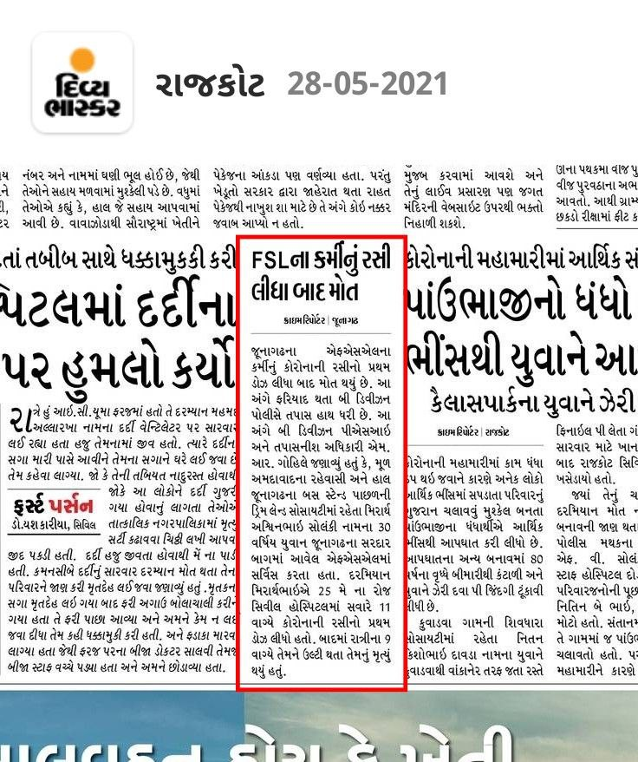
1571 | 13.05.2021 | https://twitter.com | New Delhi  Father of Reshmita Kalra died on Tuesday, April 27, due to Covid, 7 weeks after receiving first dose of COVID-19 vaccine. |  | https://twitter.com/Reshmita_Kalra/status/1392869193645625347?s=20
1572 | 25.05.2021 | https://twitter.com | New Delhi  Elder brother (49) of Suchibrata Banerjee, passed away on Thursday April 22, due to Covid pneumonia, 2 weeks after receiving first dose of Covishield COVID-19 vaccine. |  | https://twitter.com/sbb_in/status/1397136162171461636?s=19  https://twitter.com/sbb_in/status/1397221395113947139?s=19  https://twitter.com/sbb_in/status/1397142370576003080?s=19
1573 | 20.05.2021 | https://twitter.com  https://m.timesofindia.com | Uttar Pradesh: Lucknow  Dr K N Singh, Owner & Chairperson of Mayo Group of Institutions and Hospitals died on Thursday May 20, due to severe Covid pneumonia & multi organ failure, weeks after receiving COVID-19 vaccine. |  | https://twitter.com/Nkverma13196387/status/1395578693196517381?s=19  https://m.timesofindia.com/city/lucknow/lucknow-mayo-group-chief-succumbs-after-battling-covid-for-15-days/amp_articleshow/82820774.cms
1574 | 04.05.2021 | https://twitter.com | Haryana: Faridabad  Friend of R K Shahi, died on Friday, April 30, due to Covid, 10 days after receiving first dose of COVID-19 vaccine.  Shahi ji thinks that, his friend got Covid from the vaccination center, but do not doubt the obvious, magical shot. |  | https://twitter.com/RKShahi74/status/1389467840198086658?s=20
1575 | 29.05.2021 | https://twitter.com | Tamilnadu: Chennai  Dr M Anandakrishnan (92), Formar VC, Anna University, died on Saturday, May 29, due to Covid, 2 weeks after receiving second dose of COVID-19 vaccine. |  | https://twitter.com/Rama_Krishnan/status/1398481518406688769?s=19  https://twitter.com/Rama_Krishnan/status/1398486765443317765?s=19
1576 & 1577 | 28.05.2021 | https://twitter.com | Maharashtra: Mumbai  Senior citizen parents of Vidyadharana's friend, died recently, due to Covid blood clotting, within days after receiving a dose of Covishield COVID-19 vaccine. |  | https://twitter.com/vidyadharana/status/1398201149723869187?s=19
1578 & 1579 | 09.05.2021 | https://twitter.com | Uttar Pradesh: Lucknow  2 close relatives of Priyanshu died recently due to Covid, 10 to 15 days after receiving first dose of COVID-19 vaccine. |  | https://twitter.com/_lostboy_71/status/1391098431167291392?s=19
1580 | 29.05.2021 | https://twitter.com | Rajasthan: Udaipur  Dr. Fatma Liyaquat, mother of Journalist Rubika Liyaquat, passed away on Saturday, May 29, due to COVID complications, a month after receiving first dose of COVID-19 vaccine. |  | https://twitter.com/RubikaLiyaquat/status/1387032875447373827?s=19  https://twitter.com/RubikaLiyaquat/status/1392482909773201409?s=19  https://twitter.com/RubikaLiyaquat/status/1398382155592454144?s=19  https://www.shethepeople.tv/news/journalist-rubika-liyaquat-mother-dr-fatma-liyaquat-passes-away-covid-19/
1581 | 25.05.2021 | https://instagram.com | New Delhi  Mother of Kshipra Verma Bhasin, died recently in 4th week of May, due to covid, weeks after receiving second dose of Covishield COVID-19 vaccine. |  | https://instagram.com/kshipratarotreader  https://www.instagram.com/p/CPcml3zDUzi/
1582 & 1583 | 26.95.2021 | https://twitter.com | Jammu Kashmir: Samba district  According to Mohit Khajuria of Samba, 2 persons in his locality has died recently on May 19 & May 26, due to severe fever & Covid symptoms developed after receiving second dose of Covishield COVID-19 vaccine. |  | https://twitter.com/mohit10_02/status/1394881645111562240?s=19  https://twitter.com/mohit10_02/status/1397416718427987968?s=19
1584 | 29.05.2021 | https://twitter.com | Andhra Pradesh: Vijayawada  Ravi's family friend, from Vijaywada, passed away on Sunday May 16, due to persistent fever and Covid pneumonia, 2 weeks after receiving first dose of Covishield COVID-19 vaccine on April 29. |  | https://twitter.com/Ravi77895944/status/1398630156592242691?s=19  https://twitter.com/Ravi77895944/status/1398631035949047814?s=19
1585 | 29.05.2021 | https://twitter.com | Maharashtra: Mumbai  A senior doctor (46) to Dr N P Rahil from Nair hospital, passed away on Saturday, May 29, due to post covid pancreatitis & multi organ failure, 3 months after second dose of COVID-19 vaccine. |  | https://twitter.com/nprahil/status/1398599712173969413?s=19  https://twitter.com/nprahil/status/1398657976098078723?s=19
1586 | 13.05.2021 | https://twitter.com | Jharkhand: Ranchi  Mother-in-law of Yashveer Singh, passed away recently in Ranchi, due to sudden drop in O2 level & Covid lung infection, 18 days after receiving second dose of Covaxin COVID-19 vaccine. |  | https://twitter.com/YASHVEE34473075/status/1392824690608009221?s=19
1587 | 24.04.2021 | https://twitter.com | New Delhi  Aunty of Anjali Pant, passed away on Saturday April 24, due to Covid, a week after receiving COVID-19 vaccine. |  | https://twitter.com/AnjaliPant93/status/1385686902477496320?s=19
1588 | 01.05.2021 | https://twitter.com | Nidhi Goyal's uncle passed away in April, due to Covid pneumonia, 9 days after receiving first dose of COVID-19 vaccine. |  | https://twitter.com/NidhiGo87449332/status/1388460820384911361?s=19
1589 | 29.05.2021 | https://twitter.com | Telangana: Hyderabad  Gottam Jayapal Reddy (62), passed away on May 15, due to Covid pneumonia followed by a cardiac arrest, days after receiving a dose of COVID-19 vaccine. |  | https://twitter.com/RaviKir55812964/status/1398365711622295552?s=19  https://twitter.com/RaviKir55812964/status/1398859103099756545?s=19
1590 | 09.05.2021 | https://twitter.com | New Delhi  Father of Anshul Arora, passed away on April 26, due to Covid, 14 days after receiving second dose of COVID-19 vaccine on April 12. |  | https://twitter.cohttps://twitter.com/Kashyap_Ritesh1/status/1388056333572657155?s=19m/vanshul/status/1391444635453562881?s=19
1591 To 1595 | 23.04.2021 | https://twitter.com | Ahemdabad, Noida, Chennai  Aunty of Harsh Shah, passed away recently due to Covid after, receiving second dose of Covishield vaccine.  3 relatives of Ritesh Kashyap died recently after few days of receiving COVID-19 vaccine.  A relative of 2024 Tamilian, died recently due to Covid after first dose of COVID-19 vaccine. |  | https://twitter.com/harshec201/status/1385659597357142020?s=19  https://twitter.com/Kashyap_Ritesh1/status/1388056333572657155?s=19  https://twitter.com/MagChennai/status/1387643581737836544?s=19
1596 To 1598 | 04.05.2021 | https://twitter.com | Guwahati, Boduppal (TS), Greater Noida  Pratik's father expired at Guwahati, on May 04, due to Covid, days after receiving COVID-19 vaccine.  Relative of Vinay Kumar from Boduppal died recently due to Covid, after receiving first dose of COVID-19 vaccine. Mother of Rajkumar from Greater Noida died due to Covid, after receiving dose of Covishield COVID-19 vaccine. |  | https://twitter.com/FaisalWahid16/status/1389287392075341826?s=19  https://twitter.com/Vinay_Kumar_M/status/1390399092619059201?s=19  https://twitter.com/rajk779/status/1391220109042061312?s=19
1599 | 14.05.2021 | https://twitter.com | Andhra Pradesh: Visakhapatnam  Dr. P. Venugopal, HOD Paediatrics, Andhra Medical College, died on Friday May 14, due to COVID, days after receiving a dose of Covishield COVID-19 vaccine. |  | https://twitter.com/rbhavanirao/status/1398942449767047169?s=19  https://www.thehindu.com/news/cities/Visakhapatnam/two-doctors-die-of-virus/article34561174.ece
1600 & 1601 | 12.05.2021 | https://twitter.com | New Delhi, Bengaluru  Mother of Mohit Sharma from Delhi passed away recently due to Covid, days after receiving first dose of Covishield COVID-19 vaccine.  Chandini Choudhury's sister's father-in-law, expired on May 13, days after receiving second dose of COVID-19 vaccine. |  | https://twitter.com/MohitSh93416402/status/1392546910439833603?s=19  https://twitter.com/ChandiniChoudh7/status/1392861912589758464?s=19
1602 | 28.05.2021 | https://twitter.com | Uttar Pradesh: Sultanpur district  Sabhajit Singh from Shahabuddinpur village, died on May 11, due to Covid, 2 weeks after receiving second dose of Covishield COVID-19 vaccine. |  | https://twitter.com/sunil200220/status/1398203723055210500?s=19
1603 & 1604 | 18.05.2021 | https://twitter.com | Odisha  2 colleagues of Jyoti Mohan died recently due to Covid lung infection & heart attack, 19 days after receiving first dose of COVID-19 vaccine. |  | https://twitter.com/jm4change/status/1394474728002265090?s=19
1605 | 30.05.2021 | https://twitter.com | Maharashtra: Mumbai  Father of Ambish Kashmiri, passed away on May 21, due to Covid, a month after receiving first dose of Covishield COVID-19 vaccine. |  | https://twitter.com/ambishkashmiri/status/1399077783205146631?s=19  https://twitter.com/ambishkashmiri/status/1390429563394543618?s=19
1606 To 1611 | 31.05.2021 | https://twitter.com | Relative of Harshdeep Singh,  2 Relatives of Sujeet,  2 Relatives of Renu &  Grandfather of Raghav Ramanuj, died recently due to Covid, days after receiving Covishield COVID-19 vaccine. |  | https://twitter.com/hdstweet/status/1394954577217298435?s=19  https://twitter.com/iamsujeet/status/1399263214504980483?s=19  https://twitter.com/reji_peter/status/1399257764497551360?s=19  https://twitter.com/i_am_RAGHAV/status/1389472884079284228?s=19
1612 To 1618 | 30.05.2021 | https://www.dailyexcelsior.com | J&K : Jammu  Sanjeev Pargal reports,  Jammu and Kashmir on May 29 reported 46 COVID casualties and 2253 cases. Jammu accounted for 30 deaths.  Among the fatalities in Jammu, seven COVID victims were vaccinated—one fully and six partially. |  | https://www.dailyexcelsior.com/7-vaccinated-persons-16-women-kas-officers-mother-among-30-die-in-jammu/
1619 To 1622 | 29.04.2021 | https://twitter.com | Patna, Hyderabad, Eastern U.P.  School teacher Upasana Kumari from Khaspur, Patna, passed away on April 29, due to Covid, 4 weeks after receiving first dose of Covishield COVID-19 vaccine.  Father of Utkarsh MK from Hyderabad, passed away recently, due to Covid, days after receiving second dose of Covishield COVID-19 vaccine.  2 relatives of Anand from Eastern U.P. died recently due to Covid, after receiving a dose of Covishield COVID-19 vaccine. |  | https://twitter.com/biru11111/status/1387682282811494400?s=19  https://twitter.com/UTKARSHMK1/status/1394526790891102210?s=19  https://twitter.com/dontmess_a/status/1399318910470483975?s=19
1623 | 01.06.2021 | https://twitter.com | Tamilnadu: Nilgiris district  Mother-in-law (85) of Supriya Sahu (IAS officer) from Coonoor, passed away on Tuesday June 01, due to Covid, days after receiving second dose of COVID-19 vaccine. |  | https://twitter.com/supriyasahuias/status/1399559620717252609?s=19
1624 To 1626 | 27.04.2021 | https://twitter.com | Dhanbad (JH), Bhilai (CG), Mumbai (MH)  Father of Ankesh Dwivedi,  Mother of Shubhasish Das &  Family friend (54, F) of Deshpande,  Died recently due to Covid, days after receiving first dose of Covishield COVID-19 vaccine. |  | https://twitter.com/Ankeshdwivedi3/status/1386965935886536710?s=19  https://twitter.com/Ankeshdwivedi3/status/1386965937954254852?s=19  https://twitter.com/shubha_1982/status/1387984617089679363?s=19  https://twitter.com/randomiserrr/status/1388402155497742338?s=19
1627 | 01.06.2021 | https://m.jagran.com | Uttar Pradesh: Moradabad district  Mrs. Anita Ajay Singh Tomar, resident of Rajaji puram Moradabad, died on Monday, May 31, due to sudden stomach ache & vomiting, within just 4 hours after receiving first dose of COVID-19 vaccine. |  | https://m.jagran.com/lite/uttar-pradesh/moradabad-city-corona-vaccination-news-female-accountant-dies-after-vaccination-in-moradabad-family-members-accused-cmo-started-investigation-21696820.html
1628 To 1630 | 31.05.2021 | https://twitter.com | Gurgaon (HR), Indore (MP), Lucknow (UP)  3 family members of Dr. V. N. Tikku, died in last 20 days, due to Covid, after receiving first dose of Covishield COVID-19 vaccine.  Other than that 20 close relatives of Dr. Tikku, caught Covid after their first jab of COVID-19 vaccine. |  | https://twitter.com/neeruvntikku/status/1399376963261792263?s=19  https://twitter.com/neeruvntikku/status/1399406814932869122?s=19
1631 To 1634 | 01.05.2021 | https://twitter.com | Pune (MH), Prayagraj (UP), Chennai (TN)  1 Relative (M, 50+) of Vijay Patil,  2 Professor colleagues of Dr.Jagriti Rana & Father of Ram,  died recently due to Covid, after taking first dose of Covishield, second dose of Covishield & second dose of Covaxin COVID-19 vaccines respectively. |  | https://twitter.com/v_c_p/status/1388502760136445952?s=19  https://twitter.com/JagritiRana7/status/1388787019715727361?s=19  https://twitter.com/RAM_RNGRN/status/1398245642661732353?s=19  https://twitter.com/RAM_RNGRN/status/1399414259818315778?s=19  https://twitter.com/RAM_RNGRN/status/1399428983876423682?s=19
1635 To 1640 | 11.05.2021 | https://twitter.com | Mumbai (MH), Hyderabad (TS), Cuttack (OD)  Father of Abhay Vasekar,  3 Relatives of Mahek Shah's friends  2 Close relatives of Venkata died recently due to Covid, after first dose (2 cases) & second dose of Covishield COVID-19 vaccine respectively. |  | https://twitter.com/abhayvasekar/status/1391978087089246208?s=19  https://twitter.com/MahekMShah/status/1393753077572784128?s=19  https://twitter.com/coolvicky05/status/1393541182450323456?s=19
1641 To 1643 | 31.05.2021 | https://twitter.com | New Delhi  3 relatives (aged 50-70) of Shalini Vig (founder of Hope foundation) passed away in last 24 hours of May 31st, due to Covid, few weeks after receiving second dose of Covishield COVID-19 vaccine. |  | https://twitter.com/shalinivig/status/1399386748442996737?s=19  https://twitter.com/shalinivig/status/1399732430290882573?s=19  https://twitter.com/shalinivig/status/1399395478131728384?s=19
1644 To 1648 | 18.05.2021 | https://twitter.com | (KA), Chennai (TN), Varanasi (UP), Alwar (RJ)  2 relatives of Bhaskar's friend, Father of Sayeeshwar, Father of Amod Malviya–Vijay Kumar Malviya, Mother of Satya RaoSaheb died recently due to Covid complications, days after receiving second dose of Covishield & first dose of Covaxin COVID-19 vaccine. |  | https://twitter.com/the_bhaskar/status/1394483662184325121?s=19  https://twitter.com/sayeeshwar/status/1394879923819630592?s=19  https://twitter.com/amodm/status/1399652829648670720?s=19  https://twitter.com/Satya_RaoSahab/status/1380063485845905410?s=19
1649 To 1651 | 29.05.2021 | https://twitter.com | Chennai (TN), Nirmal (TS), Jaypore (OD)  Mother-in-law of Sanobar Sultana, An ambulance driver from Nirmal & An associate professor from Dr. Ayush Behera's College, died recently due to Covid, days after receiving first dose of COVID-19 vaccine & second dose of Covaxin (2 cases) respectively. |  | https://twitter.com/sanobarsultana/status/1398602209315627016?s=19  https://twitter.com/drdd4n6/status/1351833853455859714?s=19  https://twitter.com/drayush_behera/status/1382694249716662289?s=19
1652 To 1766 | 02.06.2021 | https://www.bhaskarhindi.com | Maharashtra State  68 policemen have died in April 2021  47 policemen have died in May 2021  Out of 01,99,039 policemen of the Maharashtra state, there are 01,33,683 who have been given both doses of vaccine to prevent corona infection.  Hence we can say that the majority of policemen who died in last 3 months were vaccinated with at least one dose of vaccine. |  | https://www.bhaskarhindi.com/city/news/20-policemen-died-even-after-taking-both-the-vaccines-254957
1767 | 04.06.2021 | https://www.bhaskar.com | Actress Rinku Singh Nikumbh, from Ayushmann Khurrana's "Dream Girl" movie passed away after suffering from Covid-19 on June 02, 2021.  Rinku's cousin Chanda Singh Nikumbh has confirmed that she had taken her first dose of COVID-19 vaccine on May 7, 2021. |  | https://www.bhaskar.com/entertainment/bollywood/news/dream-girl-actress-rinku-singh-nikumbh-passes-away-due-to-covid-19-128559281.html
1768 | 04.06.2021 | https://www.bhaskar.com | Haryana: Jind  19 year old girl, Priya died on June 03 at Rohtak PGIMS, due to severe reaction, dizziness and vomiting, two days after receiving her first dose of Covishield COVID-19 vaccine. |  | https://www.bhaskar.com/local/haryana/news/jindharyana-19-year-old-girls-health-deteriorated-soon-after-taking-covishields-dose-two-days-later-she-died-in-pgims-128559271.html
1769 To 1962 | 04.06.2021 | https://www.indiatoday.in  https://www.newsbytesapp.com  https://www.ibtimes.co.in | According to latest June 04 report from IMA, 624 doctors have died in India due to second wave of Covid-19. On May 22 they had reported 420 deaths. i.e. 204 newly reported deaths.  And according to, IMA President J.A. Jayalal, the majority of the doctors who died during the second wave due to COVID have received at least one dose of the vaccine. |  | https://www.indiatoday.in/coronavirus-outbreak/story/624-doctors-died-due-to-covid-19-in-second-wave-ima-1810648-2021-06-04  https://www.newsbytesapp.com/news/india/420-doctors-died-in-second-coronavirus-wave-ima/story  https://www.ibtimes.co.in/covid-second-wave-killing-doctors-despite-getting-jab-raises-concerns-india-details-836495
1963 To 1966 | 01.06.2021 | https://twitter.com | Mumbai (MH), Pune (MH), Kerala, Gujarat  Father of Deepak Pargaonkar, Neighborhood old woman of Mahesh Kumar, Father of Arun's friend, Aunty of Hardik Chaudhari, died recently days after receiving Covishield COVID-19 vaccine. |  | https://twitter.com/dpargaster/status/1399627105894240257?s=19  https://twitter.com/Maheshdhoni1/status/1400375861186945027?s=19  https://twitter.com/Charakan/status/1399622177284976648?s=19  https://twitter.com/live_hardik/status/1398905015436156930?s=19
1967 To 1970 | 03.06.2021 | https://twitter.com | Pune (MH), Greater Noida (UP), Jodhpur (RJ)  Father of Dhanekula Siva Prasad,  2 veteran ladies from Gurjinder Vihar, G.Noida, & Father of Suresh Kumar P,  died recently due to Covid, days after receiving Covishield (2 cases) & Covaxin COVID-19 vaccine respectively. |  | https://twitter.com/DSivaP_Speaks/status/1400422127421968385?s=19  https://twitter.com/Voice_4_India/status/1400144958099578883?s=19  https://twitter.com/SureshK39954617/status/1391628165701767169?s=19  https://twitter.com/SureshK39954617/status/1391561969048571904?s=19
1971 To 1976 | 14.05.2021 | https://twitter.com | New Delhi (DL), Jabalpur (MP), Bengaluru (KA), Tamilnadu (TN)  Father of Raj, MIL of Akhilesh Agarwal, FIL (& his 2 colleagues) of Dilip Sharma & Mother of Suj_tweets, all died recently due to Covid after receiving Covaxin COVID-19 vaccine. |  | https://twitter.com/Raj43409648/status/1393146758629269505?s=19  https://twitter.com/akhi0099/status/1390146345814532097?s=19  https://twitter.com/dilip_0235/status/1387357437213089798?s=19  https://twitter.com/Suj_tweets/status/1392540752882769920?s=19
1977 To 1979 | 22.05.2021 | https://twitter.com | Gandhinagar (GJ), New Delhi (DL), Raiganj (WB),  One of the elderly family member of Prof. Satish Pandey, a neighbour uncle of Anshu & Dr. Prithviraj Jha, died recently due to Covid, days after receiving Second dose of Covaxin & a second dose of COVID-19 vaccine respectively. |  | https://twitter.com/SatishPan2013/status/1395809969908240384?s=19 https://twitter.com/SatishPan2013/status/1395810918290935809?s=19  https://twitter.com/Anshu67278678/status/1398729955123499015?s=19  https://twitter.com/Banerjeeiitb/status/1389959671109144579?s=19
1980 | 03.06.2021 | https://rj24news.com | Chhattisgarh: Raigarh district  47 year old Rakesh Chauhan, an auto rickshaw driver, resident of Railway Banglapara, died on June 03, just within hours after receiving second dose of Covaxin COVID-19 vaccine, due to severe reaction, seizures & frothing from the mouth. |  | https://rj24news.com/?p=12714
1981 | 04.06.2021 | https://www.yahoo.com | Maharashtra: Nagpur  67 year old Chandan Nimje, former Govt employee, contracted Covid immediately a day after vaccination in April & died on May 26 due to Covid, a month after receiving COVID-19 vaccine. |  | https://www.yahoo.com/news/corona-warrior-hero-dies-covid-103603925.html
1982 to 1985 | 20.04.2021 | https://twitter.com | New Delhi (DL) 2, Uttar Pradesh (UP), Thane (MH),  Joyeeta Bhattacharjee, Sanjay Arora, Mother of Dharmendra Kumar & Mother of Sunil died recently due to Covid after 1st dose of Covaxin (2) & after a dose of Covishield (1) COVID-19 vaccine (1) respectively. |  | https://twitter.com/rupasubramanya/status/1384520277753729024?s=19  https://twitter.com/RohitkrSh/status/1395795562876735491?s=19  https://twitter.com/kdharmendra/status/1400981671973896192?s=19  https://twitter.com/Sunil2774/status/1391579893851475972?s=19
1986 to 1990 | 03.06.2021 | https://www.livehindustan.com | Uttarakhand  2382 Uttarakhand policemen have come positive so far. Of these, 93 percent of the Jawan had taken both doses of the corona vaccine. 5 of these have lost their lives. |  | https://www.livehindustan.com/uttarakhand/story-more-than-2300-policemen-infected-in-uttarakhand-93-percent-had-taken-both-doses-of-vaccine-4087854.html
1991 to 2015 | 24.06.2021 | https://m.timesofindia.com  https://www.newsclick.in  https://www.amarujala.com  https://t.me | Uttar Pradesh  "78 policemen have lost their lives since January 1 this year till now," & "90% staff of the UP police department has been vaccinated as they were frontline workers."  ~(ADG) Prashant Kumar said.  Earlier on May 06, 48 no. of deaths among UP police were reported by DGP Hitesh Chandra. So there are 30 newly reported deaths. |  | https://m.timesofindia.com/city/meerut/162-up-cops-succumbed-to-covid-19-since-outbreak-says-adg-law-order/amp_articleshow/82887998.cms  https://www.newsclick.in/UP-162-police-personnel-died-COVID-19-far-54-west-UP-alone  https://www.amarujala.com/lucknow/more-than-four-thousand-policemen-infected-in-the-second-wave-of-corona-48-killed  https://t.me/EscapeTheMatrix/1291
2016 To 2019 | 04.06.2021 | https://twitter.com | (TN), (TN), Pune (MH), (TN)  Uncle of Siddharth Asaithambi, 87 yr old relative of Kasthuri Shankar, Father of Mangesh, Uncle of Rajesh, died recently due to Covid, after receiving first dose of Covaxin vaccine (3) & second dose of COVID-19 vaccine (1) respectively |  | .https://twitter.com/SidAsaithambi/status/1400882240297398274?s=19  https://twitter.com/KasthuriShankar/status/1388192317526347780?s=19  https://twitter.com/mangesh54321/status/1400794845766033410?s=19  https://twitter.com/anindiansvoice/status/1401047380024197120?s=19
2020 To 2022 | 06.06.2021 | https://hindi.news18.com | Uttar Pradesh: Mathura district  Former Pradhan, Dara Singh & local resident Santosh has confirmed that 3 persons from ol (ओल) village has died recently due to contracting covid days after receiving COVID-19 vaccine. |  | https://hindi.news18.com/news/nation/markets-heat-up-rumors-on-vaccine-people-made-strange-excuses-for-not-taking-vaccine-3612608.html
2023 | 02.06.2021 | https://www.newindianexpress.com | Telangana: Hyderabad  SV Prasad, 69-year-old former Chief Secretary of undivided Andhra Pradesh, died on June 01, due to Covid weeks after receiving 2nd dose of COVID-19 vaccine. |  | https://www.newindianexpress.com/states/telangana/2021/jun/02/age-and-new-covid-19-variants-may-lead-to-reinfections-say-experts-2310551.html
2024 To 2027 | 05.06.2021 | https://twitter.com | (MH), (MP), (BR), Chennai (TN)  Father of Vaibhav Raut, Relative of Anubhav Khare's friend, Mother of Anushree, Aunt of Jayashree B, died contracting COVID & blood clotting complications, days after receiving Covaxin, Covishield & COVID-19 vaccine (2). |  | https://twitter.com/rautvaibhav23/status/1401027002195402754?s=19  https://twitter.com/khareanubhav/status/1400390918419648514?s=19  https://twitter.com/Anushree910/status/1387424420940029955?s=19  https://twitter.com/jai_amma/status/1401551214299344908?s=19
2028 To 2032 | 06.06.2021 | https://twitter.com | (AP), (OD), (IN), (TS)  Father of Dr. Giri Prasad, A woman known to Tarini Prasad Muni, Father of Aditi Shekar, & Father & Mother of Shashi Punagasela,  died recently after contracting COVID, days after receiving Covaxin (2), Covishield (1) & COVID-19 (2) vaccine respectively. |  | https://twitter.com/ramgiriprasad/status/1401598824485855232?s=19  https://twitter.com/MuniTarini/status/1401495520913223686?s=19  https://twitter.com/aditishekar/status/1400923467956903939?s=19  https://twitter.com/SPunagasela/status/1397841701733949453?s=19
2033 To 2037 | 29.04.2021 | https://twitter.com | (IN), Delhi (DL), Raipur (CG), Sonipat (HR)  Both parents of Dr. Vardhan Reddy, Father of Alisha Nanda, Father of Ritu Karemoare, & Uncle of Dhruv Upadhyay all died recently due to Covid & fatal heart attack, days after receiving Covishield COVID-19 vaccine. |  | https://twitter.com/Vardhanreddymd/status/1388072460927524864?s=19  https://twitter.com/alisha_nanda8/status/1383074069755547652?s=19  https://twitter.com/alisha_nanda8/status/1398967697052880896?s=19  https://twitter.com/karemoare/status/1399063178143694848?s=19  https://twitter.com/dhruvupadhyay07/status/1397546568572563456?s=19
2038 | 08.06.2021 | https://www.imphaltimes.com | Manipur: Thoubal district  37 year old housewife & mother of 7 month old infant, Kiranbala Devi from Sangaiyumpham, died on June 07, within 5 hours after receiving COVID-19 vaccine. |  | https://www.imphaltimes.com/news/item/20626-housewife-died-hours-after-covid-vaccination
2039 To 2042 | 08.06.2021 | https://twitter.com | Udaipur (RJ), Gulbarga (KA), Jalandhar (PB), Bhopal (MP)  Brother of Rajnish, Relative of Akshay Harwalkar, Elder brother of Ajay Kumar Sharma, Mother of Ishan Saxena, died recently due to Covid after receiving second dose of Covishield (3) & a first dose of COVID-19 vaccine (1) respectively. |  | https://twitter.com/rajnish1911/status/1402270749650522127?s=19  https://twitter.com/HarwalkarAkshay/status/1393927959371653120?s=19  https://twitter.com/sharmaajay041/status/1402268922657873933?s=19
2043 To 2046 | 26.04.2021 | https://twitter.com | Vijaywada (AP), (AP), Bengaluru (KA), Faridabad (HR)  Mother of Sairam Kurra, Neighbouring uncle of Guntapalli Karunakar, Mother of Siva Avis & Father of Rajkumar Tomer died recently due to Covid, weeks after receiving 1st & 2nd dose of Covaxin (2), 2nd dose of Covishield (1) & second dose of COVID-19 vaccine (1) respectively |  | https://twitter.com/sai2779/status/1386578302077341698?s=19  https://twitter.com/karunakarg/status/1402251672886276098?s=19  https://twitter.com/avistwiter/status/1401789869672652800?s=19  https://twitter.com/Rajkuma62487344/status/1395074721578844162?s=19
2047 | 08.06.2021 | https://epaper.prabhatkhabar.com | Jharkhand: Dhanbad district  37 year old Ganesh Chaudhari, Finance Manager at, Bharat Coking Coal Limited (BCCL) HQ office, Dhanbad, died on Monday June 07, due to brain hemorrhage, just within 2 days after receiving first dose of COVID-19 vaccine. |  | https://epaper.prabhatkhabar.com/m5/3121379/DHANBAD-City/DHANBAD#page/5/1
2048 To 2050 | 03.06.2021 | https://twitter.com | Ahmedabad (GJ), Bengaluru (KA), Chennai (TN)  Father-in-law of Nirmal Shankar Sahay, Relative of Shrihara, Mother of Vinoth, died recently due to Covid, days after receiving first & second dose of Covishield (2) and first dose of Covaxin (1) COVID-19 vaccines respectively. |  | https://twitter.com/SahayNirmal/status/1400316065314267142?s=19  https://twitter.com/shriharap/status/1399699153400172548?s=19  https://twitter.com/Vinothk50225581/status/1396079805171257353?s=19
2051 | 01.06.2021 | https://m.facebook.com | Tamilnadu: Chennai  28 year old S.Velmurugan, died on Monday, May 31st due to sudden brain stroke, 4 days after receiving first dose of Covishield COVID-19 vaccine.  He was forced by his employer to take the vaccine to continue his job. |  | https://m.facebook.com/story.php?story_fbid=3969900719741885&id=100001659888155
2052 & 2053 | 11.06.2021 | https://twitter.com | Bengaluru (KA), Chennai (TN)  Mother of Harshil Mathur & Father of Lincy Rajathi S. died recently due to Covid, days after receiving Second dose of Covishield & first dose of Covaxin respectively. |  | https://twitter.com/harshilmathur/status/1403228339427414017?s=19  https://twitter.com/lincy129/status/1401605522864836609?s=19
2054 to 2058 | 10.06.2021 | https://twitter.com | Bhubaneswar (OD), Bengaluru (KA)  3 family members of Rakesh Nayak & at least 2 friends of Ravindra Vasisht died recently due to Covid days after receiving second dose of Covaxin & Covishield COVID-19 Vaccine respectively. |  | https://twitter.com/OdiSriUS/status/1402872163301040128?s=19  https://twitter.com/rvasisht/status/1402875863956221954?s=19
2059 | 11.06.2021 | https://www.bhaskar.com | Rajasthan: Jaipur  Dr. Ashok Panagariya (71), Famous Neurologist & Padmashri awardee doctor from Rajasthan died today at 15:50 hrs on June 11 due to COVID and lung failure, 8 weeks after receiving Second dose of Covishield COVID-19 Vaccine. |  | https://www.bhaskar.com/amp/local/rajasthan/news/rajasthan-doctor-ashok-panagariya-passes-away-due-lung-failure-128584566.html
2060 & 2061 | 30.04.2021 | https://m.facebook.com | Mumbai (MH), Kathua (JK)  Mother of Ganga Shetty Kuthadi & Father of Gourav Sarngal died recently due to COVID, days after receiving first & second dose of Covishield vaccine respectively. |  | https://m.facebook.com/story.php?story_fbid=6207684115924466&id=100000488178910  https://m.facebook.com/story.php?story_fbid=4342857729091238&id=100001011620404
2062 | 11.06.2021 | https://newsmeter.in | Telangana: Hyderabad  45 year old man S. Narsi Reddy, resident of Meerpeth in Balapur, died on June 11, due to a suspected cardiac arrest, just within hours after receiving first dose of Covishield COVID-19 vaccine. |  | https://newsmeter.in/top-stories/45-yr-old-dies-hours-after-getting-covishield-shot-in-hyderabad-679437
2063 to 2068 | 11.06.2021 | https://twitter.com | (DL), Hyderabad (TS), Bengaluru (KA), (DL)  Father of Parimal Takker, Colleague's aunt of Ram Kailash Nath, Great Grandmother of Om Pranush, 3 known persons of Pragya Tiwari, died recently due to heart attack & Covid, days after receiving second dose of Covaxin (2) & second dose of COVID-19 vaccine (4) respectively. |  | https://twitter.com/parimaltakker/status/1403293118405877765?s=19  https://twitter.com/RamKailashNath/status/1403560677696884743?s=19  https://twitter.com/ompranush/status/1402315403133661190?s=19  https://twitter.com/PragyaTiwari/status/1403434639570604035?s=19
2069 | 12.06.2021 | https://twitter.com  https://www.thequint.com | Haryana: Gurugram  Radiologist Padmavati (Chinna) Dua (61), wife of journalist Vinod Dua, passed away on Friday, 11 June, due to Covid, weeks after receiving first dose of Covishield COVID-19 vaccine. |  | https://twitter.com/RashmiRekhaRath/status/1403537246699933698?s=19  https://www.thequint.com/coronavirus/radiologist-chinna-dua-journo-vinod-dua-wife-succumbs-to-covid
2070 to 2072 | 12.06.2021 | https://twitter.com | Bhubaneswar (OD), (TN), (IN)  Mother of Priyanka Das, Friend of Magizhnan Selvaraj's Father, Neighbour of Karan Agarwal, died recently due to Covid, Heart attack & Brain stroke, days after receiving Covaxin (2) & Covishield (1) vaccine respectively. |  | https://twitter.com/Priyank10180175/status/1402160631432683522?s=19  https://twitter.com/Magizhnan_S/status/1388508008104169473?s=19  https://twitter.com/karanagarwal1/status/1403246794520162304?s=19
2073 to 2167 | 12.06.2021 | https://twitter.com  https://www.indiatoday.in  https://www.ibtimes.co.in | According to latest report on June 12 from IMA, 719 doctors have died in India during second wave of COVID, On June 04 they had reported 624 deaths. i.e. 95 newly reported deaths.  And according to, IMA President J.A. Jayalal, the majority of the doctors who died during the second wave due to COVID have received at least one dose of the vaccine. |  | https://twitter.com/ANI/status/1403553634986565633?s=19  https://www.indiatoday.in/coronavirus-outbreak/story/624-doctors-died-due-to-covid-19-in-second-wave-ima-1810648-2021-06-04  https://www.ibtimes.co.in/covid-second-wave-killing-doctors-despite-getting-jab-raises-concerns-india-details-836495
2168 | 13.06.2021 | https://www.amarujala.com | New Delhi  Dr. Navin Ram (63), Inspector General rank officer of BSF (Border Security Force) & Head of medical department, died on Saturday, June 12, due to Covid complications, weeks after receiving second dose of COVID-19 vaccine. |  | https://www.amarujala.com/india-news/bsf-head-of-medical-department-dr-naveen-ram-died-of-coronavirus
2169 to 2172 | 12.06.2021 | https://twitter.com | (IN), Mumbai (MH), (TN), (TN)  Firend of Piyush Ghosh, Housekeeping staff of Arathi Manay, Father in law & Cousin of Sikkandar Sirajudeen died recently due to blood clotting & Covid days after receiving first dose of Covishield (3) & second dose of COVID-19 vaccine (1) respectively. |  | https://twitter.com/PiyushGhosh01/status/1403694516276588548?s=19  https://twitter.com/arathimy/status/1403597566361497604?s=19  https://twitter.com/SikkandarSiraj1/status/1403787641951199235?s=19  https://twitter.com/SikkandarSiraj1/status/1403955691098820608?s=19
2173 to 2175 | 11.05.2021 | https://m.facebook.com | Secunderabad (TS), (TN), (RJ)  Manasa Mahathi's husband's friend, Grandfather of Raghav Ramanuj & Mother of Kavach Sisodia, died recently due to Covid, days after receiving first (2) & second (1) dose of Covishield COVID-19 vaccine. |  | https://m.facebook.com/story.php?story_fbid=10165487908950012&id=799895011  https://m.facebook.com/story.php?story_fbid=3903813096375547&id=100002406862476  https://m.facebook.com/story.php?story_fbid=3925693047477954&id=100001118923543
2176 | 10.06.2021 | https://www.divyahimachal.com | Himachal Pradesh: Chamba district  65 year old woman, resident of Bihuta village of Kunedh, died Tuesday, June 08, due to Covid, days after receiving second dose of COVID-19 vaccine. |  | https://www.divyahimachal.com/2021/06/took-both-doses-yet-died-of-corona/
2177 | 13.06.2021 | https://www.naidunia.com | Chhattisgarh: Kawardha district  An old man from Kawardha, died on May 08 due to Covid, few weeks after receiving first dose of Covaxin COVID-19 Vaccine.  Though the man died on May 08, his mobile number received a SMS stating that he has been successfully vaccinated with second dose on June 12. |  | https://www.naidunia.com/chhattisgarh/kawardha-congratulatory-message-for-applying-the-vaccine-came-in-the-name-of-the-dead-elderly-6901024
2178 To 2198 | 06.06.2021 | https://indianexpress.com | New Delhi  As of June 06, 42 personnel of the Delhi Police, have lost their lives to COVID-19 during the second wave of the pandemic  Earlier on April 29 & May 12, Delhi police had confirmed 21 deaths of partially/fully vaccinated personnel. i.e. 21 newly reported deaths. |  | https://indianexpress.com/article/cities/delhi/delhi-police-covid-second-wave-deaths-7346290/  https://t.me/EscapeTheMatrix/1193  https://t.me/EscapeTheMatrix/1388
2199 & 2200 | 11.06.2021 | https://twitter.com  https://m.facebook.com | Bengaluru (KA), Hyderabad (TS)  Mother in law of Manisha Bhatt & Dental Surgeon Dr. Gandhi Babu, died recently due to Covid & Cardiac arrest, days after first dose of Covishield COVID-19 vaccine. |  | https://twitter.com/Manvinu/status/1403325458561728515?s=19  https://m.facebook.com/story.php?story_fbid=4364121743609649&id=100000356001328
2201 | 13.06.2021 | https://www.livehindustan.com | Uttar Pradesh: Amroha district  50 year old woman, Viro Devi, resident of Gharot village of Hasanpur tehsil, died on Sunday, June 13, suspected due to heart attack, 18 hours after receiving first dose of Covishield COVID-19 vaccine. |  | https://www.livehindustan.com/uttar-pradesh/amroha/story-woman-dies-18-hours-after-installation-of-coveshield-in-amroha-4120866.html
2202 to 2204 | 11.06.2021 | https://www.dw.com | उत्तर प्रदेश: अलीगढ़  "अलीगढ़ मुस्लिम यूनिवर्सिटी की पूर्व छात्रा २७ वर्षीय आबिदा अहमद दुखी हैं लेकिन काफी गुस्से में भी हैं. इस साल अप्रैल महीने में कोरोना की दूसरी लहर शुरू होने के बाद, उन्होंने अपने परिवार के तीन सदस्यों को खो दिया. निजी तौर पर नुकसान होने के बावजूद, आबिदा ने कोरोना टीके की पहली खुराक लगवाने का साहस किया."  Uttar Pradesh: Aligarh -"Abida Ahmed, 27, an alumna of Aligarh Muslim University, is sad but also very angry. After the second wave of corona started in the month of April this year, she lost three of her family members. Despite the personal loss, Abida dared to take the first dose of the corona vaccine." |  | https://www.dw.com/hi/%E0%A4%95%E0%A5%8B%E0%A4%B0%E0%A5%8B%E0%A4%A8%E0%A4%BE-%E0%A4%95%E0%A4%BE-%E0%A4%9F%E0%A5%80%E0%A4%95%E0%A4%BE-%E0%A4%B2%E0%A4%97%E0%A4%B5%E0%A4%BE%E0%A4%A8%E0%A5%87-%E0%A4%B8%E0%A5%87-%E0%A4%AA%E0%A4%B0%E0%A4%B9%E0%A5%87%E0%A4%9C-%E0%A4%95%E0%A4%B0-%E0%A4%B0%E0%A4%B9%E0%A5%87-%E0%A4%AF%E0%A5%82%E0%A4%AA%E0%A5%80-%E0%A4%95%E0%A5%87-%E0%A4%AE%E0%A5%81%E0%A4%B8%E0%A4%B2%E0%A4%AE%E0%A4%BE%E0%A4%A8/a-57851266
2205 | 12.06.2021 | https://thepatrakar.in | Chhattisgarh: Baloda Bazar district  85 year old man Panchuram Verma from Lachhanpur, developed Covid symptoms day after receiving COVID-19 vaccine & died within next 10 days. |  | https://thepatrakar.in/2021/06/12/vaccine-was-given-in-fever-itself-died-after-being-positive-now-afraid-to-be-vaccinated/
2206 | 12.06.2021 | http://dhunt.in/ | Odisha: Angul district  58 year old man, Sharat Chandra Senapati, resident of Khamar village of Chhendipada tehsil, died on Friday, June 11, due to sudden seizures, just within 2 hours after receiving first dose of COVID-19 vaccine. |  | http://dhunt.in/h923H?s=a&uu=0x7e3a56a9fd9636b3&ss=pd
2207 To 2210 | 15.06.2021 | https://www.indiatoday.in | India Today TV has accessed the report of the AEFI or serious adverse events following immunization committee.  he death assessment report shows that the 68-year-old received his vaccine shot on March 8, 2021, and died due to anaphylaxis.  It is the first death that we have seen in which the reason of death after an investigation was found to be anaphylaxis after vaccination,” Dr NK Arora, AEFI chairperson, said.  While three more deaths were found to be vaccine-related, the government panel has only confirmed the death of one person after the Covid vaccination. |  | https://www.indiatoday.in/amp/coronavirus-outbreak/story/govt-confirms-first-death-after-covid-vaccination-in-india-1814976-2021-06-15
2211 To 2216 | 13.06.2021 | https://twitter.com | (IN), Pune (MH), (TN), Bhubaneswar (OD)  2 aunts of Ashish B., 2 relatives of Sarang Lakare, Mother of Shridhar Akula & Mother of Manoj Das, died recently due to Covid, days after second dose of Covishield (4) & Second dose of Covaxin (2) respectively. |  | https://twitter.com/ashishbee11/status/1404124190815309825?s=19  https://twitter.com/SarangLakare/status/1399344114156457989?s=19  https://twitter.com/ibeingShridhar/status/1403651923538898947?s=19  https://twitter.com/stingdas/status/1404080252679200769?s=19
2217 To 2221 | 12.06.2021 | https://twitter.com | Ranchi (JH), (GJ), (MH), (DL)  Father & a relative of Arunesh Sinha, Father of Niraj Patel, Father of RR Patil & Father in law of Ankita Mukhopadhyay all died recently due to Covid, after first (4) & Second (1) dose of Covishield COVID-19 vaccine respectively. |  | https://twitter.com/AruneshhSinhaa/status/1403700850673946625?s=19  https://twitter.com/Niraj_Patel26/status/1381618648524070917?s=19  https://twitter.com/RRPatil_AAP/status/1399788375272562695?s=19  https://twitter.com/muk_ankita/status/1404313713100824576?s=19
2222 To 2226 | 01.05.2021 | https://twitter.com | Jaipur (RJ), (PB), (DL), (DL)  A relative of Vimal Soni, Team member of punjabtoday.in, 2 sisters known to Krittivas Mukherjee & a known middle aged man to Navroop Singh, died recently due to Covid & Blood clots, days after receiving first dose of Covishield COVID-19 vaccine. |  | https://twitter.com/SoniVmlsik/status/1388370220490784769?s=19  https://twitter.com/punjabtoday1/status/1404305485147172868?s=19  https://twitter.com/Krittivasm/status/1404723672368230400?s=19  https://twitter.com/NavroopSingh_/status/1404724347680428032?s=19
2227 To 2231 | 14.06.2021 | https://twitter.com | (DL), (DL), (TN)  2 patients of Dr. Vijay Pahwa, Uncle of Rattan Praveen, 2 milk vendors from Tiruvarur died recently due to Covid, days after receiving second dose of Covishield COVID-19 vaccine. |  | https://twitter.com/Health_Z_Wealth/status/1404754637656264704?s=19  https://twitter.com/rattanpraveen/status/1404253102471999488?s=19  https://twitter.com/sivismyname/status/1404369234721841163?s=19
2232 | 12,06.2021 | 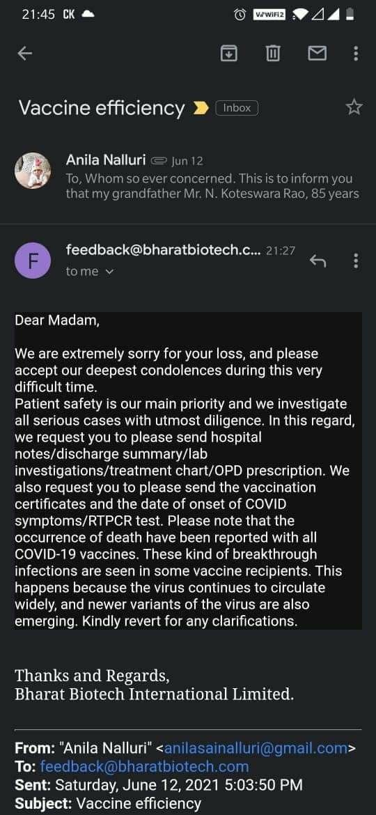 | Andhra Pradesh: Guntur  Mr. N. Koteswara Rao (85), died on May 25 due to contracting Covid Pneumonia, weeks after receiving second dose of Covaxin COVID-19 vaccine.  When contacted, Bharat Biotech said, "occurance of deaths have been reported with all Covid-19 vaccines & it's because of breakthrough infection from the virus that's widely circulating". |  | 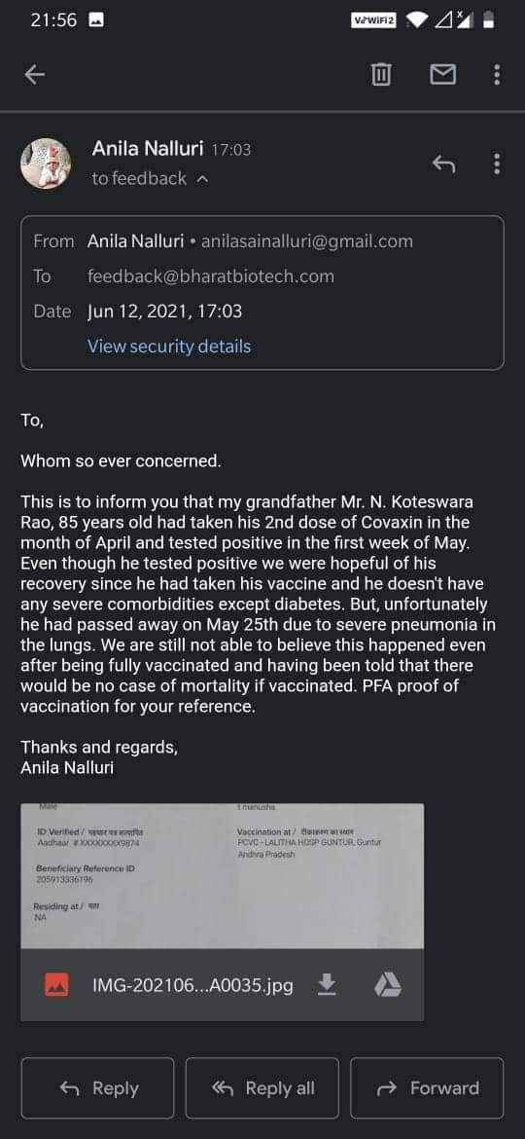
2233 To 2235 | 13.05.2021 | https://twitter.com | Bharatpur (RJ), Mumbai (MH), Hyderabad (TS)  Former BJP district chief Shivraj Tamraoli, 61 year Neighbour of Harshit Pandey & Mother of Neti Srinivas died due to Covid, days after first dose of Covishield, first dose of Covaxin & second dose of COVID-19 vaccine respectively. |  | https://twitter.com/AnkurG_Patrakar/status/1392754671664525317?s=19  https://twitter.com/pandeyhp96/status/1404476865461374976?s=19  https://twitter.com/pandeyhp96/status/1404780125397295107?s=19  https://twitter.com/netisrini64/status/1394318565063360515?s=19
2236 To 2238 | 25.05.2021 | https://twitter.com | Cuttack (OD), Varanasi (UP), Hyderabad (TS)  Uncle of Desraj Singh, Uncle of Rohit & Uncle of SK Pani died recently due to Covid, days after receiving Second (1) & first (1) dose of COVID-19 vaccine & Second dose of Covishield (1) respectively. |  | https://twitter.com/ADX_Desraj/status/1397106596518445059?s=19  https://twitter.com/Rohit99933766/status/1396005175437955076?s=19  https://twitter.com/Skpani5/status/1397100319566225412?s=19
2239 | 16.06.2021 | https://m.timesofindia.com | Karnataka: Chikkballapur district  27 year old, Dr Manu V from Chintamani town, died on Wednesday, June 16 at Bengaluru, due to Covid, weeks after receiving second dose of Covid-19 vaccine. |  | https://m.timesofindia.com/city/bengaluru/27-year-old-doctor-succumbs-to-covid-19-in-karnataka/articleshow/83583188.cms
2240 | 16.06.2021 | NEWSPAPAER | Mizoram: Mamit district  28 year old man, Zomuansanga from Zawlnuam village, died on Tuesday, June 15, due to Covid Pneumonia, a week after receiving first dose of Covid-19 vaccine. |  | 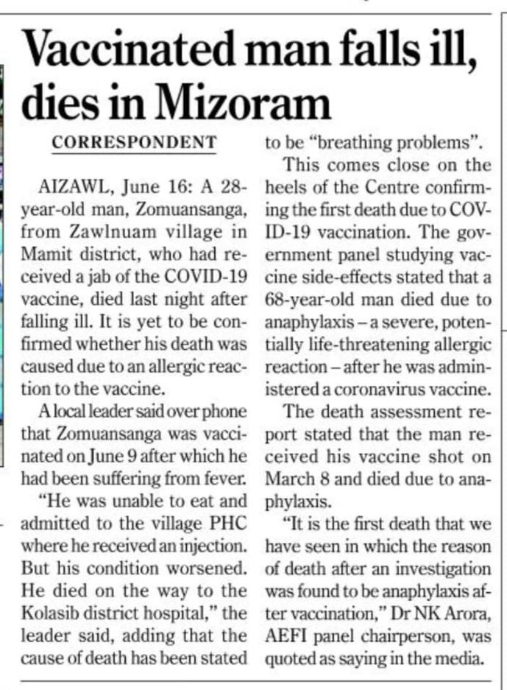
2241 To 2246 | 24.04.2021 | https://twitter.com | Varanasi (UP), (AP), Mumbai (MH)  3 relatives of Yuvan Rudra, Parents of Adarsh's close friend & Uncle of Swati Parekh, died recently due to Covid, days after receiving first dose of COVID-19 vaccine. |  | https://twitter.com/landofdeed/status/1385823509444706311?s=19  https://twitter.com/curryputtar/status/1405245877690662913?s=19  https://twitter.com/swati7007/status/1382992095359557632?s=19
2247 To 2250 | 11.04.2021 | https://twitter.com | (DL), Pune (MH), Hyderabad (TS)  Family member of Manoj, Mother of Malati Wani, Father of Hemant Virmani & his friend's father died recently due to Covid, days after receiving first dose of COVID-19 vaccine. |  | https://twitter.com/manojsi11/status/1381171746812784640?s=19  https://twitter.com/MalatiWani/status/1381183801204727811?s=19  https://twitter.com/hemantvirmani/status/1383701797177491472?s=19
2251 To 2256 | 17.06.2021 | https://www.youtube.com | Father of Amudha Roy,  Uncle of Subhash Raisikh,  Aunty of Mukul Kumar,  Rakesh Chauhan,  Father of Neelima Sahu, &Father in law of Kriti Kumari, died after first dose (4) & Second dose (2) of COVID-19 vaccine. |  | Source: Comment section of YouTube video.  https://youtu.be/X0aJvqmzfCI
2257 To 2260 | 16.06.2021 | https://twitter.com | Mumbai (MH), (MH), Hyderabad (TS)  2 family members of Parveen Kader, Father of Rohan Joshi & Mother of Aditi Das died recently due Covid, days after receiving first dose of COVID-19 vaccine. |  | https://twitter.com/ParveenKader/status/1404886180802531333?s=19  https://twitter.com/Joshirohanr/status/1397229470109536262?s=19  https://twitter.com/RtAttitude_Adi/status/1383346768184676361?s=19
2261 | 18.06.2021 | News from Vijay Karnataka newspaper dated June 18, 2021. https://vijaykarnatakaepaper.com | Karnataka: Uttar Kannada district  69 year old man, Maadeva Puttu Naik, from Ankola, died within an hour after receiving first dose of COVID-19 vaccine.  He had reached the taluka vaccination center by riding a bicycle with his wife as a pillion. |  | 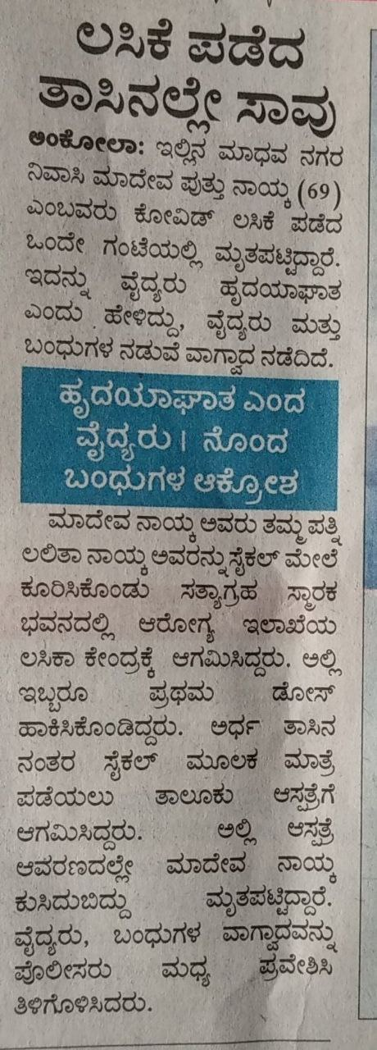
2262 To 2266 | 05.05.2021 | https://twitter.com | (BR), Gurgaon (HR), (OD), (UK)  Father & Mother of Sanjay Agrawal, Father of Anil Bansal, Father-in-law of Suraj Kumar & mother of Pushpa Bisht died recently due to covid, after receiving first dose (3) & Second dose (2) of COVID-19 vaccine. |  | https://twitter.com/Sanjay725040/status/1389702821453332484?s=19  https://twitter.com/AnilBansal13/status/1404239826723901442?s=19  https://twitter.com/SMaharana89/status/1405709314413588482?s=19  https://twitter.com/pushpabist3/status/1394929345878130692?s=19
2267 To 2270 | 01.05.2021 | https://twitter.com | (MH), Bhubaneswar (OD), Mumbai (MH), (IN)  Father of Satish Nikam, Elina Sahoo (33), Father-in-law of Raj Georgian & MBBS student Rahul Shivakumar (22+), died recently due to Covid & heart attack days after receiving first dose (3) & second dose (1) of COVID-19 vaccine respectively. |  | https://twitter.com/SatishN71868704/status/1388432810575159299?s=19  https://twitter.com/AnirudhsOdisha/status/1405472306105700353?s=19  https://twitter.com/Rajeev13267155/status/1384135824501968907?s=19  https://twitter.com/Navaneetpatil2/status/1405571720933560323?s=19
2271 | 18.06.2021 | https://enewsinsight.com | Odisha: Cuttack  Dr. Debasis Panigrahi (56), Odisha Vigilance Director and Senior IPS Officer of ADG Rank, passed away on June 18, at a Kolkata Hospital due to Covid complications, weeks after receiving second dose of COVID-19 vaccine. |  | https://enewsinsight.com/odisha-vigilance-director-dr-debasis-panigrahi-passes-away/
2272 | 17.06.2021 | https://www.livehindustan.com | Uttar Pradesh: Etah  A young girl, Rakhi Bansal from Etah, suffered from fever from the same day she took her first dose of COVID-19 vaccine on June 02, hospitalized within 2 days & died on Thursday, June 17 at Delhi AIIMS. |  | https://www.livehindustan.com/uttar-pradesh/etah/story-etah-39-s-girl-dies-in-delhi-aiims-4133268.html
2273 | 19.06.2021 | https://odishatv.in | Odisha: Sundargarh district  32 year old woman Kabita Dantali, from Rourkela, died on June 18 at RGH, just a day after receiving first dose of COVID-19 vaccine. |  | https://odishatv.in/news/covid-19/woman-dies-after-receiving-covid-19-vaccine-in-odisha-50273/amp
2274 | 19.06.2021 | Date: June 19, page 11/14  https://m.paperboy.com/awaz-dhanbad-epaper/1865 | Jharkhand: Hazaribagh district  74 year old man Naimuddin Ansari, resident of Galhobar village, of Bishnugarh, died on Thursday, June 17, just within 3 hours after receiving second dose of COVID-19 vaccine. |  | 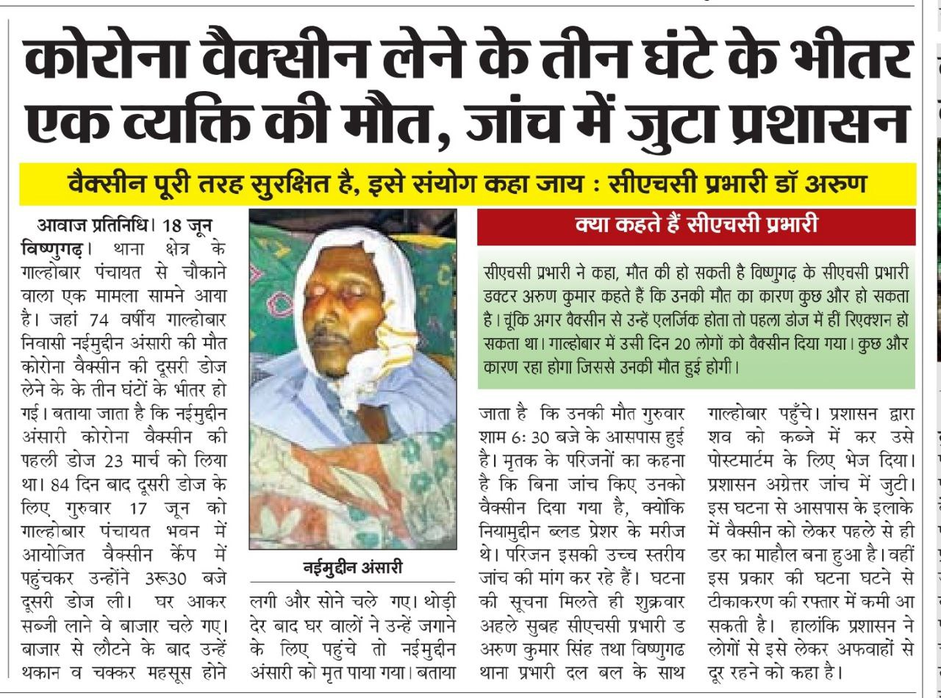
2275 To 2278 | 20.06.2021 | https://prachand.in | Madhya Pradesh: Shivpuri district  Havildar Premnarayan Dwivedi,  School teacher Surendra Sharma,  Engineer & teacher Vinay Chaturvedi, & Surajpal  died recently due to sudden deterioration in health & lung failure, days after receiving second dose of COVID-19 vaccine. |  | https://prachand.in/four-deaths-due-to-delta-plus-variant-of-corona-in-shivpuri-20210620
2279 To 2282 | 17.06.2021 | https://twitter.com | Lucknow (UP), (DL), (DL), (UP)  Maternal uncle of S P (Rinku) Singh, Father of Sabneesh, Renuka Dhar's friend's mother & Father-in-law of Dharmendra Kumar died recently due to Covid, weeks after receiving first dose (3) & Second dose (1) of Covishield COVID-19 vaccine. |  | https://twitter.com/rinku302m2007/status/1405572059938263046?s=19  https://twitter.com/Sabneesh/status/1406311259432120321?s=19  https://twitter.com/DharRenuka/status/1403912267951861763?s=19  https://twitter.com/kdharmendra/status/1405563840595730441?s=19
2283 | 20.06.2021 | https://m.timesofindia.com | Uttar Pradesh: Agra  A 22 year old girl from Agra, died on Friday, June 18, due to blood clotting in brain's venous sinuses, after receiving first dose of Covishield COVID-19 vaccine on June 02. |  | https://m.timesofindia.com/city/delhi/girl-dies-days-afterjab-organ-donation-without-autopsy-barred/articleshow/83675584.cms
2284 | 19.06.2021 | https://www.newspointapp.com/hindi/nbt/nbt/videos/news?id=caacbbd3c81885372f7c4b8e7453dccb | Rajasthan: Ajmer district  Hemraj Lakshakar, a young man from Tihari village died on Sunday, June 19, within 8 hours after receiving COVID-19 vaccine. |  | https://www.newspointapp.com/hindi/nbt/nbt/videos/news?id=caacbbd3c81885372f7c4b8e7453dccb
2285 To 2288 | 20.06.2021 | https://twitter.com | Bhavnagar (GJ), Bengaluru (KA), (KA), Mumbai (MH)  Father of Prof. Jay Gohil, Mother in law of Yash Kumar, Colleague of Dushan & friend of Sujata Anandan died recently due to Covid days after receiving first dose (3) & Second dose (1) of COVID-19 vaccine. |  | https://twitter.com/jayukids/status/1406625692909981704?s=19  https://twitter.com/yNaughtYash/status/1384378617010921472?s=19  https://twitter.com/Dushan7k/status/1396447267544997891?s=19  https://twitter.com/sujataanandan/status/1406619764303138822?s=19
2289 To 2290 | 27.05.2021 | https://m.facebook.com | Jorhat (AS), Prayagraj (UP), Cuttack (OD)  Father of Arnab Khound & Professor Dilip Kumar Chatterjee died on March 23, April 12 & June 16, due to Covid, weeks after receiving first dose of Covishield (1) & COVID-19 vaccine (2) respectively. |  | https://m.facebook.com/story.php?story_fbid=3947638801925006&id=100000367741229  https://m.facebook.com/story.php?story_fbid=1833221553520808&id=941814642661508  https://twitter.com/TrishaS03677259/status/1381558600573800451?s=19
2291 | 17.06.2021 | Newspaper : Samaj | Village : Kushupur, Mathasahi, Gope  Name: Gangadhar Rout  Age : 56  Date of death after the vaccine : 16th June 2021 |  | 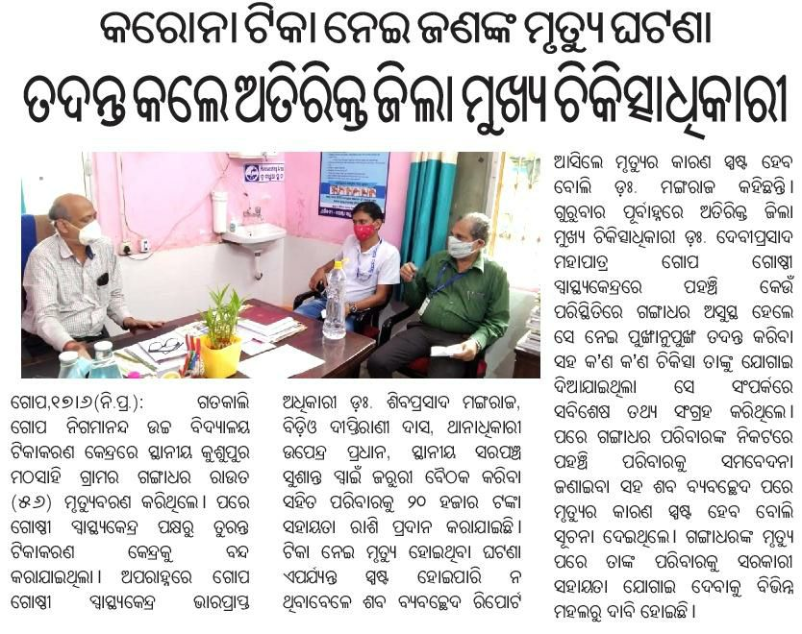
2292 To 2299 | 29.05.2021 | https://twitter.com | (DL), (KA), (TS), (JK)  Mother of Rahul Yadav, 4 family members of Anoop S, 2 acquaintance of Ravindra Reddy & Father of Sumit Warikoo, died recently due to Covid weeks after receiving first dose of Covaxin (1), first dose of COVID-19 vaccine (4) & second dose of Covishield (3). |  | https://twitter.com/yadav7020/status/1398463700021907457?s=19  https://twitter.com/noop_1882/status/1405040230743252995?s=19  https://twitter.com/ReddyRavinder37/status/1406153213095538688?s=19  https://twitter.com/sumeet_war/status/1406649149257248776?s=19
2300 To 2302 | 22.06.2021 | https://twitter.com | (DL), (KL), (DL)  Mother of Priyanjali, Preethi Ramadoss's friend's father, 65Y man acquaintance of Seema Sapral died recently due to Covid, days after Second dose of Covishield COVID-19 vaccine. |  | https://twitter.com/Priyanjalis26/status/1407404472846852097?s=19  https://twitter.com/RamadossPreethi/status/1407406224233046016?s=19  https://twitter.com/SeemaSapraLaw/status/1406716022560800768?s=19
2303 | 22.06.2021 | https://www.divyabhaskar.co.in | Gujarat: Ahemdabad district  20 year old girl, Sonia Chauhan, from Odhav village died on Monday June 21, due to heart attack, within 24 hours after receiving first dose of COVID-19 vaccine. |  | https://www.divyabhaskar.co.in/amp/local/gujarat/ahmedabad/news/young-woman-dies-of-heart-attack-within-24-hours-of-being-vaccinated-the-family-said-there-were-no-heart-problems-complications-after-the-vaccine-128629033.html
2304 To 2308 | 23.06.2021 | https://twitter.com | Mumbai (MH), Navi Mumbai (MH), (DL), (IN)  Father of Naina, Mother of Mohiddin's friend, 2 relatives of Anisha, Senior doctor to Dr Priyanka Katru died due to Covid complications, days after receiving second dose of COVID-19 vaccine. |  | https://twitter.com/NaIna0806/status/1407603811712081924?s=19  https://twitter.com/immohiddin/status/1407598277655089153?s=19  https://twitter.com/anishastwt/status/1407663124354764800?s=19  https://twitter.com/PriyankaKatru/status/1407644846936838149?s=19
2309 | 24.06.2021 | https://thekhabrilal.com | Chhattisgarh: Mahasamund district  22 year old mother of an infant, Triveni Gaud, resident of Belar village of Pithora block, died within 17 hours after receiving first dose of COVID-19 vaccine. |  | https://thekhabrilal.com/?p=139115
2310 | 24.06.2021 | https://www.aajtak.in | Uttar Pradesh: Banda district  81 year old woman, Shanti Nigam, resident of Banda, died on April 27, due to heart attack, a month after receiving first dose of Covishield COVID-19 vaccine.  But even after her demise, relatives received a SMS on June 23, saying that she has been vaccinated with second dose. |  | https://www.aajtak.in/india/uttar-pradesh/story/up-news-dead-woman-given-vaccine-shocking-news-action-will-be-taken-1278823-2021-06-24
2311 | 24.06.2021 | www.youtube.com | Tamilnadu: Salem district  A young mother of 3 month old twin babies, Subalakshmi, died on June 24, due to heart attack, a day after being forcefully vaccinated with a dose of COVID-19 vaccine, when she went to the hospital for regular child vaccination of her babies. Nurse in the hospital told her, if she gets the COVID-19 jab, then only she will vaccinate her babies. |  | https://youtu.be/Vpe48Nj8Qzo
2312 To 2314 | 25.06.2021 | https://twitter.com | Mumbai (MH), Mumbai (MH), (KA)  Uncle of Aniket Walunj's friend, Neighbour of Abhishek Das, Muralee's Cousin's Father in law died recently due to contracting Covid after receiving Covishield COVID-19 vaccine. |  | https://twitter.com/AniketWalunj33/status/1408270601186254851?s=19  https://twitter.com/abhishek8das/status/1407013538015502336?s=19  https://twitter.com/ramuralee/status/1408801137780682760?s=19
2315 | 28.06.2021 | https://www.ibc24.in | Chhattisgarh: Raipur  A young man from Tekari village near Raipur died on June 27, a day after receiving a dose of COVID-19 vaccine. |  | https://www.ibc24.in/news/after-applying-the-vaccine-the-young-man-drank-heavily-died-in-the-hospital-after-suffering-183366
2316 To 2319 | 16.062021 | https://www.bhaskar.com | Madhya Pradesh: Raisen & Dewas district  At least 2 people in Thikari village & at least 2 people in Donta village died in June month, due to contracting covid, days after receiving COVID-19 vaccine. |  | https://www.bhaskar.com/local/mp/bhopal/news/in-the-village-where-rumors-of-three-dying-after-getting-vaccinated-in-reality-there-is-no-such-death-128601399.html
2320 | 26.06.2021 | www.amarujala.com | Himachal Pradesh: Shimla  A 20 year old girl died at IGMC Shimla on June 26, two weeks after receiving first dose of COVID-19 vaccine. |  | https://www.amarujala.com/shimla/girl-died-two-weeks-after-covid-19-vaccination-panchayat-representative-unconscious
2321 To 2325 | 28.06.2021 | https://twitter.com | Meerut (UP), Bengaluru (KA), Rewa (MP), Bengaluru (KA)  Father of Harshit Kumar, Young (F, 20+) friend of Keshav Mahato, 2 old persons from village of NK Mishra & Mother of Ambika Gupta died recently after contracting Covid & heart attack, days after receiving first dose (4) & second dose (1) of Covishield COVID-19 vaccine. |  | https://twitter.com/Er_kumarharshit/status/1409504768213409802?s=19  https://twitter.com/keshavmahato/status/1409391192282861568?s=19  https://twitter.com/Nil00706309/status/1409424534655049730?s=19  https://twitter.com/ambikagupta16/status/1409548590637207564?s=19
2326 | 30.06.2021 | https://twitter.co | Mumbai, Maharashtra  Bollywood Film Producer and actress Mandira Bedi's husband, Raj Kaushal (49), died due to a heart attack early Wednesday on June 30 morning, 2 months after receiving second dose of Covishield COVID-19 vaccine. |  | https://twitter.com/thetruthin/status/1410109884222164994?s=19  https://www.instagram.com/p/COKIDWCJ5X6/
2327 To 2330 | 29.06.2021 | https://twitter.com | (DL), (MH), (DL)  Father of Nirupama Halder, Father & Grandmother of Nikhil Bhaskar Patil & Mother of Hitesh Chandra, died recently due to contracting Covid, days after receiving first dose (3) of COVID-19 vaccine & second dose (1) of Covaxin. |  | https://twitter.com/Nirupamahalder/status/1409753500913860609?s=19  https://twitter.com/impatil247/status/1409637297335652352?s=19  https://twitter.com/impatil247/status/1409637754774818816?s=19  https://twitter.com/chhadz/status/1408823406972129283?s=19
2331 | 30.06.2021 | https://arunachaltimes.in | Arunachal Pradesh: Lohit district  85 year old man without any comorbidiy, died on June 29, due to covid, 2 months after receiving first dose of COVID-19 vaccine. |  | https://arunachaltimes.in/index.php/2021/06/30/one-more-succumbs-to-covid-19-states-death-toll-at-168/
2332 To 2338 | 14.06.2021 | https://twitter.com | Alwar (RJ), (UP), (IN),  3 relatives of Abhishek Saini, 1 Relative of Nikhil Govindam, 2 acquaintance & 1 relative of Deb Bose died recently due to Covid & heart attack, days after receiving first dose of COVID-19 vaccine (3) & Covishield (1) & second dose of Covaxin (3). |  | https://twitter.com/joinsainiabhi/status/1404454811311894530?s=19  https://twitter.com/inikhilgovindam/status/1409438149793619972?s=19  https://twitter.com/de_bose/status/1409486563000524802?s=19
2339 To 2417 | 29.06.2021 | https://twitter.com  https://www.ibtimes.co.in | According to latest report on June 30 from IMA, 798 doctors have died in India during second wave of COVID, On June 12 they had reported 719 deaths. i.e. 79 newly reported deaths.  And according to, IMA President J.A. Jayalal, the majority of the doctors who died during the second wave due to COVID have received at least one dose of the vaccine. |  | https://twitter.com/ANI/status/1409959689744371716?s=19  https://twitter.com/ANI/status/1403553634986565633?s=19  https://www.ibtimes.co.in/covid-second-wave-killing-doctors-despite-getting-jab-raises-concerns-india-details-836495
2418 | 28.06.2021 | https://www.jagran.com | Punjab: Moga district  A young person, Mohan Verma, resident of Badhni Kalan village, died on June 28, less than 2 days after receiving first dose of COVID-19 vaccine. |  | https://www.jagran.com/punjab/moga-youth-died-after-fever-21781544.html
2419 | 28.06.2021 | https://www.bhaskar.com | Madhya Pradesh: Morena district  Ajay Jatav (28), resident of Saxena Ka Pura village of Banmore tehsil, died on June 28, 5 days after receiving the first dose of COVID-19 vaccine. |  | https://www.bhaskar.com/local/mp/gwalior/morena/news/after-deteriorating-health-he-was-admitted-to-birla-hospital-and-later-to-jayarogya-hospital-death-today-relatives-kept-the-body-at-the-door-of-the-house-demanded-financial-compensation-128644877.html
2420 To 2485 | 27.06.2021 | https://hindi.news18.com  https://t.me  https://www.newindianexpress.co | Madhya Pradesh  Total 152 MP Police personnel have died till date, due to Corona, since March 2020.  35 died until December 2020.  i.e. 115 police personnel died since January 2021, after vaccination drive started.  According to April 30 IE report: 44 police personnel had died till April 30, 2021 since January 2021.  And 90% of the police force was vaccinated until April 2021.  Now, as of June 27 report of News 18 Hindi: 73 more police personnel have died in the last 2 months.  If we consider 90% police personnel are vaccinated then at least 66 out of 73 died were vaccinated. |  | https://hindi.news18.com/news/madhya-pradesh/bhopal-50-lakh-compensation-given-to-the-family-of-only-7-after-the-death-of-152-policemen-in-mp-due-to-corona-nodelsp-3636151.html  https://t.me/EscapeTheMatrix/1225  https://www.newindianexpress.com/nation/2021/apr/30/madhya-pradesh-loses-42-cops-to-covid-19in-april-2021-2296662.html
2486 to #2493 | 26.06.2021 | https://www.indiatoday.in  https://t.me | Tamilnadu  A study published in the Indian Journal of medical revealed that 31 TN police personnel died between April 13 and May 14 during the second wave of the pandemic.  According to the study, 4 of these 31 police personnel had taken 2 doses of the vaccine, 7 had taken 1 dose and the rest 20 were unvaccinated.  i.e. 11 Tamilnadu Police personnel died after vaccination.  3 deaths of police personnel from TN was reported earlier on this channel.  Though this "Study" seems to be manipulative, we will take these nos on face value. |  | https://www.indiatoday.in/coronavirus-outbreak/story/31-policemen-succumbed-covid-19-during-second-wave-tamil-nadu-study-1819607-2021-06-26  https://t.me/EscapeTheMatrix/1310  https://t.me/EscapeTheMatrix/1387
2494 To 2497 | 28.06.2021 | https://twitter.com | Chennai (TN), Chennai (TN), New Delhi (DL)  Father of Krithika Vachali, Sai Pralhad K's Father's friend & 2 patients of Dr. Vijay Pahwa died recently due to contracting Covid days after receiving second dose of COVID-19 vaccine. |  | https://twitter.com/krit_vachali/status/1409378197670567937?s=19  https://twitter.com/SaiPrahladK/status/1410129608645570561?s=19  https://twitter.com/Health_Z_Wealth/status/1409581974331662347?s=19
2498 | 30.06.2021 | https://www.patrika.com | Chhattisgarh: Durg district  30 year old woman, Ratnamali, resident of Risali locality of Bhilai city, died on June 29, within few hours after receiving first dose of COVID-19 vaccine. |  | https://www.patrika.com/bhilai-news/death-after-getting-vaccinated-reached-the-vaccination-center-6924662/
2499 to 2612 | 14.06.2021 | https://timesofindia.indiatimes.com | Goa state  Directorate of health services (DHS) data for period from April 24 to June 7, revealed,  1,798 fatalities due to Covid-19 in second wave,  6 of the fatalities — 0.4% — were fully vaccinated.  A little under 10% of the fatalities — 157 persons — had taken the first dose of the vaccine.  i.e. 163 deaths after full & partial vaccination.  49 deaths were reported earlier on this channel.  i.e. 163 - 49 = 114 newly reported deaths. |  | https://timesofindia.indiatimes.com/city/goa/in-peak-of-2nd-wave-99-6-of-those-who-died-werent-fully-vaccinated/articleshow/83494314.cms  https://t.me/EscapeTheMatrix/1267  https://t.me/EscapeTheMatrix/1300
2613 | 01.07.2021 | https://www.instagram.com | Telangana: Hyderabad  18 year old Rithaika Sri Omtri (Rithu) died on Saturday, June 19, within 21 days after receiving first dose of Covishield COVID-19 vaccine on May 29.  Cause of death: Blood clotting in Brain.  CVST (Cerebral Venous Sinus Thrombosis) and,  VITT (Vaccine Induced Thrombotic Thrombocytopenia).  Now her parents have started a campaign page on instagram to spread awareness about COVID-19 vaccine side effects. |  | https://www.instagram.com/p/CQvqb3BMDga/
2614 To 2616 | 28.06.2021 | https://twitter.com | (BR), Trivandrum (KL), Bengaluru (KA)  Uncle of Tantan Singh, relative of H.B. Krishna & uncle of VJ died recently due to heart attack & Covid, days after receiving first dose (1), Second dose (1) of Covishield & Second dose (1) of Covaxin. |  | https://twitter.com/tantan_singh/status/1410505058022608903?s=19  https://twitter.com/HBKrishna/status/1410380777410420742?s=19  https://twitter.com/wikki6/status/1410128449675489286?s=19
2617 To 2619 | 30.06.2021 | https://twitter.com | Madurai East (TN), Hyderabad (TS), Bengaluru (KA)  Close friend of Karthik Sankar, Relative of Praveen Ananthula & Father of Jyoti Kumar Indrasingh died recently due to Covid, days after receiving first dose (1) & Second dose (2) of Covaxin COVID-19 vaccine. |  | https://twitter.com/karthiksankar14/status/1410279405780303878?s=19  https://twitter.com/Praveenananth09/status/1404451933188890627?s=19  https://twitter.com/IndrasinghJyoti/status/1410827106771034116?s=19
2620 | 03.07.2021 | https://tamil.news18.com | Tamilnadu: Madurai district  29 year old Andrew Simon, a software engineer, resident of New Vilangudi town of Madurai, died on morning of July 03, due to a suspected heart attack, a day after receiving first dose of Covishield vaccine.  He and his wife were vaccinated with the first dose of Covshield at the Samayanallore Primary Health Center at 2 pm on July 02. |  | https://tamil.news18.com/news/tamil-nadu/madurai-district-young-man-who-was-vaccinated-against-corona-has-been-died-ekr-vet-495677.html
2621 To 2623 | 03.07.2021 | https://twitter.com | Mumbai (MH), New Delhi (DL), (IN)  Father of Nihar Shetty, Wife of Ganga Prasad Gupta & a relative of Sameer Dheer died recently due to Covid & Blood clotting after receiving Covishield COVID-19 vaccine. |  | https://twitter.com/niharshetty89/status/1411182393428385793?s=19  https://twitter.com/Dheer_Sameer/status/1394549284410826753?s=19
2624 | 03.07.2021 | https://www.lokmatnews.in | Odisha: Kendrapara district  35 year old Asha worker, Saraswati Mallik from Chhata, died on July 02, due to covid, days after receiving second dose of COVID-19 vaccine. |  | https://www.lokmatnews.in/india/asha-worker-who-took-both-doses-of-anti-kovid-19-vaccine-dies-of-infection-b421/
2625 | 03.07.2021 | https://www.amarujala.com | Himachal Pradesh: Mandi district  26 year old youth, Panna Lal, resident of Banwar Kalan village of Dharmpur tehsil, died on Friday, July 02, due to sudden vomiting, 3 days after receiving first dose of COVID-19 vaccine. |  | https://www.amarujala.com/shimla/sudden-death-of-young-man-after-three-days-of-receiving-covid-vaccine-in-dharampur-mandi-himachal
2626 | 04.07.2021 | https://www.bhaskar.com | Bihar: Muzaffarpur district  A young girl in her 20's, Shivani Shah from Jahangirpur village of Muraul block died on Sunday July 04, due to severe fever following a day after receiving first dose of COVID-19 vaccine. |  | https://www.bhaskar.com/amp/local/bihar/muzaffarpur/news/bihar-news-bihar-police-daroga-died-due-to-vaccination-in-muzaffarpur-128664676.html
2627 & 2628 | 04.07.2021 | https://www.naidunia.com | Madhya Pradesh: Indore  68 year old woman from Nilkanth Colony & 47 year old man from Sukhlia suburb died after first dose of COVID-19 vaccine, but months after their relatives still received SMS saying that the deceased has successfully received the second dose of vaccine. |  | https://www.naidunia.com/madhya-pradesh/indore-message-for-getting-the-vaccine-coming-even-after-two-months-of-death-ayush-department-is-saying-join-yoga-class-stay-healthy-6959907
2629 | 05.07.2021 | https://www.mid-day.com  https://www.hindustantimes.com | Maharashtra: Mumbai  A human rights activist, Father Stan Swamy (84) died on July 05, due to covid complications & cardiac arrest, 1.5 months after receiving COVID-19 vaccine.  He was forcefully vaccinated by jail authorities against his will when he was already feeling unwell. |  | https://www.mid-day.com/amp/mumbai/mumbai-news/article/elgaar-accused-father-stan-swamy-unwell-yet-given-covid-19-vaccine-in-jail-bombay-hc-informed-23174118  https://www.hindustantimes.com/india-news/activist-stan-swamy-accused-in-elgar-parishad-case-succumbs-to-cardiac-arrest-101625478894101-amp.html
2630 | 04.07.2021 | https://www.youtube.com | Karnataka: Bengaluru  45 year old woman, Chandrikala, died on Sunday, July 04, within 3 hours after she was allegedly forcefully vaccinated with COVID-19 vaccine at hospital before discharge, where she was admitted for treatment of high blood pressure. |  | https://youtu.be/jt1mxcQY-Oc
2631 | 05.07.2021 | https://tcp24.news | Madhya Pradesh: Guna district  83 year old woman, Shantibai Sharma, died on Monday, July 05, within 45 minutes of receiving second dose of Covishield vaccine.  Anganwadi worker Sima Dhakad, persuaded and accompanied Shantibai to the vaccination center, but when Shantibai's health deteriorated after vaccination, she left her while on the way back to home. |  | https://tcp24.news/2021/07/05/big-news-woman-dies-after-45-minutes-of-getting-the-vaccine-if-her-health-deteriorates-she-left-anganwadi-on-the-way/
2632 To 2634 | 05.07.2021 | https://twitter.com | (WB), (WB), (AP)  Neighbour of Zara Butter, Father of Somnath Manna & Colleague of Ramesh died recently due to Covid & Cardiac arrest, days after receiving COVID-19 vaccine. |  | https://twitter.com/ButterZara7/status/1412088327184871426?s=19  https://twitter.com/soomann/status/1411199290232410113?s=19  https://twitter.com/ramesh_ydp/status/1410150915034603520?s=19
2635 To 2637 | 15.05.2021 | https://twitter.com | (DL), Chhindwara (MP), (DL)  18 year old friend of Tanush Arora, Family member of Ashish & Shiv Kumar's friend's wife died recently die to contracting Covid, days after receiving first dose (2) & second dose (1) of Covaxin COVID-19 vaccine. |  | https://twitter.com/TanushArora1/status/1393275734249009153?s=19  https://twitter.com/AShri121/status/1387896482976591873?s=19  https://twitter.com/kummarshiv/status/1390831505493037059?s=19
2638 To 2643 | 05.07.2021 | https://twitter.com | Delhi (DL), Punjab (PB), Delhi (DL)  Father of G.S. Tripathy, 3 close friends & 1 relative of Priya Sharma & Mother of Sankalp Krishna died recently due to blood clotting & Covid, after receiving first dose of Covishield (1) & first dose of COVID-19 (5) vaccine. |  | https://twitter.com/gstripathy/status/1412282916680257536?s=19  https://twitter.com/Priya_Sharma30/status/1412275082416713730?s=19  https://twitter.com/SANKALPKRISHNA/status/1411922102085582855?s=19
2644 | 05.07.2021 | https://timesofindia.indiatimes.com | Maharashtra: Nagpur  58 year old man, Daulat Shahu from Hansapuri Nagpur, died on Saturday July 3, at Indira Gandhi Government Medical College & Hospital, just within 2 hours after receiving second does of Covishield COVID-19 vaccine. |  | https://timesofindia.indiatimes.com/city/nagpur/hiding-chest-pain-man-takes-vax-dies-2-hours-later/articleshow/84126065.cms
2645 | 06.07.2021 | https://www.jagran.com | Uttar Pradesh: Basti district  22 year old Hirendra Maurya, resident of Kothwa, died on Tuesday, July 06, within 24 hours after receiving COVID-19 vaccine. |  | https://www.jagran.com/uttar-pradesh/basti-youth-dies-under-mysterious-circumstances-21805766.html
2646 to 2662 | 05.07.2021 | https://hindi.news18.com | Rajasthan: Jaipur  17 children have died in Jaipur in last 2 months due to high count of antibodies developed after receiving COVID-19 antibody vaccine causing multi system inflammatory syndrome (MIS). |  | https://hindi.news18.com/news/rajasthan/jaipur-jaipur-news-children-are-getting-mis-syndrome-after-corona-nodss-3645565.html
2663 & 2664 | 08.06.2021 | https://www.patrika.com/ | Madhya Pradesh: Khargone district  2 persons have died recently in Nandia gram panchayat of Chiriya area after receiving COVID-19 vaccine.  Because of this, in a village with population of 4000 only 60 persons have received the vaccine. The villages told that, they will not get the vaccine, no matter what happens. |  | https://www.patrika.com/khargone-news/fear-of-vaccine-in-tribal-society-disease-can-lead-to-death-6884922/
2665 | 09.07.2021 | https://www.tribuneindia.com | Himachal Pradesh: Shimla  Veteran Congress leader and six-time chief minister Virbhadra Singh (87), died at 4:00 am on Thursday, July 08, after a long hospitalization due to Covid. He took first dose of COVID-19 vaccine on March 03 & was hospitalized on April 13.  “Have I turned 60? I still feel young," “I had no hesitation whatsoever in getting vaccinated and everyone should go for it. It’s for the good of us all,” he said, after taking the coronavirus vaccine shot at the Deen Dayal Upadhyay Hospital in Shimla on March 03. |  | https://www.tribuneindia.com/news/himachal/former-himachal-cm-virbhadra-singh-dies-of-covid-complications-at-87-279722  Virbhadra Singh takes Covid jab  https://m.tribuneindia.com/news/himachal/virbhadra-singh-takes-covid-jab-220099
2666 | 08.07.2021 | https://www.bhaskar.com | Madhya Pradesh: Gwalior  50 year old Ramole Pal, resident of Bahodapur of Gwalior city, died on July 06, a day after receiving second dose COVID-19 vaccine at Sindhia School Fort, vaccination camp. |  | https://dainik-b.in/QCpuwDehHhb
2667 | 08.07.2021 | https://www.amarujala.com | Uttar Pradesh: Raibareli district  75 year old man, Ramprasad, resident of Sehgon Pashchim village of Bachhrawan, died on Thursday July 08, a hour after receiving COVID-19 vaccine, while returning home from the vaccination center. |  | https://www.amarujala.com/uttar-pradesh/raebareli/died-raibaraily-news-lko586056455
2668 | 08.07.2021 | https://www.dailythanthi.com | Tamilnadu: Vellore district  47 year old woman, Dr. Hemalatha (PHC, Saidapeth), resident of Arappakkam village died on July 07, due to severe Covid, seven weeks after receiving second dose of COVID-19 vaccine. |  | https://www.dailythanthi.com/amp/News/State/2021/07/08054718/Dr-Corona-a-woman-at-a-primary-health-center-died.vpf
2669 | 09.07.2021 | https://www.livehindustan.com | Bihar: Arariya district  41 year old woman, Aruna devi Sharma, resident of Gerki village, died on Thursday, July 08, due to fever and Covid symptoms, 3 weeks after receiving first dose of COVID-19 vaccine. |  | https://www.livehindustan.com/bihar/araria/story-woman-dies-in-suspicious-condition-in-jokihat-39-s-garki-4203119.html
2670 To 2672 | 19.06.2021 | https://twitter.com | Kolkata (WB), Bengaluru (KA), New Delhi (DL)  35 year old brother of Ishtiaque Ashraf, Relative uncle of Vamsi Krishna & a acquaintance girl to Astha Sharma died recently due to Covid, after receiving first dose of Covaxin (1), a dose of Covishield (1) & second dose of COVID-19 vaccine (1). |  | https://twitter.com/ishi_ashraf/status/1405976451787026432?s=19  https://twitter.com/tvvk360/status/1412794184885444608?s=19  https://twitter.com/astha77_77/status/1412874034677645316?s=19
2673 To 2675 | 06.07.2021 | https://twitter.com | Delhi (DL), Bhubaneswar (OD), (TN)  Mother of Gunjan Goel Singhla, Father of Biswajeet Sethi & Cousin brother of Anand died recently due to Covid days after receiving first dose (1) & second dose (2) of COVID-19 vaccine. |  | https://twitter.com/GoelSinghla/status/1399727869794787330?s=19  https://twitter.com/GoelSinghla/status/1412303447823589394?s=19  https://twitter.com/BiswajeetSethi6/status/1408247286421880835?s=19  https://twitter.com/anand_2000v/status/1411674073415913485?s=19
2676 To 2686 | 03.07.2021 | https://www.jagran.com | Punjab State  According to a study done on Punjab police personnel, NITI Aayog's Dr. V.K. Paul informed,  9 police personnel have died after 1st dose of vaccination & 2 police personnel have died after second dose of vaccination.  Published July 03, 2021 |  | https://www.jagran.com/news/national-after-two-doses-of-covid-vaccine-the-risk-of-death-decreases-by-98-percent-21793640.html
2687 | 09.07.2021 | https://www.amarujala.com | Uttar Pradesh: Agra district  Ravi Khandelwal, husband of Congress leader Shabana Khandelwal, resident of Khandari locality in Agra, died in Police detention on May 14 due to Covid, a month after he was forcefully vaccinated with COVID-19 vaccine on April 16. |  | https://www.amarujala.com/uttar-pradesh/agra/congress-woman-leader-shabana-khandelwal-accused-officer-of-agra-jail-in-case-of-husband-death
2688 | 10.07.2021 | https://m.facebook.com | Andhra Pradesh: Chittoor district  Neighbour to Aparna Krishnan, a woman Kanthamma (50+), resident of Paalaguttapalle village, died due to severe fever, 2 days after receiving COVID-19 vaccine. |  | https://m.facebook.com/story.php?story_fbid=4360942703965000&id=100001479391128
10.07.2021 |  | http://www.dailythanthi.com | Tamilnadu: Theni district  Village: Badrakalipuram, Tehsil: Dombucheri  6 month old unborn baby of Sylvia (23), died in womb, on July 10, a day after she was vaccinated with first dose of Covishield COVID-19 vaccine on advice of Dombucheri PHC staff, where she went for a pregnancy test. |  | http://www.dailythanthi.com/districts/chennai/2021/07/10220414/infant-death-in-the-womb-of-a-pregnant-woman-vaccinated.vpf
2689 | 12.07.2021 | https://www.amarujala.com | Tamilnadu: Chennai  A 62 year old man from Chennai, died recently, three weeks after receiving a dose Covishield COVID-19 vaccine. 16 days after vaccination he was admitted to hospital due to high fever & jaundice where he was given plasma therapy for 5 times before he died. |  | https://www.amarujala.com/india-news/coronavirus-jaundice-occurred-after-covishield-vaccine-one-patient-died
2690 To 2721 | 12.07.2021 | https://indianexpress.com | Published: July 12, 2021  331 Central Armed Police Forces (CAPF) personnel have succumbed to Covid-19 so far, Out of 331, 40% (i.e.132) personnel have died in second wave beginning 3rd week of March 2021.  “By the time the second wave of the pandemic started, most of the personnel had received the first dose.”,Said CAPF official.  99% personnel are partially vaccinated & 90% are fully vaccinated.  100 deaths among paramilitary forces were reported on this channel earlier (May 11, 2021) i.e. 32 newly reported deaths. |  | https://indianexpress.com/article/india/over-330-covid-deaths-in-central-police-forces-40-per-cent-in-second-wave-7400095/  https://t.me/EscapeTheMatrix/1334
2722 | 09.07.2021 | https://www.lokmat.com | Maharashtra: Thane district  Jagdish Shetty (51), resident of Gujarathi nagar in Shahapur, died on July 08, due to a heart attack a day after receiving COVID-19 vaccine.  On morning of July 08, Jagdish ji was standing in a queue at vaccination center to vaccinate his wife, but suddenly collapsed due to heart attack & died on the way to hospital. |  | https://www.lokmat.com/maharashtra/man-died-heart-attack-while-standing-corona-vaccination-queue-a653/
2723 | 24.05.2021 | https://maharashtratimes.com | Maharashtra: Chandrapur district  A person, resident of Kem village in Bamani grampanchayat, Ballarpur tehsil, died in April month, due to catching severe fever after receiving first dose of COVID-19 vaccine. |  | https://maharashtratimes.com/maharashtra/nagpur/villagers-from-chandrapur-district-of-maharashtra-are-avoiding-vaccination/articleshow/82900686.cms
2724 | 25.06.2021 | https://www.patrika.com | Odisha: Bhubaneswar  According to the study conducted by Bhubaneswar's Regional Medical Research Center,  361 fully vaccinated study subjects  274 found COVID positive after 14 days  227 found symptomatic after 14 days  027 landed in hospital  001 died  Published June 25, 2021 |  | https://www.patrika.com/miscellenous-india/people-infected-even-after-both-doses-of-vaccine-in-odisha-6914168/
2725 | 13.07.2021 | https://indianexpress.com | Gujarat: Kheda district  A healthcare worker of Muljibhai Patel Urological Hospital, of Nadiad town died in ICU days after contracting covid after receiving second dose of COVID-19 vaccine. |  | https://indianexpress.com/article/cities/ahmedabad/86-staff-got-covid-more-than-a-month-after-vaccination-study-7401726/
2726 | 14.07.2021 | https://www.amarujala.com | Uttar Pradesh: Kaushambi district  A young man Dilip Kumar, resident of Berua village of Charawa died on Monday July 12, due to severe fever & Covid symptoms, a week after receiving COVID-19 vaccine. |  | https://www.amarujala.com/uttar-pradesh/kaushambi/youth-dies-in-suspicious-condition-wife-s-condition-critical-relatives-claim-that-he-died-of-fever-after-getting-kovid-vaccine-kaushambi-news-ald3108108195
2727 To 2729 | 25.06.2021 | https://twitter.com | Panvel (MH), (DL), (MP)  Father of Hemlata Nerurkar, A boy in his 20s and Father in law of Shruti Joshi died recently due to Covid & blood clots in brain days after receiving first dose of Covaxin (1), first dose (1) and second dose of Covishield (1) vaccine. |  | https://twitter.com/hemsn/status/1408490245100761090?s=19  https://twitter.com/ashishsurgeon/status/1414789954916405256?s=19  https://twitter.com/SS07117/status/1397413516403904514?s=19
2730 To 2734 | 14.07.2021 | https://twitter.com | (UP), Pune (MH), Mumbai (MH)  Vivek Kumar's dad's friend, 3 relatives of Samit Vartak & Sunil Parthak's friend's dada died recently due to Covid days after receiving second dose of Covishield (1) & second dose of COVID-19 vaccine (4). |  | https://twitter.com/vivekku67280518/status/1415936161919377411?s=19  https://twitter.com/SamitVartak/status/1415703836266618886?s=19  https://twitter.com/sunil_phatak/status/1415560561773871107?s=19
2735 | 15.07.2021 | https://www.vastaviktadarshan.page/2021/07/blog-post_15.html | Madhya Pradesh: Indore  Vishnu (Babalu) Yadav, senior Congress leader of Bhagirath pura & Secretary of Congress State Committee died on Wednesday, July 14, due to sudden cardiac arrest, within 8 hours after receiving the first dose of COVID-19 vaccine. |  | https://www.vastaviktadarshan.page/2021/07/blog-post_15.html
2736 To 2825 | 18.07.2021 | https://www.deccanherald.com | Karnataka state  According to Karnataka state health department's analysis of breakthrough infections, 90 people have died due Covid-19 in Karnataka despite being vaccinated. Among the analysed 82% were vaccinated with first dose & 18% were fully vaccinated with second dose of COVID-19 vaccine.  Published July 18, 2021 |  | https://www.deccanherald.com/state/top-karnataka-stories/90-died-of-covid-19-in-karnataka-despite-vaccination-1009918.html
2826 To 2883 | 10.07.2021 | https://www.ndtv.com | Meghalaya state  According to Meghalaya Chief Minister Conrad Sangma, 58 number of vaccinated people have died in second wave in Meghalaya. |  | https://www.ndtv.com/india-news/92-covid-patients-who-died-werent-vaccinated-meghalaya-chief-minister-2483749#publisher=newsstand
2884 To 2932 | 09.07.2021 | https://www.hindustantimes.com | Maharashtra  "54 policemen from the state police force have died of Covid-19 despite receiving the vaccine." Sanjeev Singhal,  ADG (administration),  Maharashtra Police.  5 deaths among MH police were reported earlier on this channel. i.e. 49 newly reported deaths. |  | https://www.hindustantimes.com/cities/mumbai-news/74-police-personnel-in-maharashtra-fully-vaccinated-101625854892867.html
2933 | 14.07.2021 | https://www.bhaskar.com | Jharkhand: West Singhbhum district  31 year old Gitavali Pinguva, a B.Ed student at Chaibasa Mahila college, died on Tuesday, July 13, a day after receiving COVID-19 vaccine at local CHC. |  | https://www.bhaskar.com/local/jharkhand/jamshedpur/chaibasa/news/chest-pain-due-to-drug-reaction-student-dies-geetavali-was-a-resident-of-tirulpi-in-kumardungi-128702453.html
2934 | 18.07.2021 | https://www.livehindustan.com | Bihar: Arariya district, Raniganj tehsil, Laxmipur panchayat, Jagir itahi village.  26 year old young woman, Chanchala devi Sharma, died on Sunday, July 18, just a day after receiving COVID-19 vaccine. |  | https://www.livehindustan.com/bihar/araria/story-suspicious-death-of-woman-in-kursakanta-phc-during-treatment-4235432.html
2935 | 16.07.2021 | https://www.linkedin.com/feed/update/activity:6821506276569309184 | Karnataka: Bengaluru  20 year old young girl, Karunaya Venugopalan, a MSc student died on 10th of July, due to persistent fever & MIS-A (Multisystem Inflammatory Syndrome in Adults) within a month after receiving first dose of Covishield COVID-19 vaccine. |  | https://www.linkedin.com/feed/update/activity:6821506276569309184
2936 | 19.07.2021 | https://www.naidunia.com | Chhattisgarh: Baloda Bazar - Bhatapara district  Dr. Shailendra Sahu (35), Covid hospital incharge at Baloda Bazar, died on Monday, July 19, due to Covid complications, days after receiving second dose of COVID-19 vaccine. |  | https://www.naidunia.com/chhattisgarh/balod-bazar-covid-hospital-in-charge-doctor-died-from-corona-in-balodabazar-covid-hospital-in-charge-raipur-doctor-died-from-corona-6978724
2937 To 2939 | 21.07.2021 | https://twitter.com | Mumbai (MH), Patna (BR), New Delhi (DL)  Father of Swati Hingarh, Anil Yadav's friend's father & Brother in law of Prashant Rathod died recently due to Covid days after receiving second dose of Covishield COVID-19 vaccine. |  | https://twitter.com/SwatiHingarh/status/1417726072842461193?s=19  https://twitter.com/anil5129/status/1416442985059815427?s=19  https://twitter.com/PrashantDrathod/status/1416462703023955969?s=19
2940 & 2941 | 16.07.2021 | https://twitter.com | Telangana (TS), New Delhi (DL)  Aunt of Mathew & Brother (47) of Tikendra Singh died recently due to Covid & heart attack, days after receiving first dose of Covishield COVID-19 vaccine. |  | https://twitter.com/mathew20_mathew/status/1416017141371789318?s=19  https://twitter.com/humanist_tk/status/1416967974318010377?s=19
2942 To 2955 | 21.07.2021 | https://timesofindia.indiatimes.com | West Bengal: Kolkata  According to the study conducted by Peerless General Hospital at Kolkata, total 14 people died due to contracting Covid, days after receiving first dose (11) & second dose (3) of COVID-19 vaccine. |  | https://timesofindia.indiatimes.com/city/kolkata/hosp-study-only-3-out-of-40-cov-victims-died-after-taking-2-shots/articleshow/84595590.cms
2956 To 2959 | 21.06.2021 | https://twitter.com | Sirsa (HR), Bengaluru (KA), Mumbai (MH)  Brother of Karnail Singh, Neighbour (55) of user Mei Kandar & friend's firends of Sharell's husband died recently due to Covid & heart attack days after receiving COVID-19 vaccine. |  | https://twitter.com/Karnail73815372/status/1406939668650725380  https://twitter.com/MEIKANBOM/status/1418160485799661571?s=19  https://twitter.com/AboutIndia/status/1418105023024668675?s=19
2960 To 2963 | 22.07.2021 | https://twitter.com | Kerala (KL), Lucknow (UP)  An acquaintance of Rosamma Thomas & 3 patients of Pulmonologist doctor at KGMU Lucknow died recently due to heart attack & Covid complications after receiving second dose of COVID-19 vaccine. |  | https://twitter.com/rosammat/status/1418137408118267904?s=19  https://twitter.com/Dilliwasi/status/1417834144239800330?s=19
2964 | 27.03.2021 | https://www.livehindustan.com | Bihar: Gaya district  Vindhyavasini devi Sharma, an Anganwadi worker, resident of Konch tehsil, died due to contracting Covid in 3rd week of March, 15 days after receiving second dose of COVID-19 vaccine. |  | https://www.livehindustan.com/bihar/story-70-year-old-woman-dies-and-3-more-sick-after-taking-corona-vaccine-in-pathedi-belsar-block-of-vaishali-of-bihar-stir-in-health-department-medical-team-reached-village-for-investigation-3940378.html
2965 | 27.01.2021 | https://www.aajtak.in | Odisha: Naupada district  27 year old health worker, from Naupada district died on January 26, at VIMSAR Burla in Sambalpur, 3 days after receiving first dose of COVID-19 vaccine. |  | https://www.aajtak.in/coronavirus/story/odisha-healthcare-worker-dies-after-taking-covid-vaccine-govt-says-not-linked-to-vaccination-1198441-2021-01-27
2966 | 16.02.2021 | https://navbharattimes.indiatimes.com | Chhattisgarh: Raipur  34 year old Assistant Sub Inspector of Police from Raipur died on February 14, due to cardiac arrest, 2 days after receiving first dose of COVID-19 vaccine. |  | https://navbharattimes.indiatimes.com/state/chhattisgarh/raipur/chhattisgarh-police-officer-dead-after-corona-vaccination-investigation-is-on/articleshow/80935456.cms
2967 | 24.07.2021 | https://www.jagran.com | Uttar Pradesh: Aligarh district  25 year old, Sunny Pal, from Bistauli village of Vijaynagar died on Friday, July 23 due to sudden uneasiness & vomiting, 3 days after receiving first dose of COVID-19 vaccine. |  | https://www.jagran.com/uttar-pradesh/aligarh-city-death-of-a-young-man-due-to-a-hoax-in-aligarh-relatives-gave-a-complaint-to-the-police-21859778.html
2968 | 24.07.2021 | https://www.maalaimalar.com | Tamilnadu: Chennai  47 year old homeguard Gokul, who was working at Muthialpet Police Station in Chennai, died on Friday, July 23, suspected due to heart attack, within a day after receiving COVID-19 vaccine. |  | https://www.maalaimalar.com/amp/news/district/2021/07/24022557/2846936/tamil-news-Kayts-soldier-suffocates-to-death.vpf
2969 To 2971 | 25.07.2021 | https://twitter.com | (KL), Bhubaneswar (OD), Mumbai (MH)  70 year old Mr. Kutti, Relative of Neel Srichandan, Chaya's firiend's mother died recently due to Covid complications days after receiving first dose of Covishield (1) & second dose of COVID-19 vaccine (2). |  | https://twitter.com/mgups2002/status/1418955707685109760?s=19  https://twitter.com/NeelSrichandan/status/1419247658334441479?s=19  https://twitter.com/_chAyA_/status/1416774610046042114?s=19
2972 | 29.07.2021 | https://www.livehindustan.com | Uttar Pradesh:  Jhansi district 23 year old girl Kalpana Singh, from village Gudha, died on Wednesday July 28, the same day she was vaccinated with the first dose of COVID-19 vaccine. |  | https://www.livehindustan.com/uttar-pradesh/jhansi/story-the-death-of-the-student-was-by-hanging-not-by-the-vaccine-4271399.html
2973 To 2976 | 02.07.2021 | https://m.facebook.com  https://twitter.com | New Delhi (DL), (TN), Hisar (HR)  Inderpal Singh (64), a lady gynaecologist from TN & a couple from Hisar died recently due to Covid & Anaphylaxis after receiving COVID-19 vaccine. |  | https://m.facebook.com/story.php?story_fbid=3088045971469473&id=100007923007783  https://twitter.com/c400_t/status/1421123247823679494/photo/1
2977 | 30.07.2021 | http://www.univarta.com | Madhya Pradesh: Raisen district  45 year old woman, Maanbai, from village Khodi tekapar of Gairatganj tehsil died on Friday July 30, a day after receiving first dose of COVID-19 vaccine. |  | http://www.univarta.com/news/madhya-pradesh-chhattisgarh/story/2463092.html
2978 To 3075 | 30.07.2021 | https://timesofindia.indiatimes.com | Out of 2,952 railway employees who died due to Covid-19, 98 had taken Covid vaccine, the railway ministry told Lok Sabha on Friday, July 30, 2021. |  | https://timesofindia.indiatimes.com/india/98-railway-staff-who-succumbed-to-covid-had-been-vaccinated-government/articleshow/84902127.cms
3076 To 3098 | 03.08.2021 | https://indianexpress.com | Interim results from a "Covishield" effectiveness study of 1.59 million healthcare and frontline workers of the Indian armed forces until May 30, 2021: Recorded 23 deaths among vaccinated personnel. |  | https://indianexpress.com/article/explained/covishield-study-shows-breakthrough-impact-7427402/
3099 To 3101 | 17.08.2021 | https://indianexpress.com | The study was conducted by Pune-based National Institute of Virology. Among 677 who got infected even after taking the vaccine, 3 people died. |  | https://indianexpress.com/article/cities/pune/india-covid-vaccination-breakthrough-infections-delta-variant-7407456/
3102 | 30.07.2021 | https://www.naidunia.com | Madhya Pradesh:  Shajapur district 30 year old woman, Babita, resident of village Matewa of Mohan Babodiya tehsil, died on Friday, July 30, within 72 hours after receiving COVID-19 vaccine. |  | https://www.naidunia.com/madhya-pradesh/shajapur-sajapur-news-6994006
3103 | 02.08.2021 | https://twitter.com | Karnataka: Bengaluru  Ex-army Major, Shailendra Singh (45+) founder of http://WomenCabs.com died on August 01, due to second cardiac arrest, 2 months after receiving first dose of COVID-19 vaccine. |  | https://twitter.com/c400_t/status/1422235698912919554/photo/1  https://twitter.com/c400_t/status/1422235698912919554/photo/2  https://twitter.com/c400_t/status/1422235698912919554/photo/3  https://twitter.com/c400_t/status/1422235698912919554/photo/4
3104 | 02.08.2021 | https://www.dtnext.in | Tamilnadu: Chengalpattu district  A 57 year old man died on Sunday, August 01, at Vedachalam general hospital, within an hour after receiving second dose of Covishield COVID-19 vaccine at Arts college in Chengalpattu. |  | https://www.dtnext.in/News/City/2021/08/02011007/1309813/Man-dies-of-cardiac-arrest-after-2nd-dose-of-COVID-.vpf
3105 | 01.08.2021 | https://www.jagran.com | Uttar Pradesh: Rampur district  A young man, Vinod Kumar from Dhanura village of Swar tehsil died at Moradabad private hospital on August 01, a week after receiving COVID-19 vaccine. |  | https://www.jagran.com/uttar-pradesh/moradabad-city-rampur-youth-dies-after-getting-corona-vaccine-waiting-for-post-mortem-report-21884830.html
3106 | 01.08.2021 | https://www.amarujala.com | Punjab: Mohali district  70 year old woman, Sudershan Kaur, died on Friday, July 30, on the way to PGI hospital Chandigarh, hours after receiving second dose of COVID-19 vaccine. |  | https://www.amarujala.com/punjab/mohali/health-deteriorated-after-getting-corona-vaccine-elderly-woman-died-on-the-way-to-pgi-mohali-news-pkl422024938
3107 To 3356 | 28.07.2021 | https://ndtv.in | Maharashtra  This study done on 15,202 Covid patients admitted in government medical colleges between May 11 to July 12 of 2021 Mortality in Vaccinated patients 12% of 15,202 = 1824 || 13.71% of 1824 = 250 |  | https://ndtv.in/india-news/maharashtra-88-of-covid-patients-and-95-fatalities-in-state-run-hospitals-weren-t-vaccinated-2497212#publisher=newsstand
3357 | 03.02.2021 | https://www.todayhimachal.com | Himachal Pradesh: Sirmaur district  19 year old girl, Uma devi, resident of Kotdi village of Nahan tehsil, died on Monday, August 02, due to sudden dizziness & vomiting, just few hours after receiving COVID-19 vaccine. |  | https://www.todayhimachal.com/2021/08/blog-post_23.html?m=1
3358 | 25.07.2021 | NEWSPAPER | Himachal Pradesh: Mandi district  Krishna (50+), a woman pharmacist from health department at Sundernagar city died on Sunday, July 25, few days after receiving second dose of COVID-19 vaccine. |  | 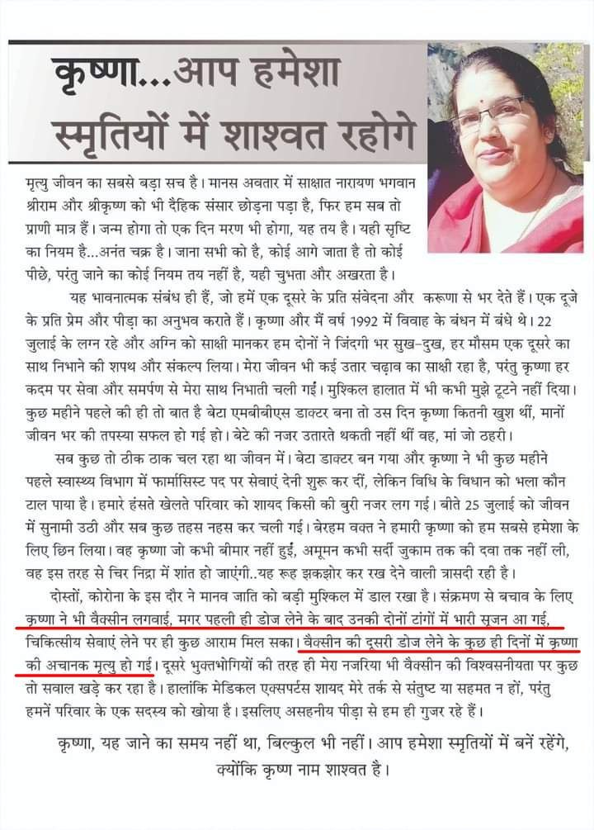
3359 To 3378 | 04.08.2021 | https://www.deccanherald.com | Karnataka: Bengaluru  Research conducted at Apollo Hospital, for over 40 days between April 21 and May 30. They found that 148 patients were cases of breakthrough infection.  In the end, of the 20 patients who died, all had received one dose of the vaccine. |  | https://www.deccanherald.com/state/top-karnataka-stories/more-than-half-of-hospitalised-covid-19-cases-among-vaccinated-in-bengaluru-1015918.html
3379 | 10.04.2021 | https://twitter.com | Maharashtra: Pune  32 year old young man, Jaideep Khare, died this week due to heart attack, 8 weeks after receiving first dose of COVID-19 vaccine. |  | https://twitter.com/JediKhare/status/1402603527713693704?s=19  https://twitter.com/JediKhare/status/1380804477314236419?s=19
3380 To 3383 | 02.08.2021 | https://www.researchsquare.com | A observational study was conducted by Institute of Medical Sciences (BHU) in a tertiary hospital of north India since 5th February 2021 among 1500 Covishiled vaccinated participants;  4 participants died; 1 was partially vaccinated & 3 were fully vaccinated. |  | https://www.researchsquare.com/article/rs-772465/v1
3384 To 3391 | 11.07.2021 | https://www.hindustantimes.com | Delhi  12 personnel of Delhi police have succumbed to Covid-19 despite being fully vaccinated.  Earlier on April 29 & May 15, Delhi police had confirmed deaths of 17 & 04, partially & fully vaccinated personnel respectively.  Hence there are 8 new reported deaths of fully vaccinated personnel. |  | bit.ly/3A9yoOl  bit.ly/3cA9MVx || bit.ly/35dUiTp
3392 To 3402 | 28.07.2021 | https://timesofindia.indiatimes.com | Maharashtra  Now TOI news report explicitly mentions 261 fatalities among vaccinated people from the study conducted by Department of Medical Education and Directorate of Medical Education and Research, Government of Maharashtra on, 15,202 Covid patients admitted in government medical colleges between May 11 and July 12 of 2021.  Earlier NDTV news report hadn't mentioned the numbers, hence we had calculated the fatalities of 250 using mortality percentage.Hence there are 11 more deaths than we had considered. |  | https://timesofindia.indiatimes.com/city/mumbai/88-of-covid-patients-and-95-fatalities-in-state-run-hosps-werent-vaccinated/articleshow/84809684.cms  https://t.me/EscapeTheMatrix/2138?single
3403 & 3404 | 10.08.2021 | https://www.esakal.com | Maharashtra: Solapur district  2 patients died in july month due to covid, who had received first dose of COVID-19 vaccine. |  | https://www.esakal.com/paschim-maharashtra/solapur/a-patient-taking-two-doses-of-corona-vaccine-can-easily-recover-from-the-illness-ssd73
3405 | 05.08.2021 | https://m.jagran.com | Uttar Pradesh: Firozabad district  In district jail at Firozabad,  A 32 year prisoner named Betaal died on Wednesday, August 04, within few hours after receiving COVID-19 vaccine.  And health of 6 other prisoners suddenly deteorated after the Health Department team administered COVID-19 vaccine to more than 7 dozen prisoners living in barrack number 14. |  | https://m.jagran.com/uttar-pradesh/firozabad-health-21897622.html
3406 | 05.08.2021 |  | Uttar Pradesh: Chitrakoot district  41 year old farmer, Shivakant, resident of Byoor village, died on Wednesday, August 04, a day after receiving COVID-19 vaccine. |  | https://www.amarujala.com/uttar-pradesh/chitrakoot/chitrakoot-farmer-died-under-suspicious-circumstances
3407 to 3497 | 06.08.2021 | https://www.thehindu.com | Kerala: Ernakulam district  91 people have died in Ernakulam district due to Covid breakthrough infections, among which 83 people were partially vaccinated & 8 people were fully vaccinated.  The district has seen 22,996 cases Covid breakthrough infections so far. Out of which 9,229 cases were detected in July month alone. |  | https://www.thehindu.com/news/cities/Kochi/steady-climb-in-breakthrough-infections-in-ernakulam/article35756112.ece
3498 To 3503 | 27.07.2021 | https://www.newindianexpress.com | Karnataka: Bengaluru  6 people have died in 2 Bengaluru city Hospitals due to Covid breakthrough infection.  Jayanagar General Hospita l- 4 people died (3 had received first dose, 1 had received second dose).  Manipal Hospital - at least 2 people died who had received first dose. |  | https://www.newindianexpress.com/cities/bengaluru/2021/jul/27/in-breakthrough-infection-cases-most-patients-show-mild-symptoms-2335911.html
3504 | 06.08.2021 | https://www.livehindustan.com | Bihar: Nalanda district  36 year old woman, Dharmshila devi, resident of Khirauna village of Rahui tehsil, died on August 06, a day after receiving COVID-19 vaccine. |  | https://www.livehindustan.com/bihar/story-woman-dies-on-next-day-after-taking-coronavirus-vaccine-stir-in-health-department-4297895.html
3505 | 07.08.2021 | https://www.naidunia.com | Madhya Pradesh: Bhind district  35 year old Kamlesh Dohare, resident of Rawatpura's Tola village of Gormi tehsil, died on Saturday, August 07, within few hours after receiving first dose of Covishield COVID-19 vaccine. |  | https://www.naidunia.com/lite/madhya-pradesh/bhind-bhind-news-6999090
3506 To 3553 | 07.08.2021 | http://www.nagalandpost.com | Nagaland  State Health & Family Welfare department, in its weekly bulletin released on Saturday, August 7, said that, 10% of Covid-19 deaths (48 of total 478 nos) reported since March this year in the state were those who had received at least a single dose of COVID-19 vaccine. |  | http://www.nagalandpost.com/state-witnessed-44-increase-in-weekly-covid-cases-h-fw/237862.html
3554 To 3558 | 01.08.2021 | https://timesofindia.indiatimes.com | Goa  State epidemiologist Dr Utkarsh Betodkar told TOI, Of the 2168 Covid-19 deaths between April 24 to July 27, 168 (7.75%) people had received at least single dose of COVID-19 vaccine.  Earlier on June 14, TOI had reported total 1798 deaths between April 24 to June 07. of which 163 had received at least a single dose. |  | bit.ly/3xy4odh  bit.ly/3xwZDRn  https://t.me/EscapeTheMatrix/1972
3559 To 3567 | 17.05.2021 | https://twitter.com | (HR), Bengaluru (KA), Mumbai (MH), Kannur (KL), Bengaluru (KA)  3 acquaintance of Harman Singh, 2 elderly acquaintance of Nidhi D, Grandmother of Narayan Iyer's friend, 2 acquaintance of Rahul Rajan & 30 year old friend of user nitessamurai's daughter died days after receiving COVID-19 vaccine. |  | https://twitter.com/harmansingh2013/status/1394327554627047427?s=19  https://twitter.com/nidhidan/status/1394545937737928704?s=19  https://twitter.com/Narayaniyer19/status/1394344230617710594?s=19  https://twitter.com/rajanrahul58/status/1394607424049336322?s=19  https://twitter.com/nitesamurai/status/1422176385557168132?s=19
3568 To 3570 | 11.08.2021 | https://twitter.com | (IN), (DL), (DL)  Uncle of Arbinder Dua, Father of Vishal Sikka & Prateek Khurana (31), died recently, days after receiving days after receiving COVID-19 vaccine | .  https://twitter.com/ArbinderDua/status/1425454764523806728?s=19  https://twitter.com/sikka_com/status/1425452634819891206?s=19  https://twitter.com/adarsh3344/status/1425339306109923329?s=19
3571 To 3573 | 09.08.2021 | https://twitter.com | Mysuru (KA), Hyderabad (TS), Mumbai (MH)  Friend of Dwijesh Bharadwaj, Father of Amar Perla's Friend & Bollywood casting director Seher Aly Latif died recently days after receiving COVID-19 vaccine. |  | https://twitter.com/dwijesh009/status/1424462080837492740?s=19  https://twitter.com/amarperla/status/1422832101150257153?s=19  https://twitter.com/smwhtlatelatif/status/1390726608131031042?s=19
3574 | 13.08.2021 | https://m.economictimes.com | Maharashtra: Mumbai  63 year old woman died due to covid complications days after receiving second dose of Covishield COVID-19 vaccine. |  | https://m.economictimes.com/news/india/mumbais-first-delta-fatality-is-fully-vaccinated-woman-63/articleshow/85292187.cms
3575 | 12.08.2021 | https://epaper.bhaskar.com | Madhya Pradesh: Ratlam district  57 year old, Kanhaiyalal Baghel, Irrigation department employee at Ratlam city, died on April 04 due to contracting Covid, 11 days after receiving first dose of COVID-19 vaccine. | https://epaper.bhaskar.com/ratlam/132/12082021/mpcg/-2/
3576 | 13.08.2021 | https://www.aajtak.in | Maharashtra: Raigad district  69 year old man from Raigarh district died on July 22, due to contracting COVID, days after receiving second dose of COVID-19 vaccine. |  | https://www.aajtak.in/india/maharashtra/story/first-delta-plus-variant-death-in-mumbai-6-of-the-other-family-members-have-covid-too-ntc-1308699-2021-08-13
3577 | 13.08.2021 | https://www.onmanorama.com | Kerala: Pathanamthitta district  19 year old girl, Nova Sabu, a graduation student, resident of Kozhencherry town, died due to brain haemorrhage, on Thursday morning of August 12, 15 days after receiving first dose of COVID-19 vaccine. |  | https://www.onmanorama.com/news/kerala/2021/08/13/student-dies-brain-hemorrhage-covid-vaccine-side-effect.amp.html
3578 | 12.08.2021 | https://www.naidunia.com | Madhya Pradesh: Bhind district  35 year old man, Ramsiya Kushwaha, resident of Chandupura village of Bhind tehsil, died on Thursday, August 12, due to fever & vomiting blood, 3 days after receiving first dose of Covishield COVID-19 vaccine. |  | https://www.naidunia.com/madhya-pradesh/bhind-bhind-news-7002520
3579 to  3581 | 17.07.2021 | https://twitter.com | Miraj (MH), Goa (GA), Mumbai (MH)  Dr. Rajesh Shah (53), Grandfather of Rana Lincoln Das & Colleague (28) of Neha died recently due to contracting Covid & cardiac arrest, days after receiving COVID-19 vaccine. |  | https://twitter.com/orthopgk/status/1416446208055267333?s=19  https://twitter.com/ranalincoln7272/status/1424967846140907521?s=19  https://twitter.com/Neh_hope_faith/status/1410155790564921349?s=19
3582 | 18.08.2021 | https://www.jagran.com | Uttar Pradesh: Kushi Nagar district  28 year old woman, Mamata Patel, resident of Naurangia village of Nebua Naurangiya tehsil, died on Tuesday, August 17, just one day after receiving COVID-19 vaccine. |  | https://www.jagran.com/uttar-pradesh/gorakhpur-city-woman-died-in-suspicious-circumstances-in-kushinagar-21937098.html
3583 & 3584 | 18.08.2021 | https://m.jagran.com/ | Uttar Pradesh: Gorakhpur district  A 58 year old woman from Pipraich tehsil & A 51 year old man from Sahjanwa tehsil have died recently, days after receiving COVID-19 vaccine. |  | https://m.jagran.com/uttar-pradesh/gorakhpur-city-anti-corona-vaccine-safe-and-effective-15-lakh-48-thousand-people-got-vaccinated-all-safe-21938039.html
3585 | 20.08.2021 | http://www.naidunia.com | Madhya Pradesh: Narsinghpur district  45 year old woman, Janaki bai Thakur, resident of Bichuwa village of Kareli tehsil, died on Thursday, August 19, a day after receiving COVID-19 vaccine. |  | http://www.naidunia.com/madhya-pradesh/narsimhapur-narsinghpur-news-7006961
3586 | 23.08.2021 | https://www.divyahimachal.com | Himachal Pradesh: Chamba district  60 year old woman, resident of Rajnagar village of Chamba tehsil, died on Sunday, August 22, due to contracting Covid, days after receiving second dose of COVID-19 vaccine. |  | https://www.divyahimachal.com/2021/08/%E0%A4%95%E0%A5%8B%E0%A4%B0%E0%A5%8B%E0%A4%A8%E0%A4%BE-%E0%A4%B8%E0%A5%87-%E0%A4%AE%E0%A4%B9%E0%A4%BF%E0%A4%B2%E0%A4%BE-%E0%A4%95%E0%A5%80-%E0%A4%AE%E0%A5%8C%E0%A4%A4/
3587 | 22.08.2021 | https://keralakaumudi.com | Kerala: Kottayam district  7 week pregnant woman, Mahima Mathew (31), resident of Kanjirapally tehsil, died on Friday, August 20, due to brain haemorrhage, just 15 days after receiving first dose of COVID-19 vaccine. |  | https://keralakaumudi.com/en/news/mobile/news-amp.php?id=622988&u
3588 To 3641 | 22.08.2021 | https://punemirror.indiatimes.com | Maharashtra: Pune district  54 people have died in Pune city (41 nos.) & Pimpri-Chinchwad area (13 nos.), due to Covid despite receiving at least one dose of the COVID-19 vaccine. |  | https://punemirror.indiatimes.com/pune/civic/54-deaths-in-pune-district-after-covid-19-vaccination/amp_articleshow/85527800.cms
3642 | 22.08.2021 | NEWSPAPER | Kerala: Ernakulam district  39 year old man, Rajesh from Kochi, died on Sunday, August 22, due to covid complications, 3 weeks after receiving a dose of Covishield COVID-19 vaccine. |  | 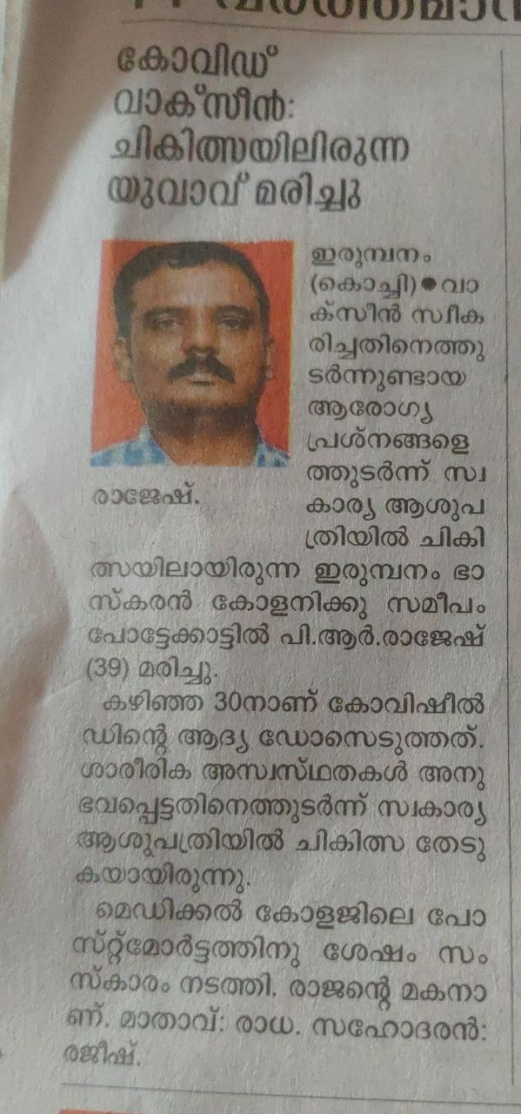
3643 | 14.08.2021 | https://ahmednagarlive24.com | Maharashtra: Ahmednagar district  56 year old teacher, Mrs. Padma Krishna Tambe, resident of Dadh Budruk village of Rahata tehsil, died on Friday, August 13, days after receiving second dose of COVID-19 vaccine. |  | https://ahmednagarlive24.com/2021/08/14/corona-dies-after-taking-both-doses-of-vaccine-incidents-in-the-district/
3644 | 24.08.2021 | https://english.mathrubhumi.com | Kerala: Pathanamthitta district  37 year old woman, Divya R Nair, resident of Naranganam village, died on Monday, August 23, due to brain haemorrhage, 3 weeks after receiving first dose of COVID-19 vaccine. |  | https://english.mathrubhumi.com/mobile/news/kerala/women-dies-of-brain-haemorrhage-family-complains-of-covid-vaccine-related-complications-young-women-in-pathanamthitta-died-due-to-brain-haemorrhage-1.5939454
3645 | 24.08.2021 | https://www.newindianexpress.com | Kerala: Thrissur District  P. Babu, A staff at Guruvayur Devaswom board, native of Vellalasserry, died on Sunday, August 22, due to contracting Covid pneumonia, a month after receiving second dose of COVID-19 vaccine. |  | https://www.newindianexpress.com/states/kerala/2021/aug/24/kerala-man-who-took-two-shots-of-vaccine-dies-after-covid-infection-2349238.html
3646 | 25.08.2021 | https://malayorashabdam.truevisionnews.com | Kerala: Kasaragod district  21 year old girl student, Ranjitha, resident of Vavadukkam village of Bedadukka panchayat, died on Wednesday, August 25, due to fever, vomiting & finally bleeding in the brain, 3 weeks after she took the first dose of Covishield COVID-19 vaccine. |  | https://malayorashabdam.truevisionnews.com/news/vaccinated-student-death-kasargode-covid-19-covid-vaccine/
3647 | 25.08.2021 | https://www.facebook.com  https://www.anandabazar.com | West Bengal : Kolkata  Tabla Maestro Pandit Subhankar Banerjee (55), died on Wednesday, August 25, due to contracting Covid pneumonia after receiving second dose of Covid-19 vaccine & undergoing a 2 month long hospitalization. |  | https://www.facebook.com/524366087/posts/10157947345346088/  https://www.anandabazar.com/entertainment/classical-tabla-player-pt-subhankar-banerjee-died-of-covid-dgtl/cid/1300186
3648 | 25.08.2021 | NEWSPAPER | Karnataka: Udupi district  23 year old young girl, Ashwini, resident of Harkur village of Kundapur tehsil, died on Wednesday, August 25, just 2 days after receiving COVID-19 vaccine. |  | 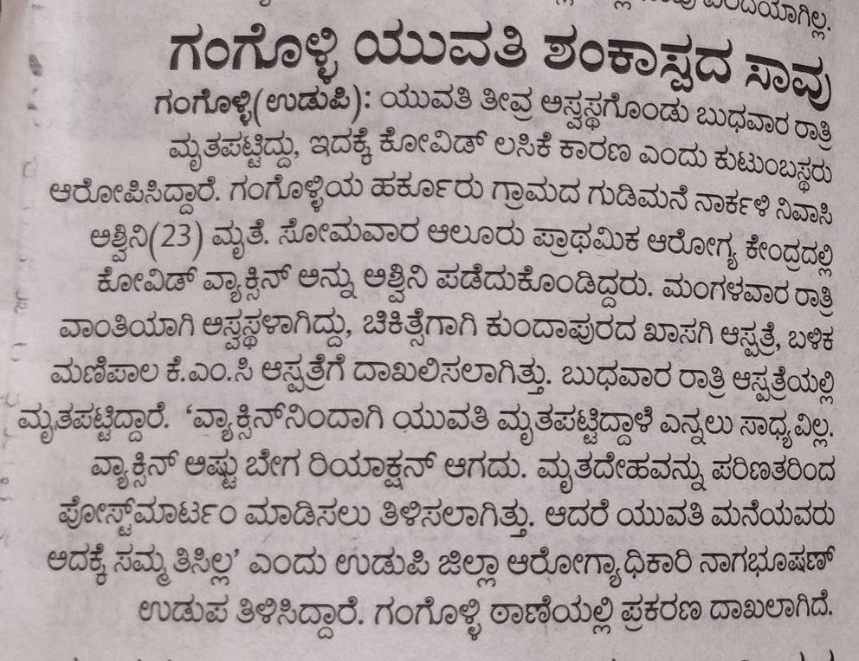
3649 To 3774 | 27.08.2021 | https://www.thehindu.com | Karnataka state  H&FW department has reported 14,421 breakthrough COVID-19 infections, and 126 deaths.  109 deaths were reported among those who have taken the first dose, and 17 deaths were reported among the fully vaccinated.  Though this is clearly manipulated and controlled release of data, meant to highlight breakthrough infections & need for a booster shot, we will consider these nos on their face value. |  | https://www.thehindu.com/news/national/karnataka/state-sees-14421-breakthrough-infections/article36129007.ece
3775 | 28.08.2021 | https://www.jagran.com | Odisha: Cuttack city  42 year old man, Sanjeev Haldar, resident of Annapurna nagar of Chauliaganj locality, died on Saturday, August 28, just within an hour after receiving second dose of COVID-19 vaccine. |  | https://www.jagran.com/odisha/cuttack-sensation-spread-at-vaccination-center-in-cuttack-youth-dies-family-members-allege-negligence-21969006.html
3776 To 3778 | 27.08.2021 | https://twitter.com/ | Pune (MH), Mumbai (MH), Coimbatore (TN)  Grandfather of Sumeet, Friend of Pravesh Jain & Arun Kanth's Friend's mother died due to contracting Covid pneumonia & cardiac arrest, days after receiving COVID-19 vaccine. |  | https://twitter.com/hypernationalst/status/1431233758674309124?s=19  https://twitter.com/PRAVESHPARAS/status/1414920867386040320?s=19  https://twitter.com/kanthisback/status/1430887784370212867?s=19
3779 To 3782 | 29.03.2021 | https://twitter.com/ | Ahmedabad (GJ), Bengaluru (KA), Chennai (TN), (WB)  An acquaintance of Bijal Shah, Husband of MC member, Uncle of user BG's friend & an acquaintance of Aumlaan died due to heart attack & cardiac arrest, hours after receiving COVID-19 vaccine. |  | https://twitter.com/BijalShah2016/status/1376591035816497166?s=19  https://twitter.com/_A_political/status/1384452446907342849?s=19  https://twitter.com/joBeeGeorgeous/status/1384427197721501698?s=19  https://twitter.com/aumlaan_tweets/status/1430777908319199232?s=19
3783 | 29.08.2021 | https://www.amarujala.com | Uttar Pradesh: Chitrakoot district  50 year old man, Laldas, resident of Khoh village, died on Saturday, August 28, just a day after receiving COVID-19 vaccine on August 27. |  | https://www.amarujala.com/uttar-pradesh/chitrakoot/alleged-death-due-to-corona-vaccine-chitrakoot-news-knp649021190
3784 | 01.09.2021 | https://www.amarujala.com | Uttar Pradesh: Jaunpur district  65 year old man, Jagannath Pal, resident of Mitawa village, died on Tuesday, August 31, at Maharajganj vaccination center, just 30 minutes after receiving COVID-19 vaccine. |  | https://www.amarujala.com/uttar-pradesh/varanasi/corona-vaccination-in-jaunpur-up-old-man-dies-after-vaccine-dose
3785 | 01.09.2021 | https://hindi.news18.com | Uttar Pradesh: Azamgarh district  55 year old man, Rampati Ram, resident of dewait village of Mehnagar tehsil, died on Wednesday, September 01, just within 3 hours after receiving COVID-19 vaccine. |  | https://hindi.news18.com/news/uttar-pradesh/azamgarh-a-few-hours-after-the-introduction-of-the-covid-vaccine-the-middle-aged-died-nodssp-3722025.html
3786 | 02.09.2021 | https://www.livehindustan.com | Bihar: Jamui district, Gidhaur tehsil  71 year old woman, Lakhiya devi, resident of Mahuli village of Kolhua panchayat, died on Wednesday, September 01, just 17 hours after receiving COVID-19 vaccine. |  | https://www.livehindustan.com/bihar/jamui/story-giddhaur-rumored-death-of-woman-after-taking-vaccine-doctor-said-wrong-4492896.html
3787 To 3790 | 08.06.2021 | https://twitter.com | Puducherry (PY), (IN), (PB), Vadodara (GJ)  Mother of user BuoyPlunger, Rajveer from Sidheart family, H Brar's uncle's friend & Aunt of Taniya Vaidya died recently due to contracting covid, days after receiving COVID-19 vaccine. |  | https://twitter.com/BuoyPlunger/status/1402247558597005323?s=19  https://twitter.com/TeamSidharthFC/status/1422477686308442112?s=19  https://twitter.com/Siddhar70543152/status/1422516460241362949?s=19  https://twitter.com/BrarH3M/status/1432605739588022275?s=19  https://twitter.com/VaidyaTaniya/status/1432653000665755654?s=19
3791 to #3798 | 01.09.2021 | https://twitter.com | New Delhi (DL), Ahmedabad (GJ), Palsit Burdwan (WB),  Father of Jatin Sharma, Father of Parth Joshi & 6 acquaintances of Amit KG, died recently due to Kidney failure, Covid pneumonia & heart attack, days after receiving COVID-19 vaccine. |  | https://twitter.com/jatinsharma360/status/1433092426193784837?s=19  https://twitter.com/jatinsharma360/status/1433318940864745476?s=19  https://twitter.com/parth9009/status/1433274080141221893?s=19  https://twitter.com/amytkg/status/1433111708457857027?s=19
3799 & 3800 | 02.09.2021 | https://www.timesnownews.com | Rajasthan: Jhalawar district  2 people from the tribal Kanjar community of Narayankheda area of Jhalrapatan tehsil died recently after receiving COVID-19 vaccine. |  | https://www.timesnownews.com/amp/india/article/rajasthan-vaccine-hesitancy-makes-tribals-run-away-from-home-say-its-killing-people-video/807057
3801 | 02.09.2021 | https://www.newindianexpress.com | Andhra Pradesh: Krishna district, Gannavaram tehsil  30 year old man, S K Subhani, resident of Marlapalem village died on Tuesday, August 31, just within hours after receiving COVID-19 vaccine. |  | https://www.newindianexpress.com/states/andhra-pradesh/2021/sep/02/30-year-old-man-dies-after-receiving-covid-jab-in-andhra-pradeshs-krishna-district-2353186.amp
3802 | 03.09.2021 | https://indianexpress.com | Haryana: Hisar district  26 year old youth, Rohit, resident of Barwala town, died on early Wednesday, September 01, three days after receiving first dose of Covishield COVID-19 vaccine. |  | https://indianexpress.com/article/cities/chandigarh/youth-dies-under-mysterious-circumstances-family-says-death-caused-by-vaccine-7485797/
3803 | 02.09.2021 | https://www.seithipunal.com | Tamil Nadu: Villupuram district, Gingee tehsil  37 year old woman, Vijaya, resident of Mahadevimangalam village, died on Thursday, September 02, due to heart attack, just within 24 hours after receiving first dose of Covishield COVID-19 vaccine. |  | https://www.seithipunal.com/tamilnadu/viluppuram-gingee-valathi-near-mahadevimangalam-village
3804 | 04.09.2021 | https://ahmedabadmirror.com | Gujarat: Surat city  30 year old youth, Hemant Patil, resident of Nilgiri Circle area of Surat city died on Thursday, September 02, just 2 days after receiving COVID-19 vaccine. |  | https://ahmedabadmirror.com/youth-dies-2-days-after-covid-jab-family-blames-vaccine/81806235.html
3805 To 3808 | 02.09.2021 | https://twitter.com | Faridabad (HR), Ahmedabad (GJ), Kolar (KA)  Father & Mother of shri. Sachin Sekhri, Koyena Basu's batchmet's school friend & a dentist in Meera's neighborhood died recently due to Covid pneumonia, blood clotting & heart attack, days after receiving COVID-19 vaccine. |  | https://twitter.com/BasuKoyena/status/1433461121457922049?s=19  https://twitter.com/meera029/status/1433706747047280643?s=19
3809 | 25.08.2021 | https://m.deepika.com | Kerala: Pathanamthitta district, Kozhenchery tehsil  28 year old woman, Arya Satheesan, resident of Kaipattoor village of Vallicode panchayat, died on Monday, August 23, due to vomiting & blood clotting, days after receiving first dose of COVID-19 vaccine. |  | https://m.deepika.com/article/news-detail/360528/amp
3810 | 27.08.2021 | https://m.deepika.com | Kerala: Alappuzha District, Karthikappally tehsil  20 year old youth, Ananthu, resident of Chingoli village near Haripad town, died on Thursday, August 26, due to stomach aches & vomitting, just a day after receiving second dose of Covishield COVID-19 vaccine. |  | https://m.deepika.com/article/news-detail/360631
3811 | 05.09.2021 | https://www.timesnownews.com | Gujarat: Banaskantha district  Mukesh Joshi, a resident of Palanpur town died in month of June of 2021, soon after receiving first dose of COVID-19 vaccine.  Still the Health officials sent him a SMS saying he has been successfully administered second dose of COVID-19 vaccine. |  | https://www.timesnownews.com/ahmedabad/article/jab-goof-up-in-gujarat-man-gets-second-dose-of-covid-vaccine-after-death/808001
3812 | 04.06.2021 | https://www.telegraphindia.com | Uttar Pradesh: Bareilly district  Lalit Mohan Garg (65), resident of Subhash nagar locality of Bareilly city, died on April 25, due to contracting Covid pneumonia, soon after receiving his first dose of COVID-19 vaccine. |  | https://www.telegraphindia.com/india/message-on-dead-mans-phone-2nd-covid-jab-done/cid/1817714
3813 | 01.06.2021 | https://timesofindia.indiatimes.com | Gujarat: Dahod district  Madhu Sharma (72), resident of Limdi town of Zalod tehsil, died on April 15, due to Heart attack, 6 weeks after receiving her first dose of COVID-19 vaccine. |  | https://timesofindia.indiatimes.com/city/vadodara/dead-citizens-vaccinated-in-dahod/articleshow/83125609.cms
3814 | 06.09.2021 | https://publictv.in | Karnataka: Hassan district  35 year old youth, Vasant Naik, resident of Boranakoppalu Tandi village of Arasikere tehsil, died on Monday, September 06, within 2 days after receiving COVID-19 vaccine. |  | https://publictv.in/son-death-after-receiving-the-vaccine-parent-allegation?amp
3815 | 06.09.2021 | https://www.amarujala.com | Uttar Pradesh: Kanpur Nagar district  67 year old woman, Chandavati, resident of Tejkamalpur village of Ghatampur tehsil, died on Monday, September 06, due to heart attack, just within hours after receiving COVID-19 vaccine. |  | https://www.amarujala.com/uttar-pradesh/ghatampur/ghatampur-death-of-old-woman-returned-home-after-corona-vaccination
3816 | 05.09.2021 | https://www.amarujala.com | Haryana: Jind district  46 year old woman, named Usha, resident of Mandi kurd village of Pillukhera tehsil, died on Saturday, September 04, due to persistent fever, 11 days after receiving COVID-19 vaccine. |  | https://www.amarujala.com/haryana/jind/woman-s-death-family-said-health-deteriorated-after-getting-corona-vaccine-jind-news-rtk62305596
3817 | 02.09.2021 | https://amritvichar.com | Uttar Pradesh: Barabanki district  31 year old woman, Neelam, resident of Bichhalkha village of Ramnagar tehsil, died on Saturday, September 04, due to persistent fever, just 4 days after receiving COVID-19 vaccine. |  | https://amritvichar.com/barabanki-ailing-woman-dies-after-vaccination-husband-alleges-negligence-in-treatment/
3818 | 07.09.2021 | https://www.esakal.com | Maharashtra: Jalgaon district  75 year old man, Kashinath Sonar, resident of Samata nagar, died on Sunday, September 05, he fell unconscious & collapsed at vaccination center after receiving COVID-19 vaccine & died within next 12 hours at a local hospital. |  | https://www.esakal.com/jalgaon/marathi-news-jalgaon-corona-vaccination-center-elderly-man-dies-after-being-vaccinated-bms86
3819 To 3853 | 05.09.2021 | https://www.lokmat.com | Maharashtra state:  State Family Office in their reply (on September 02) to a RTI query filed by Dr. Dinesh Solunke (on March 09) has confirmed 35 deaths (January 2021 to April 2021), of people who had received COVID-19 vaccine. |  | https://www.lokmat.com/mumbai/so-far-35-people-have-died-state-after-being-vaccinated-against-kovid-pdc-a601/
3854 To 3860 | 19.04.2021 | https://twitter.com | (GJ), (JH), (UP), Begusarai (BR)  4 acquaintance of Kapil Joshi, Father of Sunny Raj, Mother of Vipul's friend & a acquaintance of Prince Yaduvanshi, died in month of April & May 2021, days after receiving COVID-19 vaccine |  | https://twitter.com/KapilJo96330194/status/1384195699185635330?s=19  https://twitter.com/SunnyRa58214116/status/1389099022846074881?s=19  https://twitter.com/RealVipulk/status/1389398118257418246?s=19  https://twitter.com/PrinceRJD_/status/1389982638824329225?s=19
3861 To 3865 | 10.05.2021 | https://twitter.com | Chanod-Vapi (GJ), Sarni (MP), Dehari-Shahganj (UP)  A person from Sarvendra B Rai's Chanod village, at least 2 people from Arjun Jharbade's Sarni village & 2 teachers from Etesham Khan's Dehari village died in month of May 2021, days after receiving COVID-19 vaccine. |  | https://twitter.com/sbrai1137/status/1391801483771924487?s=19  https://twitter.com/ArjunJharbade1/status/1394282467360579584?s=19  https://twitter.com/rhman330/status/1395379086139170817?s=19
3866 To 3869 | 21.05.2021 | https://twitter.com | Ahmednagar (MH), Ranipur Haridwar (UK), (IN), Pilibhit (UP)  A person from Santosh Gughe's Ahmednagar city, Father of Neeraj Sharma, Elder brother of Ravi Shankar & Rajendra Agnihotri died in month of May, June & July 2021, days after receiving COVID-19 vaccine. |  | https://twitter.com/GhugeSantosh1/status/1395562428742598666?s=19  https://twitter.com/neerajsharmapg/status/1396820572311490561?s=19  https://twitter.com/Ravisha23624235/status/1399763122194325507?s=19  https://twitter.com/sanjays7828/status/1414666331618697216?s=19
3870 To 3873 | 17.08.2021 | https://twitter.com | Chiplun (MH), Vrindavan (UP), Vadodara (GJ), Mumbai (MH)  Aditya Shekhar Kulkarni (29), A relative of Vibhor Bharadwaj Sharma, Dr Mohnish Malhotra (54) & a family friend of Chaya died in the month of August & September 2021, days after receiving COVID-19 vaccine. |  | https://twitter.com/PhulpagarRohan/status/1427588809760272388?s=19  https://twitter.com/PhulpagarRohan/status/1427588832426221582?s=19  https://twitter.com/winwithvibhor/status/1434082043487395840?s=19  https://twitter.com/imacuriosguy/status/1434813974457958406?s=19  https://twitter.com/_chAyA_/status/1434897294348914689?s=19
3874 | 02.09.2021 | https://www.nationalnewstime.com | Uttar Pradesh: Pilibhit district 60 year old man, Salik Ram, resident of Pureina village, died on September 02, due to suspected heart attack, he collapsed near Bhadera village while returning from vaccination centre at Bilaspur, just hours after receiving second dose of COVID-19 vaccine. |  | https://www.nationalnewstime.com/archives/48624
3875 | 26.08.2021 | https://newspr.live | Bihar: Aurangabad district  25 year old youth, Umesh Bhuia, resident of Pade Bigha village of Deo tehsil, died on Thursday, August 26, due to sudden deterioration in health & suffocation in throat, just a day after he received first dose of COVID-19 vaccine on August 25. |  | https://newspr.live/news/youth-dies-after-taking-corona-vaccine-there-is-uproar-among-family-members/
3876 | 28.08.2021 | https://vijayapatha.in | Karnataka: Chamarajanagar district  64 year old man, Mahadevaiah, resident of Heggadahalli village of Gundlupet tehsil, died on August 27, due to sudden deterioration in health, a week after receiving second dose of Covishield COVID-19 vaccine. |  | https://vijayapatha.in/news/district-chamarajanagar-older-person-dies-after-coronavirus-second-vaccine/
3877 | 09.08.2021 | https://www.prajavani.net | Karnataka: Koppal district  25 year old pregnant woman, Manjula Yamanurappa Meti, resident of Sebankatti village of Kushtagi tehsil, died early morning of August 06, due to heavy bleeding which started few hours of receiving first dose of COVID-19 vaccine.  14 pregnant women were vaccinated on August 05 at Hulgera village vaccination center. |  | https://www.prajavani.net/amp/district/koppal/a-pregnant-lady-died-in-kustagi-due-to-bleeding-856241.html
3878 | 07.09.2021 | http://m.dinamalarnellai.com | Tamil Nadu: Virudhunagar district  56 year old woman, Dhanalakshmi, resident of Avarampatti village of Rajapalayam tehsil, died on Tuesday, September 07, due to vomiting and deterioration of health, hours after she received COVID-19 vaccine & died within 24 hours. |  | http://m.dinamalarnellai.com/web/districtnews/73232
3879 | 09.09.2021 | https://zeenews.india.com | Uttar Pradesh: Balrampur district  81 year old woman, Rajpati, resident of Badhya Pakri village of Utaraula tehsil, died on June 04, 2021, 6 weeks after receiving first dose of COVID-19 vaccine. |  | https://zeenews.india.com/marathi/health/the-woman-who-died-2-months-ago-has-now-been-vaccinated/582881/amp
3880 | 08.09.2021 | https://www.amarujala.com | Uttar Pradesh: Sonbhadra district  48 y/o woman, Kaushalya Dhangar, resident of Karaundiya village of Chatra tehsil, died on Wednesday, September 08, due to gradual deterioration in health, 2 days after receiving COVID-19 vaccine. |  | https://www.amarujala.com/uttar-pradesh/sonebhadra/death-of-woman-who-got-covid-vaccine-two-days-ago-sonbhadra-news-vns610494218
3881 | 10.09.2021 | https://www.amarujala.com | Uttar Pradesh: Chitrakoot district  60 year old man, Fulchandra, resident of Sonepur village, died on Friday, September 10, due to severe fever, just 2 days after receiving COVID-19 vaccine. |  | https://www.amarujala.com/uttar-pradesh/chitrakoot/villager-s-death-allegation-of-negligence-chitrakoot-news-knp651421777
3882 | 24.04.2021 | https://www.youtube.com | Tamil Nadu: Cuddalore district  A youth, Siva Prakash, resident of Bhuvanagiri tehsil, died on April 24, 2021, due to seizures, on the same day he received first dose of Covaxin COVID-19 vaccine. |  | https://www.youtube.com/watch?v=_8doPyoi0rE
3883 | 08.04.2021 | https://youtu.be | Tamil Nadu: Chennai  56 y/o man Ramalingam, a travel company owner & resident of Thiruvanmiyur area, died on April 08, 2021, a day after receiving COVID-19 vaccine. |  | https://youtu.be/-C6qJChvqXY
3884 | 30.07.2021 | https://youtu.be | Kerala: Thrissur district  69 y/o man, Chandran, resident of Puthencheria village, died on Friday, July 30, 2021, after he collapsed at vaccination centre, waiting in queue for second dose, days after receiving first dose of COVID-19 vaccine. |  | https://youtu.be/jwUg4PksgNA
3885 | 21.04.2021 | https://youtu.be | Kerala: Malappuram district  76 y/o woman, Chakki kutti, resident of Aliparamba village, died in third week of April 2021, due to vomitting & felling unconscious, on the same day she received COVID-19 vaccine. |  | https://youtu.be/SvL9_OvRzPo
3886 To 3891 | 07.05.2021 | https://twitter.com | Rajkot (GJ), Ajara (MH), Chennai (TN), CBD Belapur (MH)  Uncle of Naliniba Jadeja, 2 close relatives of Prakash Jadhav, Meeran Maideen, Mr & Mrs Basrur died recently (May - July), days after receiving COVID-19 vaccine. |  | https://twitter.com/naliniba/status/1390609932831969285?s=19  https://twitter.com/JayshriSai/status/1401817845818814471?s=19  https://twitter.com/tadarahim7/status/1402679998037721088?s=19
3892 To 3894 | 09.08.2021 | https://twitter.com | (TN), Mumbai (MH), Palakkad (KL)  A youth - Kadaldeepan, Priyanka Tiwari & maternal uncle of Sh Venugopalan Govindan died recently (Aug-Sept), days after receiving COVID-19 vaccine. |  | https://twitter.com/LA3BQyysjEEEkc6/status/1424773650742321161?s=19  https://twitter.com/gvenugopalan/status/1436328651893600260?s=19
3895 | 09.09.2021 | https://epaperm.patrika.com | Madhya Pradesh: Betul district  Dilip Tongse, a transport business owner, resident of Betul city, died in second week of September, two weeks after receiving second dose of COVID-19 vaccine.  Patrika newspaper, Bhopal edition, page no.5, September 09, 2021 |  | https://epaperm.patrika.com/madhyapradesh/bhopal/2021-9-9/52/page-5.html#
3896 | 12.09.2021 | https://www.lokmat.com | Maharashtra: Chandrapur district  35 y/o man, Shyammurthi Adelwar, resident of Yerghavaan village, died on Saturday, September 11, due to seizures, just within 9 hours after receiving first dose of COVID-19 vaccine. |  | https://www.lokmat.com/chandrapur/person-dies-within-hours-being-vaccinated-against-corona-a692/
3897 To 3939 | 08.09.2021 | https://www.saamana.com | Maharashtra: Goregaon, Mumbai  According to the report, Total 43 vaccinated people against COVID-19, have died in NESCO COVID care center at Goregaon Mumbai between the period, March 01 to September 07, 2021. |  | https://www.saamana.com/576-corona-patient-died-no-vaccine/
3940 | 12.09.2021 | https://athnews11.in | Jharkhand: Garhwa district, Kandi tehsil  60 y/o man, Suresh Ram resident, of Sonpura village of Baliyari panchayat, was sick since receiving first dose of COVID-19 vaccine. While he was hospitalized at Garhwa hospital, doctors injected him second dose of Covishield COVID-19 vaccine on September 02 without informing his relatives & he died on September 10. |  | https://athnews11.in/?p=7323
3941 | 10.09.2021 | https://www.gstv.in | Gujarat: Sabarkatha district A woman, Taraben Patel, resident of Poglu village in Prantij taluka, died on April 28, days after receiving first dose of COVID-19 vaccine. Still a certificate of second dose was sent via SMS on September 05, 2021. |  | https://www.gstv.in/vaccine-gujarat-state-gujarati-news-2/
3942 To 4846 | 09.09.2021 | https://www.onmanorama.com | Kerala state  According to the study published by the Kerala State Health Department (between June 18 to September 03, 2021), 905 people who died due to COVID-19 disease were vaccinated !! |  | https://www.onmanorama.com/news/kerala/2021/09/09/covid-vaccine-prevents-death-health-department.html
4847 | 09.09.2021 | https://hindi.oneindia.com | Uttar Pradesh: Sitapur district  A youth, Rajaram, resident of Godhwa village, of Maholi tehsil, died on September 07, due to persistent fever, just a day after receiving first dose of COVID-19 vaccine. |  | https://hindi.oneindia.com/videos/amphtml/news-c66/sitapur-2021-sep-09-1631200862580143622-1778002.html
4849 To 4856 | 24.04.2021 | https://twitter.com | Raipur (CG), Gurgaon (HR), Mumbai (MH), (IN)  Mother of R.P. Singh, 5 known cases to Dr. Rahul Bhargava, Neighbour of Mayank Arya & Mother of Tripti died during April to June 2021, days after receiving Covishield (2) & Covaxin (6) COVID-19 vaccine. |  | https://twitter.com/rpsinghraipur/status/1385854114035159042?s=19  https://twitter.com/RahulDoc2/status/1399056251527385093?s=19  https://twitter.com/smartmayankarya/status/1399458969840619524?s=19  https://twitter.com/Tripti26624667/status/1401868954675519496?s=19
4857 To 4861 | 07.06.2021 | https://twitter.com | Kurnool (AP), Garhwal (UK), Bhokar Nanded (MH), Udaipur (RJ)  Father of Prasanna Kumara, 2 neighbours of MS Rautela, a 52 y/o man from Pimpalgaon, a woman from Udaipur, died in Jun-July 2021, days after receiving Covaxin (1) & Covishield (4) COVID-19 vaccine. |  | https://twitter.com/prasannainovate/status/1401722015761850371?s=19  https://twitter.com/MSRAUTELA7/status/1410278874961694725?s=19  https://twitter.com/Pashu711/status/1413861408890970120?s=19  https://twitter.com/UdaipurKiran/status/1414549818123370496?s=19
4862 To 4865 | 18.06.2021 | https://twitter.com | Raipur (CG), Ongole (AP), (UP), Mumbai (MH)  Wife of Sh. S.K. Jain, Nannuri Padmasri (52), Anaesthetist colleague of Dr. Sarika Jain & relative of Adv. Vivekananda Gupta, died in Jul-Aug 21, days after receiving Covaxin (2) & Covishield (2) COVID-19 vaccine. |  | https://twitter.com/SKJain02393171/status/1416813559506300934?s=19  https://twitter.com/SKJain02393171/status/1427197640177901568?s=19  https://twitter.com/thami73197848/status/1425116337723088903?s=19  https://twitter.com/thami73197848/status/1428378803366244355?s=19  https://twitter.com/Drsarikajain76/status/1426410034552926219?s=19  https://twitter.com/vivekanandg/status/1427683883206672390?s=19
4866 | 14.09.2021 | https://www.livehindustan.com | Bihar: Nalanda district  27 y/o woman, Babita devi, resident of Fata Bigha village of Nagarnausa tehsil, died on early morning of Tuesday, September 14, just 10 hours after receiving first dose of COVID-19 vaccine. |  | https://www.livehindustan.com/bihar/biharsharif/story-tell-the-death-of-woman-due-to-corona-vaccine-that-road-jam-4586006.html
4867 | 14.09.2021 | https://www.amarujala.com | Uttar Pradesh: Etawah district  41 y/o Meeradevi Singh, resident of Dharwar village of Jaswantnagar tehsil, died on Tuesday, September 14, due to persistent fever, cough & cold, 2 weeks after receiving COVID-19 vaccine. |  | https://www.amarujala.com/uttar-pradesh/etawah/crime-etawah-news-knp652172380
4868 | 15.09.2021 | https://www.newstracklive.com | Andhra Pradesh: Kurnool district  A youth, Pedda Laxmi devi, resident of Chagalamarri village of Allagadda tehsil, died on June 06, Just 5 days after receiving first dose of COVID-19 vaccine. |  | https://www.newstracklive.com/news/kurnool-second-dose-of-corona-vaccine-to-the-dead-person-sc1-nu303-ta901-1463712-1.html
4869 | 15.09.2021 | https://www.lokmat.com | Maharashtra: Amaravati district  55 y/o man, Shankar Kekan, resident of Antargaon village of Daryapur tehsil, died on September 14, due to suspected heart attack, hours after receiving second dose of Covishield COVID-19 vaccine. |  | https://www.lokmat.com/amravati/vaccinated-morning-died-afternoon-a686/
4870 | 16.09.2021 | https://www.youtube.com | Tamil Nadu: Krishnagiri district  A healthcare worker, woman nurse, Malarkodi, resident of Govindpuram village of Uthangarai tehsil, died on September 15, due to persistent high fever, just 3 days after receiving second dose of Covishield COVID-19 vaccine. |  | https://youtu.be/A8SWYfMITAQ
4871 To 4874 | 15.09.2021 | https://twitter.com | Vadodara (GJ), (WB), New Delhi (DL), (UP)  Mother of Shashikant Kumar, Lady help of Jyoti Koul, Father of Nitin Jain & Colleague of mr Shukla died between May to Sept 2021, days after receiving COVID-19 vaccine. |  | https://twitter.com/gercbrd/status/1438018176822898688?s=19  https://twitter.com/jytkoul/status/1438337107416649730?s=19  https://twitter.com/nit_jain/status/1438375333124730882?s=19  https://twitter.com/Shuks80/status/1437388949836550150?s=19
4875 | 17.09.2021 | https://tarunbharat.com | Maharashtra: Sindhudurg district  58 y/o woman, Yogita Ghadi, resident of Tirlot village of Devgad taluka, on Thursday, September 16, fell unconscious at vaccination center, and died within an hour after receiving first dose of COVID-19 vaccine. |  | https://tarunbharat.com/dailynews/1044428
4876 | 18.09.2021 | https://www.aajtak.in | Bihar: Purnia district  A woman from Purnia town, died on May 18, due to Covid pneumonia, 3 weeks after receiving first dose of Covishield COVID-19 vaccine. |  | https://www.aajtak.in/india/bihar/story/controversy-over-record-vaccination-in-bihar-on-pm-modi-birthday-ntc-1328472-2021-09-18
4877 | 16.09.2021 | https://www.lokmat.com | Maharashtra: Kolhapur district  32 y/o woman, Gita Sagar Patil, resident of Bhatanwadi village of Karveer tehsil, died on Wednesday, September 15, due to brain hemorrhage, just within 2 hours after receiving first dose of COVID-19 vaccine. |  | https://www.lokmat.com/kolhapur/death-married-woman-due-bleeding-brain-incident-bhatanwadi-a696/
4878 | 18.09.2021 | https://www.livehindustan.com | Bihar: Nalanda district  30 y/o youth, Sudan Ravidas, resident of Pariauna village of Noorsarai tehsil, died on September 18, a week after receiving a dose of COVID-19 vaccine. |  | https://www.livehindustan.com/bihar/biharsharif/story-road-jammed-for-three-hours-after-the-death-of-the-young-man-4614531.html
4879 | 18.09.2021 | https://www.patrika.com | Madhya Pradesh: Bhind district  65 y/o man, Vikram Singh, resident of Daboha village of Bhind tehsil, died on May 03, three weeks after receiving first dose of COVID-19 vaccine. |  | https://www.patrika.com/gwalior-news/second-vaccine-of-corona-was-given-to-the-dead-person-certificate-als-7075287/
4880 | 19.09.2021 | https://www.bhaskar.com | Haryana: Mewat district  52 y/o man, named Lallu, resident of Akera village of Nuh tehsil, died on Friday, September 17, within an hour after receiving a dose of COVID-19 vaccine. |  | https://www.bhaskar.com/local/delhi-ncr/gurgaon/news/health-deteriorated-due-to-corona-vaccine-in-mewat-death-during-treatment-128938342.html
4881 | 19.09.2021 | https://www.tv9hindi.com | Madhya Pradesh: Agar Malwa district  65 y/o woman, Vidyadevi Sharma, resident of Chhawani Naka ward no.16, died on May 01, due to Covid, 7 weeks after receiving first dose of Covishield COVID-19 vaccine. |  | https://www.tv9hindi.com/state/madhya-pradesh/madhya-pradesh-health-department-second-dose-of-corona-vaccine-given-to-dead-woman-830574.html
4882 | 19.09.2021 | https://thebegusarai.in | Bihar: Begusarai district  42 y/o man, Arjun Sahani, resident of Korai village of Garhpura tehsil, died on Friday, September 17, within 12 hours after receiving first dose of Covishield COVID-19 vaccine. |  | https://thebegusarai.in/begusarai-news/rumors-of-death-spread-due-to-taking-kovid-vaccine-in-begusarai/
4883 | 19.09.2021 | https://www.hindustantimes.com | Assam: Guwahati  Arunachal Pradesh's Advocate General, Nilay Dutta (68) died of a "massive heart attack" in Karnataka's Coorg on Sunday, September 19. He was fully vaccinated back in April month. |  | https://www.hindustantimes.com/india-news/arunachal-advocate-general-nilay-dutta-dies-of-heart-attack-at-68-101632036338980.html  https://twitter.com/nilaydutta/status/1387169599020421120?s=19
4884 | 21.09.2021 | https://www.livehindustan.com | Uttar Pradesh: Mainpuri district  62 y/o woman, Lajjawati Singh, resident of Bariyar village of Kishni tehsil, died on Monday, September 20, just within 3 hours after receiving second dose of COVID-19 vaccine. |  | https://www.livehindustan.com/uttar-pradesh/mainpuri/story-after-getting-vaccinated-the-condition-of-the-old-woman-deteriorated-death-4631506.html
4885 | 23.09.2021 | https://www.amarujala.com | Uttar Pradesh: Ghazipur district  62 y/o woman, Lalmati devi, resident of Sultanpur village of Mohammadabad tehsil, died on Thursday, September 23, just within an hour after receiving first dose of Covishield COVID-19 vaccine. |  | https://www.amarujala.com/uttar-pradesh/ghazipur/woman-dies-under-suspicious-circumstances-ghazipur-news-vns6133065130
4886 & 4887 | 10.06.2021 | https://banaskanthaupdate.com | Gujarat: Banaskantha district  Raichand Kalani (63) & Kanjibhai Ravatji Makvana, resident of Madal village of Lakhani tehsil, died in the month of April 2021, days after receiving first dose of COVID-19 vaccine,  Still their relatives received SMS of "second dose being successfully adminstered" to the deceased in the month of June. |  | https://banaskanthaupdate.com/2021/06/10/surprise-after-the-statues-of-2-persons-in-lakhani/
4888 | 25.09.2021 | https://www.livehindustan.com | Uttar Pradesh: Hapur district  50 y/o man, Sundarpal, resident of Bhowapur village of Simbhawali tehsil, died on Saturday, September 25, due to persistent fever, within few days after receiving a dose of COVID-19 vaccine. |  | https://www.livehindustan.com/uttar-pradesh/hapur/story-middle-aged-dies-of-fever-in-bhowapur-4664868.html
4889 | 26.09.2021 | https://www.patrika.com | Madhya Pradesh: Jabalpur district  Bhagwan Das Gotele, watchman at Netaji Subhash Chandra Bose Medical College of Jabalpur, developed severe fever & Abdominal pain after receiving first dose of COVID-19 which was forcefully given to him by college staff, died within 18 hours after vaccination, on early morning of Saturday, September 25. |  | https://www.patrika.com/jabalpur-news/medical-college-watchman-dies-after-vaccination-in-jabalpur-7089500/
4890 To 4892 | 25.09.2021 | https://www.theweek.in | West Bengal  According to Bengal police reports, two deaths after the second dose were reported from Eastern Frontier Rifles (EFR) of Bengal police, while one was reported in Siliguri police commissionerate in North Bengal’s Darjeeling district. |  | https://www.theweek.in/news/india/2021/09/25/west-bengal-police-survey-few-covid-19-infections-3-deaths-after-2nd-vaccine-dose.html
4893 To 4895 | 28.09.2021  10.09.2021  27.09.2021 | https://epaper.bhaskar.com  https://twitter.com | Rajgarh, Dhar (MP), (WB), (GJ)  A 28 y/o Nathu Bhil from Mahapura village, Mother of Amulan's friend & A 58y/o female relative of Rupesh Jaju died due to fever & heart attack days after receiving COVID-19 vaccine |  | https://epaper.bhaskar.com/dhar/dhar-bhaskar/360/2012/mpcg/0/  https://twitter.com/aumlaan_tweets/status/1436209750505558017?s=19 https://twitter.com/RupeshJaju/status/1375723207764758531?s=19
4896 | 26.09.2021 | https://www.jagran.com | Haryana: Panipat district  41 y/o man, Ranajit, resident of Hari Singh Colony of Panipat, died on Saturday September 25, due to suspected heart attack, just within 3.5 hours after receiving first dose of Covishield COVID-19 vaccine. |  | https://www.jagran.com/haryana/panipat-bike-mechanic-dies-after-three-and-a-half-hours-after-first-dose-of-corona-vaccine-22058667.html
4897 To 4929 | 03.06.2021 | https://hindi.theprint.in | Chhattisgarh: Raipur district  Many people have died in "nearby villages of Raipur" after taking first dose of COVID-19 vaccine until May 2021.  Pavani - 07 nos, Tikari - 10 nos,  Khauna - 08 nos & Dharsiwa - 08 nos  Published: June 03, 2021 |  | https://hindi.theprint.in/india/low-sex-drive-impotency-death-whats-keeping-raipur-villagers-away-from-covid-vaccine/220011/
4930 | 30.09.2021 | https://www.amarujala.com | Haryana: Jhajjar district  A woman, Sumitra Dahiya, resident of Bahadurgarh, died on May 04, due to Covid complications, 3 weeks after receiving first dose of COVID-19 vaccine |  | https://www.amarujala.com/chandigarh/second-dose-of-corona-vaccine-administered-on-record-to-a-woman-four-months-after-death
4931 | 29.09.2021 | https://www.puthiyathalaimurai.com | Tamil Nadu: Tiruvallur district  A 9-month pregnant woman, Lavanya (25), resident of Thiruttani town, died on September 29, due to sudden breathlessness, just within 8 hours after receiving second does of COVID-19 vaccine. |  | https://www.puthiyathalaimurai.com/newsview/117307/A-pregnant-woman-who-took-2nd-dose-covid-vaccine-died-due-to-sudden-suffocation-in-Thiruvallur.html
4932 | 26.09.2021 | NEWSPAPER | Tamil Nadu: Tiruchirapalli district  70 y/o man, Marudhai, resident of Kavalkarapalayam village, died on September 26, due to headache (suspected brain stroke), within 8 hours after receiving COVID-19 vaccine. |  | 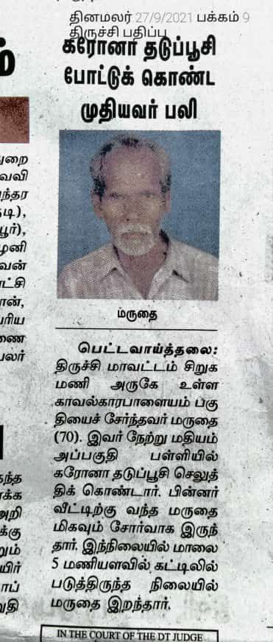
4933 | 30.09.2021 | https://www.livehindustan.com | Uttar Pradesh: Pratapgarh district  Hari Narayan Tiwari, resident of Amargarth village of Patti tehsil, died in month of July 2021, days after receiving first dose of COVID-19 vaccine. |  | https://www.livehindustan.com/uttar-pradesh/pratapgarh-kunda/story-amazing-corona-vaccine-was-given-to-the-deceased-4697757.html
4934 | 29.09.2021 | https://thevoices.in | Chhattisgarh: Jashpur district  An old man, Bahal Ram, resident of Manora, died on September 27, due to cardiac arrest, within 6 hours after receiving a dose of COVID-19 vaccine. |  | https://thevoices.in/old-man-dies-after-getting-covid-19-vaccine,-administration-starts-investigation
4935 | 02.10.2021 | https://newstrack.com | Uttar Pradesh: Sonbhadra district  41 y/o man, Ram Prasad Yadav, a Volvo dumper driver, resident of Baasi village of Shaktinagar, died on September 08, due to gradual deterioration of health after receiving first dose of Covishield COVID-19 vaccine in a vaccination camp organised by his company. |  | https://newstrack.com/uttar-pradesh/vindhyachal/sonbhadra/sonbhadra-latest-today-hindi-crime-news-corona-vaccine-ke-bad-karmchari-ki-maut-bgr-deco-consortium-company-289905
4936 | 02.10.2021 | https://www.livehindustan.com | Uttar Pradesh: Bareilly district  60+ y/o woman, Chabili devi, resident of Pargawan village of Kyara tehsil, died on March 18, 2021, 10 days after receiving first dose of COVID-19 vaccine. |  | https://www.livehindustan.com/uttar-pradesh/bareily/story-after-the-funeral-the-woman-got-the-kovid-vaccine-sent-congratulations-4713848.html
4937 | 01.10.2021 | https://www.news18.com  https://twitter.com | Maharashtra: Mumbai  29 y/o TV actress Manisha Yadav, died on October 1st, due to brain haemorrhage, weeks after receiving COVID-19 vaccine. |  | https://www.news18.com/news/movies/manisha-yadav-aka-salima-begum-of-jodha-akbar-passes-away-4274984.html  https://twitter.com/manishayadav164/status/1407639618955132930?t=Fi8ug2KUqGZ9tG227nR-qA&s=19
4938 & 4939 | 03.10.2021 | https://www.livehindustan.com | Bihar: Begusarai district  22 y/o Pawan Kumar Chaurasiya & 62 y/o Ramanand Paswan, resident of Tetrahi village of Khodawandpur tehsil, died in September & October 02, within 4 hours & 8 hours respectively after receiving first dose of COVID-19 vaccine. |  | https://www.livehindustan.com/bihar/begusarai/story-family-raised-questions-on-the-death-of-the-elderly-4728936.html
4940 To 4942 | 27.09.2021 | https://twitter.com | Chennai (TN), Mumbai (MH), (TN)  32 y/o Brother of Annapoorna Ranganathan, Endocrinologist Dr. Sudhindra Kulkarni & Uncle of Maathira died in September & October 2021, days after receiving a dose of COVID-19 vaccine |  | https://twitter.com/annaranganathan/status/1442369656518373377?s=19 https://twitter.com/annaranganathan/status/1442442345094402055?s=19 https://twitter.com/pnhin/status/1443930100496543748?t=bcOoWmSxX59eMNn1kvUyHg&s=19  https://twitter.com/Maathira20/status/1444146625799069698?t=ukeMBgjcWyxPr9j4g8Q_KQ&s=19
4943 | 03.10.2021 | NEWSPAPER | Tamil Nadu: Dindigul district  53 y/o man, Raja, a farm/coolie worker, resident of Sempatty village of Nilakottai tehsil, died on October 3rd, due to chest pain (suspected heart attack), just within 2 hours after receiving first dose of Covishield COVID-19 vaccine. |  | 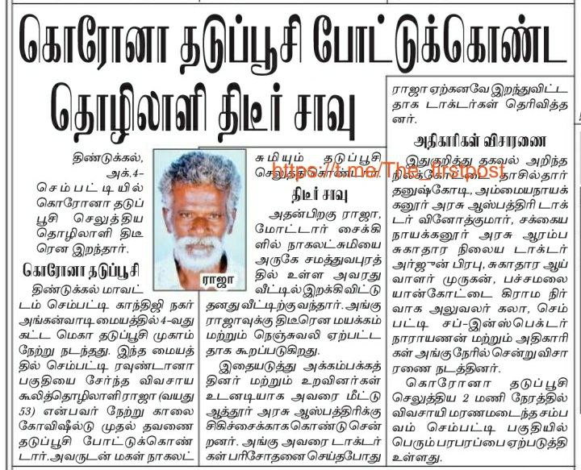
4944 | 01.10.2021 | https://www.etvbharat.com/ | Puducherry Union Territory  19+ y/o teenager, Sankalp Reddy, Second year medical student, at Lakshminarayanan Private Medical College, Pondicherry, died on October 1st, within few hours after receiving first does of COVID-19 vaccine. |  | https://www.etvbharat.com/amp/tamil/tamil-nadu/bharat/puducherry-medical-student-death-police-started-investigation/tamil-nadu20211002234917353
4945 | 03.102021 | https://www.lokmat.com | Maharashtra: Pune district  25 y/o youth, Aakash Kore, resident of Chikhali locality of Pimpari Chinchwad, died on October 3rd, due to heart attack, within 48 hours after receiving second dose of COVID-19 vaccine. |  | https://www.lokmat.com/pimpri-chinchwad/young-died-within-2-days-after-second-dose-corona-vaccination-a727/amp/
4946 | 04.10.2021 | https://hindi.news18.com | Himachal Pradesh: Kangra district  74 y/o man, Om Prakash Sood, resident of Gopalpur village, died in month of April 2021, days after receiving first dose of Covishield COVID-19 vaccine.  On September 30, Relatives of deceased received a SMS saying Om Prakash being successfully vaccinated with second dose. |  | https://hindi.news18.com/amp/news/himachal-pradesh/dharamsala-5-months-after-death-of-a-man-the-message-of-successful-double-dose-of-vaccination-came-hrrm-3778921.html
4947 | 10.10.2021 | http://www.dailythanthi.com | Tamilnadu: Theni district  Village: Badrakalipuram, Tehsil: Dombucheri  6 month old unborn baby of Sylvia (23), died in womb, on July 10, a day after she was vaccinated with first dose of Covishield COVID-19 vaccine on advice of Dombucheri PHC staff, where she went for a pregnancy test. |  | http://www.dailythanthi.com/districts/chennai/2021/07/10220414/infant-death-in-the-womb-of-a-pregnant-woman-vaccinated.vpf
4948 | 22.08.2021 | https://keralakaumudi.com | Kerala: Kottayam district  7 week unborn baby died in womb, with Mahima Mathew (31), resident of Kanjirapally tehsil, who died on Friday, August 20, due to brain haemorrhage, just 15 days after receiving first dose of COVID-19 vaccine. |  | https://keralakaumudi.com/en/news/mobile/news-amp.php?id=622988&u
4949 | 09.08.2021 | https://www.prajavani.net | Karnataka: Koppal district  An unborn baby died with 25 year old pregnant woman, Manjula Yamanurappa Meti, resident of Sebankatti village of Kushtagi tehsil, who died early morning of August 06, due to heavy bleeding whichy started few hours of receiving first dose of COVID-19 vaccine.  14 pregnant women were vaccinated on August 05 at Hulgera village vaccination center. |  | https://www.prajavani.net/amp/district/koppal/a-pregnant-lady-died-in-kustagi-due-to-bleeding-856241.html
4950 | 29.09.2021 | https://www.puthiyathalaimurai.com | Tamil Nadu: Tiruvallur district  A 9-month old unborn baby died with mother, Lavanya (25), resident of Thiruttani town, who died on September 29, due to sudden breathlessness, just within 8 hours after receiving second does of COVID-19 vaccine. |  | https://www.puthiyathalaimurai.com/newsview/117307/A-pregnant-woman-who-took-2nd-dose-covid-vaccine-died-due-to-sudden-suffocation-in-Thiruvallur.html
4951 | 04.10.2021 | http://www.naidunia.com | Madhya Pradesh: Gwalior district,  A 7-month old baby died due to premature delivery of mother Rinku Kushwaha (28), resident of Ajaypur village, due to severe fever a day after receiving first dose of COVID-19 vaccine. |  | http://www.naidunia.com/madhya-pradesh/gwalior-gwalior-vaccination-news-seven-months-pregnant-delivered-two-days-after-the-vaccine-the-child-died-7076813
4952 | 09.10.2021 | https://www.amarujala.com | Uttar Pradesh: Deoria district  84 y/o man, Shriprakash Tiwari, resident of Raghav nagar area of Deoria town, died on May 05, 2021, 5 weeks after receiving first dose of COVID-19 vaccine.  Relatives received SMS of 2nd dose of vaccination of Shriprakash on October 05, 2021. |  | https://www.amarujala.com/uttar-pradesh/deoria/vaccination-message-of-died-person-on-mobile-phone-deoria-news-gkp4122357191
4953 | 06.10.2021 | https://www.prabhasakshi.com | Madhya Pradesh: Chhindwara district  An old woman, Bhagyalakshmi Ratnakar, resident of Sanchar colony of Chhindwara town, died on April 19, 2021, 2 weeks after receiving first dose of COVID-19 vaccine.  Later her son came to know about her mother being administratored 2nd dose of vaccine on September 07, 2021. |  | https://www.prabhasakshi.com/national/woman-died-in-april-vaccine-and-certificate-issued-in-september
4954 | 12.10.2021 | https://www.hindustantimes.com | Telangana: Hyderabad  40 y/o Mahesh Koneru, a young Telugu film producer died of cardiac arrest on Tuesday, October 12 at his residence in Hyderabad, months after receiving second dose of Covaxin COVID-19 vaccine. |  | https://www.hindustantimes.com/entertainment/telugu-cinema/telugu-producer-mahesh-koneru-dies-of-cardiac-arrest-jr-ntr-left-speechless-101634023290442.html  https://twitter.com/smkoneru/status/1346682200566054912
4955 | 28.01.2021 | https://m.jagran.com | Uttarakhand: Pithoragarh district  A man from Gangolihat village named Pratap, who was working at Amaria child nutrition center, died on January 28, 2021, within few hours after receiving first dose of COVID-19 vaccine. |  | https://m.jagran.com/lite/uttar-pradesh/pilibhit-every-center-worker-was-killed-in-the-case-of-corona-tika-21315783.html
4956 | 02.10.2021 | https://twitter.com | Maharashtra: Nanded district  A person named Basha Shaikh, resident of Shelgaon tehsil, died in last week of September, 3 days after receiving a dose of COVID-19 vaccine.  He was forcefully vaccinated by local government & health agencies by threatening to stop food ration & govt scheme benefits. |  | https://twitter.com/ShaikhKhwaja_/status/1444152216302936070
4957 | 12.10.2021 | https://www.prabhatkhabar.com | Bihar: Kaimur district  Ashok Kumar Singh, resident of Karigaon village of Bhitti panchayat, died on April 04, 2021, just 2 days after receiving first dose of COVID-19 vaccine.  Later relatives of deceased received SMS informing 2nd dose being administered to Ashok Kumar on October 11, 2021. |  | https://www.prabhatkhabar.com/state/bihar/kaimur/the-advocate-who-died-five-months-ago-also-got-the-second-vaccine-of-covid-know-what-the-cs-told-the-reason-asj
4958 | 24.09.2021 | https://www.tv9hindi.com | Madhya Pradesh: Bhopal district  61 y/o woman, Sushila Tiwari, resident of Bhopal, died on April 13, 2021, 4 weeks after receiving first dose of Covishield COVID-19 vaccine.  Son of deceased received SMS informing 2nd dose of vaccination to his mother on September 09, 2021. |  | https://www.tv9hindi.com/state/madhya-pradesh/madhya-pradesh-corona-vaccine-second-dose-message-sent-to-dead-women-mobile-family-not-feeling-good-838481.html/amp
4959 To 4964 | 10.10.2021 | https://m.patrika.com | Gujarat: Valsad district  6 people among 65 vaccinated people who tested positive have died in September 2021 in Valsad district. |  | https://m.patrika.com/amp-news/surat-news/corona-in-valsad-65-positive-7114858/
4965 To 5118 | 12.10.2021 | https://twitter.com  https://www.onmanorama.com  https://dashboard.kerala.gov.in | Kerala state  57% (154 out of 270 people) of those who died due to COVID-19 in the last three days (Oct 09,10 & 11) had taken vaccines. |  | https://twitter.com/Onmanorama/status/1447886803403296770  https://www.onmanorama.com/news/kerala/2021/10/12/kerala-covid-cases-deaths-among-vaccinated.html  https://dashboard.kerala.gov.in/covid/
5119 | 14.10.2021 | https://indianexpress.com | Maharashtra: Pune  Bodybuilding expert and fitness trainer Kaizzad Capadia (49) who worked with Bollywood actors like Tiger Shroff, passed away on Wednesday, October 13, due to heart attack days/weeks after receiving first dose of COVID-19 vaccine. |  | https://indianexpress.com/article/cities/pune/k11-school-founder-kaizzad-capadia-death-covid-7570886/
5120 To 5122 | 15.10.2021 | https://twitter.com | Palghar (MH), Mumbai (MH), Ranaghat (WB)  24 y/o Hitesh Kadave - died within few hours,  BIL of Jeevan Bhatia - died after 5 days,  48 y/o mother of Pritam's friend - died after a week,  of receiving Covishield COVID-19 vaccine. |  | https://twitter.com/rithusvac/status/1448844541377712135  https://twitter.com/JeevanBhatia/status/1439537165034082306  https://twitter.com/DPritamKB/status/1446938937197404163
5123 To 5125 | 16.10.2021 | https://twitter.com | Faridabad (HR), (DL), (DL)  Father of Vinod Ahlawat, Father of Saurabh Kumar & BIL's father of Neha Bhatt died recently days after receiving Covishield & Covaxin COVID-19 vaccine. |  | https://twitter.com/VinodAhlawat19/status/1449260700333854720  https://twitter.com/_theskumar/status/1437017726589964291  https://twitter.com/nehabhatt70/status/1449628766188179457
5126 & 5127 | 13.10.2021 | https://twitter.com | Mysore (KA), Mumbai (MH)  45+ y/o woman, relative of Harshit & Aunty of Anu died within hours & after a month respectively of receiving second dose of COVID-19 vaccine. |  | https://twitter.com/harshithbj2/status/1448174321906581504  https://twitter.com/learner_ant/status/1447840199392727042
5128 | 17.10.2021 | https://m.jagran.com | Uttar Pradesh: Siddharthnagar district  A woman Saroj devi, resident of Didee village, died on Saturday, October 16, due to sudden deterioration of health, few days after receiving COVID-19 vaccine. |  | https://m.jagran.com/uttar-pradesh/sant-kabir-nagar-sudden-deteriorating-health-of-woman-death-22120239.html
5129 & 5130 | 15.10.2021 | https://www.naidunia.com | Madhya Pradesh: Datia district,  Bhander tehsil, Berachh village.  24 y/o pregnant woman Rinki Rajak & her 8 month old unborn baby died on Wednesday, October 13, 2021, less than 2 weeks after receiving COVID-19 vaccine.  She was forcefully vaccinated by a nurse at the local hospital on Sept 30th, despite her refusal. |  | https://www.naidunia.com/lite/madhya-pradesh/datia-datiya-woman-dead-7098709
5131 | 18.10.2021 | https://www.naidunia.com | Madhya Pradesh: Balaghat district  75 y/o man, Nanhelal Bisen, resident of Balharpur village of Lalburra tehsil, died on March 31st 2021, 10 days after receiving first dose of Covishield COVID-19 vaccine.  Post Nanhelal's death, relatives received SMS of his successful 2nd dose vaccination on September 23, 2021. |  | https://www.naidunia.com/lite/madhya-pradesh/balaghat-balaghat-news-7106381
5132 | 18.10.2021 | https://navbharattimes.indiatimes.com | New Delhi  Oct 18: A leading private hospital in Delhi, Sir Ganga Ram Hospital (SGRH) said on Monday that, 7 cases of Covishield COVID-19 vaccine related thrombotic thrombocytopenia (VITT) were detected in the institute & one of these patients has died due to complications. |  | https://navbharattimes.indiatimes.com/india/seven-cases-of-thrombotic-thrombocytopenia-related-to-anti-covid-vaccine-one-person-died/articleshow/87114152.cms
5133 | 20.10.2021 | https://www.amarujala.com | Uttar Pradesh: Gaziabad district  78 y/o man, Vishwa Bihari Saxena, resident of Kavi Nagar mandal, died on May 07, 2021, due to Covid pneumonia, six weeks after receiving first dose of Covishield COVID-19 vaccine.  Relatives received SMS of his 2nd dose of vaccination on October 18, 2021. |  | https://www.amarujala.com/amp/delhi-ncr/ghaziabad/ghaziyabad-ghaziabad-news-gbd228001960
5134 | 17.10.2021 | https://www.telegraphindia.com | Gujarat: Ahmedabad  29 y/o Avi Barot, a Cricketer & Saurashtra team's wicketkeeper-batsman, died on Friday October 15, due to sudden cardiac arrest, days after receiving a dose of COVID-19 vaccine. |  | https://www.telegraphindia.com/sports/saurashtras-avi-barot-passes-away-at-29/cid/1834841
5135 | 23.10.2021 | https://timesofindia.indiatimes.com | Bengaluru: Karnataka  36-year-old homemaker D Mangala died hours after receiving her second Covid-19 jab in Hegganahalli, west Bengaluru, on Friday 22nd October 2021.  The woman was identified as, a resident of Lakshmannagar in Kamakshipalya |  | https://timesofindia.indiatimes.com/city/bengaluru/homemaker-died-hours-after-2nd-jab/articleshow/87215365.cms
5136 | 07.09.2021 | https://www.thehindu.com | Madurai : Tamil Nadu  56-year-old woman M. Dhanalakshmi of Solapuram, who died on 7th September 2021 reportedly after being administered the COVID-19 vaccine at a camp held here on Monday, alleged medical negligence. |  | https://www.thehindu.com/news/cities/Madurai/complaint-over-death-of-woman-after-taking-covid-vaccine-prompts-post-mortem/article36347985.ece/amp/?__twitter_impression=true
5137 | 17.03.2021 | https://www.jagran.com | Buxar, Bihar  Ghurahu Singh from Dumraon block of the district of Naya Bhojpur died on March 15 after his relatives had brought him to get the vaccine in Dumraon PHC Kovid. He died about four hours after receiving the vaccine. |  | https://www.jagran.com/bihar/patna-city-one-died-after-covid-vaccination-in-buxar-district-of-bihar-health-department-alert-21468626.html
5138 & 5139 | 06.10.2021 | https://m.timesofindia.com | Government report confirms second Covid vaccination-related death  The first confirmed Covid vaccine -related death was that of a 68-year old man, who died due to anaphylaxis after being vaccinated in March 2021 The deceased had received Covishield  The 2nd deceased was a 47-year-old man, died because of anaphylaxis after being administered Covaxin, in June 2021: |  | https://m.timesofindia.com/city/pune/govt-report-confirms-2nd-covid-vax-related-death/amp_articleshow/86793459.cms
5140 | 28.10.2021 | www.youtube.com | Vishnu Kushwaha a youth dies on 17th September 2021 18 hours after taking second dose of vaccine |  | https://www.youtube.com/watch?v=olVmVdMAiog
5141 | 19.10.2021 | https://twitter.com | Chennai, Tamil Nadu  Vibhor Sharma’s friend’s 37 year old landlord died on 18th October 2021 due to sudden heart attack. after taking the second shot of covishield 3 days prior. |  | https://twitter.com/winwithvibhor/status/1450425829293395977
5142 | 21.10.2021 | Dainik Bhaskar Newspaper | Danapur- Nasriganj, Bihar  51 year old Anjana Devi dies on 26th April 2021 after 15 days after receiving the 1st dose of Covid Vaccine on 11th April 2021 |  | 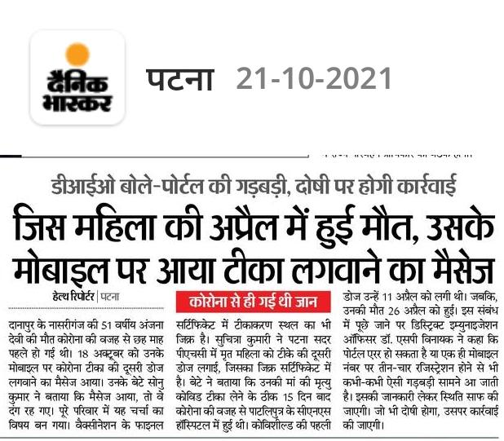
5143 | 22.10.2021 | https://twitter.com | Gurgaon, Haryana  Kapil Sharma’s father dies 5 months after receiving the 1st vaccine dose. |  | https://twitter.com/KapilSKalhan/status/1451497059920404485  https://twitter.com/KapilSKalhan/status/1450361556395462658
5144 | 18.10.2021 | https://twitter.com | Patil Farmer lost his 56 year old elder sister on 17th October 2021 1 month after vaccination |  | https://twitter.com/antpadv/status/1450032274959790083
5145 | 25.10.2021 | https://janjwar.com | Dalit woman dies after taking corona vaccine in uttar pradesh.  The family of the Dalit woman who died after vaccination claims that it happened after taking the vaccine in the locality. |  | https://janjwar.com/top-stories/uttar-pradesh-news-gorakhpur-dalit-woman-died-after-corona-vaccine-in-cm-home-district-783308
5146 | 28.10.2021 | https://twitter.com | Mumbai, Maharashtra  Mohammed Saeed  aged 75,  Dies of Cardiac arrest on 28th October 3 weeks after second jab. |  | https://twitter.com/Sr21387318/status/1453594593153327107?s=20
5147 | 27.10.2021 | https://twitter.com | Nagpur, Maharashtra  Mother of Jayalakshmi Sarikonda, died on October 27, due to Covid pneumonia, days after receiving second dose of COVID-19 vaccine. |  | https://twitter.com/jayalakshmi1908/status/1452602732041355275  https://twitter.com/jayalakshmi1908/status/1453193935732363271  https://twitter.com/jayalakshmi1908/status/1453408127345303554
5148 | 19.10.2021 | https://greatgameindia.com | Ganesh Nagar, East Delhi  Mrs. Savita (45) Wife of Ganga Prasad Gupta was vaccinated with the first dose on April 14, 2021 and died within days on April 25th 2021. |  | https://greatgameindia.com/i-blame-myself-for-vaccinating-my-wife/
5149 | 26.10.2021 | https://www.udayavani.com | Mittoor, Bantwal, Karnataka  27 year old Hasinar died on 27th March 2021 after receiving the 1st dose of covid vaccine |  | https://www.udayavani.com/homepage-karnataka-edition/karavali/karavali-puttur-belthangady/covid-vaccine-messege#google_vignette
5150 | 30.10.2021 | https://www.google.com  https://www.theguardian.com | Bengaluru, Karnataka  Kannada actor Puneeth Rajkumar (46) received the first dose of the COVID-19 vaccine on 7th April 2021 and died due to cardiac arrest on 29th October 2021 |  | https://www.google.com/amp/s/www.thenewsminute.com/article/sandalwood-star-puneeth-rajkumar-gets-his-first-dose-covid-19-vaccine-146780%3famp  https://www.theguardian.com/world/2021/oct/30/indian-actor-puneeth-rajkumar-dies-aged-46-after-heart-attack
5151 & 5152 | 29.10.2021 | https://www.bhaskar.com | Gopal Thakur of Dadabari Extension had installed the first day on April 14 2021. He died on 10 June 2021.  Radha Kishan Sharma of Retwali died on May 1. He got vaccinated on 11 April. |  | https://www.bhaskar.com/local/rajasthan/kota/news/second-dose-was-applied-to-two-dead-certificate-also-issued-129071039.html
5153 To 5155 | 27.10.2021 | https://www.newsclick.in | Bihar  Ashok Kumar Singh, a resident of Karigaon village and an advocate in the sub-divisional court in Kaimur district, died of suspected COVID-19 symptoms on April 4. He was administered the first dose of the vaccine on April 2 2021.  Dularchand Shah, a resident of Bansohi village in Siwan district , died in April after he developed breathlessness. He was administered the first dose of COVID-19 vaccination days before he died.  In Purnia district, a woman Tripti Roy, who died in August, got vaccinated with the second dose of the COVID-19 vaccination on September 17 2021.. |  | https://www.newsclick.in/Three-People-Bihar-Reported-Have-Got-Second-Shot-COVID-19-Vaccine-After-Their-Deaths?__cf_chl_managed_tk__=pmd_DaIaqBRWxcfmOUN3lKNKAcscJZu54mdRSu1Ow88KeZ0-1635835087-0-gqNtZGzNA2WjcnBszQg9
5156 | 31.10.2021 | https://twitter.com | Pune, Maharashtra  Dr D.V. Shilaskar.Pune - Aged 87 - Covishield Dose 1 - Vaccinated 26th March, Death on - 31st March 2021  Adverse effects - facial drooping, nausea, breathlessness, fell down multiple times after it, last fall coincided with a heart attack and death. |  | https://twitter.com/Ketaki39014637/status/1454737408256184320?s=20
5157 & 5158 | 30.10.2021 | https://twitter.com | Seby Joseph lost 2 people below 40 years due to heart attack and 1 with brain hemorrhage just days after vaccination. |  | https://twitter.com/josephseby78/status/1450713783257632772?s=20
5159 | 31.10.2021 | https://twitter.com | Bir Bhadra Lost a relative to a heart attack in 2021 after covid vaccination |  | https://twitter.com/BirBhadra8/status/1454747093051060224?s=20
5160 & 5161 | 29.10.2021 | https://twitter.com | Jaya lost someone close & Karthik lost his aunt just 3 days after the vaccine. |  | https://twitter.com/jaytwri/status/1454035495613132800?s=20  https://twitter.com/karthikvpc/status/1454047927299547140
5162 | 31.10.2021 | https://m.facebook.com | Karan Kabir Bajwa’s Brother, Kabir Bajwa died 10 days after taking the 1st shot of Covishield |  | https://m.facebook.com/story.php?story_fbid=10159521161736578&id=538011577
5163 | 01.11.2021 | https://m.timesofindia.com | Trichi, Tamilnadu  Selvaraj Govindhachettiyar, hailing from Beschi street in Woraiyur, had taken his first dose at MGMGH on April 28. Two weeks later, he contracted Covid-19 and succumbed to the infection on May 15. |  | https://m.timesofindia.com/city/trichy/man-dead-5-mths-ago-got-dose-2-now-sms/articleshow/87442759.cms
5164 | 04.11.2021 | https://www.thestatesman.com  https://www.google.com/amp/s/bengali.abplive.com | Kolkatta, WestBengal  Senior West Bengal Minister Subrata Mukherjee passed away with a cardiac arrest in Kolkata on November 4 2021. He had received the corona vaccine on 3rd March 2021. |  | https://www.thestatesman.com/bengal/bengal-minister-subrata-mukherjee-passes-away-1503022826.html/amp?fr=operanews  https://www.google.com/amp/s/bengali.abplive.com/videos/news/kolkata-corona-vaccine-subrata-biman-got-vaccin-at-sskm-corona-804121/amp
5165 & 5166 | 11.10.2021 | https://timesofindia.indiatimes.com | Tumakuru, Karnatala  47-year-old pontiff of Kuppuru Gadduge Mutt and a 32-year-old nurse due to Covid-19 — despite being fully vaccinated |  | https://timesofindia.indiatimes.com/city/mysuru/deaths-among-vaccinated-population-too-few-to-be-cause-for-worry-experts/articleshow/86927602.cms
5167 | 01.08.2021 | Vaccine & Death Certificates | Mumbai, Maharashtra  70 year old Chandrabhaga Harbhau Ware, was vaccinated with Covishield on 14.07.2021 and died on 1st August 2021  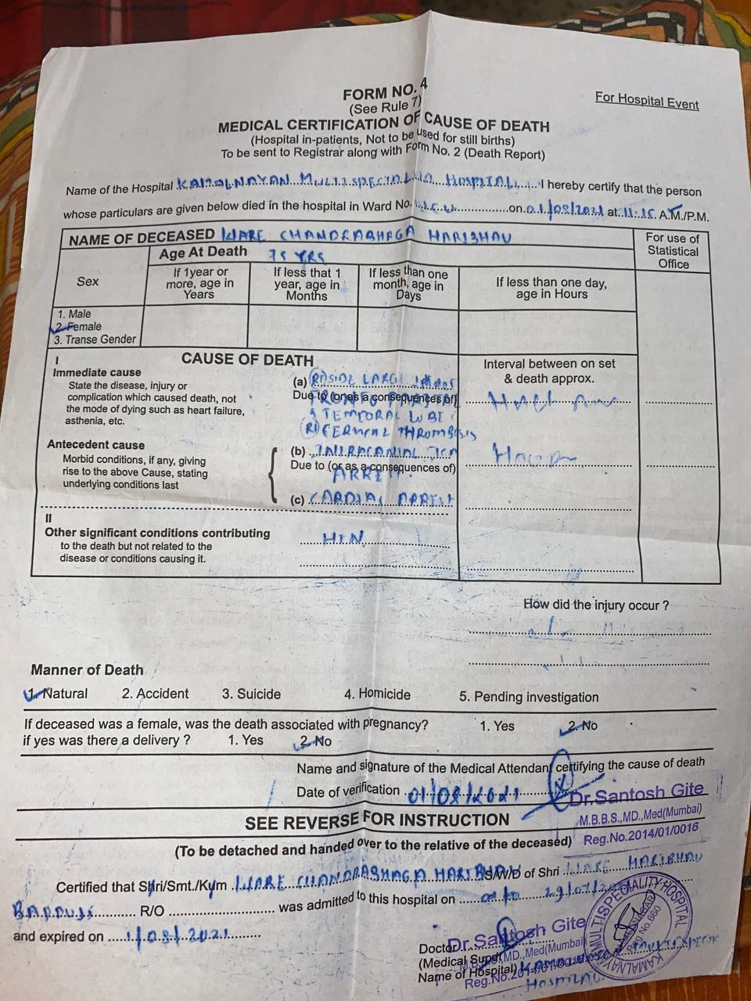 |  | 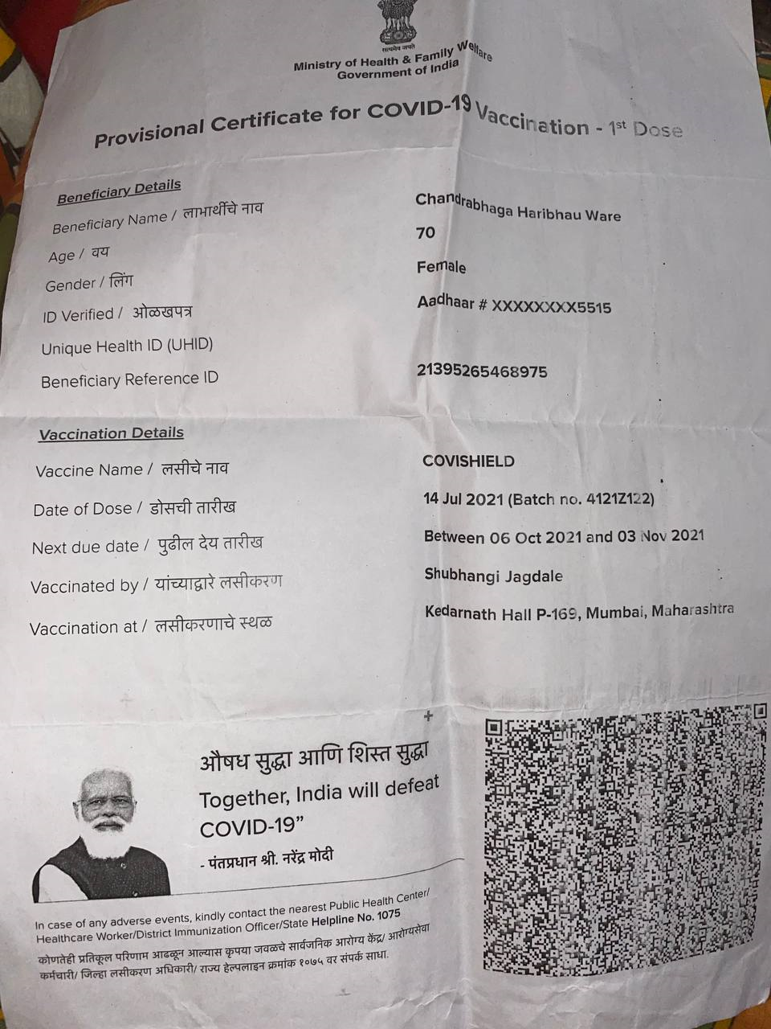
5168 | 08.11.2021 | https://t.me/VaccineDeathsIndia | Bengaluru, Karnataka  Abdul Matif Majinda Age: 49 Date of death: 8 Nov 2021 Date of Vaccination: 29 Oct 2021 (first dose)  He had no (serious) prior health concerns before getting his first dose of vaccination.  He allegedly suffered from heart issues, body pain after being vaccinated and his deteriorating health condition led to his death. |  | https://t.me/VaccineDeathsIndia/1271  https://t.me/VaccineDeathsIndia/1274
5169 | 09.11.2021 | https://www.bhaskar.com | Jabalpur, MadhyaPradesh  Ravi Shankar Yadav (45), a resident of Bagheli ward number 75 died on 8th November 2021 a few hours after taking the 2nd dose of the corona vaccine |  | https://www.bhaskar.com/local/mp/jabalpur/news/the-death-of-the-laborer-who-reached-home-after-getting-the-vaccine-installed-the-ruckus-of-the-family-on-this-death-in-jabalpur-the-health-department-can-be-in-trouble-the-dead-body-will-be-of-th-129098551.html?_branch_match_id=949517096147628718&utm_campaign=129098551&utm_medium=sharing&_branch_referrer=H4sIAAAAAAAAA8soKSkottLXT0nMzMvM1k3Sy8zTT%2FXJKSnKKMkwzE4CAFqLVZUfAAAA
5170 | 04.11.2021 | https://hindi.oneindia.com  https://navbharattimes.indiatimes.com | Rajnandgaon: Khairagarh, Chattisgarh  52 year old MLA Devvrat Singh  got the second dose of vaccine on 31st May 2021 and died on 3rd November with a heart attack. |  | https://hindi.oneindia.com/videos/rajanandaganv-khairagadh-vidhayak-ne-lagavai-vaiksin-ki-dusari-doj-apani-bari-aane-par-nisankoch-vaiksin-lagavae-devavrat-sinh-dhnt-1585436.html  https://navbharattimes.indiatimes.com/state/chhattisgarh/other-cities/chhattisgarh-khairagarh-mla-devvrat-singh-death-after-heart-attack-cm-bhupesh-baghel-condoles/articleshow/87522358.cms
5171 | 10.11.2021 | https://www.deccanherald.com | Sehore District, Madhyapradesh  19 year old Shubham Parmar was administered the first dose of the Covid-19 vaccine at Bhanvra village on the afternoon of November 6 2021 and died within 48 hours on 8th November 2021 |  | https://www.deccanherald.com/national/19-year-old-dies-within-48-hours-of-taking-covid-19-vaccine-post-mortem-conducted-at-aiims-1049204.html
5172 | 10.11.2021 | https://jalgaonlive.news | Jalgaon, Maharashtra  47 year old Devidas Khadke took the 1st dose of Covishield vaccine at 3:30 p.m on 8th November and passed away within a few hours. |  | https://jalgaonlive.news/one-death-after-vaccination-in-jalgaon/
5173 | 01.09.2021 | Vaccine & Death Certificates | Jorhat Assam  64 year old Rekha Rani De, was vaccinated with Covishield on 5th May 2021 and died on 1st September 2021  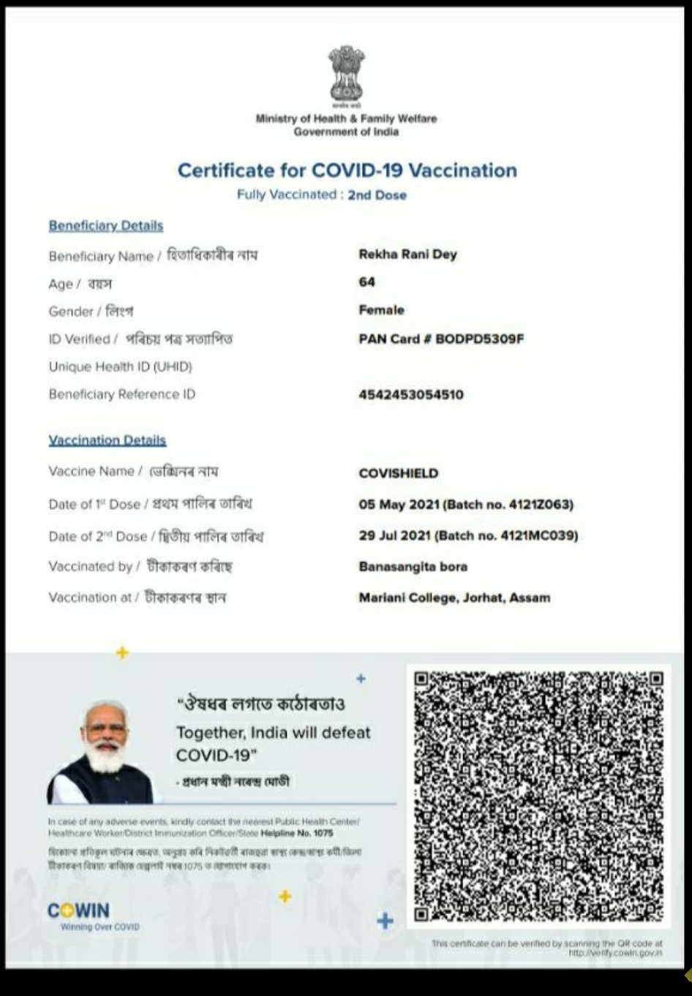 |  | 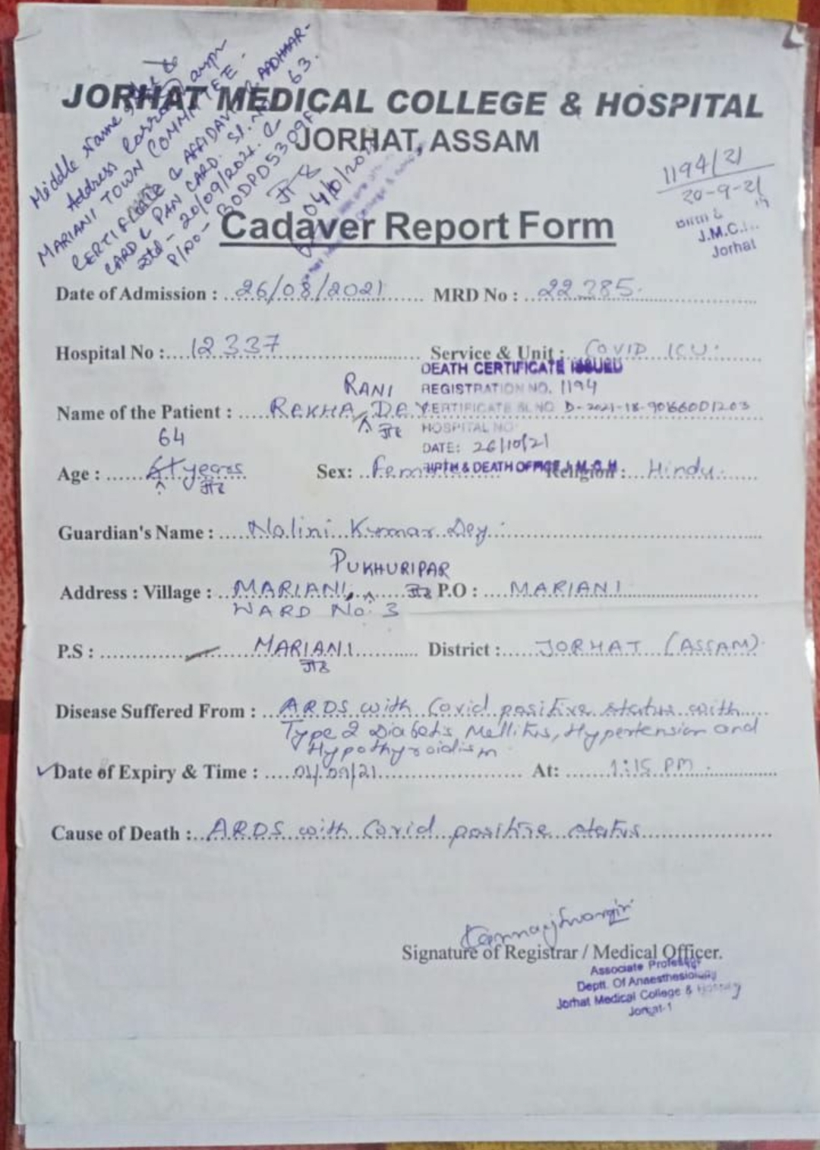
5174 | 09.11.2021 | https://youtube.com | Hailakandi, Assam  A labourer died after a week; caught fever after taking the first dose of Covaxin taken on October 30th 2021 |  | https://youtube.com/watch?v=oKp4DED854w&feature=share
5175 | 16.11.2021 | https://starofmysore.com | Mysuru, Karnataka  39 year old Suresh a Ashokapuram resident Suresh was vaccinated for COVID on Nov. 12 during a door to door COVID vaccination drive conducted by the Health Department but 10 minutes later, blood starting oozing from the mouth and nose and he breathed his last on 15th November 2021 evening. |  | https://starofmysore.com/relatives-of-ashokapuram-resident-who-died-after-taking-covid-vaccine-stage-protest/amp/
5176 | 23.08.2021 | https://keralaspeaks.news | Kerala  39 year old P. R .Rajesh(39), Died after his 1st dose of covishield vaccination |  | https://keralaspeaks.news/yet-another-death-in-kerala-due-to-alleged-side-effects-of-covid-vaccination/
5177 To 5818 | 270.8.2021 | https://tv.mathrubhumi.com | Kerala  95 + 546 deaths Total 641 deaths. 95 people died after receiving two doses of the covid vaccine. A single injection killed 546 people. Most of the people who died after getting the vaccine were the elderly and those with other diseases |  | https://tv.mathrubhumi.com/amp/news/kerala/death-even-after-taking-two-doses-of-covid-vaccine-1.98981
5819 To 6154 | 17.11.2021 | https://twitter.com | Tamil Nadu  336 vaccinated people died in Aug, Sept & Oct as per Tamil Nadu govt data. |  | https://twitter.com/ramyakannan/status/1460950746497617920
6155 | 12.11.2021 | Sangamner Panchayat Samiti report | Sangamner, Maharashtra  37 year old Health Officer Amol Kishor Jangam  Took the First dose of Covishield on 08.02.2021 and the second dose on 17.03.2021 and died on 05.05.2021  Ref Id 21391546603530 |  | 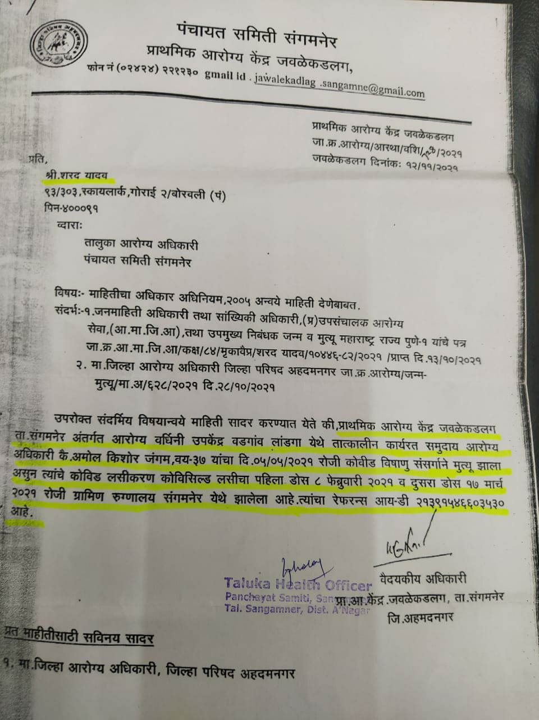
6156 | 23.09.2021 | https://www.snews4u.com | Bhopal, Madhyapradesh  Vidya Sharma was given the first dose of Covshield on March 8, but on May 1, 2021, she passed away. |  | https://www.snews4u.com/2021/09/blog-post_23.html?m=1
6157 | 18.11.2021 | NEWSPAPER  https://indianexpress.com | Chennai, Tamil Nadu  61 year old Popular Tamil director and actor RNR Manohar had taken two vaccines and died on 17.11.2021 |  | https://indianexpress.com/article/entertainment/tamil/tamil-director-actor-rmr-manohar-passes-away-at-61-7627359/  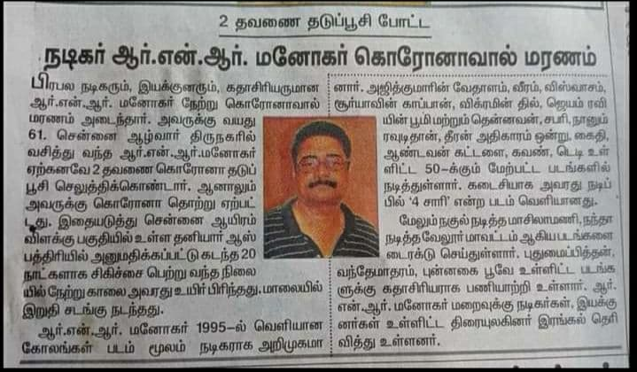
6158 | 19.11.2021 | https://mobile.twitter.com | Raman’s colleague’s 65 year old wife, who was double vaccinated, collapsed suddenly without warning and died of cardiac arrest on 18th November 2021. |  | https://mobile.twitter.com/cbm1963/status/1461549357333893126
6159 & 6160 | 20.11.2021 | https://timesofindia.indiatimes.com | Indore & Bhopal, Madhyapradesh  A 69 year old who was fully vaccinated died of covid on 15th November 2021 & a 54 year old Rashmi Gupta, wife of Dr Rajendra Gupta, had taken the 2nd dose of the vaccine in February 2021 died on 19th November 2021. |  | https://timesofindia.indiatimes.com/city/bhopal/fully-vaccinated-woman-dies-of-covid-in-bhopal/articleshow/87809688.cms  https://www.freepressjournal.in/bhopal/bhopal-radiologists-wife-who-died-of-covid-19-didnt-have-comorbidities
6161 | 18.11.2021 | https://www.bhaskar.com | Malajpur, Madhyapradesh  A 62 year old woman Ganga Bai, wife of Madhukar Ingle took the 2nd dose of covishield on 17.11.2021 because she was not being given the ration and died within six hours. |  | https://www.bhaskar.com/local/mp/hoshangabad/betul/news/6-hours-after-the-second-dose-the-womans-bp-became-high-died-in-the-hospital-129132594.html
6162 | 20.11.2021 | https://www.nationalheraldindia.com | Aurangabad, Bihar  Rinku Devi, took the second dose of Covid-19 vaccine on 20.11.2021 collapsed on the road while returning home, in Bhadua village.Her husband Jitendra Singh rushed her to the Sadar Hospital where the doctors declared her dead on arrival. |  | https://www.nationalheraldindia.com/health/bihar-woman-dies-after-taking-second-dose-of-covid-vax
6163 & 6164 | 19.11.2021 | https://timesofindia.indiatimes.com | Gurugram, Haryana  A 75-year-old woman who was fully vaccinated died of Covid on 18th November 2021. She had taken her second shot of Covishield on 10th August 2021. & On 14th November 2021, a 71-year-old man died of Covid, t had taken his second shot of Covishield about five months ago. |  | https://timesofindia.indiatimes.com/city/gurgaon/2nd-covid-death-this-wk-both-70-comorbid-fully-vaxxed/articleshow/87788207.cms?from=mdr
6165 | 27.10.2021 | https://timesofindia.indiatimes.com | Mangaluru  Hasainar Mithur, 72, a farmer from Mithur village in Bantwal took the first dose of Covishield on March 24 2021 and passed away on 27th April 2021. |  | https://timesofindia.indiatimes.com/city/mangaluru/dakshina-kannada-man-who-died-in-april-gets-second-dose-certificate-on-october-14/articleshow/87300006.cms?from=mdr
6166 | 08.11.2021 | https://timesofindia.indiatimes.com | Madurai, Tamilnadu  A 20-year-old woman who was 34 weeks pregnant passed away on 6th November 2021. She was partially vaccinated. |  | https://timesofindia.indiatimes.com/city/madurai/20-yr-old-pregnant-woman-dies-of-covid-in-madurai/articleshow/87573509.cms?from=mdr
6167 | 23.09.2021 | https://timesofindia.indiatimes.com | Morbi, Gujarat  Rajendra Jadeja of Morbi’s Maliya taluka who took the first dose of vaccine in March but died before taking the second dose. |  | https://timesofindia.indiatimes.com/city/rajkot/dead-man-in-morbi-gets-jab-certificate/articleshow/86434718.cms?from=mdr
6168 | 21.11.2021 | https://news.abplive.com | Trichy, Tamilnadu  Selvaraj Govindhachettiyar from Bescho Street in Woraiyur of Tiruchy district took his first dose of Covishield vaccine at MGMGH on April 28 2021 was infected with novel coronavirus and later he died due to the infection without responding to treatment on May 15. |  | https://news.abplive.com/tamil-nadu/tamil-nadu-man-gets-second-dose-of-vaccine-5-months-after-death-says-sms-from-cowin-app-1490885/amp?utm_campaign=fullarticle&utm_medium=referral&utm_source=inshorts
6169 | 18.11.2021 | https://www.freepressjournal.in | Udaigarh, Madhyapradesh  Tikamsingh Dohare got the first shot of Covaxin on April 7, and died exactly within 20 days. |  | https://www.freepressjournal.in/indore/vaccination-drive-mess-administration-vaccinates-dead-man-in-madhya-pradesh
6170 | 25.10.2021 | https://www.freepressjournal.in | Dhar, Madhyapradesh  50-year-old, Mukesh Mukati of Kalsada Bujurg village under Teesgaon block of Dhar had received first dose of Covishield on March 13 2021, died on May 3 2021. |  | https://www.freepressjournal.in/indore/madhya-pradesh-man-died-in-may-3-but-health-department-says-second-jab-done-on-october-7
6171 | 21.11.2021 | https://zeenews.india.com | Hooghly District, West Bengal  Saraswati Das (72) was a resident of Subhash Palli, Ward 13 of Dunkuni Municipality., took the first dose on March 23 this year. But she died on April 29, a month after being infected with the corona. |  | https://zeenews.india.com/bengali/state/covid-vaccination-certificate-of-second-dose-of-an-old-lady-comes-after-8-months-of-her-death_412749.html
6172 | 21.11.2021 | Source : Dinamani news paper, Coimbatore edition, page 07 | Mayiladuthurai, Tamilnadu  Samydurai, Male, 70, from Purasangadu Village, Mudigandalur, had taken the vaccine on 20th November 2021 at a Vaccination camp along with other 56 people. He felt chestpain on Sunday, the sameday doctors confirmed that he is no more. |  | 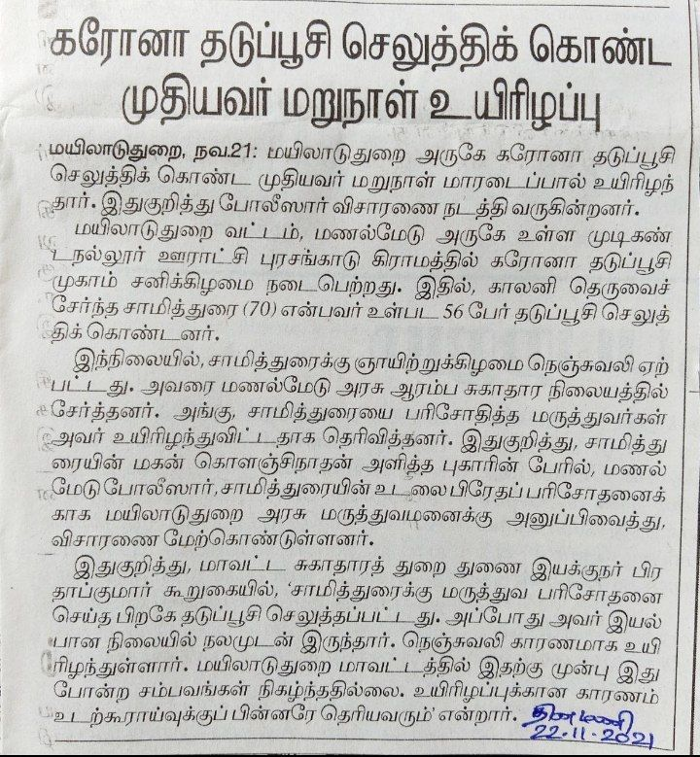
6173 | 21.11.2021 | https://twitter.com | Delhi  Israr Ahmed Sheikh, Journalist, Former Editor  @IndiaSpendHindi and India News, Ex BITV, Zee, Sahara, India TV, @Gonews_India had taken the Sputnik vaccine on 25th June 2021 and passed away on 20th November 2021 night due to a heart attack. |  | https://twitter.com/nicefiddler/status/1462632132329672708?s=20  https://twitter.com/PrashantTandy/status/1462309206850097157
6174 | 22.11.2021 | https://m.timesofindia.com | Mumbai, Maharashtra  Six months after being immunised with both doses, Kandivli resident Sharadchandra Shenoy (63) succumbed to Covid-19 pneumonia in October 2021. |  | https://m.timesofindia.com/city/mumbai/elders-share-in-mumbai-covid-toll-up-nears-pre-vaccination-days/articleshow/87838515.cms

