1) Open attachment 202649 in MS Excel
https://bugs.documentfoundation.org/attachment.cgi?id=202649
2) Copy chart from ‘Sheet2’
3) In Writer-edited DOCX paste special:
Edit → Paste Special → Paste Special… (Ctrl+Shift+V)
→ Graphics Device Interface metafile (GDI)
4) Save DOCX
5) Reload file or reopen with LO restart.

Result:
Shifted and stretched portion of chart is visible in plotting area.

as in below EMF picture:

Expected result:
EMF-vector-chart similar to inserted below raster-bitmap.
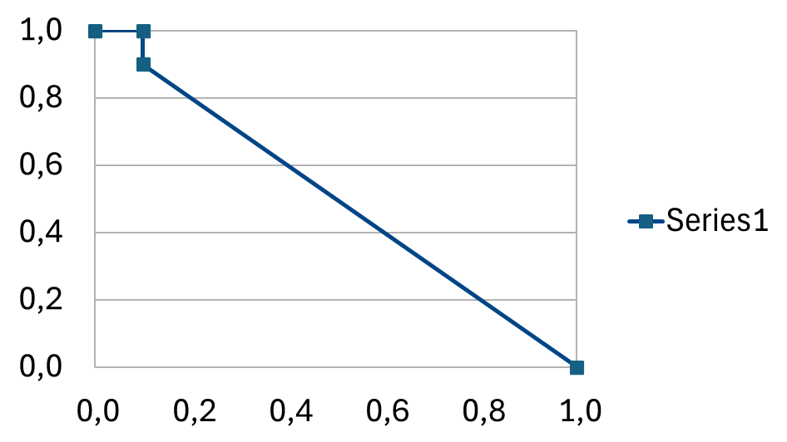

Version: 25.8.1.1 (X86_64)
Build ID: 54047653041915e595ad4e45cccea684809c77b5
CPU threads: 16; OS: Windows 11 X86_64 (build 26100); UI render: Skia/Raster; VCL: win
Locale: pl-PL (pl_PL); UI: en-US
Calc: CL threaded

https://bugs.documentfoundation.org/show_bug.cgi?id=168237
The operation must be performed between MS Excel and LO Writer

