The trace layout window
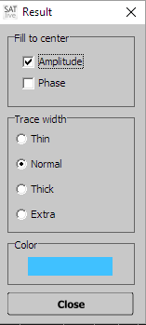
The top of the window shows the name of the trace, which is modified using this window.

Fill to Center
This function fills the area between the trace and the center of the display (in the transfer-function measurement) or to the bottom of the display in the FFT measurement.
You can activate the fill for the phase – trace and for the amplitude – trace separately.
The fill is transparent, so intersections remain clearly visible.

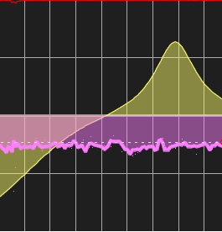
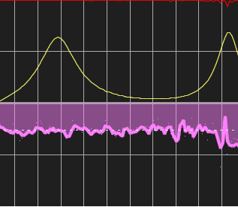

Hints:
- The changes are applied immediately.
- Use the transparency setting in Setup → Display to modify the transparency of the filled area. See page for information about this setup window.

Trace Width
Select the width of the trace in this area.
This setting is used to draw the line of the trace, but does not affect the filling (if any). The changes are applied immediately.
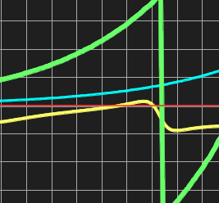

Red: Thin, Lime: Normal, Yellow: Thick and Green: Extra

Color
Click on this area to open the color-selection dialog for the trace. Any change is applied immediately.

Close
Click on this area to close the window.

The combfilter – pattern menu
This menu controls the combfilter – pattern tool.
You'll finde a close description of combfilters and of the combfilter – pattern tool starting on page Error: Reference source not found in this document.
You'll find the menu in the upper menu area. It shows only during the measurement of the transfer – function.

Display Modes
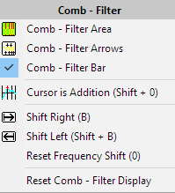
The upper three entries active the combfilter – pattern (see page Error: Reference source not found) in the display area.
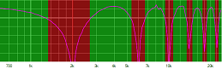
- Combfilter Area:
The pattern shows in the background of the amplitude – trace display. The range of addition is marked green and the range of cancellation is marked red.
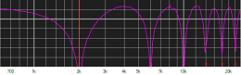
- Combfilter Arrows:
The points of maximum addition and maximum cancellation are marked with small arrows, where the arrows for the addition show on the top of the display area and the arrows for the cancellation show on the bottom of the display area.
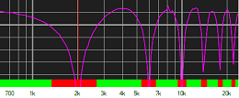
- Combfilter Bar:
This display uses the same colors as the Combfilter Area display, but it shows as a solid bar at the bottom of the display area.

Hint: You can use multiple displays at the same time.

