Room Acoustic Calculation
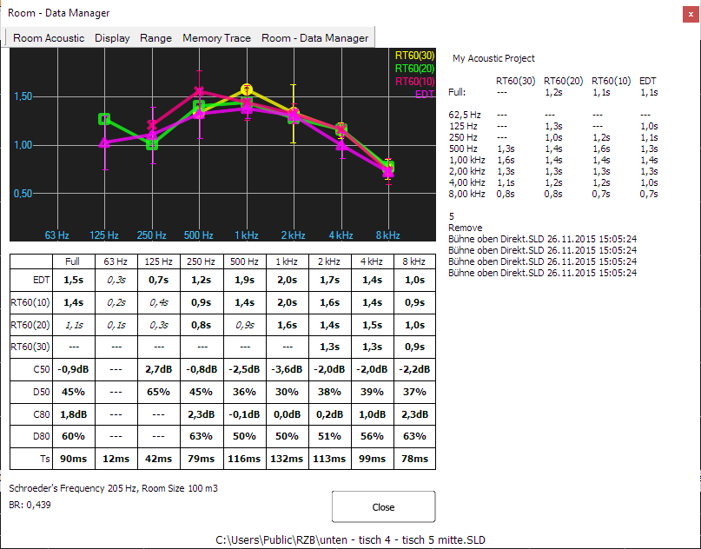
SATlive offers a room acoustic tool to calculate room – acoustic values using an impulse response. The quality of the results relates to the quality of the impulse response used, so you should take care to create a good impulse response (use long impulse responses). The room-acoustic tool is invoked in the menu Tools (see page 3).
The traces for the reverberation times are shown at the top. Below the graphic there is a table containing the numerical values of the reverberation times and other room – acoustic parameters (see page 3 for details).
The room – data manger (see page 3) on the right side of the window allows you to easily average different measurements of the same room.
The tool starts using the last selected calculation settings. See page 3 for details.
You can modify the settings using the menu entry Configure Schroeder Trace in the menu entry Room Acoustic.

The views of the acoustic window
The acoustic window supports two different modes.
- In the Single trace mode mode different acoustic values, all based on the same measurement (the so called master – trace), will show in the display and in the numeric display.
- Using the Multi trace mode you can display a certain room-acoustic value of more than one trace.
Use the entry Show multiple traces in the menu Display (see page Error: Reference source not found) to toggle between the two views.

Managing Traces in Multi Trace Mode
Using the multi – trace mode you can display up to eleven different traces in the display.
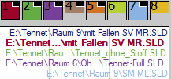
You can control the visibility of the main – trace, of the memory – trace and of the room – data trace in their menus.
The control of the eight trace latches is similar to the quick – trace handling (see page Error: Reference source not found for details) and can be done using the popup menu.
- To assign the main – trace to a trace – latch use the entry Copy to Trace – Memory in the menu Main – Trace.
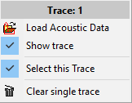
- Use the entry Load Acoustic Data to load stored acoustic data into the trace – memory.
- Show trace toggles the visibility of the trace. You can also click on the upper area of the icon to toggle the visibility of the trace.
- The entry Select this Trace brings the trace to the front and shows its values in the lower area. The name of the trace will show in the header. Click on the lower area of the icon to select the trace using the mouse.
- The entry Clear single trace will remove the acoustic data from this trace.

