Actual lines | Rendering by MS Word | Rendering by LO 24.2
 | 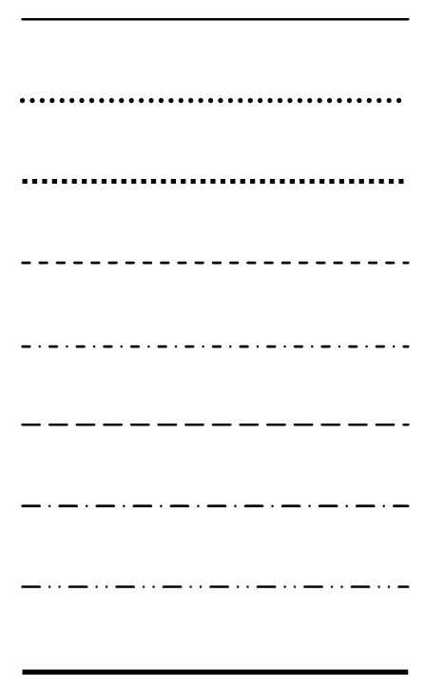 | 