Hello! I am the floatingtable!
We are the nested groupshapes
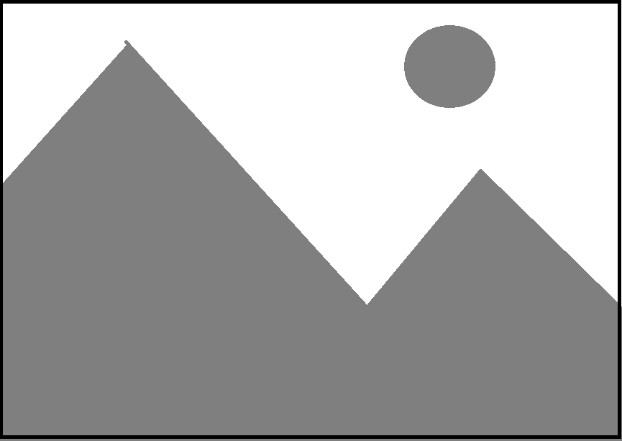
We are the nested groupshapes

