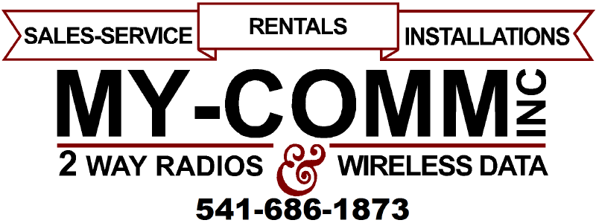
30200
WORK ORDER
☐ 2-WAY
☐ TRUNKING
☐ CELLULAR
☐ PAGER
☐ MIC
☐ RENTAL
☐ DEMO
☐ REPAIR
☐ INSTALL
☐ SET-UP
☐ PROGRAM
QTY | PART # | DESCRIPTION | PRICE | TOTAL
DECODE: ☐ YES ☐ NO CODE: CODE
BATT (mAh) – RATED: RATED ANYL: ANALYZED COND: CONDITIONED
ANTENNA SWR: FORWARD: FORWARD REFLECTED: REFLECTED

MAINT. PERFORMED: Click here to enter text. |  | TOTAL PARTS
LABOR
DATE | EMPLOYEE | START | END | REG | O/T | TYPE
 |  |  |  |  |  | ☐B ☐ F
 |  |  |  |  |  | ☐B ☐ F
 |  |  |  |  |  | ☐B ☐ F
Click here to enter text.
Click here to enter text.
Click here to enter text.
LTR CODE: Click here to enter text. ESN: Click here to enter text.
LOCK CODE: Click here to enter text. DECODE: Click here to enter text.
VEH. TYPE/ LIC: Click here to enter text. MOB/ PAG TEL/ #: Click here to enter text.
ACCESSORIES: ☐ MICROPHONE ☐ ANTENNA ☐ CASE ☐ BATTERY ☐ CLIP ☐ OTHER: OTHER ACCESS.
SYMPTOMS: Click here to enter text.
INVOICE #: Click here to enter text. CUSTOMER P.O. #: Click here to enter text.
COMPANY: Click here to enter text. UNIT: Click here to enter text.
CONTACT: Click here to enter text. PHONE: Click here to enter text.
MAKE/ MODEL/ S/N #: Click here to enter text.
BENCH LABOR | AS CHECKED | AS ADJUSTED
POWER OUTPUT
FREQ. ERROR
MODULATION
DIG/TONE LEVEL
DTMF LEVEL
Rx SENS
Click here to enter text.

TECHNICAL SERVICE

SHIPPING CHARGES

TRAVEL TIME
WARRANTY REPAIR? ☐ YES ☐ NO
TOTAL
COMPLETED DATE: Click here to enter text.

